Build and run specifyproject with Maven instructions:

This instructions is written based on following environment:

Mac OS X version 10.6.7
NetBeans IDE 7.0.1
glassfish-3.1.1
MySQL JDBC driver: mysql-connector-java-5.1.16-bin.jar
Specify database version: 6.4

Setup NetBeans IDE:
- Download NetBeans from: http://netbeans.org/
- Install NetBeans IDE. Refer to online instructions: http://netbeans.org/community/releases/70/install.html

Checkout source Code from Subversion:
Check out source code from sourceforge subversion: http://specify.svn.sourceforge.net/svnroot/specify/trunk/SpecifyEnterprise/SpecifyEJB

- Go to directory where you want to store source code. Run svn commend:
svn co http://specify.svn.sourceforge.net/svnroot/specify/trunk/SpecifyEnterprise/SpecifyEJB
- A SpecifyEJB folder will be created, and it contains three modules and one super pom.xml. The pom.xml will build specifyproject in which has three modules: specify-datamodel, specify-data-jpa and specify-data-service.

dialog 1
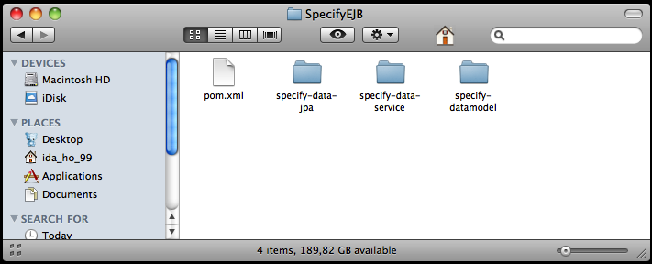

Import project into NetBeans:

- Open NetBeans IDE.
- From File, click Open Project, Open Project dialog displays.

dialog - 2
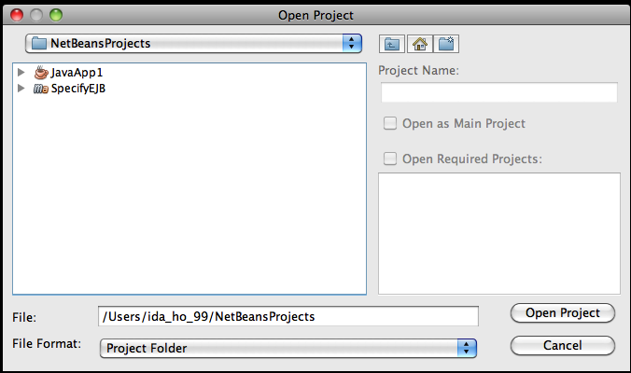
- Navigate to project directory, select SpecifyEJB, check Open Required Projects, then click Open Project.

dialog - 3
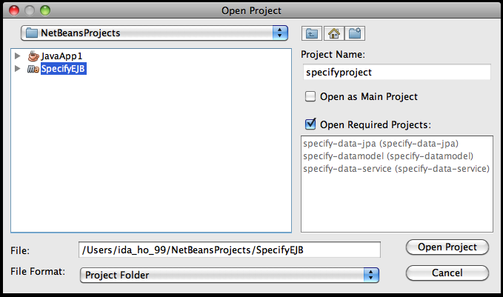

- specifyproject will import into NetBeans IDE with three modules: specify-datamodel, specify-data-jpa and specify-data-service

Build project:

- Select parent project - specifyproject, right click, then click Clean and Build, project start to build, it will take few minutes to build at first time.

dialog - 4
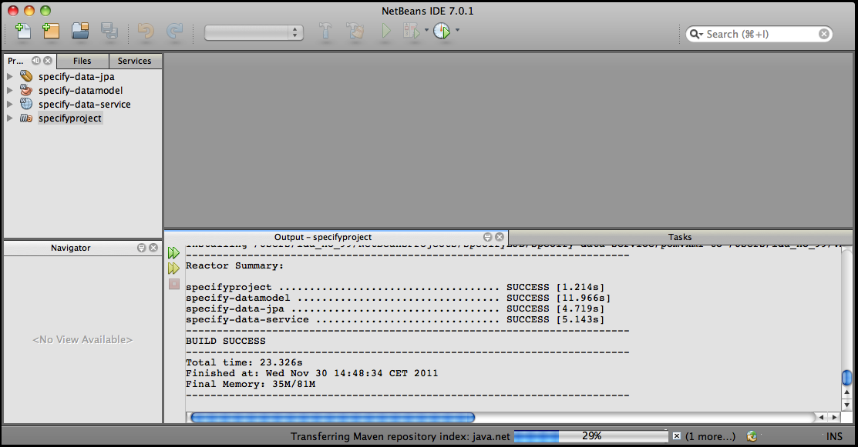
- After successfully build specifyproject, build submodules by following orders:
- Select specify-datamodel, right click and then click Clean and Build, specify-datamodel start to build.
- Select specify-data-jpa, right click and then click Clean and Build, specify-data-jpa start to build.
- Select specify-data-service, right click and then click Clean and Build, specify-data-service start to build.

Note:
If build failed by missing external 3rd party jars, you need to manually download and install.
- Download missing jars from their web site.
- Manually install jars into local repository. Refer online instructions:
http://maven.apache.org/guides/mini/guide-3rd-party-jars-local.html

Set up glassfish server:

The glassfish-3.1.1 is downloaded with NetBeans, by default it is located at Applications – NetBeans folder.

To create and configure MySql datasource in glassfish.

- Download MySQL JDBC driver from http://dev.mysql.com/downloads/connector/j/
- Extract the contents of the zip file
- Copy mysql-connector-java-x.x.x-bin.jar to glassfish-installation-dir/lib folder. (ex: Applications/NetBeans/glassfish-3.1.1/glassfish/lib)
- Start Glassfish Application server.
To sart glassfish server, run the command “./asadmin start-domain domain1” from glassfish-installation-dir/bin.

dialog – 5
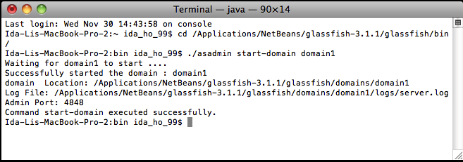
or start Glassfish Application server from NetBeans IDE:
From NetBeans IDE, select tab Services, click on Servers, and right click GlassFish Server 3.x, then click Start

- Login to GlassFish admin console. The default url for GlassFish admin console will be http://localhost:4848. The default username and password for accessing the admin console will be admin and adminadmin respectively.
- From Common Task menu expand Resources menu by clicking on Resources menu.
- Expand JDBC under Resources.
- Click on ‘JDBC Connection Pools’ under JDBC menu. The Connection Pools page will be displayed.

dialog - 6
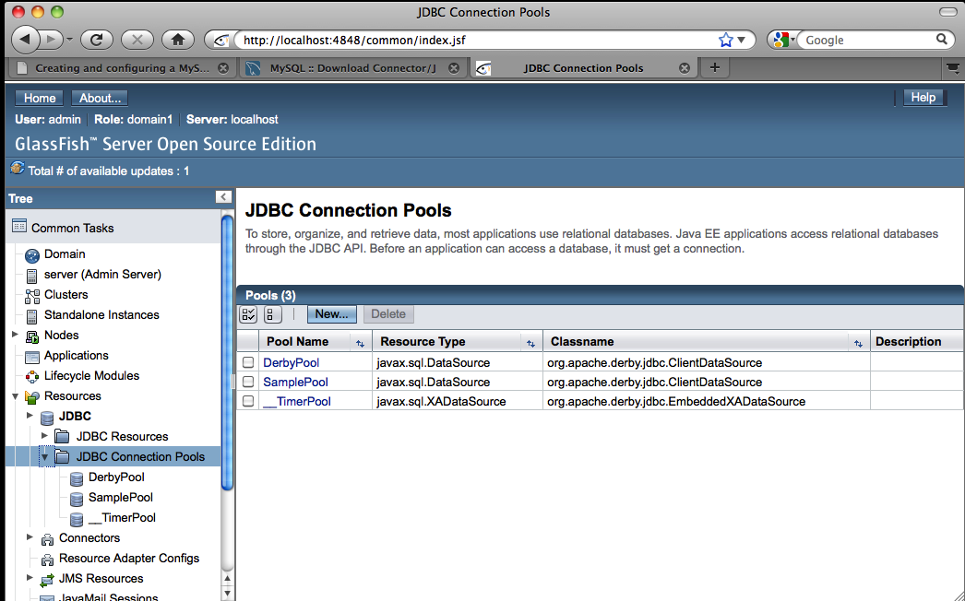

- Click on New.
- Enter a name in Pool Name. Select javax.sql.ConnectionPoolDataSource as your ‘Resource Type’ and select MySQL as your ‘Database vendor’.

dialog – 7
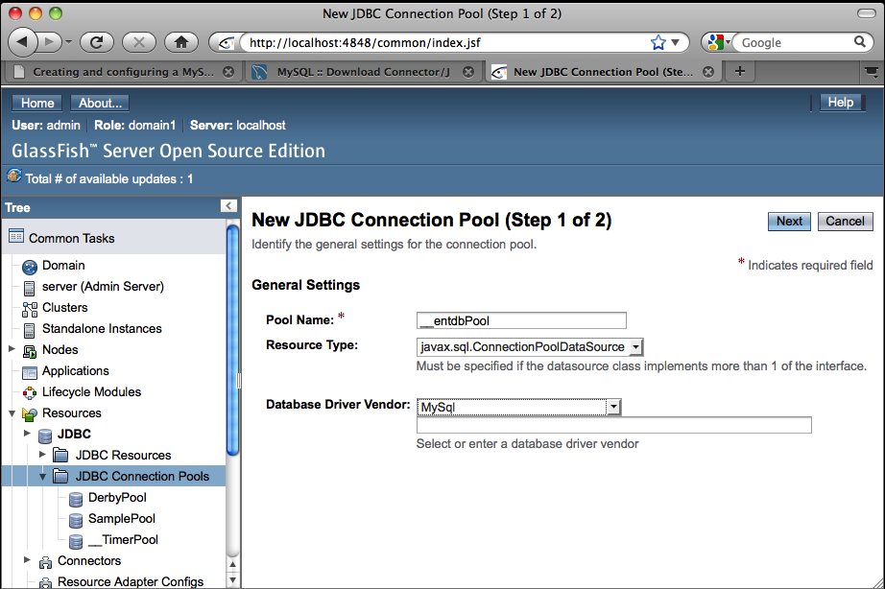
- Click on Next.
- Fill the Additional Properties according to your need. Minimum you need to fill the following fields.
- databaseName
- password
- user
- serverName
- portNumber

(note: I found sometimes the properties name are case sensitive, don't understand why)

dialog - 8
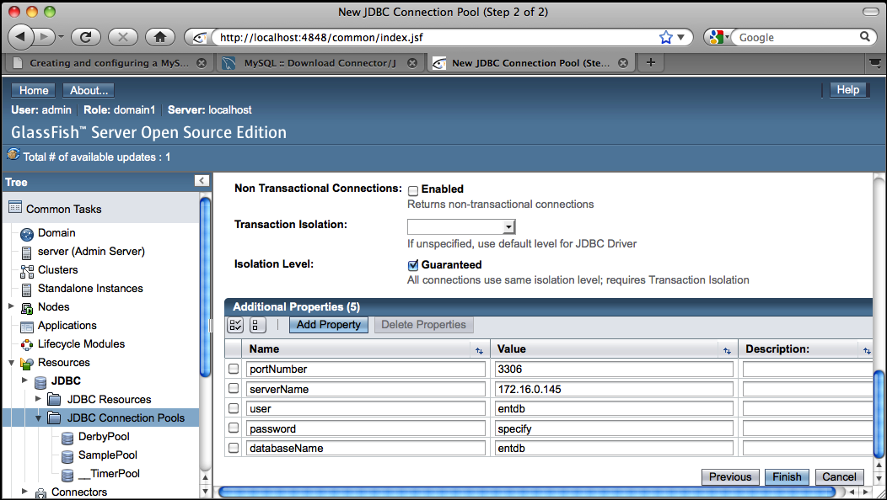
- Click on Finish. You will be taken to the Connection Pools page.
- Click on the Connection Pool you created to open Edit Connection Pool page.
- Click on Ping. If connection pool is setup correctly, you will get a Ping Succeeded message.

dialog - 9
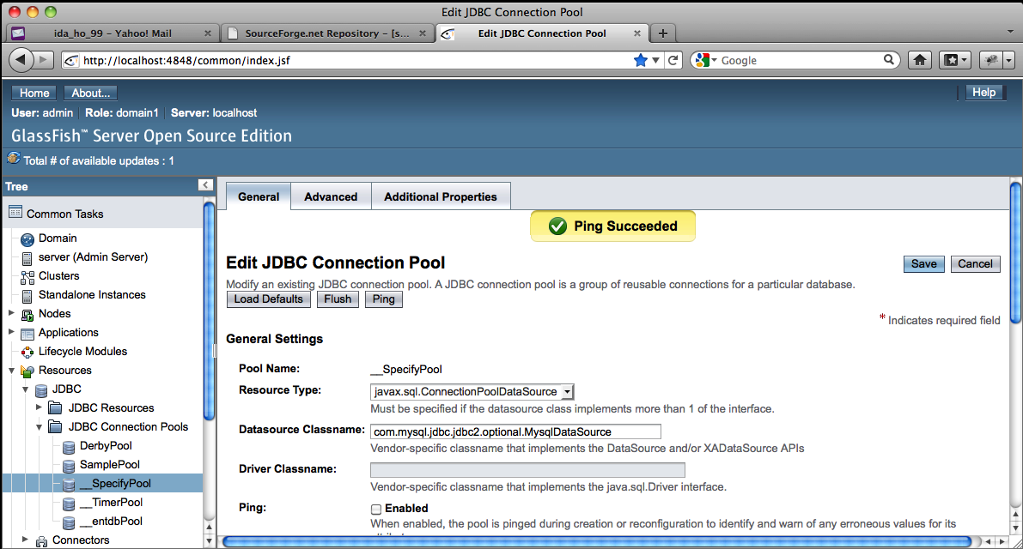

- Now click on JDBC Resources under JDBC menu. The JDBC resources page will be displayed.
- Click on New.
- Enter a JNDI Name for your data source. From Pool Name drop down list, select the connection pool you just created as Pool Name.
(note: this JNDI Name will be used in persistence.xml in specify-data-jpa as jta-data-source for connecting to database)

dialog – 10
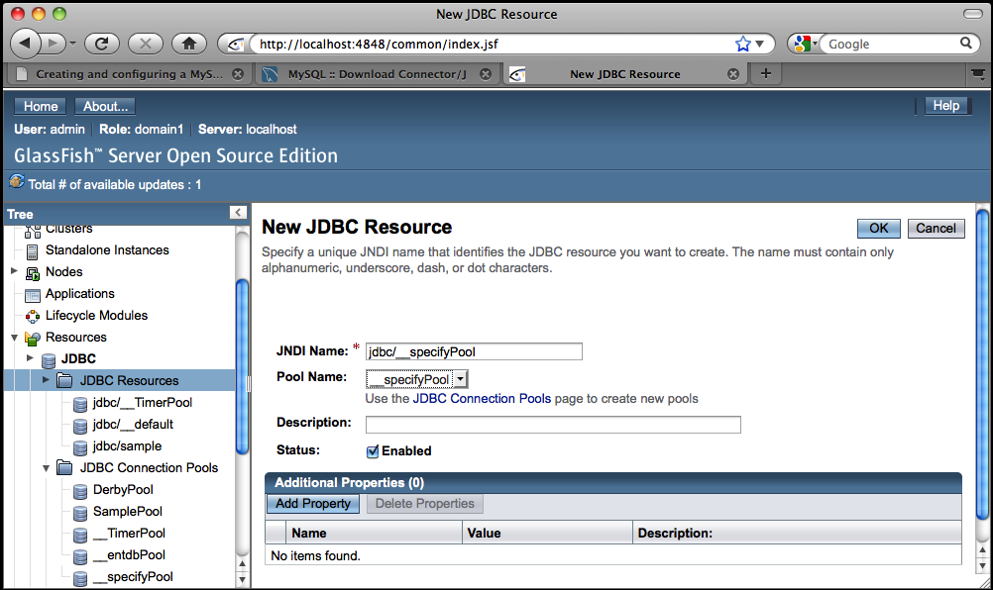
- Click OK to finish setup connection pool in glassfish.

You have created a database connection pools in glassfish, now you need to set JNDI Name in specify-data-jpa persistence.xml

- From NetBeans IDE, under specify-data-jpa, click on Other Sources, under src/main/resources, META-INF, click persistence.xml to open it.
- Put JNDI Name you just created in glasfish in <jta-data-source>JNDI Name</jta-data-source>

dialog - 11
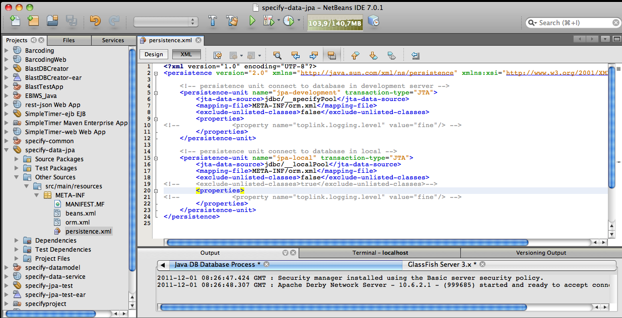
- Click specify-data-jpa Source Packages, click SpecifyDaoImpl.java under package se.nrm.specify.specify.data.jpa to open it in edit area.
- Copy persistence-unit name from persistence.xml into @PersistenceContext(unitName=”unit name”).
Ex:
@PersistenceContext(unitName = "jpa-development")
private EntityManager entityManager;

dialog – 12
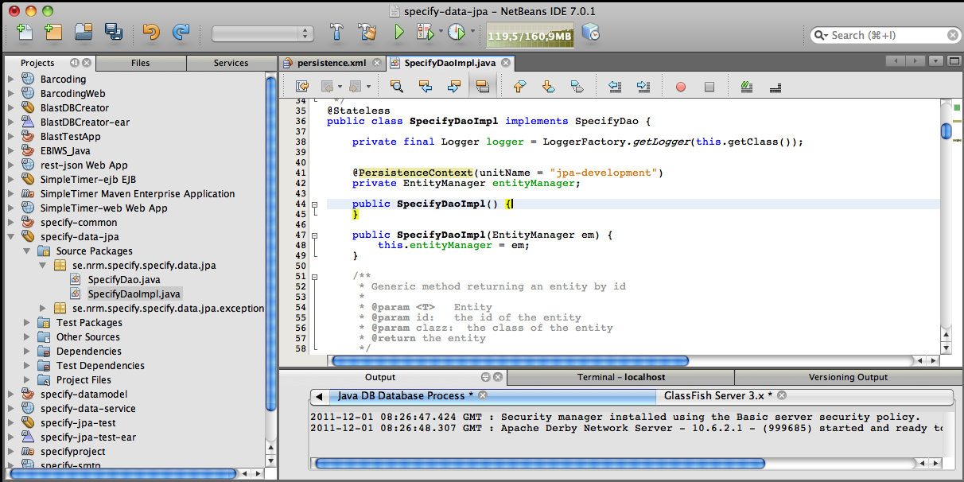
- Rebuild spcify-data-jpa by right click, click Clean and Build.
- Rebuild specify-data-service by right click, click Clean and Build.

Set up log in glassfish:

specifyproject is using SLF4J logging frame work with log4j implementation.

- Create a log4j.xml or log4j.properties file
- Put this file into glassfish-installation-dir/domains/domain1/lib/classes
- Download slf4j-api-1.6.1.jar, slf4j-log4j12-1.6.1.jar and log4j-1.2.16.jar
- Put above three jars into glassfish-install-dir/domains/domain1/lib/ext

Deploy specify-data-service into glassfish:

After successfully build specify-data-service, a specify-service.war file created in target folder. Start glassfish Application server. Login to GlassFish admin console. Click on Applications , Applications page displays. Click Deploy to open Deploy Applications or Modules page. In Location, Browse to SpecifyEJB/specify-data-service/target/specify-service.war, then click OK

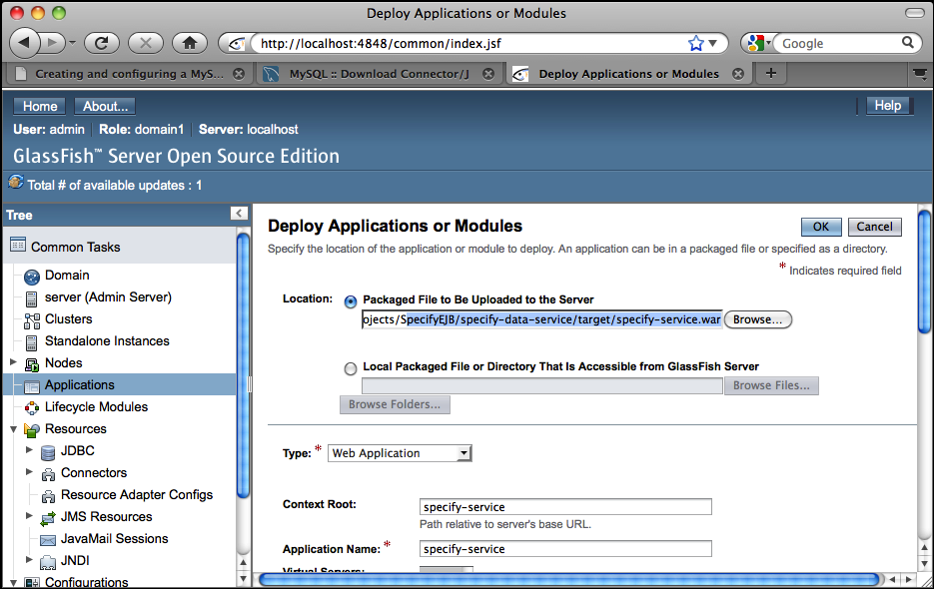
dialog - 13

specify-data-service shall be deployed successfully.

dialog - 14
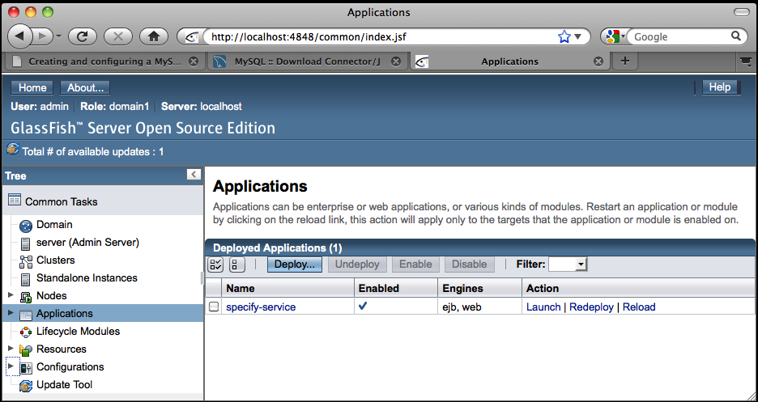
Now you can test specify-service (web service) by run main method in specify-data-service/Source Packages/se.nrm.specify.data.service.client.SpecifyClient.java

(note: you may need to change web service uri in UriBuilder.fromUri(“webserviceuri”).build(); in private method getBaseURI() to the uri that your specify-data-service deployed, for example: if you deployed specify-data-service in local glassfish, the uri should be: http://localhost:8080/specify-service/. 8080 is default port for glassfish client, and specify-service is the name of the war file deployed in in glassfish)

