Michael Frayne
Final Project EXC – Jump and Branch
CMPEN 331 – Section 2

Abstract
This project is a culmination of 3 labs with the goal of creating a MIPS CPU. To involved breaking down the CPU process of performing one instruction into distinct section to allow for pipelining which drastically increases performance. Five pipeline stages were used to achieve this with multiple modules in each block handling different tasks. These stages included Instruction Fetch (IF), Instruction Decode (ID), Execution (EXE), Memory (MEM), Write Back (WB). This project also provides a clear understanding of MIPS CPU operations and how instructions can be handled to computed as fast as possible.
Instruction Fetch Stage (IF)
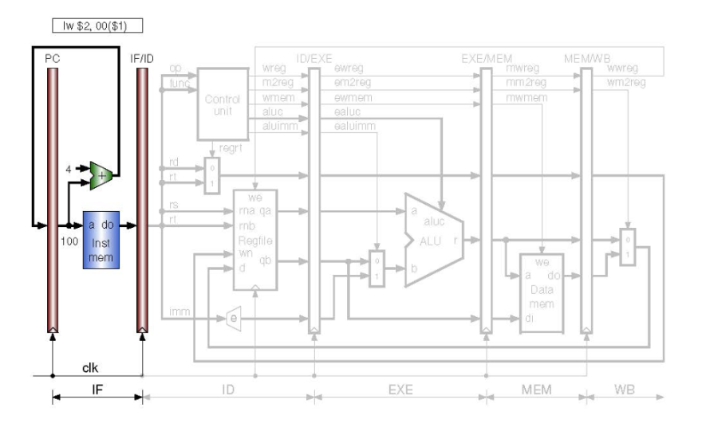
The IF stage contains four modules. It starts at the program counter (pc) that stores the current instruction that the computer is on. The pc counter is updated on the positive edge of every clock cycle based on the output of the pc adder. The pc adder increments the program count by 4 because MIPS processors are byte addressable and instructions are 4 bytes long. The program counter must therefore move four bytes to reach the start of the next instruction. The instruction memory uses the pc to determine which instruction needs to be computed. Stores instruction which are then accessed using the pc and given to the IF/ID pipeline register. This module is similar to the program counter and the three other pipeline registers in the MIPS Datapath as it only moves data to the next stage on the positive clock edge which is the behavior that allows for the synchronization that pipelining requires.
Instruction Decode Stage (ID)
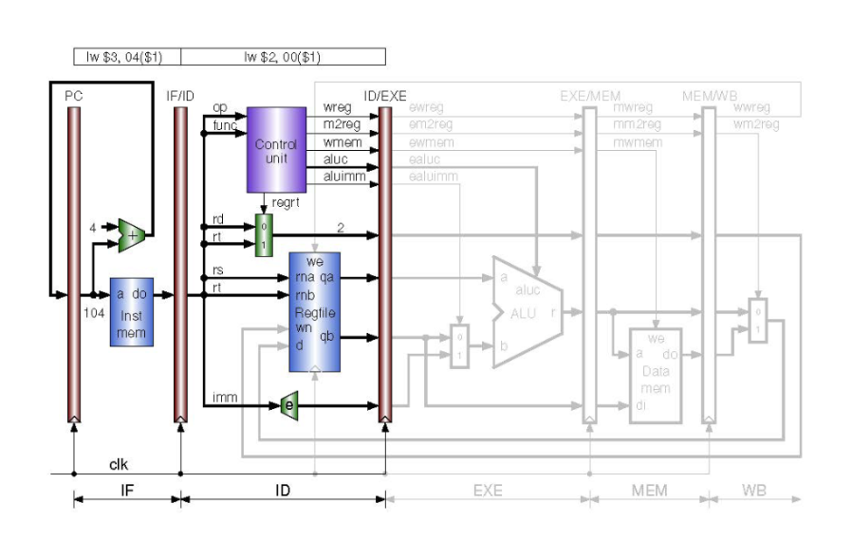
After the instructions are fetched they must be decoded. MIPS has three main types of instructions that allow the 32 bits of each instruction to be interpreted differently. The first 6 bits and last 6 bits are the op code and function code respectively. The op code determines the type of instruction, (R, I, or J) and the function code determines what R-type function to perform. These two codes are given to the Control Unit which sets values for various multiplexers and modules to determine how data will flow to the following stages based on the op code and function code that determines how the instruction is supposed to work. One of the multiplexors for which the control unit determines the selector bits for determines whether rt or rd is used as the destination register. This is important for R-type and I-type instructions since I type instructions store computations between rs and an immediate value in rt while R-type instruction store computations rs and rt in rd. The regfile stores which reads and sends data from registers to the next stage and writes data to register after the writeback stage. The ID stage also contains the immediate extender module which extends an immediate 16 bit signed value to a 32 bit signed value so it can be computed with 32 bit values from registers. The final module in this stage is the ID/EXE pipeline register that moves data to the next stage of the pipeline on the positive edge of the clock.

Execute Stage (EXE)
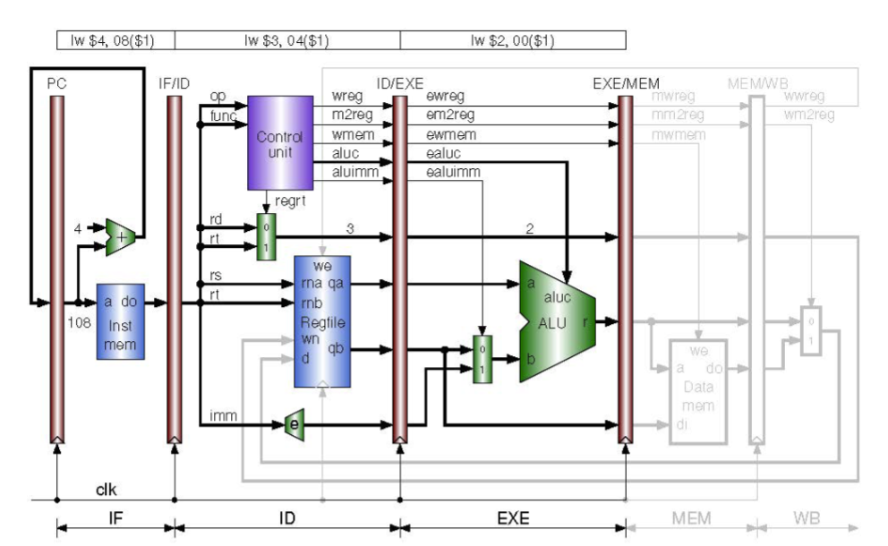
After instructions are decoded and data is red from the registers the computations take place that execute the instruction in the EXE stage. This stage contains three different modules. The first is simply a multiplexer that determines whether the immediate value is used or register value for the second value of computation. This is determined by the Control unit based on whether the instruction is an R-type or I-type instruction. That value and another value from a register is fed into the ALU which is determined by the control unit. Once the computation is completed the result is sent to the EXE/MEM pipeline register which send the data to the next stage of the pipeline on the next positive clock edge.

Memory Stage (MEM)
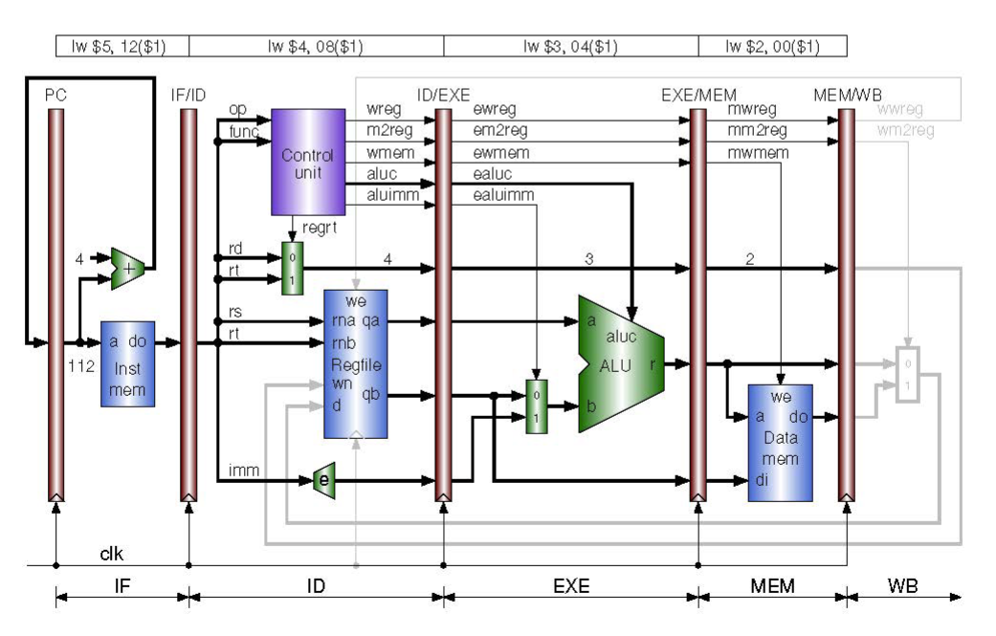
The MEM stage only contains two modules. The first is the data memory module which is used for load and store instructions to send and receive data to the main memory of the computer. Weather this module loads or stores is determined by the control unit and is sent down the pipeline to be received at the same time as the data that is being stored or loaded. If data is loaded it is sent to the MEM/WB pipeline register to get sent to the final pipeline stage on the next positive clock cycle.

Writeback Stage (WB)
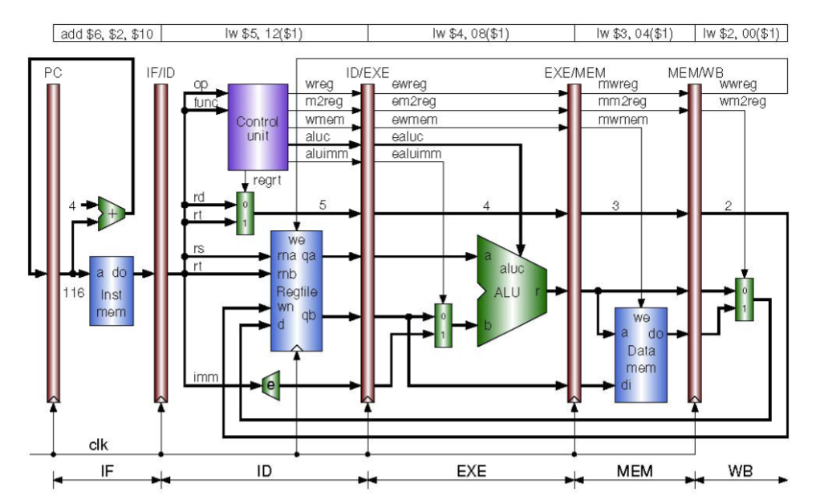
The final stage in the MIPS process is the write backstage. This stage only contains one multiplexor which whetherloaded data or the result of the alu is sent back to the regfile to be written to a register if needed.

Completed MIPS Pipelined CPU
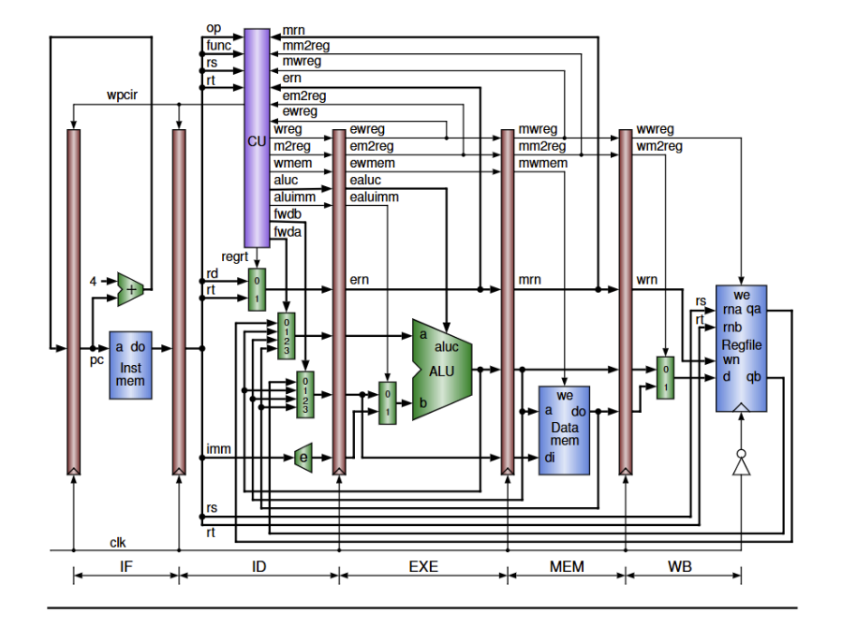
The completed MIPS Datapath contains all pipeline stages combined along with hazard prevention and forwarding. These two features prevent slowdowns in the system which help speed up the completion of a set of instructions. This fille Datapath only contains two extra multiplexers that are used to forward data from the EXE, MEM, and WB stages and some updates to the control unit that check for data hazards and pause the first two stages as needed. These features complete the design of the MIPS processor outlined for the project.

Completed Pipeline with Jump and Branch (Extra Credit)
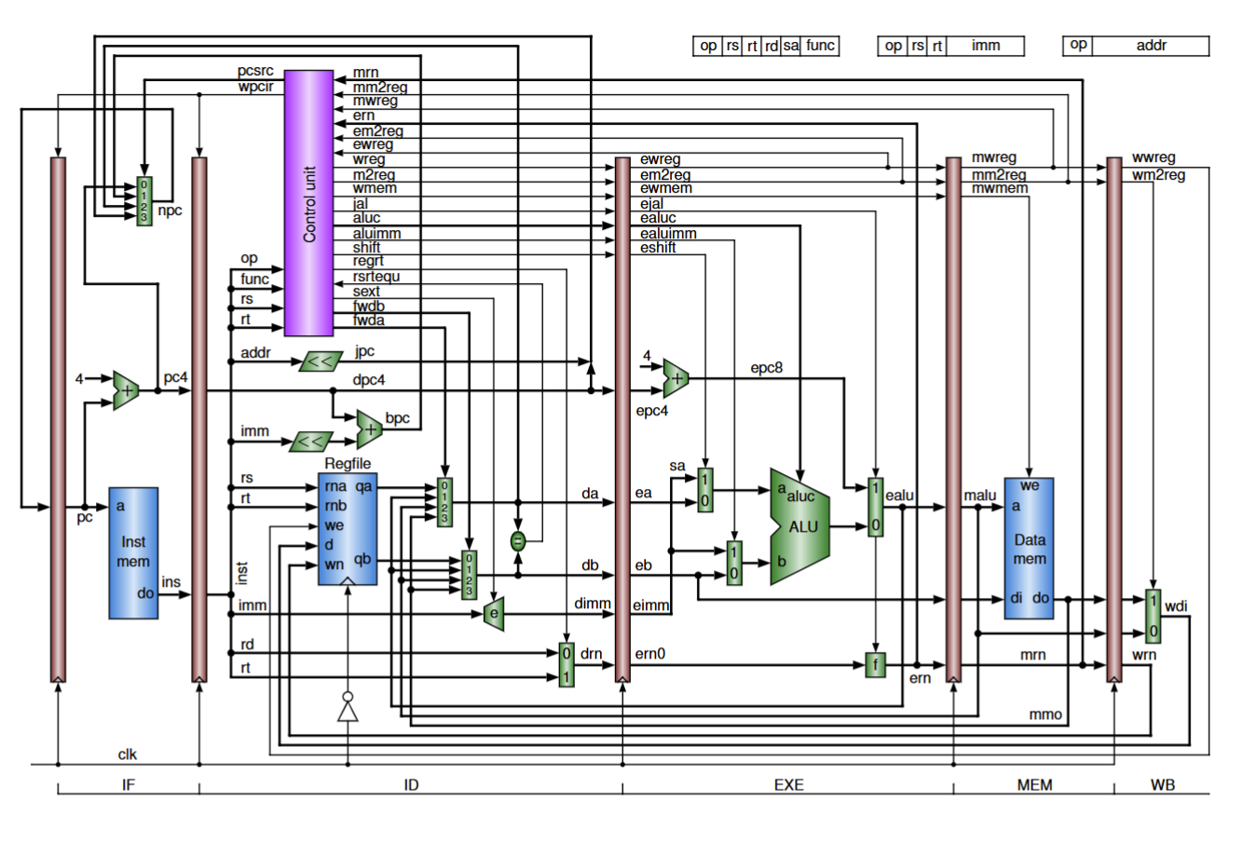
For the extra credit portion of the assignment, I implemented Branches and Jumps on top of the pipelined design with data hazard prevention. To do this I added a couple multiplexors to the design that helped change the program counter to where it was needed. The main multiplexor is a four to 1 multiplexor in the IF stage. This multiplexor chooses between the normal nextPc, or the address of a jump, equal to branch or not equal to branch. The address is determined by the Control Unit. The Control Unit was also updated to interperate jump, jump and link, jr, bne, and beq instructions.

- Verilog design code
`timescale 1ns / 1ps
//////////////////////////////////////////////////////////////////////////////////
// Company:
// Engineer:
//
// Create Date: 10/29/2025 07:53:28 PM
// Design Name:
// Module Name: IFID
// Project Name:
// Target Devices:
// Tool Versions:
// Description:
//
// Dependencies:
//
// Revision:
// Revision 0.01 - File Created
// Additional Comments:
//
//////////////////////////////////////////////////////////////////////////////////

//IF Stage
module ProgramCounter(
input wire [31:0] npc,
input wire clk,
input wire wpcir,
output reg [31:0] pc
);
initial begin
pc = 32'd0;
end
always @ (posedge clk)
begin
if(wpcir==0)begin
pc <= npc;
end
end
endmodule

module PCMux(
input wire [1:0] pcsrc,
input wire [31:0] pc4,
input wire [31:0] bpc,
input wire [31:0] da,
input wire [31:0] jpccat,
output reg [31:0] npc
);
always @(*) begin
case(pcsrc)
2'b00: npc = pc4;
2'b01: npc = bpc;
2'b10: npc = da;
2'b11: npc = jpccat;
endcase
end
endmodule

module PcAdder(
input wire [31:0] pc,
output reg [31:0] pc4
);
always @(*)begin
pc4 = pc + 32'd4;
end
endmodule

/*
module InstructionMemory(
input wire [31:0] pc,
output reg [31:0] instOut
);

reg [31:0] memory [0:63];
//include more instructions that match with lab document
initial begin
memory[25] = {6'b100011,5'b00001,5'b00010,5'b00000,5'b00000,6'b000000};
memory[26] = {6'b100011,5'b00001,5'b00011,5'b00000,5'b00000,6'b000100};
memory[27] = {6'b100011,5'b00001,5'b00100,5'b00000,5'b00000,6'b001000};
memory[28] = {6'b100011,5'b00001,5'b00101,5'b00000,5'b00000,6'b001100};
memory[29] = {6'b000000,5'b00010,5'b01010,5'b00110,5'b00000,6'b100000};
end

always @(*) begin
instOut = memory[pc[7:2]];
end
endmodule
*/

module InstructionMemory ( // instruction memory, rom
input wire [31:0] pc, // rom address
output reg [31:0] instOut // rom content = rom[a]
);
reg [31:0] rom [0:63]; // rom cells: 64 words * 32 bits
// rom[word_addr] = instruction // (pc) label instruction
initial begin
rom[6'h00] = 32'h3c010000; // (00) main: lui $1, 0
rom[6'h01] = 32'h34240050; // (04) ori $4, $1, 80
rom[6'h02] = 32'h0c00001b; // (08) call: jal sum
rom[6'h03] = 32'h20050004; // (0c) dslot1: addi $5, $0, 4
rom[6'h04] = 32'hac820000; // (10) return: sw $2, 0($4)
rom[6'h05] = 32'h8c890000; // (14) lw $9, 0($4)
rom[6'h06] = 32'h01244022; // (18) sub $8, $9, $4
rom[6'h07] = 32'h20050003; // (1c) addi $5, $0, 3
rom[6'h08] = 32'h20a5ffff; // (20) loop2: addi $5, $5, -1
rom[6'h09] = 32'h34a8ffff; // (24) ori $8, $5, 0xffff
rom[6'h0a] = 32'h39085555; // (28) xori $8, $8, 0x5555
rom[6'h0b] = 32'h2009ffff; // (2c) addi $9, $0, -1
rom[6'h0c] = 32'h312affff; // (30) andi $10,$9,0xffff
rom[6'h0d] = 32'h01493025; // (34) or $6, $10, $9
rom[6'h0e] = 32'h01494026; // (38) xor $8, $10, $9
rom[6'h0f] = 32'h01463824; // (3c) and $7, $10, $6
rom[6'h10] = 32'h10a00003; // (40) beq $5, $0, shift
rom[6'h11] = 32'h00000000; // (44) dslot2: nop
rom[6'h12] = 32'h08000008; // (48) j loop2
rom[6'h13] = 32'h00000000; // (4c) dslot3: nop
rom[6'h14] = 32'h2005ffff; // (50) shift: addi $5, $0, -1
rom[6'h15] = 32'h000543c0; // (54) sll $8, $5, 15
rom[6'h16] = 32'h00084400; // (58) sll $8, $8, 16
rom[6'h17] = 32'h00084403; // (5c) sra $8, $8, 16
rom[6'h18] = 32'h000843c2; // (60) srl $8, $8, 15
rom[6'h19] = 32'h08000019; // (64) finish: j finish
rom[6'h1a] = 32'h00000000; // (68) dslot4: nop
rom[6'h1b] = 32'h00004020; // (6c) sum: add $8, $0, $0
rom[6'h1c] = 32'h8c890000; // (70) loop: lw $9, 0($4)
rom[6'h1d] = 32'h01094020; // (74) stall: add $8, $8, $9
rom[6'h1e] = 32'h20a5ffff; // (78) addi $5, $5, -1
rom[6'h1f] = 32'h14a0fffc; // (7c) bne $5, $0, loop
rom[6'h20] = 32'h20840004; // (80) dslot5: addi $4, $4, 4
rom[6'h21] = 32'h03e00008; // (84) jr $31
rom[6'h22] = 32'h00081000; // (88) dslot6: sll $2, $8, 0
// use 6-bit word address to read rom
end
always @(*) begin
instOut = rom[pc[7:2]];
end
endmodule

module IFIDPipelineRegister(
input wire [31:0] instOut,
input wire clk,
input wire wpcir,
input wire [31:0] pc4,
output reg [31:0] dpc4,
output reg [31:0] dinstOut
);

always @ (posedge clk) begin
if(wpcir==0) begin
dpc4 <= pc4;
dinstOut <= instOut;
end
end
endmodule

//ID stage
module ControlUnit(
input wire [5:0] op,
input wire [5:0] func,
input wire [4:0] rs,
input wire [4:0] rt,
input wire [4:0] mrn,
input wire mm2reg,
input wire mwreg,
input wire [4:0] ern,
input wire em2reg,
input wire ewreg,
input wire rsrtequ,
output reg [1:0]pcsrc,
output reg wpcir,
output reg wreg,
output reg m2reg,
output reg wmem,
output reg jal,
output reg [3:0] aluc,
output reg aluimm,
output reg shift,
output reg regrt,
output reg sext,
output reg [1:0] fwda,
output reg [1:0] fwdb
);
reg i_rs;
reg i_rt;
initial wpcir = 0;
initial pcsrc = 2'b00;
always @(*) begin
case(op)
6'b000000://r-types
begin
case(func)
6'b100000://add instruction
begin
wreg = 1'b1;
m2reg = 1'b0;
wmem = 1'b0;
aluc = 4'b0010;
aluimm = 1'b0;
regrt = 1'b0;
pcsrc = 2'b00;
jal =1'b0;
shift = 1'b0;
sext = 1'bx;
end
6'b100010://subtract instruction
begin
wreg = 1'b1;
m2reg = 1'b0;
wmem = 1'b0;
aluc = 4'b0110;
aluimm = 1'b0;
regrt = 1'b0;
pcsrc = 2'b00;
jal =1'b0;
shift = 1'b0;
sext = 1'bx;
end
6'b100100://AND instruction
begin
wreg = 1'b1;
m2reg = 1'b0;
wmem = 1'b0;
aluc = 4'b0000;
aluimm = 1'b0;
regrt = 1'b0;
pcsrc = 2'b00;
jal =1'b0;
shift = 1'b0;
sext = 1'bx;
end
6'b100101://OR instruction
begin
wreg = 1'b1;
m2reg = 1'b0;
wmem = 1'b0;
aluc = 4'b0001;
aluimm = 1'b0;
regrt = 1'b0;
pcsrc = 2'b00;
jal =1'b0;
shift = 1'b0;
sext = 1'bx;
end
6'b100110://XOR instruction
begin
wreg = 1'b1;
m2reg = 1'b0;
wmem = 1'b0;
aluc = 4'b0011;
aluimm = 1'b0;
regrt = 1'b0;
pcsrc = 2'b00;
jal =1'b0;
shift = 1'b0;
sext = 1'bx;
end
6'b000000://sll instruction
begin
wreg = 1'b1;
m2reg = 1'b0;
wmem = 1'b0;
aluc = 4'b0100;
aluimm = 1'b0;
regrt = 1'b0;
pcsrc = 2'b00;
jal =1'b0;
shift = 1'b1;
sext = 1'bx;
end
6'b000010://srl instruction
begin
wreg = 1'b1;
m2reg = 1'b0;
wmem = 1'b0;
aluc = 4'b0101;
aluimm = 1'b0;
regrt = 1'b0;
pcsrc = 2'b00;
jal =1'b0;
shift = 1'b1;
sext = 1'bx;
end
6'b000011://sra instruction
begin
wreg = 1'b1;
m2reg = 1'b0;
wmem = 1'b0;
aluc = 4'b1000;
aluimm = 1'b0;
regrt = 1'b0;
pcsrc = 2'b00;
jal =1'b0;
shift = 1'b1;
sext = 1'bx;
end
6'b001000://jr instruction
begin
wreg = 1'b0;
m2reg = 1'bx;
wmem = 1'b0;
aluc = 4'bxxxx;
aluimm = 1'bx;
regrt = 1'bx;
pcsrc = 2'b10;
jal =1'b0;
shift = 1'bx;
sext = 1'bx;
end
endcase
end
6'b100011://lw
begin
wreg = 1'b1;
m2reg = 1'b1;
wmem = 1'b0;
aluc = 4'b0010;
aluimm = 1'b1;
regrt = 1'b1;
pcsrc = 2'b00;
jal = 1'b0;
shift = 1'b0;
sext = 1'b1;
end
6'b101011://sw
begin
wreg = 1'b0;
m2reg = 1'b0;
wmem = 1'b1;
aluc = 4'b0010;
aluimm = 1'b1;
regrt = 1'bx;
pcsrc = 2'b00;
jal = 1'b0;
shift = 1'b0;
sext = 1'b1;
end
6'b001000://addi
begin
wreg = 1'b1;
m2reg = 1'b0;
wmem = 1'b0;
aluc = 4'b0010;
aluimm = 1'b1;
regrt = 1'b1;
pcsrc = 2'b00;
jal = 1'b0;
shift = 1'b0;
sext = 1'b1;
end
6'b001100://andi
begin
wreg = 1'b1;
m2reg = 1'b0;
wmem = 1'b0;
aluc = 4'b0000;
aluimm = 1'b1;
regrt = 1'b1;
pcsrc = 2'b00;
jal = 1'b0;
shift = 1'b0;
sext = 1'b0;
end
6'b001101://ori
begin
wreg = 1'b1;
m2reg = 1'b0;
wmem = 1'b0;
aluc = 4'b0001;
aluimm = 1'b1;
regrt = 1'b1;
pcsrc = 2'b00;
jal = 1'b0;
shift = 1'b0;
sext = 1'b0;
end
6'b001110://xori
begin
wreg = 1'b1;
m2reg = 1'b0;
wmem = 1'b0;
aluc = 4'b0011;
aluimm = 1'b1;
regrt = 1'b1;
pcsrc = 2'b00;
jal = 1'b0;
shift = 1'b0;
sext = 1'b0;
end
6'b000100://beq
begin
wreg = 1'b0;
m2reg = 1'bx;
wmem = 1'b0;
aluc = 4'b0110;
aluimm = 1'b0;
regrt = 1'bx;
if(rsrtequ==1)
pcsrc = 2'b01;
else
pcsrc = 2'b00;
jal = 1'b0;
shift = 1'b0;
sext = 1'b1;
end
6'b000101://bne
begin
wreg = 1'b0;
m2reg = 1'bx;
wmem = 1'b0;
aluc = 4'b0110;
aluimm = 1'b0;
regrt = 1'bx;
if(rsrtequ==0)
pcsrc = 2'b01;
else
pcsrc = 2'b00;
jal = 1'b0;
shift = 1'b0;
sext = 1'b1;
end
6'b001111://lui
begin
wreg = 1'b1;
m2reg = 1'b0;
wmem = 1'b0;
aluc = 4'b1001;
aluimm = 1'b1;
regrt = 1'b1;
pcsrc = 2'b00;
jal = 1'b0;
shift = 1'bx;
sext = 1'bx;
end
6'b000010://j
begin
wreg = 1'b0;
m2reg = 1'bx;
wmem = 1'b0;
aluc = 4'bxxxx;
aluimm = 1'bx;
regrt = 1'bx;
pcsrc = 2'b11;
jal = 1'b0;
shift = 1'bx;
sext = 1'bx;
end
6'b000011://jal
begin
wreg = 1'b1;
m2reg = 1'bx;
wmem = 1'b0;
aluc = 4'bxxxx;
aluimm = 1'bx;
regrt = 1'bx;
pcsrc = 2'b11;
jal = 1'b1;
shift = 1'bx;
sext = 1'bx;
end
endcase
if (wpcir) begin
wreg = 1'b0;
m2reg = 1'b0;
wmem = 1'b0;
jal = 1'b0;
end

end
//stall
always @(*) begin
i_rs = (op != 6'b000010) && (op != 6'b000011);
i_rt = (op == 6'b000000) || (op == 6'b000100) || (op == 6'b000101);
if (ewreg && em2reg && (ern != 5'd0) &&((i_rs && ern == rs) || (i_rt && ern == rt))) begin
wpcir = 1'b1;
end else begin
wpcir = 1'b0;
end
end

//forward a
always @(*) begin
if (ewreg && (ern != 0) && (ern == rs))
fwda = 2'b01;

else if (mwreg && (mrn != 0) && (mrn == rs) && !mm2reg)
fwda = 2'b10;

else if (mwreg && (mrn != 0) && (mrn == rs) && mm2reg)
fwda = 2'b11;

else
fwda = 2'b00;
end

//forward b
always @(*) begin
if (ewreg && (ern != 0) && (ern == rt))
fwdb = 2'b01;

else if (mwreg && (mrn != 0) && (mrn == rt) && !mm2reg)
fwdb = 2'b10;

else if (mwreg && (mrn != 0) && (mrn == rt) && mm2reg)
fwdb = 2'b11;

else
fwdb = 2'b00;
end
endmodule

module addrLeftShift(
input wire [25:0] addr,
output reg [31:0] jpc
);
always @ (*)begin
jpc = {4'b0000,addr,2'b00};
end
endmodule

module immLeftShift(
input wire [15:0] imm,
output reg [31:0] immShift
);
always @ (*)begin
immShift = {{14{imm[15]}}, imm, 2'b00};
end
endmodule

module branchAddr(
input wire [31:0] dpc4,
input wire [31:0] immShift,
output reg [31:0] bpc
);
always @(*) begin
bpc = dpc4+immShift;
end
endmodule

module fwdaMux(
input wire [1:0] fwda,
input wire [31:0] qa,
input wire [31:0] ealu,
input wire [31:0] malu,
input wire [31:0] mdo,
output reg [31:0] da
);
always @(*) begin
case(fwda)
2'b00: da <= qa;
2'b01: da <= ealu;
2'b10: da <= malu;
2'b11: da <= mdo;
endcase
end
endmodule

module fwdbMux(
input wire [1:0] fwdb,
input wire [31:0] qb,
input wire [31:0] ealu,
input wire [31:0] malu,
input wire [31:0] mdo,
output reg [31:0] db
);
always @(*) begin
case(fwdb)
2'b00: db <= qb;
2'b01: db <= ealu;
2'b10: db <= malu;
2'b11: db <= mdo;
endcase
end
endmodule

module ImmediateExtender(
input wire [15:0] imm,
input wire sext,
output reg [31:0] dimm
);
always @(*) begin
if(sext==1)begin
dimm = {{16{imm[15]}},imm};
end
else begin
dimm = {16'b0,imm};
end
end

endmodule

module RsRteq(
input wire [31:0] da,
input wire [31:0] db,
output reg rsrtequ
);
always @(*) begin
if(da==db)begin
rsrtequ <= 1;
end
else begin
rsrtequ <= 0;
end
end
endmodule

module RegrtMultiplexer(
input wire [4:0] rt,
input wire [4:0] rd,
input wire regrt,
output reg [4:0] drn
);

always @(*) begin
if(regrt == 0)begin
drn = rd;
end
else begin
drn =rt;
end
end
endmodule

module jpcConcat(
input wire [31:0] jpc,
input wire [31:0] dpc4,
output reg [31:0] njpc
);
always @(*) begin
njpc = {dpc4[31:28], jpc[27:0]};
end
endmodule

//EXE Stage
module IDEXEPipelineRegister(
input wire wreg,
input wire m2reg,
input wire wmem,
input wire jal,
input wire [3:0] aluc,
input wire aluimm,
input wire shift,
input wire [31:0] dpc4,
input wire [31:0] da,
input wire [31:0] db,
input wire [31:0] dimm,
input wire [4:0] drn,
input wire clk,
output reg ewreg,
output reg em2reg,
output reg ewmem,
output reg ejal,
output reg [3:0] ealuc,
output reg ealuimm,
output reg eshift,
output reg [31:0] epc4,
output reg [31:0] ea,
output reg [31:0] eb,
output reg [31:0] eimm,
output reg [4:0] ern0
);

always @(posedge clk) begin
ewreg <= wreg;
em2reg <= m2reg;
ewmem <= wmem;
ejal <= jal;
ealuc <= aluc;
ealuimm <= aluimm;
eshift <= shift;
epc4 <= dpc4;
ea <= da;
eb <= db;
eimm <= dimm;
ern0 <= drn;
end

endmodule

module Epc4Addr(
input wire [31:0] epc4,
output reg [31:0] epc8
);
always @(*) begin
epc8=epc4+4;
end

endmodule

module ALUMultiplexerA(
input wire [31:0] sa,
input wire [31:0] ea,
input wire eshift,
output reg [31:0] a
);
always @(*) begin
case(eshift)
1'b1: a = sa;
1'b0: a = ea;
endcase
end

endmodule

module ALUMultiplexerB(
input wire [31:0] eimm,
input wire [31:0] eb,
input wire ealuimm,
output reg [31:0] b
);
always @(*) begin
case(ealuimm)
1'b1: b = eimm;
1'b0: b = eb;
endcase
end

endmodule

module ALU(
input wire [31:0] a,
input wire [31:0] b,
input wire [3:0] ealuc,
output reg [31:0] r
);
always @(*) begin
case(ealuc)
//AND
4'b0000: r = a & b;

//OR
4'b0001: r = a | b;

//add
4'b0010: r = a + b;

//xor
4'b0011: r = a^b;

//subtract
4'b0110: r = a - b;

//slt
4'b0111: begin
if(a<b)begin
r=1;
end
else begin
r=0;
end
end

//NOR
4'b1100: r = ~(a|b);

//sll
4'b0100: r = b<<a[4:0];

//srl
4'b0101: r = b>>a[4:0];

//sra
4'b1000: r = b>>>a[4:0];

//lui
4'b1001:r = b<<16;
endcase
end
endmodule

module ALUjalMux(
input wire ejal,
input wire [31:0] epc8,
input wire [31:0] r,
output reg [31:0] ealu
);
always @(*) begin
case(ejal)
1'b1: ealu = epc8;
1'b0: ealu = r;
endcase
end
endmodule

module forwardingUnit(
input wire [4:0] ern0,
input wire ejal,
output reg [4:0] ern
);
always @(*) begin
case(ejal)
1'b0: ern = ern0;
1'b1: ern = 5'b11111;
endcase
end
endmodule

//MEM Stage
module EXEMEMPipelineRegister(
input wire ewreg,
input wire em2reg,
input wire ewmem,
input wire [31:0] ealu,
input wire [31:0] eb,
input wire [4:0] ern,
input wire clk,
output reg mwreg,
output reg mm2reg,
output reg mwmem,
output reg [31:0] malu,
output reg [31:0] di,
output reg [4:0] mrn
);
always @(posedge clk)begin
mwreg <= ewreg;
mm2reg <= em2reg;
mwmem <= ewmem;
malu <=ealu;
di <= eb;
mrn <= ern;
end
endmodule

/*
module DataMemory(
input wire [31:0] mr,
input wire [31:0] mqb,
input wire mwmem,
input wire clk,
output reg [31:0] mdo
);
reg [31:0] memory [0:63];

initial begin
memory[0] = 32'hA00000AA;
memory[1] = 32'h10000011;
memory[2] = 32'h20000022;
memory[3] = 32'h30000033;
memory[4] = 32'h40000044;
memory[5] = 32'h50000055;
memory[6] = 32'h60000066;
memory[7] = 32'h70000077;
memory[8] = 32'h80000088;
memory[9] = 32'h90000099;
end

always @(negedge clk) begin
if(mwmem==1)begin
memory[mr[31:2]] <= mqb;
end
end

//shift mr by 2 bits if need to by byte addressable
always @(*) begin
mdo <= memory[mr[31:2]];
end

endmodule
*/
module DataMemory( // data memory, ram
input wire clk, // clock
input wire [31:0] malu, // ram address
input wire [31:0] di, // data in (to memory)
input wire we, // write enable
output reg [31:0] mdo // data out (from memory)
);
reg [31:0] ram [0:31]; // ram cells: 32 words * 32 bits
integer i;
initial begin // ram initialization
for (i = 0; i < 32; i = i + 1)
ram[i] = 0;
// ram[word_addr] = data // (byte_addr) item in data array
ram[5'h14] = 32'h000000a3; // (50) data[0] 0 + a3 = a3
ram[5'h15] = 32'h00000027; // (54) data[1] a3 + 27 = ca
ram[5'h16] = 32'h00000079; // (58) data[2] ca + 79 = 143
ram[5'h17] = 32'h00000115; // (5c) data[3] 143 + 115 = 258
// ram[5'h18] should be 0x00000258, the sum stored by sw instruction
end

always @(*) begin
mdo = ram[malu[6:2]]; // use 5-bit word address
end
always @ (posedge clk) begin
if (we) ram[malu[6:2]] = di; // write ram
end
endmodule

//WB Stage
module MEMWBPipelineRegister(
input wire mwreg,
input wire mm2reg,
input wire [4:0] mrn,
input wire [31:0] malu,
input wire [31:0] mdo,
input wire clk,
output reg wwreg,
output reg wm2reg,
output reg [4:0] wrn,
output reg [31:0] walu,
output reg [31:0] wdo
);

always @(posedge clk) begin
wwreg <= mwreg;
wm2reg <= mm2reg;
wrn <= mrn;
walu <= malu;
wdo <= mdo;
end

endmodule

module WritebackMultiplexer(
input wire [31:0] walu,
input wire [31:0] wdo,
input wire wm2reg,
output reg [31:0] wdi
);
always @(*) begin
case(wm2reg)
1'b1: wdi = wdo;
1'b0: wdi = walu;
endcase
end
endmodule

module RegisterFile(
input wire [4:0] rs,
input wire [4:0] rt,
input wire [4:0] wdestReg,
input wire [31:0] wbData,
input wire wwreg,
input wire clk,
output reg [31:0] qa,
output reg [31:0] qb
);
reg [31:0] registers [0:31];
integer i;
initial begin
for(i = 0; i<32; i = i+1) begin
registers[i] = 32'h0000;
end
end
always @(*) begin
qa = registers[rs];
qb = registers[rt];
end

always @(negedge clk) begin
if(wwreg==1)begin
registers[wdestReg] <= wbData;
end
end
endmodule

//TODO adjust data path and add wires needed
//TODO read through documentation and figure out what waveform should look like
//TODO write intro and abstract for report

//Data Path
module Datapath(
input wire clk_dp,
output wire [31:0] pc_dp,
output wire [31:0] instOut_dp,
output wire [31:0] ealu_dp,
output wire [31:0] malu_dp,
output wire [31:0] wdi_dp
);

//wire [31:0] pc_dp;
wire [31:0] pc4_dp;
wire [31:0] npc_dp;

wire wpcir_dp;

wire [31:0] dinstOut_dp;
wire [31:0] dpc4_dp;

wire [5:0] op_dp = dinstOut_dp[31:26];
wire [4:0] rs_dp = dinstOut_dp[25:21];
wire [4:0] rt_dp = dinstOut_dp[20:16];
wire [4:0] rd_dp = dinstOut_dp[15:11];
wire [5:0] func_dp = dinstOut_dp[5:0];
wire [15:0] imm_dp = dinstOut_dp[15:0];

wire wreg_dp;
wire m2reg_dp;
wire wmem_dp;
wire jal_dp;
wire aluimm_dp;
wire shift_dp;
wire sext_dp;
wire regrt_dp;
wire [3:0] aluc_dp;
wire [1:0] pcsrc_dp;

wire [31:0] qa_dp;
wire [31:0] qb_dp;
wire [31:0] da_dp;
wire [31:0] db_dp;
wire [31:0] dimm_dp;

wire [31:0] immShift_dp;
wire [31:0] bpc_dp;
wire [31:0] jpc_dp;
wire [31:0] jpccat_dp;

wire rsrtequ_dp;
wire [4:0] drn_dp;

wire [1:0] fwda_dp;
wire [1:0] fwdb_dp;

wire ewreg_dp;
wire em2reg_dp;
wire ewmem_dp;
wire ejal_dp;
wire ealuimm_dp;
wire eshift_dp;
wire [3:0] ealuc_dp;

wire [31:0] epc4_dp;
wire [31:0] ea_dp, eb_dp;
wire [31:0] eimm_dp;
wire [4:0] ern0_dp;

wire [31:0] epc8_dp;
wire [31:0] a_dp, b_dp;
wire [31:0] r_dp;

wire [4:0] ern_dp;

wire mwreg_dp;
wire mm2reg_dp;
wire mwmem_dp;

wire [31:0] di_dp;
wire [4:0] mrn_dp;

wire [31:0] mdo_dp;

wire wwreg_dp;
wire wm2reg_dp;
wire [4:0] wrn_dp;
wire [31:0] walu_dp;
wire [31:0] wdo_dp;

wire [25:0] addr_dp = dinstOut_dp[25:0];
wire [31:0] shamt_dp = {16'd0, eimm_dp[31],eimm_dp[14:0]};

// IF stage
ProgramCounter PC (
.npc(npc_dp),
.clk(clk_dp),
.wpcir(wpcir_dp),
.pc(pc_dp)
);

PCMux PCMUX(
.pcsrc(pcsrc_dp),
.pc4(pc4_dp),
.bpc(bpc_dp),
.da(da_dp),
.jpccat(jpccat_dp),
.npc(npc_dp)
);

PcAdder PC_ADD (
.pc(pc_dp),
.pc4(pc4_dp)
);

InstructionMemory IMEM (
.pc(pc_dp),
.instOut(instOut_dp)
);

// ID stage
IFIDPipelineRegister IFID (
.instOut(instOut_dp),
.clk(clk_dp),
.wpcir(wpcir_dp),
.pc4(pc4_dp),
.dpc4(dpc4_dp),
.dinstOut(dinstOut_dp)
);

ControlUnit CU (
.op(op_dp),
.func(func_dp),
.rs(rs_dp),
.rt(rt_dp),
.mrn(mrn_dp),
.mm2reg(mm2reg_dp),
.mwreg(mwreg_dp),
.ern(ern_dp),
.em2reg(em2reg_dp),
.ewreg(ewreg_dp),
.rsrtequ(rsrtequ_dp),
.pcsrc(pcsrc_dp),
.wpcir(wpcir_dp),
.wreg(wreg_dp),
.m2reg(m2reg_dp),
.wmem(wmem_dp),
.jal(jal_dp),
.aluc(aluc_dp),
.aluimm(aluimm_dp),
.shift(shift_dp),
.sext(sext_dp),
.regrt(regrt_dp),
.fwda(fwda_dp),
.fwdb(fwdb_dp)
);

addrLeftShift ALS(
.addr(addr_dp),
.jpc(jpc_dp)
);
immLeftShift ILS(
.imm(imm_dp),
.immShift(immShift_dp)
);

branchAddr BADDR(
.dpc4(dpc4_dp),
.immShift(immShift_dp),
.bpc(bpc_dp)
);

RegisterFile RF (
.rs(rs_dp),
.rt(rt_dp),
.wdestReg(wrn_dp),
.wbData(wdi_dp),
.wwreg(wwreg_dp),
.clk(clk_dp),
.qa(qa_dp),
.qb(qb_dp)
);

fwdaMux FWD_A (
.fwda(fwda_dp),
.qa(qa_dp),
.ealu(ealu_dp),
.malu(malu_dp),
.mdo(mdo_dp),
.da(da_dp)
);

fwdbMux FWD_B (
.fwdb(fwdb_dp),
.qb(qb_dp),
.ealu(ealu_dp),
.malu(malu_dp),
.mdo(mdo_dp),
.db(db_dp)
);

ImmediateExtender IMMEXT (
.sext(sext_dp),
.imm(imm_dp),
.dimm(dimm_dp)
);

RsRteq EQ (
.da(da_dp),
.db(db_dp),
.rsrtequ(rsrtequ_dp)
);

RegrtMultiplexer REGDST (
.rt(rt_dp),
.rd(rd_dp),
.regrt(regrt_dp),
.drn(drn_dp)
);

jpcConcat JPCcc(
.jpc(jpc_dp),
.dpc4(dpc4_dp),
.njpc(jpccat_dp)
);

// EXE stage
IDEXEPipelineRegister IDEXE (
.wreg(wreg_dp),
.m2reg(m2reg_dp),
.wmem(wmem_dp),
.jal(jal_dp),
.aluc(aluc_dp),
.aluimm(aluimm_dp),
.shift(shift_dp),
.dpc4(dpc4_dp),
.da(da_dp),
.db(db_dp),
.dimm(dimm_dp),
.drn(drn_dp),
.clk(clk_dp),
.ewreg(ewreg_dp),
.em2reg(em2reg_dp),
.ewmem(ewmem_dp),
.ejal(ejal_dp),
.ealuc(ealuc_dp),
.ealuimm(ealuimm_dp),
.eshift(eshift_dp),
.epc4(epc4_dp),
.ea(ea_dp),
.eb(eb_dp),
.eimm(eimm_dp),
.ern0(ern0_dp)
);

Epc4Addr EADDR(
.epc4(epc4_dp),
.epc8(epc8_dp)
);

ALUMultiplexerA ALUMUXA (
.sa(shamt_dp),
.ea(ea_dp),
.eshift(eshift_dp),
.a(a_dp)
);

ALUMultiplexerB ALUMUXB (
.eimm(eimm_dp),
.eb(eb_dp),
.ealuimm(ealuimm_dp),
.b(b_dp)
);
ALU ALU(
.a(a_dp),
.b(b_dp),
.ealuc(ealuc_dp),
.r(r_dp)
);

ALUjalMux AJM(
.ejal(ejal_dp),
.epc8(epc8_dp),
.r(r_dp),
.ealu(ealu_dp)
);

forwardingUnit F(
.ern0(ern0_dp),
.ejal(ejal_dp),
.ern(ern_dp)
);

// MEM stage
EXEMEMPipelineRegister EXEMEM (
.ewreg(ewreg_dp),
.em2reg(em2reg_dp),
.ewmem(ewmem_dp),
.eb(eb_dp),
.ealu(ealu_dp),
.ern(ern_dp),
.clk(clk_dp),
.mwreg(mwreg_dp),
.mm2reg(mm2reg_dp),
.mwmem(mwmem_dp),
.di(di_dp),
.malu(malu_dp),
.mrn(mrn_dp)
);

DataMemory DMEM (
.malu(malu_dp),
.di(di_dp),
.we(mwmem_dp),
.clk(clk_dp),
.mdo(mdo_dp)
);

// WB stage
MEMWBPipelineRegister MEMWB (
.mwreg(mwreg_dp),
.mm2reg(mm2reg_dp),
.mrn(mrn_dp),
.malu(malu_dp),
.mdo(mdo_dp),
.clk(clk_dp),
.wwreg(wwreg_dp),
.wm2reg(wm2reg_dp),
.wrn(wrn_dp),
.walu(walu_dp),
.wdo(wdo_dp)
);

WritebackMultiplexer WBMUX (
.walu(walu_dp),
.wdo(wdo_dp),
.wm2reg(wm2reg_dp),
.wdi(wdi_dp)
);

endmodule

- Test Bench Design Code
`timescale 1ns / 1ps
//////////////////////////////////////////////////////////////////////////////////
// Company:
// Engineer:
//
// Create Date: 10/29/2025 08:08:34 PM
// Design Name:
// Module Name: testbench
// Project Name:
// Target Devices:
// Tool Versions:
// Description:
//
// Dependencies:
//
// Revision:
// Revision 0.01 - File Created
// Additional Comments:
//
//////////////////////////////////////////////////////////////////////////////////

//need to set up a datapath function
module testbench();
reg clk_tb;
wire [31:0] pc_tb;
wire [31:0] instOut_tb;
wire [31:0] ealu_tb;
wire [31:0] malu_tb;
wire [31:0] wdi_tb;
/*
wire [31:0] pc_tb;
wire [31:0] dinstOut_tb;
wire ewreg_tb;
wire em2reg_tb;
wire ewmem_tb;
wire ealuimm_tb;
wire [3:0] ealuc_tb;
wire [4:0] edestReg_tb;
wire [31:0] eqa_tb;
wire [31:0] eqb_tb;
wire [31:0] eimm32_tb;
wire mwreg_tb;
wire mm2reg_tb;
wire mwmem_tb;
wire [4:0] mdestReg_tb;
wire [31:0] mr_tb;
wire [31:0] mqb_tb;
wire wwreg_tb;
wire wm2reg_tb;
wire [4:0] wdestReg_tb;
wire [31:0] wr_tb;
wire [31:0] wdo_tb;
wire [31:0] wbData_tb;
*/

//Datapath datapath_tb(clk_tb,pc_tb,dinstOut_tb,ewreg_tb, em2reg_tb, ewmem_tb, ealuimm_tb, ealuc_tb, edestReg_tb, eqa_tb,eqb_tb,eimm32_tb, mwreg_tb,mm2reg_tb,mwmem_tb,mdestReg_tb,mr_tb,mqb_tb,wwreg_tb,wm2reg_tb,wdestReg_tb,wr_tb,wdo_tb,wbData_tb);
Datapath datapath_tb(
.clk_dp(clk_tb),
.pc_dp(pc_tb),
.instOut_dp(instOut_tb),
.ealu_dp(ealu_tb),
.malu_dp(malu_tb),
.wdi_dp(wdi_tb)
);
initial begin
clk_tb = 0;
end
always begin
#1
clk_tb = ~clk_tb;
end

endmodule

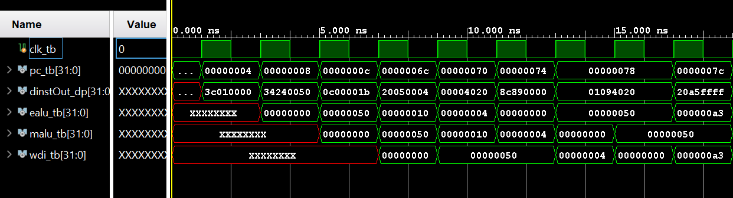
- Waveform

- Schematic
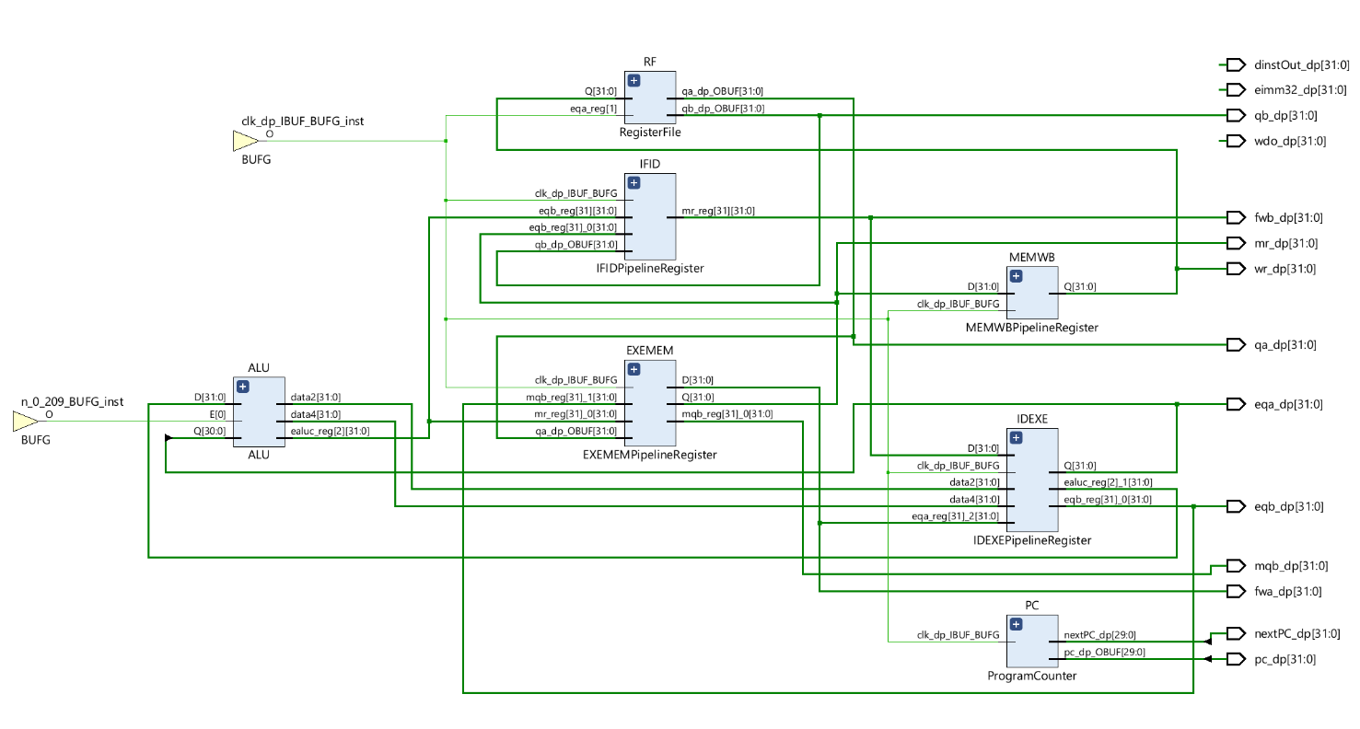

- I/O Planning
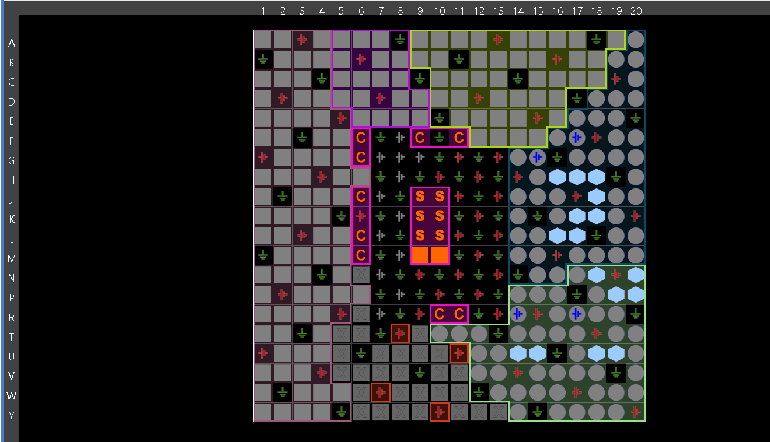

- Floor Planning
