Proposal Builder — Harrisburg Rep Guide
App build: 2ba808c · 2026-09-21 13:30
Guide generated: 2026-09-21 17:13
This is the shortest path through the app's two real jobs: building a client proposal, and building an attribution report after a campaign runs. If you can't get through page one alone, something in here needs fixing -- tell whoever generated this guide.
If your screen doesn't match a screenshot below, check the build stamp in the app's own sidebar against the one above -- the app may have changed since this guide was generated.

Task 1 — Build a proposal
The real path: upload the avail, fill the Setup band, paste notes, draft, review the plan, pick case studies, generate, download.
1. Open the app. “Build a proposal” is the home page, and the Setup band at the top is the first thing to fill in.
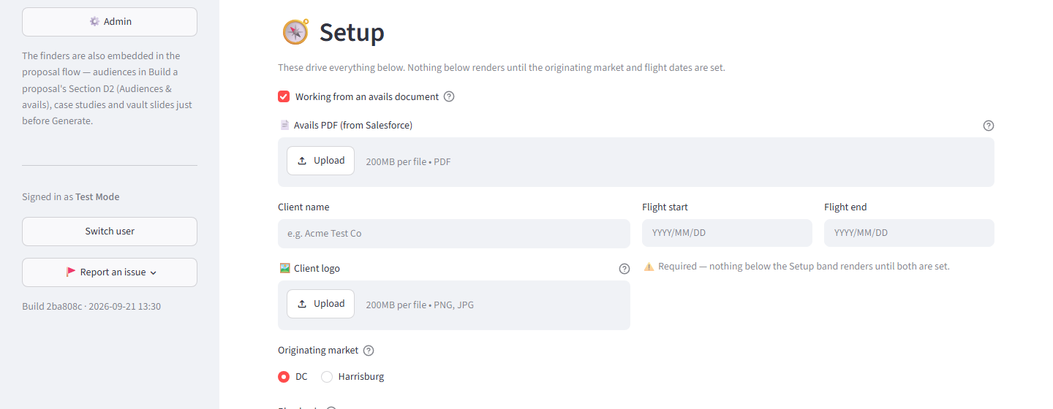
⚠ The gate: nothing below the Setup band appears until the originating market and both flight dates are set. This is deliberate -- it stops a rep from filling out a form that has nowhere to put the numbers yet.
2. Upload the avail. Drop the Salesforce avails PDF onto “Avails PDF (from Salesforce).” The client name, the flight dates, and every audience/geography group on the document are filled in for you.
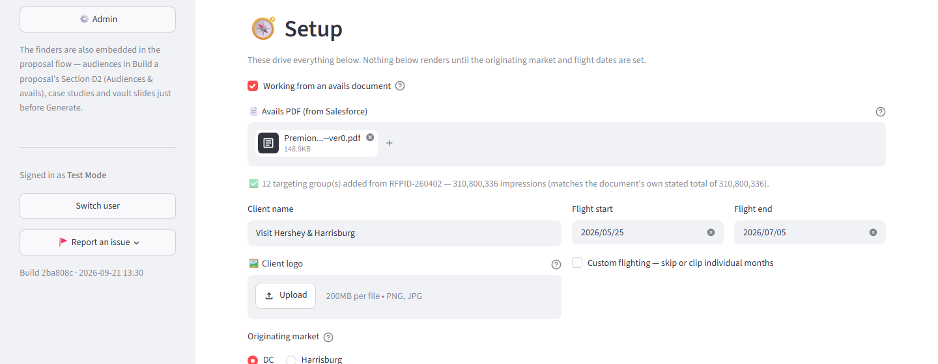
3. Pick the originating market -- Harrisburg, for this walkthrough. With the market and both flight dates set, the rest of the form opens.
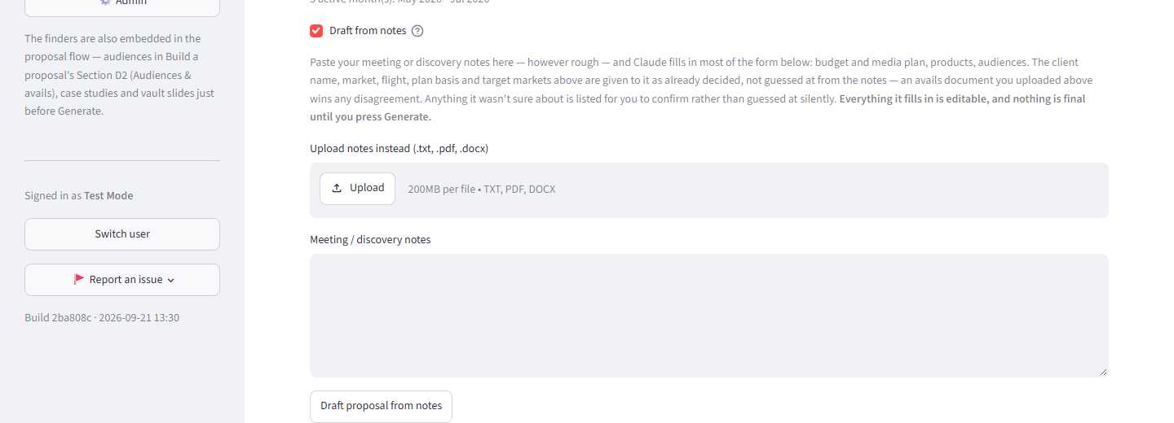
4. Paste the meeting or discovery notes into “Meeting / discovery notes” and click “Draft proposal from notes.” Claude fills in the plan -- budget, products, audiences -- and lists anything it wasn’t sure about for you to confirm.
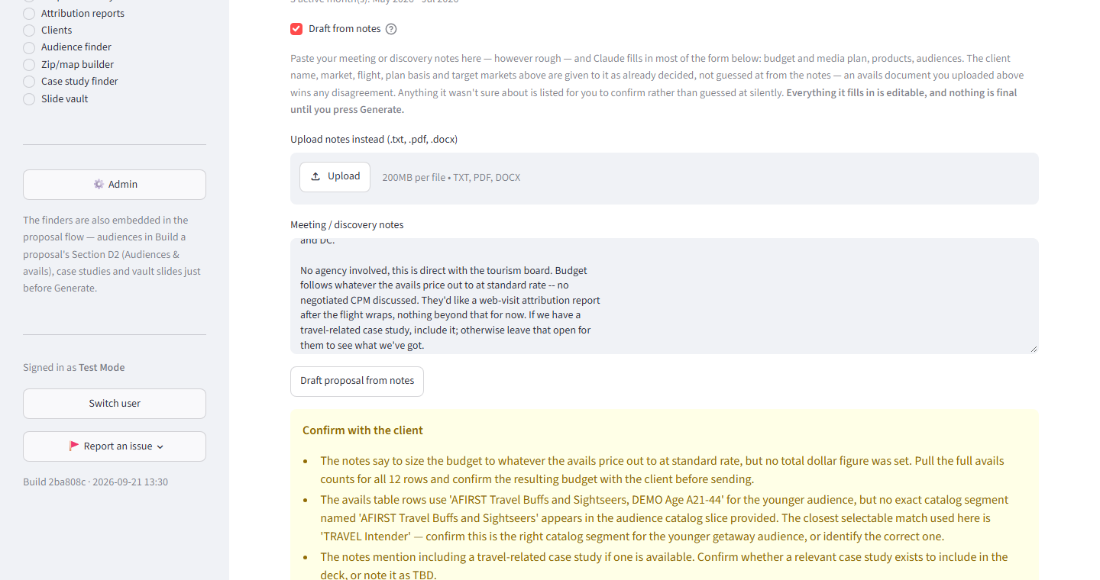
⚠ Draft from notes is optional. Skip it and build the plan by hand instead -- but it’s what fills the plan in for you, so most reps use it, and everything it fills in stays editable afterward.
5. Review the plan Claude built, in “E. Proposal / media plan.” Every row -- Tactic, Geo, Targeting, Cost -- is editable.
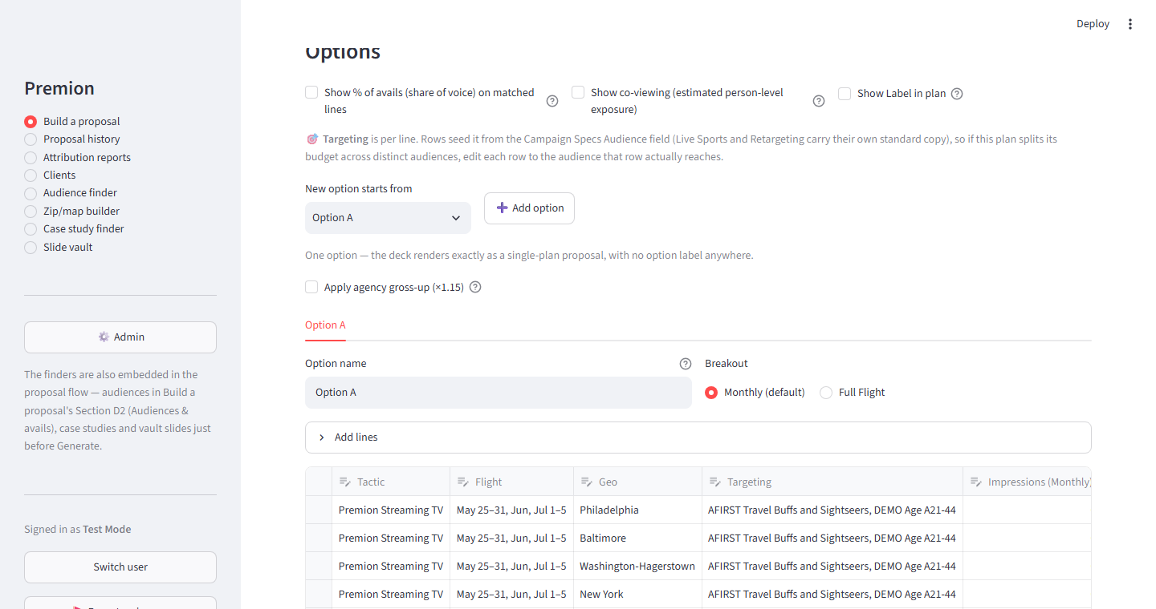
6. In the avails table (“D2. Audiences & avails”), check the “Plan” column for each row you actually want on the deck.
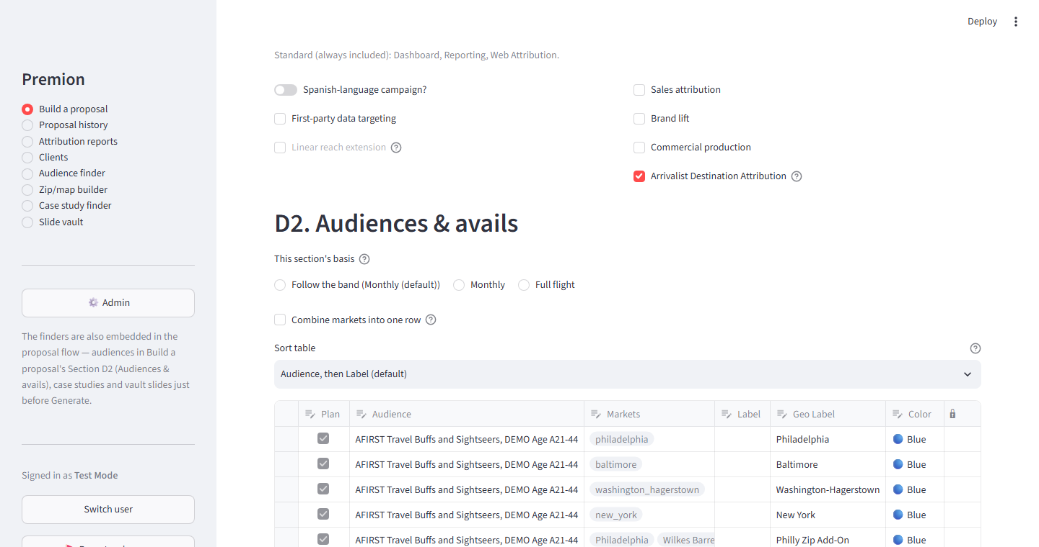
⚠ The Plan checkbox is the real on/off switch for the deck. A row can sit in this table as research an audience or geography you looked at but decided not to sell -- without ever appearing in the proposal, unless its Plan box is checked.
7. Pick case studies, if any fit. Open “Case studies” near the bottom of the page and check the ones to include -- matches for this vertical are suggested first.
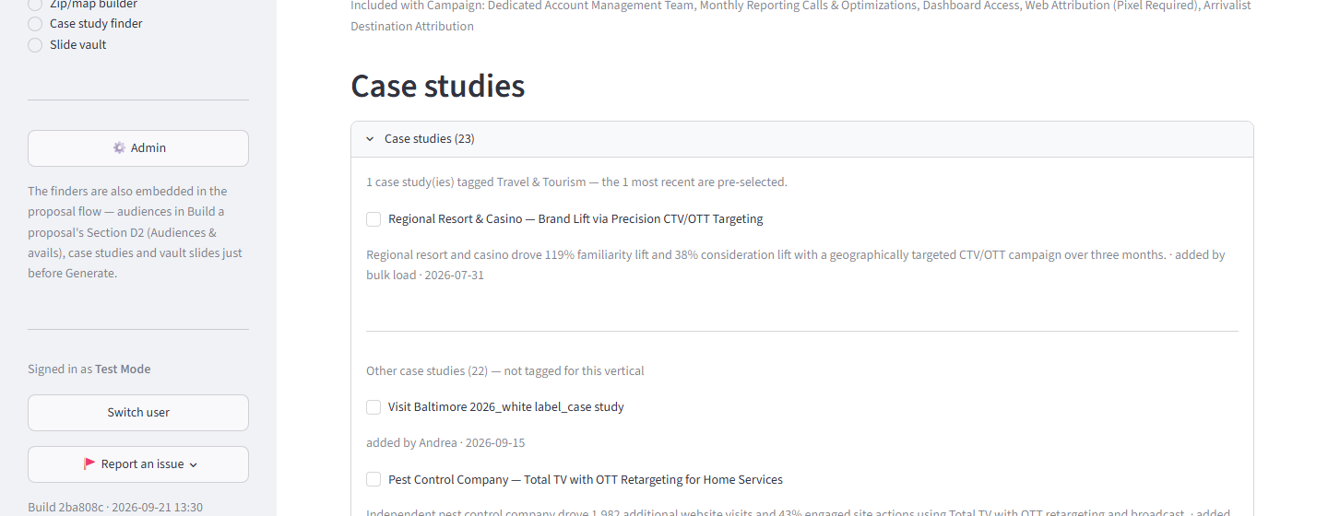
8. Click Generate, then download the finished PowerPoint.
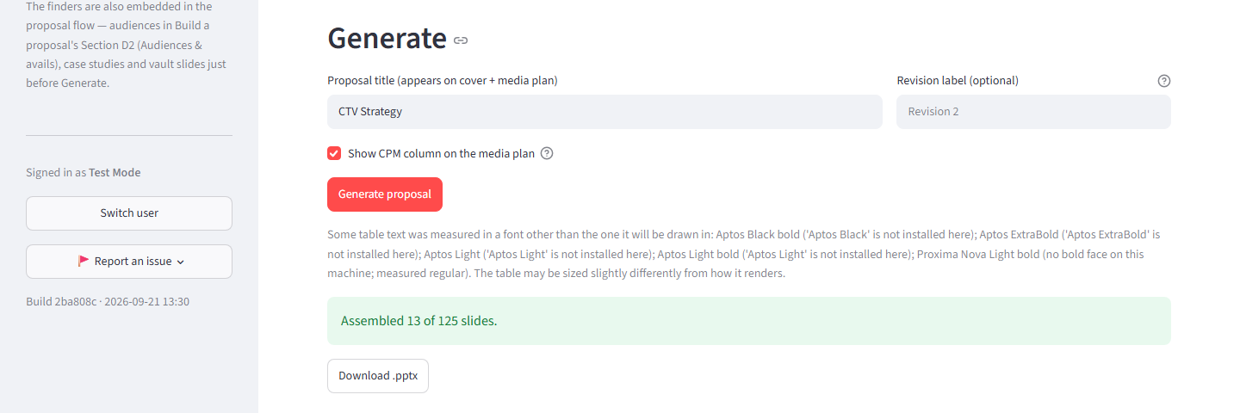

Task 2 — Build an attribution report
The real path: upload the export, confirm the client, link a proposal if one exists, fill goals, review the optimization checklist if one appears, generate, download.
1. Open “Attribution reports” from the sidebar. You land on the “New report” tab.
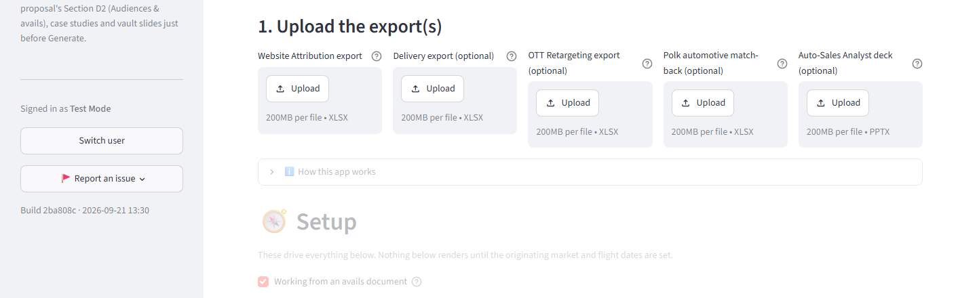
2. Upload the Website Attribution export.
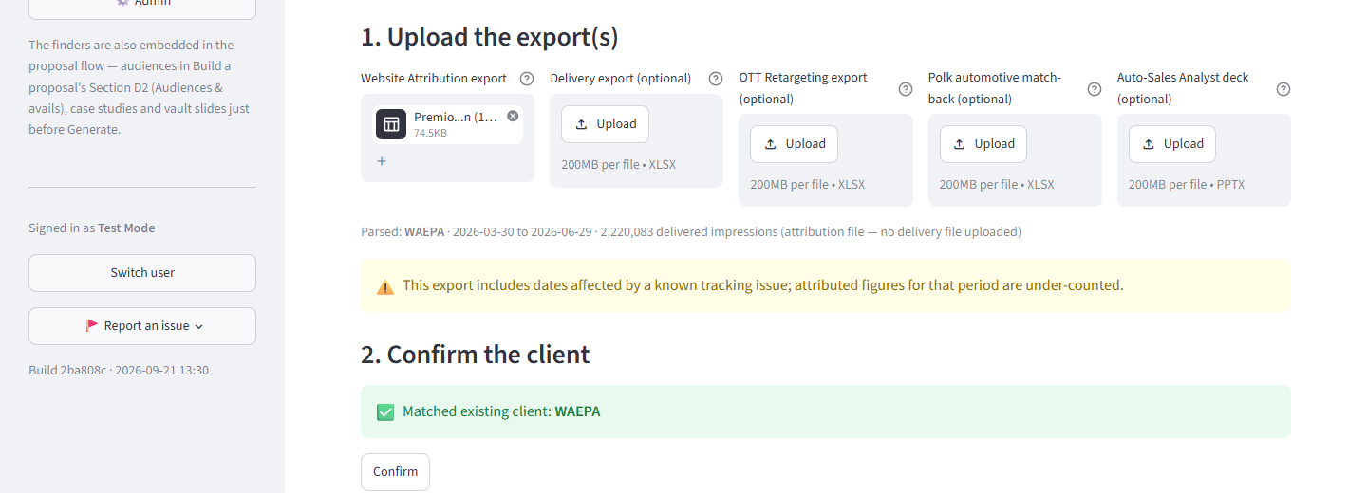
⚠ The Delivery export is optional. Upload it too and the report gains a Delivery Recap slide; without it, that slide is simply left out -- nothing else about the report changes.
3. Confirm the client match the app found.
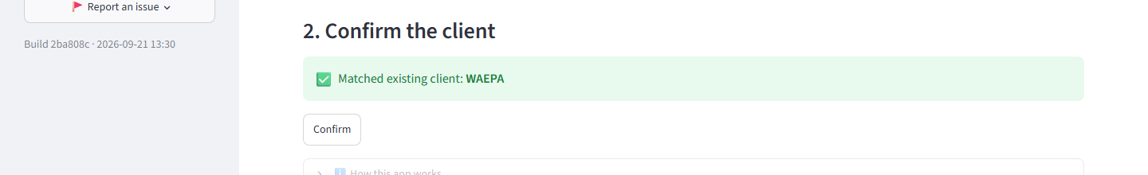
4. Report type -- Monthly, Multi-month recap, or Wrap-up -- is inferred automatically from the export's own span (and, once a proposal's linked, its flight). Always editable.
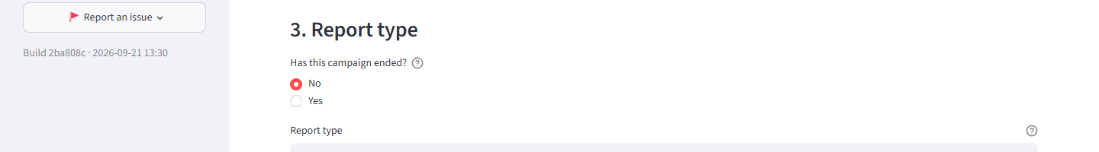
5. Link a proposal, if one exists for this client -- the app finds the best match and offers it as the default. Choose “No proposal” instead to build the report standalone.
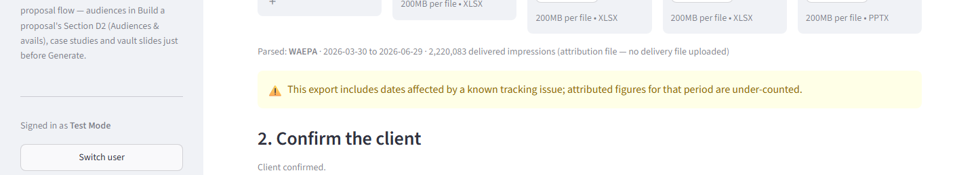
6. Fill in Goals, unless a linked proposal already filled them in for you.
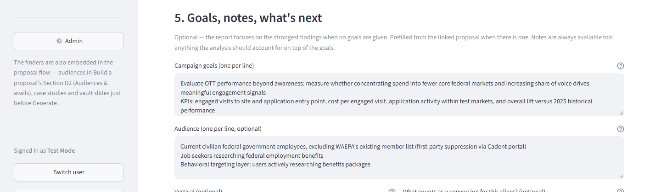
⚠ Goals are optional either way. Linking a proposal pre-fills them from it; leave them blank with no proposal linked and the report highlights the strongest findings in the data instead.
7. If the optimization engine has a recommendation, an “Optimization recommendations” checklist appears here -- accept, edit, or decline each one before Generate. If it doesn’t appear, there’s nothing to do.
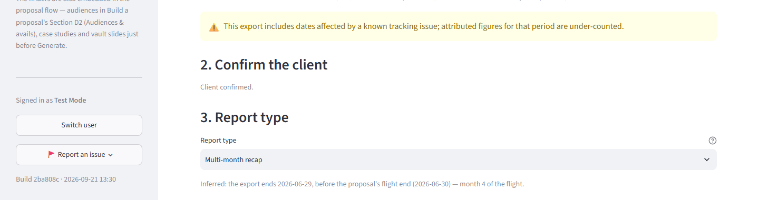
8. “Preview narrative” lets you read Claude’s draft before it becomes part of the deck.
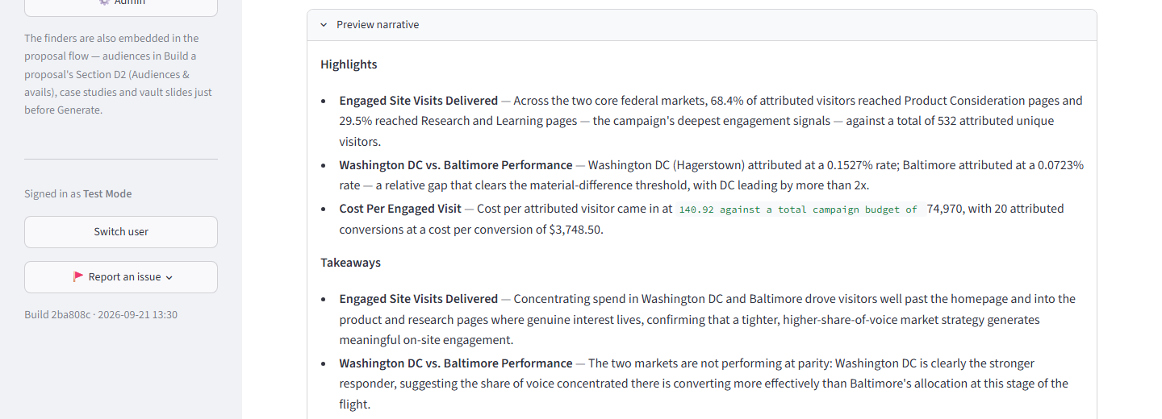
⚠ Preview narrative is optional. Skip it and Generate drafts the narrative automatically -- either way, once a draft has been previewed, Generate uses it exactly as it stands rather than drafting a second time.
9. Decide whether to also build the one-slide summary.
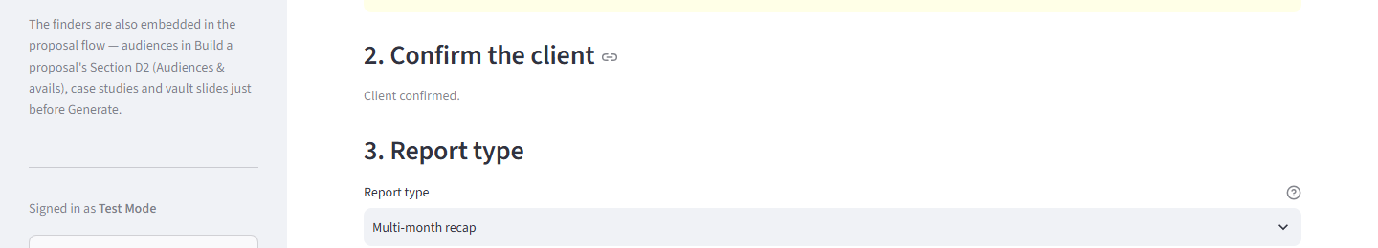
⚠ “Also build a one-slide summary” is a toggle, not a separate task -- check it before Generate to get an abbreviated, single-slide version alongside the full report deck.
10. Click “Generate report deck,” then download it.
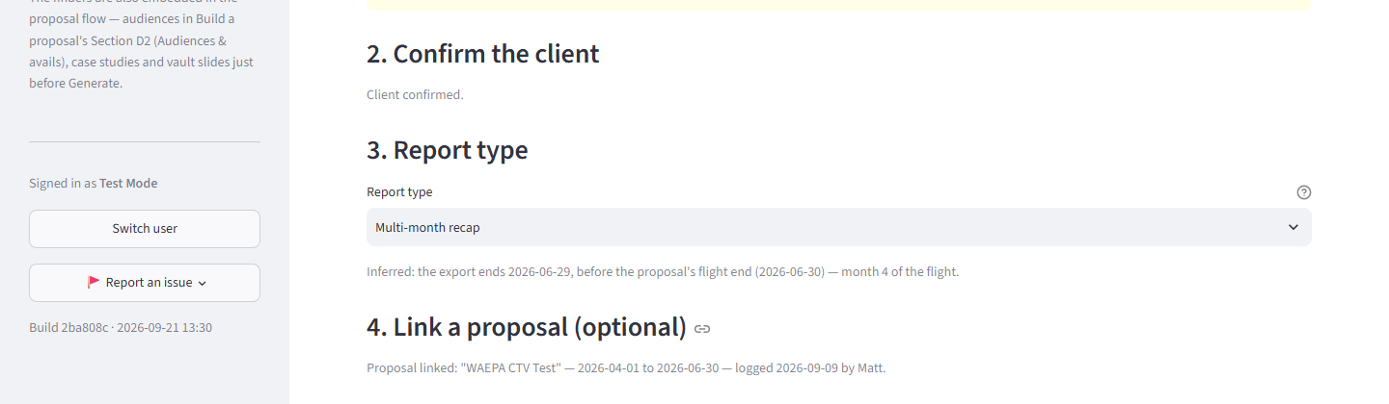

Reference
Everything below is a lookup, not a task -- short, standalone pieces you'll reach for occasionally rather than every time.

Audience finder
Look up what Premion can target, outside of building a proposal.
1. Browse or search the catalog directly, by category or name.
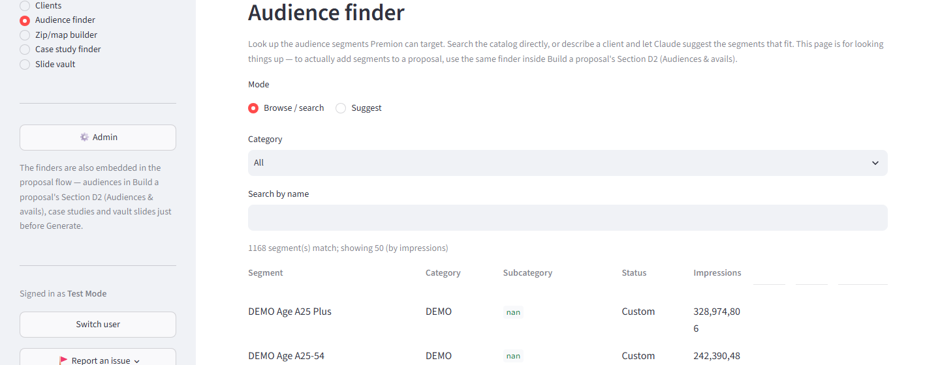
⚠ This page is for looking things up. To actually add a segment to a proposal, use the same finder inside Build a proposal's Section D2 (Audiences & avails).
2. Or switch to Suggest, describe the client or campaign, and Claude picks the segments that fit.
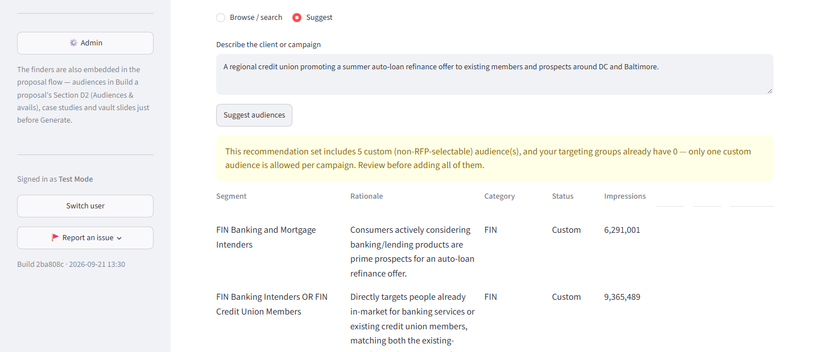

Case study finder
Browse past campaigns you can show a client as proof.
1. Browse by vertical or product, or search by title.
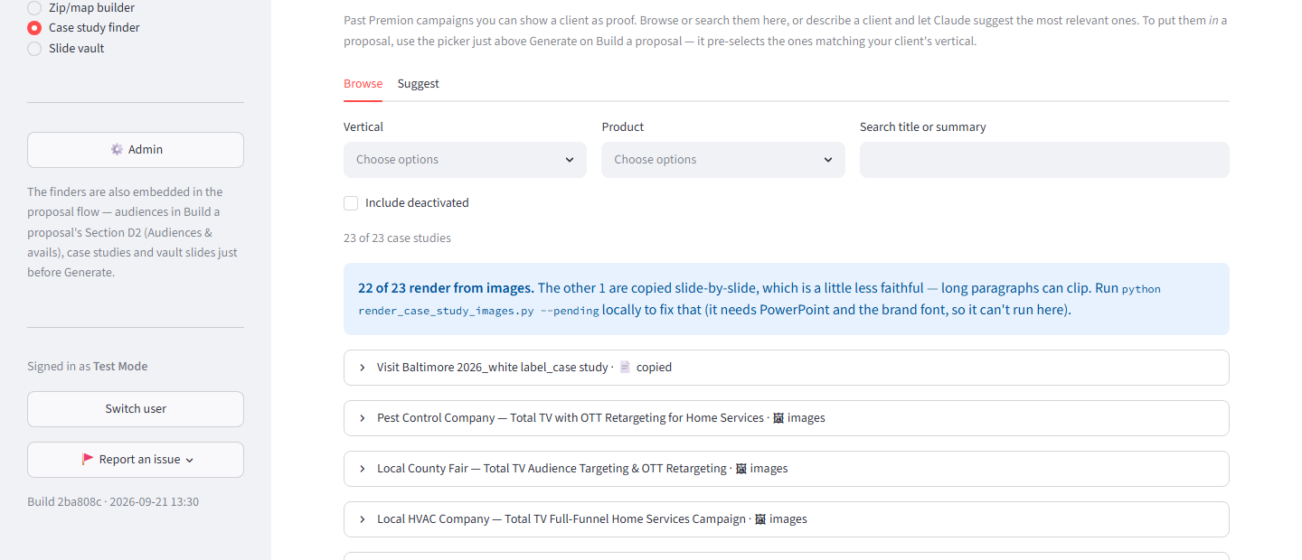
⚠ To put one IN a proposal, use the picker just above Generate on Build a proposal -- it pre-selects the case studies matching the client's vertical automatically.

Slide vault
Individual slides worth reusing -- a chart, a capabilities page, a research stat -- even when the rest of the deck around them isn't.
1. Add a slide: upload the source deck, then tick the slide(s) worth keeping. Each ticked slide becomes its own entry everyone building a proposal can pull in.
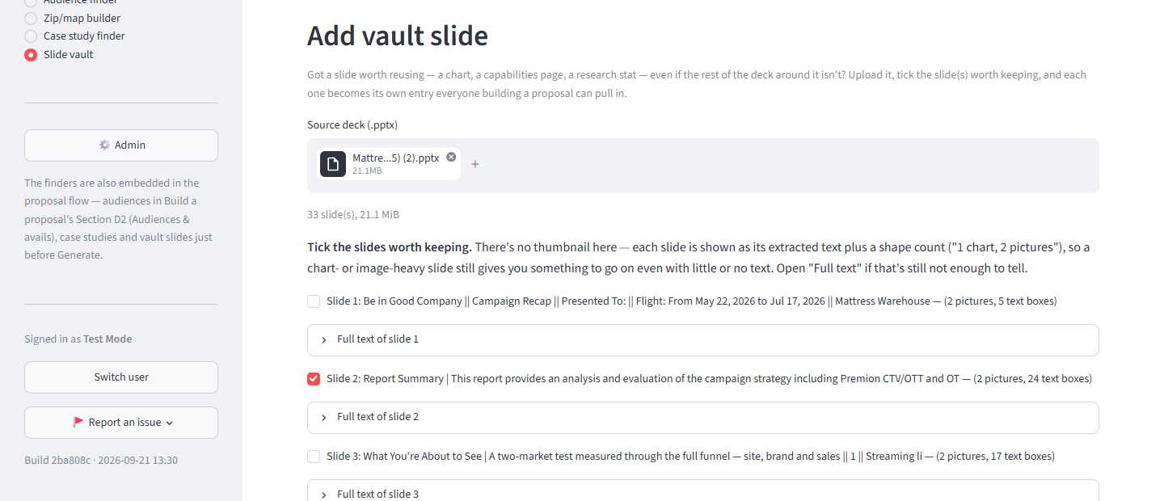
2. Use one in a proposal: the “Vault slides” picker sits right next to the case-study picker, just above Generate on Build a proposal.
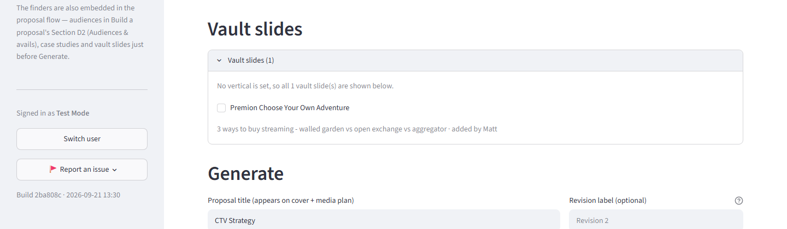

Zip/map builder
See exactly where a proposal's targeting actually reaches, or build a geography slide with no proposal at all.
1. “This proposal” plots every targeting group that's been resolved to real zips (Build a proposal's Section D2 geo expander) on one map, each group in its own color.
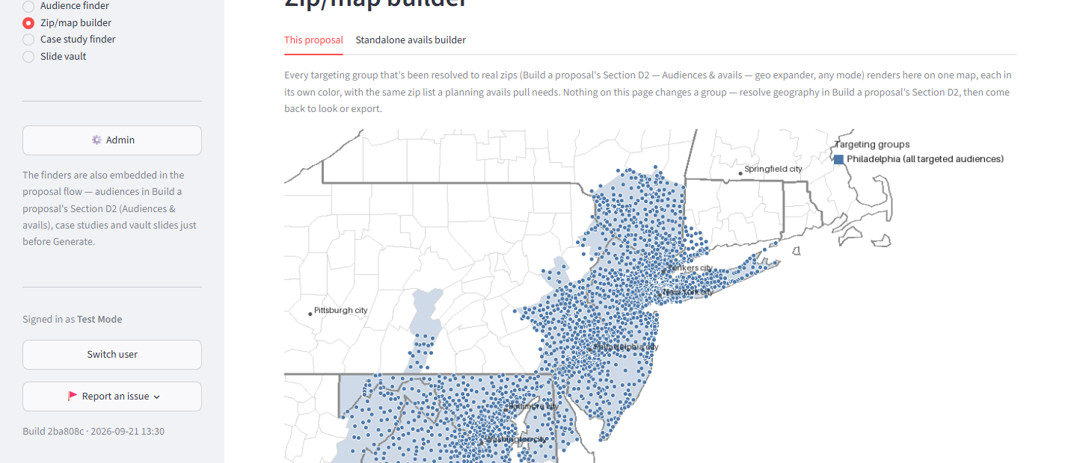
2. “Standalone avails builder”: upload an avails PDF with no proposal, no client name, no budget, and download just the geography slide.
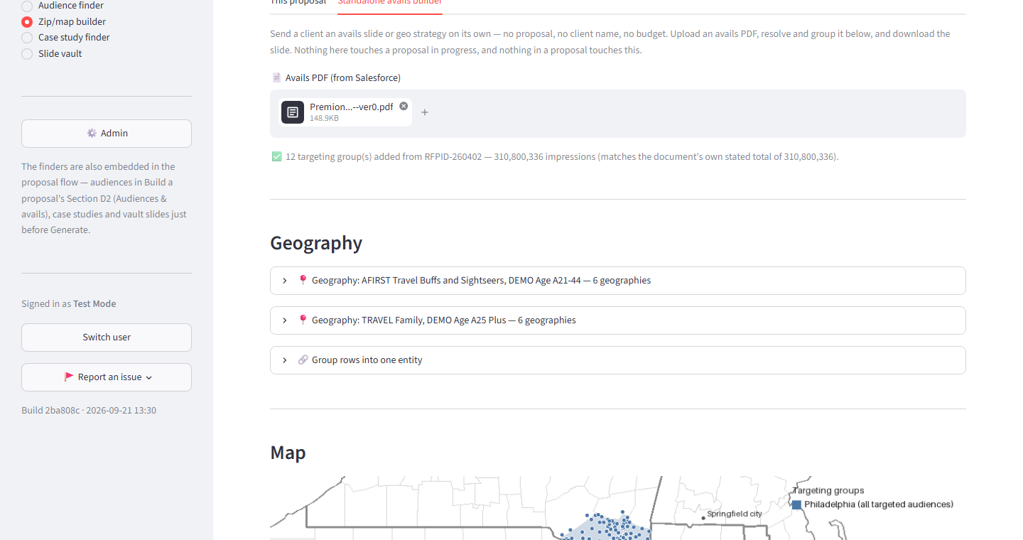

Clients
Everything for one account in one place.
1. Pick a client to see its vertical, its optimization level, its trend across reports, and every proposal, report, and case study logged for that account.
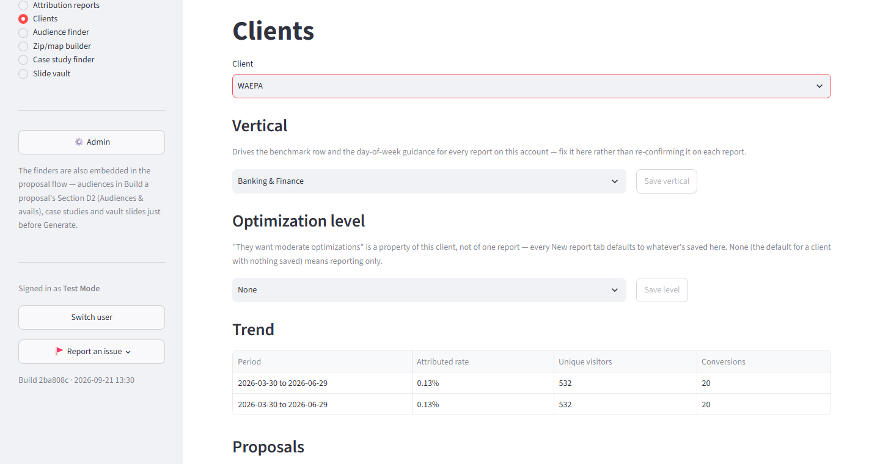
2. Open a report row to see its series -- which other reports it's linked with, if any. Optimization recommendations judge a value across every period in the series, not just this one month.
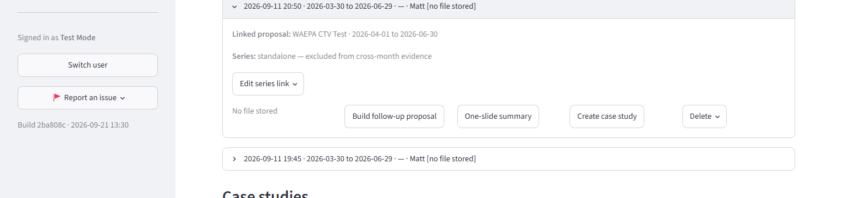
⚠ “Edit series link” lets you unlink a report that shouldn't count toward the trend (a re-pull, an out-of-sequence upload), or join it to another report's series by hand. Most reports link themselves automatically -- this is only for fixing one that guessed wrong.
3. From a report row, “Create case study” builds a case study straight from that report's own facts -- no new drafting call needed.
