**Unit 5 Project Sample:**

**ELK Web Design Site**

**Step 1: Define Audience / Tone**

* Who will visit your site? Potential employers? New clients or customers?

ELK Design is a design agency, so potential clients looking to build simple and responsive marketing websites.

* What can make you and/or your product stand out against your competitors?

We go through a formal visual design process with all of our clients ensuring for high quality and thoughtful designs.

* How would you speak to your clientele if you were communicating in person? How could you translate that style and tone digitally?

Professional with a bit of a “wink.” Using our logo and copy as a means to convey a more serious tone and use contrasting bright and bold designs.

* What colors represent you or your product?

Black white and grey for a serious tone with a bit of yellow for color and liveliness.

* What images illustrate your message?

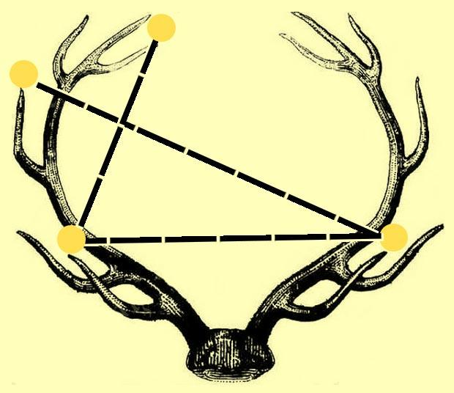

**Step 2: Define Site Structure**

What are the three-to-five pages titled?

Work, About, and Contact

What will be the purpose for each?

What should each page contain? Will there be textual content? Or just images?

**Homepage**

*Intro to ELK Design*

Contains:

* Title
* Navigation
* Logo
* Who we are
* What we do

**Work**

*Showcase the design and development portfolio*

Contains:

* Title
* Navigation
* Images of our portfolio work
  + Title
  + Image
  + Date published
  + Description

**About**

*About our process and philosophy*

* Title
* Navigation
* Image
* Paragraph

**Contact**

*Contact information*

* Title
* Navigation
* Body text