**Unit 5 Project Specs:**

**Purple People Web Design Site**

**Step 1: Define Audience / Tone**

* **Who will visit your site? Potential employers? New clients or customers?**

Purple People is a connection website, to help couples meet socially in their city or town, a sort of welcome wagon for those new in town, or existing couples looking to expand their social connections. Include local Trivia contests, with Dinner, and have Tables compete as teams, to foster friendship and connections. Prizes would have to be redeemed as a whole, by Table, so all couples could participate.

* **What can make you and/or your product stand out against your competitors?**

Our company will work with local gathering places, to help facilitate the meeting of other couples, and help the local businesses be able to provide a gathering place, and establish a warm, comforting place for couples to get to know each other. This will provide the local businesses with revenue, and help people get more familiar with their businesses. Mobile OS development is key.

* **How would you speak to your clientele if you were communicating in person? How could you translate that style and tone digitally?**

We will speak in an informal, local-dialect way( if possible), with a little bit of humor thrown in to break the ice. We will translate this to a Logo to convey old time friendships (barn dances, etc) that involved the whole community, a long time ago (Late 1800s Early 1900s). We will use an Art Deco Style, that will contrast in Vivid Colors.

* **What colors represent you or your product?**

Lavender (aka Orchid) with Sea Foam Green or Peach to convey the Art Deco Interiors of stylish residences that were all the rage, from the 1920s to the 1940s.

* **What images illustrate your message?**

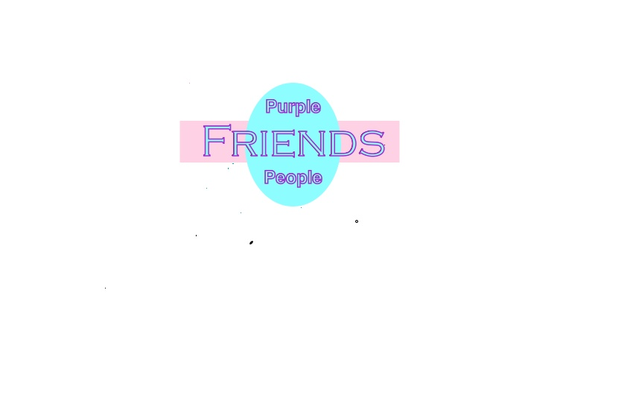

**Step 2: Define Site Structure**

**What are the three-to-five pages titled?**

Home ->

**Couples** **Couples With Kids** **Married Couples** **Married Couples With Kids** **Civil Unions** **Civil Unions With Kids**

**What will be the purpose for each?**

Each Heading will be its own units

**What should each page contain? Will there be textual content? Or just images?**

There will be Text and Images.

**Homepage**

*Purple People*

Contains:

* Title
* Navigation
* Logo (Wordmark)
* Motto; Vision
* Explanation of what we are

**About**

* Navigation Bar
* Title
* Mission Statement

**Couples**

*Age Range of Couples: Greatest Generation, Baby Boomers, Generation X, Generation Y, Millennials*

Contains:

* Title
* Navigation
* Your Profile/Text
* Compatible Couples / Profiles
* Body Text & Pictures

**Couples - Details**

* Title
* Navigation
* Title
* Statistics
* Body & Text
* Images