Experience for finding an appointment and booking
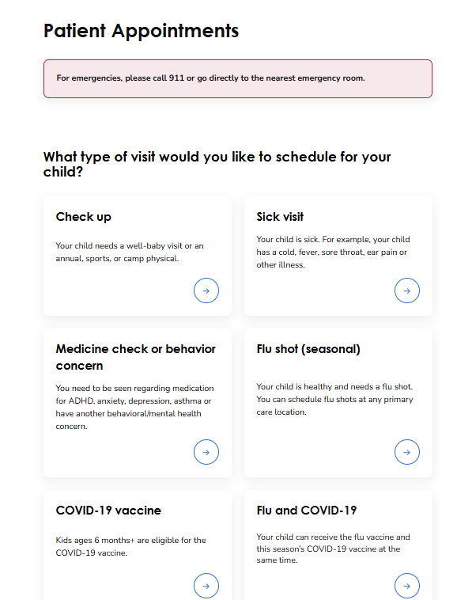

I will click Sick Visit.
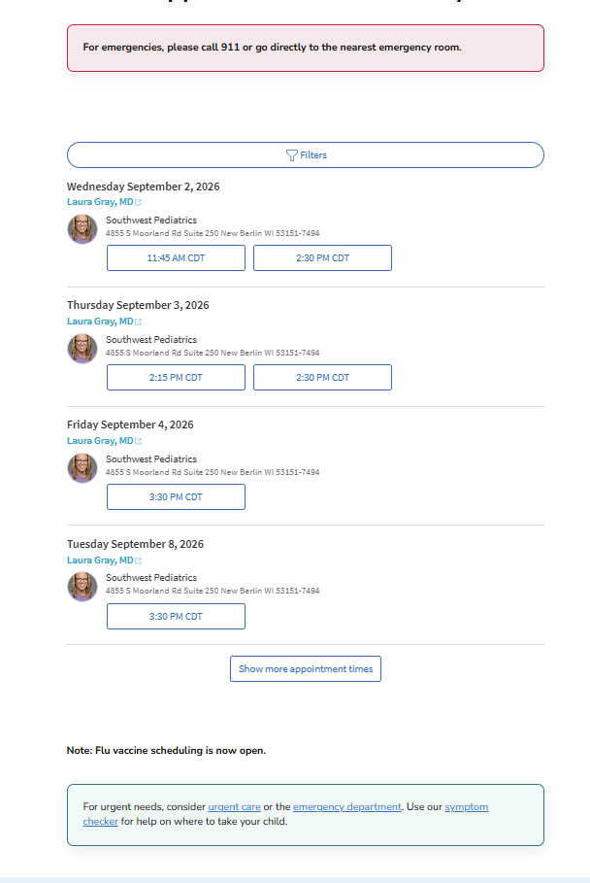
Then select one of the days. Keep in mind that the demo is next week so we need to manage that. Perhaps using current date PLUS?
This is the next screen before moving into the MyChart interface.
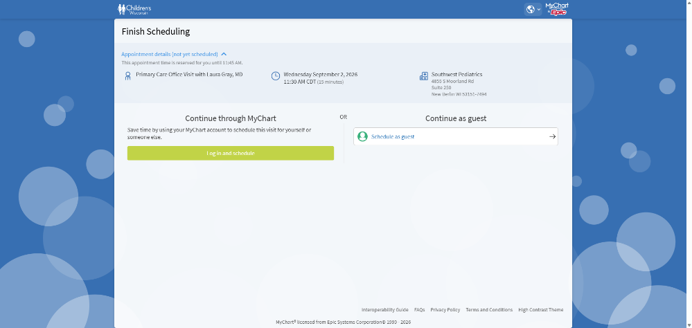
I want to login. But from here forth I don’t have screen shots since I donot have MyChart so we need to be creative

