Mind the distance: spatial proximity confounds tissue-tissue correlations reported by Richiardi et. al

Spiro P.Pantazatos

The report by Richiardi et. al. explores potential relationships between gene expression and distributed spatial patterns of synchronous brain activity consistently observed in resting state fMRI (1). The authors correctly state that “While functional networks are distributed spatially, meaning they cross over different tissue types, and that their sample can be spatially distant, it is important to ensure that a high strength fraction does not simply reflect the fact that tissues are the same.” They attempt to correct for spatial proximity by omitting edges between regions falling in the same “tissue class”, which are ontological labels provided by Allen Brain Atlas (Supplementary Table 4 in (1). However, this approach, which relies on arbitrary label boundaries, inadequately controls for spatial proximity. As illustrated in **Panel A**, nearby regions **a** and **c** will fail to have their edges removed by an arbitrary label boundary (arrow) that divides them, while more distant edges (**a-b**) within a tissue label will be removed instead. Even after applying the Richiardi et. al correction based on removing within-label edges, there remains a strong dependence of tissue-tissue correlations on distance (R=-0.10, p<10E-6), with nearby regions tending to have higher tissue-tissue correlations (**Panel B**). On average, within network (Wi) edges are significantly shorter than out-of-network (T-W) edges (Wi distances vs. T-W distances 2-sample t-test: t(793,573)=-73.5, Wi mu=51.3 mm, T-W mu=75.5 mm). This dependence on distance would thus bias the Wi strength fraction to be greater relative to a null distribution which calculates Wi using much longer range connections (i.e. T-W edges which are labeled Wi as part of the shuffling procedure).

When a more effective and direct correction for spatial proximity is applied by removing proximal edges, within-network strength fraction is no longer greater than the null distribution. **Panel C** shows a strong dependence of strength fraction (SF) on spatial proximity. “Tissue” refers to the original within-tissue class correction applied by Richiardi. et. al. and demonstrates their primary findings (p<10E-4). However, as short distances (edges) are removed (< 4 through 24 mm) the SF falls monotonically until it is no longer greater than the null distribution at <20 mm. In addition, applying linear regression to adjust for effects of distance (3) using the original edges used in Richiardi et. al strength fraction calculations (i.e. “tissue” in Panel C) leads to a large *negative* strength fraction which is lower than the null distribution (SF=-0.61, p=1, data not shown). *Thus the claim that “Given that we used only cortical samples, that we removed edges linking tissues of the same class, and that functional networks are spatially distributed, this finding cannot emerge from spatial proximity or gross tissue similarity” is false.* Moreover, the null distribution used in Richiardi et. al is flawed by the fact that the permutation strategy assumes all regions are equally exchangeable, which is not the case given the local spatial autocorrelation in gene expression and distance bias mentioned above.

It is likely that the optimization approach used to derive the 136 consensus genes (i.e. multiplying each gene’s expression by 10 and recalculating the strength fraction) identified genes with both high local spatial autocorrelation and variability across the cortex. This is consistent with the observation that >75% consensus genes are in the top 10% of genes found to have consistently high region-to-region variability (so called differentially stable, DS, genes) across the cortex identified in Hawrylyzc et. al. (2). In addition, GO functions related to potassium channels (featured prominently in Richiardi et. al. Supplemental Table S3) were most over-represented among high-DS genes (*P* < 1.70 × 10−12) in Hawrylyzc et. al. (2). Given that genes high in differential stability (i.e. consistent region-to-region variability, *irrespective of belonging to resting state functional networks*) are more likely to be involved in brain functioning (2), this could account for the slight enrichment (p=0.006) of SNPs associated with functional network strength fraction observed in the IMAGEN portion of the Richiardi et. al. analyses.

Figure 2 in Richiardi et. al. is potentially highly misleading, and does not constitute evidence for “definite differences in functional connectivity strength mostly within the functional networks themselves.” Given that the authors used a post-hoc, biased approach to generate the loosely thresholded functional connectivity difference matrices and maps, it is unclear whether comparable results could be generated when applying their scoring procedure to 136 genes randomly selected from the background set or from the top 10% of genes showing variability across the cortex (i.e. cortical DS genes reported in {{Hawrylycz, 2015}}). Finally, the results from mouse tractography data (p=0.011 Mantel correlation, Figure 3 in Richiardi et. al.) does not make any adjustment for spatial proximity, and could again be confounded.

The Richiardi et. al. study takes an important first attempt towards identifying genes whose spatial pattern of cortical expression relate to distributed functional networks consistently observed in resting state fMRI. However, they are not quite there yet. Further work will be required to adequately control for the confounding effects of spatial proximity. While here distances were computed in 3D MNI space, computing distances in flattened cortical surface (2D) space would make distance measurements more accurate. Matlab (and Python code pending) replicating the primary results presented in Richiardi et. al. and results presented here are available at <https://github.com/spiropan/ABA_functional_networks>

Acknowledgments

This work was supported in part by a Janssen Postdoctoral Research Fellowship and a K01MH108721 (Mentors: J. John Mann and Paul Pavlidis).

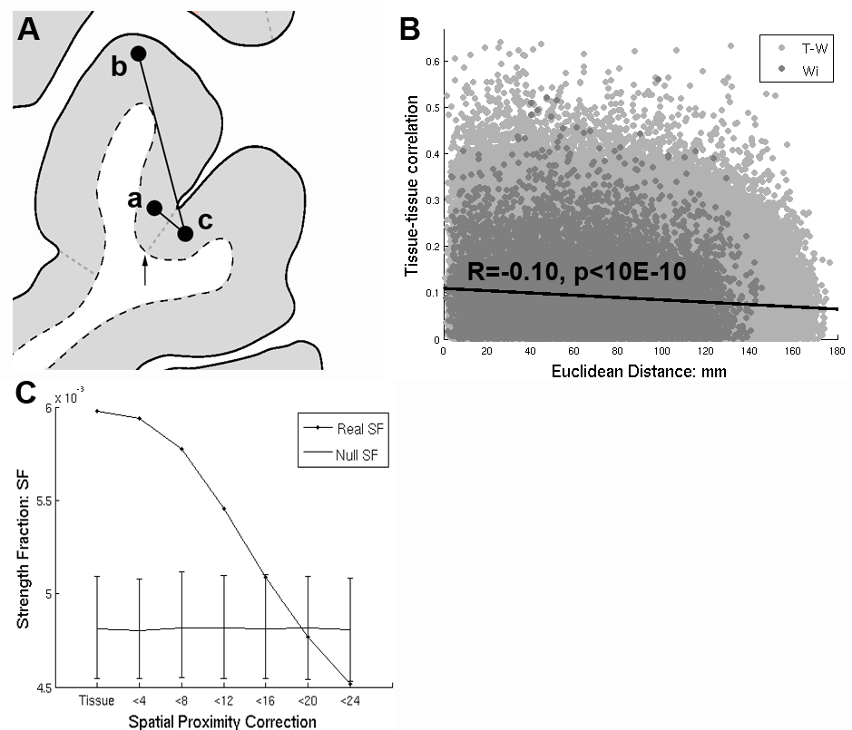

**References**

1. Richiardi J, Altmann A, Milazzo AC, Chang C, Chakravarty MM, Banaschewski T, et al. BRAIN NETWORKS. Correlated gene expression supports synchronous activity in brain networks. Science. 2015;348(6240):1241-4.

2. Hawrylycz M, Miller JA, Menon V, Feng D, Dolbeare T, Guillozet-Bongaarts AL, et al. Canonical genetic signatures of the adult human brain. Nat. Neurosci. 2015;18(12):1832-44.

3. French L, Pavlidis P. Relationships between gene expression and brain wiring in the adult rodent brain. PLoS computational biology. 2011;7(1):e1001049.