In the resource sheet we find all of the different workers that I have appointed. It is called resource sheet because it lists indeed the resources of the company (the workers). Also, in here we find the profession, the pay, and additional expense that come by using them in a determinate project.

CIS – 285

LAB -1

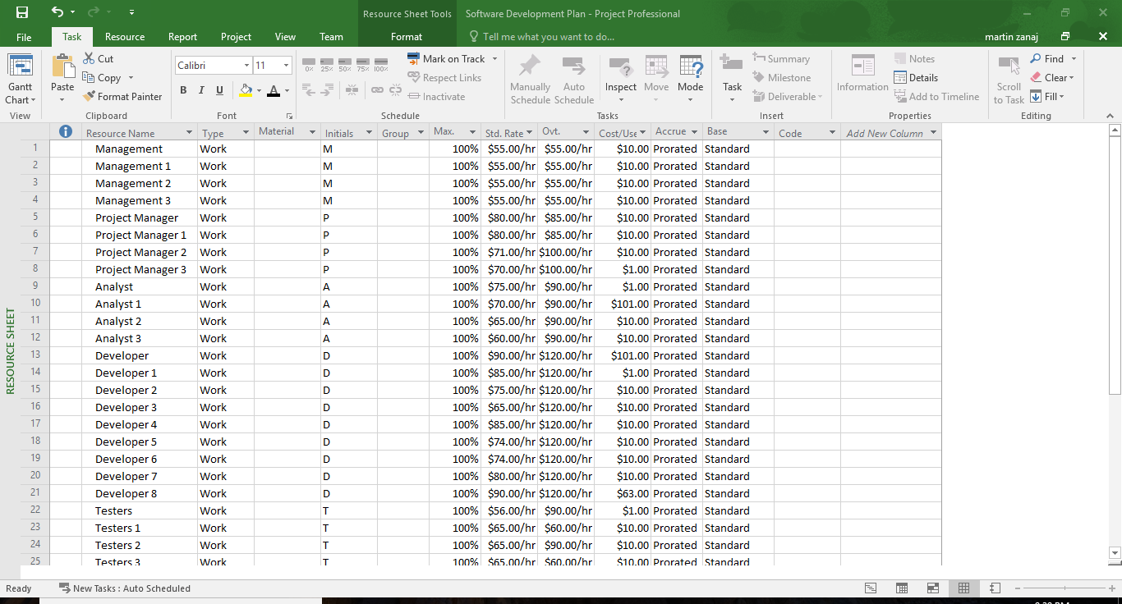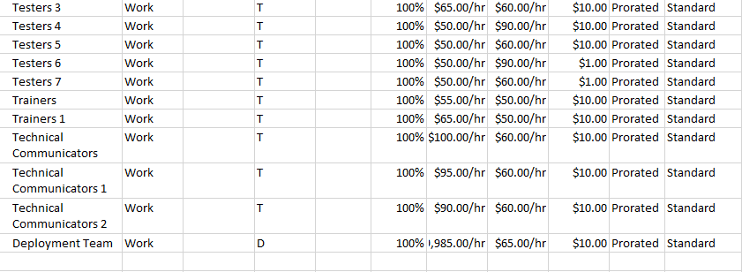1) Resource Sheet

2) Task usage

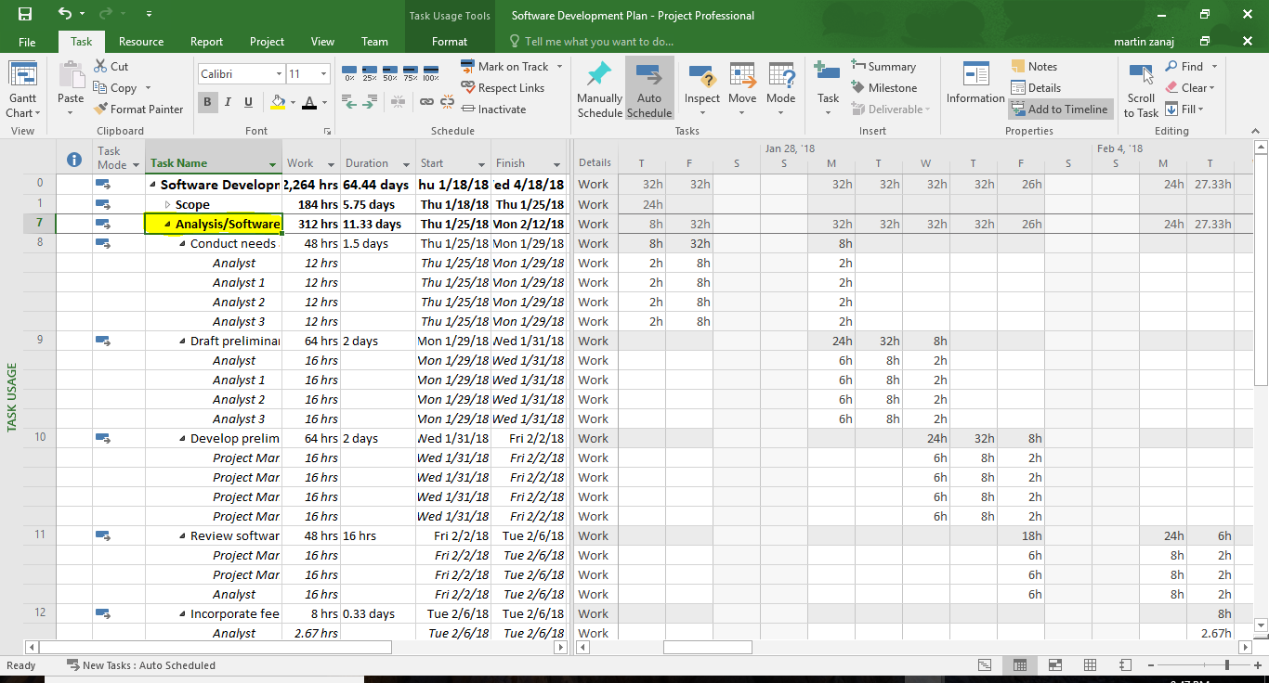In the task usage we can each of the different task that the project consists of. In addition we can open each task, in this case I have opened ANALYSIS/SOFTWARE DEVLP. We can note, the amount of days/ hours it will take to complete the task, and all of the different workers that are going to work on the different subtasks. Also, on the right hand side we are able to see the different hours needed to complete each of the different tasks.

3) Calendar

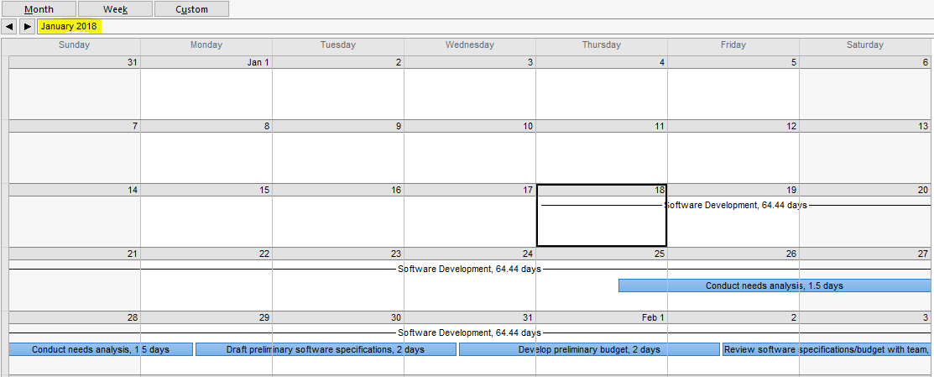**January**

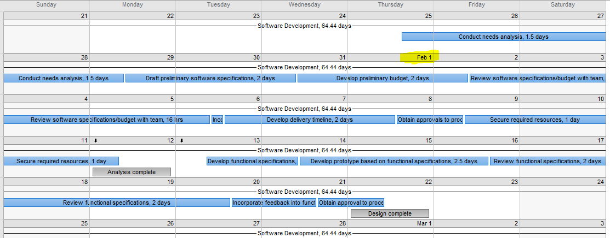**February**

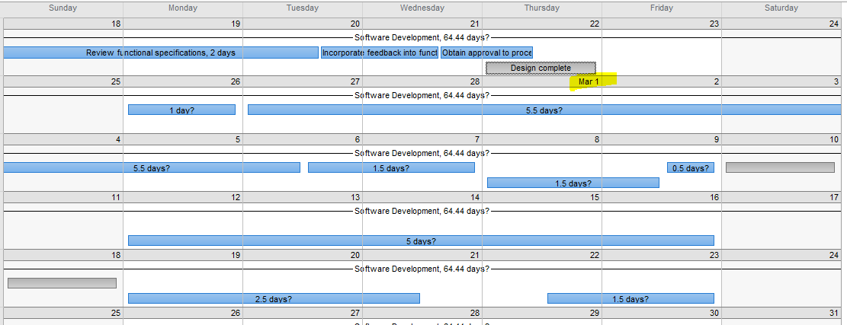**March**

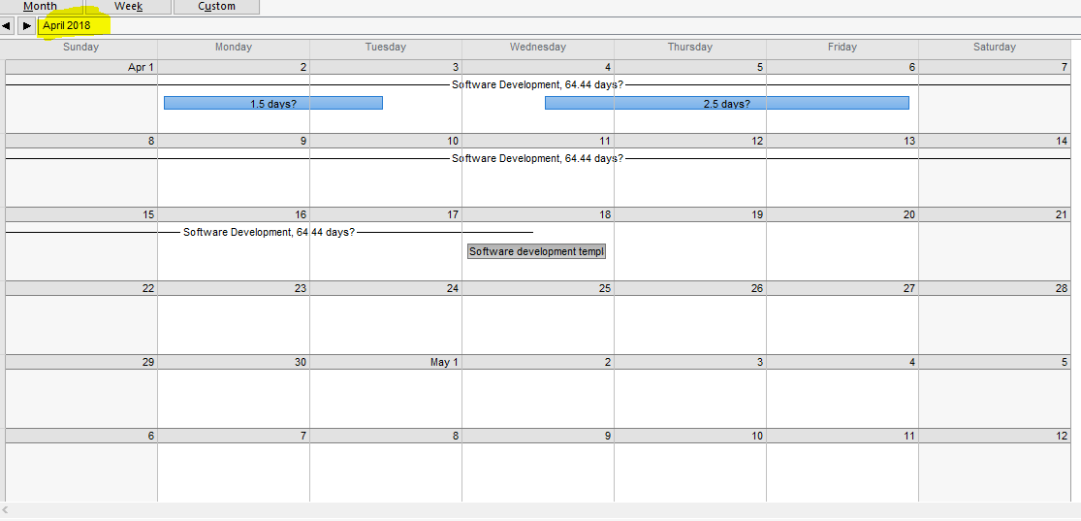**April**

In here is depicted the network diagram, which shows all of the different task that ought to be accomplished. Also, we can see the critical path. The boxes in red are the critical path which are the essential task that ought to be done on time and in a specific order, just so that the rest can be accomplished without problems.

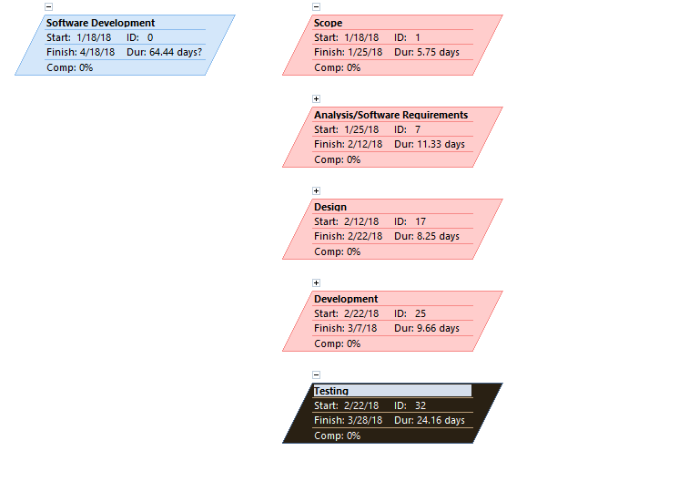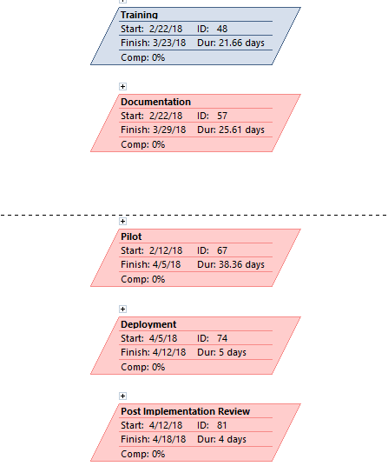**4) Network Diagram & Critical Path**



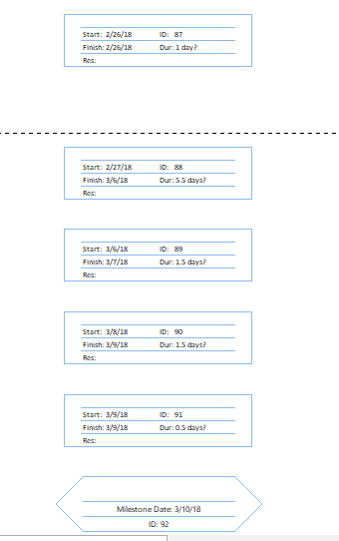

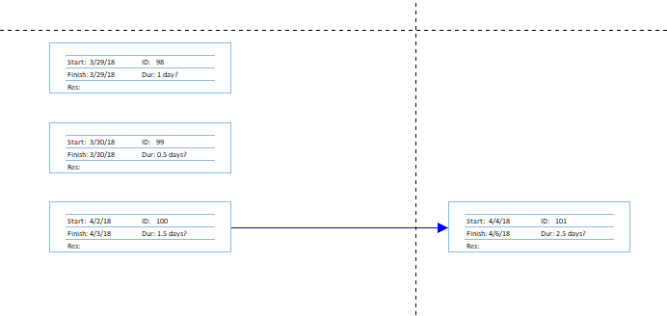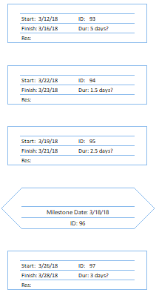

**5) Additional (5) reports**

1) Total Cost Report ($1mln)

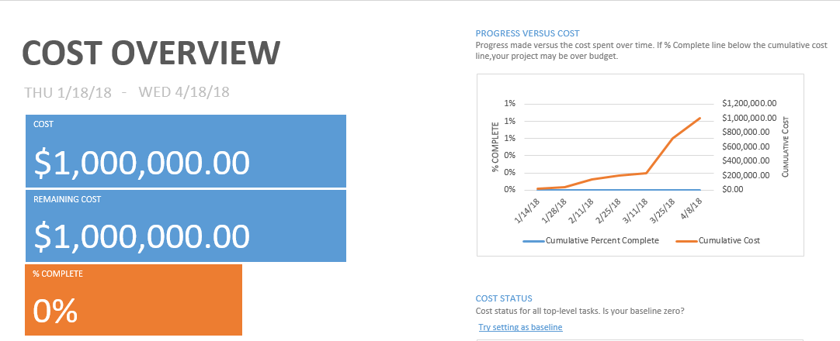

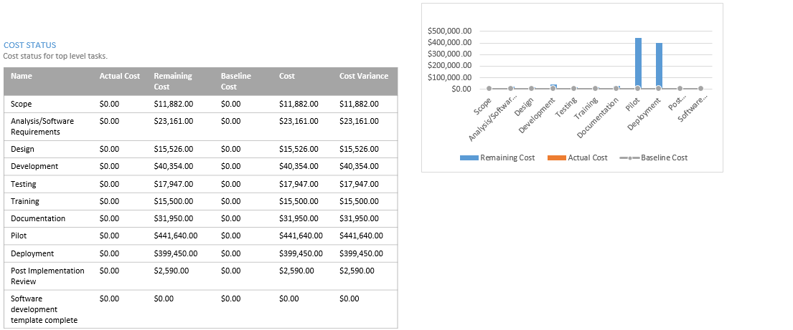

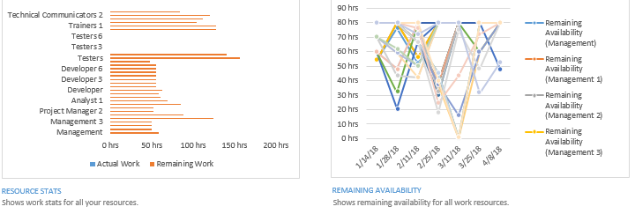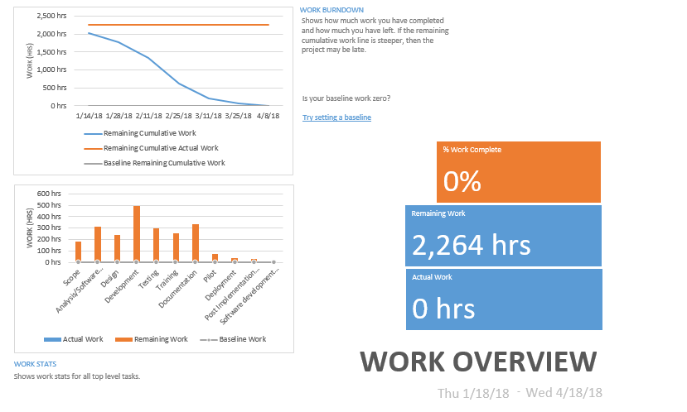2) Work Overview

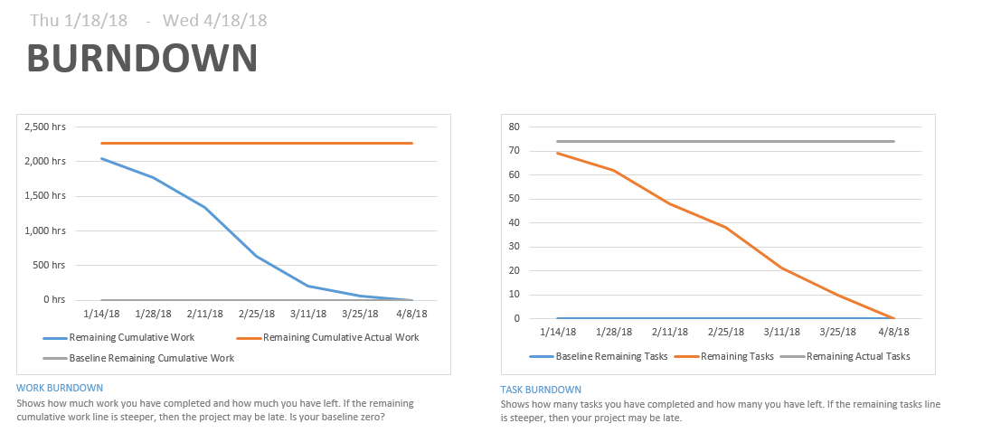3) Burndown

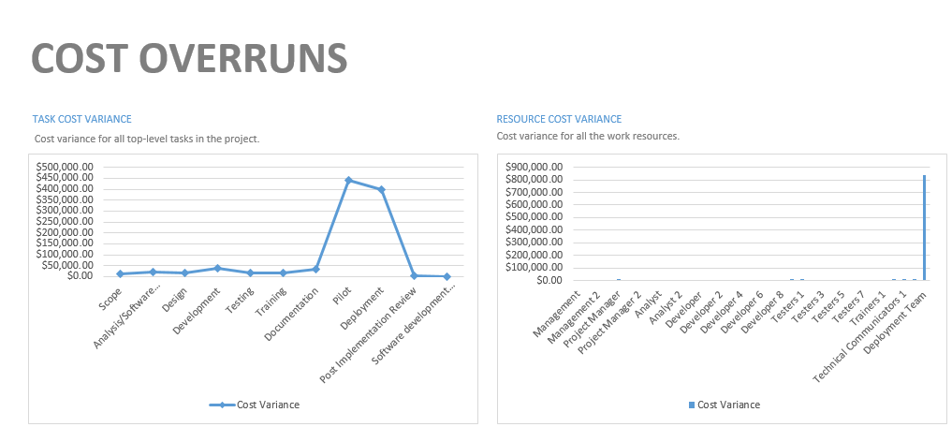4) Cost Overrun

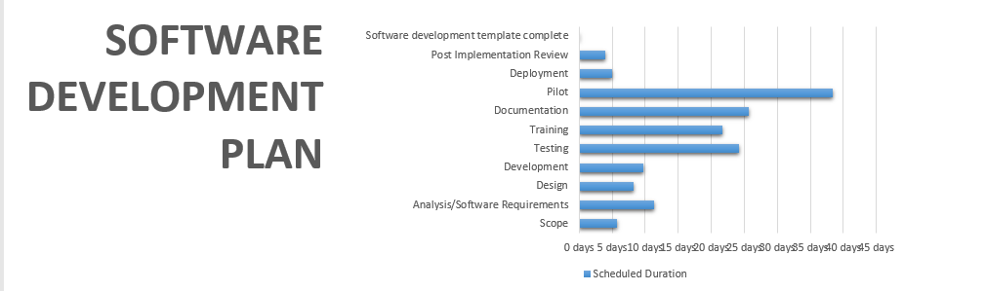5) Software Development Plan ☺