Marco Seman

Professor Tommy Xu

CIS 285 – Software Engineering Tools

January 24, 2018

Lab 1-2

Contents

1) Resource Sheet 2

2) Task Usage 3

3) Calendar 4

4) Network Diagram and Critical Path 6

4.1 Network Diagram 6

4.2 Critical Path 7

5) Cost Report 7

5.1) Total Cost Report - $1 Million 7

5.2) Cost Overruns 8

5.3) Cost Status 10

5.4) Cost Details 10

5.5) Work Burndown 11

# **Resource Sheet**

* In the Resource Sheet, we can find all the different workers along with the job title that I have assigned to them. The reason for a resource sheet is to list the company’s workers and their resources. In the resource sheet, we can find how much each worker makes on an hourly pay, their job title, and additional expenses that come by using them in a determinate project. A total of 42/42 employees were used in this project with an hourly pay of between $50-100 and expenses that are between $100-1000.

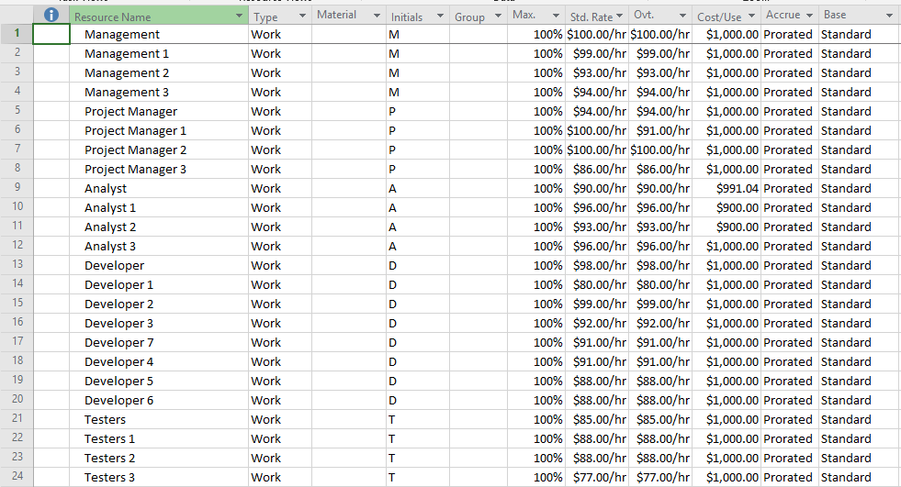

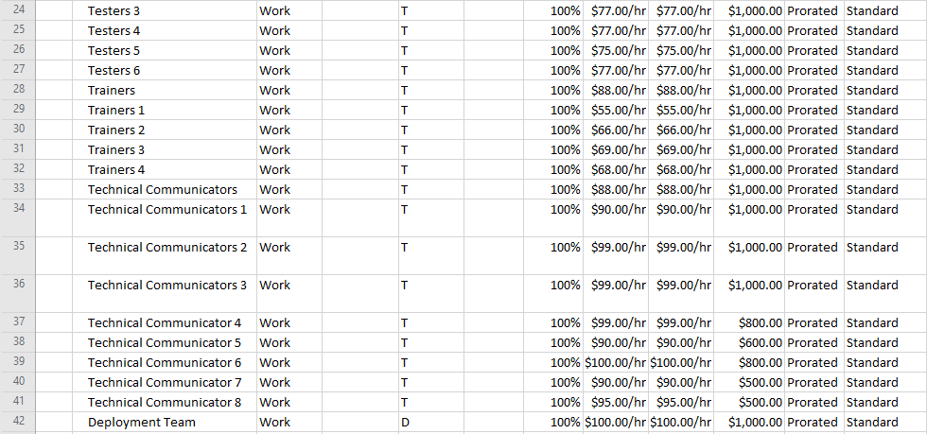

# Task Usage

* The task usage describes the different tasks that the project must include. Each major task has sub tasks associated inside of them along with the length in terms of hours, days, or weeks required to complete such tasks. On the right-hand side of the tasks, we can also view the different hours required to complete each of the tasks assigned. The software development and Testing phases are expanded to reveal the tasks assigned for that specific project.

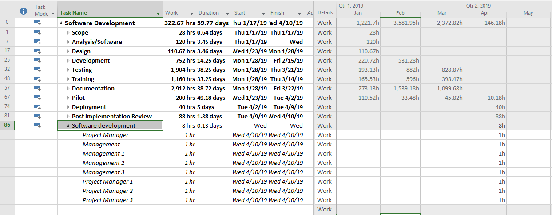

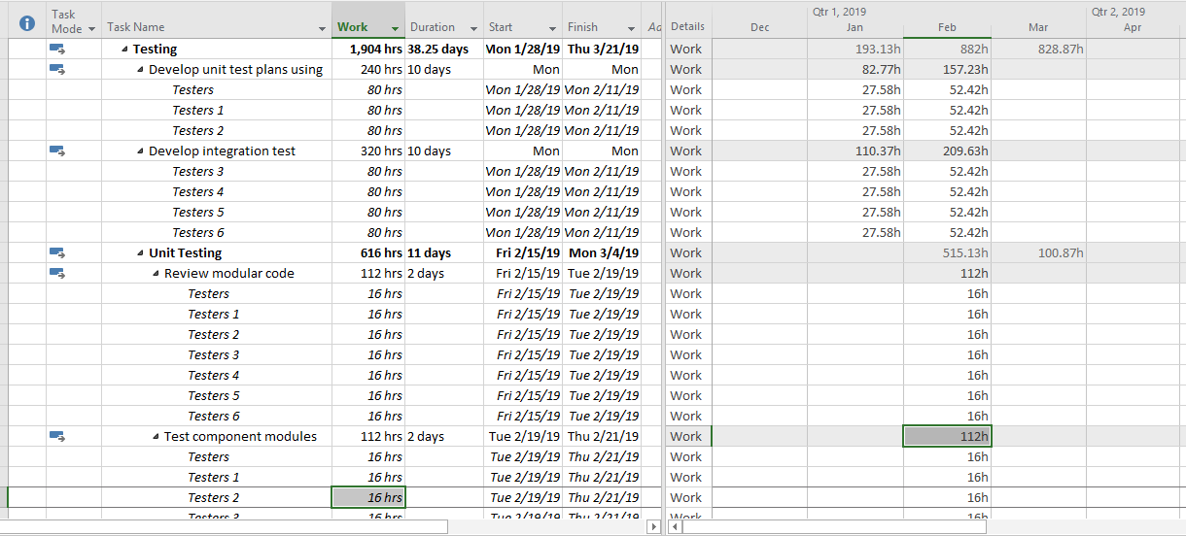

# Calendar

* The project needs to be completed within 60 days starting on January 17, 2019. The calendar below reveals the project being completed within the appropriate timeline along with the specific software development phases completed within that time span.

January:

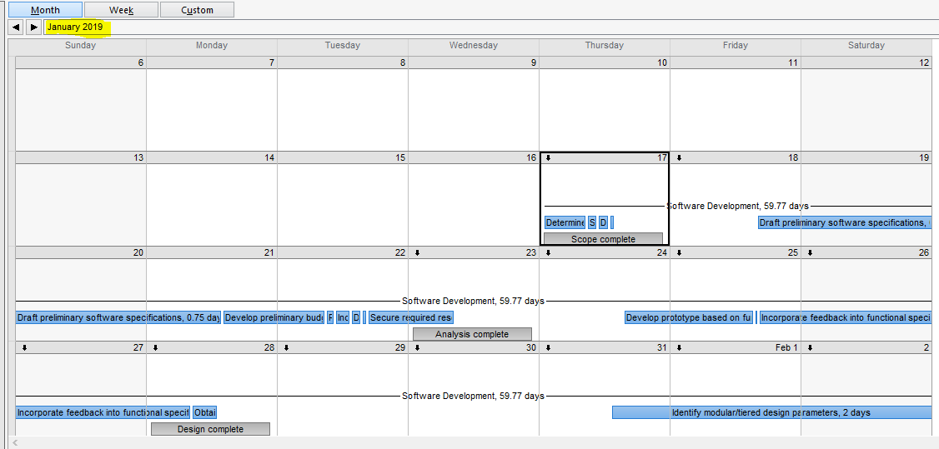

February:

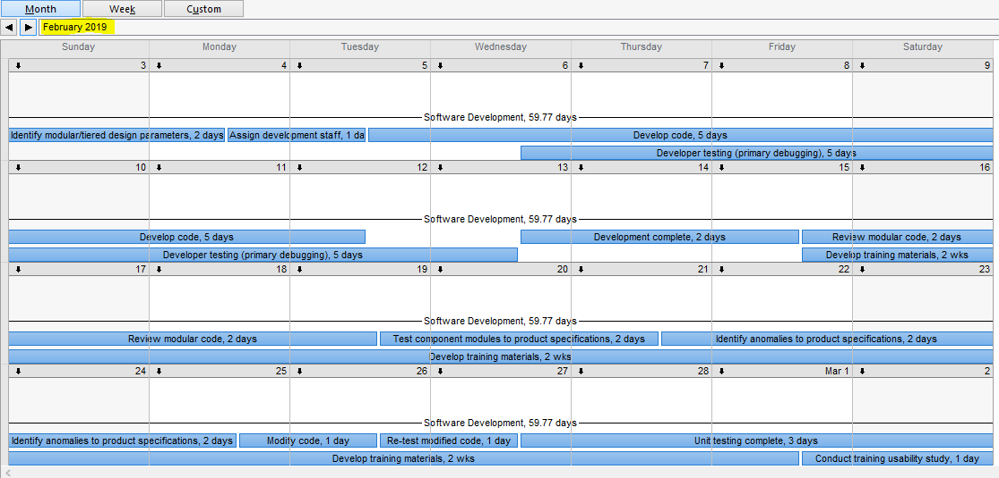

March:

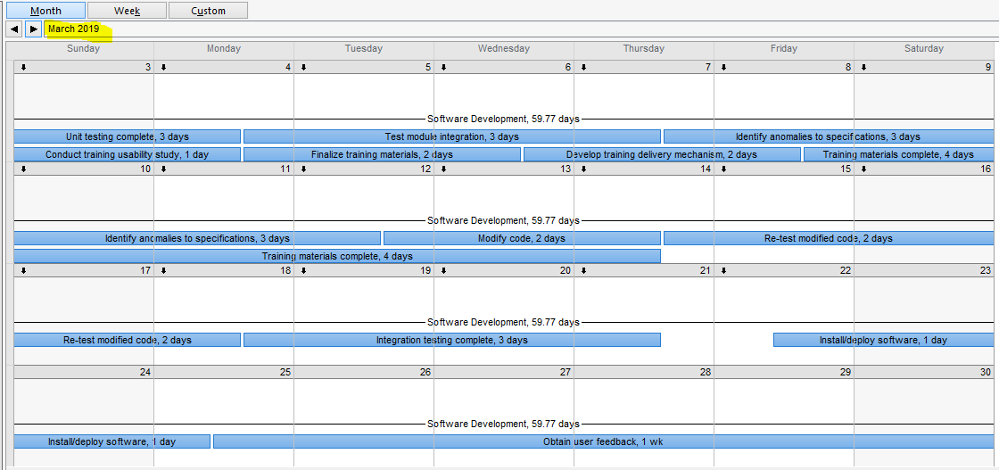

April:

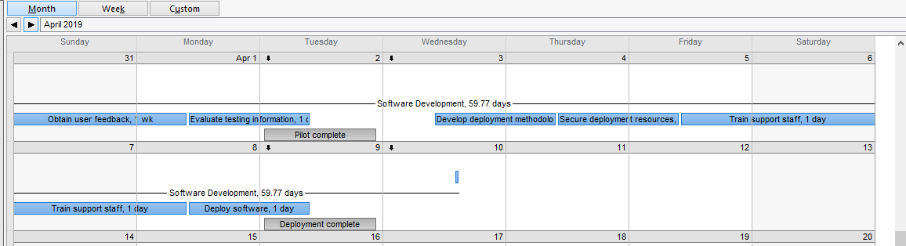

# Network Diagram and Critical Path

* Network diagram reveals interdependent relationships between groups, steps, and different tasks that all impact the project
* In critical path (the red boxes) reveal the tasks that need to be completed in a specific time and order without modifications to the dates to reduce complexity. The goal of critical path is to prevent time frame problems and process bottlenecks.

## 4.1 Network Diagram

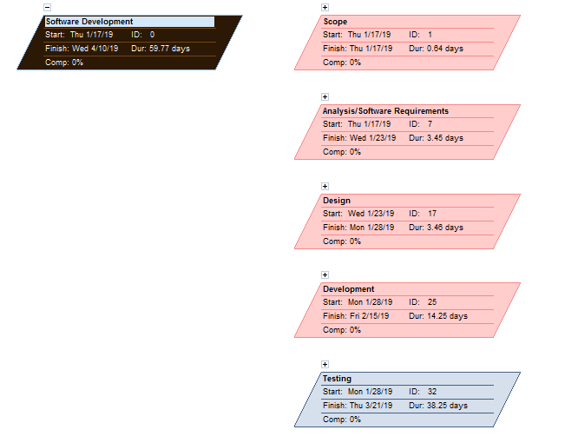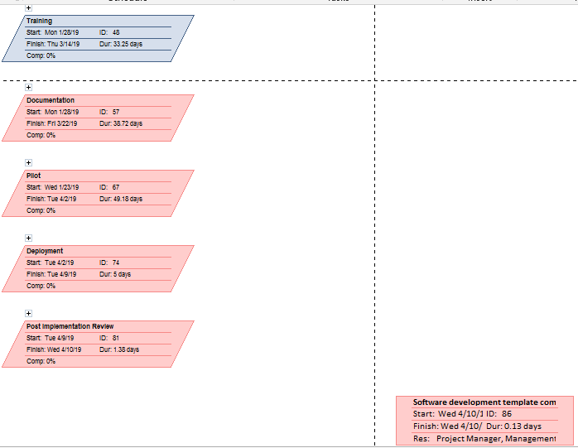



## 4.2 Critical Path

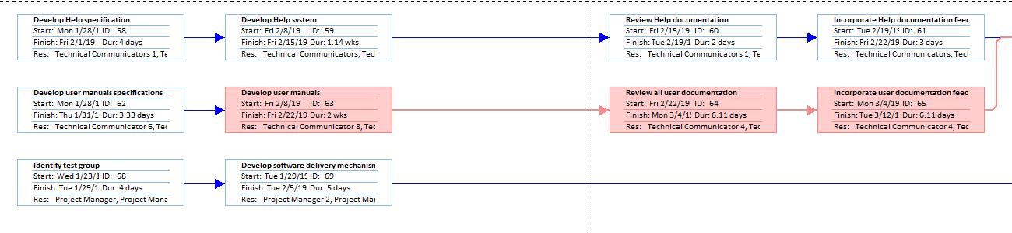

# Cost Report

## 5.1) Total Cost Report - $1 Million

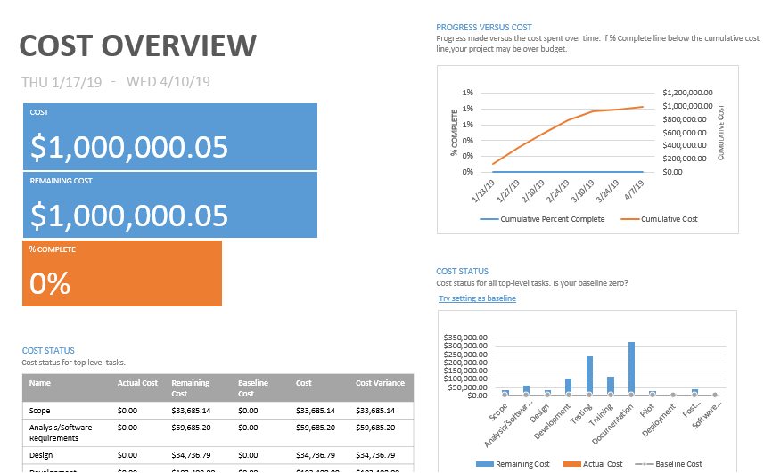

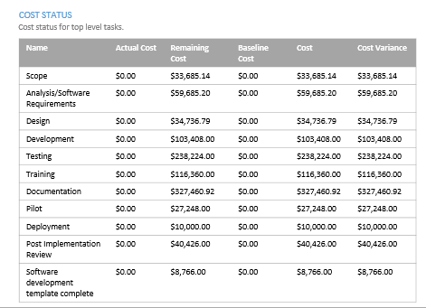

## 5.2) Cost Overruns

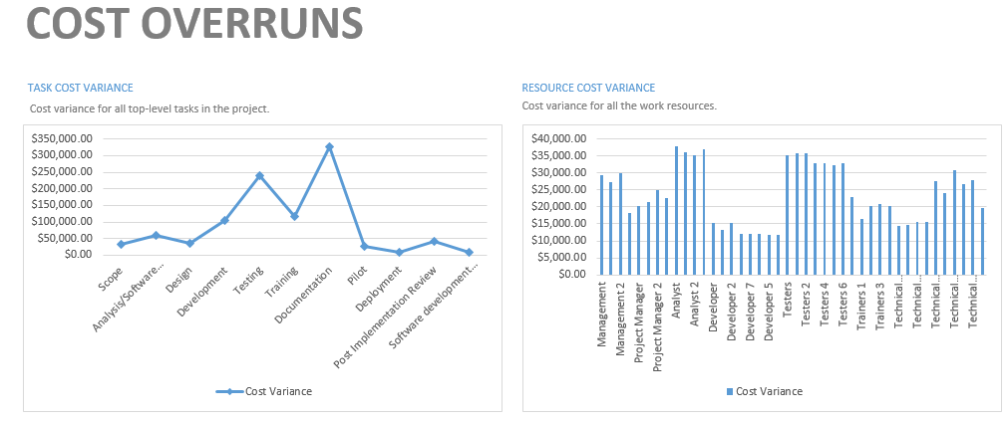

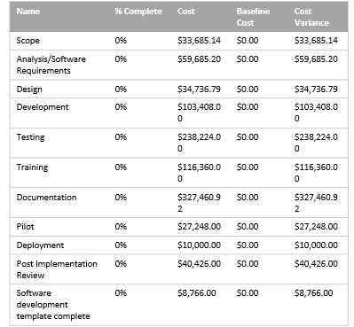

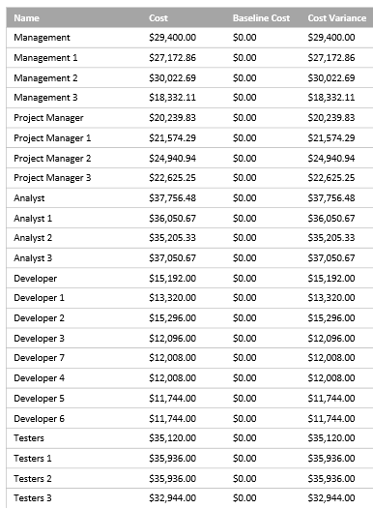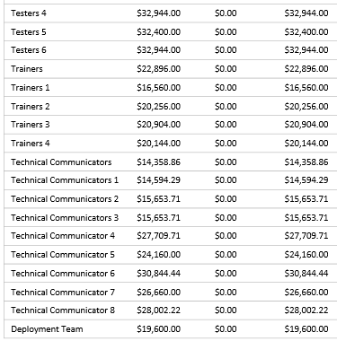

## 5.3) Cost Status

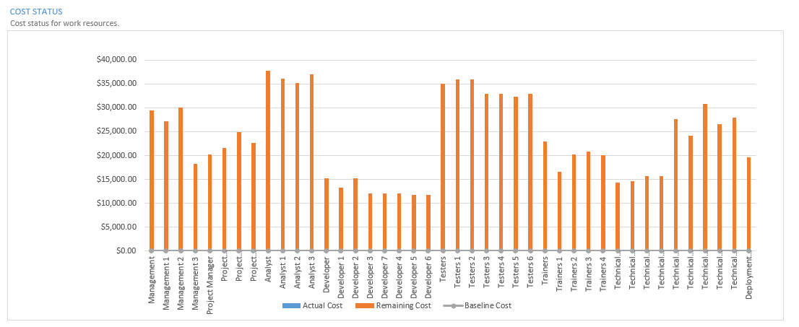

## 5.4) Cost Details

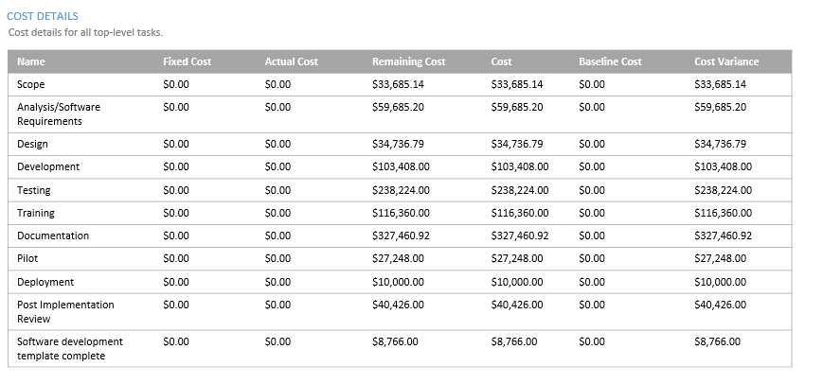

## 5.5) Work Burndown

