Marco Seman

CIS 285 Software Engineering Tools

Lab 4

February 7, 2019

Appendix 1 screenshot of review change

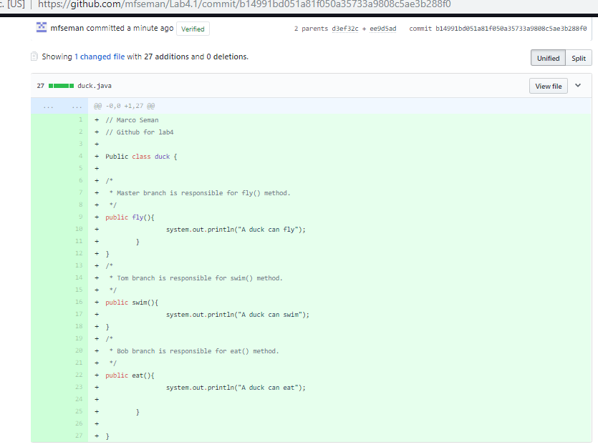

Appendix 2 Screenshot of Merge request page

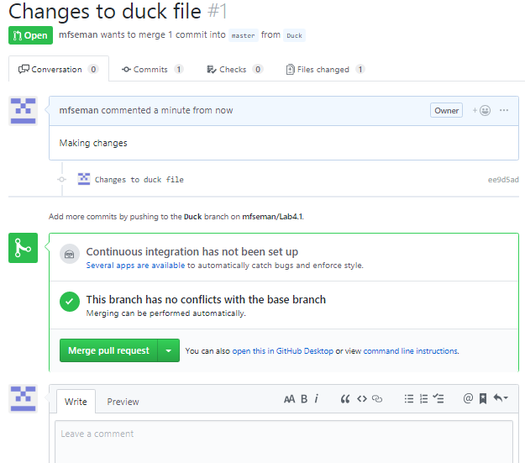

Screenshot of reports and explanation: