Marco Seman

CIS 285 Software Engineering Tools

Professor Xu

February 14, 2019

Lab 5 UML Modeling Use Case:

Customer Description of Desired Software:

The E-Guard shall allow parents to check web activity, keystroke, chat, email, IM and launched application.

System Requirement Steps:

Name: Web Activity

Actor/User: Guardian/Parent

Use Case Entry Conditions:

1. When the user logs into the computer
2. When the user selects his/her web browser
3. When the user searches the internet
4. When the user visits a site(s)

Use Case Exit Conditions:

1. User will not be able to go anonymous
2. User cannot remove website activity logs
3. Parent exits activity

Event Flow:

1. The user will first log onto the computer
2. The user will then decide on its web browser (Assuming the user is automatically connected to the internet)
3. The user will then search the internet
4. The user will be able to search any website
5. The user will exit the web application
6. E-Guard will save the users history and web activity
7. There will be 2 files generated: 1) Safe Websites visited. 2) Unhealthy websites visited
8. E-guard will determine whether a website is safe or not
9. E-guard updates their database
10. E-guard sends parents the user’s activity log and keystrokes by email
11. The parents will receive the email and view the logs

Use Case Diagram:

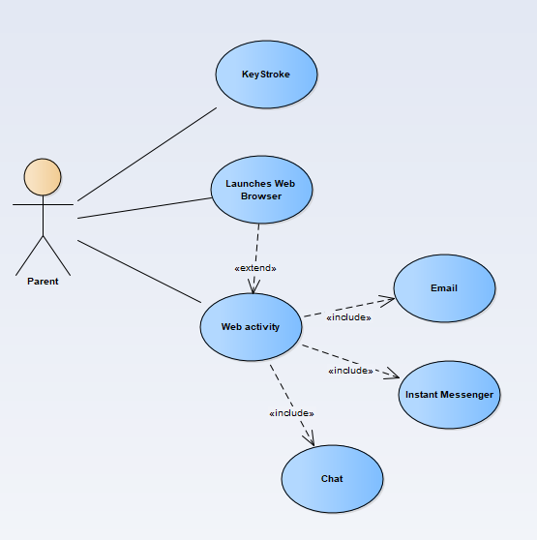

Use Case Web Activity Description:

