Article

去中心化的動態協調機制在多代理系統中的設計與實現：基於發佈訂閱模型

Design and Implementation of Decentralized Dynamic Coordination in Multi-Agent Systems: Based on the Publish-Subscribe Model

Ching Han Chen 1, Ming Fang Shiu 1,*

1 Department of Computer Science and Information Engineering National Central University, Taiwan; [pierre@g.ncu.edu.tw](mailto:pierre@g.ncu.edu.tw) (C.H.C); [108582003@cc.ncu.edu.tw](mailto:108582003@cc.ncu.edu.tw) (M.F.S.)

* Correspondence: [108582003@cc.ncu.edu.tw](mailto:108582003@cc.ncu.edu.tw); Tel.: +886-3-4207151 ext.35211

**Abstract:** 基於發佈訂閱式的通訊架構，本文介紹了一種可行的去中心化機制，可實現自動負載平衡和客戶端識別，以提高多代理系統的效率和靈活性。首先，自動負載平衡機制確保了當多個伺服代理提供相同的服務時，能夠通過代理間的自動協調，有效分配工作負載。其次，客戶端識別功能保證了即使在多客戶端提出相同請求的情況下，系統也能有效率地回應至正確的客戶。最後，去中心化的代理架構允許所有代理自行完成協調，無需依賴中間代理的溝通。這使得系統能夠根據需要隨時進行熱動態調整，從而最大化系統的彈性。本架構適用於需要高度可靠性和擴展性的多代理環境，展現了去中心化技術在複雜系統設計中的巨大優勢。

This article discusses a feasible decentralized mechanism based on the publish-subscribe model that enables automatic load balancing and client identification, enhancing the efficiency and adaptability of multi-agent systems. The mechanism for automatic load balancing assures that when multiple agents offer the same services, workloads are distributed effectively through autonomous inter-agent coordination. Additionally, the client identification feature ensures that even when multiple clients issue the same requests, the system can respond efficiently to the correct clients. The decentralized architecture further allows all agents to independently complete coordination without the need for communication with a central intermediary. This grants the system the ability to perform hot dynamic adjustments as needed, thereby maximizing its flexibility. The architecture is ideal for multi-agent environments that demand high reliability and scalability, showcasing the significant benefits of decentralized technology in designing complex systems.

**Keywords:** Complex system, Decentralized mechanism, Distributed artificial intelligence, Multi-agents system, Publish-subscribe model

1. Introduction

As a result of advances in artificial intelligence (AI) and the enhancement of embedded system performance, model prediction by deep learning networks has been widely implemented in cloud services and edge computing. These scattered intelligent nodes can be integrated into a valuable service. A Multi-Agent Systems (MAS), one of the Distributed Artificial Intelligence (DAI) [1] applications, is an extension of agent technology in which a group of loosely connected autonomous agents acts in an environment to achieve a common goal [2]. In this study, we have designed a flexible framework suitable for distributed computing based on the widely adopted publish-subscribe communication architecture in Multi-Agent Systems. We also demonstrate an implementation for these Multi-Agent Systems.

Because of its parallel computation capability, robustness, scalability, low cost, and reusability, MAS technology is suitable for large systems [3]. In terms of the agent organization architecture, a holonic agent organization with a recursive structure [4] can easily model a complex system [5]. The publish-subscribe architecture is valued for enhancing MAS flexibility, yet it presents challenges in message overhead and load balancing [nn]. Addressing these issues to ensure system reliability requires a nuanced design approach and may involve additional mechanisms such as message compression, Quality of Service (QoS) adjustments, and consensus algorithms.

The issue of message overhead typically arises in one-to-many communication scenarios, where a single agent serves multiple client agents. This occurs as server agents often publish responses using the same topic, and client agents must filter out messages not pertinent to them, leading to unnecessary message propagation. Additionally, load balancing becomes challenging in many-to-one scenarios, such as determining the executing agent within a cluster designed to enhance response efficiency and fault tolerance. We are attempting to address these issues through a dynamic decentralized approach at the framework level.

Decentralized mechanisms, exemplified by those used in cryptocurrencies, are highly effective in multi-agent systems by enabling autonomy, and scalability. This dynamic coordination allows for independent decision-making and seamless adaptation, akin to the decentralized consensus models that underpin cryptocurrencies, ensuring secure and transparent transactions without centralized authority. This dynamic coordination not only bolsters system robustness—making it resilient against failures—but also enhances efficiency and privacy through reduced communication overhead and localized data processing.

我們設計了一個軟體框架，使得開發者能夠基於此框架建立基於發佈-訂閱的多代理系統。而同時獲得了多代理系統的優點，將代理間因的隔離了且不受限於特定的Pub-Sub系統實作，包括MQTT, DDS或ROS等。

This paper is divided into five sections. Section 1 provides a brief overview of the context of this study. Section 2 proposes a design based on bionic inspiration from physiology and MAS theory. Section 3 validates the proposed strategy through experiments with a navigation system for the visually impaired. Section 4 discusses the experimental results. Finally, Section 5 concludes the study and outlines future plans.

2. Method

To achieve complex AI integration, two components, structure and coordination, are proposed herein. To accommodate a variety of constraints, a hierarchical organizational structure with modularization and decoupling was selected. System coordination is a communication mechanism with global circulation and regional specialization that utilizes a general and stable communication protocol. In this study, both techniques were integrated to achieve complex systems that satisfy autonomous agents.

2.1.Structure Design

Physiology has a hierarchical structure, with cells serving as the fundamental unit. From the outside, tissues, organs, and systems are sequentially formed, resulting in a whole individual. From the inside, the cell itself is composed of organelles with different functions. Among these organelles, the nucleus, which contains lower-level entities such as nucleoli and chromosomes, is regarded as the most crucial internal organelle. The composition and shape of the units at each level confer unique functions to them [9]. For example, stereoscopic vision is possible because the eyes are formed in pairs. Hence, hierarchical structure and organizational style are regarded as the fundamental principles of physiological composition.

MASs can be used to solve specific problems involving computational entities [21]-[23]. In a MAS, each computational entity is referred to as an agent. A MAS is defined as a network of agents in which the agents communicate with each other and share resources to solve higher-order problems that are beyond the capacity of a single agent. MASs have numerous organizational structures [2], with holonic MAS being suitable for designing complex AI systems [24].

A holon is a stable and coherent structure that can be sub-structured by multiple holons as part of a larger framework. The concept of a holon was initially used to explain the social behavior of biological species [25]. However, the hierarchical structure of the holon and its interactions have been used to model the behavior of large-scale organizations in the manufacturing and commercial sectors [26-28]. In a MAS, an agent that appears to be a single entity may also be composed of numerous subagents.

Each holon has a head agent that can communicate with the environment or other agents, and this head agent has numerous resources and communication capabilities. In inhomogeneous MASs, the selection of head agents may be random, as illustrated by the rotation strategy used in distributed wireless sensor networks (WSNs) [29]. However, in a heterogeneous architecture, the agent capabilities determine such selection. Some holons can be further combined to form superholons depending on the requirements. Fig. 1 depicts a superholon composed of three holons. Agents H-21 and H-31 are head agents responsible for contacting agent H-1, and H-4 is an atomic agent with no subagents.

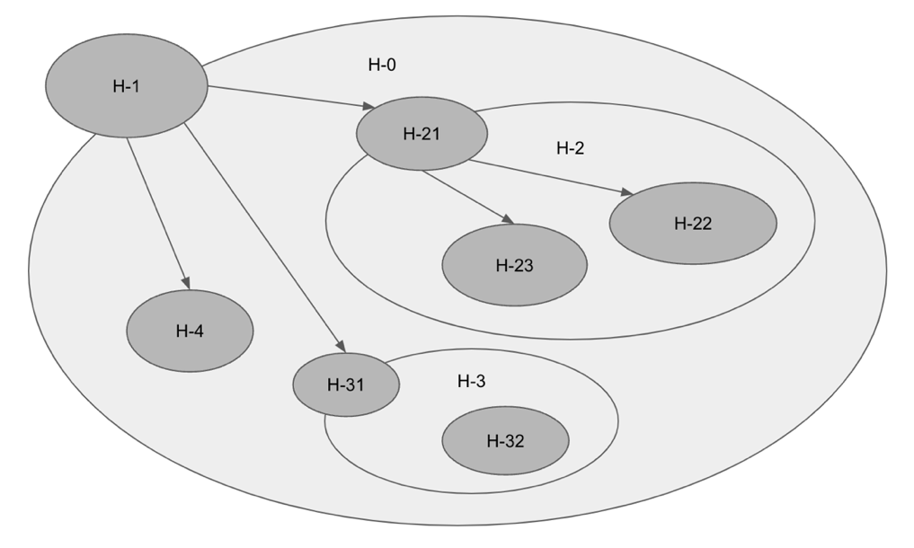

**Fig. 1 Example of a Holonic MAS**

Generally, the holonic MAS recursive continuous structure is similar to a physiological system and can be easily used to emulate biological tissues. In this study, a holonic MAS was used to implement the structural design of complex intelligent agents, resulting in an architecture capable of incorporating diverse perceptions and actions.

2.2. Coordinated Design

In the human body, organs and tissues are coordinated by two major systems: the circulatory system and the nervous system. The circulatory system uses blood to transport substances required by the cells throughout the body and to remove metabolites. The nervous system communicates with various tissues and organs, receives external information, and transmits this information to the processing area. This study, to imitate the circulatory system to share global data, and to learn from the nervous system to process regional information.

2.2.1. Circulatory System and Global Coordination

The circulatory system transports life-sustaining substances throughout the body, such as oxygen, hormones, and antibodies. It uniformly delivers nutrients to all organs and tissues. The heart serves as the central generator of the circulatory system. Although the circulatory system is capable of global transmission, it is slow, and the substances that can be transmitted are limited in number and size.

MQTT uses a message broker as its centralized message routing core. As shown in Fig. 2, the delivery content of MQTT is highly streamlined. It is intended for Internet of Things (IoT) environments with limited computational resources and network bandwidth. The publisher of MQTT sends messages on a specific topic to the message broker, and the subscribers of the same topic on the client side receive the content transmitted by the broker. As a result of the decoupling design used, the publisher and subscriber are not required to share information such as their location.

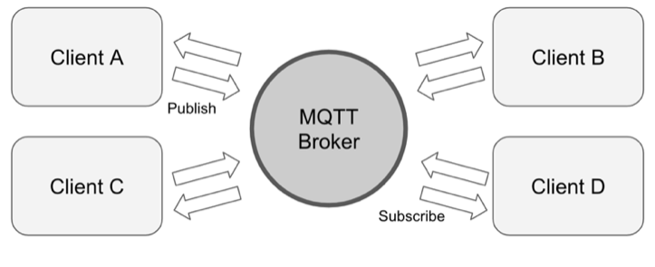

**Fig. 2 MQTT Architecture**

Because of the similarity between MQTT and the circulatory system, MQTT can serve as a global communication mechanism for complex artificial agents. It can also be used for system initialization, heartbeats, status notifications, or announcements, among other applications.

2.2.2. Nervous System and Regional Coordination

The nervous system coordinates various tissues and organs, receives external information, and transmits this information to relevant receptors, such as the brain or muscles. Different organs or tissues, such as the eyes, ears, and skin, produce distinct messages. This involves regional and specialized message transfer. The nervous system rapidly responds to a particular target by processing a large amount of information at an electronic speed. For instance, the visual cells in the retina continuously transmit large amounts of photosensitive data to the visual areas of the brain. The tactile cells on the skin respond to intermittent stimuli, starting from the peripheral nervous system and running to the somatosensory regions of the cerebral cortex.

As depicted in Fig. 3, OMG’s DDS is a relay protocol and an API standard used for data-centric connections [30]. It integrates system components and provides the low-latency data connections required by IoT systems. The DDS features a highly scalable architecture, high reliability, high speed, and point-to-point transmission. It has also been successfully implemented in wireless sensor network (WSN) systems [31]. Similar to MQTT, the DDS establishes information links by publishing and subscribing to topics. However, it is not limited by narrow frequencies or low power consumption, confirming its reliability and security.

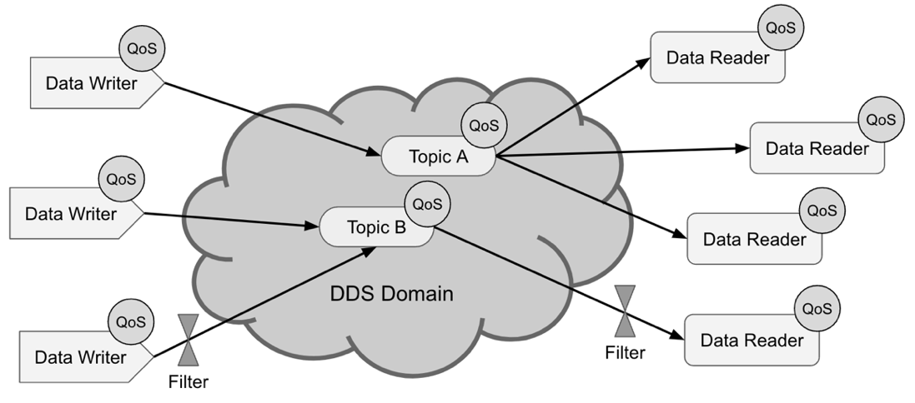

**Fig. 3 DDS Deployment Scenario**

Because the DDS protocol can securely and reliably transmit messages at a high speed, its point-to-point characteristics satisfy the requirements for regional transmission. Therefore, in this research, the DDS was used to study the nervous system as a message delivery system for sight, hearing, touch, or any perception or feedback.

2.3. Integration of Structure and Coordination

Because of the lightweight nature of MQTT, all agents are designed as MQTT clients without burdening the whole system. Thus, all the agents in the system can gracefully obtain the system status, which is advantageous for overall control. Fig. 4 depicts the scenario of agent and MQTT integration.

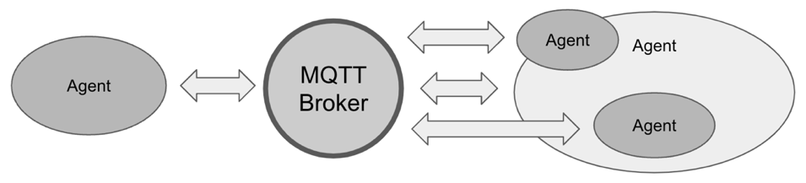

**Fig. 4 Agent and MQTT Integration Scenario**

Agents publish or subscribe to related topics as required. Head agents often serve as message receivers and communicate with other agents within the same super-agent by using the same mechanism. Fig. 5 depicts the scenario of agent and DDS integration.

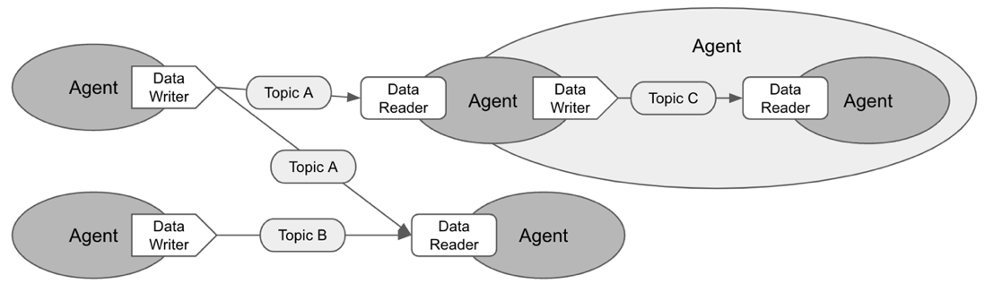

**Fig. 5 Agent and DDS Integration Scenario**

2.3. Integration Design

Fig. 6 depicts the class diagram of the integration of agents and coordination. HolonicAgent represents the core, and HeadAgents and BodyAgents represent the collection of head agents and subagents, respectively. MQTT is the fundamental communication protocol for agents in the global circulation system, and MqttClient is a private member of HolonicAgent, which allows the agent to have built-in MQTT connection and reception capabilities.

All agents inherit from HolonicAgent to form a hierarchical structure, and they use the DDS to achieve neural message transmission depending on their specific behavior. Each super-agent is a DDS domain that publishes or subscribes to related topics with the required QoS, such as the DEADLINE policy to confirm the date of the data or the TRANSPORT_PRIORITY policy to define the transmission priority order [20], in order to achieve the purpose of a specific agent.

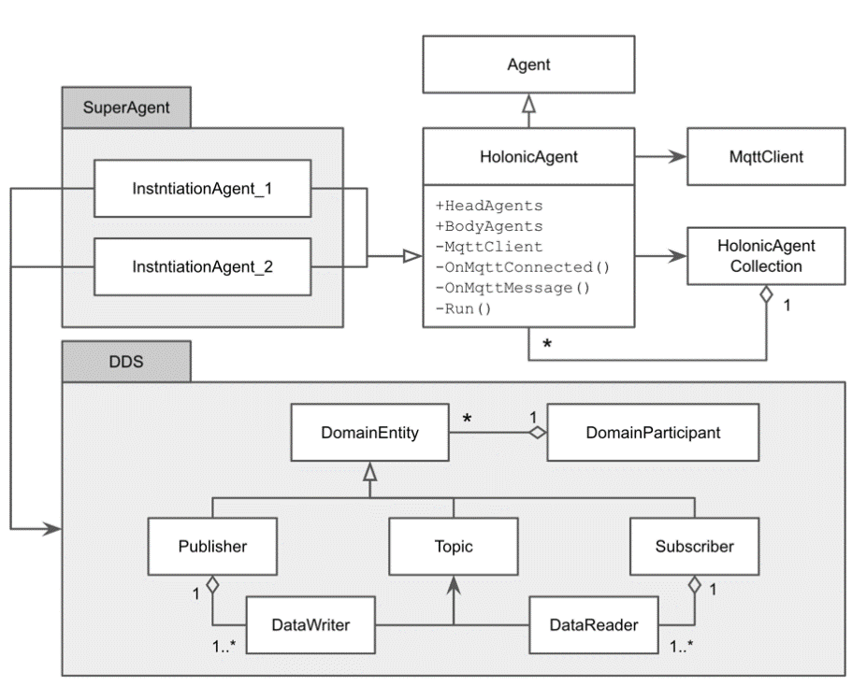

**Fig. 6 Class diagram of integration**

According to the sequence diagram depicted in Fig. 7, the DDS and MQTT serve to transmit messages for the agents. Action 1 entails generating an independent process immediately after the root agent is initialized. Action 2 entails subscribing to or publishing relevant topics within the QoS constraints. Action 3 entails recursively calling all the subagents to initiate the action. The agent main action is performed in a separate process of Action 2 until it is notified of its termination. Finally, Action 4 entails generating a global broadcast with MQTT, with a system termination notification serving as an example in this study.

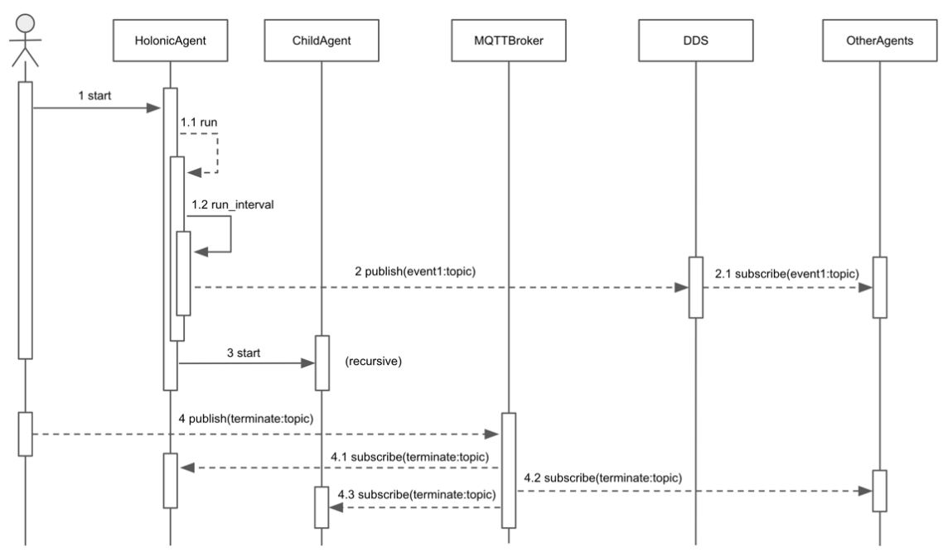

**Fig. 7 Sequence Diagram of Integration**

The implementation of this architecture: <https://github.com/mfshiu/abdi.git>

3. Results

On the basis of the proposed complex artificial agent integration method, an experiment with a navigation system for the visually impaired was planned to verify the feasibility of the design and evaluate the results.

3.1. Experiment Design

Generally, developing a navigation system for visually impaired individuals can demonstrate the feasibility of a proposed architecture. This is a sufficiently complex agent system that must integrate numerous AI systems, including machine learning modules [32]. The completion of this system was expected to confirm the feasibility of the proposed architecture.

Because of their limited vision, visually impaired individuals experience numerous transportation inconveniences. Their primary limitations stem from the selection of routes, the avoidance of obstacles while walking, and the avoidance of obstacles on the road [33]. Therefore, in this study, a system was designed to assist visually impaired individuals in determining the optimal route to their destination and to inform them of the road conditions. This system must communicate in a multiturn dialogue and execute appropriate actions and responses [34].

The navigation system for the visually impaired consists of a visual system, a sound system, an auditory system, a navigation system, and a dialogue system. The navigation system includes a road subsystem, which can detect the surrounding environment, and a path planning subsystem. The visual system obtains images with depth values from a 3D camera and sends these images to the visual receiving area of the navigation system through image preprocessing. The images are then used as the source of environmental detection. The dialogue system receives speech from the auditory system, understands the language used, and generates instructions, such as providing a destination or interrupting navigation. After speech synthesis, the dialogue system creates a natural language response, which is then sent to the user by the vocal system. Finally, human–machine interaction is achieved.

Table 1 lists the general definitions of the agents, Table 2 lists the definitions of the global MQTT topics, and Table 3 lists the definitions and descriptions of the internal DDS topics. Fig. 8 depicts the overall system structure design, which conforms to the continuity structure of holonic MASs.

**Table 1. Agents IDs**

|  |  |  |  |  |  |
| --- | --- | --- | --- | --- | --- |
| **ID** | **Agent** | **ID** | **Agent** | **ID** | **Agent** |
| 000 | Visually Impaired Navigation System |  |  |  |  |
| A00 | Navigation System | B00 | Dialogue System | D00 | Hearing System |
| A01 | Visual Reception | B01 | Voice Output | D01 | Microphone |
| A02 | Command Reception | B02 | Auditory Reception | D02 | Background Denoising |
| A03 | Path Planning | B03 | NLU | E00 | Sound System |
| A10 | Environment Detection | B04 | NLG | E01 | Speaker |
| A11 | Road Detection | C00 | Vision System | E02 | Voice Reception |
| A12 | Obstacle Detection | C01 | 3D Camera | E03 | Tone Processing |
| A13 | Signboard Detection | C02 | Image Preprocessing | F00 | Speech Synthesis |

**Table 2. MQTT Topics**

|  |  |  |  |
| --- | --- | --- | --- |
| **ID** | **Topic** | **Format** | **Content** |
| M1 | Startup | Text | System startup notification |
| M2 | Terminating | Text | System shutdown notification |
| M3 | Heartbeat | Text | System heartbeat |
| M4 | Status | Text | System Status |
| M5 | Information | Text | Global message |

**Table 3. DDS Topics**

|  |  |  |  |  |
| --- | --- | --- | --- | --- |
| **ID** | **Topic** | **Format** | **Concerned**  **Super-agents** | **Content** |
| 1 | Vision | Image | C | Video frame from 3D Camera |
| 2 | VisionProcessed | Image | AC | processed image |
| 3 | TextVoice | Text | AB | Text before speech synthesis |
| 4 | SynthesizedSpeech | Audio | E | voice after speech synthesis |
| 5 | InputVoice | Audio | BD | Audio phrase of hearing |
| 6 | InputSentence | Text | B | Text phrase of hearing |
| 7 | OutputSentence | Text | B | Sentences to be output |
| 8 | UserIntention | Text | B | User intent after understanding |
| 9 | UserCommand | Text | AB | The command of action |
| 10 | OutputContent | Text | B | Output of dialogue system |
| 11 | SoundProcessed | Audio | D | processed sound |
| 12 | Sound | Audio | D | sound phrase from Microphone |
| 13 | WalkCommand | Text | A | Commands required by the navigation |
| 14 | WalkTarget | Text | A | navigation destination |
| 15 | WalkRoute | Text | A | path to destination |
| 16 | StreetTarget | Text | A | The closest target currently in the path |
| 17 | StreetVision | Image | A | street view |
| 18 | SignInfo | Text | A | sign on the road |
| 19 | RoadInfo | Text | A | Road information while walking |
| 20 | OutputVoice | Audio | E | the sound that will be made |
| 21 | OutputVoiceProcessed | Audio | E | upcoming sound after pitch processing |

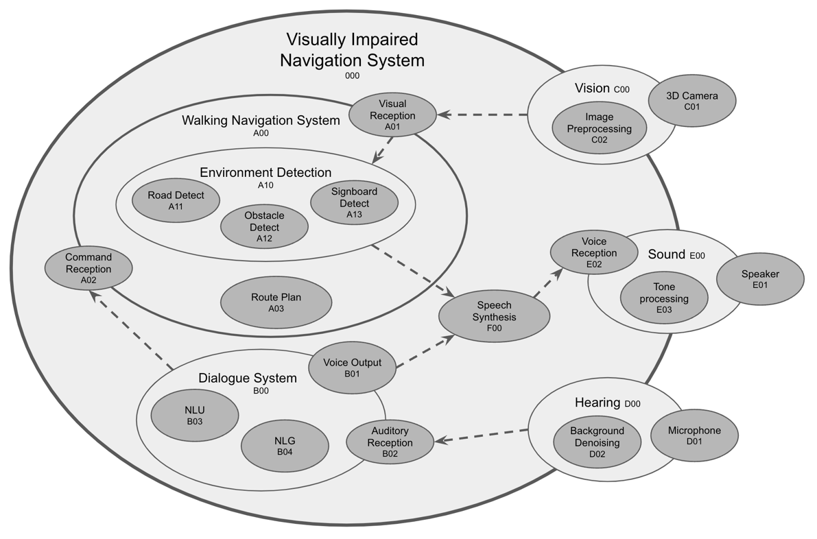

**Fig. 8 Structural Design of Navigation System for Visually Impaired**

Agents at all levels perform independent processes and communicate with other agents through MQTT and the DDS. This means that the physical environment of the system is unlimited. The agents can be separated from one another. For example, the environment detection agent may be located in another deep learning server, and natural language understanding [36] may utilize certain cloud services. Neither affects the overall system architecture.

3.2. Experiment Results

For the system to function, many messages with different topics are sent between the agents. The DDS stimulates the nervous system to transmit a variety of data while meeting the required QoS. MQTT is similar to the circulatory system in terms of systemic message notification. These actions occur in parallel. Table 4 illustrates working snippets representing speakers, words, and how sentences are formed inside the system.

**Table 4. System execution record**

|  |  |  |  |
| --- | --- | --- | --- |
| **No.** | **Speaker** | **Words** | **Agents with topics flow** |
| 1 |  | (System startup) | 000(M1) |
| 2 | User | Please take me to the MRT station. | D01(12) 🡪 D02(11) 🡪 D00(5) 🡪 B02(6) 🡪 B03 |
| 3 | Navigator | Okay, let me check, please wait. | B00(10) 🡪 B04(7) 🡪 B01(3) 🡪 F00(4) 🡪 E02(20) 🡪 E03(21) 🡪 E01 |
| 4 | Navigator | There is Zhongyi Station 300 meters nearby. May I take you there? | B00(9) 🡪 A02(13) 🡪 A03(15) 🡪 B00(10) 🡪 B04(7) 🡪 B01(3) 🡪 F00(4) 🡪 E02(20) 🡪 E03(21) 🡪 E01 |
| 5 | User | Yes, that’s right. | D01(12) 🡪 D02(11) 🡪 D00(5) 🡪 B02(6) 🡪 B03 |
| 6 | Navigator | Please walk straight along the sidewalk. | 1. B00(9) 🡪 A02(13) 🡪 A00(15) 2. C01(1) 🡪 C02(2) 🡪 A01(2) 🡪 A11 3. A11(19) 🡪 A10(3) 🡪 F00(4) 🡪 E02(20) 🡪 E03(21) 🡪 E01 |
| 7 | User | Hi, partner, I would like to take a break. | D01(12) 🡪 D02(11) 🡪 D00(5) 🡪 B02(6) 🡪 B03 |
| 8 | Navigator | Okay, I will suspend until you call me. | 1. B00(10) 🡪 B04(7) 🡪 B01(3) 🡪 F00(4) 🡪 E02(20) 🡪 E03(21) 🡪 E01 2. B00(M4: Suspend) |
| 9 |  | (System suspended) |  |
| 10 | User | Please take me to the MRT station. | D01(12) 🡪 D02(11) 🡪 D00(5) 🡪 B02(6) 🡪 B03 |
| 11 | Navigator | Okay, let’s go. | 1. B00(M4: Resume) 2. B00(10) 🡪 B04(7) 🡪 B01(3) 🡪 F00(4) 🡪 E02(20) 🡪 E03(21) 🡪 E01 |
| 12 | Navigator | We are passing 7-11 convenience store on the left. | 1. C01(1) 🡪 C02(2) 🡪 A01(2) 🡪 A13 2. A13(18) 🡪 A10(3) 🡪 F00(4) 🡪 E02(20) 🡪 E03(21) 🡪 E01 |
| 13 | Navigator | You have already arrived the MRT station. | A00(3) 🡪 F00(4) 🡪 E02(20) 🡪 E03(21) 🡪 E01 |
| 14 |  | (System terminate) | 000(M2) |

Note 1: The format of the content in the fourth column is as follows: source agent ID (publish topic ID) 🡪 target agent ID (publish topic ID).

Note 2: The sequential items in the fourth column represent parallelized processes, but the former affect the behavior of the latter.

During the experiment, the existence of the head agent was ambiguous. According to the design, the head agent served as a communication bridge for the super-agent. However, during the planning of the experiment, the super-agent sometimes directly addressed external communication, such as environmental detection (A10) or the auditory system (E00). Therefore, because the head agent served only as a message forwarder, it was omitted. To avoid the duplication of unnecessary information, the super-agent or internal body agents directly published the message. The head agent existed only when messages were converted or filtered.

Here, the holonic MAS aided in the design of structures. Publishing and subscribing to topics between agents also increased the flexibility of the system. The agents in the system were easily modified so as to gracefully update the system. Importantly, the system had a large number of repeated paths, for example, hearing and understanding (D01(12) 🡪 D02(11) 🡪 D00(5) 🡪 B02(6) 🡪 B03), vision and recognition (C01(1) 🡪 C02(2) 🡪 A01(2) 🡪 A11, A12, A13), and voice output (A00, B00(10) 🡪 B04(7) 🡪 B01(3) 🡪 F00(4) 🡪 E02(20) 🡪 E03(21) 🡪 E01). These paths were dynamic subsystems of the cross-agent service whose discovery aided in understanding and optimizing the system (e.g., in terms of pipelining).

The execution time of the dynamic subsystem was calculated as follows:

|  |  |
| --- | --- |
| $$R=\{a_{1},a_{2},…,a_{n}\}$$ | (1) |
| $$elapsed time=\sum_{i}^{n}{t(R[a_{i}])}$$ | (2) |

where $R$ is the ordered set of agents, $a_{i}$ is the specific agent, and $t$ is the function used to compute the execution time.

4. Discussion

According to physiology, distributed, hierarchical, regional, and global communication are essential mechanisms of complex intelligent agents. In this study, these insights were applied to the coordination of organizational structure and communication. A complex AI integration framework was also designed and experimentally validated.

The interior of complex intelligent agents is primarily heterogeneous, and entire systems can form a homogeneous connection through the interface between agents and topics. All modules and components at any level are agents, which is advantageous for constructing a fully autonomous system.

The participant discovery of the DDS [35] allows agents to dynamically participate in the system, thereby rendering the system scalable. For instance, adding Lidar’s distance sensing to a visual agent can improve the accuracy of road detection. The system can also be upgraded or repaired online.

As a more advanced protocol, OMG’s DDS is functionally a superset of MQTT and can cover the majority of its features. Because of its wide compatibility and simple implementation, MQTT is still used as a solution for global communication. Given its low frequency and power consumption, its lightweight centralized protocol meets the global communication requirements. Therefore, MQTT is regarded as an essential communication capability for agents.

Some studies have highlighted the benefits of continuous multiagent organization and autonomy [36]. The abstraction of the inner operations of holonic agents has allowed for great flexibility in behavioral decisions. However, predicting the final behavior of a holonic agent is difficult because of the lack of knowledge regarding the internal structure of holons [37].

5. Conclusions

The proposed complex framework for AI integration is a middle layer between the operating system and its applications. It helps organize the system and facilitates the sharing of information and parallelization of processes. This may allow developers to increase their productivity by working in parallel teams and focusing more on the developmental aspect. This study, however, did not investigate the synchronization of parallel processing between agents, which will be provided as a supplementary study in the future.

In addition to functional development, the decision-making of complex AI systems can be crucial at times. Decisions can be made through negotiation or competition among agents or through the application of game theory [38]. MAS-based structures can employ the theory of multiagent decision-making [39] to provide more intelligent decision-making.

System prototypes are great for rapid development, whether for early validation or for iterative development. This is the advantage of the iterative methodology and the essence of agile software development [40]. This complex AI integration framework allows developers to rapidly build verifiable systems.

The framework implements the belief–desire–intention (BDI) software model [41]. This architecture incorporates the concepts of belief and intention but omits desire. Therefore, integrating the desire concept may allow the system to provide more active services and bring it closer to an optimal autonomous system. Future research should focus on implementing the complete BDI methodology.

Among the future implementations of the proposed architecture in more complex AI systems are autonomous mobile robots, intelligent navigation robots, and manufacturing assistance systems for Industry 4.0.

References

1. Chaib-Draa, B., Moulin, B., Mandiau, R., & Millot, P. (1992) Trends in distributed artificial intelligence. *Artificial Intelligence Review*, *6*(1), 35-66. <https://doi.org/10.1007/BF00155579>
2. Balaji, P. G., & Srinivasan, D. (2010) An introduction to multi-agent systems. In *Innovations in multi-agent systems and applications-1,* pp 1-27. Springer, Berlin, Heidelberg. <https://doi.org/10.1007/978-3-642-14435-6_1>
3. Vlassis, N. (2007) A concise introduction to multiagent systems and distributed artificial intelligence. *Synthesis Lectures on Artificial Intelligence and Machine Learning*, *1*(1), 1-71. <https://doi.org/10.2200/S00091ED1V01Y200705AIM002>
4. Schillo, M., & Fischer, K. (2003, July) A taxonomy of autonomy in multiagent organisation. In *International Workshop on Computational Autonomy*, pp 68-82. Springer, Berlin, Heidelberg. <https://doi.org/10.1007/978-3-540-25928-2_6>
5. Gaud, N., Galland, S., Gechter, F., Hilaire, V., & Koukam, A. (2008) Holonic multilevel simulation of complex systems: Application to real-time pedestrians simulation in virtual urban environment. *Simulation Modelling Practice and Theory*, *16*(10), 1659-1676. <https://doi.org/10.1016/j.simpat.2008.08.015>
6. Chen, C. H., Lin, M. Y., Shih, Y. C., & Chen, C. C. (2022) High-precision time synchronization chip design for industrial sensor and actuator network. *Microprocessors and Microsystems*, *91*, 104507. <https://doi.org/10.1016/j.micpro.2022.104507>
7. Ciobanu, G. (2015) Scalable distributed implementation of a biologically inspired parallel model. *Complex & Intelligent Systems*, *1*(1), 69-80. <https://doi.org/10.1007/s40747-015-0003-3>
8. Mengistu, H., Huizinga, J., Mouret, J. B., & Clune, J. (2016) The evolutionary origins of hierarchy. *PLoS computational biology*, *12*(6), e1004829. <https://doi.org/10.1371/journal.pcbi.1004829>
9. Barrett, K. E., Boitano, S., Barman, S. M., & Brooks, H. L. (2010) Ganong’s review of medical physiology twenty.
10. Sikora, R., & Shaw, M. J. (1998) A multi-agent framework for the coordination and integration of information systems. *Management science*, *44*(11-part-2), S65-S78. <https://doi.org/10.1287/mnsc.44.11.S65>
11. Jennings, N. R. (1993) Commitments and conventions: The foundation of coordination in multi-agent systems. *The knowledge engineering review*, *8*(3), 223-250. <https://doi.org/10.1017/S0269888900000205>
12. Balaji, P. G., Sachdeva, G., Srinivasan, D., & Tham, C. K. (2007, September) Multi-agent system based urban traffic management. In *2007 IEEE Congress on Evolutionary Computation*, pp 1740-1747. IEEE. <https://doi.org/10.1109/CEC.2007.4424683>
13. Chen, B., Cheng, H. H., & Palen, J. (2009) Integrating mobile agent technology with multi-agent systems for distributed traffic detection and management systems. *Transportation Research Part C: Emerging Technologies*, *17*(1), 1-10. <https://doi.org/10.1016/j.trc.2008.04.003>
14. Roche, R., Blunier, B., Miraoui, A., Hilaire, V., & Koukam, A. (2010, November) Multi-agent systems for grid energy management: A short review. In *IECON 2010-36th Annual Conference on IEEE Industrial Electronics Society,* pp 3341-3346. IEEE. <https://doi.org/10.1109/IECON.2010.5675295>.
15. Pipattanasomporn, M., Feroze, H., & Rahman, S. (2009, March) Multi-agent systems in a distributed smart grid: Design and implementation. In *2009 IEEE/PES Power Systems Conference and Exposition,* pp 1-8. IEEE. <https://doi.org/10.1109/PSCE.2009.4840087>
16. Sousa, N., Oliveira, N., & Praça, I. (2021) A Multi-Agent System for Autonomous Mobile Robot Coordination. *arXiv preprint arXiv:2109.12386*. <https://doi.org/10.48550/arXiv.2109.12386>
17. Salvador Palau, A., Dhada, M. H., & Parlikad, A. K. (2019) Multi-agent system architectures for collaborative prognostics. *Journal of Intelligent Manufacturing*, *30*(8), 2999-3013. <https://doi.org/10.1007/s10845-019-01478-9>
18. Kim, J. H., Shim, H. S., Kim, H. S., Jung, M. J., Choi, I. H., & Kim, J. O. (1997, April) A cooperative multi-agent system and its real time application to robot soccer. In *Proceedings of International Conference on Robotics and Automation,* Vol. 1, pp 638-643. IEEE. <https://doi.org/10.1109/ROBOT.1997.620108>
19. Hunkeler, U., Truong, H. L., & Stanford-Clark, A. (2008, January) MQTT-S—A publish/subscribe protocol for Wireless Sensor Networks. In *2008 3rd International Conference on Communication Systems Software and Middleware and Workshops (COMSWARE'08)* pp 791-798. IEEE. <https://doi.org/10.1109/COMSWA.2008.4554519>
20. An, K., Kuroda, T., Gokhale, A., Tambe, S., & Sorbini, A. (2013) Model-driven generative framework for automated omg dds performance testing in the cloud. *ACM Sigplan Notices*, *49*(3), 179-182. <https://doi.org/10.1145/2637365.2517216>
21. Khosla, R., & Ichalkaranje, N. (2004) *Design of intelligent multi-agent systems: human-centredness, architectures, learning and adaptation* (Vol. 162). Springer Science & Business Media.
22. Jain, L. C. (2002) *Intelligent agents and their applications* (Vol. 98). Springer Science & Business Media.
23. Wooldridge, M., & Jennings, N. R. (1995) Intelligent agents: Theory and practice. *The knowledge engineering review*, *10*(2), 115-152.
24. Rodriguez, S., Hilaire, V., Gaud, N., Galland, S., & Koukam, A. (2011) Holonic multi-agent systems. In *Self-organising Software,* pp 251-279. Springer, Berlin, Heidelberg. <https://doi.org/10.1007/978-3-642-17348-6_11>
25. Koestler, A. (1967) The ghost in the machine, hutchinson & co. *Publishers Ltd., London*.
26. Giret, A., & Botti, V. (2005) Analysis and design of holonic manufacturing systems. In *18th International Conference on Production Research (ICPR2005)*.
27. Peters, R., & Többen, H. (2005, August) A reference-model for holonic supply chain management. In *International Conference on Industrial Applications of Holonic and Multi-Agent Systems,* pp 221-232. Springer, Berlin, Heidelberg. <https://doi.org/10.1007/11537847_20>
28. Wieczerzycki, W. (2005, August) Polymorphic Agent Clusters–the Concept to Design Multi-Agent Environments Supporting Business Activities. In *International Conference on Industrial Applications of Holonic and Multi-Agent Systems,* pp 233-245. Springer, Berlin, Heidelberg. <https://doi.org/10.1007/11537847_21>
29. Rachid, B., & Hafid, H. (2014) Distributed Monitoring for Wireless Sensor Networks: a Multi-Agent Approach. International Journal of Computer Network & Information Security, 6(10). <https://doi.org/10.5815/ijcnis.2014.10.02>
30. Pardo-Castellote, G. (2003, May) Omg data-distribution service: Architectural overview. In *23rd International Conference on Distributed Computing Systems Workshops, 2003. Proceedings.* pp 200-206. IEEE. <https://doi.org/10.1109/ICDCSW.2003.1203555>
31. Beckmann, K., & Thoss, M. (2010, October) A model-driven software development approach using OMG DDS for wireless sensor networks. In *IFIP International Workshop on Software Technolgies for Embedded and Ubiquitous Systems,* pp 95-106. Springer, Berlin, Heidelberg. <https://doi.org/10.1007/978-3-642-16256-5_11>
32. Chen, C. H., Shiu, M. F., & Chen, S. H. (2021) Use Learnable Knowledge Graph in Dialogue System for Visually Impaired Macro Navigation. *Applied Sciences*, *11*(13), 6057. <https://doi.org/10.3390/app11136057>
33. Hsieh, I. H., Cheng, H. C., Ke, H. H., Chen, H. C., & Wang, W. J. (2021) A CNN-Based Wearable Assistive System for Visually Impaired People Walking Outdoors. *Applied Sciences*, *11*(21), 10026. <https://doi.org/10.3390/app112110026>
34. Wang, Y., Rong, W., Zhang, J., Zhou, S., & Xiong, Z. (2020) Multi-turn dialogue-oriented pretrained question generation model. *Complex & Intelligent Systems*, *6*(3), 493-505. <https://doi.org/10.1007/s40747-020-00147-2>
35. An, K., Gokhale, A., Schmidt, D., Tambe, S., Pazandak, P., & Pardo-Castellote, G. (2014, May) Content-based filtering discovery protocol (CFDP) scalable and efficient OMG DDS discovery protocol. In *Proceedings of the 8th ACM International Conference on Distributed Event-Based Systems,* pp. 130-141. <https://doi.org/10.1145/2611286.2611300>
36. Schillo, M., & Fischer, K. (2003, July) A taxonomy of autonomy in multiagent organisation. In *International Workshop on Computational Autonomy,* pp. 68-82. Springer, Berlin, Heidelberg. <https://doi.org/10.1007/978-3-540-25928-2_6>
37. Chowdhary, K. (2020) Natural language processing. *Fundamentals of artificial intelligence*, pp 603-649. <https://doi.org/10.1007/978-81-322-3972-7_19>
38. Zhen, H. L., Wang, Z., Li, X., Zhang, Q., Yuan, M., & Zeng, J. (2022) Accelerate the optimization of large-scale manufacturing planning using game theory. *Complex & Intelligent Systems*, *8*(4), 2719-2730. <https://doi.org/10.1007/s40747-021-00352-7>
39. Bulling, N. (2014) A survey of multi-agent decision making. *KI-Künstliche Intelligenz*, *28*(3), 147-158. <https://doi.org/10.1007/s13218-014-0314-3>
40. Abrahamsson, P., Salo, O., Ronkainen, J., & Warsta, J. (2017) Agile software development methods: Review and analysis. *arXiv preprint arXiv:1709.08439*. <https://doi.org/10.48550/arXiv.1709.08439>
41. Rao, A. S., & Georgeff, M. P. (1995, June) BDI agents: from theory to practice. In *Icmas,* Vol. 95, pp 312-319.

**Statements and Declarations:**

*To be used for all articles, including articles with* *biological applications*

* **Funding**

Not applicable

* **Conflicts of interest / Competing interests**

On behalf of all authors, the corresponding author states that there is no conflict of interest.

* **Availability of data and material**

All data generated or analyzed during this study are included in this published article.

* **Code availability**

The source code generated during the current study is available from the corresponding author upon reasonable request.

* **Authors' contributions**

Ching Han Chen and Ming Fang Shiu conceived the presented idea. M.F.S. developed the theory and performed the computations. C.H.C. verified the analytical methods and supervised the findings of this work. All authors discussed the results and contributed to the final manuscript.

**Additional declarations for articles in life science journals that report the results of studies involving humans and/or animals**

* Ethics approval: Not applicable
* Consent to participate: Not applicable
* Consent for publication: Not applicable