CS1571 – Introduction to Artificial Intelligence

Assignment 3

Name: You Zhou ([yoz13@pitt.edu](mailto:yoz13@pitt.edu))

People Soft Number: 3729901

Problem 1:

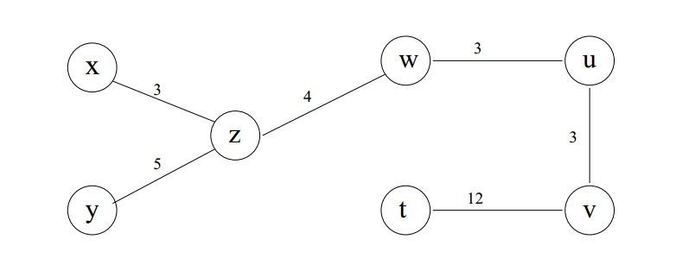

|  |  |  |  |  |  |  |  |
| --- | --- | --- | --- | --- | --- | --- | --- |
| **Forward Checking** | t | u | v | w | x | y | z |
| Initial  State  Analysis | 0 | {0,3,6,9} | 0  The most obvious choice | {0,3,6,9}  mod 4  {0,1,2,3} | 2 | 0 | 5  The second most obvious one |
| **Now, pretending we didn’t know the information given by the row above …** | | | | | | | |
| Put 0 to v | 0 |  | 0 |  | 2 | 0 |  |
| Put 0 to u | 0 | 0 | 0 |  | 2 | 0 |  |
| **To show how Forward Checking works, I will choose the wrong one for w.** | | | | | | | |
| Put 0 to w | 0 | 0 | 0 | 0 | 2 | 0 |  |
| **Here comes a problem, given the constraints acting on z, z has no choice!** | | | | | | | |
| **Backtracking – Re-value w** | | | | | | | |
| Put 9 to w | 0 | 0 | 0 | 9 | 2 | 0 |  |
| Put 5 to z | 0 | 0 | 0 | 9 | 2 | 0 | 5 |
| **Goal Condition Achieved!** | | | | | | | |

|  |  |  |  |  |  |  |  |
| --- | --- | --- | --- | --- | --- | --- | --- |
| **Arc Consistency** | t | U | v | w | x | y | z |
| Put 0 to v | 0 |  | 0 |  | 2 | 0 |  |
| Put 0 to u | 0 | 0 | 0 |  | 2 | 0 |  |
| **Pretending the former steps are the same …** | | | | | | | |
| **The Arc Consistency algorithm will check bi-directionally.** | | | | | | | |
| **Basing on restraints acting on z, z only has one choice 5.** | | | | | | | |
| z = 5 & w = 0 inconsistent | | | | | | | |
| z = 5 & w = 3 inconsistent | | | | | | | |
| z = 5 & w = 6 inconsistent | | | | | | | |
| z = 5 & w = 9 consistent! | | | | | | | |
| Put 9 to w | 0 | 0 | 0 | 9 | 2 | 0 |  |
| Put 5 to z | 0 | 0 | 0 | 9 | 2 | 0 | 5 |
| **Goal Condition Achieved** | | | | | | | |

Problem 2:

Part (a):

|  |  |  |  |  |
| --- | --- | --- | --- | --- |
| Initial Energy | Initial Temperature | Try # | Accept # | Best Tour Energy |
| 302.129 | 100.000 | 100000 | 92383 | 92.976 |

Part (b):

|  |  |  |  |  |
| --- | --- | --- | --- | --- |
| Initial Energy | Initial Temperature | Try # | Accept # | Best Tour Energy |
| 286.932 | 10.000 | 10000000 | 6001875 | **63.677** |

Part (c):

Geometric Cooling Scheme: $T_{i+1}=0.85T_{i} \left(T_{0}= T_{init}\right)$

Min{Average} = 68.723 Max{Average} = 70.089

It’s quite simple comparing with other classmates’ possible “fancy” and twisted functions; however, the geometric cooling scheme with coefficient between 0.85 and 0.99 inclusive are proved to be most optimal for TSP. As temperature converges to 0 faster, the tolerance for higher energy tour becomes less, and this strictness is crucial for only 20000-step simulation! For small number of steps, too much tolerance for potentially optimal configurations would face a danger – it accepts a configuration with higher energy, hoping this configuration would evolve into a more optimal one, but, due to the small number of steps, this configuration might not have a chance to fully evolve!

Part (d)

|  |  |
| --- | --- |
|  | Least Energy |
| n = 50 | 127.201 |
| n = 100 | 99.820 |
| n = 150 | 96.569 |
| n = 200 | 92.715 |
| n = 250 | 86.515 |
| n = 300 | 82.213 |
| n = 350 | 79.821 |
| n = 400 | 81.223 |
| n = 450 | 82.114 |
| n = 500 | 78.893 |

**Table for varying number of generations:**

As the number of generations goes larger, the optimal energy decreases in a linear manner, this is because, the *next_gen()* function can combine and evaluate more crossovers, thereby increasing the chance of producing optimal candidate.

**Table for varying population size:**

|  |  |
| --- | --- |
|  | Least Energy |
| p = 50 | 144.965 |
| p = 100 | 102.832 |
| p = 150 | 93.620 |
| p = 200 | 83.466 |
| p = 250 | 80.990 |
| p = 300 | 82.451 |
| p = 350 | 78.946 |
| p = 400 | 79.109 |
| p = 450 | 76.977 |
| p = 500 | 73.674 |

As the size of population goes larger, the optimal energy decreases in a linear manner, this is because, with more potential candidates to be chosen, it’s less likely to miss optimal configurations.

|  |  |
| --- | --- |
|  | Least Energy |
| m = 0.00 | 227.137 |
| m = 0.05 | 74.075 |
| m = 0.10 | 71.284 |
| m = 0.15 | 69.529 |
| m = 0.20 | 68.702 |
| m = 0.25 | 68.780 |

**Table for varying mutation probability:**

With more chance of mutating existing configurations, the population gains more randomness, avoiding having too many similar candidates in population. The energy drops steeply from zero chance to 5% chance, but it decreases rather slowly thereafter.

**Table for varying survival rate:**

|  |  |
| --- | --- |
|  | Least Energy |
| r = 0.0 | 81.079 |
| r = 0.2 | 76.554 |
| r = 0.4 | 79.297 |
| r = 0.6 | 81.852 |
| r = 0.8 | 80.291 |
| r = 1.0 | 78.564 |

It’s quite unexpected that, with higher survival rate, energy drops, since I would expect that more crossovers and permutations would lead to optimality. However, we should remember that a more optimal configuration is **NOT** guaranteed.