Lab 3: Propositional Logic & Model Checking
Course: CS3081 Artificial Intelligence Semester: Fall 2026
Student Name | Student ID
Ghaida alsaadi | S2117336
Mohammad Tabahi | S24108951
Juri alamri | S21107373

Task 1 - Understand the Code
1.1 harry.py: The knowledge base is true in only one of the eight possible assignments: rain = True, hagrid = False, dumbledore = True.
rain | hagrid | dumbledore | KB
False | False | False | False
False | False | True | False
False | True | False | False
False | True | True | False
True | False | False | False
True | False | True | True
True | True | False | False
True | True | True | False
Because rain is true in every model satisfying the knowledge base, model_check(knowledge, rain) returns True.
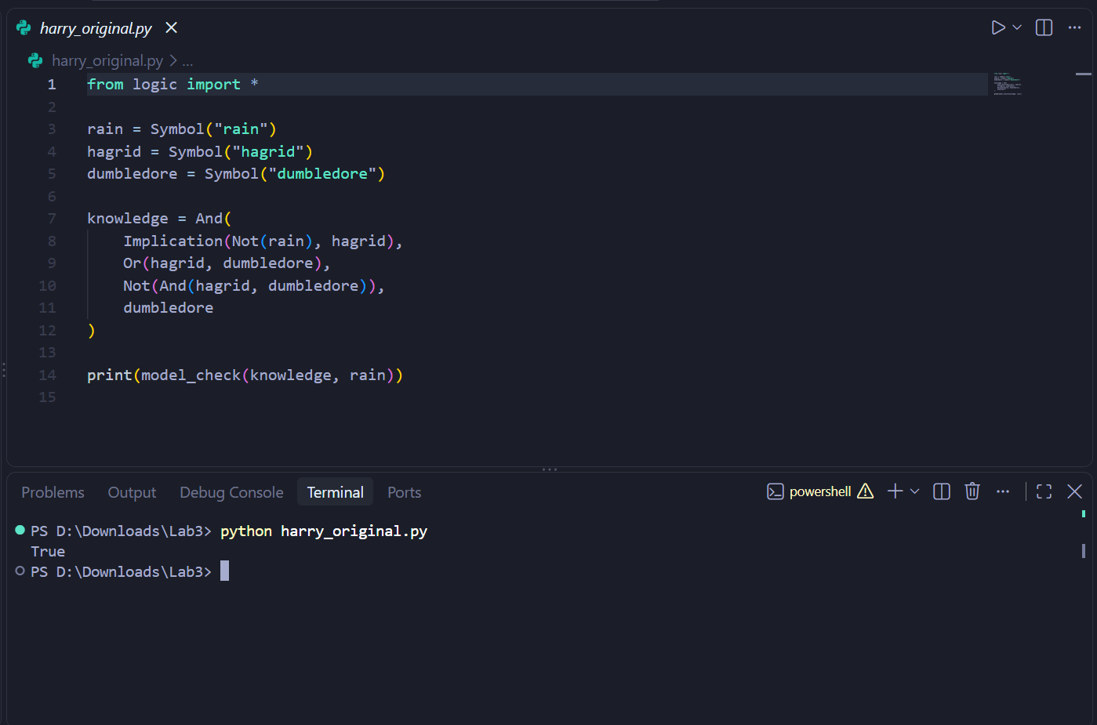
Figure 1. Original harry.py: True.

Task 1 - clue.py
ColMustard and ProfPlum are excluded, so MsScarlet is the suspect. Kitchen and ballroom are excluded, leaving library. Revolver is excluded, and the unknown-card constraint eliminates wrench. The remaining weapon is knife.
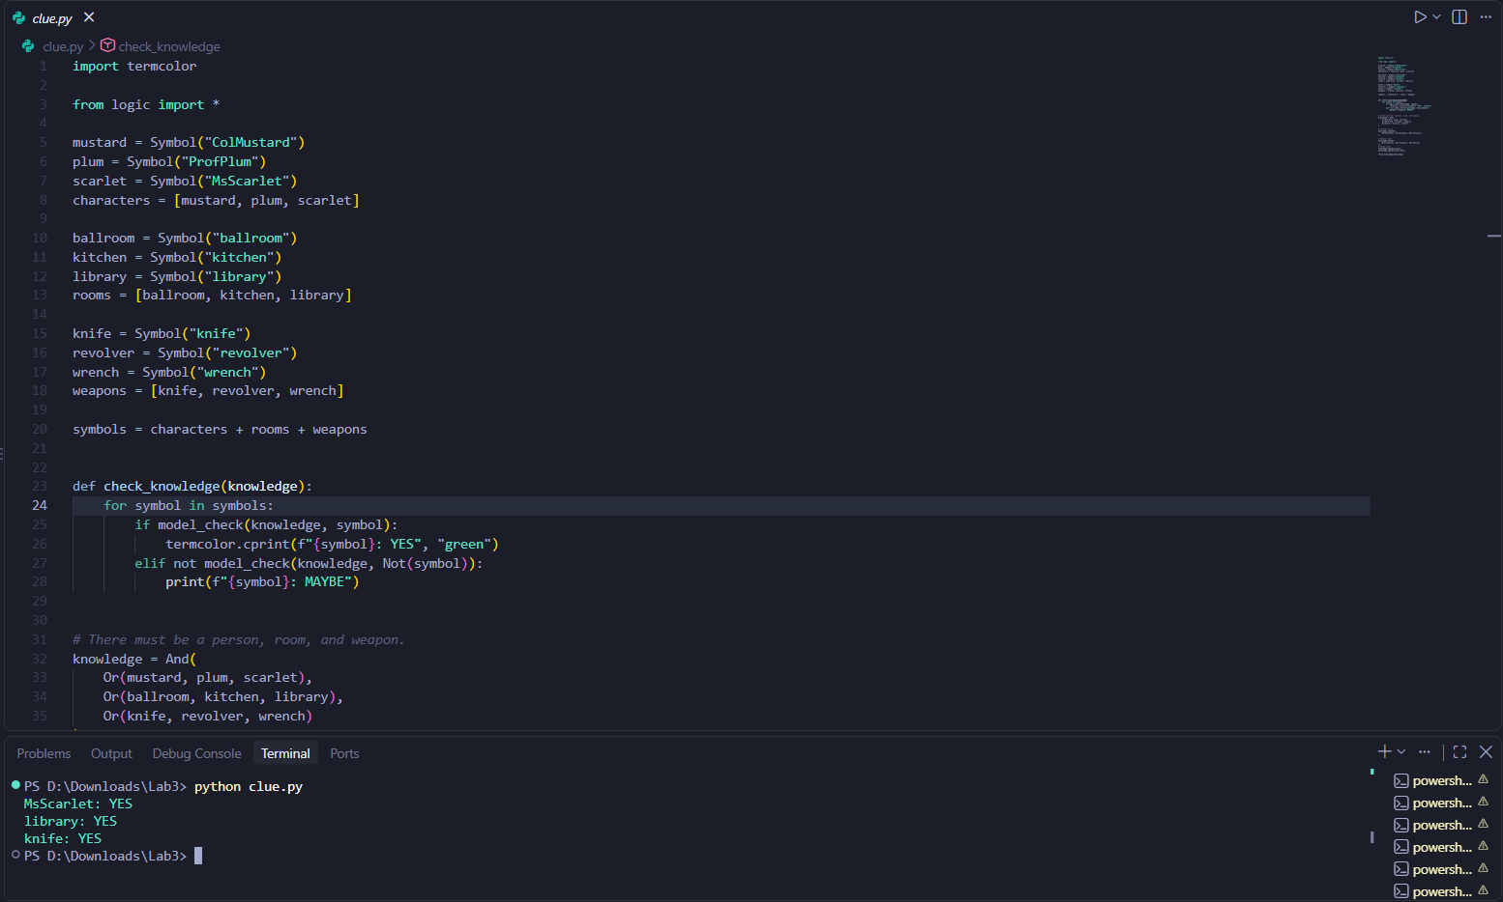
Figure 2. clue.py: MsScarlet, library, and knife.

Task 2 - Modify harry.py
I removed the final dumbledore fact from the knowledge base.
Prediction: False. Actual output: False.
Rain is no longer guaranteed. For example, rain = False, hagrid = True, and dumbledore = False satisfies the remaining rules. Therefore, the knowledge base does not entail rain.
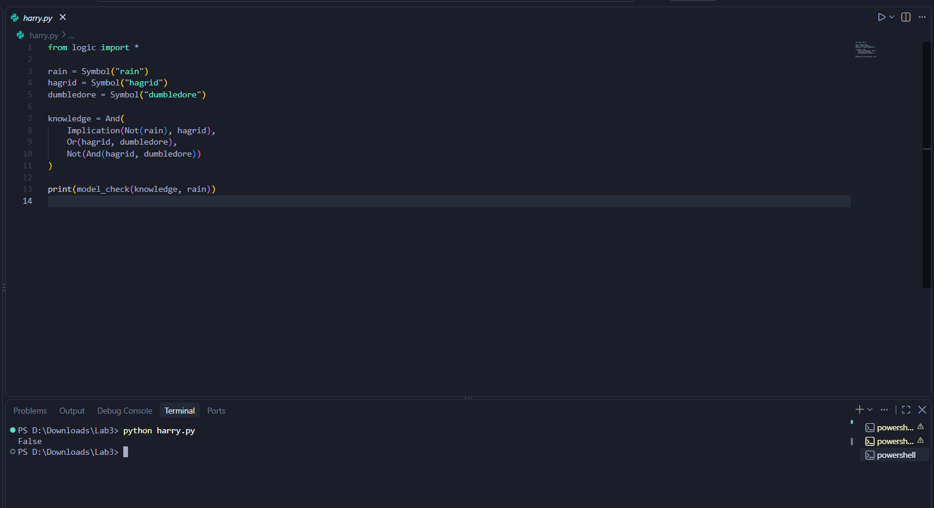
Figure 3. Modified harry.py: False.

Task 2 - Remove the Minerva Clue
I removed MinervaGryffindor from puzzle.py.
Prediction: No certain house assignments. Actual output: No assignments printed.
Eight valid house assignments remain, and no person has the same house in every valid assignment.
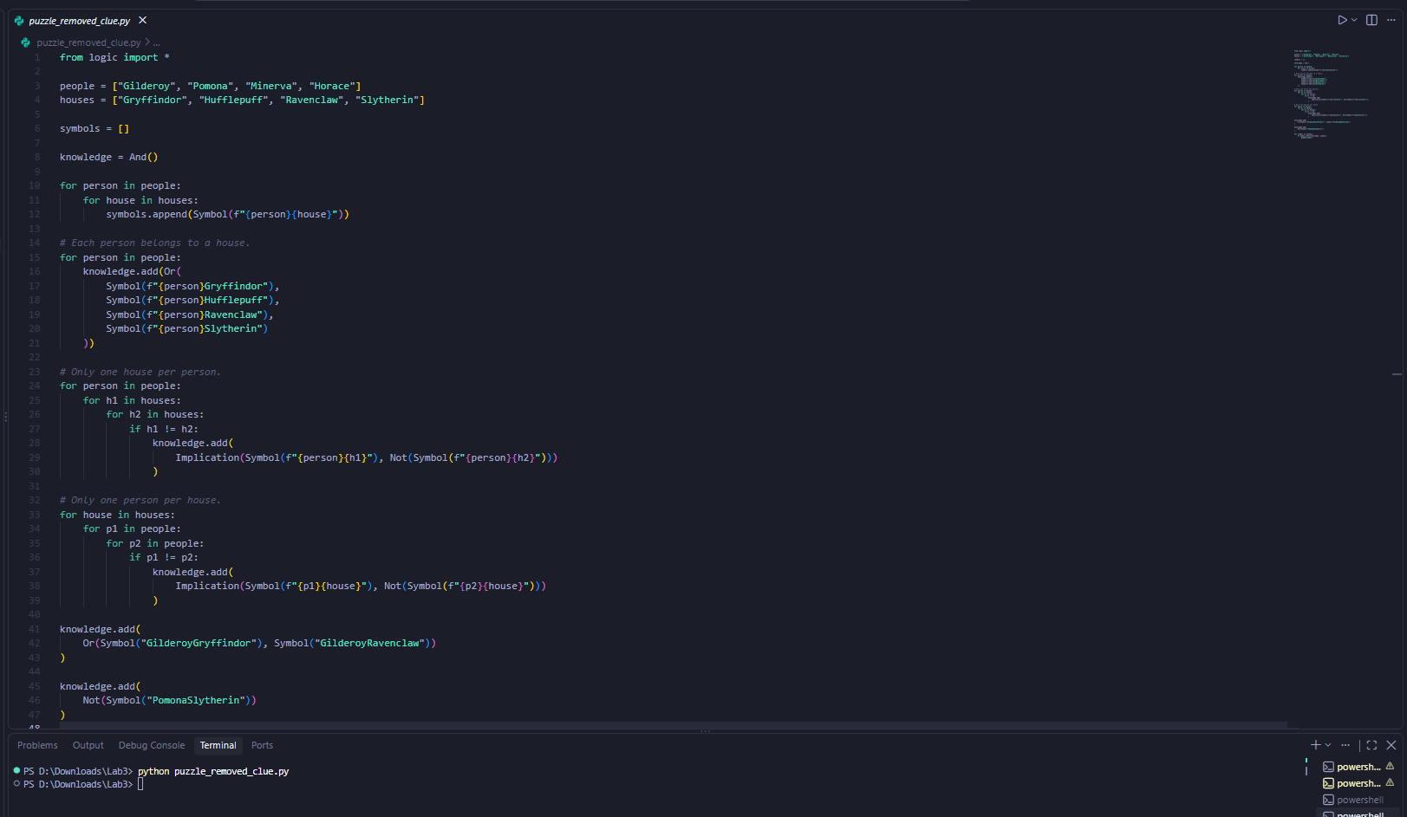
Figure 4. puzzle.py with the Minerva clue removed.

Task 2 - Add a New Clue
I added a compound clue using And: Gilderoy is in Ravenclaw, Pomona is in Hufflepuff, and Horace is in Slytherin. This leaves Gryffindor for Minerva and gives one unique solution.
Prediction: One complete assignment. Actual output: All four assignments.
Person | House
Gilderoy | Ravenclaw
Pomona | Hufflepuff
Minerva | Gryffindor
Horace | Slytherin
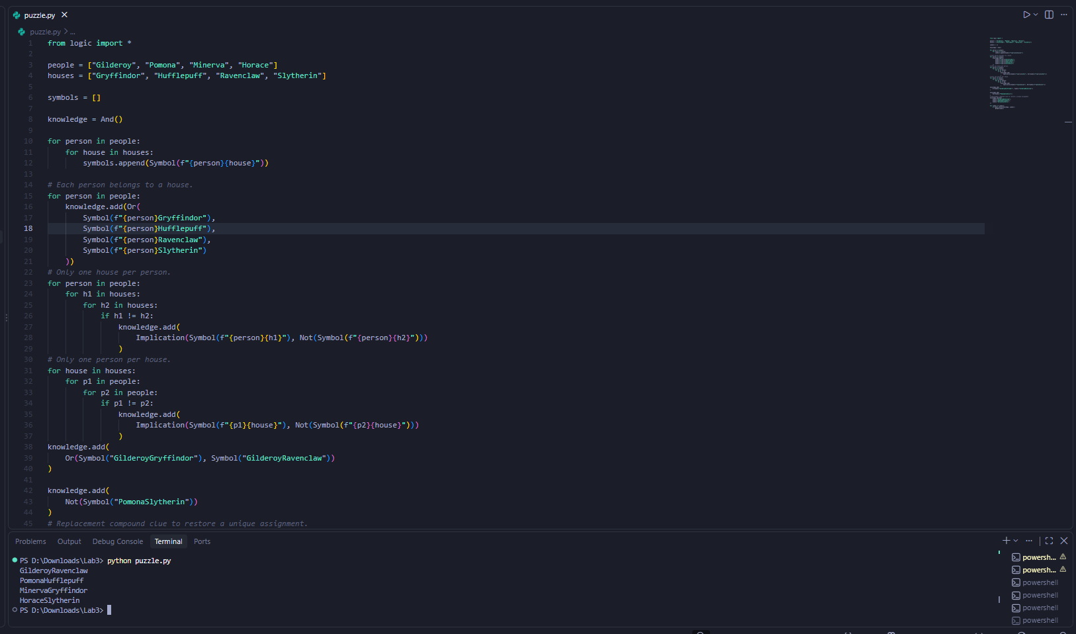
Figure 5. puzzle.py after adding the compound clue.

Task 3 - Knights and Knaves
Each person must be a knight or a knave, but not both. A knight tells the truth, while a knave lies.
Puzzle | Result
0 | A: Knave
1 | A: Knave; B: Knight
2 | A: Knave; B: Knight
3 (Bonus) | A: Knight; B: Knave; C: Knight
Puzzle 0: A cannot be both types, so A lies. Puzzle 1: A cannot truthfully say both are knaves; B is therefore a knight. Puzzle 2: A lies about being the same kind, while B truthfully says they are different.
Bonus Puzzle 3: A said "I am a knight." B lies about what A said, so B is a knave. B also lies about C, making C a knight. C confirms that A is a knight.
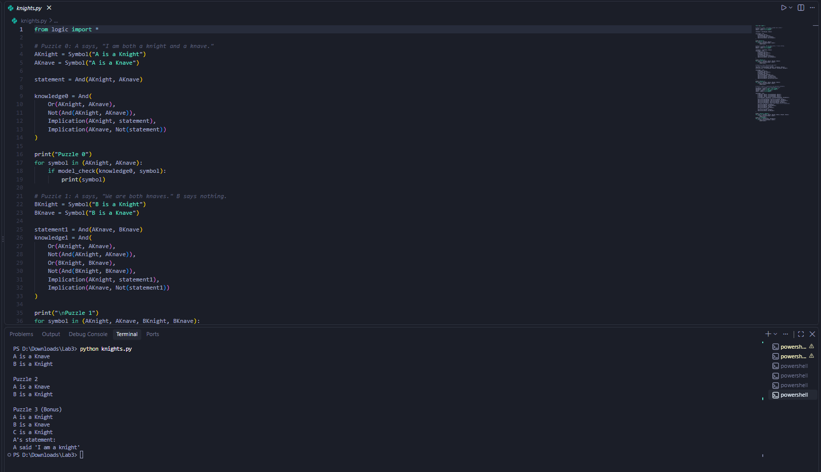
Figure 6. knights.py results for Puzzles 0-3 (saved output).
Conclusion: Model checking confirmed the expected results. Changing the knowledge base changed what could be logically proved.

