Hilo Game

Diagram Classe

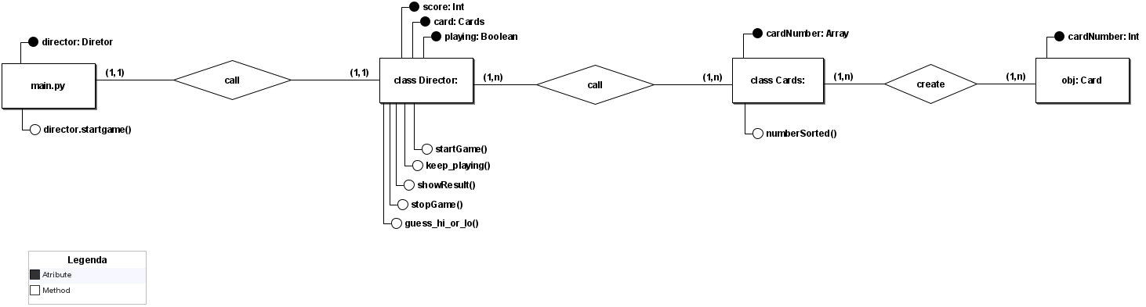

Class: Card

**Responsibility**:

To generate array with the number’s cards, and to use random pack to get one number card

**Behaviors:**

-numberSorted

**State:**

-cardNumber

Class: Director

**Responsibility:**

Call the principal functions to start, stop, show result and calculate the score.

**Behaviors**:

-startGame

-showResult

-stopGame

-guess_hi_or_ho

**State**:

-score

-card

-playing

Object: Card

**Responsibility:**

-To hold the number card of an array list

**Behaviors:**

-getCardNumber

**State:**

-cardNumber