Justice Calls and We Answered!

FOSE3000 Making Science Work for You and Society: Capstone

Assessment Task 5: Project Plan

8th June 2025

# Contents

Executive Summary 2

Introduction to the Problem 3

Project Aims 3

Proposed Solution and Approach 3

Timeline for Implementation 4

Stage 1: Research & Planning (month 1-3) 4

Stage 2: Website & Call Centre Development (month 4-6) 4

Safety measures 4

Stage 3: Pilot Launch (month 7-9) 5

Stage 4: Full Launch & Evaluation (month 10-12) 5

Stage 5: Beyond 12 Months 5

Gantt Chart 5

Project Roles, Budget, and Staff 5

Staff Allocation 5

Budget and Justification 5

Budget Area Breakdown Bar Chart 8

Budget Justification 8

Risk Mitigation 9

Risks, Potential Issues, and Risk Mitigation 9

Impacts and Benefits 10

Conclusion 10

Appendices 11

Appendix A: Statement of Contribution 11

Appendix B: Evidence of effective teamwork 12

Appendix C: Reference List 13

Appendix D: Email reply from Shark Digital 14

Appendix E: Email reply from Udo 15

Appendix F: Project Gantt Chart 16

# Executive Summary

“Women don't endure simply because we can; no, women endure because we aren't given any other choice - they wanted us weak but forced us to be strong.”

― Amanda Lovelace, The Witch Doesn't Burn in This One

From overworked women resigned to domestic labour, to the fight for women’s legal rights in the 19th century, and the unrealised gender equality promised in the 1948 Universal Declaration of Human rights - today’s disparities are not new. The United Nations proposed a number of goals for international development, including a few regarding the topic of gender equality and justice, which have assisted in the empowerment of disadvantaged women. However, despite global progress, hurdles to legal access remain firmly entrenched, as asylum seekers lack access to legal counsel, and people with low-income legal needs remain unmet; Women are facing quiet legal challenges.

This inequality is greatly enhanced by the societal structures, that is, preventing women from being fully aware of their rights, so we plan to address this with a service that connects women in crisis to pro bono legal assistance and provide resources through a call centre and website, designed to help women take the first step in navigating crises together, accelerating progress toward gender equality (UN Goal 5), equal opportunity (Goal 10), and justice (Goal 16). To execute our plan, we start by partnering with law firms to ensure that cases are taken up by those who can fight for justice and can give necessary counselling sessions; we will also partner with community shelters to encourage victims, specifically those of domestic violence, to speak up for themselves, as they are often the ones who need justice the most but remain silent the longest, or perhaps forever.

What we will offer:

* A call centre and website: For immediate access to legal resources and support
* A secured database (both online and offline): For case documentation and evidence collection
* Strategic partnerships with legal firms: To ensure cases are directed properly to pursue justice
* Collaborations with community shelters: To encourage victims to come forward

Now “to hold a pen is to be at war”, Voltaire once wrote. We now hold data, voices, and the will to fight silence. When legal systems are so foreign that it will take an estimated 286 years to close gaps in legal protection and remove discriminatory laws against women, we must rewrite access itself. Our solution does not merely suggest reform - it builds it in alignment with the UN Sustainable Development Goals 5, 10 and 16. This is not charity. It is overdue and as Shakespeare said,

​​”Thyself shall see the act;

For, as thou urgest justice, be assured

Thou shalt have justice, more than thou desir'st.” (1605)

# 

# Introduction to the Problem

Legal systems are meant to protect everyone, but in practice, they often leave women without real access to justice (Melgar & Kosanovic, 2021). Our project, Justice Calls, addresses this gap by making legal support more accessible for women who are often excluded due to systemic, social, and psychological barriers.

Through our research, we found that women frequently face a combination of issues: fear of retaliation, financial dependence, lack of trust in legal systems, and difficulty navigating fragmented support services (Melgar & Kosanovic, 2021; Slosar et al., 2022). These challenges are even greater for those who are also part of other marginalised groups: like migrant women, Indigenous women, and those from rural areas (United Nations Women [UNW], 2023).

This problem directly connects to UN SDG 5: Gender Equality, which includes targets like eliminating violence against women and ensuring equal rights to resources, property, and justice. But the issue doesn’t stop there. Our project also supports UN SDG 10: Reduced Inequalities by prioritising help for those from marginalised communities, and UN SDG 16: Peace, Justice, and Strong Institutions by working to make justice systems more inclusive and responsive.

By using data and direct support tools like a call centre and digital platform, our project aims to remove those barriers, thus offering practical, immediate pathways to legal aid that are sensitive to each woman’s circumstances.

# 

# Project Aims

This initiative aims to support women experiencing hardship by providing immediate, accessible guidance through a centralised call centre and app. Our project seeks to:

1. **Streamline Access to Resources:** Offer real-time advice on available services (e.g., crisis housing, counselling, legal aid) tailored to individual circumstances, addressing fragmented support systems highlighted by organisations like The Women’s Centre and Mission Australia.
2. **Spread Information:** Educate women on essential steps for safety and legal recourse, such as documenting abuse and understanding rights, empowering them with the available resources.
3. **Encourage Legal Preparedness:** Guide women in gathering evidence (medical records, witness statements) and navigating legal processes, showing them what the process may look like for them, and increasing the likelihood of their case being taken on pro bono.
4. **Provide Targeted Support (Equal Opportunities):** Use collected data to categorise cases efficiently, directing women to appropriate services while partnering with law firms to prioritise pro bono representation. We reduce outcome disparities by directing marginalised women to tailored support services.

By integrating these aims, the project addresses systemic barriers such as inconsistent service access, lack of legal clarity, and unclear resource availability, allowing for safer pathways for women to escape violence and gain legal justice (UNW, 2023).

# 

# Proposed Solution and Approach

Our proposed solution connects disadvantaged women to pro bono legal services through a multi-faceted approach: a call centre and a website. A guided questionnaire will help to assess each woman's situation and match her with law firms with appropriate and relevant expertise, and pro bono availability. This would mean women receive timely, and targeted legal advice.

This initiative responds directly to the urgent needs of the most disadvantaged women in Australia. These include Aboriginal and Torres Strait Islander women, who are 32 times more likely to be hospitalised due to family violence than non-Indigenous women (AIHW, 2019); Victims of domestic and family violence, who often fear retaliation or lack the resources to seek help, especially due to coercive control or financial abuse; Migrant and refugee women, who face visa-related vulnerabilities, isolation, and language barriers, and may not be aware of their rights; Women with disabilities, who are more likely to experience abuse and face barriers to seeking help (Coumarelos et al., 2012); Rural and remote women, who may lack nearby services and be discouraged by community stigma; Young women, especially those at risk of exploitation or homelessness, who may not know their rights or how to access help; LGBTQ+ women, particularly trans women. All of these groups often face systemic discrimination and may avoid services due to previous negative experiences.

There are a variety of legal needs across these groups, from housing and family law, to immigration and protection orders. Our project is designed to triage cases accordingly.

Accessibility is a core part of our approach. Some women may not have internet access, and some women may feel intimidated or uncomfortable making a phone call. Offering both of these options allows and empowers women to choose what suits them best, meeting them where they are at.

There are similar existing services available such as Circle Green’s Vulnerable Women’s Project (Circle, 2025), and they focus on legal support in specific locations. We aim to create a national referral and matching network system. We also aim to introduce a feedback loop after women are provided with said legal services, for both law firms and our women clientele, which would help us to assess our impact and continuously upgrade and improve our services.

We are filling a crucial gap. We’ll provide streamlined, accessible, and adaptable pathways to legal support for women in hardship. We are open to partnering with existing initiatives so that we can maximise the impact; We want to work together, not in competition, so we can provide justice where it’s needed most.

# Timeline for Implementation

## Stage 1: *Research & Planning (month 1-3)*

A questionnaire can serve as the first source of information, spread to spaces with those in need e.g. women's shelters. This will provide information such as an estimate of the number of people requiring such services, the details and severity of cases, and how long they have been waiting for assistance. These women have likely experienced trauma , so the questionnaire needs to be worded with sensitivity so as to avoid making our clients feel unwelcome or threatened.

Simultaneously a questionnaire can be sent to legal firms to create awareness of the project and to find firms which are aligned with our cause who can provide the legal aid or guide us in an alternative method. Once we have collected enough sample data we begin designing the website and modelling the call centre.

## Stage 2: *Website & Call Centre Development (month 4-6)*

The website is published online and the questionnaire data is collected. The questionnaire is made open to the public, including making it accessible online via our website allowing women in difficult scenarios to access it. Call centre workers are recruited and trained, ensuring they have trauma-informed communication skills, and know how to properly guide the clients depending on their unique scenario.

### Safety measures

The data that the project will collect is very personal and sensitive, which can be easily misused if not properly protected. Prior to launching the project we implement layered data protection systems to include an air-gap computer to remove the internet connection to the stored data. The database is regularly monitored for any security threats or data leaks. The whole system is tested to ensure security, also as a training exercise for the trained call centre workers to ensure compliance knowledge.

## Stage 3: *Pilot Launch (month 7-9)*

The project is launched only in NSW, Australia initially, allowing for feedback and management of any issues on a smaller scale. We introduce a feedback page on our website so that clients can voice their opinions anonymously, allowing them to avoid confrontation. This feedback will be filtered for relevant feedback then evaluated and implemented.

## Stage 4: *Full Launch & Evaluation (month 10-12)*

Once the NSW region has accumulated ample amounts of feedback and any major issues are mitigated, we incrementally expand our reach to other Australian regions. We establish the different needs and resources currently available in each Australian region, ensuring we have relevant expertise and knowledge for each jurisdiction. This would in turn create more call centres working simultaneously with the law firms who are able to provide the legal aid. If the expected traffic to the call centres is not as high as estimated, our secondary plan is to spread awareness by starting online campaigns, and to continue to adapt from feedback and do so until we reach as many people as we can.

## Stage 5: *Beyond 12 Months*

The end goal is a service that can reach all of Australia, and have the call centre running 24/7, so by this point in the project we will have data which will allow us to specialise our services to pertain to certain cultures and demographics. We are able to reach women in rural areas and women who do not speak English. We continue to improve to make the service more accessible, time efficient, and help those in need.

## Gantt Chart

See Appendix F: Project Gantt Chart. The chart works as a theoretical framework for the project's progress with some added room for error. Time is allocated for a backup plan to be worked on simultaneously, as the main project could encounter a roadblock or fail to meet the funding budgets due to unforeseen circumstances. Thus working on these plans simultaneously, ensures that we make a difference on the issue in one way or another. Secondly the time needed to complete does not perfectly match with the date of completion. This is because the graph only takes into account working days, as well as some extra time to accommodate days where no progress can be made due to unforeseen circumstances.

# Project Roles, Budget, and Staff

## Staff Allocation

* **Director**: This person would be in charge of making connections between the Not For Profit sector and law firms & establishing relationships in order to fulfill their pro bono quotas and finding which law firms would best suit the legal needs of our clients.
* **Call centre**: This would be a team of four personnel to be on call for assistance. Their duties would be to take calls, data entry, provide direction if requested, and provide details to law firms.

## Budget and Justification

| **Category** | **Item Description** | **Quantity** | **Cost per Unit** | **Total Cost (Annual)** | **Notes** |
| --- | --- | --- | --- | --- | --- |
| **Personnel**  **Total: $508,212** | JC Director | 1 | $119,056 | $119,056 | Grade 6 Office manager step 1 (salaried) (including on-costs) |
| JC team wages | 4 | $97,289 | $389,156 | Grade 5 office clerk step 1 (38 hrs/week with 49.23aud/hr (including 26.5% on-costs) |
| **Workstations**  **Total:**  **$9758** | Laptop | 5 | $1571.50 | $7857.50 | One laptop per team member  Brand: Dell latitude 3520 |
| Microsoft 365 | 1 | $140 | $140 | Microsoft 365 family 6 users PC/MAC 1 year subscription |
| USB Flash Drive | 5 | $12 | $60 | For individuals to secure data storage  Brand: SanDisk Ultra USB 3.0 Flash Drive |
| Office chair | 5 | $131 | $655 | Seating for each workstation  [From: Fast Furniture](https://www.fastofficefurniture.com.au/officefurniture/home-office-furniture/condo-home-study-chair/?gad_source=1) |
| Office Table | 5 | $209 | $1045 | Individual desks  [From: Value Office Furniture](https://valueofficefurniture.com.au/officefurniture/training-room-furniture/corporate-desk/?gad_source=1) |
| **Shared**  **Office**  **Equipment**  **Total:**  **$4465** | Printer | 1 | $159 | $159 | For printing of documents and legal form  Brand: [Epson Workforce Pro WF-3820](https://www.officeworks.com.au/shop/officeworks/p/epson-workforce-pro-wf-3820-printer-epwf3820) |
| Paper (ream) | 30 | $8 | $240 | Assuming 5 employees will need 200 pages/month  Thus, 2 reams per month→24 reams per year  Budgeting for 30 reams(25% buffer)  From: [Officeworks](https://www.officeworks.com.au/shop/officeworks/p/j-burrows-100-recycled-a4-paper-500-sheets-jbrec100a4) |
| Epson 812 value packs | 9 | $124 | $1116 | Following the previous assumption, we anticipate using around 6 color cartridges and 34 black cartridges. Since we will order 9 value packs, each pack will have one black. That is how we will have 36 black cartridges.  From: [Officeworks (value pack)](https://www.officeworks.com.au/shop/officeworks/p/epson-812-durabrite-ultra-ink-cartridge-value-pack-ep812val) and [Officeworks black cartridges](https://www.officeworks.com.au/shop/officeworks/p/epson-812-durabrite-ultra-ink-cartridge-black-ep812blk) |
| Epson 812 black cartridges | 27 | $34.50 | $931.50 |
| Scanner+Photocopy | 1 | $269 | $269 | To share printing documents like legal forms and to digitise paperwork  Brand: [Brother L2800DW Mono Laser Multi-Function Printer](https://www.officeworks.com.au/shop/officeworks/p/brother-l2800dw-mono-laser-multi-function-printer-brl2800dw) |
| External Hard Disk | 2 | $118 | $236 | For shared backup and secure case data transfer  1 disk for the office  1 disk for off site transport + to avoid redundancy  We need an extra disk to store backups safely and also that way we practice data security.  Brand: [Toshiba 2TB Canvio Ready Portable Hard Drive](https://www.officeworks.com.au/shop/officeworks/p/toshiba-2tb-canvio-ready-portable-hard-drive-tocvrdy2tb) |
| Telephone (landline) | 2 | $184 | $368 | One line for general communication and another line for hotline or legal support requests. Brand: [Grandstream GXP2135 High-End 8 Line Corded Desk IP Phone Black](https://your.officechoice.com.au/products/grandstream-gxp2135-high-end-8-line-corded-desk-ip-phone-black) |
| Internet | 1 | $1145.76 / year | $1145.76 | Source: [iinet NBN Internet Plan](https://www.iinet.net.au/internet-product/broadband/nbn/plans/fibre?utm_source=whistleout&utm_medium=affiliate&utm_campaign=whistleout-nbn-listing&utm_id=whistleout-nbn-listing-20240502496&utm_content=none&gad_source=7&dclid=CMOilbn8uY0DFSWJZgIdFhobGQ)  chosen from [List of NBN Plans](https://www.whistleout.com.au/Broadband/Guides/NBN-1000-ultrafast-internet#:~:text=NBN%20Unlimited%201000,-nbn%C2%AE%20750&text=Commitment:%20no%20contract%20and%20no,purchase%20one%20from%20SpinTel%20upfront) |
| **Office:**    **Total:**  **$78200** | Rent (Including water, electricity, etc.) | 50 sqm | $1564 / sqm | $78200 | Assuming 10sqm place per person needed. Sydney CBD Gross Face Rent: Around $1,564 per square meter per annum.  Source: [Sydney CBD Office Market](https://content.knightfrank.com/research/304/documents/en/sydney-cbd-office-market-february-2025-11988.pdf?) |
| **Insurance and other expenses:**  **Total:**  **$11449** | General Insurance |  | $1200 / year | $1200 | For operating a public service- covers injury or property damage |
| WorkCover |  | $8148.50 / year | $8148.50 | Required under law; average rate: 1.73% of total annual wages($486,445) |
| Contents Insurance |  | $600 / year | $600 | Should cover damage or theft |
| Professional Indemnity |  | $1500 / year | $1500 | Will cover legal liability from advice or support |
| **Website:**  **Total:**  **$2000** | Website Build | 1 | $1,400 | $1,400 | Website design and development (custom 5-page site)  Includes consultation, Google SEO, training, 3 months free hosting |
| Web Hosting (month) | 9 | $30 | $270 | Ongoing hosting & licensing;  Begins after 3 months free |
| Email Hosting (month) | 12 | $27.50 | $330 | 5 email accounts, 5GB storage each |
| **Marketing:**  **Total:**  **$9,240** | Digital Marketing Campaign (month) | 12 | $770 | $9240 | Includes SEO, Google Ads, basic social media. (Shark Digital est. $700 + GST/month) |
| **Contingency Fund:**  **$31,166** | Contingency Fund | 12 |  | $31,166 | 5% of total budget ($623,324), for unforeseen costs |

**Total: $654,490**

## Budget Area Breakdown Bar Chart

“Personnel” is the most distinct budget area, which means the cost in this sector differs significantly from all other categories and “Office” being the second tells us that the largest expenses in our budget are personnel and office, as they are separate from other categories.

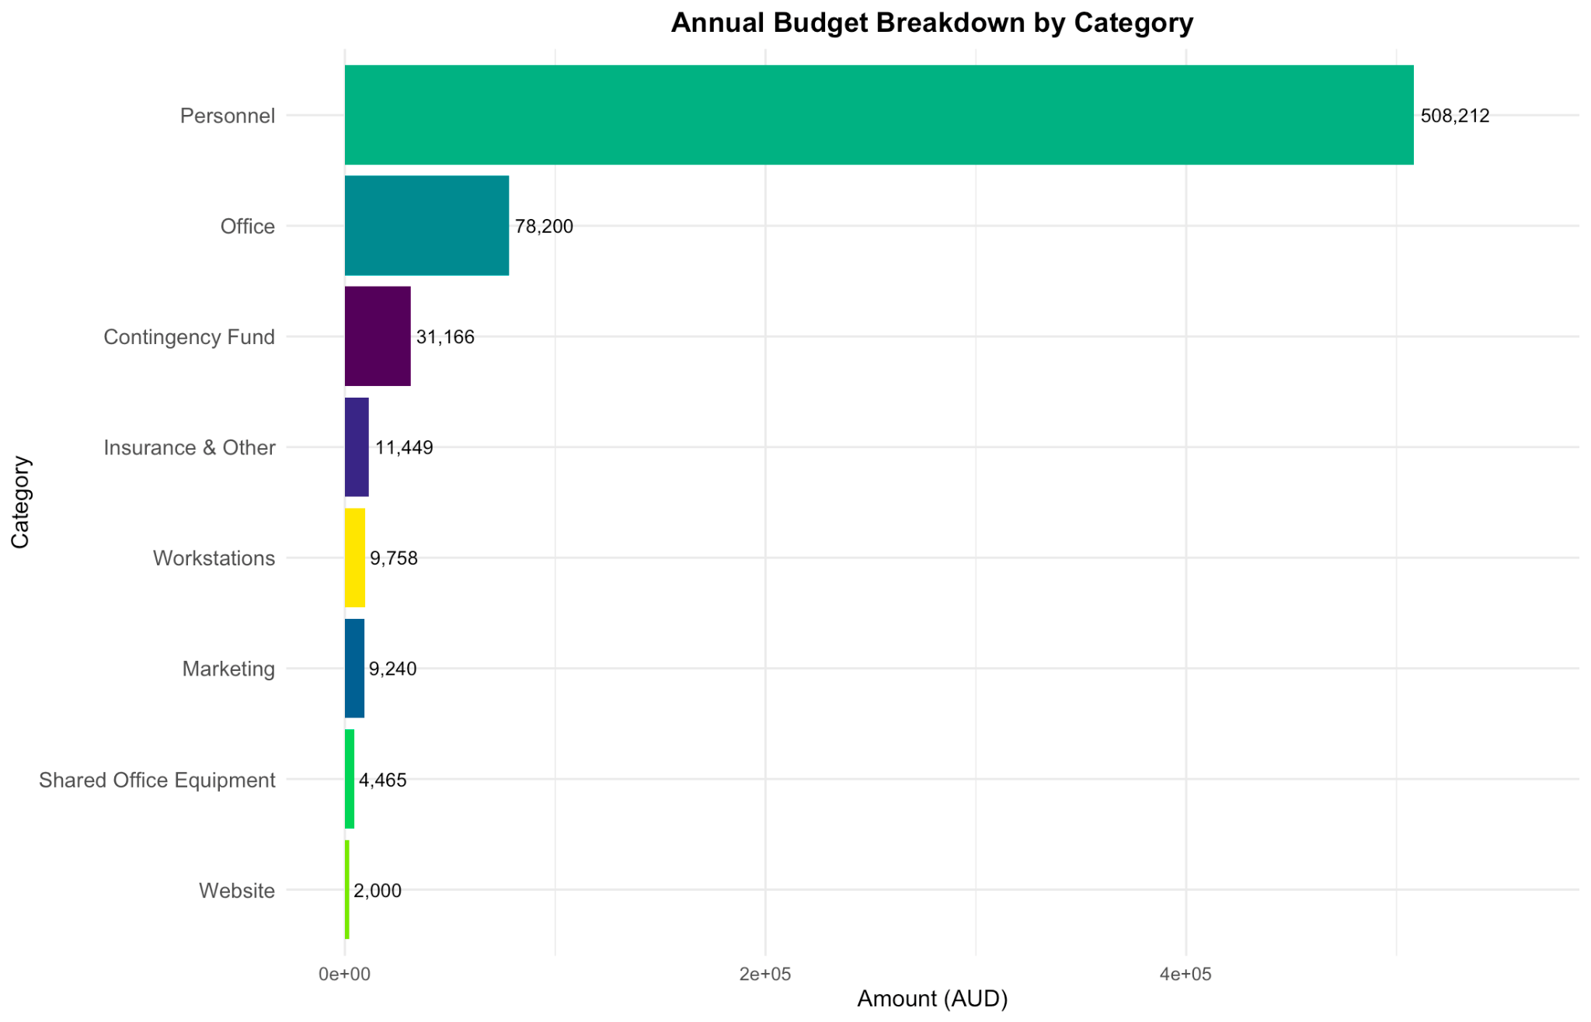

## Budget Justification

To justify our budget, we used the data from Women’s Community Shelters (WCS) to measure the social impact. The WCS plays a significant role in providing safety, support and shelter to women facing domestic violence, homelessness or any general crisis. While researching our data regarding domestic violence, we have noticed an interesting pattern.

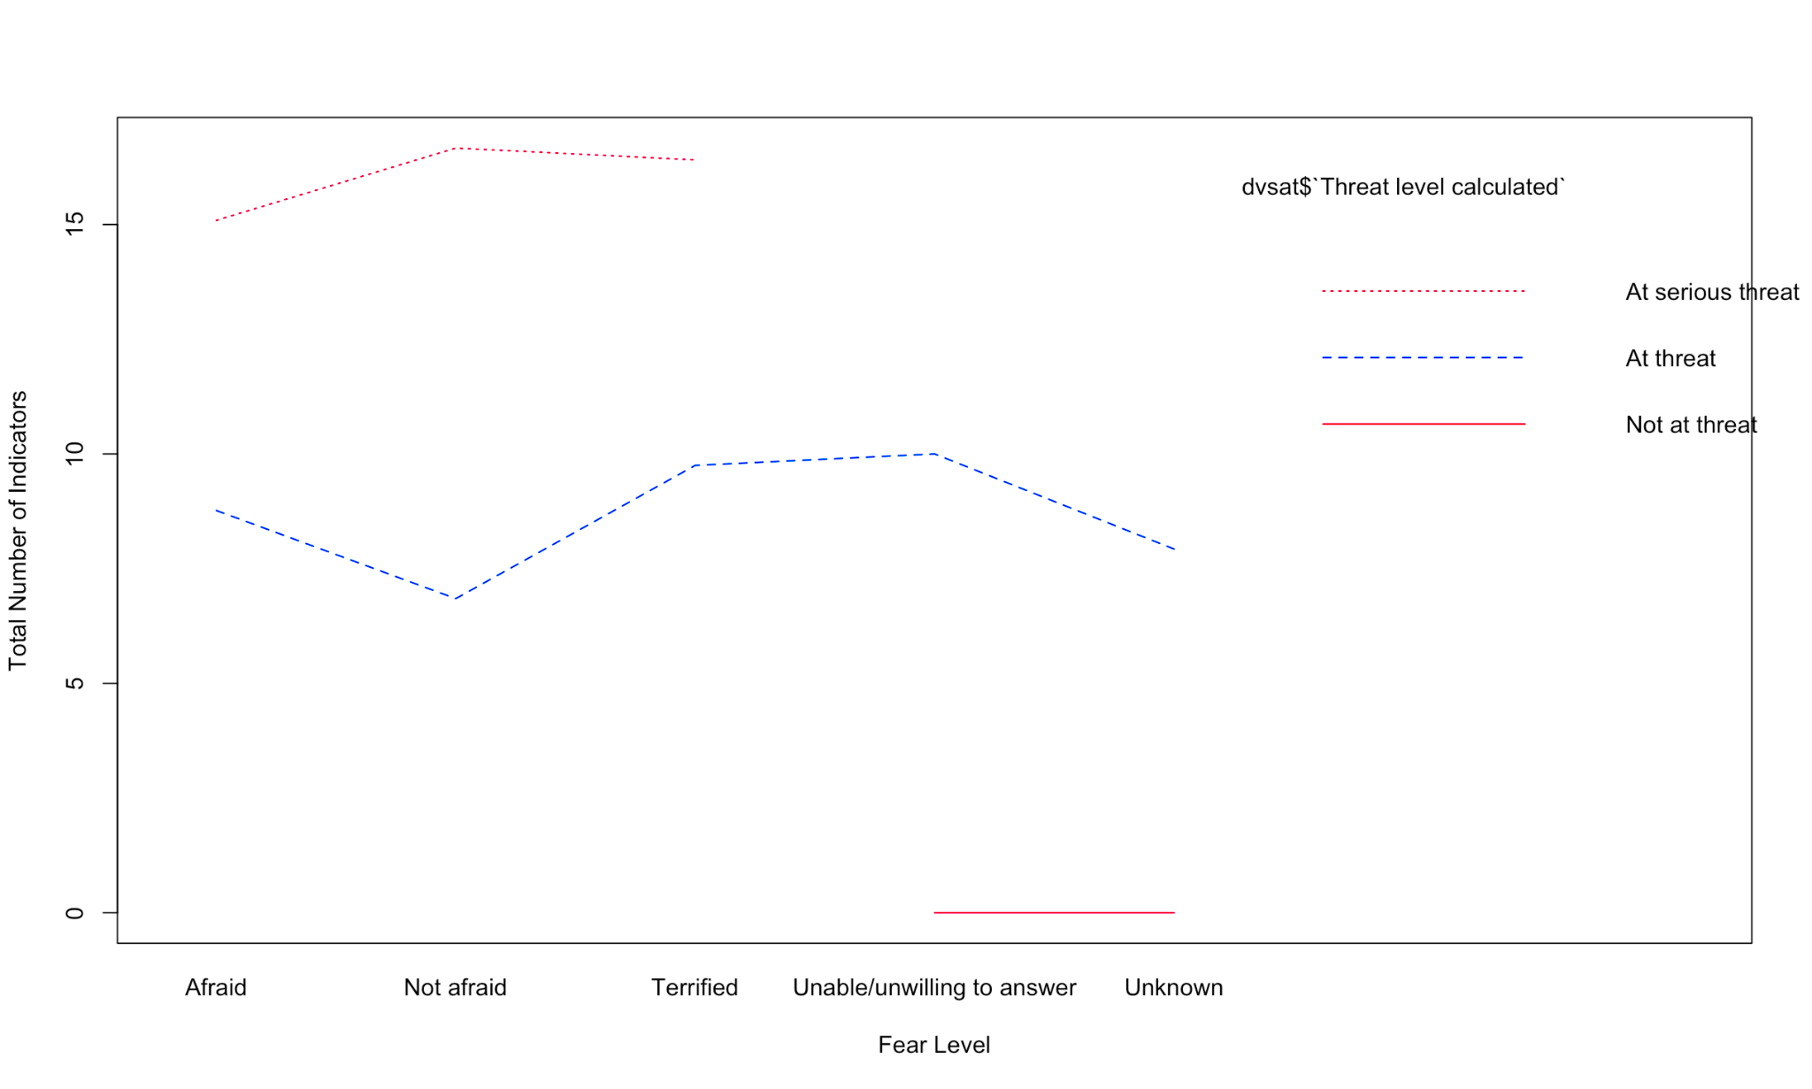

Figure 2: Line chart for the distribution of the threat consciousness across fear levels

As we can see from the line chart (Figure 2), ‘At serious threat’ clients have a higher position compared to ‘At threat’ and ‘Not at threat’, which means the individuals in the ‘At serious threat’ category may experience more intense fear-related symptoms. According to the graph, we say that the stages can be differentiated based on the perceived threat level and the clients at serious threat need more support both emotionally and legally. Thus, our organisation will not provide one size fits all services. Instead we distinguish our services according to the client's needs. This system influenced our budget design and resource allocation as:

* Staff need time and coordination efforts to assist high risk individuals, which leads us to necessitate adequate staffing to manage complex cases.
* Our website system will be designed such that it will capture and flag client risk levels at first contact so that it will help us to prioritise cases effectively.
* Our campaigns will be able to engage diverse audiences with evidence.

Our budget reflects an evidence-driven approach. Personnel costs account for the time and expertise required to deliver support, while workstations and shared office equipment ensure operational efficiency. In addition, the website infrastructure is designed to triage client needs based on their situation, prioritising those at higher risk. These decisions, grounded in data, demonstrate that our resource allocation is not arbitrary, but rather aligned with areas proven to impact well-being positively.

## Risk Mitigation

To address these risks, we’re ensuring staff are trained with psychological support to reduce turnover/burnout and general trauma. We will also provide cybersecurity training to embed strong data protection into our platform design from the start. Legal partnerships will be formalised early in the project with clear role definitions and expectations. Community outreach through shelters and advocacy groups will help build trust and increase accessibility. We’ll also use feedback loops and flexible implementation plans to adapt as we go, ensuring the project can respond quickly to obstacles. By planning and embedding simple yet effective risk mitigation strategies, we reduce the high start up costs.

## Risks, Potential Issues, and Risk Mitigation

| **Strengths**   * Strong alignment with multiple UNSDGs, especially Goals 5, 10, and 16 * Clear social impact, with a well-defined and under-served target audience * Data-driven approach helps prioritise urgent cases efficiently * Flexibility in delivery through both tech (digital) and human (call centre) support * Emphasis on partnerships (not in competition) | **Weaknesses**   * Reliance on partnerships with law firms * Potential for high emotional/psychological toll on staff. Staff burnout or turnover is also a possibility * High startup costs, particularly for staffing and digital infrastructure * Potential difficulties in reaching women without access to phones or the internet |
| --- | --- |
| **Opportunities**   * Growing demand for pro bono legal work and strong corporate social responsibility trends * Opportunity to work alongside existing organisations to fill current service gaps rather than compete with them * Use of anonymised data could provide broader insights into legal aid accessibility issues & potentially improve legal access strategies over time | **Threats**   * Dependence on external legal support * Low initial uptake due to lack of awareness or public trust * Advert strategies add to high start up costs * Legal liability or reputational risk if sensitive data is mishandled * Expensive cybersecurity measures * Resistance from legal aid/delays in getting partnership approvals |

# Impacts and Benefits

A successful implementation of our initiative would yield several positive outcomes. Women receive enhanced safety and legal preparedness with gaining access to real-time advice on evidence collection and safety planning, reducing their immediate risks and empowering them to access legal action. It would streamline access to key resources by connecting women efficiently with advice, resources, and legal aid, addressing difficult support systems available. Structured interventions can assist in repairing communities and relationships damaged by abuse, supporting healthy futures for women and their children. Addressing systemic barriers (e.g., financial or gender-related challenges) works towards reducing inequalities for marginalised groups in Australia.

The primary beneficiaries from this project would be women experiencing hardship, who receive tailored guidance on legal processes, safety planning, and community resources, enhancing their autonomy and safety. Their children benefit indirectly through improved family situations and resources for mental health support.

Secondary beneficiaries include the law firms involved in providing pro bono hours. They gain a structured pipeline to pro bono cases, improving efficiency in service delivery. Australian communities also benefit, with reduced long-term healthcare and legal costs associated with unaddressed issues e.g., domestic violence.

The short-term outcomes of the project include greater resource awareness of community resources (e.g., housing, legal aid), which can be measured via community knowledge surveys. Over time the rates of legal engagement will rise with the number of women pursuing legal action with our partnered law firms, tracked using our case management data.

# Conclusion

Many women in Australia don’t have access to proper legal support, especially those in domestic violence situations, those having immigration issues, those in poverty, and other women in difficult situations. Our legal system is tricky to navigate, expensive, and daunting. Many women don’t know their rights and don’t know where to start. They often don’t get the justice they need, and instead stay silent, quietly suffering.

Our proposed solution of an easy-to-use call centre and website helps connect women to pro bono legal assistance, where they can get information on their rights, and proper legal representation. By partnering with law firms and community shelters, we are reaching out to communities that require legal help for disadvantaged women. We want to make this as accessible as we can for those who need it the most.

By supporting “Justice Calls”, you support:

* Women’s access to legal aid
* Justice that prioritises disadvantaged and vulnerable women
* UN Sustainable Development goals 5, 10, and 16

It’s time we made justice accessible not just for those that can afford it, but for all, because no woman should suffer in silence when Justice Calls.

## Appendix C: Reference List

1. Australian Institute of Health and Welfare. (2019). *Australia's welfare 2019: in brief*. Canberra: AIHW. doi:10.25816/5d5e1912778e0
2. Coumarelos, C., Macourt, D., People, J., McDonald, H., Wei, Z., Iriana, R., & Ramsey, S. (2012). *Legal Australia-Wide Survey Legal Need in Australia.* Law and Justice Foundation of New South Wales.
3. Lovelace, A. (2018). *The witch doesn’t burn in this one*. Andrews McMeel Publishing.
4. Melgar, F., & Kosanovic, J. (2021, March 3). *Women receive half as many publicly-funded Legal Aid grants as men in Australia* [Review of *Women receive half as many publicly-funded Legal Aid grants as men in Australia*]. Special Broadcasting Service; Special Broadcasting Service. https://www.sbs.com.au/language/english/en/article/women-receive-half-as-many-publicly-funded-legal-aid-grants-as-men-in-australia/6w0nygumk
5. Shakespeare, W. (1605). The Merchant of Venice. Cengage Learning
6. Slosar, M., John, S., Bernstein, D., Hardin, B., Hughes, R., Jennings, L., Layton, J., Scruggs, J., & Stevens, H. (2022). *The Justice Gap: The Unmet Civil Legal Needs of Low-income Americans.* Legal Services Corporation.
7. UN Women. (2023). *Gender Equality Outlook Report*.
8. *Vulnerable Women’s Project - Projects - Circle Green Community Legal.* (2025). Circle Green Community Legal. https://circlegreen.org.au/projects/vulnerable-womens-project/
9. Women’s Community Shelter. (2024). *Dataset collected for MATH3599 – PACE Unit* [Unpublished raw data]. Macquarie University.

## Appendix D: Email reply from Shark Digital

For marketing budget research we contacted Shark Digital. These figures reflect the current market at the time of writing, though are subject to change.

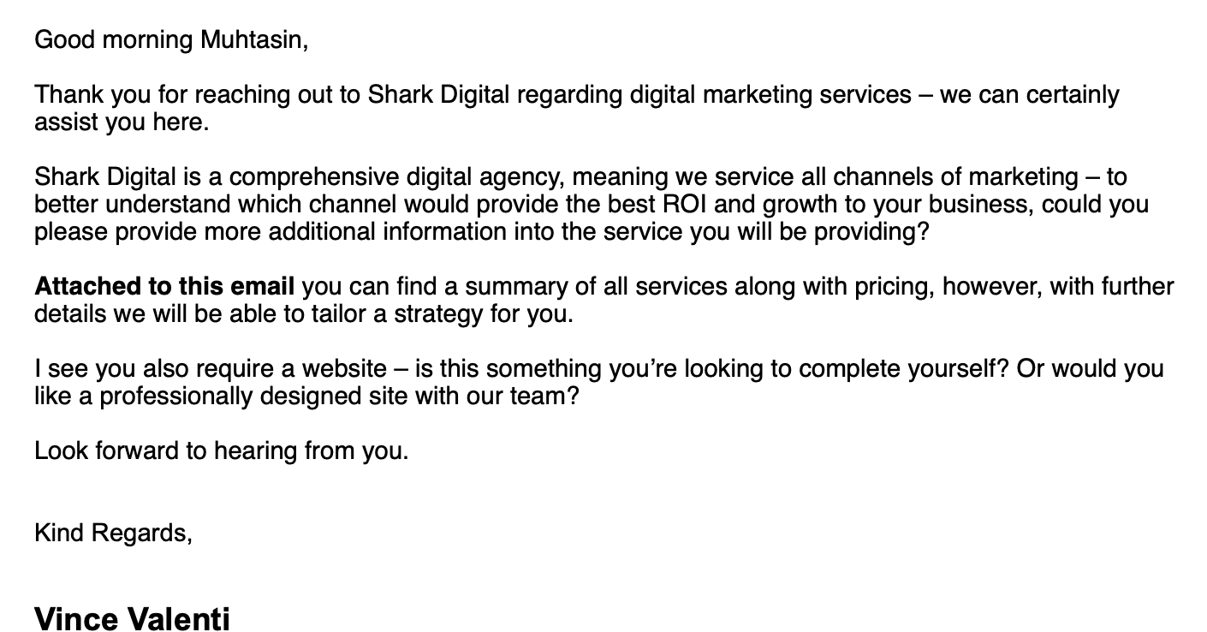

## 

## Appendix E: Email reply from Udo

For website building and maintenance research we contacted Udo. These figures reflect the current market at the time of writing, though are subject to change.

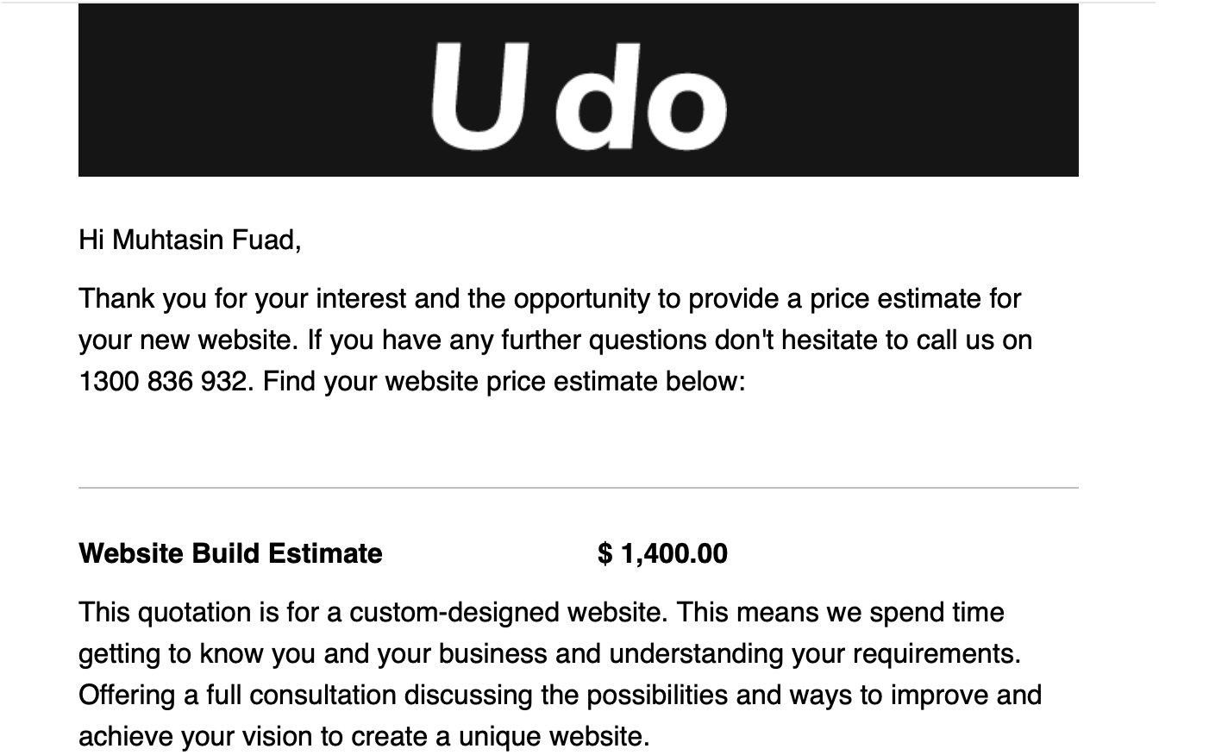

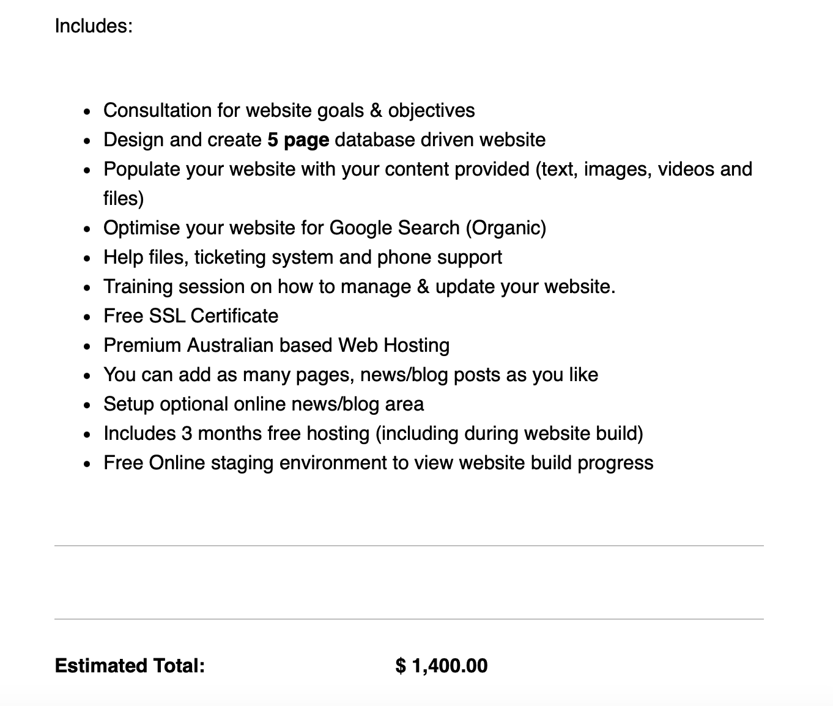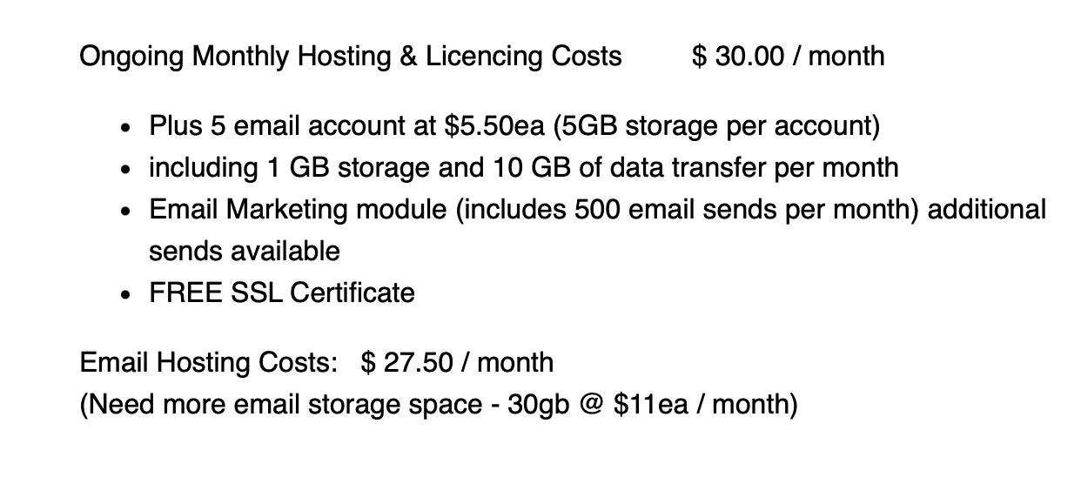

## Appendix F: Project Gantt Chart

