Screenshots

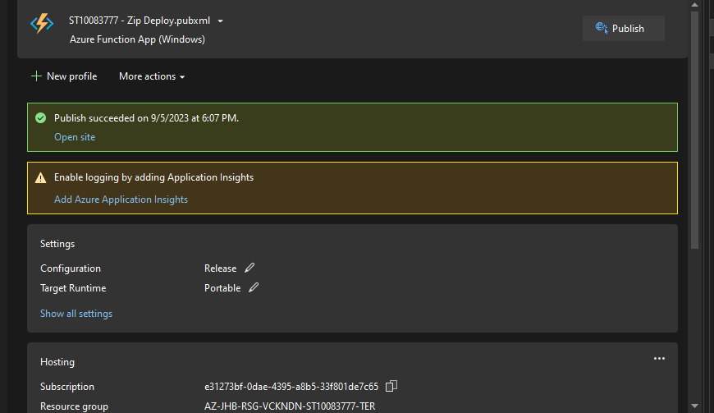

Code:

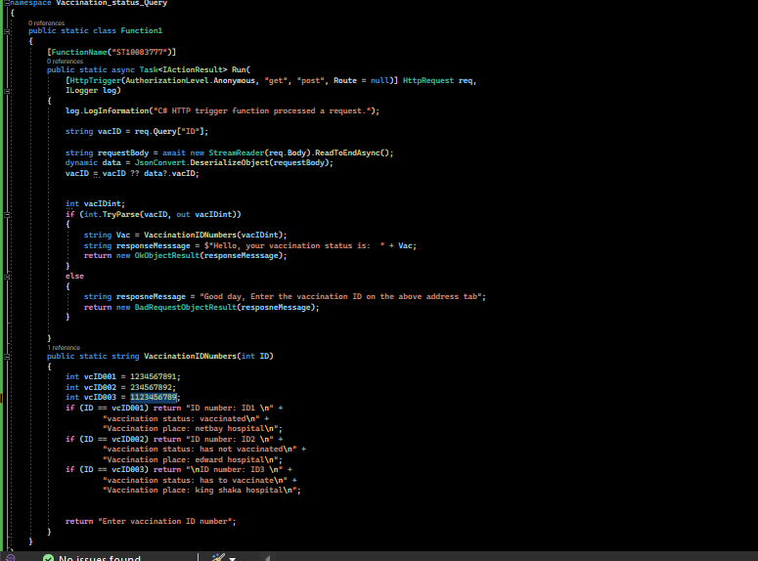

Home Page

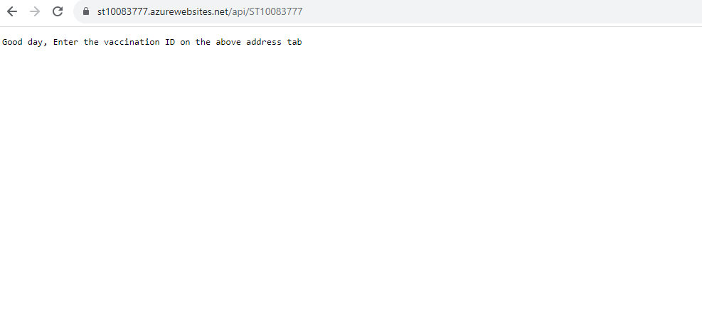

ID 1 response

Links:

ID1: <https://st10083777.azurewebsites.net/api/ST10083777?id=1234567891>

ID2: <https://st10083777.azurewebsites.net/api/ST10083777?id=234567892>

ID3: <https://st10083777.azurewebsites.net/api/ST10083777?id=1123456789>