-Descargar selenium WebDriver

-Descargar chrome WebDriver

-Crear Proyecto en Eclipse

-New Project-(dentro) new packages en carpeta SRC-(dentro) new class (elegir incorpore el main)

<http://javafaq.nu/java-example-code-134.html>

# Conexión

-Descargar driver Oracle

-Importar al proyecto(como librería externa)

-Cadena Conexión:

## Descargar Driver de Oracle

<https://www.oracle.com/technetwork/apps-tech/jdbc-112010-090769.html>

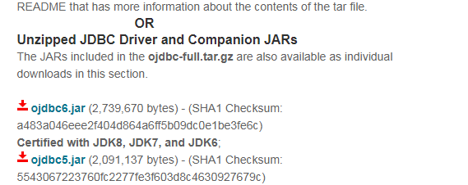

## Importar proyecto:

Proyecto(d)-propiedades-Path build –libraries-add external libraries : busco el ojdbc

## Cadena Conexión

**jdbc:oracle:thin:@localhost:1521:xe**

jdbc(API)-oracle(BD)-thin (DRIVER)-localhost(servidor)-1521(puerto)-xe(service_name)

1. **Driver class:**The driver class for the oracle database is **oracle.jdbc.driver.OracleDriver**.
2. **Connection URL:**The connection URL for the oracle10G database is **jdbc:oracle:thin:@localhost:1521:xe** where jdbc is the API, oracle is the database, thin is the driver, localhost is the server name on which oracle is running, we may also use IP address, 1521 is the port number and XE is the Oracle service name. You may get all these information from the tnsnames.ora file.
3. **Username:**The default username for the oracle database is **system**.
4. **Password:**It is the password given by the user at the time of installing the oracle database.

*Código:*

Connection connection = **null**;

System.***out***.println("-------- Oracle JDBC Connection Testing ------");

**try** {

Class.*forName*("oracle.jdbc.driver.OracleDriver");

} **catch** (ClassNotFoundException e) {

System.***out***.println("No se encontro el Driver Oracle ");

e.printStackTrace();

**return**;

}

System.***out***.println("Existe el OJDBC");

**try** {

connection = DriverManager.*getConnection*(

"jdbc:oracle:thin:@localhost:1521:xe", "sys as sysdba", "Negro123");

} **catch** (SQLException e) {

System.***out***.println("Fallo la conexion a la BD");

e.printStackTrace();

**return**;

}

**if** (connection != **null**) {

System.***out***.println("Tomaste el control de la base FELICITACIONES!");

} **else** {

System.***out***.println("Fallo la conexion a la BD");

}

## Fuente

Javapoint: conectar java a Oracle

<https://www.javatpoint.com/example-to-connect-to-the-oracle-database>

Conectar netbeans a Oracle

<http://ingluisfransv.blogspot.com/2013/01/conectar-java-utilizando-netbeans-ide.html>

<https://netbeans.org/kb/docs/ide/oracle-db.html>