

CS553 Information Retrieval System Homework-1

Mahmut Furkan Gön  
21902582

[furkan.gon@bilkent.edu.tr](mailto:furkan.gon@bilkent.edu.tr)

# Introduction

This homework explores integrating different retrieval techniques, including TF-IDF, BM25, and embedding-based models, to improve information retrieval performance. By assigning varying weights to these methods, the task evaluates their combined effectiveness using the Mean Average Precision (MAP) metric.

The goal is to analyze how weight configurations impact retrieval performance for different embedding models (scratch-trained FastText, pre-trained FastText, and fine-tuned FastText models) and to identify the best and worst-performing configurations. Through systematic experimentation and visualization, the homework provides insights into the strengths and weaknesses of these approaches in handling diverse queries.

# Coding and Implementation

Python language is used in this homework assignment. I followed the steps explained in the homework assignment. Firstly, I downloaded the CISI dataset. Then, load the dataset and examine the dataset. Investigated the columns in each csv file. Then, I considered the possible preprocessing steps. I applied the following preprocessing steps one by one:

* Decapitalized (lowered) every word.
* Removed the punctuation.
* Tokenized the text with the word_tokenize function from the nltk library.
* Removed stop words using stopwords from the nltk corpus.
* Lemmatized the text with WordNetLemmatizer from the nltk library again.

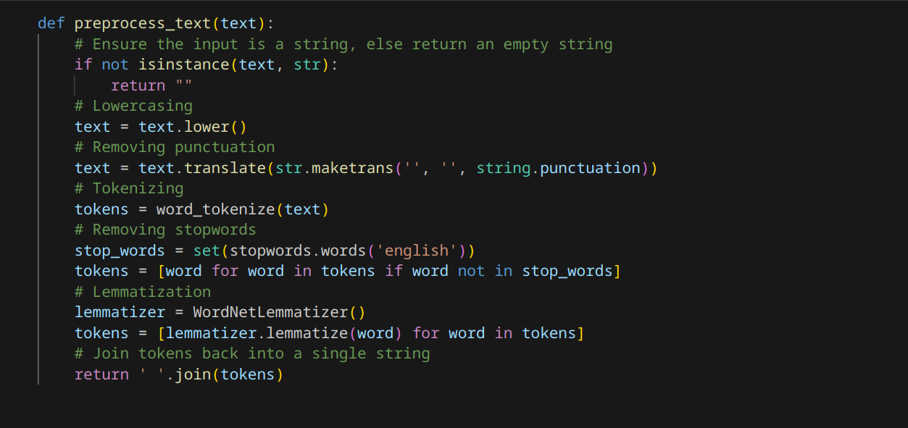

Fig 1: Preprocessing function

# Experiments and Results

|  |  |  |  |  |
| --- | --- | --- | --- | --- |
| Model | TF-IDF Weight | BM25 Weight | Embedding Weight | MAP |
| scratch | 1 | 0 | 0 | 0.05106627128060904 |
| scratch | 0 | 1 | 0 | 0.05172594739367601 |
| scratch | 0 | 0 | 1 | 0.051785456414701794 |
| scratch | 0.0 | 0.1 | 0.9 | 0.05582977971070579 |
| scratch | 0.1 | 0.1 | 0.8 | 0.05934239478655705 |
| scratch | 0.2 | 0.1 | 0.7 | 0.05893289510455144 |
| scratch | 0.3 | 0.1 | 0.6 | 0.058287938634519046 |
| scratch | 0.4 | 0.1 | 0.5 | 0.05680398853649627 |
| scratch | 0.5 | 0.1 | 0.4 | 0.05497962806785183 |
| scratch | 0.6 | 0.1 | 0.3 | 0.05327287920261702 |
| scratch | 0.7 | 0.1 | 0.2 | 0.05286030743177971 |
| scratch | 0.8 | 0.1 | 0.1 | 0.052415352862821014 |
| scratch | 0.9 | 0.1 | 0.0 | 0.052157772214985486 |
| scratch | 0.0 | 0.2 | 0.8 | 0.056263600551108225 |
| scratch | 0.1 | 0.2 | 0.7 | 0.058556747766503915 |
| scratch | 0.2 | 0.2 | 0.6 | 0.057310545316372266 |
| scratch | 0.3 | 0.2 | 0.5 | 0.0571991783565703 |
| scratch | 0.4 | 0.2 | 0.4 | 0.05657693061188594 |
| scratch | 0.5 | 0.2 | 0.3 | 0.055306716260049835 |
| scratch | 0.6 | 0.2 | 0.2 | 0.053507380745870525 |
| scratch | 0.7 | 0.2 | 0.1 | 0.05209256263797636 |
| scratch | 0.8 | 0.2 | 0.0 | 0.05218205361899426 |
| scratch | 0.0 | 0.3 | 0.7 | 0.05503711761417479 |
| scratch | 0.1 | 0.3 | 0.6 | 0.056575946076264705 |
| scratch | 0.2 | 0.3 | 0.5 | 0.05624713374155509 |
| scratch | 0.3 | 0.3 | 0.4 | 0.056446192849699275 |
| scratch | 0.4 | 0.3 | 0.3 | 0.05530321448266533 |
| scratch | 0.5 | 0.3 | 0.2 | 0.053003568661947366 |
| scratch | 0.6 | 0.3 | 0.1 | 0.052402818885380356 |
| scratch | 0.7 | 0.3 | 0.0 | 0.051883941480027444 |
| scratch | 0.0 | 0.4 | 0.6 | 0.054680079908744135 |
| scratch | 0.1 | 0.4 | 0.5 | 0.056458659124057245 |
| scratch | 0.2 | 0.4 | 0.4 | 0.05624655985244379 |
| scratch | 0.3 | 0.4 | 0.3 | 0.055031833972036766 |
| scratch | 0.4 | 0.4 | 0.2 | 0.05444676206339012 |
| scratch | 0.5 | 0.4 | 0.1 | 0.05352543488692246 |
| scratch | 0.6 | 0.4 | 0.0 | 0.05257476761808997 |
| scratch | 0.0 | 0.5 | 0.5 | 0.05406378192530837 |
| scratch | 0.1 | 0.5 | 0.4 | 0.05531891338504431 |
| scratch | 0.2 | 0.5 | 0.3 | 0.0548069424249132 |
| scratch | 0.3 | 0.5 | 0.2 | 0.05520153733086391 |
| scratch | 0.4 | 0.5 | 0.1 | 0.054744766928360104 |
| scratch | 0.5 | 0.5 | 0.0 | 0.05298100720218981 |
| scratch | 0.0 | 0.6 | 0.4 | 0.053409075467556064 |
| scratch | 0.1 | 0.6 | 0.3 | 0.054071311101273216 |
| scratch | 0.2 | 0.6 | 0.2 | 0.054365806620078484 |
| scratch | 0.3 | 0.6 | 0.1 | 0.0553016229099144 |
| scratch | 0.4 | 0.6 | 0.0 | 0.05360318099184925 |
| scratch | 0.0 | 0.7 | 0.3 | 0.05357445613382243 |
| scratch | 0.1 | 0.7 | 0.2 | 0.054660634412638194 |
| scratch | 0.2 | 0.7 | 0.1 | 0.054176898186078674 |
| scratch | 0.3 | 0.7 | 0.0 | 0.05517497893242858 |
| scratch | 0.0 | 0.8 | 0.2 | 0.05274161898953321 |
| scratch | 0.1 | 0.8 | 0.1 | 0.05383704209409983 |
| scratch | 0.2 | 0.8 | 0.0 | 0.05412741505385292 |
| scratch | 0.0 | 0.9 | 0.1 | 0.052304295937540664 |
| scratch | 0.1 | 0.9 | 0.0 | 0.053549910243703994 |
| pretrained | 1 | 0 | 0 | 0.05106627128060904 |
| pretrained | 0 | 1 | 0 | 0.05172594739367601 |
| pretrained | 0 | 0 | 1 | 0.018990591306322354 |
| pretrained | 0.0 | 0.1 | 0.9 | 0.02815673551574203 |
| pretrained | 0.1 | 0.1 | 0.8 | 0.03844822411384682 |
| pretrained | 0.2 | 0.1 | 0.7 | 0.04256487254781539 |
| pretrained | 0.3 | 0.1 | 0.6 | 0.04745250553139519 |
| pretrained | 0.4 | 0.1 | 0.5 | 0.04979396954880709 |
| pretrained | 0.5 | 0.1 | 0.4 | 0.051586639474824295 |
| pretrained | 0.6 | 0.1 | 0.3 | 0.05240828758922308 |
| pretrained | 0.7 | 0.1 | 0.2 | 0.05253439989776238 |
| pretrained | 0.8 | 0.1 | 0.1 | 0.05217730272958026 |
| pretrained | 0.9 | 0.1 | 0.0 | 0.052157772214985486 |
| pretrained | 0.0 | 0.2 | 0.8 | 0.035753536476316995 |
| pretrained | 0.1 | 0.2 | 0.7 | 0.04280452191206623 |
| pretrained | 0.2 | 0.2 | 0.6 | 0.04645362842936972 |
| pretrained | 0.3 | 0.2 | 0.5 | 0.04993015802943292 |
| pretrained | 0.4 | 0.2 | 0.4 | 0.0522877872342114 |
| pretrained | 0.5 | 0.2 | 0.3 | 0.052439005243169794 |
| pretrained | 0.6 | 0.2 | 0.2 | 0.05226174851135952 |
| pretrained | 0.7 | 0.2 | 0.1 | 0.052170168612560186 |
| pretrained | 0.8 | 0.2 | 0.0 | 0.05218205361899426 |
| pretrained | 0.0 | 0.3 | 0.7 | 0.04064936202947387 |
| pretrained | 0.1 | 0.3 | 0.6 | 0.04669087095604629 |
| pretrained | 0.2 | 0.3 | 0.5 | 0.050652031932013585 |
| pretrained | 0.3 | 0.3 | 0.4 | 0.05212665961309989 |
| pretrained | 0.4 | 0.3 | 0.3 | 0.052409679105476 |
| pretrained | 0.5 | 0.3 | 0.2 | 0.0530910894389454 |
| pretrained | 0.6 | 0.3 | 0.1 | 0.05262432726008912 |
| pretrained | 0.7 | 0.3 | 0.0 | 0.051883941480027444 |
| pretrained | 0.0 | 0.4 | 0.6 | 0.04382403495052723 |
| pretrained | 0.1 | 0.4 | 0.5 | 0.04903415388693943 |
| pretrained | 0.2 | 0.4 | 0.4 | 0.05225056275526557 |
| pretrained | 0.3 | 0.4 | 0.3 | 0.05343515458268431 |
| pretrained | 0.4 | 0.4 | 0.2 | 0.053080903273588456 |
| pretrained | 0.5 | 0.4 | 0.1 | 0.05223027029136584 |
| pretrained | 0.6 | 0.4 | 0.0 | 0.05257476761808997 |
| pretrained | 0.0 | 0.5 | 0.5 | 0.04698273039610928 |
| pretrained | 0.1 | 0.5 | 0.4 | 0.05078175688998129 |
| pretrained | 0.2 | 0.5 | 0.3 | 0.052956478100135033 |
| pretrained | 0.3 | 0.5 | 0.2 | 0.05478732489748218 |
| pretrained | 0.4 | 0.5 | 0.1 | 0.05347307515525036 |
| pretrained | 0.5 | 0.5 | 0.0 | 0.05298100720218981 |
| pretrained | 0.0 | 0.6 | 0.4 | 0.04913379843894235 |
| pretrained | 0.1 | 0.6 | 0.3 | 0.05280324376217966 |
| pretrained | 0.2 | 0.6 | 0.2 | 0.05319885438685883 |
| pretrained | 0.3 | 0.6 | 0.1 | 0.054848052657123926 |
| pretrained | 0.4 | 0.6 | 0.0 | 0.05360318099184925 |
| pretrained | 0.0 | 0.7 | 0.3 | 0.050590365548116724 |
| pretrained | 0.1 | 0.7 | 0.2 | 0.052546636430355606 |
| pretrained | 0.2 | 0.7 | 0.1 | 0.05400374714969718 |
| pretrained | 0.3 | 0.7 | 0.0 | 0.05517497893242858 |
| pretrained | 0.0 | 0.8 | 0.2 | 0.051234538801638405 |
| pretrained | 0.1 | 0.8 | 0.1 | 0.05287175864422831 |
| pretrained | 0.2 | 0.8 | 0.0 | 0.05412741505385292 |
| pretrained | 0.0 | 0.9 | 0.1 | 0.05012286193029343 |
| pretrained | 0.1 | 0.9 | 0.0 | 0.053549910243703994 |
| finetuned | 1 | 0 | 0 | 0.05106627128060904 |
| finetuned | 0 | 1 | 0 | 0.05172594739367601 |
| finetuned | 0 | 0 | 1 | 0.05346210669539131 |
| finetuned | 0.0 | 0.1 | 0.9 | 0.05892331136486038 |
| finetuned | 0.1 | 0.1 | 0.8 | 0.060731256770783205 |
| finetuned | 0.2 | 0.1 | 0.7 | 0.05916204809861412 |
| finetuned | 0.3 | 0.1 | 0.6 | 0.05830069522592451 |
| finetuned | 0.4 | 0.1 | 0.5 | 0.05784380772948028 |
| finetuned | 0.5 | 0.1 | 0.4 | 0.055800514806221446 |
| finetuned | 0.6 | 0.1 | 0.3 | 0.05371812934246286 |
| finetuned | 0.7 | 0.1 | 0.2 | 0.052935188362258266 |
| finetuned | 0.8 | 0.1 | 0.1 | 0.052492459996522266 |
| finetuned | 0.9 | 0.1 | 0.0 | 0.052157772214985486 |
| finetuned | 0.0 | 0.2 | 0.8 | 0.057388964171932934 |
| finetuned | 0.1 | 0.2 | 0.7 | 0.05906649133534935 |
| finetuned | 0.2 | 0.2 | 0.6 | 0.05798993966894849 |
| finetuned | 0.3 | 0.2 | 0.5 | 0.05809737116417444 |
| finetuned | 0.4 | 0.2 | 0.4 | 0.057267165102312535 |
| finetuned | 0.5 | 0.2 | 0.3 | 0.05564148681757513 |
| finetuned | 0.6 | 0.2 | 0.2 | 0.05406564732208454 |
| finetuned | 0.7 | 0.2 | 0.1 | 0.05223583752971832 |
| finetuned | 0.8 | 0.2 | 0.0 | 0.05218205361899426 |
| finetuned | 0.0 | 0.3 | 0.7 | 0.05732258963029452 |
| finetuned | 0.1 | 0.3 | 0.6 | 0.05745053924423698 |
| finetuned | 0.2 | 0.3 | 0.5 | 0.05748307107997188 |
| finetuned | 0.3 | 0.3 | 0.4 | 0.05653002724093476 |
| finetuned | 0.4 | 0.3 | 0.3 | 0.0558989975415657 |
| finetuned | 0.5 | 0.3 | 0.2 | 0.05347202307274018 |
| finetuned | 0.6 | 0.3 | 0.1 | 0.05250964459171733 |
| finetuned | 0.7 | 0.3 | 0.0 | 0.051883941480027444 |
| finetuned | 0.0 | 0.4 | 0.6 | 0.05601317189512648 |
| finetuned | 0.1 | 0.4 | 0.5 | 0.057272859466867374 |
| finetuned | 0.2 | 0.4 | 0.4 | 0.05672039703940664 |
| finetuned | 0.3 | 0.4 | 0.3 | 0.05590114080498122 |
| finetuned | 0.4 | 0.4 | 0.2 | 0.05519523997140936 |
| finetuned | 0.5 | 0.4 | 0.1 | 0.05359239015113045 |
| finetuned | 0.6 | 0.4 | 0.0 | 0.05257476761808997 |
| finetuned | 0.0 | 0.5 | 0.5 | 0.05562722998453557 |
| finetuned | 0.1 | 0.5 | 0.4 | 0.0561837289839155 |
| finetuned | 0.2 | 0.5 | 0.3 | 0.05509778280423603 |
| finetuned | 0.3 | 0.5 | 0.2 | 0.055149171824676706 |
| finetuned | 0.4 | 0.5 | 0.1 | 0.054734849339614935 |
| finetuned | 0.5 | 0.5 | 0.0 | 0.05298100720218981 |
| finetuned | 0.0 | 0.6 | 0.4 | 0.054124725464122725 |
| finetuned | 0.1 | 0.6 | 0.3 | 0.05496758068518452 |
| finetuned | 0.2 | 0.6 | 0.2 | 0.05466606587810567 |
| finetuned | 0.3 | 0.6 | 0.1 | 0.05601504534015741 |
| finetuned | 0.4 | 0.6 | 0.0 | 0.05360318099184925 |
| finetuned | 0.0 | 0.7 | 0.3 | 0.05392068350957547 |
| finetuned | 0.1 | 0.7 | 0.2 | 0.05416262780577079 |
| finetuned | 0.2 | 0.7 | 0.1 | 0.05416341501861336 |
| finetuned | 0.3 | 0.7 | 0.0 | 0.05517497893242858 |
| finetuned | 0.0 | 0.8 | 0.2 | 0.05337049167791565 |
| finetuned | 0.1 | 0.8 | 0.1 | 0.05431066889933724 |
| finetuned | 0.2 | 0.8 | 0.0 | 0.05412741505385292 |
| finetuned | 0.0 | 0.9 | 0.1 | 0.05259970845383551 |
| finetuned | 0.1 | 0.9 | 0.0 | 0.053549910243703994 |

Table 1: Extensive results of the experiments

Table 1 depicts the results I obtained from the experiments. For each FastText model, I weighted TF-IDF, BM25, and FastText embeddings so that the weights’ sum adds up to 1.0. I tried every possible combination of multiple of 0.1 for every ranking and embedding. The following figures demonstrate the results for different controlled variables.

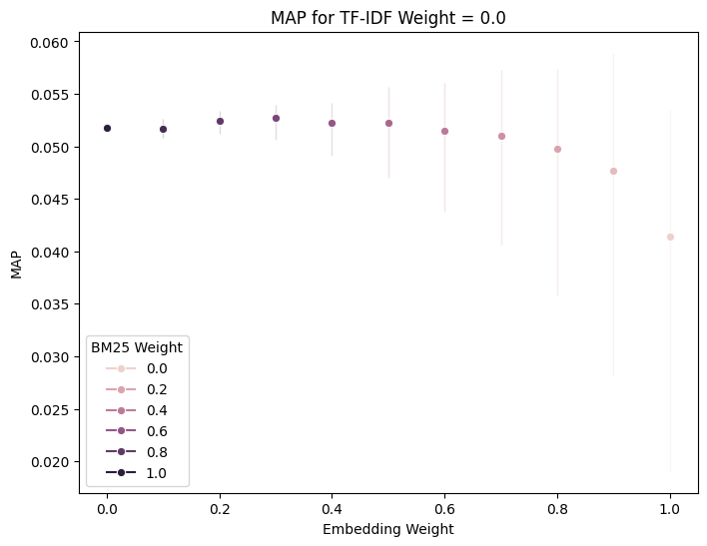

Fig 2: Controlled Variable: TF-IDF weight at 0.0

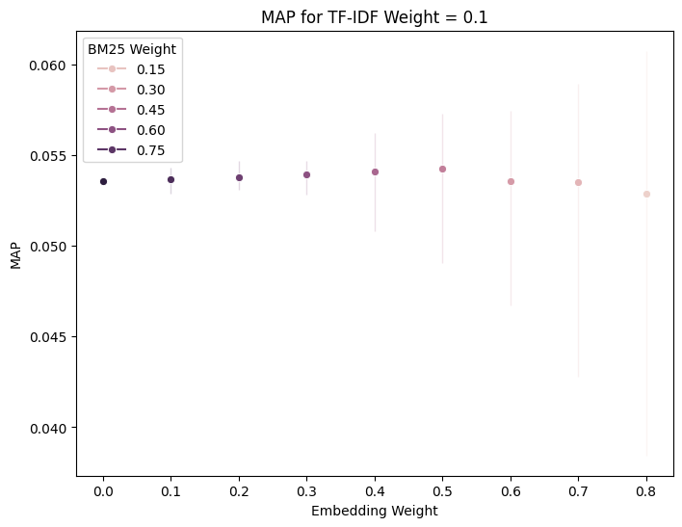 Fig 3: Controlled Variable: TF-IDF weight at 0.1

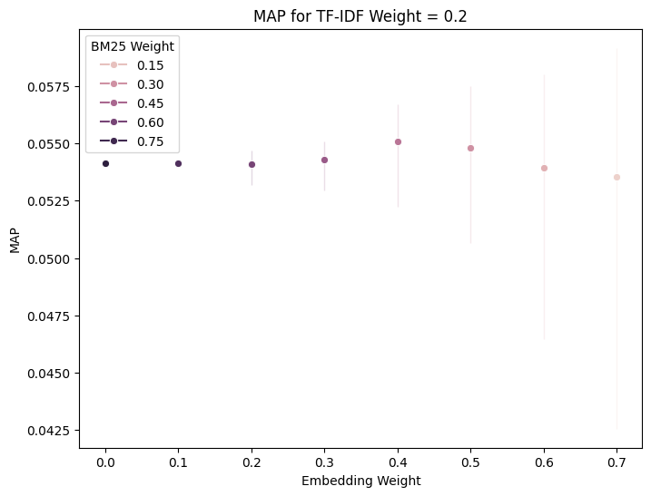 Fig 4: Controlled Variable: TF-IDF weight at 0.2

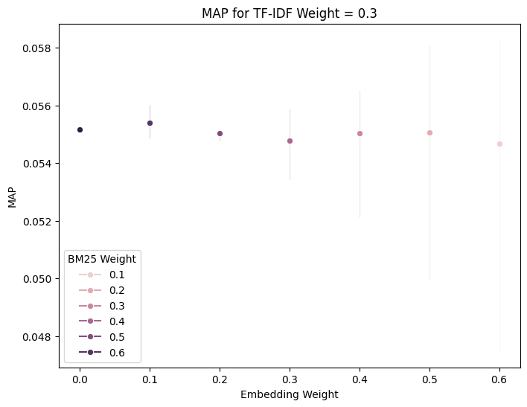 Fig 5: Controlled Variable: TF-IDF weight at 0.3

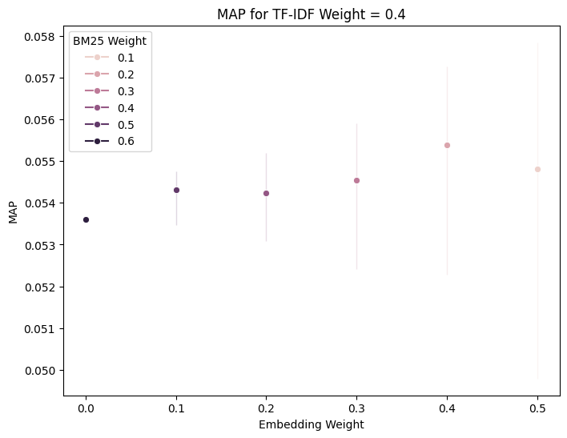

Fig 6: Controlled Variable: TF-IDF weight at 0.4

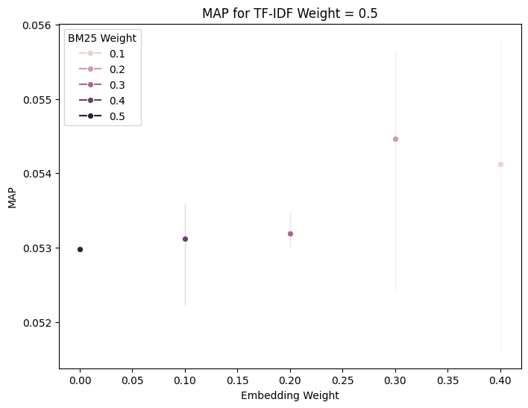 Fig 7: Controlled Variable: TF-IDF weight at 0.5

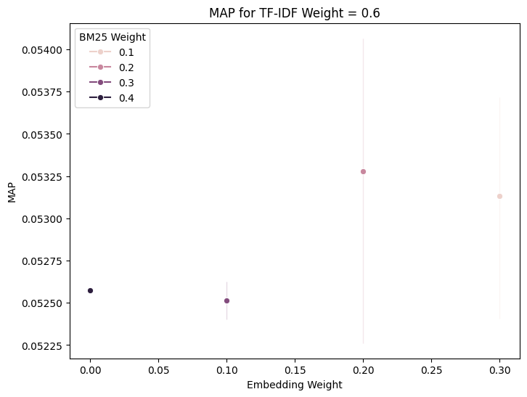

Fig 8: Controlled Variable: TF-IDF weight at 0.6

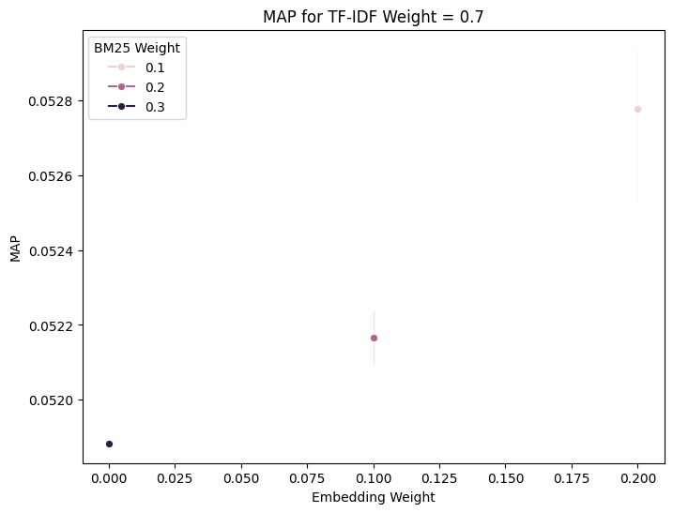 Fig 9: Controlled Variable: TF-IDF weight at 0.7

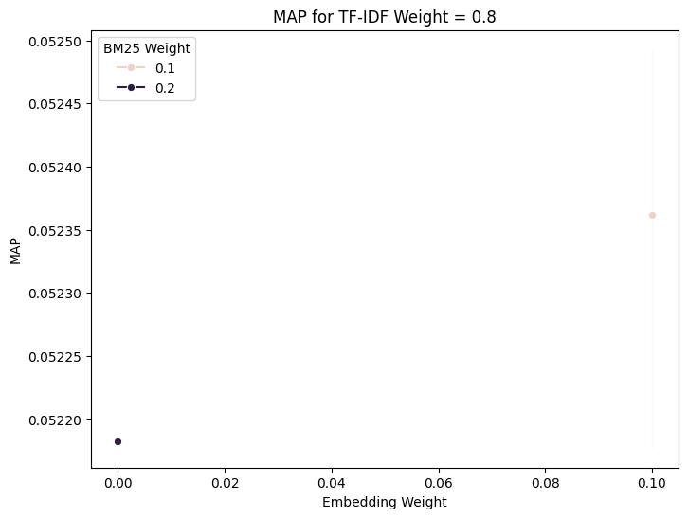 Fig 10: Controlled Variable: TF-IDF weight at 0.8

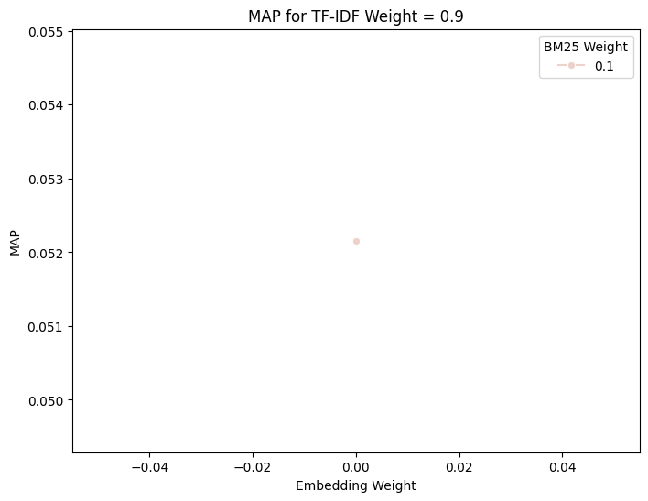Fig 11: Controlled Variable: TF-IDF weight at 0.9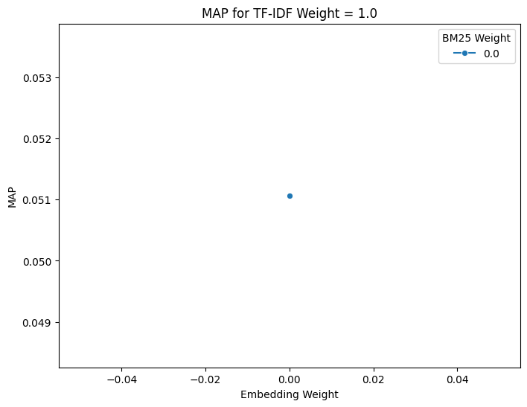 Fig 12: Controlled Variable: TF-IDF weight at 1.0 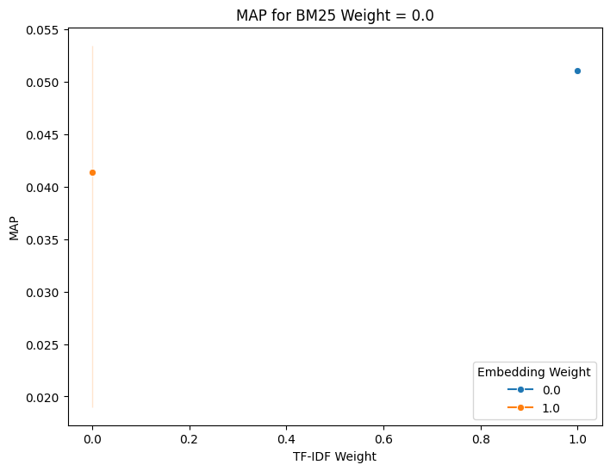 Fig 13: Controlled Variable: BM25 weight at 0.0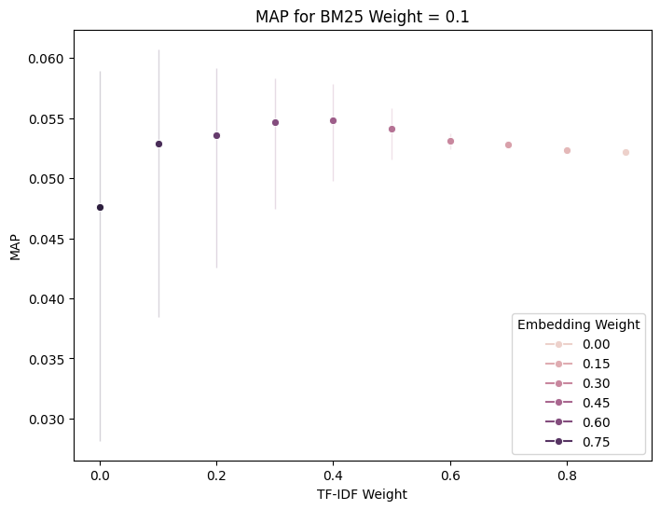 Fig 14: Controlled Variable: BM25 weight at 0.1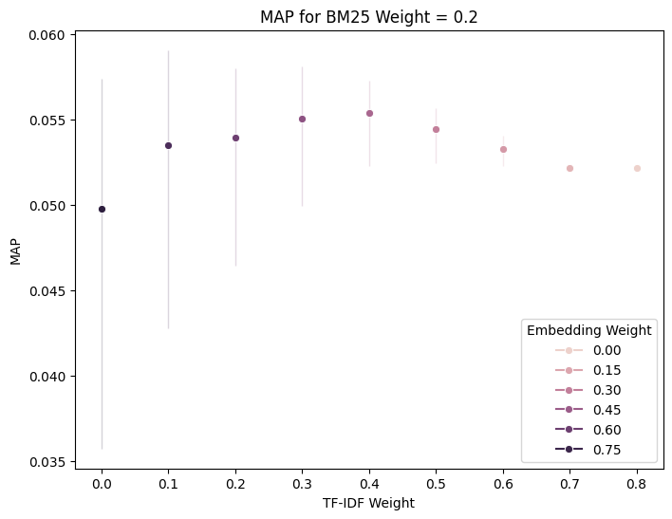 Fig 15: Controlled Variable: BM25 weight at 0.2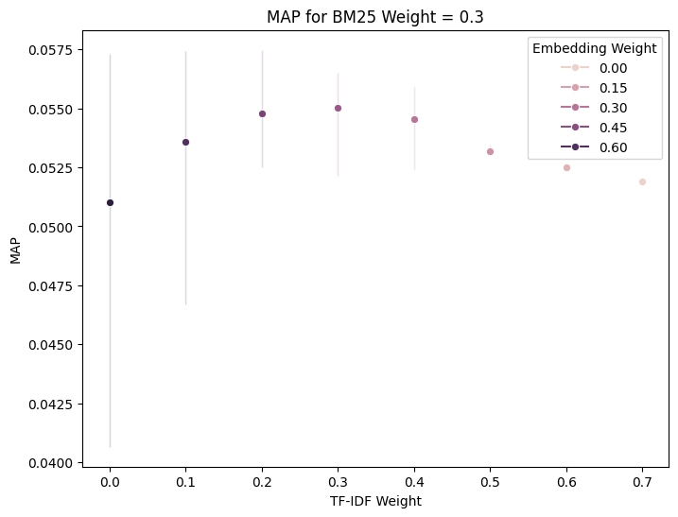 Fig 16: Controlled Variable: BM25 weight at 0.3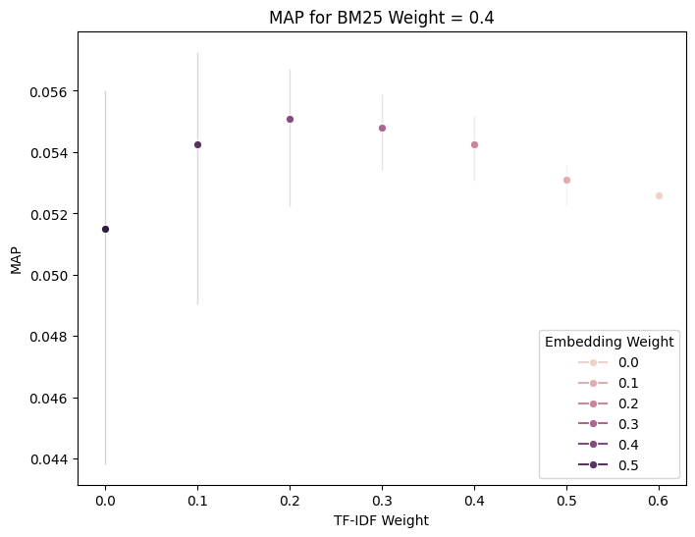 Fig 17: Controlled Variable: BM25 weight at 0.4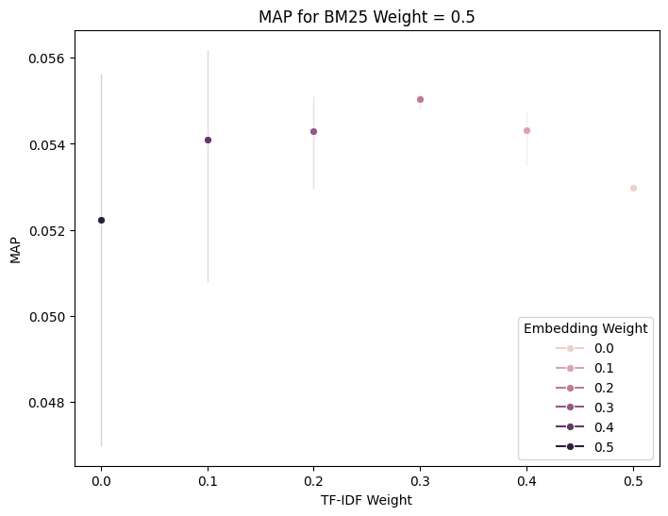 Fig 18: Controlled Variable: BM25 weight at 0.5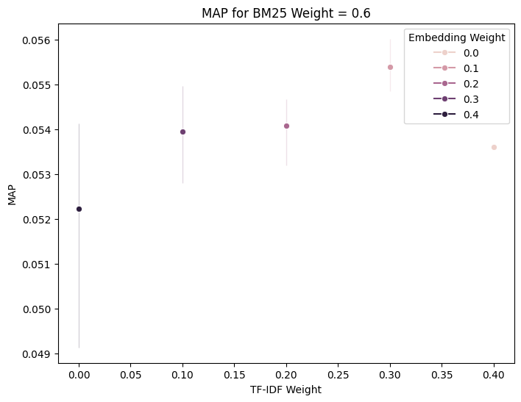 Fig 19: Controlled Variable: BM25 weight at 0.6 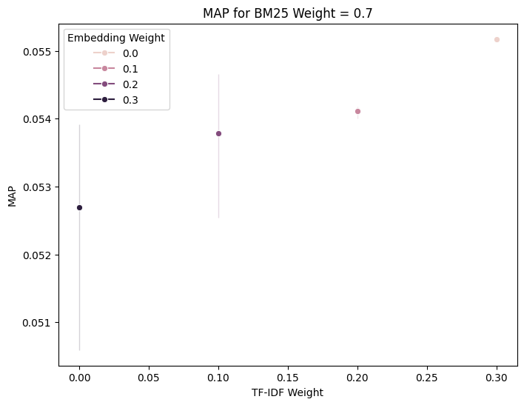 Fig 20: Controlled Variable: BM25 weight at 0.7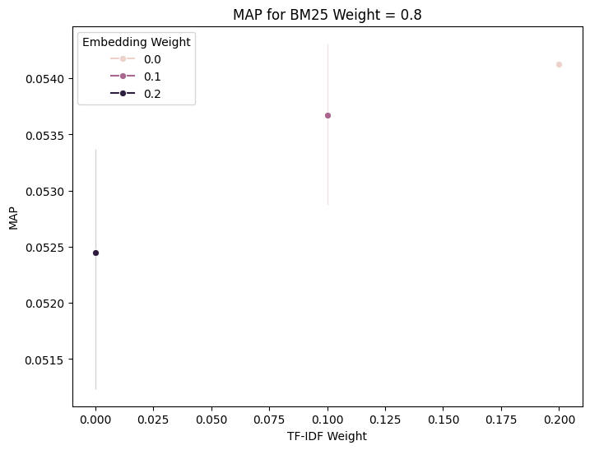 Fig 21: Controlled Variable: BM25 weight at 0.8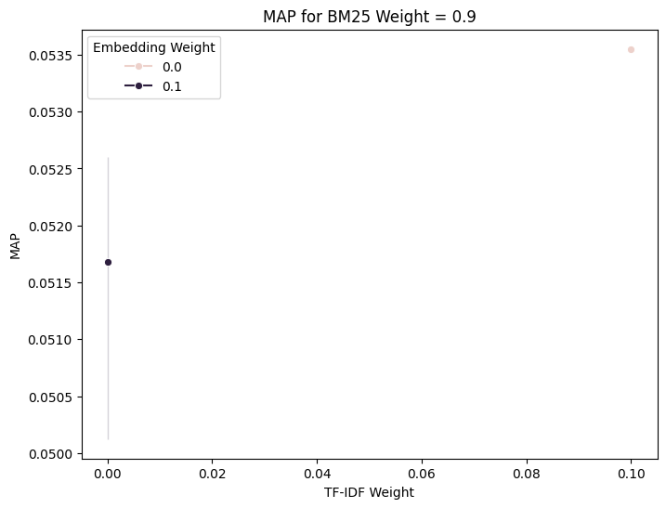 Fig 22: Controlled Variable: BM25 weight at 0.9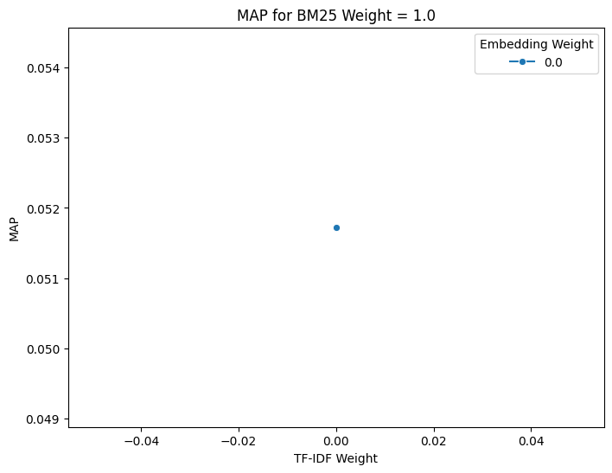 Fig 23: Controlled Variable: BM25 weight at 1.0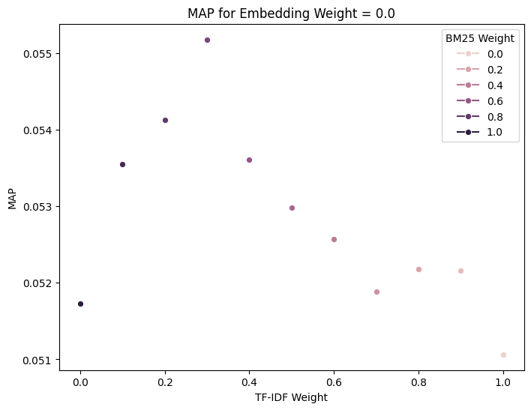 Fig 13: Controlled Variable: Embedding weight at 0.0