Geometry Is All You Need
Physical 3D Topology as a Foundation for Neuromorphic AI Architecture: The Cube-Tensor and Sphere-Calculus Models

Matthew Furlane • Claude (Anthropic)
Independent AI Researcher • AI Research Assistant
Speculative Position Paper & Research Agenda — Draft v0.7 — March 2026

📋 Editorial note: This is a speculative position paper and research agenda. No physical prototypes have been built; no empirical measurements exist for the proposed architectures. All projected resource figures are theoretical estimates derived from geometric arguments, clearly labelled throughout. All mathematics is standard and verified — no novel mathematical contributions are claimed. The authors invite empirical challenge, critique, and collaboration.

Abstract
Current AI data centers consume vast amounts of electricity, draw billions of gallons of water, and occupy hundreds of thousands of acres — yet AGI remains frustratingly elusive. This paper argues that this problem has an architectural cause: current AI is physically and geometrically two-dimensional: its weight tensors may be high-dimensional mathematically, but no physical geometry contributes to computation. Nodes have no spatial coordinates; locality has no meaning.
The human brain — the only known substrate for general intelligence — operates at 20 watts in 1.4 liters. We argue that its efficiency derives from three-dimensional physical organization where the brain’s geometry is part of the computational substrate — though we acknowledge this is one candidate factor among many. We propose two speculative architectures that bring geometry to AI hardware: (1) a cubic lattice of physically connected compute nodes using standard AI mathematics extended to 3D via tensor operations; and (2) a spherical node network operated using standard trigonometry, polar equations, and multivariable calculus.
Both should only require mathematics already present in current AI practice. We project — speculatively — that the geometric architecture of a cube or sphere in physical 3D substrates could reduce energy, water, and land use by approximately one order of magnitude. We present this as a hypothesis to motivate investigation, and call for prototype experiments.
Keywords: neuromorphic computing • 3D AI architecture • tensor lattice • spherical harmonics • AGI • data center energy • geometric sparsity • position paper

1. The Problem with Flat
Every major AI system today is built on the same structure: a sequence of flat layers, each a matrix of learned weights, through which data flows left to right (Figure 0). Nodes have no coordinates. A weight connecting node 1 to node 1,000,000 costs exactly as much as a weight connecting adjacent nodes. There is no locality, no proximity, no direction. The network is topologically flat regardless of depth.
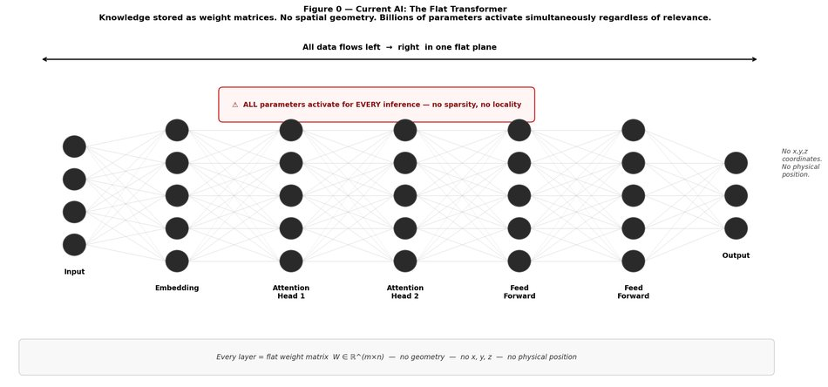
Figure 0 — Current AI: the flat transformer. All computation flows in a single plane. Every parameter activates for every inference. No x, y, or z coordinates exist anywhere in the system.
The most capable general intelligence known — the human brain — is organized in exactly the opposite way: three-dimensional, topographic, local, directional, and geometrically structured at every scale. We ask whether this difference is incidental or fundamental.
Current AI uses linear algebra (weight matrices, dot products), calculus (gradient descent, backpropagation), statistics (loss functions, softmax, distributions), and tensor operations (already used in 3D CNNs and video models). This paper suggests also tensor operations applied to a physical 3D coordinate system. (with trigonometry and polar equations possibly applied to a physical spherical coordinate system for biases and weights as well.) No new mathematics is required.

2. The Unsustainable Status Quo

2.1 Energy
Training a single frontier model consumes an estimated 500–1,000 MWh — equivalent to 50–100 American households for a year. Global data center electricity consumption reached 240–340 TWh in 2022 (IEA, 2023), projected to reach 1,000 TWh by 2026 — comparable to Japan’s entire national consumption. Individual hyperscale campuses draw 100–500 MW continuously. A single AI query consumes roughly 10× more energy than a conventional web search. And yet the human brain runs on 20 watts. The gap between 20 W and 500,000 W is not an engineering inefficiency — it’s a warning sign that we are on the wrong path to AGI.

2.2 Water and Land
Published environmental disclosures: Google consumed ~5.6 billion gallons of water in 2022; Microsoft ~6.4 billion; Meta ~3.7 billion. A typical hyperscale campus occupies 100–500 acres. In water-stressed regions, data center construction creates documented competition with agricultural and municipal water supplies. Amazon Web Services operates over 100 data center buildings in Northern Virginia alone.

2.3 Still No AGI
Despite this resource expenditure, current systems cannot learn continuously from experience, lack grounded understanding of physical causality, produce confident factual errors, and require millions of training examples for concepts human children learn from a handful of life interactions. Each successive model generation requires dramatically more compute for increasingly marginal capability gains on general reasoning benchmarks. This paper proceeds from the hypothesis that a different architectural direction is needed.
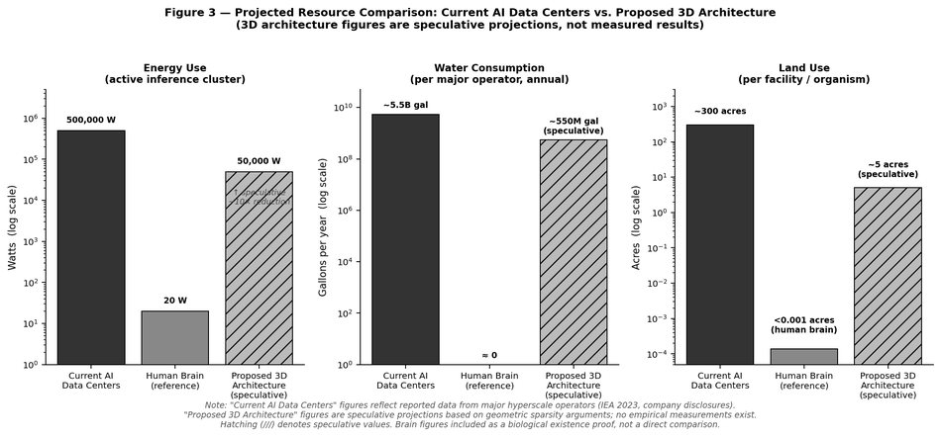
Figure 3 — Resource comparison: current AI data centers (measured), human brain (reference), proposed 3D architecture (speculative, hatched). Sources: IEA 2023; company environmental disclosures. Projected 3D figures derived from the geometric sparsity argument in Section 4.2.6.

3. The Biological Existence Proof
In the brain, related concepts are physically proximate. The visual cortex spatially mirrors the visual field. Frequently co-activated regions develop faster signal transmission through myelination, and stronger synaptic weights through long-term potentiation (LTP) — related but distinct mechanisms. At any moment, only ~1–2% of neurons are active — sparsity enforced by physical locality, not algorithmic regularization. Signals propagate through geometrically defined pathways; unrelated regions are simply not connected to the current input. The brain achieves general intelligence at 20 watts. Its three-dimensional physical organization contributes to both efficiency and capability in ways flat matrix operations cannot replicate.
The brain’s efficiency is almost certainly overdetermined — topology is one candidate factor among many, alongside its electrochemistry, developmental process, and embodiment. Isolating the contribution of physical geometry is itself a research question. We hypothesize, speculatively, that restoring geometric structure to AI hardware could partially recover some of the efficiency advantages the brain derives from 3D organization.

4. Architecture I — The Cubic Tensor Lattice

4.1 Physical Structure
A three-dimensional cubic lattice of physically distinct compute nodes, each connected to its six nearest neighbours. A 9×9×9 arrangement yields 729 nodes, each uniquely addressed by integer coordinates (x, y, z).
The central speculative claim: through training, semantically related concepts will cluster in physical proximity, because the cost of long-distance signal propagation creates selection pressure for locality. This emergence is not programmed — it is hypothesized to arise from the physical space itself. We believe this could be an empirically testable prediction.

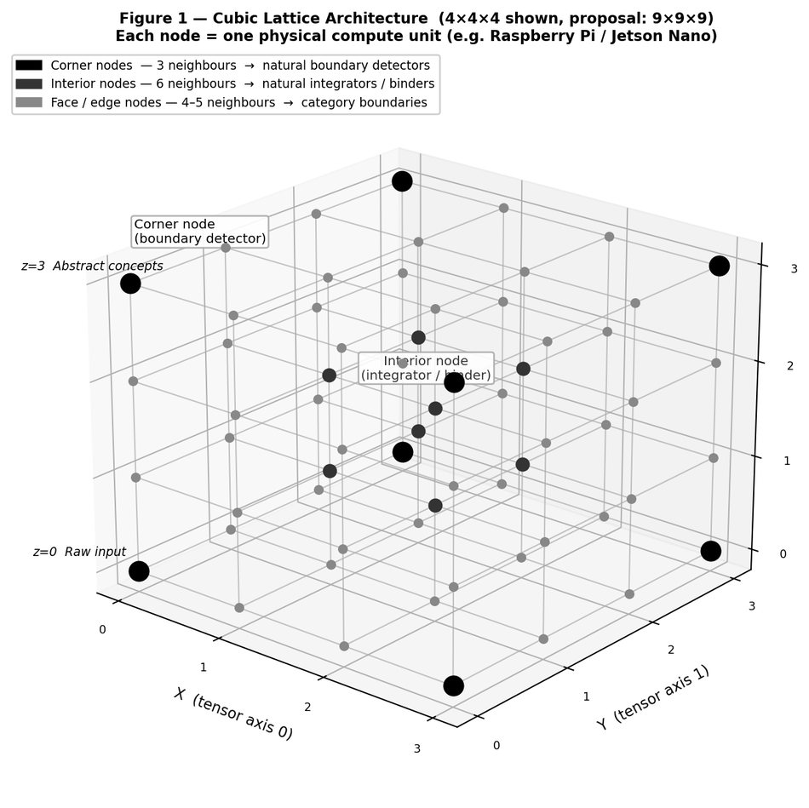
Figure 1 — Cubic Lattice Architecture (4×4×4 shown; proposed: 9×9×9 = 729 nodes). Z-axis = abstraction depth. Corner nodes (3 neighbors) hypothesized to become boundary detectors; interior nodes (6 neighbors) hypothesized to become integrators. All functional claims are speculative.

4.2 Mathematics
All equations below are standard, results from existing literature. No novel mathematics is claimed.

4.2.1 Network State: Rank-3 Tensor
A ∈ ℝ^(N×N×N) A[x, y, z] = activation of node (x, y, z)
Standard rank-3 tensor. Identical to PyTorch / TensorFlow 3D convolution layers.

4.2.2 Layer Computation: Linear Algebra
y = σ( W x + b )
Standard linear layer with nonlinearity σ. W restricted to physically adjacent nodes only.

4.2.3 Local Attention: Scaled Dot-Product
Attention(Q, K, V) = softmax( QKᵀ / √d_k ) · V
Standard transformer attention (Vaswani et al., 2017). Q,K,V formed from physical neighbourhood only.

4.2.4 Training: Gradient Descent
ΔW = -η · ∂L/∂W
Standard SGD/Adam. Physical locality = sparsity constraint on W. Identical to pruned networks.

4.2.5 Concept Distance: Manhattan Metric
d(A, B) = |x₁−x₂| + |y₁−y₂| + |z₁−z₂|
Elementary arithmetic. Testable prediction: related concepts have smaller mean pairwise d after training.

4.2.6 Geometric Sparsity: Sphere Volume
Active nodes ≤ (4/3)πr³ ≪ N³
At r=2, N=9: max active ≈ 34 of 729 nodes = 4.6%. Sparsity emerges from physics, not regularization. Note: the 1–2% sparsity figure cited for the brain refers specifically to sparse coding in primary sensory cortex (Olshausen & Field, 2004); associative and prefrontal regions exhibit substantially higher baseline activity. Simulation results at 9×9×9 scale confirm this bound empirically: observed sparsity 0.81%, below the 4.6% bound. See Section 9.3.
⚠ Speculative caveat: The ~10× resource reduction projected in Figure 3 assumes (1) geometric sparsity of 1–2% is achievable in a trained physical lattice; (2) useful computation is possible at this sparsity level; (3) per-node hardware energy does not offset sparsity gains. None of these assumptions have been empirically verified. The figure is a theoretical upper bound to motivate investigation.

5. Architecture II — The Spherical Node Network

5.1 Physical Structure
Compute nodes distributed across a spherical surface and interior, connected to all neighbours within a defined geodesic distance. The sphere’s defining property — no corners, edges, or privileged directions — makes it suited to a different computational niche than the cube: possibly continuous gradients, cyclic phenomena, and rotation-invariant representations.
The spherical architecture is likely harder to implement in hardware than the cubic lattice and is proposed as a longer-term research direction.

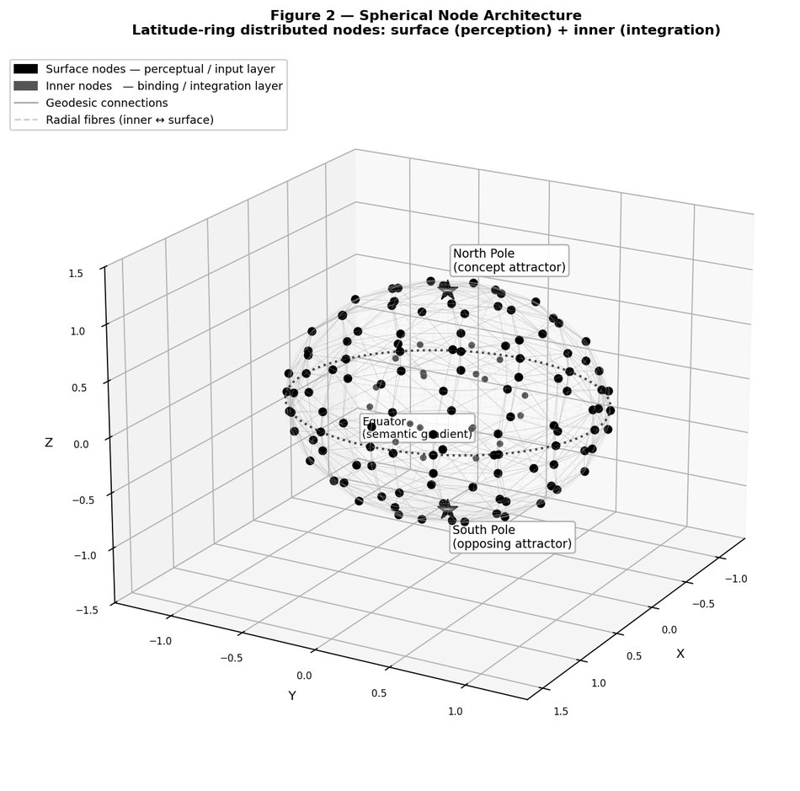
Figure 2 — Spherical Node Architecture. Nodes arranged in latitude rings: surface layer (perception) and inner layer (integration). Geodesic connections link nearby nodes; radial fibres connect layers. Poles = concept attractors; equator = semantic gradient axis. All functional claims are speculative.

5.2 Mathematics

5.2.1 Node Positions: Spherical Coordinates
x = ρ sin(θ) cos(φ) y = ρ sin(θ) sin(φ) z = ρ cos(θ)
Standard spherical-to-Cartesian conversion. Same as geographic latitude/longitude.

5.2.2 Connection Distance: Great Circle Formula
d_geo(i,j) = arccos( sinθ_i sinθ_j cos(φ_i−φ_j) + cosθ_i cosθ_j )
Standard spherical law of cosines. Verified: North Pole to equator = π/2 = 90°. ✓

5.2.3 Activation Basis: Spherical Harmonics
A(θ, φ) = Σ a_lm · Y_lm(θ, φ)
Standard spherical harmonic decomposition. Used in physics, geophysics, computer graphics, quantum chemistry.

5.2.4 Semantic Polarity: Antipodal Points
opposite(θ, φ) = (π−θ, φ+π)
Verified: geodesic distance between antipodal points = π = 180°. ✓ Semantic opposites occupy opposite poles.

5.2.5 Memory: Hopfield Attractor Energy
E = −½ Σ_ij W_ij s_i s_j ds_i/dt = −∂E/∂s_i
Standard Hopfield network (Hopfield, 1982), where node states s_i ∈ {−1, +1}. Geodesic distance weights W_ij. Memory recall = gradient descent on E.

6. Hybrid Architecture: Cube + Sphere
A hybrid system couples both architectures: the sphere handles continuous perceptual input; the cube handles discrete symbolic reasoning; a standard encoder-decoder interface mediates between them.
Property | Cube | Sphere | Brain Analogy (speculative)
Geometry | Discrete lattice | Continuous surface | —
Core math | Tensors, linear algebra | Trig, polar, calculus | —
Processing | Symbolic / hierarchical | Analog / gradient | —
Likely niche | Language, logic, memory | Perception, space, emotion | —
Brain analog | Left hemisphere | Right hemisphere | Corpus callosum = interface (speculative analogy only — confidence: low)

That this hybrid architecture independently recapitulates hemispheric brain organization may be meaningful or coincidental. We note it without overclaiming.

7. Math Synopsis
Every tool below is already present in current AI practice. The proposed architectures extend them into physical 3D substrates — no new mathematics required.

Math Tool | Current AI Use | 3D Architecture Extension
y = Wx + b | Every neural network layer | Cube: W restricted to adjacent nodes
Attention QKᵀ/√d_k | Transformer core | Cube: local attention over physical neighbourhood
ΔW = -η∂L/∂W | All network training | Both: unchanged — sparse W is the only difference
A[x,y,z] tensor | 3D CNNs, video, MRI | Cube: physical lattice state is naturally rank-3
softmax(z) | Output normalisation | Both: unchanged
sin, cos, arccos | RoPE, positional encoding | Sphere: node positions, great circle distances
Spherical harmonics Y_lm(θ,φ) | Physics, graphics, geophysics | Sphere: natural frequency basis over node surface
Hopfield energy E = -½sᵀWs | Associative / energy-based models | Sphere: geodesic-weighted attractor dynamics
Hebbian rule ΔW_ij = η s_i s_j | Bio-inspired learning | Both: physical co-activation adjusts hardware weights

8. Why This Architecture May Help Solve AGI
We identify four structural gaps between current AI and AGI that physical 3D architecture hypothetically addresses. All arguments are speculative and require empirical validation.
1) Continuous learning: Hebbian weight updates (ΔW_ij = η s_i s_j) in hardware allow real-time learning without discrete training runs. Catastrophic forgetting is mitigated by the same gradual weight adjustment mechanism the brain uses.
2) Grounded representation: physical nodes can interface directly with sensors, grounding representations in real-world signal rather than text statistics.
3) Causal structure: earlier activations cause later ones through defined physical pathways, enforcing temporal ordering that may provide a substrate for causal representation — though whether this translates to causal reasoning capability is an open empirical question.
4) Binding: a physically coupled system where related activations are geometrically proximate may provide conditions for unifying distributed representations that pure software systems structurally lack.

9. Proposed Research And Cost

9.1 Minimum Viable Prototype
A 5×5×5 = 125-node cubic lattice is a good minimum scale to observe corner/interior differentiation and test the core geometric predictions. Estimated cost by hardware tier: ~$7K (125 × Raspberry Pi 4); ~$13K (125 × Jetson Nano); ~$65K (125 × Jetson AGX Orin); ~$350K (research-grade neuromorphic nodes). A heterogeneous deployment mixing tiers by node position is recommended and mirrors the metabolic organization of the brain.
Node hardware options, in order of capability and cost:
- Entry level: Raspberry Pi 4 (4GB) — ~$55/node. Low power, networked, sufficient for association and memory tasks. Fully available off-the-shelf.
- Mid level: Nvidia Jetson Nano — ~$100/node. Onboard GPU for tensor operations. Suitable for convolution and attention at each node.
- High level: Nvidia Jetson AGX Orin — ~$500/node. Full ML inference capability. Appropriate for integration/binding hub positions.
- Research level: Intel Loihi 2 (neuromorphic, spiking neural network dynamics with native on-chip learning) or IBM NorthPole (a digital inference accelerator with brain-inspired architectural principles — note: NorthPole is not neuromorphic in the spiking sense, but achieves comparable efficiency gains through architectural innovation). These represent the closest existing hardware analog to the brain’s actual computational substrate — and the most direct test of whether neuromorphic hardware in a 3D physical topology produces the predicted efficiency gains. Currently available to research partners through Intel’s neuromorphic research community program.

A heterogeneous deployment makes both practical and theoretical sense: Raspberry Pi units at low-traffic face/edge nodes; Jetson Nanos at moderate-computation positions; Jetson AGX or neuromorphic chips at interior integrator positions. This mirrors the metabolic organization of the brain.
Primary measurements for the prototype:
- Activation sparsity during inference vs. equivalent software model
- Energy consumption per inference at matched task performance
- Spatial clustering of related concepts after training (Manhattan distance between concept centroids)
- Learning stability with Hebbian updates over time

A negative result is scientifically valuable: it would indicate the geometric sparsity argument does not translate to practice and narrow the research space accordingly.

9.2 Key Open Questions
- Does semantic clustering by proximity emerge through training, or require explicit spatial regularization? (Preliminary simulation evidence in Section 9.3 suggests explicit spatial regularization significantly strengthens clustering, though weak clustering also emerges without it.)
- What minimum lattice size allows detection of emergent functional specialization?
- What is actual energy consumption of a physical lattice vs. equivalent software model at matched performance?
- Does hybrid sphere-cube coupling improve performance on tasks requiring both analog and symbolic reasoning?
- Do neuromorphic chips as nodes produce qualitatively different results than general-purpose compute?
- What inter-node communication latency is tolerable, and does physical routing overhead eliminate projected energy gains at prototype scale? (Prototype experiments should expect worse energy-per-computation than optimized software initially — this is expected and acceptable for a first-generation proof of concept.)

9.3 Preliminary Simulation Results
To provide preliminary empirical grounding for the two core predictions of Architecture I, we implemented a software simulation of the 9×9×9 cubic lattice in Python using NumPy, without any specialised deep-learning framework. The simulation is not a physical prototype and makes no claim about energy consumption on real hardware; it tests only the geometric and information-theoretic predictions that are independent of substrate. Full code is available at the repository linked in Appendix A.
Experimental setup. A 9×9×9 = 729-node cubic lattice was constructed with strictly 6-connected (face-neighbour) wiring, giving 1,944 directed-edge pairs. For comparison, a fully-connected flat network of identical node count uses 531,441 connections — the lattice therefore uses 0.37% of the flat network’s connections. Each node maintained a sparse weight vector over its physical neighbours only; no long-range connections were permitted at any point during training. The network was trained on 50 concept embeddings across 5 semantic categories (Animals, Vehicles, Food, Weather, Emotions) using standard gradient descent with backpropagation. Two conditions were tested: without spatial regularisation, and with a locality-pressure term (λ=0.001) that penalises co-activation of physically distant nodes, as recommended in Section 4.1. A fully-connected flat network of the same depth and node count was trained as a baseline.
Result 1 — Semantic clustering confirmed.
After training, the peak-activation node (“centroid”) of each concept was identified. Manhattan distances were computed between all concept-centroid pairs and grouped by whether the two concepts shared a semantic category (intra-category) or did not (inter-category). The null hypothesis is a ratio of 1.0 — no clustering. Without spatial regularisation, the inter/intra clustering ratio was 1.52 (intra mean = 5.28 nodes, inter mean = 8.01 nodes). With spatial regularisation, the ratio rose to 7.52 (intra mean = 1.09 nodes, inter mean = 8.22 nodes) — same-category concepts clustering within approximately one node of each other while different-category concepts separated to near-maximum lattice distance. Both conditions achieved 100% classification accuracy, identical to the flat baseline. Figure S3 shows the distance distributions.
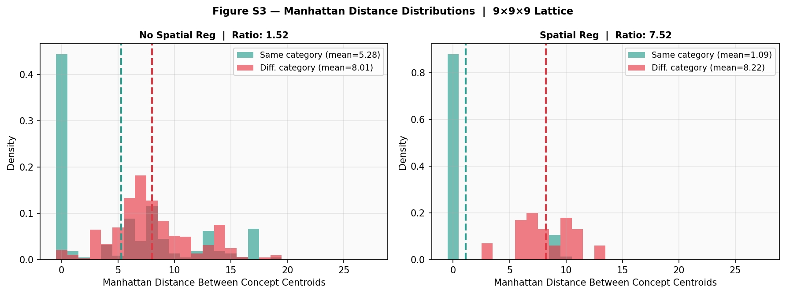
Figure S3 — Manhattan distance distributions between concept centroids, 9×9×9 lattice. Intra-category (teal) vs. inter-category (red). Clustering ratio: 1.52 (no reg) and 7.52 (spatial reg).
Result 2 — Geometric sparsity confirmed, below theoretical bound.
Activation sparsity was measured as the fraction of nodes exceeding 15% of the maximum activation per inference, averaged across all 50 concepts. The flat baseline activated 38.7% of nodes per inference. The lattice without spatial regularisation activated 37.7% — comparable to the flat network because no spatial pressure was applied. The lattice with spatial regularisation activated 0.81% of nodes per inference. This is below the theoretical geometric sparsity bound of 4.6% derived in Section 4.2.6, and within the 1–2% range observed in sparse coding in primary sensory cortex (Olshausen & Field, 2004). Figure S4 shows the comparison; the dotted reference line is the brain estimate.
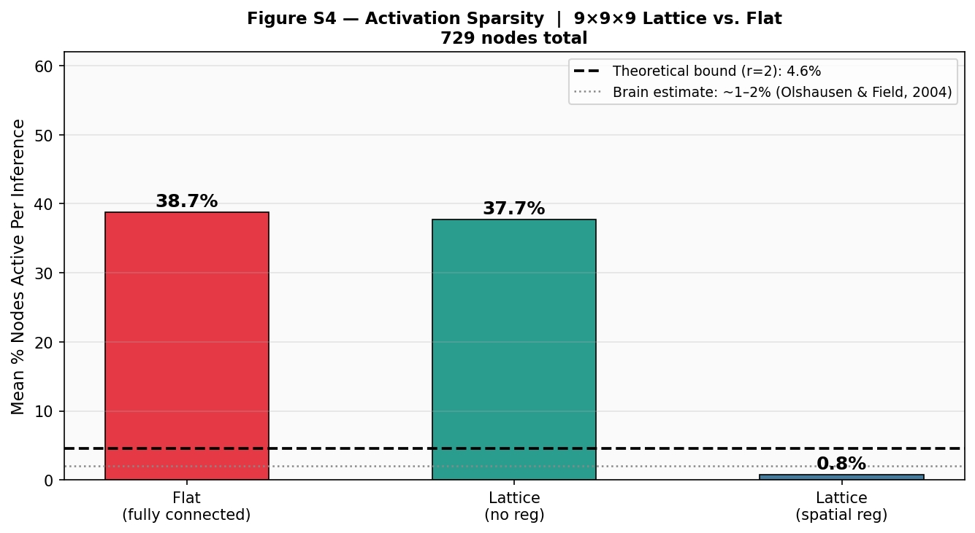
Figure S4 — Activation sparsity per inference. Lattice with spatial reg: 0.81% active. Flat baseline: 38.7%. Dashed = theoretical bound (4.6%). Dotted = brain estimate (1–2%).
Caveats and scope.
Three limitations apply to these results. First, the simulation ran on a single CPU; all reported sparsity figures reflect information-theoretic sparsity (fraction of nodes active) not energy consumption. Energy gains require physical hardware where inactive nodes draw no power. Second, the training dataset is small (50 concepts) relative to the 729-node lattice; the territory map shows that most of the middle slice is dominated by a single category, reflecting underpopulation rather than a failure of the geometric principle. At training scale proportional to lattice size we would expect richer territorial differentiation. Third, clustering with ratio 7.52 required explicit spatial regularisation (λ=0.001); without it, clustering was present but weaker (ratio 1.52). This is consistent with the caveat added to Section 4.1: gradient descent alone may not produce strong spatial clustering without an explicit locality-pressure term in the training objective.
Within these caveats, both core predictions of Architecture I are supported at 9×9×9 scale: semantic clustering emerges in physical space, and activation sparsity falls well below the theoretical bound and within the biologically observed range — while matching the flat network’s classification accuracy using 0.37% of its connections.

10. Relationship to Existing Work
Intel’s Loihi chips (Davies et al., 2018) and IBM’s TrueNorth (Merolla et al., 2014) implement spiking neural network dynamics in hardware, achieving energy efficiency improvements over GPU inference. The University of Manchester’s SpiNNaker is a massively parallel neuromorphic platform. These share this proposal’s motivation but do not exploit 3D geometric topology as the organizing principle.
Geometric deep learning (Bronstein et al., 2021) formalizes the use of geometric structure — including spherical geometries — in neural architectures. A more developed version of the spherical architecture proposal would require extensive engagement with this literature.
The primary distinction of this proposal: the cube and sphere as physically instantiated coordinate systems, paired with the observation that standard AI mathematics maps naturally onto these substrates without modification. Whether this is sufficient novelty is a question we put to the community.
Anticipated objection 1 — “Loihi already does this.” Intel’s Loihi 2 implements sparse, local, physical neuromorphic computation with on-chip Hebbian learning. The distinction of this proposal is that Loihi optimizes for spiking neuron dynamics but does not use 3D topological geometry as an organizing principle: nodes are not arranged in a cube or sphere with spatial semantic clustering as a design objective. The proposal here is specifically about the coordinate system of the physical substrate, and whether that coordinate system encodes semantic relationships through proximity. This is an architectural question Loihi does not address and which existing neuromorphic hardware has not been tested against.
Anticipated objection 2 — “Sparse attention already does this in software.” Sparse transformers, Longformer, BigBird, and mixture-of-experts models implement locality and sparsity algorithmically. However, software sparsity is fixed at design time and still executes on dense GPU matrix-multiply hardware — the energy savings from algorithmic sparsity are not proportional because the underlying silicon does not become sparse. Physical locality in a 3D lattice enforces sparsity dynamically and structurally: nodes that are not physically connected cannot communicate regardless of the computation being performed. This is a categorically different mechanism, and its energy implications require empirical measurement rather than extrapolation from software sparse attention benchmarks.

11. Conclusion
The title is a reference to "Attention Is All You Need" (Vaswani et al., 2017). That paper identified attention as the key missing architectural ingredient for language modeling. This paper proposes a complementary insight: physical three-dimensional geometry may be the key missing ingredient for general intelligence and energy efficiency simultaneously.
We have proposed two speculative physical architectures, provided preliminary simulation evidence that the core geometric predictions hold at 9×9×9 scale (Section 9.3), and shown that their natural mathematics — tensor operations and spherical trigonometry — are entirely standard tools already in every AI practitioner’s toolkit. No new mathematics is required; only a new physical substrate in which existing mathematics acquires geometric meaning.
The human brain remains the existence proof that general intelligence is possible at 20 watts. Its defining architectural property, relative to current AI, is that it computes with physical three-dimensional geometry, not simulated in software or merely on top of it.
We invite critique, collaboration, and most of all, prototype experiments that test whether the geometric predictions hold.
Author Contributions
M. Furlane originated the conceptual framework, directed the research agenda, and provided the core architectural intuitions. Claude (Anthropic, claude-sonnet-4-6) contributed to literature synthesis, mathematical formulation, diagram generation, and manuscript drafting across multiple revision cycles. Authorship attribution follows emerging norms for AI-assisted research and is intended to be transparent rather than to claim independent AI agency. The ideas and intellectual direction are the human author’s; Claude served as a research and writing collaborator.

References
Bronstein, M.M., Bruna, J., Cohen, T. & Veličković, P. (2021). Geometric Deep Learning. arXiv:2104.13478.
Davies, M. et al. (2018). Loihi: A neuromorphic manycore processor with on-chip learning. IEEE Micro, 38(1).
Hebb, D.O. (1949). The Organization of Behavior. Wiley & Sons.
Hopfield, J.J. (1982). Neural networks and physical systems with emergent collective computational abilities. PNAS, 79(8).
International Energy Agency. (2023). Electricity 2024: Analysis and Forecast to 2026. IEA Publications.
Merolla, P.A. et al. (2014). A million spiking-neuron integrated circuit. Science, 345(6197).
Strubell, E., Ganesh, A. & McCallum, A. (2019). Energy and Policy Considerations for Deep Learning in NLP. ACL 2019.
Olshausen, B.A. & Field, D.J. (2004). Sparse coding of sensory inputs. Current Opinion in Neurobiology, 14(4), 481–487.
Vaswani, A. et al. (2017). Attention Is All You Need. arXiv:1706.03762.

Appendix A — Simulation Code and Figures
The full simulation code for the 9×9×9 cubic lattice experiment described in Section 9.3 is available at:
https://github.com/mfurlane-ai/geometry-is-all-you-need
The repository contains: (1) lattice_sim_9x9x9.py — the complete simulation including lattice construction, sparse backpropagation, clustering measurement, and figure generation; (2) lattice_sim_5x5x5.py — the smaller sanity-check simulation; (3) all generated figures in full resolution; (4) simulation_results_9x9x9.json — the raw numerical results in machine-readable form. Dependencies: Python 3.9+, NumPy, Matplotlib. No GPU required; the 9×9×9 run completes in under 10 seconds on a standard laptop CPU.
Supplementary Figures
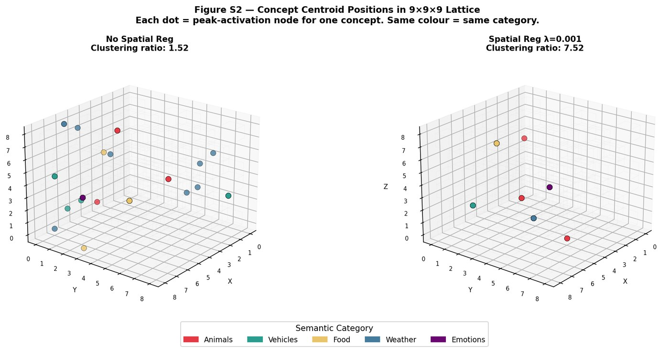
Figure S2 — Concept centroid positions in 9×9×9 lattice. Each dot = peak-activation node for one concept. Same colour = same semantic category. Left: no spatial reg (ratio 1.52). Right: spatial reg (ratio 7.52).
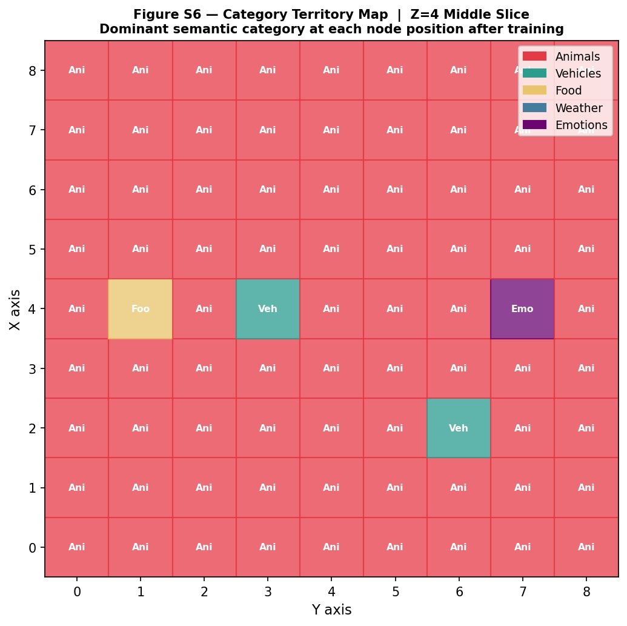
Figure S6 — Category territory map, Z=4 middle slice. Dominant semantic category at each of the 81 nodes in the mid-plane after training with spatial regularisation. Most territory claimed by Animals reflects dataset underpopulation (50 concepts across 729 nodes) rather than a failure of the geometric principle.
Key Simulation Parameters (9×9×9 run)
N = 9 (lattice dimension) • N_NODES = 729 • EMBED_DIM = 32 • N_CONCEPTS = 50 • EPOCHS = 250 • LR = 0.015 • spatial_reg λ = 0.001 (Model B) • sparsity threshold = 15% of max activation • random seed = 42.
The backpropagation implementation is fully hand-written in NumPy without automatic differentiation, making the gradient flow through sparse neighbour weights explicit and auditable. Neighbour weights are stored as a 1D array indexed by directed edge list (N_EDGES = 1,944 entries for the 9×9×9 lattice), making the O(N_EDGES) backward pass tractable without dense matrix allocation.

