# 

# Chapter 4: User Interface Design

## 4.1. Introduction

A user interface design consists of three main parts:

Page elements should be visualized on paper before building them in the computer. Just as you draw a site map to plan the site, use cartoons and storyboards to begin blocking out the site’s appearance and navigational scheme.

1. Site maps
2. Storyboards
3. Navigational maps
4. Traceability Matrix

## 4.2. Site Maps

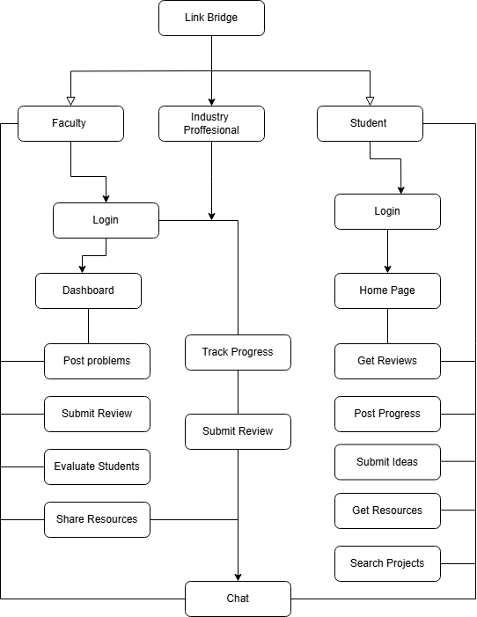

## 4.3. Story boards

A storyboard is a sequence of single images, each of which represents a distinct event or narrative. It is also a visual representation of the script illustrating the interaction between the user and the machine. It can also be imagined as a film in visual-outline form.

A storyboard can be used in two ways. It describes the task, which are a series of images showing the user, environment and the machine. It also describes the interface, which represent series of screen images indicating the user’s representation and the computer’s response and work out interaction details when asking, “what happens next?” It also shows interaction sequence at a glance and helps develop usage scenarios to help develop tools & tasks.

Here’s the story board for “Link Bridge”:

**UI_1: Login/Registration:**

*Login/Registration Page*

*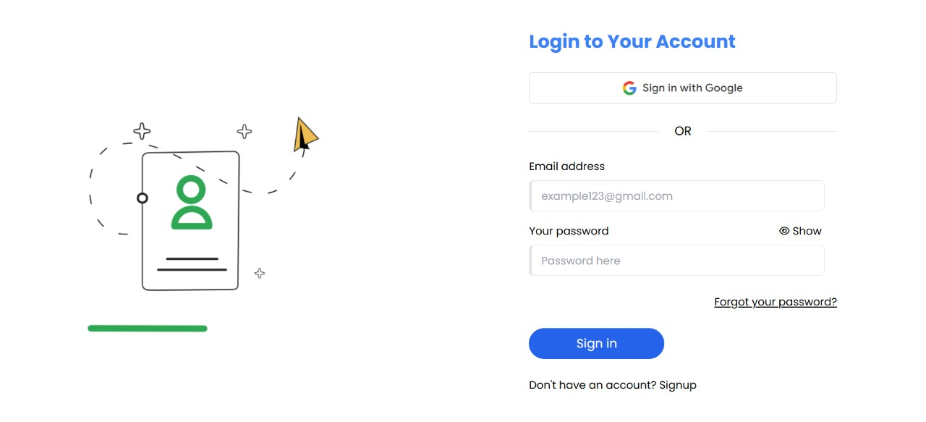Login/Signup*

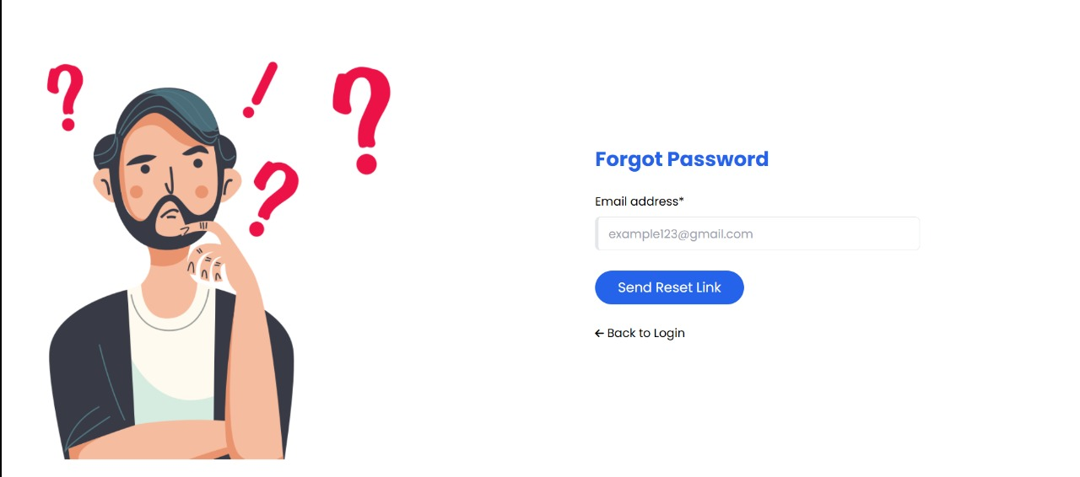

*Forgot Password*

**UI_2: Student Dashboard:**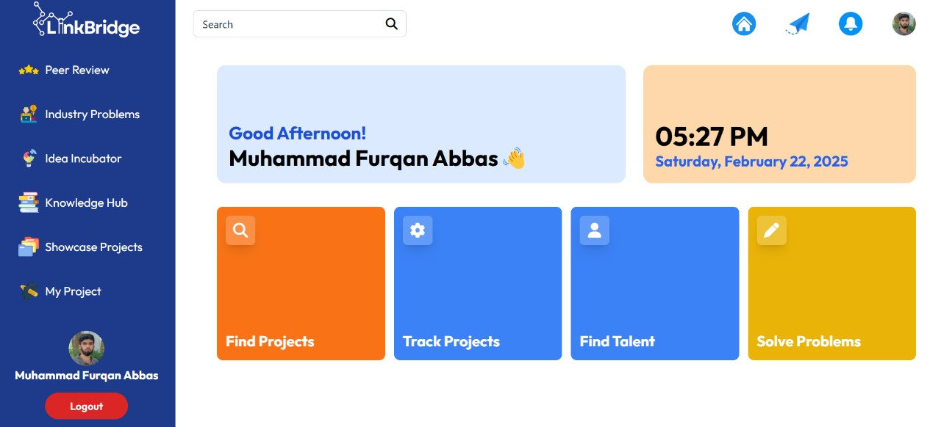

**UI_3: Peer review:**



**UI_4: Industry Problems:**

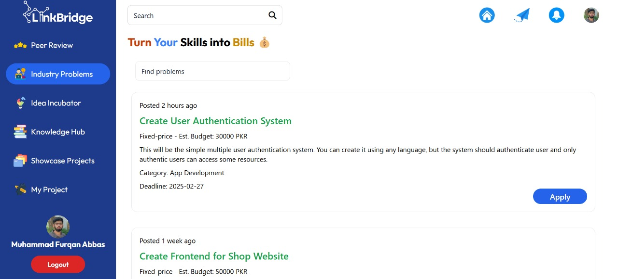

**UI_5: Idea Incubator:**

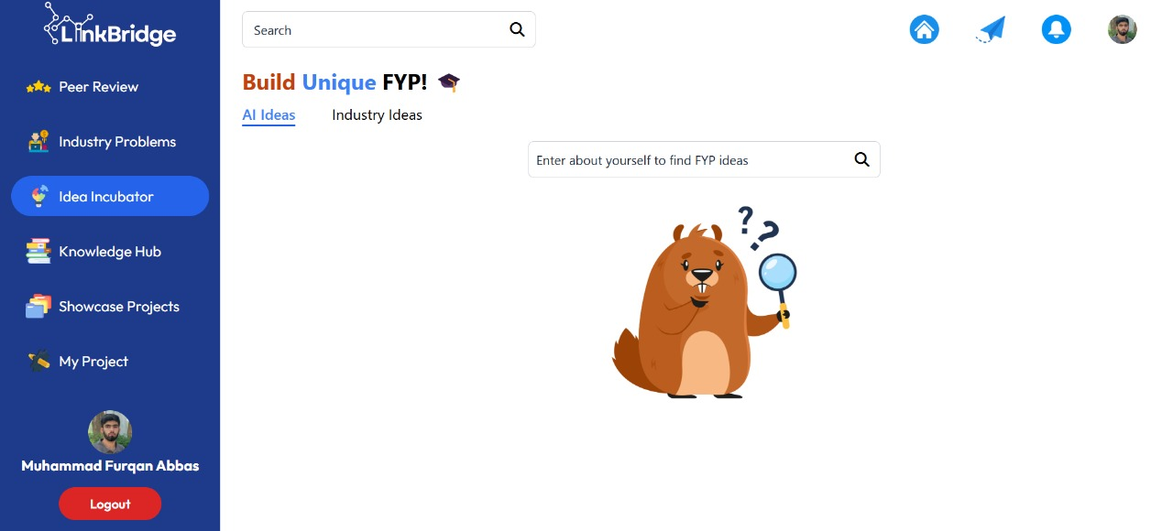

**UI_6: Knowledge Hub:**



**UI_7: Showcase Projects:**



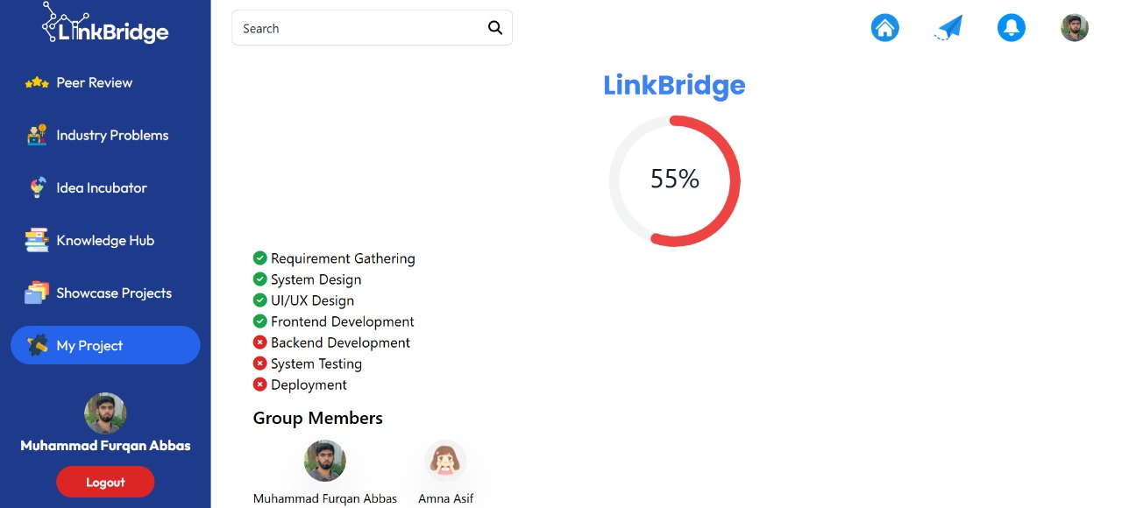**UI_8: My Projects:**

**UI_9: Student Profile:**

**UI_10: Industry’s Dashboard:**

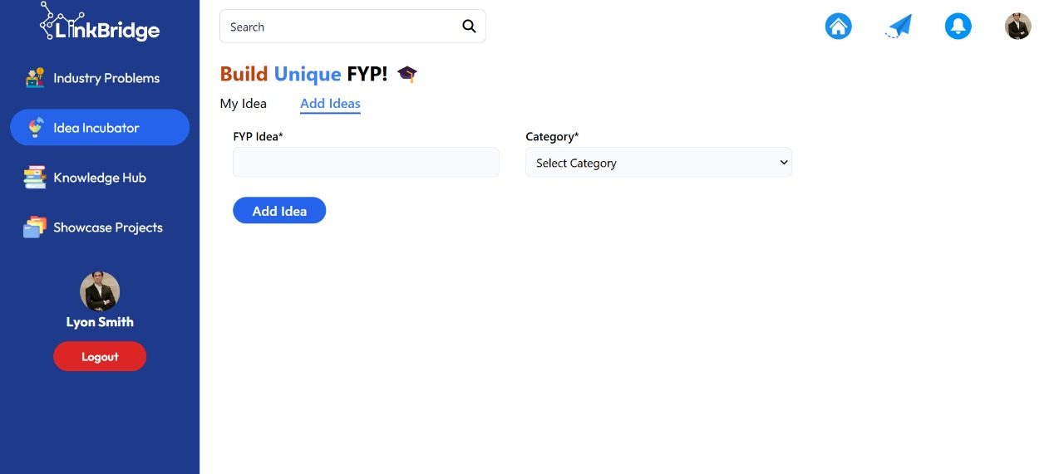

**UI_10: Teacher’s Dashboard:**

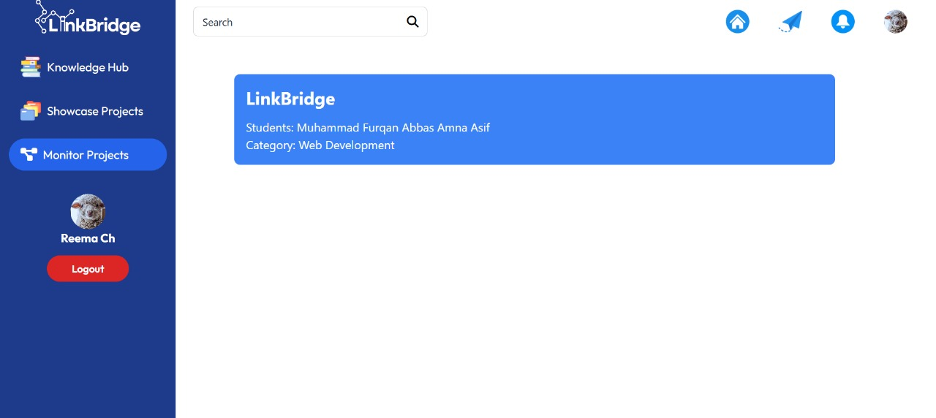

**UI_11: Chat:**

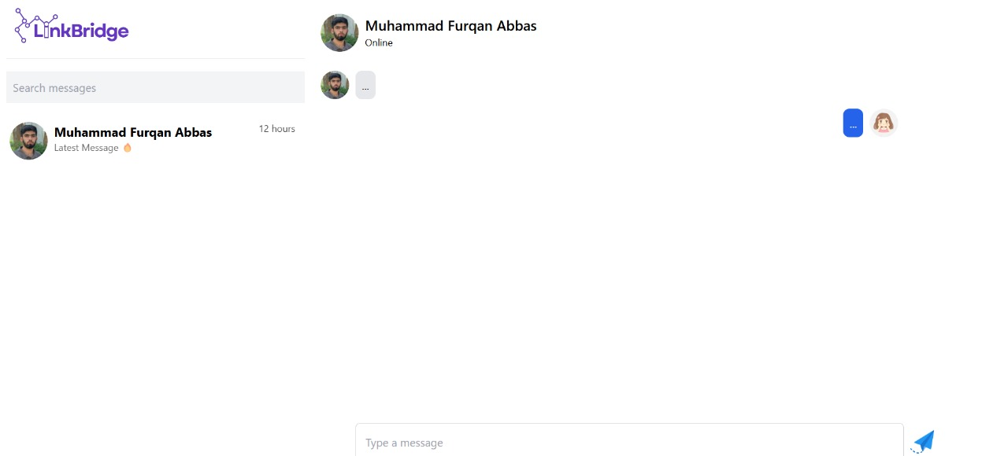

## 

## 4.4. Navigational maps:

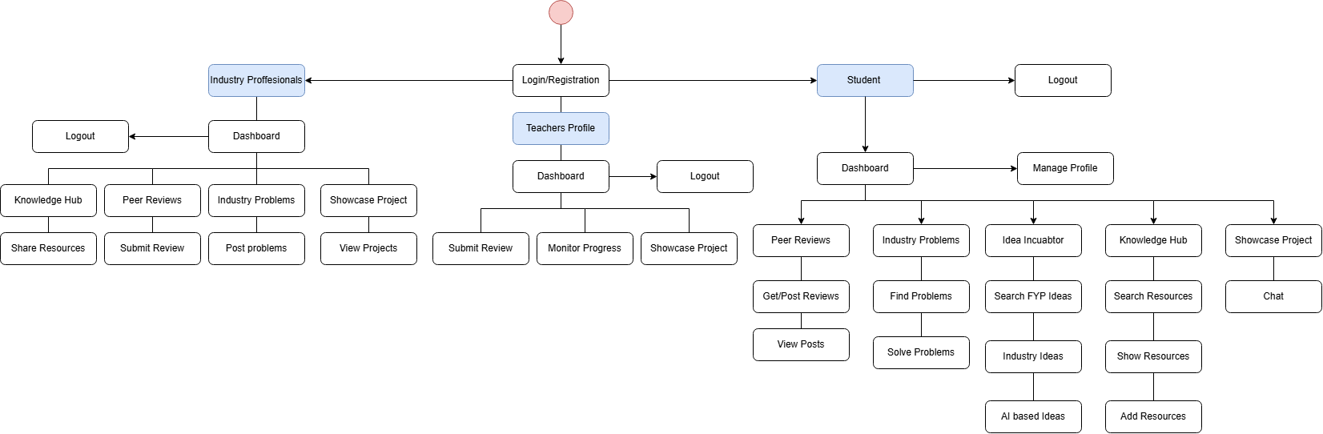

## 4.5 Trace-ability Matrix

***Table 4.1 Users should be able to login***

|  |  |
| --- | --- |
| **Feature** | **Student should be able to log in to the system.** |
| **Use Case ID** | UC-1 |
| **UI ID** | UI_1 |
| **Priority** | High |
| **Use Case Cross Ref** | Password Recovery, Two-Factor Authentication |
| **DB Table ID** | Null |
| **Dependent Classes** | Login, Student, Teacher, Industry Proffesional. |

***Table 4.2 Users should be able to Rsgister***

|  |  |
| --- | --- |
| **Feature** | **Student should be able to register.** |
| **Use Case ID** | UC-1 |
| **UI ID** | UI_1 |
| **Priority** | High |
| **Use Case Cross Ref** | Password Recovery, Two-Factor Authentication, Login. |
| **DB Table ID** | Null |
| **Dependent Classes** | Login, Student, Teacher, Industry Proffesional. |

***Table 4.3 Users Should be able to Access the Dashboard***

|  |  |
| --- | --- |
| **Feature** | **Student should be able to access and view the dashboard.** |
| **Use Case ID** | UC-2 |
| **UI ID** | UI_2 |
| **Priority** | High |
| **Use Case Cross Ref** | View Project Suggestions, Access Knowledge Hub, Edit Profile,Peer Review |
| **DB Table ID** | Null |
| **Dependent Classes** | Login,Registration |

***Table 4.4 Users Should be able to Peer Review***

|  |  |
| --- | --- |
| **Feature** | **Students and professionals should be able to perform peer reviews.** |
| **Use Case ID** | UC-3 |
| **UI ID** | UI_3 |
| **Priority** | High |
| **Use Case Cross Ref** | View Project Details, Submit Feedback, Rate Projects |
| **DB Table ID** | Null |
| **Dependent Classes** | Login,Dashboard,Profile |

***Table 4.5 Students Should be able to access industry problems***

|  |  |
| --- | --- |
| **Feature** | **Users should be able to explore and view industry-related problems.** |
| **Use Case ID** | UC-4 |
| **UI ID** | UI-4 |
| **Priority** | Medium |
| **Use Case Cross Ref** | View Industry Problems, Suggest Solutions |
| **DB Table ID** | Null |
| **Dependent Classes** | Login,Registration,Dashboard,Profile |

***Table 4.6 Students Should be able to search idess***

|  |  |
| --- | --- |
| **Feature** | **Users should be able to submit and explore innovative ideas.** |
| **Use Case ID** | UC-5 |
| **UI ID** | UI-5 |
| **Priority** | High |
| **Use Case Cross Ref** | Submit Idea, Review Idea, Collaborate on Idea |
| **DB Table ID** | Null |
| **Dependent Classes** | Login,Registration,Dashboard,Profile |

***Table 4.7 Students Should be able to access resources***

|  |  |
| --- | --- |
| **Feature** | **Users should have access to research materials and resources.** |
| **Use Case ID** | UC-6 |
| **UI ID** | UI-6 |
| **Priority** | High |
| **Use Case Cross Ref** | Access Research Material, Download Files, Search Knowledge Base |
| **DB Table ID** | Null |
| **Dependent Classes** | Login,Registration,Dashboard,Profile |

***Table 4.8 Students Should be able to Showcase Projects***

|  |  |
| --- | --- |
| **Feature** | **Users should be able to showcase their final projects.** |
| **Use Case ID** | UC-7 |
| **UI ID** | UI-7 |
| **Priority** | High |
| **Use Case Cross Ref** | Upload Project, View Project Details, Peer Review |
| **DB Table ID** | Null |
| **Dependent Classes** | Login,Registration,Dashboard,Profile |

***Table 4.9 Students Should be able to manage their projects***

|  |  |
| --- | --- |
| **Feature** | **Users should be able to manage their own projects.** |
| **Use Case ID** | UC-8 |
| **UI ID** | UI-8 |
| **Priority** | High |
| **Use Case Cross Ref** | Edit Project, Delete Project, View Project Status |
| **DB Table ID** | Null |
| **Dependent Classes** | Login,Registration,Dashboard,Profile |

***Table 4.10 Users Should be able to interact through chat***

|  |  |
| --- | --- |
| **Feature** | **Users should have real-time text, audio, and video communication.** |
| **Use Case ID** | UC-111 |
| **UI ID** | UI-9 |
| **Priority** | High |
| **Use Case Cross Ref** | Send Message, Receive Message, Start Video Call, Start Audio Call |
| **DB Table ID** | Null |
| **Dependent Classes** | Login,Registration,Dashboard,Profile |

***Table 4.11 Teachers Should be able to track progress***

|  |  |
| --- | --- |
| **Feature** | **Teachers should be able to track the progress of students.** |
| **Use Case ID** | UC-10 |
| **UI ID** | UI-10 |
| **Priority** | High |
| **Use Case Cross Ref** | View Student Progress, Review Project Milestones, Provide Feedback |
| **DB Table ID** | Null |
| **Dependent Classes** | Login,Registration,Dashboard,Profile |

# Chapter 5: Software Testing

## 5.1 Introduction:

This deliverable is based on the IEEE standard of software testing i.e. IEEE SOFTWARE TEST DOCUMENTATION Std 829-1998. This standard describes a set of basic test documents that are associated with the dynamic aspects of software testing (i.e., the execution of procedures and code). The standard defines the purpose, outline, and content of each basic document. While the documents described in the standard focus on dynamic testing, several of them may be applicable to other testing activities (e.g., the test plan and test incident report may be used for design and code reviews). This standard may be applied to commercial, scientific, or military software that runs on any digital computer. Applicability is not restricted by the size, complexity, or criticality of the software. However, the standard does not specify any class of software to which it must be applied. The standard addresses the documentation of both initial development testing and the testing of subsequent software releases. For a particular software release, it may be applied to all phases of testing from module testing through user acceptance. However, since all of the basic test documents may not be useful in each test phase, the particular documents to be used in a phase are not specified. Each organization using the standard will need to specify the classes of software to which it applies and the specific documents required for a particular test phase.

The standard does not call for specific testing methodologies, approaches, techniques, facilities, or tools, and does not specify the documentation of their use. Additional test documentation may be required (e.g., code inspection checklists and reports). The standard also does not imply or impose specific methodologies for documentation control, configuration management, or quality assurance. Additional documentation (e.g., a quality assurance plan) may be needed depending on the particular methodologies used.

Following are standard artifacts, which must be included in this deliverable:

1. Test Plan
2. Test Design Specification
3. Test Case Specification
4. Test Procedure Specification
5. Test Item Transmittal Report
6. Test Log
7. Test Incident Report
8. Test Summary Report

## 5.2. Test plan

### 7.2.1. Purpose

To prescribe the scope, approach, resources, and schedule of the testing activities. To identify the items being tested, the features to be tested, the testing tasks to be performed, the personnel responsible for each task, and the risks associated with this plan.

### 7.2.2. Outline

A test plan shall have the following structure:

1. Test plan identifier
2. Introduction
3. Test items
4. Features to be tested
5. Features not to be tested
6. Approach
7. Item pass/fail criteria
8. Suspension criteria and resumption requirements
9. Test deliverables
10. Testing tasks
11. Environmental needs
12. Responsibilities
13. Staffing and training needs
14. Schedule
15. Risks and contingencies
16. Approvals

The sections shall be ordered in the specified sequence. Additional sections may be included immediately prior to Approvals. If some or all of the content of a section is in another document, then a reference to that material may be listed in place of the corresponding content. The referenced material must be attached to the test plan or available to users of the plan.

Details on the content of each section are contained in the following sub-clauses.

#### 5.2.2.1. Test plan identifier

Specify the unique identifier assigned to this test plan.

#### 5.2.2.2. Introduction

Summarize the software items and software features to be tested. The need for each item and its history may be included. References to the following documents, when they exist, are required in the highest-level test plan:

1. Project authorization;
2. Project plan;
3. Quality assurance plan;
4. Configuration management plan;
5. Relevant policies;
6. Relevant standards.

In multilevel test plans, each lower-level plan must reference the next higher-level plan.

#### 5.2.2.3. Test items

Identify the test items including their version/revision level. Also specify characteristics of their transmittal media that impact hardware requirements or indicate the need for logical or physical transformations before testing can begin (e.g., programs must be transferred from tape to disk).

Supply references to the following test item documentation, if it exists:

a) Requirements specification

b) Design specification

c) Users guide

d) Operations guide

e) Installation guide

Reference any incident reports relating to the test items. Items that are to be specifically excluded from testing may be identified.

#### 5.2.2.4. Features to be tested

Identify all software features and combinations of software features to be tested. Identify the test design specification associated with each feature and each combination of features.

#### 5.2.2.5. Features not to be tested

Identify all features and significant combinations of features that will not be tested and the reasons.

#### 5.2.2.6. Approach

Describe the overall approach to testing. For each major group of features or feature combinations, specify the approach that will ensure that these feature groups are adequately tested. Specify the major activities, techniques, and tools that are used to test the designated groups of features.

The approach should be described in sufficient detail to permit identification of the major testing tasks and estimation of the time required to do each one.

Specify the minimum degree of comprehensiveness desired. Identify the techniques that will be used to judge the comprehensiveness of the testing effort (e.g., determining which statements have been executed at least once). Specify any additional completion criteria (e.g., error frequency). The techniques to be used to trace requirements should be specified. Identify significant constraints on testing such as test item availability, testing resource availability, and deadlines.

#### 5.2.2.7. Item pass/fail criteria

Specify the criteria to be used to determine whether each test item has passed or failed testing.

#### 5.2.2.8. Suspension criteria and resumption requirements

Specify the criteria used to suspend all or a portion of the testing activity on the test items associated with this plan. Specify the testing activities that must be repeated, when testing is resumed.

#### 5.2.2.9. Test deliverables

Identify the deliverable documents. The following documents should be included:

1. Test plan;
2. Test design specifications;
3. Test case specifications;
4. Test procedure specifications;
5. Test item transmittal reports;
6. Test logs;
7. Test incident reports;
8. Test summary reports.

Test input data and test output data should be identified as deliverables.

Test tools (e.g., module drivers and stubs) may also be included.

#### 5.2.2.10. Testing tasks

Identify the set of tasks necessary to prepare for and perform testing. Identify all inter task dependencies and any special skills required.

#### 5.2.2.11. Environmental needs

Specify both the necessary and desired properties of the test environment. This specification should contain the physical characteristics of the facilities including the hardware, the communications and system software, the mode of usage (e.g., stand-alone), and any other software or supplies needed to support the test. Also specify the level of security that must be provided for the test facilities, system software, and proprietary components such as software, data, and hardware. Identify special test tools needed.

Identify any other testing needs (e.g., publications or office space). Identify the source for all needs that are not currently available to the test group.

#### 5.2.2.12. Responsibilities

Identify the groups responsible for managing, designing, preparing, executing, witnessing, checking, and resolving. In addition, identify the groups responsible for providing the test items identified in 7.2.2.3 and the environmental needs identified in 5.2.2.11.

These groups may include the developers, testers, operations staff, user representatives, technical support staff, data administration staff, and quality support staff.

#### 5.2.2.13 Staffing and training needs

Specify test-staffing needs by skill level. Identify training options for providing necessary skills.

#### 5.2.2.14. Schedule

Include test milestones identified in the software project schedule as well as all item transmittal events.

Define any additional test milestones needed. Estimate the time required to do each testing task. Specify the schedule for each testing task and test milestone. For each testing resource (i.e., facilities, tools, and staff), specify its periods of use.

#### 5.2.2.15. Risks and contingencies

Identify the high-risk assumptions of the test plan. Specify contingency plans for each (e.g., delayed delivery of test items might require increased night shift scheduling to meet the delivery date).

#### 5.2.2.16 Approvals

Specify the names and titles of all persons who must approve this plan. Provide space for the signatures and dates.

## 5.3. Test design specification

### 5.3.1. Purpose

To prescribe the scope, approach, resources, and schedule of the testing activities. To identify the items being tested, the features to be tested, the testing tasks to be performed, the personnel responsible for each task, and the risks associated with this plan.

### 5.3.2. Outline

A test plan shall have the following structure:

1. Test plan identifier;
2. Introduction;
3. Test items;
4. Features to be tested;
5. Features not to be tested;
6. Approach;
7. Item pass/fail criteria;
8. Suspension criteria and resumption requirements;
9. Test deliverables;
10. Testing tasks;
11. Environmental needs;
12. Responsibilities;
13. Staffing and training needs;
14. Schedule;
15. Risks and contingencies;
16. Approvals.

The sections shall be ordered in the specified sequence. Additional sections may be included immediately prior to Approvals. If some or all of the content of a section is in another document, then a reference to that material may be listed in place of the corresponding content. The referenced material must be attached to the test plan or available to users of the plan.

Details on the content of each section are contained in the following sub-clauses.

#### 5.3.2.1 Test plan identifier

Specify the unique identifier assigned to this test plan.

#### 5.3.2.2. Introduction

Summarize the software items and software features to be tested. The need for each item and its history may be included. References to the following documents, when they exist, are required in the highest-level test plan:

1. Project authorization
2. Project plan
3. Quality assurance plan
4. Configuration management plan
5. Relevant policies
6. Relevant standards

In multilevel test plans, each lower-level plan must reference the next higher-level plan.

#### 5.3.2.3. Test items

Identify the test items including their version/revision level. Also specify characteristics of their transmittal media that impact hardware requirements or indicate the need for logical or physical transformations before testing can begin (e.g., programs must be transferred from tape to disk). Supply references to the following test item documentation, if it exists:

1. Requirements specification
2. Design specification
3. Users guide
4. Operations guide
5. Installation guide

Reference any incident reports relating to the test items. Items that are to be specifically excluded from testing may be identified.

#### 5.3.2.4. Features to be tested

Identify all software features and combinations of software features to be tested. Identify the test design specification associated with each feature and each combination of features.

#### 5.3.2.5. Features not to be tested

Identify all features and significant combinations of features that will not be tested and the reasons.

#### 5.3.2.6. Approach

Describe the overall approach to testing. For each major group of features or feature combinations, specify the approach that will ensure that these feature groups are adequately tested. Specify the major activities, techniques, and tools that are used to test the designated groups of features.

The approach should be described in sufficient detail to permit identification of the major testing tasks and estimation of the time required to do each one. Specify the minimum degree of comprehensiveness desired. Identify the techniques that will be used to judge the comprehensiveness of the testing effort (e.g., determining which statements have been executed at least once).

Specify any additional completion criteria (e.g., error frequency). The techniques to be used to trace requirements should be specified. Identify significant constraints on testing such as test item availability, testing resource availability, and deadlines.

#### 5.3.2.7. Item pass/fail criteria

Specify the criteria to be used to determine whether each test item has passed or failed testing.

#### 5.3.2.8. Suspension criteria and resumption requirements

Specify the criteria used to suspend all or a portion of the testing activity on the test items associated with this plan. Specify the testing activities that must be repeated, when testing is resumed.

#### 5.3.2.9. Test deliverables

Identify the deliverable documents. The following documents should be included:

1. Test plan
2. Test design specifications
3. Test case specifications
4. Test procedure specifications
5. Test item transmittal reports
6. Test logs
7. Test incident reports
8. Test summary reports

Test input data and test output data should be identiÞed as deliverables. Test tools (e.g., module drivers and stubs) may also be included.

#### 5.3.2.10. Testing tasks

Identify the set of tasks necessary to prepare for and perform testing. Identify all inter task dependencies and any special skills required.

#### 5.3.2.11. Environmental needs

Specify both the necessary and desired properties of the test environment. This specification should contain the physical characteristics of the facilities including the hardware, the communications and system software, the mode of usage (e.g., stand-alone), and any other software or supplies needed to support the test. Also specify the level of security that must be provided for the test facilities, system software, and proprietary components such as software, data, and hardware. Identify special test tools needed.

Identify any other testing needs (e.g., publications or office space). Identify the source for all needs that are not currently available to the test group.

#### 5.3.2.12. Responsibilities

Identify the groups responsible for managing, designing, preparing, executing, witnessing, checking, and resolving. In addition, identify the groups responsible for providing the test items identified in 7.2.2.3 and the environmental needs identified in 5.3.2.11.

These groups may include the developers, testers, operations staff, user representatives, technical support staff, data administration staff, and quality support staff.

#### 5.3.2.13. Staffing and training needs

Specify test-staffing needs by skill level. Identify training options for providing necessary skills.

#### 5.3.2.14. Schedule

Include test milestones identified in the software project schedule as well as all item transmittal events. Define any additional test milestones needed. Estimate the time required to do each testing task. Specify the schedule for each testing task and test milestone. For each testing resource (i.e., facilities, tools, and staff), specify its periods of use.

#### 5.3.2.15. Risks and contingencies

Identify the high-risk assumptions of the test plan. Specify contingency plans for each (e.g., delayed delivery of test items might require increased night shift scheduling to meet the delivery date)

#### 5.3.2.16. Approvals

Specify the names and titles of all persons who must approve this plan. Provide space for the signatures and dates.

## 5.4. Test Case Specification

### 5.4.1. Purpose

To define a test case identified by a test design specification.

### 5.4.2. Outline

A test case specification shall have the following structure:

1. Test case specification identifier
2. Test items
3. Input specifications
4. Output specifications
5. Environmental needs
6. Special procedural requirements
7. Inter case dependencies

The sections shall be ordered in the specified sequence. Additional sections may be included at the end. If some or all of the content of a section is in another document, then a reference to that material may be listed in place of the corresponding content. The referenced material must be attached to the test case specification or available to users of the case specification. Since a test case may be referenced by several test design specifications used by different groups over a long time period, enough specific information must be included in the test case specification to permit reuse.

Details on the content of each section are contained in the following sub-clauses.

#### 5.4.2.1. Test case specification identifier

Specify the unique identifier assigned to this test case specification.

#### 5.4.2.2 Test items

Identify and briefly describe the items and features to be exercised by this test case.

For each item, consider supplying references to the following test item documentation:

1. Requirements specification
2. Design specification
3. Users guide
4. Operations guide
5. Installation guide

#### 5.4.2.3. Input specifications

Specify each input required to execute the test case. Some of the inputs will be specified by value (with tolerances where appropriate), while others, such as constant tables or transaction files, will be specified by name. Identify all appropriate databases, files, terminal messages, memory resident areas, and values passed by the operating system.

Specify all required relationships between inputs (e.g., timing).

#### 5.4.2.4. Output specifications

Specify all of the outputs and features (e.g., response time) required of the test items. Provide the exact value (with tolerances where appropriate) for each required output or feature.

#### 5.4.2.5. Environmental needs

##### 5.4.2.5.1. Hardware

Specify the characteristics and configurations of the hardware required to execute this test case (e.g., 132 character´ 24 line CRT).

##### 5.4.2.5.2. Software

Specify the system and application software required to execute this test case. This may include system software such as operating systems, compilers, simulators, and test tools. In addition, the test item may interact with application software.

##### 5.4.2.5.3. Other

Specify any other requirements such as unique facility needs or specially trained personnel.

#### 5.4.2.6. Special procedural requirements

Describe any special constraints on the test procedures that execute this test case. These constraints may involve special set up, operator intervention, output determination procedures, and special wrap up.

#### 5.4.2.7. Inter case dependencies

List the identifiers of test cases that must be executed prior to this test case. Summarize the nature of the dependencies.

## 5.5. Test procedure specification

### 5.5.1. Purpose

To specify the steps for executing a set of test cases or, more generally, the steps used to analyze a software item in order to evaluate a set of features.

### 5.5.2 Outline

A test procedure specification shall have the following structure:

1. Test procedure specification identifier
2. Purpose
3. Special requirements
4. Procedure steps

The sections shall be ordered in the specified sequence. Additional sections, if required, may be included at the end. If some or all of the content of a section is in another document, then a reference to that material may be listed in place of the corresponding content. The referenced material must be attached to the test procedure specification or available to users of the procedure specification.

Details on the content of each section are contained in the following sub clauses.

#### 5.5.2.1. Test procedure specification identifier

Specify the unique identifier assigned to this test procedure specification. Supply a reference to the associated test design specification.

#### 5.5.2.2. Purpose

Describe the purpose of this procedure. If this procedure executes any test cases, provide a reference for each of them. In addition, provide references to relevant sections of the test item documentation (e.g., references to usage procedures).

#### 5.5.2.3. Special requirements

Identify any special requirements that are necessary for the execution of this procedure. These may include prerequisite procedures, special skills requirements, and special environmental requirements.

#### 5.5.2.4. Procedure steps

Include the steps in 8.5.2.4.1. through 8.5.2.4.10 as applicable.

##### 5.5.2.4.1. Log

Describe any special methods or formats for logging the results of test execution, the incidents observed, and any other events pertinent to the test (see Clauses 9 and 10).

##### 5.5.2.4.2. Set up

Describe the sequence of actions necessary to prepare for execution of the procedure.

##### 5.5.2.4.3. Start

Describe the actions necessary to begin execution of the procedure.

##### 5.5.2.4.4. Proceed

Describe any actions necessary during execution of the procedure.

##### 5.5.2.4.5. Measure

Describe how the test measurements will be made (e.g., describe how remote terminal response time is to be measured using a network simulator).

##### 5.5.2.4.6. Shut down

Describe the actions necessary to suspend testing, when unscheduled events dictate.

##### 5.5.2.4.7. Restart

Identify any procedural restart points and describe the actions necessary to restart the procedure at each of these points.

##### 5.5.2.4.8. Stop

Describe the actions necessary to bring execution to an orderly halt.

##### 5.5.2.4.9. Wrap up

Describe the actions necessary to restore the environment.

##### 5.5.2.4..10. Contingencies

Describe the actions necessary to deal with anomalous events that may occur during execution.

## 5.6. Test item transmittal report

### 5.6.1. Purpose

To identify the test items being transmitted for testing. It includes the person responsible for each item, its physical location, and its status. Any variations from the current item requirements and designs are noted in this report.

### 5.6.2. Outline

A test item transmittal report shall have the following structure:

1. Transmittal report identifier
2. Transmitted items
3. Location
4. Status
5. Approvals

The sections shall be ordered in the specified sequence. Additional sections may be included just prior to Approvals. If some or all of the content of a section is in another document, then a reference to that material may be listed in place of the corresponding content. The referenced material must be attached to the test item transmittal report or available to users of the transmittal report.

Details on the content of each section are contained in the following sub clauses.

#### 5.6.2.1. Transmittal report identifier

Specify the unique identifier assigned to this test item transmittal report.

#### 5.6.2.2. Transmitted items

Identify the test items being transmitted, including their version/revision level. Supply references to the item documentation and the test plan relating to the transmitted items. Indicate the people responsible for the transmitted items.

#### 5.6.2.3. Location

Identify the location of the transmitted items. Identify the media that contain the items being transmitted. When appropriate, indicate how specific media are labeled or identified.

#### 5.6.2.4. Status

Describe the status of the test items being transmitted. Include deviations from the item documentation, from previous transmittals of these items, and from the test plan. List the incident reports that are expected to be resolved by the transmitted items. Indicate if there are pending modifications to item documentation that may affect the items listed in this transmittal report.

#### 5.6.2.5. Approvals

Specify the names and titles of all persons who most approve this transmittal. Provide space for the signatures and dates.

## 5.7. Test log

### 5.7.1. Purpose

To provide a chronological record of relevant details about the execution of tests.

### 5.7.2. Outline

A test log shall have the following structure:

1. Test log identifier;
2. Description;
3. Activity and event entries.

The sections shall be ordered in the specified sequence. Additional sections may be included at the end. If some or all of the content of a section is in another document, then a reference to that material may be listed in place of the corresponding content. The referenced material must be attached to the test log or available to users of the log. Details on the content of each section are contained in the following sub clauses.

#### 5.7.2.1. Test log identifier

Specify the unique identifier assigned to this test log.

#### 5.7.2.2. Description

Information that applies to all entries in the log except as specifically noted in a log entry should be included here. The following information should be considered:

* Identify the items being tested including their version/revision levels. For each of these items, supply a reference to its transmittal report, if it exists.
* Identify the attributes of the environments in which the testing is conducted. Include facility identification, hardware being used (e.g., amount of memory being used, CPU model number, and number and model of tape drives, and/or mass storage devices), system software used, and resources available (e.g., the amount of memory available).

#### 5.7.2.3. Activity and event entries

For each event, including the beginning and end of activities, record the occurrence date and time along with the identity of the author. The information in 9.2.3.1 through 9.2.3.5 should be considered:

##### 5.7.2.3.1. Execution description

Record the identifier of the test procedure being executed and supply a reference to its specification. Record all personnel present during the execution including testers, operators, and observers. Also indicate the function of each individual.

##### 5.7.2.3.2. Procedure results

For each execution, record the visually observable results (e.g., error messages generated, aborts, and requests for operator action). Also record the location of any output (e.g., reel number). Record the successful or unsuccessful execution of the test.

##### 5.7.2.3.3. Environmental information

Record any environmental conditions specific to this entry (e.g., hardware substitutions).

##### 5.7.2.3.4. Anomalous events

Record what happened before and after an unexpected event occurred (e.g., A summary display was requested and the correct screen displayed, but response seemed unusually long. A repetition produced the same prolonged response). Record circumstances surrounding the inability to begin execution of a test procedure or failure to complete a test procedure (e.g., a power failure or system software problem).

##### 5.7.2.3.5. Incident report identifiers

Record the identifier of each test incident report, whenever one is generated.

## 5.8. Test incident report

### 5.8.1. Purpose

To document any event that occurs during the testing process that requires investigation.

### 5.8.2. Outline

A test incident report shall have the following structure:

1. Test incident report identifier
2. Summary
3. Incident description
4. Impact

The sections shall be ordered in the specified sequence. Additional sections may be included at the end. If some or all of the content of a section is in another document, then a reference to that material may be listed in place of the corresponding content. The referenced material must be attached to the test incident report or available to users of the incident report.

Details on the content of each section are contained in the following sub clauses.

#### 5.8.2.1. Test incident report identifier

Specify the unique identifier assigned to this test incident report.

#### 5.8.2.2. Summary

Summarize the incident. Identify the test items involved indicating their version/revision level. References to

the appropriate test procedure specification, test case specification, and test log should be supplied.

#### 5.8.2.3. Incident description

Provide a description of the incident. This description should include the following items:

1. Inputs
2. Expected results
3. Actual results
4. Anomalies
5. Date and time;
6. Procedure step;
7. Environment;
8. Attempts to repeat;
9. Testers;
10. Observers.

Related activities and observations that may help to isolate and correct the cause of the incident should be included (e.g., describe any test case executions that might have a bearing on this particular incident and any variations from the published test procedure).

#### 5.8.2.4.Impact

If known, indicate what impact this incident will have on test plans, test design specifications, test procedure specifications, or test case specifications.

## 5.9. Test summary report

### 5.9.1. Purpose

To summarize the results of the designated testing activities and to provide evaluations based on these results.

### 5.9.2. Outline

A test summary report shall have the following structure:

1. Test summary report identifier
2. Summary
3. Variances
4. Comprehensive assessment
5. Summary of results
6. Evaluation
7. Summary of activities
8. Approvals

The sections shall be ordered in the specified sequence. Additional sections may be included just prior to Approvals. If some or all of the content of a section is in another document, then a reference to that material may be listed in place of the corresponding content. The referenced material must be attached to the test summary report or available to users of the summary report.

Details on the content of each section are contained in the following sub clauses.

#### 5.9.2.1. Test summary report identifier

Specify the unique identifier assigned to this test summary report.

#### 5.9.2.2. Summary

Summarize the evaluation of the test items. Identify the items tested, indicating their version/revision level. Indicate the environment in which the testing activities took place.

For each test item, supply references to the following documents if they exist: test plan, test design specifications, test procedure specifications, test item transmittal reports, test logs, and test incident reports.

#### 5.9.2.3. Variances

Report any variances of the test items from their design specifications. Indicate any variances from the test plan, test designs, or test procedures. Specify the reason for each variance.

#### 5.9.2.4. Comprehensiveness assessment

Evaluate the comprehensiveness of the testing process against the comprehensiveness criteria specified in the test plan if the plan exists. Identify features or feature combinations that were not sufficiently tested and explain the reasons.

#### 5.9.2.5. Summary of results

Summarize the results of testing. Identify all resolved incidents and summarize their resolutions. Identify all unresolved incidents.

#### 5.9.2.6. Evaluation

Provide an overall evaluation of each test item including its limitations. This evaluation shall be based upon the test results and the item level pass/fail criteria. An estimate of failure risk may be included.

#### 5.9.2.7. Summary of activities

Summarize the major testing activities and events. Summarize resource consumption data, e.g., total staffing level, total machine time, and total elapsed time used for each of the major testing activities.

#### 5.9.2.8. Approvals

Specify the names and titles of all persons who must approve this report. Provide space for the signatures and dates.