# Build common DoEs using Common_DoEs.py

1. Open **Features.xlsx**.
2. Fill out the continuous features, as shown below, including their minimum and maximum levels.

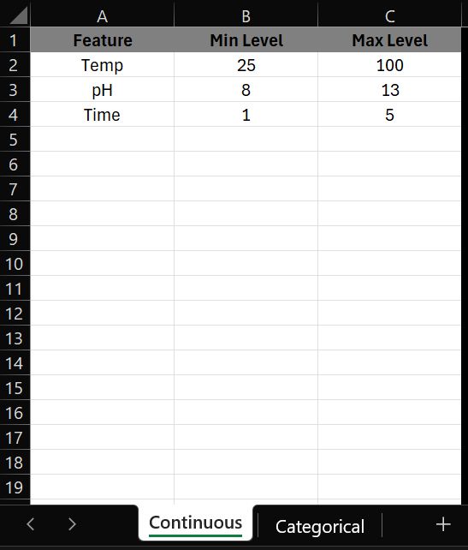

1. If categorical features are present, fill out those as well. Note that the feature name is in the A column and the other columns are the various levels of the categorical features.

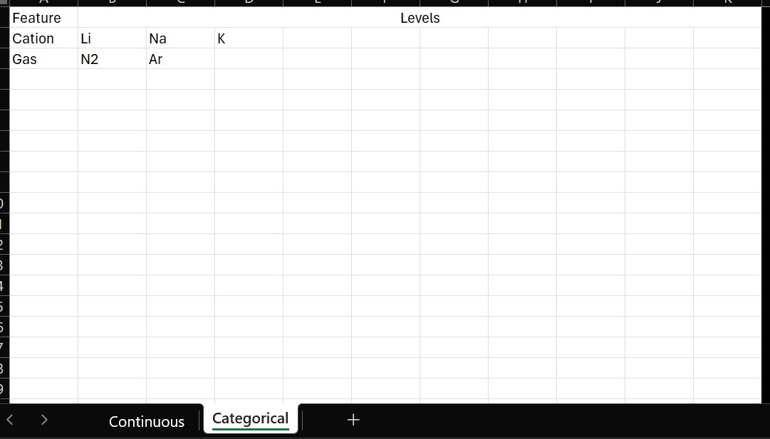

1. Open and run **Common_DoEs.py**. It should generate an excel file called **Common_DoE_designs.xlsx** which contains the most common experimental designs.
   1. Specifically, it creates a 2^n full factorial, 3^n full factorial, central composite face-centered (CCF), central composite design (CCD), and Box-Behnken design (BBD).
   2. The designs are mainly based on the continuous data. If any categorical data are entered, the designs are copied, one for each categorical level.

# Build optimal designs using Optimal_Design.R

1. Open Optimal_Design.R
2. Every section with contains the “# DEFINE_ME” key (find them using CTRL+F) needs to be manually entered. The specific lines which need to be edited are:
   1. terms = c(ENTER_FEATURE_TERMS_HERE)
      1. where ENTER_FEATURE_TERMS_HERE is a comma-separated list of terms to put in the model. For example. terms = c('A', 'B', 'A:B', 'I(A^2)', 'I(B^2)') for a 2-feature quadratic model
   2. extra_exp <- EXTRA_EXPERIMENTS
      1. where EXTRA_EXPERIMENTS is an integer of how many extra experiments to add. This should at minimum be 1.
   3. df_candidates = expand.grid(…)
      1. where the … is a comma-separated list of choices for each features. For example, … can be A = seq(40, 90, 5), B = C(‘Li’, ’Na’, ’K’). In this example, the experiment will chose feature A to be continuous and to have any value among 40, 45, 50, 55, 60, 65, 70, 75, 80, 85, 90. Similarly, feature B will be categorical and will have its levels as ‘Li’, ’Na’, or ’K’. In other words, the script will select feature combinations from the table below.

1. Run the script. It will generate a **OptimalDesign.csv** file which contains the experimental design.
   1. A common error is 

This is because the default number of experiments is not enough to properly model all the features (usually caused by one-hot encoding of categorical terms). The script should automatically add experiments until there are enough experiments.