Monica Chiu, Adriana D’Souza, Reda Ijaz, Javiar Titus, Ray Katz

CS591 E3 Mobile App Development

February 19, 2017

Assignment 4 Textbook Problems

**Chapter 3:** *Short Answers/Fill in the Code*

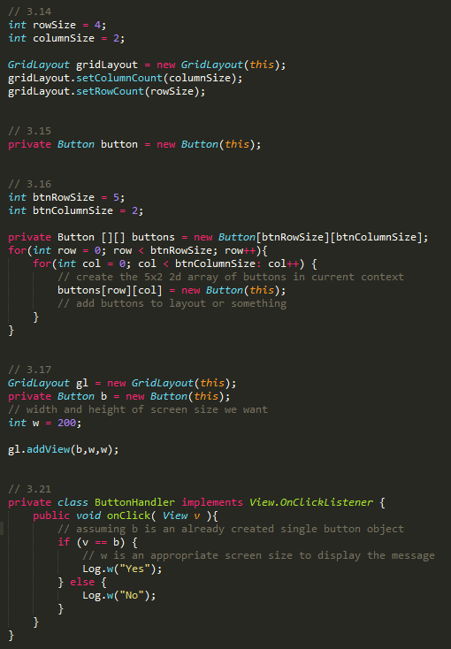

**Chapter 4:** *Multiple Choice*

4.1) As a table of rows and columns

4.2) ViewGroup

4.3) LinearLayout

4.4) So that we position components relative to other components

4.5) android.content

4.6) startActivity

4.7) onRestart

4.8) onCreate, onStart, and onResume (in that order)

4.9) onStop

4.10) Yes, for example by each accessing a public static instance variable from another class

**Chapter 7:** *Multiple Choice, Short Answers/Fill in the Code*

7.1) setOnTouchListener

7.2) getAction

7.3) bringToFront

7.4) GestureDetector

7.5) Public static inner interfaces of GestureDetector

7.6) Private methods/Constants that the action can be compared to ??

7.7) onTouchEvent

