Alkhalil Morpho Sys Source Description

Version 1.1
2011

Introduction:
Alkhalil Morpho Sys is written in Java. So to use the program, you must install Java Virtual Machine version 1.5 or later. This means that the program can be used in several systems such as Windows, Linux, Solaris, MacOs. The virtual machine can be downloaded from the Sun Microsystems web site at the following address: http://java.sun.com.

The program was written using the NetBeans IDE witch can be downloaded from http://www.netbeans.org/. To use the Arab characters, the user must choose windows-1256 in the encoding of the project properties.

Structure of the program:
The program is composed from several packages as described in the picture 1:

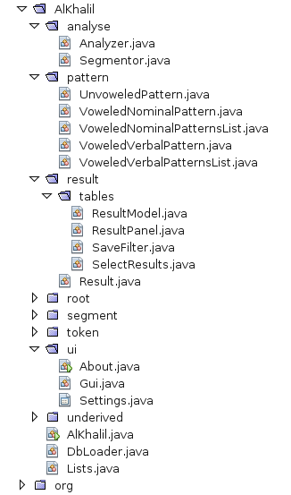Picture 1: Structure of the program

Main class:
The main class is Alkhalil.Alkhalil.

Settings:
The final user can choose to work with a large database or a small one. He can also choose a reduced number of outputs by word in the final results. This is done by the class Alkhalil.ui.Settings.

Databases:
To load the different databases from the XML files, the program use the class: Alkhalil.DbLoader.
The structure of the databases is described in the document (برنامج الخليل الصرفي قواعد المعطيات.doc). We have used the open source library Digester from Apache to consult and load the databases from XML files.

Text tokenization and normalization:
This step is done by the class Alkhalil.token.Tokens. This class tokenises the text. The constructor receives a text as input. As output it returns: the unvoweled words and the normalized words with the possible vowels signs present in the input text. The word with the possible vowels signs is used at the end of the analysis step.

Stemming phase:
This step is done by the class Alkhalil.Analyse.Segmentor. As input, it takes an unvoweled word. As an output, it produces a stem, a suffix and a prefix. The following classes are used in this phase:
- Alkhalil.segment.Prefixe
- Alkhalil.segment.Segment
- Alkhalil.segment.Suffix
- Alkhalil.segment.Stem

Morphological analysis of the words
The principal function of the program is performed by the class Alkhalil.Analyser. It analyses the stems produced by the class Alkhalil.Analyse.Segmentor. Each stem is analysed as:
- Tool word (class Alkhalil.underived.ToolWrd) or proper noun (class Alkhalil.underived.ProperNoun). The proper nouns and the tool words are checked in databases.
- Verb or noun.

Results:
At the end of the analysis step, the system produces the following results for the analysed words:
- Voweled word
- Prefix
- Stem
- Word type
- Word pattern
- Word root
- Part Of Speech (POS)
- Suffix
- Priority: used to sort the results according to the word type (verb, noun … ).
For the words that the system can't analyse, we obtain the following message: "لا توجد نتائج لتحليل هذه الكلمة" (which means: no result found).
Note the analyzed words appears only once in the result file.

Viewing and saving the results:
The viewing and saving operations are done by the class Alkhalil.result.tables.ResultPanel which uses the class Alkhalil.result.tables.SaveFilter.

Selecting some results:
The operation of saving some results in a CSV format is done by the class Alkhalil.result.tables.SelectResults.

