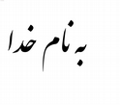Updated: **Thursday - 2018 19 July**

|  |  |
| --- | --- |
|  | MohammadReza Tayyebi  Software Solutions for Business | Art  Wesbite: [rexa.gordarg.com](mailto:rexa@gordarg.com)  Email: [rexa@gordarg.com](mailto:rexa@gordarg.com)  Tel: +98 938 806 3351 |

# Education:

|  |  |
| --- | --- |
|  | **Bu-Ali Sina University**  *Tuyserkan Faculty of Engineering and Natural Resources*  B. S; Computer Engineering (March 2016 – Current) |

# Experiences:

|  |  |
| --- | --- |
|  | **Iran TVTO**  Programming and Database Skills Teacher since 2016 (KhajeNasir Institute; Website:nasiredu.com)  Iran Skills Expert, Iran Skills Judge |
|  | **Founded Gordarg**  Since 2018  Website: Gordarg.com |

# Awards:

## 16th Khwarizmi Youth Award



Awarded as Third in Country

Title: Central Authentication System

Ministry of Science, Research and Technology  
Ministry of Education

Website: irost.org

Khwarizmi is one of the most verified and important scientific festivals in Iran.

## Top Youth in Province

Ministry of Sports and Youth  
Hamedan Governor: Ministry of Interior

About: AliAkbar festival is an award to effective youth of province, elites and sport champions.

## Iran WorldSkills 2016 Medalist

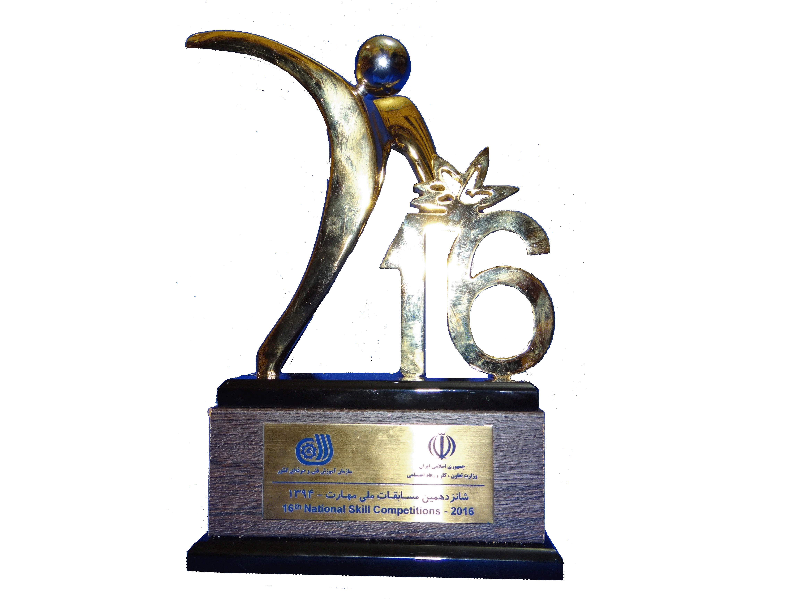

Gold medal: IT - Software Solutions for Business

TVTO: Ministry of Labour and Social Affair

Website: skill.irantvto.ir

Iran National Competitions (WorldSkills Iran) is one of the most important awards which identifies medalists for international competitions.

# Honors:

## Team Iran Competitor WorldSkills 2017 AbuDhabi, Preparation Campus

IT - Software Solutions for Business

Website: WorldSkills.org

Applied as top 4 candidates for competitions

## Team Iran Competitor WorldSkills 2017 AbuDhabi

IT - Software Solutions for Business

IRI Competitor; 44th WorldSkills Competitions

Website: WorldSkillsAbuDhabi2017.com

# Speech:

## Special speaker as top researcher in session with Hamadan zone 1 education system managers and top teachers

Ministry of Education

## Hamadan representative in first congress of National Skills Competitions elites

Ministry of Labour and Social Affair

Special guest: Assistant of Cooperatives Labor and Social Welfare's Minister.

## IRI Representative expert at Kazan, Tatarstan, Russia

Link: <https://worldskills.ru/media-czentr/novosti/ekspertyi-iz-indii,-irana-i-kitaya-obuchatsya-provedeniyu-demekzamena-po-standartam-worldskills-v-kazani.html>

Эксперты WorldSkills из Ирана, Индии и Китая примут участие в обучающей сессии по проведению демонстрационного экзамена в Казанском техникуме информационных технологий и связи. С 15 по 18 мая зарубежные эксперты будут перенимать технологию демэкзамена на примере его проведения по компетенциям «Программные решения для бизнеса» и «Мобильная робототехника».

# Skills:

Full-Stack and Data

C#, SQL Server, PHP, MySQL, NodeJS, Python, C++, Android(Kotlin, Java), Business Inteligence, Applied AI, Microsoft Windows sysadmin, Linux sysadmin.

# Art:

Qanoon (Persian = قانون) and Santur (Persian = سنتور) Soloist

## Alvand Orchestra

## Axaya Band

## Ayeen Band

Awarded as second in Fajr Music Festival, Hamedan, Iran - 2017  
Awarded as first in Niyayesh Music Festival, Qazvin, Iran - 2017