ubuntu@ubuntu-Veriton-M200-H410:~$ mkdir medha
ubuntu@ubuntu-Veriton-M200-H410:~$ cd medha
ubuntu@ubuntu-Veriton-M200-H410:~/medha$ touch tiet.txt
ubuntu@ubuntu-Veriton-M200-H410:~/medha$ echo "Today is Wednesday">tiet.txt
ubuntu@ubuntu-Veriton-M200-H410:~/medha$ echo "this is os lab">tiet.txt
ubuntu@ubuntu-Veriton-M200-H410:~/medha$ echo "Today is Wednesday">>tiet.txt
> rewrites the content of file
>> adds to the file without deleting contents
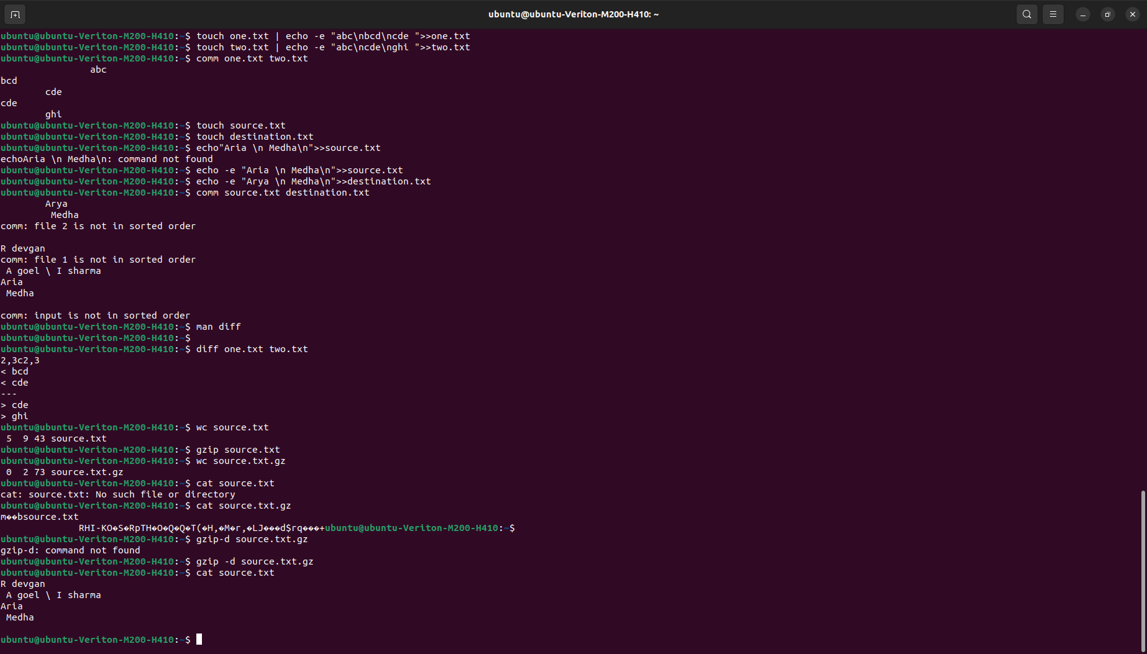
ubuntu@ubuntu-Veriton-M200-H410:~/medha$ echo -e "today \n is \t wednesday">>tiet.txt
echo -e to enable interpretation of backslash
ubuntu@ubuntu-Veriton-M200-H410:~/medha$ cat tiet.txt
this is os lab
Today is Wednesday
today
is wednesday
cat to display content of file
ubuntu@ubuntu-Veriton-M200-H410:~/medha$ cat tiet.txt>third.txt
cat to copy content of one file to another
ubuntu@ubuntu-Veriton-M200-H410:~/medha$ cat tiet.txt>>patiala.txt
cat to add contents of one file to end of another file

combine comds
we can feed output of one comds into another as input
pipeline symbol
|

ubuntu@ubuntu-Veriton-M200-H410:~/medha$ ^C
ubuntu@ubuntu-Veriton-M200-H410:~/medha$ man cat
ubuntu@ubuntu-Veriton-M200-H410:~/medha$ touch rat.txt | echo -e "a rat on mat\n ">>rat.txt | wc rat.txt
2 4 15 rat.txt

wc for word count
2-> no. of lines
4->no. of words
15->no. Of chars

ubuntu@ubuntu-Veriton-M200-H410:~/medha$ type echo
echo is a shell builtin
shell builtin -> internal comds

ubuntu@ubuntu-Veriton-M200-H410:~/medha$ type touch
touch is hashed (/usr/bin/touch)
hashed->external comds

ubuntu@ubuntu-Veriton-M200-H410:~/medha$ pwd
/home/ubuntu/medha
present working directory

ubuntu@ubuntu-Veriton-M200-H410:~/medha$ cd ..
to go one step out of file
cd ../..
cd /home absolute path
mkdir make directory
rmdir delete directory but the directory should be empty
rm -r deletes directory even if not empty it will recursively empty it
ubuntu@ubuntu-Veriton-M200-H410:~$ rm medha
rm: cannot remove 'medha': Is a directory
ubuntu@ubuntu-Veriton-M200-H410:~$ rm -r medha
comparison of two txt files
ubuntu@ubuntu-Veriton-M200-H410:~$ touch one.txt | echo -e "abc\nbcd\ncde ">>one.txt
ubuntu@ubuntu-Veriton-M200-H410:~$ touch two.txt | echo -e "abc\ncde\nghi ">>two.txt
ubuntu@ubuntu-Veriton-M200-H410:~$ comm one.txt two.txt
abc
bcd
cde
cde
ghi

col 1-> unique condents of file 1
col 2-> unique condents of file 2
col 3-> common condents of file 1 & 2

ubuntu@ubuntu-Veriton-M200-H410:~$ diff one.txt two.txt
2,3c2,3
< bcd
< cde
---
> cde
> ghi

a->append
c->change
d->delete
2,3c2,3 -> change line 2 to 3 of file 1 with line 2 to 3 of file 2

to compress the file
gzip
vzip2
after compression og file rewritten by compressed file
source.txt.gz

ubuntu@ubuntu-Veriton-M200-H410:~$ wc source.txt
5 9 43 source.txt
ubuntu@ubuntu-Veriton-M200-H410:~$ gzip source.txt
ubuntu@ubuntu-Veriton-M200-H410:~$ wc source.txt.gz
0 2 73 source.txt.gz
ubuntu@ubuntu-Veriton-M200-H410:~$ cat source.txt
cat: source.txt: No such file or directory
ubuntu@ubuntu-Veriton-M200-H410:~$ cat source.txt.gz
m��bsource.txt
RHI-KO�S�RpTH�O�Q�Q�T(�H,�M�r,�LJ���d$rq���+ubuntu@ubuntu-Veriton-M200-H410:~$
ubuntu@ubuntu-Veriton-M200-H410:~$ gzip-d source.txt.gz
gzip-d: command not found
ubuntu@ubuntu-Veriton-M200-H410:~$ gzip -d source.txt.gz
ubuntu@ubuntu-Veriton-M200-H410:~$ cat source.txt
R devgan
A goel \ I sharma
Aria
Medha

gzip -d to unzip

tar -cf cool.tar source.txt destination.txt foo zoo
-cf c for create f for archieve
compress all file to cool.tar
tar -xf cool.tar -> to unzip
zip cool.zip

