**ITP 303 Final Project Summary**

**INSTRUCTIONS:** Type out your answer directly below each question. If a question does not apply to your project, type in N/A. When finished, save this file as a PDF and upload it to the itpwebdev server via FileZilla. Then, add a link to this PDF in your student_page.html. Label it “Final Project Summary.”

**BASICS**

**Your name?**

Maia Cho

**What is the topic of your final project?**

A social personality type (MBTI & Enneagram) website (like Co-Star)!

**Who is the intended audience?**

People interested in MBTI/Enneagram

**Provide a brief summary of the functionalities of your project.**

The two main functionalities are the ability to search for users/types (+ delete them if you’re an admin) and to make and see posts. You can see users’ types and type descriptions as well as their compatibility with your types in the search function, and you can see the 8 most recently posted posts on the home page.

There’s also your profile page and the information page which display information about the user’s personality types and posts and the foundations of MBTI/Enneagram theory, respectively.

**FRONT-END**

**What is the total page count?**

6 (index.php, profile.php,search.php,update.php,login.php,register.php)

**List the names of any external stylesheet used in this project below.**

nav.css, main.css

**List any CSS libraries/frameworks used in this project (e.g. Bootstrap) below.**

Bootstrap

**List any JavaScript libraries/frameworks used in this project below.**

jQuery

**How does your project meet the Interactivity requirement?**

Being able to expand and retract the section on your profile where you see your posts.

**BACK-END**

**Attach a screenshot of the final database diagram (just the diagram, do not include any records) below.**

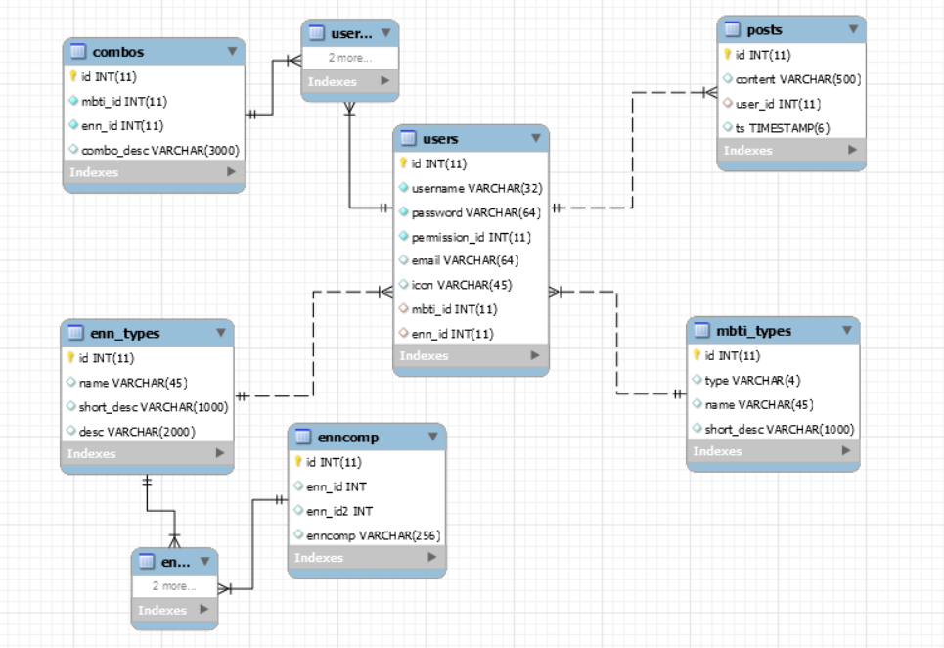

**Where in your project do you insert a record to the database (the ‘C’ in CRUD)?**

The register page and the making posts functionality.

**Where in your project do you search and display record(s) from the database (the ‘R’ in CRUD)?**

The search page (for users, MBTI types, and Enneagrams)

**Where in your project do you update and existing record(s) the database (the ‘U’ in CRUD)?**

Logged-in admins can update users’ usernames, MBTI types, or Enneagrams through the search function. you can use the admin account to do this ([admin@usc.edu](mailto:admin@usc.edu), password: admin)

**Where in your project do you delete existing record(s) from the database (the ‘D’ in CRUD)?**

Logged-in admins can delete users from the search function—you can use the admin account to do this ([admin@usc.edu](mailto:admin@usc.edu), password: admin)

**MISC**

**What two “extra” requirements did you implement and where can they be found?**

I implemented sessions and levels of membership.

Sessions: I stored the user’s login information across the session as well as their most recently searched terms

Levels of membership: general users can’t use the search function, normal members can’t delete/update information, and admins can do all of it.

**If you used any APIs or JS plugins/frameworks as one of the extra requirements, list the name and a link to their documentation.**

n/a

**If your project requires any admin credentials (i.e. only admin users can access a certain page), list the credentials below.**

n/a

**Provide any other information that you think the grader/instructor should know when grading your final project below.**

I got the information from the Enneagram Institute, 16personalities, and funkymbtification.