Date : 12/07/2024

Name : Murugesh

Email ID : [murugash336@gmail.com](mailto:murugash336@gmail.com)

Assesment:

1. Create a local git with the name "MyRepo".

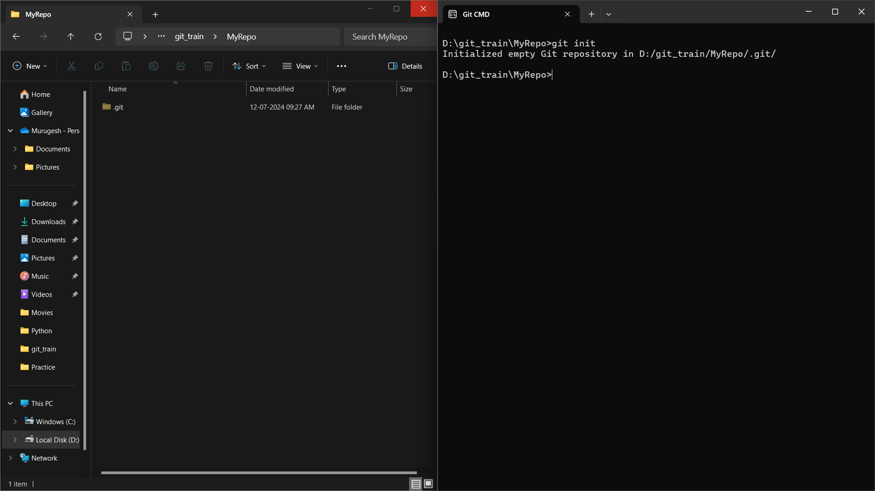

1. create one .txt file,five .c files and.java files in the area.

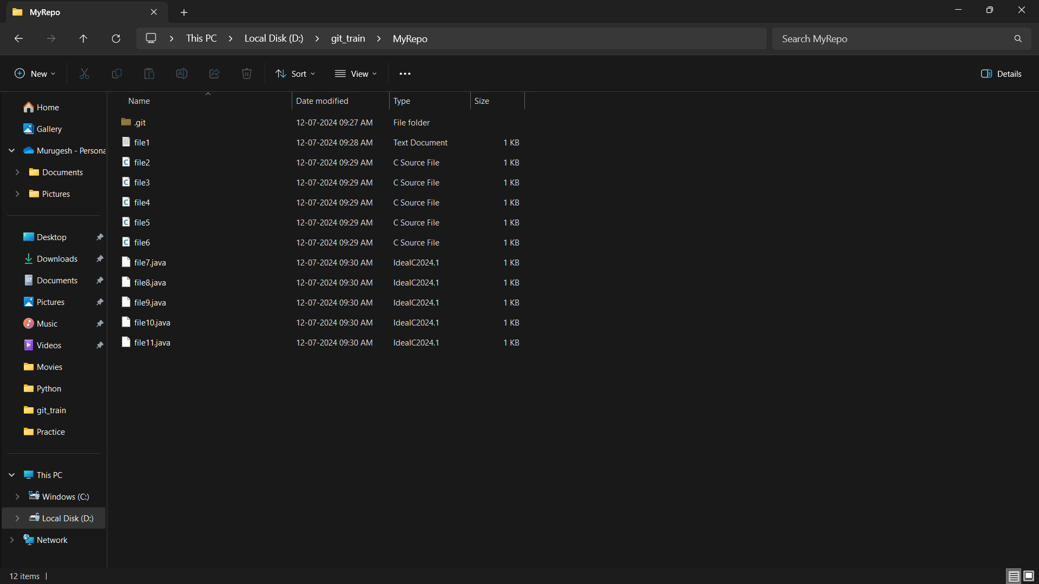

1. Verify the git status

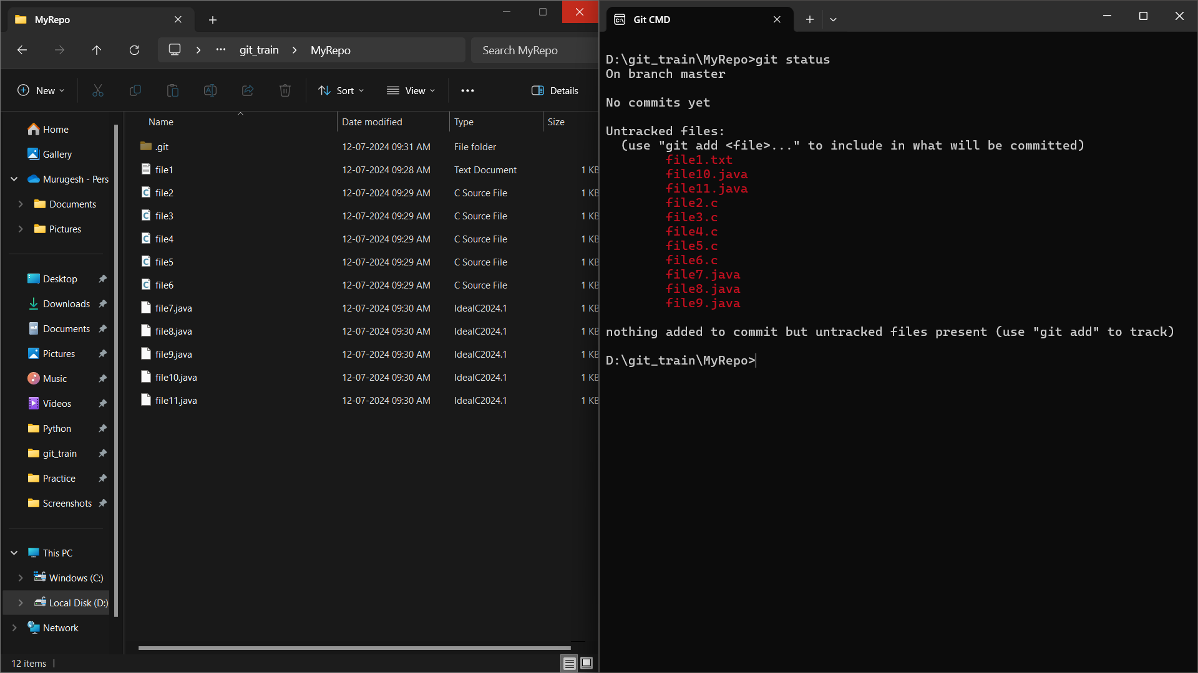

1. Add only the .txt the staging area

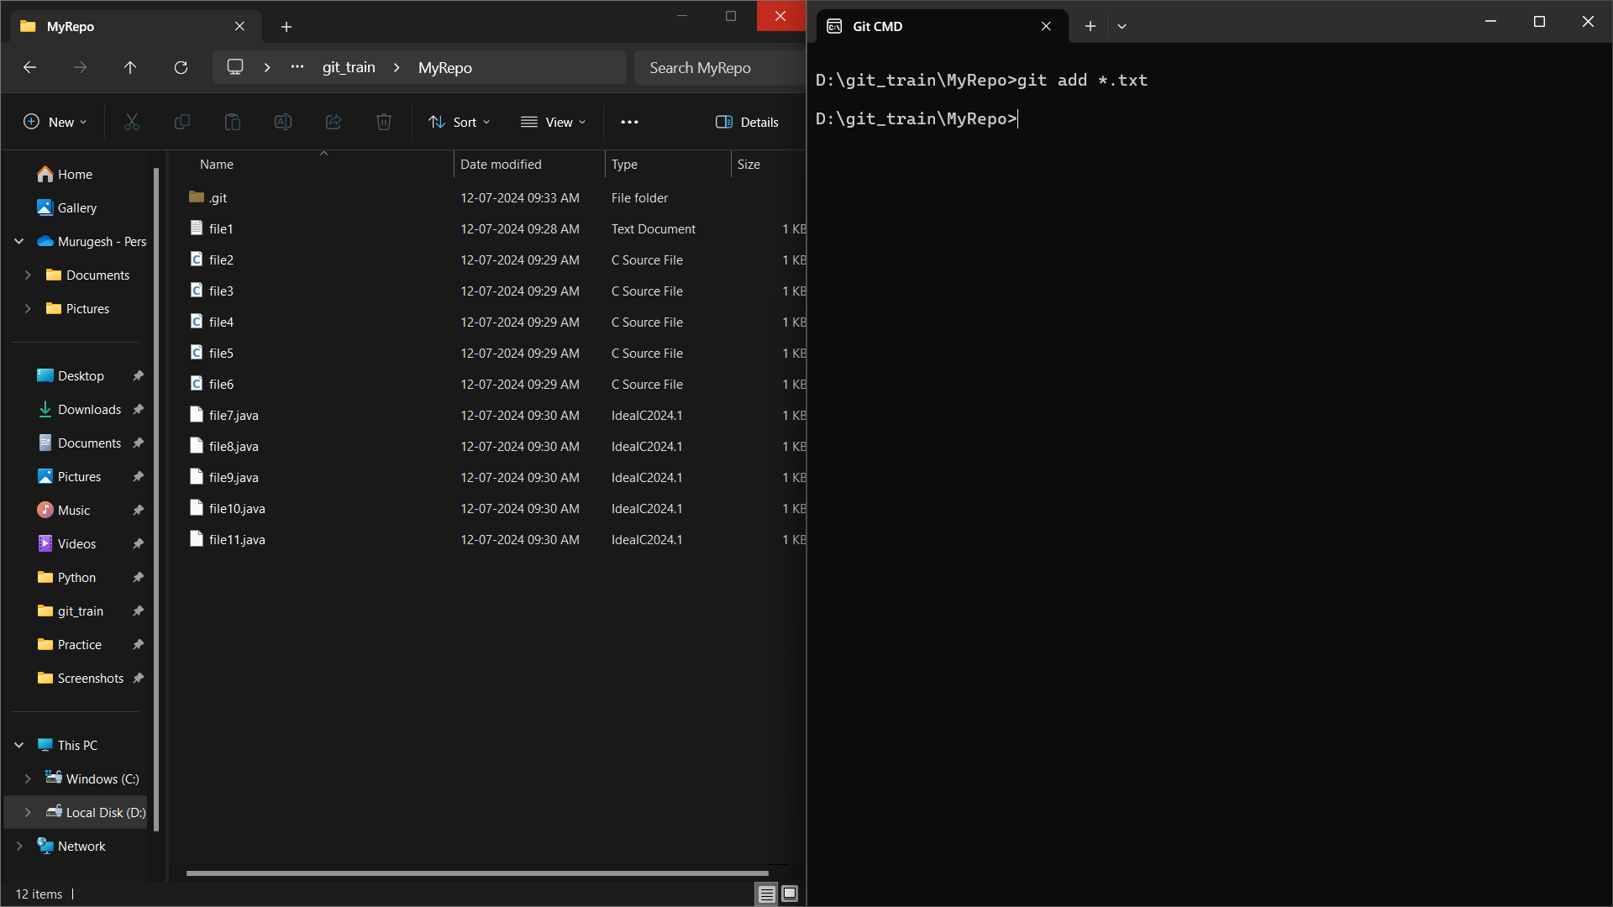

1. verify the git status

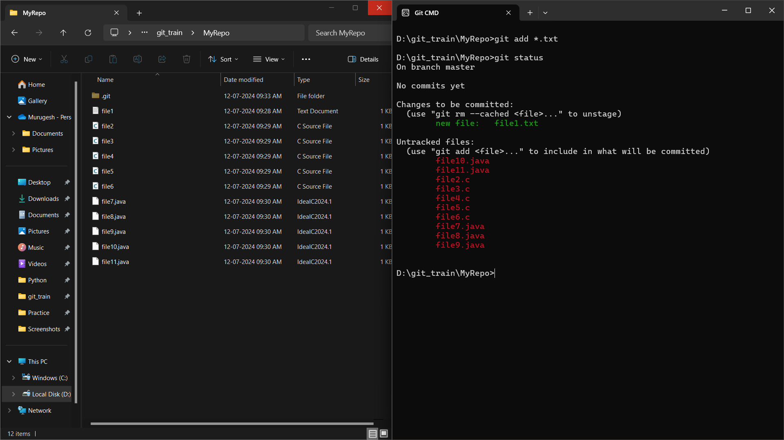

1. Make a commit with name "TXT Commit"

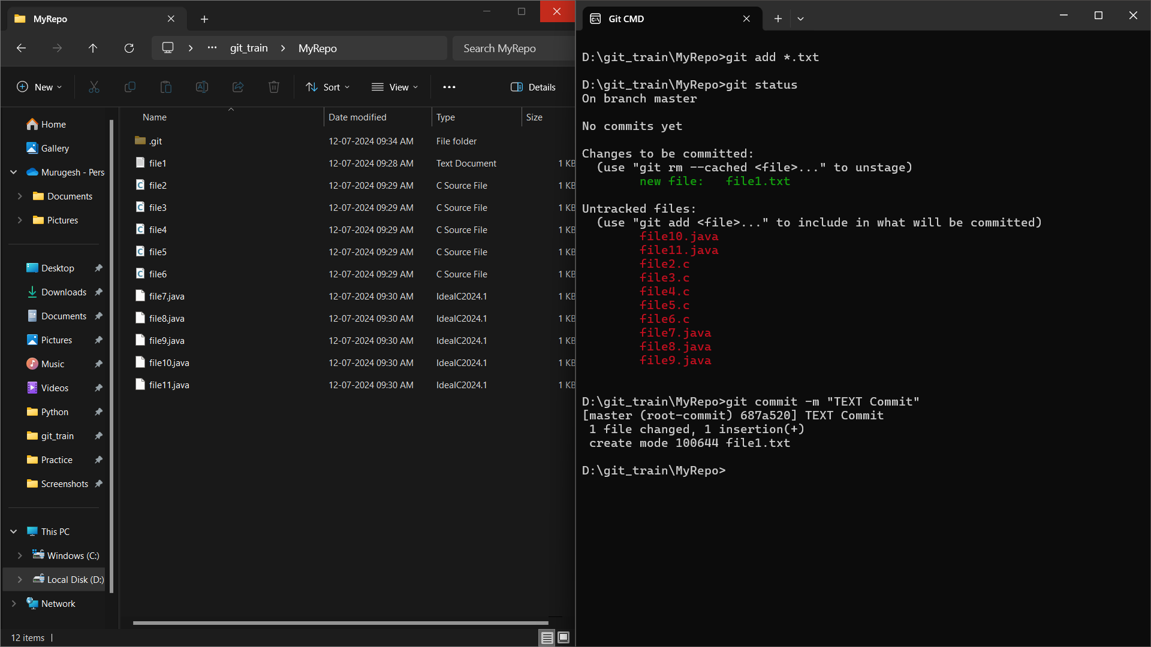

1. Add all .c files into the staging area

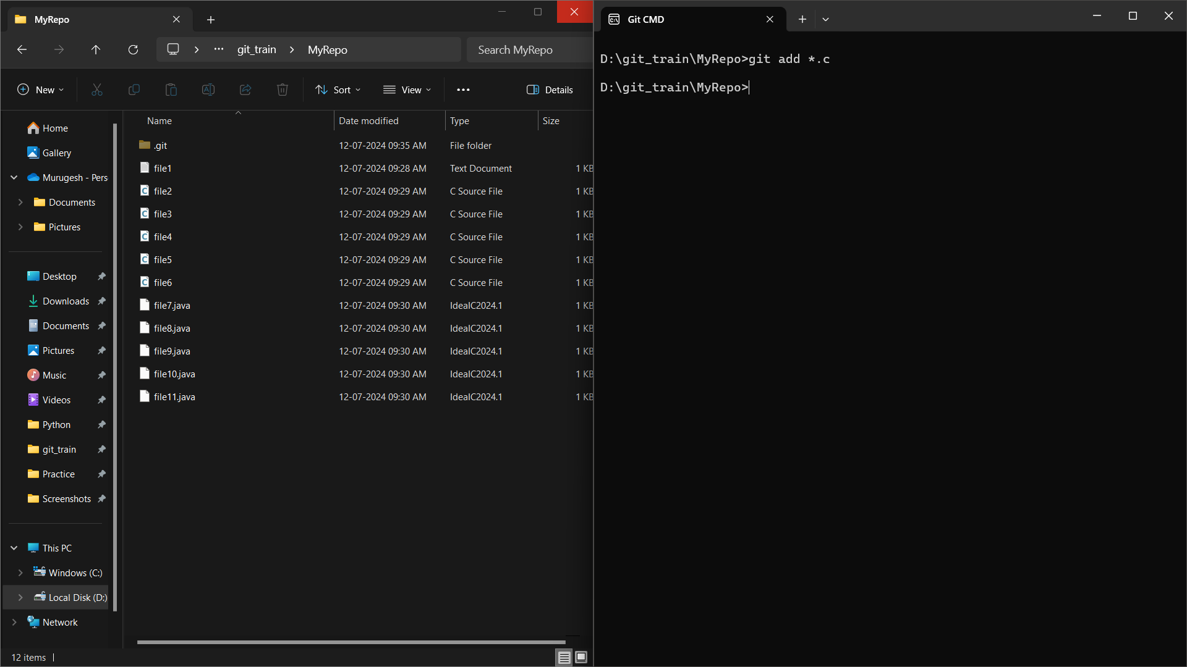

1. verify the git status

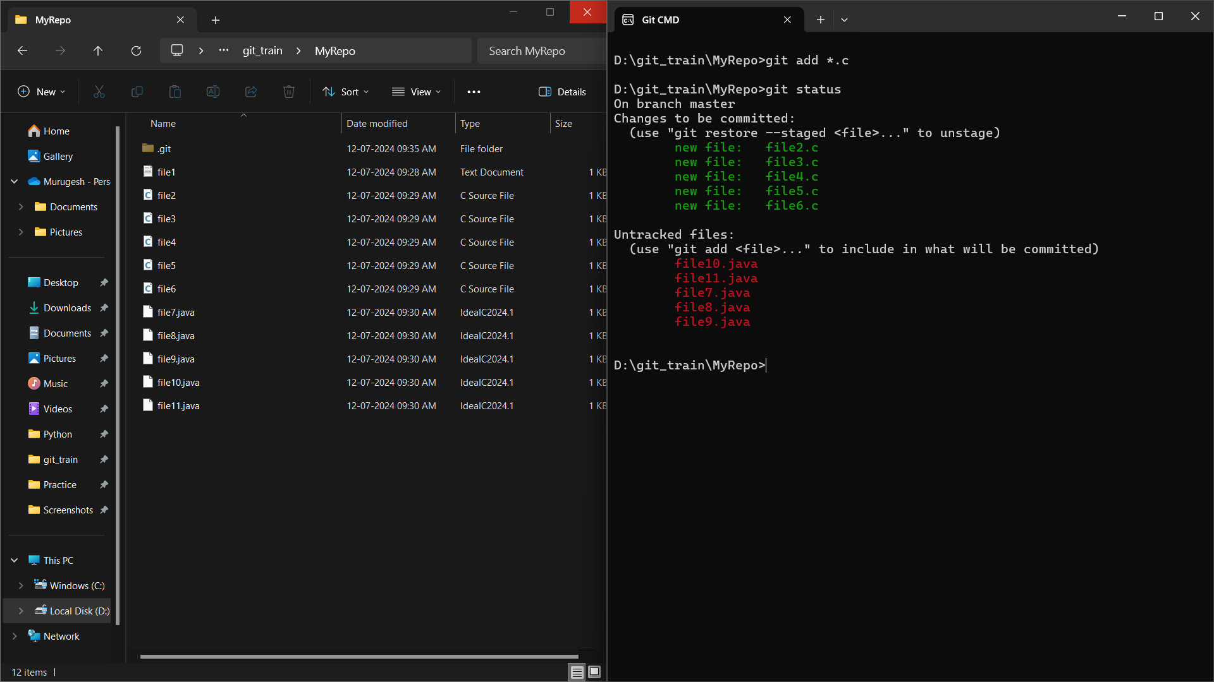

1. Make a commit with the name "C Commit"

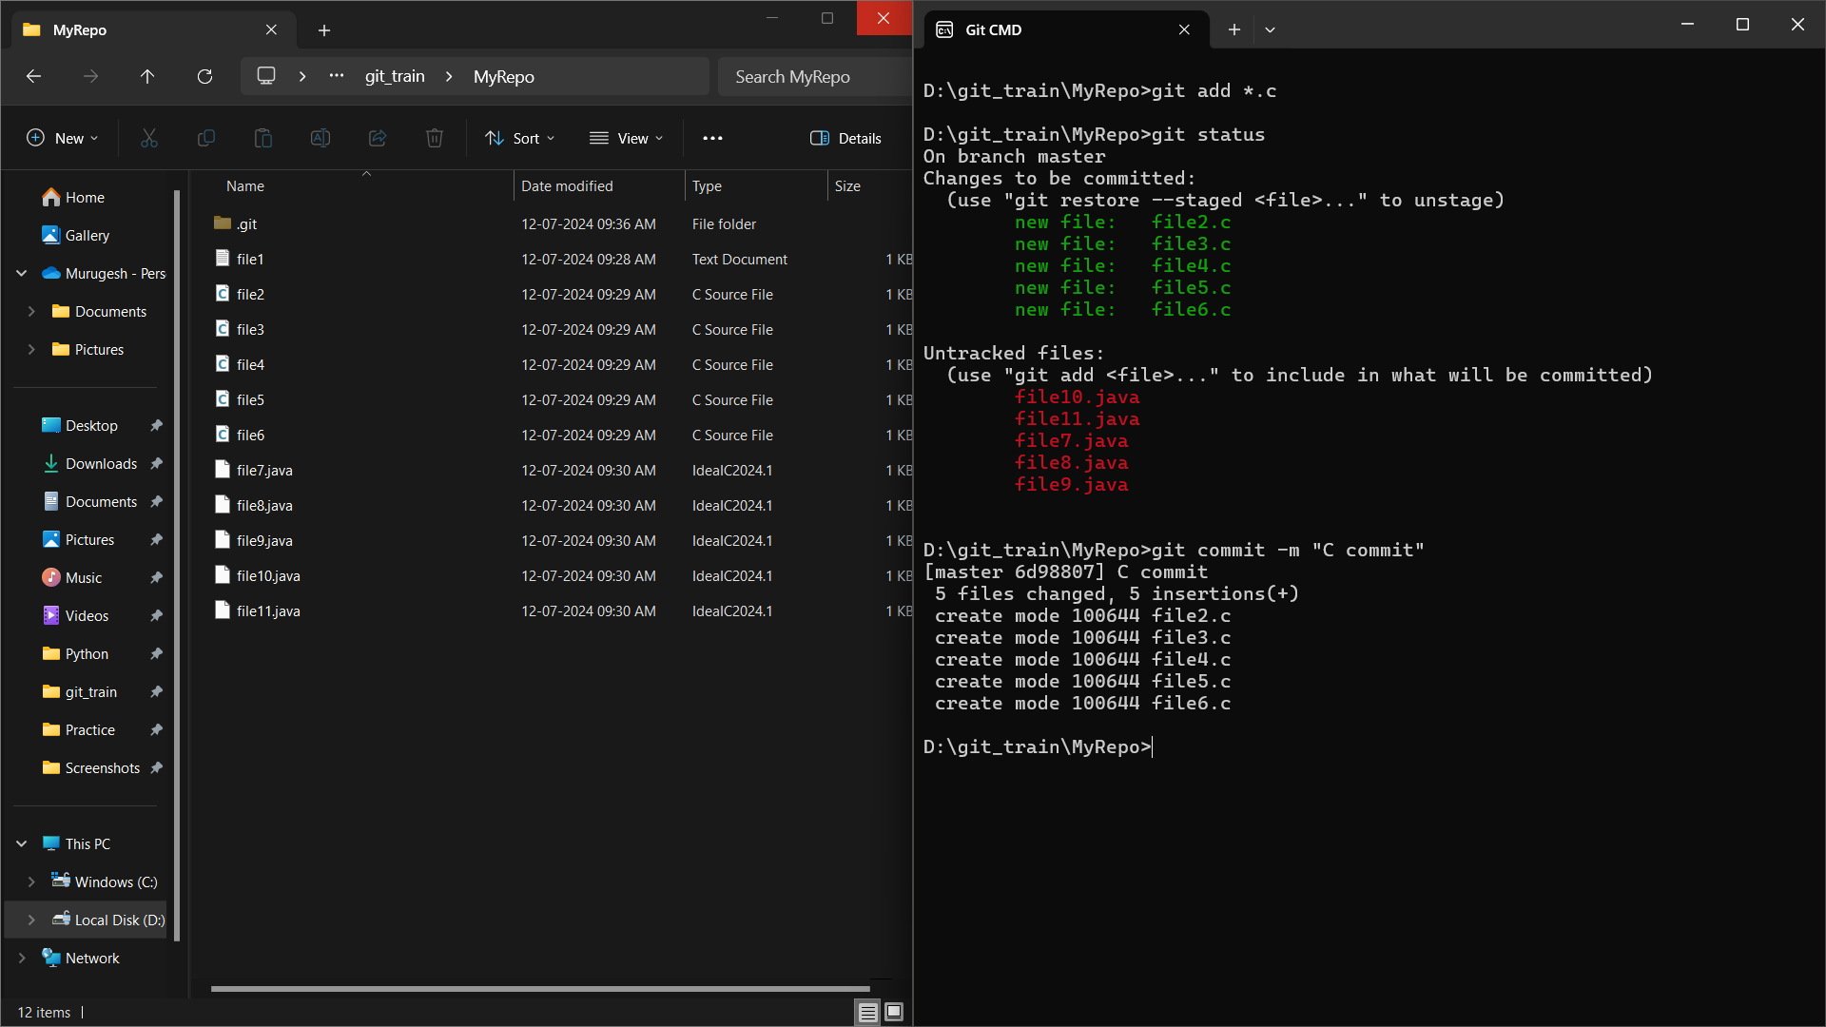

1. Add all .java files into the staging area

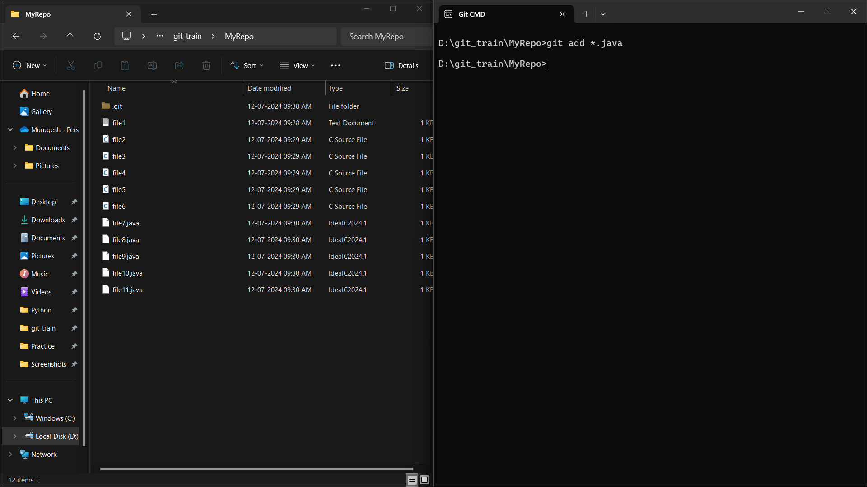

11.verify the git status

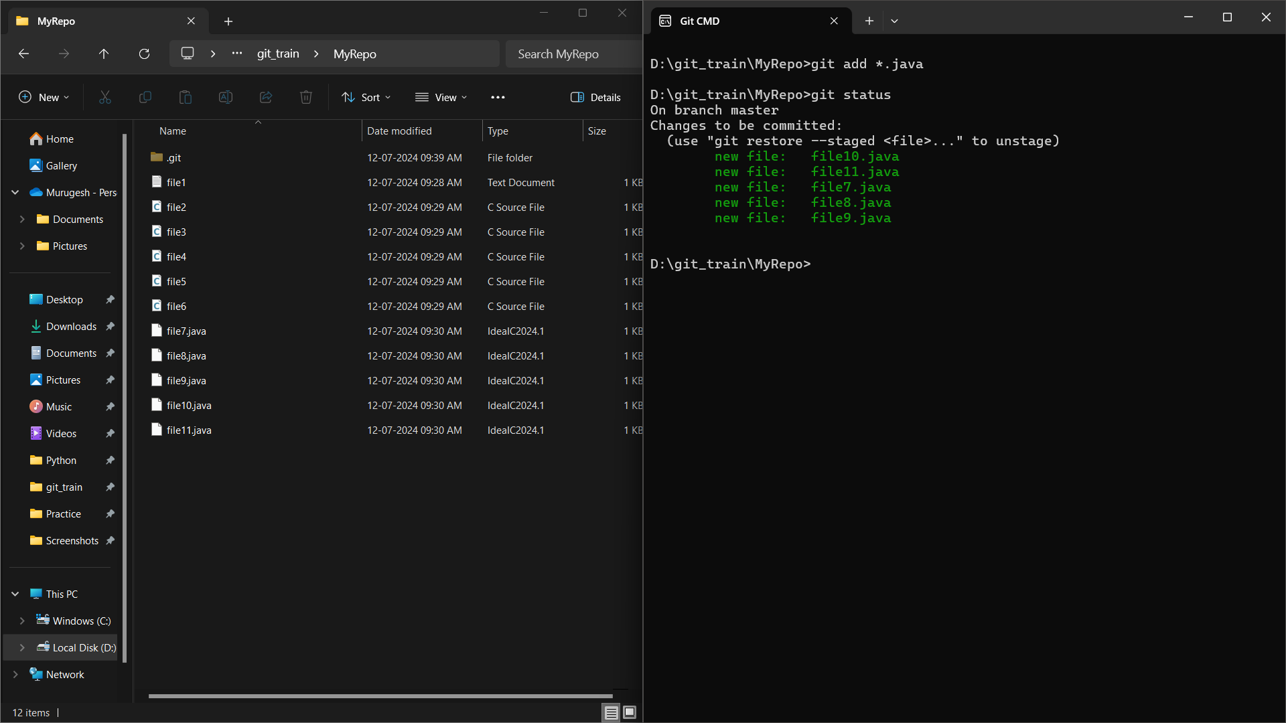

12. Make a commit with the name "Java Commit"

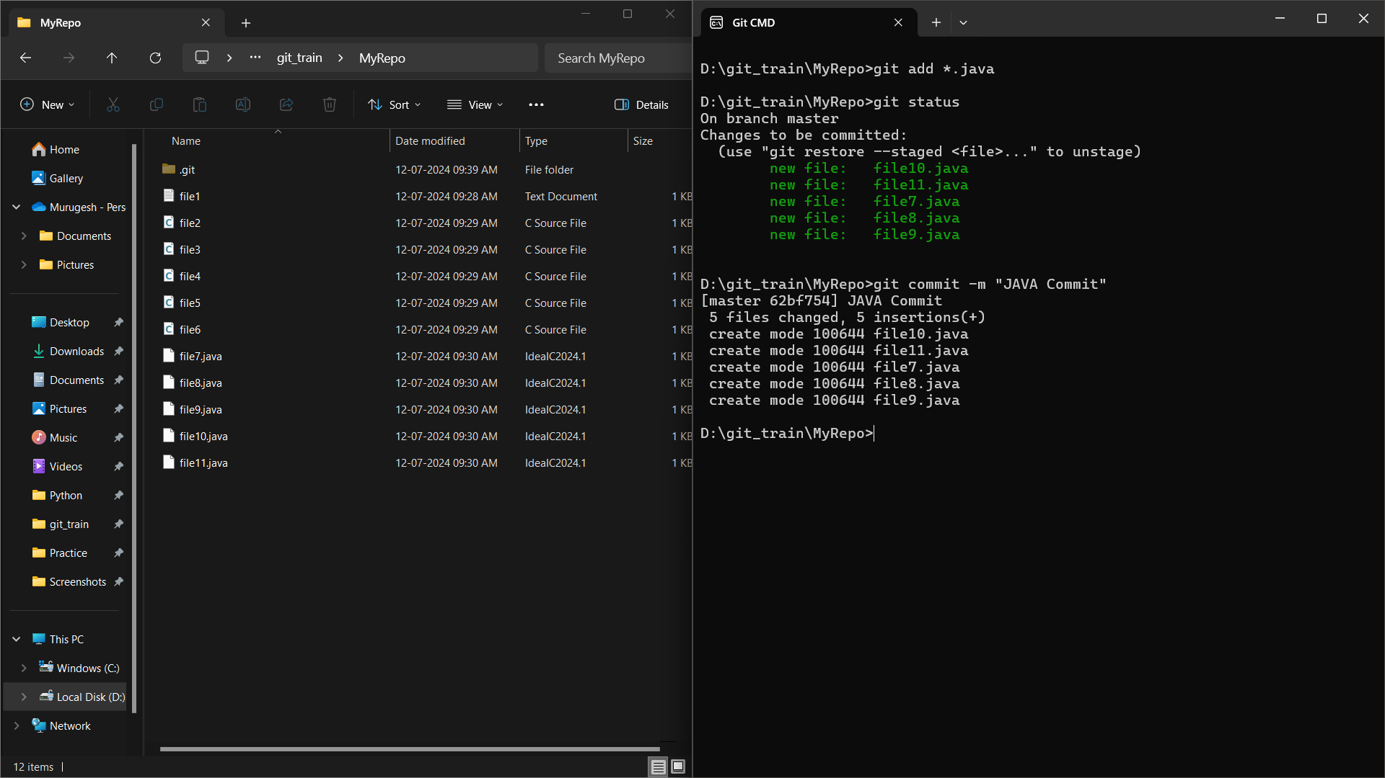

13. Delete all .java files from working area

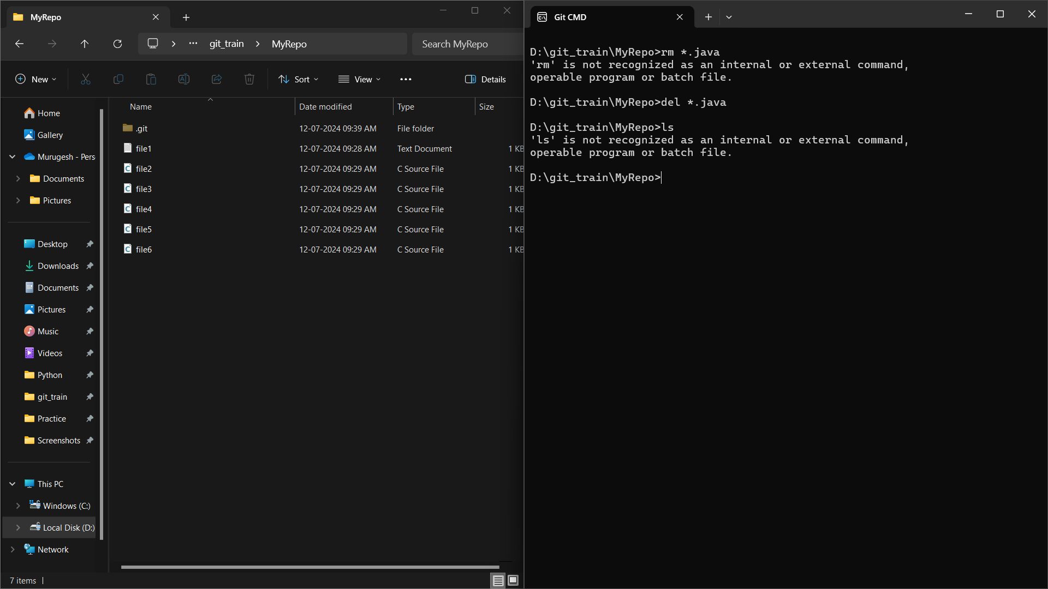

14. Now see the status

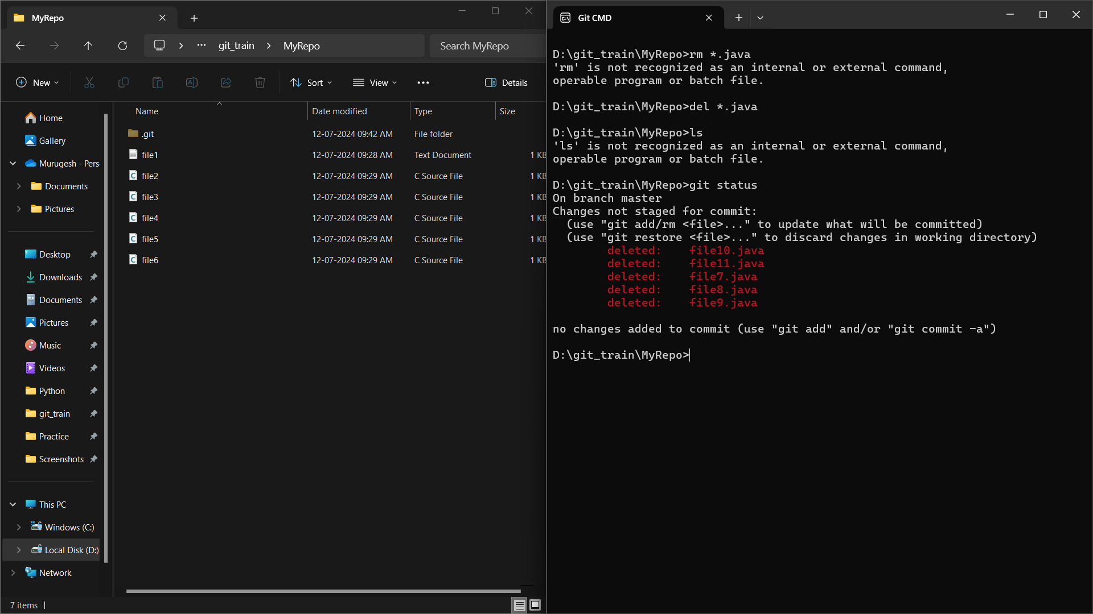

15. add the changes into the staging area

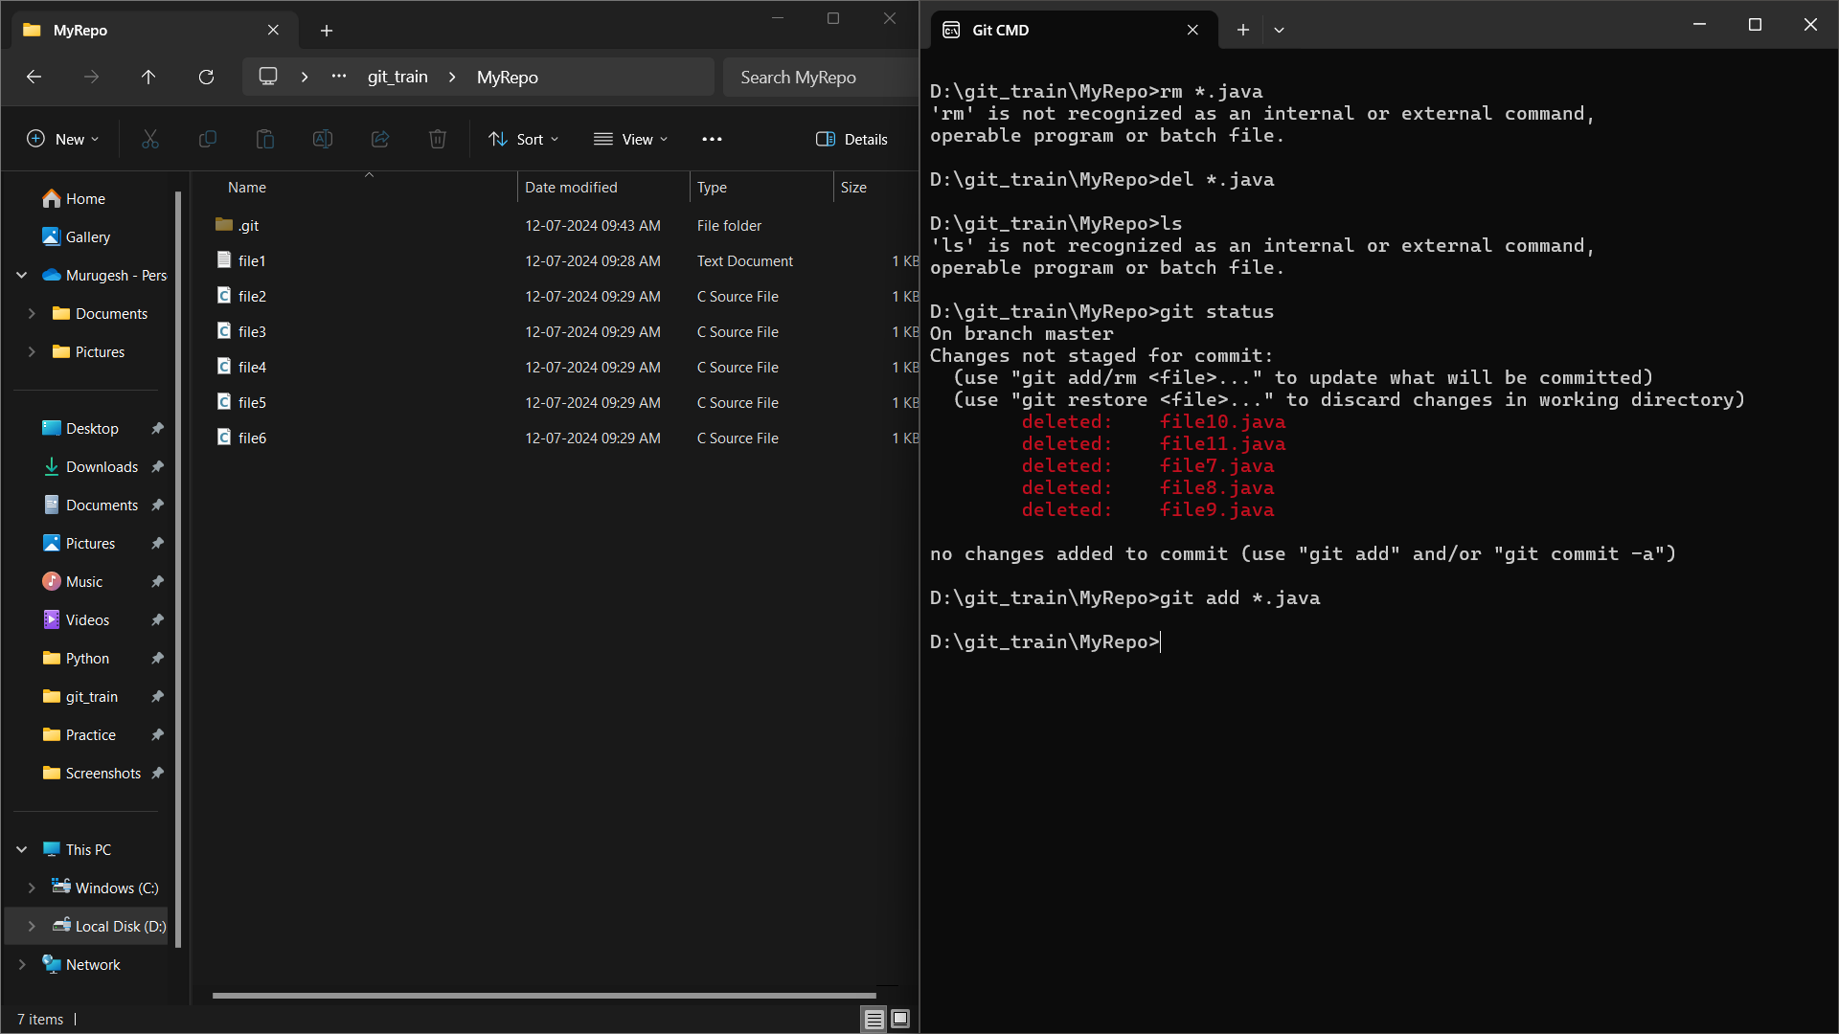

16. Make a commit with the name "Delete Java Commit"

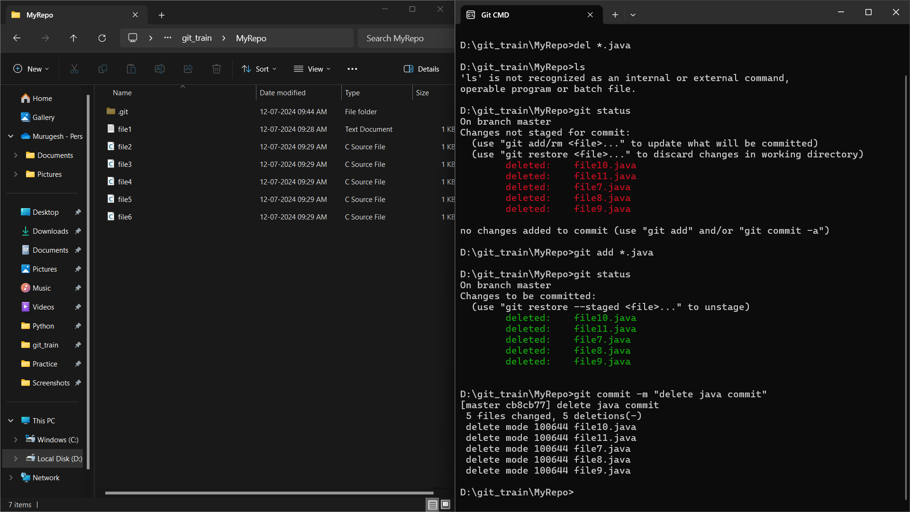

17. display all commit

