Model Development Document
Credit Risk Model — Loan_Data_Development.csv
Run ID: RUN_20260712_215141
Generated: 2026-07-12 21:54:22

1. Executive Summary
This document records the development of a credit-risk model on the Loan_Data_Development.csv dataset. The champion model, XGBoost, was selected to rank borrowers by probability of default in support of underwriting decisions.

1.1 Overall Model Verdict
GREEN
Derived from the KPI scoreboard: 5 GREEN, 0 AMBER, 0 RED across 5 discrimination/stability KPIs.

1.2 Key Results Summary
KPI | Value | RAG | Note
AUC / AUROC (Test) | 0.7058 | GREEN | Acceptable
Gini (Test) | 0.4116 | GREEN | Acceptable
KS (Test) | 0.299 | GREEN | Acceptable
AUC (OOT) | 0.695 | GREEN | Acceptable
PSI (score stability) | 0.0113 | GREEN | Strong
ECE (uncalibrated) | 0.2632 | RED | ≤0.02 target

Reference: KPI scoreboard & thresholds — Model_Comparison.xlsx and Appendix 18.1

1.3 Validation KPIs — meaning
‘Validation KPIs’ here means the model-performance metrics measured on held-out data (Test and OOT): discrimination (AUC/Gini/KS), stability (PSI/CSI), and calibration (Brier/ECE). Each carries a RAG badge against the thresholds in Appendix 18.1. RAG grades absent from source data are computed from those thresholds.

1.4 Summary of Human Review Decisions
Checkpoint | Decision | Analyst / Notes | Timestamp
Checkpoint 1 — Target Definition | approved | — | 2026-07-12T16:37:20.356590
Checkpoint 2 — Feature Shortlist | approved | — | 2026-07-12T16:37:47.964437
Checkpoint 3 — Model Sign-Off | Approve for Deployment | Mohit | 2026-07-12T17:38:05.646812

2. Project Team
Role | Name | Responsibility
Model Developer | [to be completed] | Development & documentation
Model Validator | [to be completed] | Independent validation
Model Owner | [to be completed] | Business ownership & sign-off
Governance/MRM | [to be completed] | Risk oversight

3. Purpose and Scope
Purpose: develop a statistical model that ranks borrowers by probability of default (PD) to support origination/underwriting decisions.
Standards basis: RBI model-governance expectations, US Federal Reserve/OCC SR 11-7 (Model Risk Management), and ECOA/Reg-B (fair-lending, adverse-action requirements).
Scope: single champion model (XGBoost) trained and evaluated on Loan_Data_Development.csv; out-of-time and blind-dataset scoring supported.

4. Data Overview
Observations (after indeterminate exclusion): 104,164 | Raw columns: 74
Overall default rate: 19.61%
Variable Category | Count
Numeric | 18
Categorical | 27
Date | 5
Identifier | 8
Structural leakage | 13

Reference: Full variable profile — DQR_Full_Report.xlsx → Variable_Profile

5. Data Quality Assessment
Duplicate loan IDs: 0 | Duplicate member IDs: 0

5.1 Missing Value Analysis (top 10)
Column | Missing Count | Missing %
annual_inc_joint | 104164 | 100.0%
dti_joint | 104164 | 100.0%
verification_status_joint | 104164 | 100.0%
open_acc_6m | 104164 | 100.0%
open_il_6m | 104164 | 100.0%
open_il_12m | 104164 | 100.0%
open_il_24m | 104164 | 100.0%
mths_since_rcnt_il | 104164 | 100.0%
total_bal_il | 104164 | 100.0%
il_util | 104164 | 100.0%

5.2 Consistency Check Results
Each rule encodes a business-logic constraint. The ‘Violations’ column is the COUNT OF ROWS that fail that rule (e.g. funded_amnt > loan_amnt). Zero violations = PASS. Rules whose columns are absent in this dataset are simply not applied.
Rule | Description | Violations | Status
funded_amnt <= loan_amnt | Funded amount cannot exceed loan amount | 0 | PASS
int_rate ∈ [0, 100] | Interest rate must be a valid percentage | 0 | PASS
term ∈ {36, 60} | Only standard loan terms expected | 0 | PASS
grade ∈ A–G | Only valid grade letters | 0 | PASS
dti >= 0 | Debt-to-income ratio cannot be negative | 0 | PASS
annual_inc >= 0 | Income cannot be negative | 0 | PASS
revol_util ∈ [0, 200] | Revolving utilisation must be a plausible percentage | 1 | FAIL

7 of 7 possible rules applicable to this dataset (some columns may not exist in Dataset 2)
Reference: DQR_Full_Report.xlsx → Consistency_Checks

6. Development, Test & OOT Data Plan

6.1 Data Split Strategy
Method: OOT: time-based latest 20% | Train/Test: random 70/30 within Dev 80%
Set | Size | % of Total | Default Rate
Total | 104,164 | 100% | —
Dev | 83,331 | 80% | —
Train | 58,331 | 56% | 19.43%
Test | 25,000 | 24% | 19.43%
OOT | 20,833 | 20% | 20.33%

6.2 Target Class Distribution
Category | Count | % of total
GOOD (0) | 83,736 | 43.48%
BAD (1) | 20,428 | 10.61%
INDETERMINATE (excluded) | 88,426 | 45.91%

6.3 Observation Window
Development uses the earliest vintages; the out-of-time window uses the most recent vintages by origination date (issue_year) to test temporal robustness.

7. Data Preparation Waterfall

7.1 Row Waterfall — Observation Exclusions
Stage | Rows | Change | Reason
1. Raw dataset | 192,590 |  | As supplied
2. Exclude INDETERMINATE | 104,164 | -88,426 | Censored / unknown-outcome loans excluded
3. Modelling population | 104,164 |  | GOOD + BAD only

7.2 Indeterminate Exclusions Detail
Excluded Value | Count | Reason
Current | 84,053 | Matches indeterminate pattern: 'current'
Late (31-120 days) | 2,619 | Matches indeterminate pattern: 'late'
In Grace Period | 1,287 | Matches indeterminate pattern: 'grace'
Late (16-30 days) | 467 | Matches indeterminate pattern: 'late'

8. Target Variable Definition
Binary default flag derived from 'loan_status'. BAD (1): Charged Off, Does not meet the credit policy. Status:Charged Off, Default. GOOD (0): Fully Paid, Does not meet the credit policy. Status:Fully Paid. Default rate: 19.61%. Excluded indeterminate: 88,426 rows (45.9%). Final sample: 104,164 observations.
The target is defined in THREE categories — GOOD, BAD and INDETERMINATE — not a simple binary. INDETERMINATE loans (censored or unknown future status) are EXCLUDED from training because their true outcome is not yet observable.
Raw Value | Mapped Category
Current | INDETERMINATE (excluded)
Fully Paid | GOOD (0)
Charged Off | BAD (1)
Late (31-120 days) | INDETERMINATE (excluded)
In Grace Period | INDETERMINATE (excluded)
Does not meet the credit policy. Status:Fully Paid | GOOD (0)
Late (16-30 days) | INDETERMINATE (excluded)
Does not meet the credit policy. Status:Charged Off | BAD (1)
Default | BAD (1)

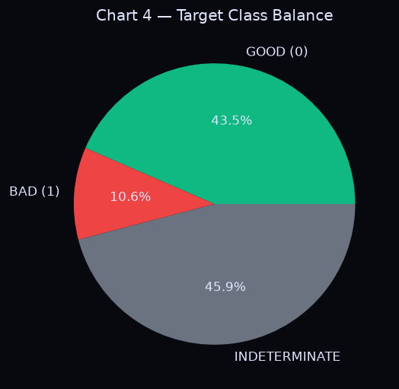
Chart 4 — Target Class Balance. GOOD / BAD / INDETERMINATE split of the population (indeterminates excluded from modelling).

9. Feature Engineering
Derived features created from raw fields; raw columns superseded by engineered ones dropped.

9.1 Derived Features
Feature | Rationale
credit_age_months | Credit history length — longer history generally predicts lower default
loan_age_months | Loan vintage — controls for origination cohort effects
grade_ordinal | LC-assigned credit grade — strong proxy for creditworthiness (1=best)
subgrade_ordinal | Finer-grained credit grade — captures risk within a grade bucket
int_rate_clean | Interest rate — higher rates indicate riskier borrowers
term_60 | 60-month flag — longer term loans have higher cumulative default probability
payment_to_income | Monthly payment burden as share of income — affordability indicator
loan_to_income | Loan-to-income ratio — key affordability measure for unsecured lending
emp_length_clean | Employment stability — longer tenure predicts lower default; -1 = unknown
has_mortgage / is_renter | Housing tenure flags — mortgage holders tend to be lower risk
any_delinq_2yr | Any 30+ dpd in last 2 years — strong default predictor
delinq_recent | Delinquency within last 12 months — recency amplifies risk signal
has_pub_rec | Any derogatory public record — bankruptcy or collection flag
high_inquiries | High inquiry count signals credit-seeking behaviour / financial stress
revol_util_clean / high_revol_util | Revolving utilisation — >75% signals credit stress
open_acc_ratio | Proportion of accounts still open — portfolio activity indicator

9.2 Categorical Encoding — One-Hot Encoding
Categorical variables with N unique values are converted into N binary flag columns, each indicating presence of that category. This avoids imposing false ordinal relationships that would exist if categories were simply numbered (e.g. encoding purpose as 1..K would wrongly imply an order/magnitude between purposes).

9.3 Behavioral Leakage Detection
Each numeric field is scored by its univariate AUC against the target; fields with unusually high standalone AUC are flagged as potential leakage and reviewed.
Column | Univariate AUC | Flag
int_rate | 0.673 | ⚠ review

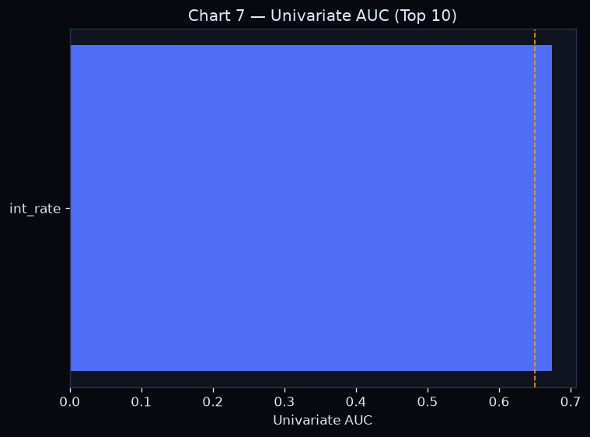
Chart 7 — Univariate AUC (Top 10). Columns whose standalone AUC ≥ 0.65 are flagged for behavioral-leakage review.

10. Variable Selection
Features selected by Information Value with a correlation filter; suspicious IV (>0.50) flagged.

10.1 Feature Reduction Journey (73 → 9)
Stage | Columns | Change
1. Raw columns | 73
2. Remove structural leakage | 60 | -13
3. Remove identifiers | 52 | -8
4. Remove date columns | 47 | -5
5. Feature engineering | 62 | +16
6. IV filter | 22 | -40
7. Correlation filter | 14 | -8
8. Final selected | 9

Reference: Feature_Selection_Detail.xlsx → IV_Table / Rejected_Features
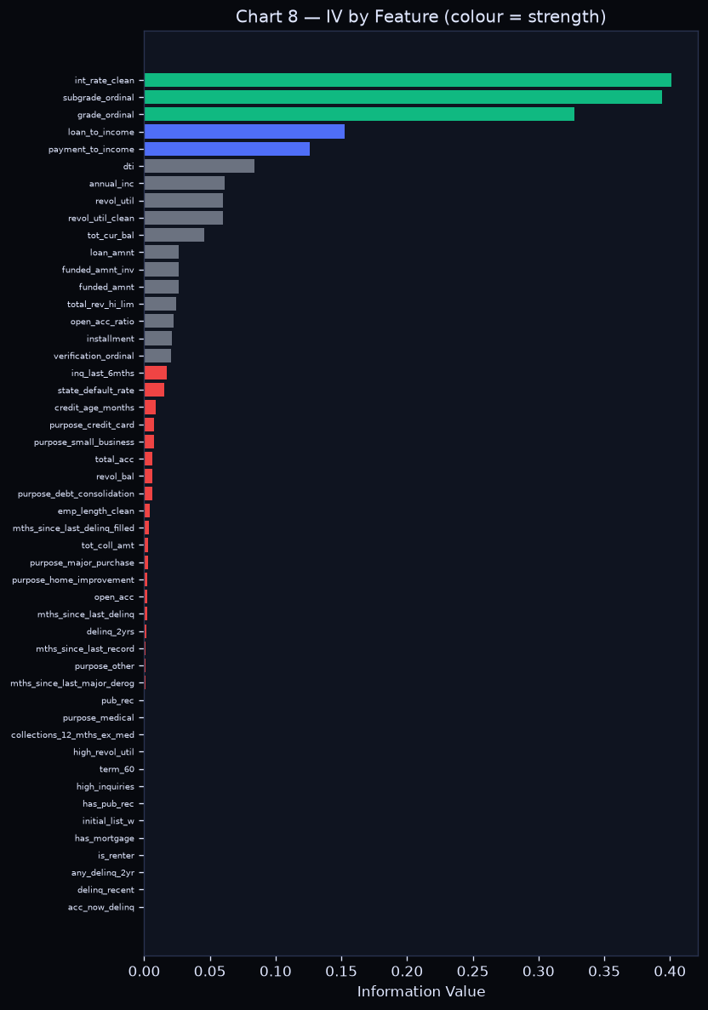
Chart 8 — Information Value for all candidate features, coloured by strength (green = strong, red = useless, amber = suspicious).

10.2 Final Selected Features (IV with RAG)
Feature | IV | Strength | RAG
int_rate_clean | 0.4014 | Strong | GREEN
loan_to_income | 0.1522 | Medium | GREEN
dti | 0.0837 | Weak | AMBER
annual_inc | 0.0609 | Weak | AMBER
revol_util | 0.0601 | Weak | AMBER
tot_cur_bal | 0.0454 | Weak | AMBER
loan_amnt | 0.0264 | Weak | AMBER
open_acc_ratio | 0.0225 | Weak | AMBER
verification_ordinal | 0.0206 | Weak | AMBER

Selected: 9 | Rejected: 40
Reference: Feature_Selection_Detail.xlsx → IV_Table, Correlation_Pairs
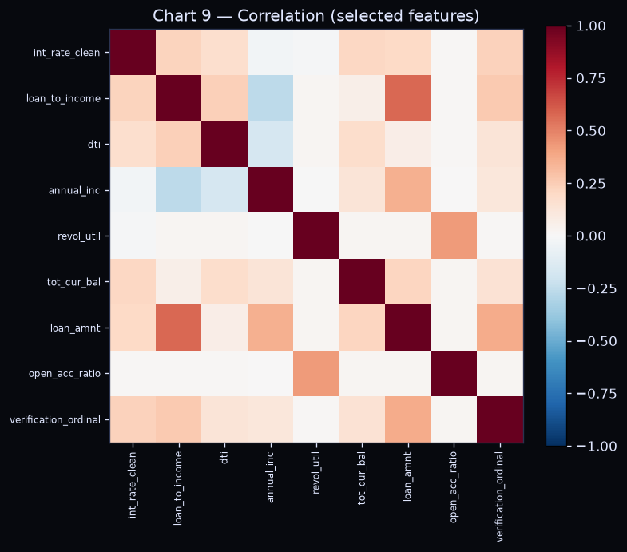
Chart 9 — Correlation heatmap of the final selected features (red = positive, blue = negative correlation).

11. Model Development

11.1 Algorithm Comparison (all candidates)
Model | AUC (test) | KS | Gini | F1 | Overfit Δ | Champion
LogisticRegression | 0.7 | 0.2912 | 0.4001 | 0.413 | -0.0059
RandomForest | 0.7038 | 0.2988 | 0.4076 | 0.4176 | 0.0268
XGBoost | 0.7058 | 0.299 | 0.4116 | 0.4165 | 0.0121 | ★
LightGBM | 0.7038 | 0.2969 | 0.4076 | 0.4159 | 0.0231
GradientBoosting_AutoML | 0.7041 | 0.2989 | 0.4082 | 0.0634 | 0.0026

Champion rationale: selected on best overfit-penalised test AUC.

11.2a Hyperparameter Search Process
Hyperparameters were tuned using Optuna's Tree-structured Parzen Estimator (TPE) sampler over 3 trials, each scored by 3-fold cross-validated AUC on the training set. TPE builds a probabilistic model of which parameter regions historically produced better AUC and progressively concentrates the search there rather than sampling uniformly at random — typically converging faster than grid or random search within a limited trial budget. The search space explored was:
Parameter | Search Range
n_estimators | [100, 500]
max_depth | [3, 7]
learning_rate | [0.01, 0.3] (log scale)
subsample | [0.6, 1.0]
colsample_bytree | [0.5, 1.0]
min_child_weight | [5, 50]

Best trial: AUC=0.6984 | Worst trial: AUC=0.6755 | Improvement: 0.0229 across 3 trials.
Trial # | CV AUC | Params
2 | 0.6984 | n_estimators=433, max_depth=4, learning_rate=0.01855998084649059, subsample=0.6733618039413735, colsample_bytree=0.6521211214797689, min_child_weight=29
1 | 0.6928 | n_estimators=123, max_depth=7, learning_rate=0.07725378389307355, subsample=0.8832290311184181, colsample_bytree=0.5102922471479012, min_child_weight=49
0 | 0.6755 | n_estimators=250, max_depth=7, learning_rate=0.1205712628744377, subsample=0.8394633936788146, colsample_bytree=0.5780093202212182, min_child_weight=12

11.2b Selected Hyperparameters — Final Values
Hyperparameter | Value
n_estimators | 433
max_depth | 4
learning_rate | 0.01855998084649059
subsample | 0.6733618039413735
colsample_bytree | 0.6521211214797689
min_child_weight | 29
scale_pos_weight | 4.146096162329069
random_state | 42
eval_metric | auc

11.3 Reproducibility
- Random seed fixed at 42 across split, model training and Optuna (TPESampler seed=42).
- Class imbalance handled via scale_pos_weight / class_weight='balanced'.
- Library versions pinned in requirements.txt; audit trail JSON captures the run.
Reference: Model_Comparison.xlsx → Model_Comparison, Champion_Hyperparams

12. Model Results & Validation

12.1 Discrimination — 3-way (Dev/Test/OOT)
Metric | Development (train) | Test | OOT
AUC | 0.7179 | 0.7058 | 0.695
Gini | 0.43579999999999997 | 0.4116 | 0.3899
KS | 0.299 | 0.299 | 0.2845

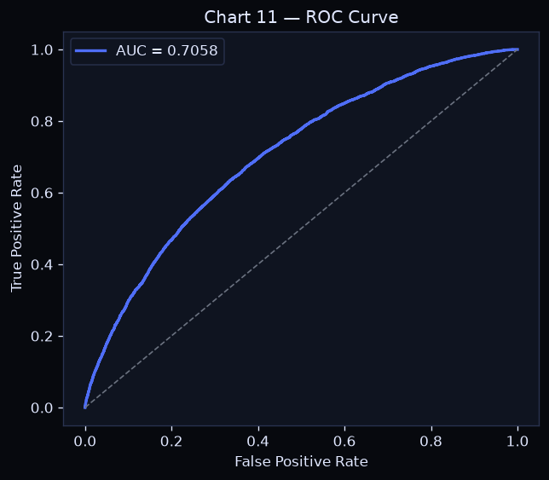
Chart 11 — ROC Curve. AUC = 0.7058 on the test set.

12.2 Variable & Score Stability (PSI / CSI)
Stability metrics require a trained model and OOT evaluation, hence reported here rather than during initial data quality review.
PSI (Population Stability Index) measures how much the SCORE distribution shifts between the development and out-of-time samples. CSI (Characteristic Stability Index) is the SAME formula applied per input FEATURE, isolating which variables drive any instability. VDI (Variable Deterioration Index) is NOT yet computed and is recorded as an open item (see §17).
Stability Metric | Value | Assessment | RAG
PSI (score) | 0.0113 | Stable | GREEN
CSI: int_rate_clean | 0.0746 | Stable | GREEN
CSI: loan_to_income | 0.0074 | Stable | GREEN
CSI: annual_inc | 0.0016 | Stable | GREEN
CSI: dti | 0.0141 | Stable | GREEN
CSI: tot_cur_bal | 0.0665 | Stable | GREEN

Reference: DQR_Full_Report.xlsx → Stability_PSI_CSI

12.3 Overfit Assessment
Train–Test AUC gap (overfit Δ): 0.0121 (target < 0.03 for GREEN).

12.4 KPI Scoreboard (RAG)
KPI | Value | RAG | Strength
Gini | 0.3899 | GREEN | Acceptable
AUC / AUROC | 0.695 | GREEN | Acceptable
KS Statistic | 0.2845 | GREEN | Acceptable
Rank Order Breaks | 0 | GREEN | No breaks
PSI (Population Stability) | 0.0113 | GREEN | Strong

12.5 Decile Rank-Order Check
Decile | N | Bad Rate | Avg Prob | RO Break
1 | 2500 | 0.040 | 0.163
2 | 2500 | 0.078 | 0.269
3 | 2500 | 0.116 | 0.331
4 | 2500 | 0.126 | 0.382
5 | 2500 | 0.159 | 0.430
6 | 2500 | 0.179 | 0.481
7 | 2500 | 0.213 | 0.530
8 | 2500 | 0.266 | 0.586
9 | 2500 | 0.322 | 0.652
10 | 2500 | 0.443 | 0.751

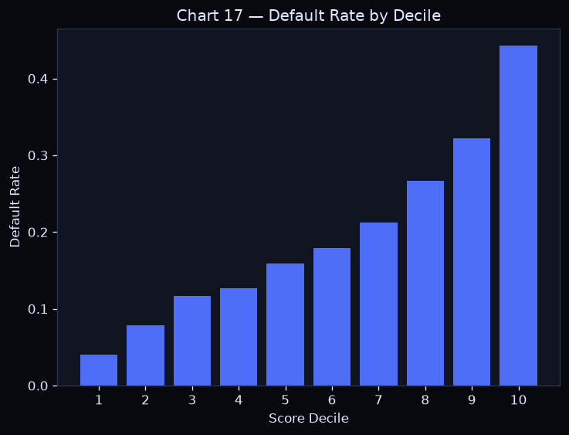
Chart 17 — Default rate by score decile (should rise monotonically with predicted risk; breaks indicate rank-order issues).

12.6 Champion vs Challengers
Model | AUC | KS | Gini | Champion
LogisticRegression | 0.7 | 0.2912 | 0.4001
RandomForest | 0.7038 | 0.2988 | 0.4076
XGBoost | 0.7058 | 0.299 | 0.4116 | ✓
LightGBM | 0.7038 | 0.2969 | 0.4076
GradientBoosting_AutoML | 0.7041 | 0.2989 | 0.4082

12.7 Confusion Matrix & Classification Report
The confusion matrix below is computed at a 0.5 probability threshold for reporting purposes only. This threshold is NOT necessarily the correct business decision threshold — the optimal cutoff should be set based on the actual cost ratio between false negatives (approving a loan that defaults) and false positives (rejecting a loan that would have performed) once that framework is agreed with the business.
 | Predicted GOOD | Predicted BAD
Actual GOOD | TN = 13,004 | FP = 7,138
Actual BAD | FN = 1,703 | TP = 3,155

Metric | Value
Accuracy | 0.6464
Precision (BAD class) | 0.3065
Recall / Sensitivity (BAD class) | 0.6494
Specificity (GOOD class) | 0.6456
F1 Score (BAD class) | 0.4165
Interpretation: at the 0.5 threshold, the model correctly identifies 64.9% of actual defaulters (recall), and when it predicts default it is correct 30.6% of the time (precision). The relatively modest precision at this threshold is expected given the 19.61% base default rate — precision and recall trade off as the threshold moves and should be tuned jointly with business cost assumptions rather than left at the default 0.5 cutoff.

Full Classification Report (per class):
Class | Precision | Recall | F1-Score | Support
Good (0) | 0.8842 | 0.6456 | 0.7463 | 20,142
Bad (1) | 0.3065 | 0.6494 | 0.4165 | 4,858
Overall Accuracy |  |  | 0.6464
Reference: Model_Comparison.xlsx → Confusion_Matrix

13. Calibration
Theory: a model can rank risk well (high AUC) yet output probabilities that do not match observed default rates. Calibration maps raw scores to well-calibrated probabilities. Platt scaling (sigmoid) fits a logistic transform; isotonic fitting learns a monotonic step function. Both are MONOTONIC, so ranking/AUC is unchanged — only the probability values move. Quality is measured by Brier score and Expected Calibration Error (ECE); we target ECE ≤ 0.02.
Variant | Brier | ECE | AUC
Uncalibrated | 0.2164 | 0.2632 | 0.7058
Sigmoid (Platt) | 0.143 | 0.0111 | 0.7058
Isotonic | 0.1432 | 0.0091 | unchanged

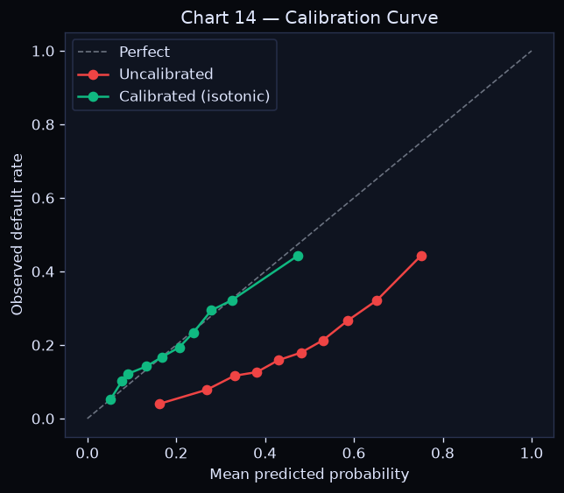
Chart 14 — Calibration curve: uncalibrated vs isotonic method.
Uncalibrated ECE status: EXCEEDS — needs calibration. Recommended method: isotonic.

13.1 Post-Calibration Reliability
Bin | Count | Mean Predicted | Actual Rate | Gap
0 | 4050 | 0.0517 | 0.0516 | -0.0001
1 | 2268 | 0.0778 | 0.1014 | 0.0236
2 | 1541 | 0.0906 | 0.1213 | 0.0307
3 | 4098 | 0.1332 | 0.142 | 0.0088
4 | 1502 | 0.1687 | 0.1678 | -0.0009
5 | 2336 | 0.2067 | 0.1935 | -0.0132
6 | 3250 | 0.2392 | 0.2345 | -0.0047
7 | 1097 | 0.2791 | 0.2944 | 0.0154
8 | 2387 | 0.3251 | 0.3217 | -0.0033
9 | 2471 | 0.4731 | 0.4423 | -0.0307

Reference: Model_Comparison.xlsx → Calibration_Reliability

14. Model Explainability (SHAP)
SHAP TreeExplainer applied to the champion model on a sample of the test set to attribute each prediction to its features.

14.1 Global Feature Importance — SHAP Beeswarm
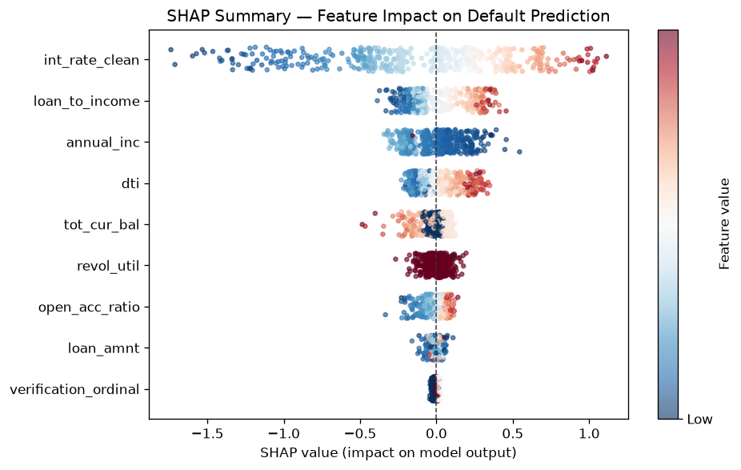
Red = high feature value, blue = low. Points right of centre increase default risk; left decrease it.
Interpretation
The SHAP beeswarm plot ranks features by their average impact on the model's predicted default probability. Each point represents one borrower in the test sample; its horizontal position shows how much that feature pushed the prediction up (increased risk) or down (decreased risk) for that specific borrower, and its colour shows whether that borrower's value for the feature was high (red) or low (blue).
The top 5 features together account for approximately 88% of total feature importance in the model, indicating that risk is driven by a concentrated but not single-variable set of signals.
Key drivers, in order of importance:
1. int_rate_clean (mean |SHAP| = 0.4799) — reflects the interest rate Lending Club assigned at origination based on the borrower's underwriting risk grade — higher rates were already priced by the platform as higher risk, so this feature's dominance confirms the model is picking up genuine, pre-existing risk signal rather than an artifact.
2. loan_to_income (mean |SHAP| = 0.1618) — captures how large the requested loan is relative to the borrower's annual income — higher ratios indicate the loan represents a larger financial commitment relative to repayment capacity.
3. annual_inc (mean |SHAP| = 0.1368) — reflects absolute income level — lower income borrowers have a smaller buffer against income shocks.
4. dti (mean |SHAP| = 0.1117) — measures existing debt burden relative to income — borrowers already carrying substantial debt obligations have less capacity to absorb a new loan payment.
5. tot_cur_bal (mean |SHAP| = 0.0627) — reflects total existing balances across accounts — a proxy for overall indebtedness.
Taken together, these drivers align with standard credit-risk intuition: pricing signal (interest rate), affordability (loan-to-income, DTI, income), and credit behaviour (utilisation, balances) all contribute independently rather than the model relying on any single dominant signal — supporting robustness against changes in any one input distribution.

14.2 Top Features by Mean |SHAP|
Feature | Mean |SHAP|
int_rate_clean | 0.47992
loan_to_income | 0.16176
annual_inc | 0.13677
dti | 0.11174
tot_cur_bal | 0.06272
revol_util | 0.04974
open_acc_ratio | 0.04671
loan_amnt | 0.02473
verification_ordinal | 0.01422

14.3 Individual Prediction Example (Adverse-Action style)
Rank | Feature | Value | Contribution
1 | int_rate_clean | 25.99 | 0.222
2 | revol_util | 79.6 | 0.0926
3 | verification_ordinal | 1.0 | 0.0081

15. Fairness & Bias Assessment
Methodology: proxy protected attributes (e.g. home ownership, verification status) are compared for predicted-risk parity on the test set. Note: this dataset lacks direct protected attributes (race, gender, age); proxy analysis is indicative only and cannot substitute for a full fair-lending review.

15.1 Predicted-Risk Parity by Proxy Attribute
4 proxy attributes assessed; 0 group(s) flagged (predicted risk deviating > 10 percentage points from the overall mean).
Attribute | Group | N | Mean Predicted | Actual Rate | Diff from Avg | Concern
verification_status | Not Verified | 8714 | 0.4084 | 0.1566 | -0.0491 | Low
verification_status | Source Verified | 7780 | 0.4641 | 0.2059 | 0.0066 | Low
verification_status | Verified | 8506 | 0.5017 | 0.2223 | 0.0442 | Low
home_ownership | MORTGAGE | 12099 | 0.4306 | 0.1738 | -0.0268 | Low
home_ownership | OWN | 2082 | 0.4777 | 0.2032 | 0.0203 | Low
home_ownership | RENT | 10794 | 0.4837 | 0.2155 | 0.0262 | Low
purpose | car | 446 | 0.3575 | 0.1099 | -0.1 | Low
purpose | credit_card | 5105 | 0.4397 | 0.1689 | -0.0178 | Low
purpose | debt_consolidation | 13940 | 0.4775 | 0.2057 | 0.0201 | Low
purpose | educational | 75 | 0.4371 | 0.2 | -0.0203 | Low
purpose | home_improvement | 1579 | 0.4059 | 0.1811 | -0.0516 | Low
purpose | house | 178 | 0.4557 | 0.1461 | -0.0018 | Low
purpose | major_purchase | 690 | 0.3844 | 0.1246 | -0.073 | Low
purpose | medical | 313 | 0.4472 | 0.1917 | -0.0102 | Low
purpose | moving | 182 | 0.4649 | 0.2418 | 0.0074 | Low
purpose | other | 1482 | 0.4544 | 0.2173 | -0.0031 | Low
purpose | small_business | 574 | 0.4763 | 0.2962 | 0.0188 | Low
purpose | vacation | 183 | 0.4374 | 0.2131 | -0.02 | Low
purpose | wedding | 224 | 0.4056 | 0.1161 | -0.0518 | Low
addr_state | AK | 75 | 0.4807 | 0.12 | 0.0233 | Low
addr_state | AL | 331 | 0.4722 | 0.2326 | 0.0147 | Low
addr_state | AR | 164 | 0.4922 | 0.2439 | 0.0347 | Low
addr_state | AZ | 581 | 0.4652 | 0.1773 | 0.0078 | Low
addr_state | CA | 4423 | 0.4476 | 0.1958 | -0.0099 | Low
addr_state | CO | 536 | 0.4682 | 0.1735 | 0.0108 | Low
addr_state | CT | 373 | 0.4385 | 0.1877 | -0.019 | Low
addr_state | DC | 93 | 0.3927 | 0.086 | -0.0648 | Low
addr_state | DE | 85 | 0.4555 | 0.1882 | -0.002 | Low
addr_state | FL | 1787 | 0.4633 | 0.2043 | 0.0058 | Low
addr_state | GA | 755 | 0.4405 | 0.1762 | -0.017 | Low
addr_state | HI | 130 | 0.4792 | 0.1846 | 0.0217 | Low
addr_state | IL | 927 | 0.4535 | 0.1888 | -0.0039 | Low
addr_state | IN | 269 | 0.5024 | 0.2416 | 0.0449 | Low
addr_state | KS | 194 | 0.4822 | 0.1649 | 0.0247 | Low
addr_state | KY | 209 | 0.4716 | 0.2344 | 0.0141 | Low
addr_state | LA | 301 | 0.4604 | 0.1628 | 0.0029 | Low
addr_state | MA | 617 | 0.4421 | 0.1896 | -0.0154 | Low
addr_state | MD | 587 | 0.4442 | 0.1925 | -0.0133 | Low
addr_state | MI | 618 | 0.4742 | 0.1974 | 0.0167 | Low
addr_state | MN | 414 | 0.4665 | 0.1981 | 0.009 | Low
addr_state | MO | 374 | 0.4629 | 0.2299 | 0.0054 | Low
addr_state | MT | 71 | 0.4982 | 0.1268 | 0.0407 | Low
addr_state | NC | 645 | 0.4749 | 0.2279 | 0.0175 | Low
addr_state | NH | 120 | 0.4527 | 0.2083 | -0.0048 | Low
addr_state | NJ | 957 | 0.4459 | 0.2048 | -0.0116 | Low
addr_state | NM | 138 | 0.4693 | 0.1957 | 0.0119 | Low
addr_state | NV | 370 | 0.4579 | 0.2568 | 0.0004 | Low
addr_state | NY | 2070 | 0.453 | 0.2068 | -0.0045 | Low
addr_state | OH | 764 | 0.4835 | 0.216 | 0.0261 | Low
addr_state | OK | 201 | 0.465 | 0.1891 | 0.0075 | Low
addr_state | OR | 335 | 0.4659 | 0.1821 | 0.0084 | Low
addr_state | PA | 868 | 0.4603 | 0.197 | 0.0028 | Low
addr_state | RI | 93 | 0.4235 | 0.1828 | -0.0339 | Low
addr_state | SC | 252 | 0.4687 | 0.1865 | 0.0113 | Low
addr_state | SD | 63 | 0.5017 | 0.1587 | 0.0443 | Low
addr_state | TN | 207 | 0.4996 | 0.2512 | 0.0422 | Low
addr_state | TX | 1863 | 0.4467 | 0.1616 | -0.0108 | Low
addr_state | UT | 196 | 0.4727 | 0.1786 | 0.0153 | Low
addr_state | VA | 807 | 0.444 | 0.171 | -0.0135 | Low
addr_state | VT | 41 | 0.4412 | 0.0976 | -0.0163 | Low
addr_state | WA | 572 | 0.4654 | 0.1836 | 0.0079 | Low
addr_state | WI | 320 | 0.4715 | 0.1969 | 0.0141 | Low
addr_state | WV | 109 | 0.4732 | 0.1376 | 0.0158 | Low
addr_state | WY | 59 | 0.4878 | 0.1356 | 0.0303 | Low

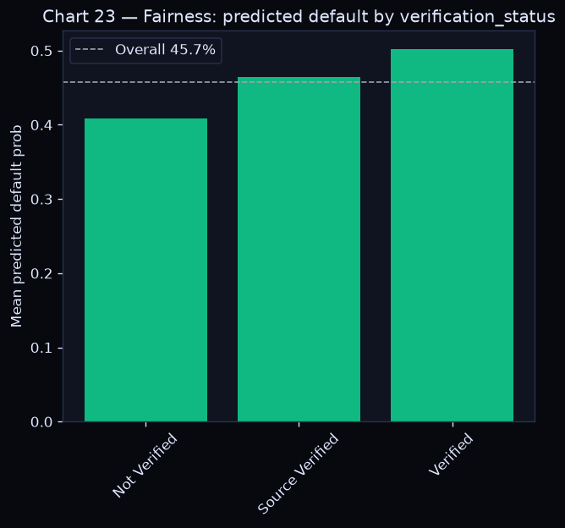
Chart 23 — Predicted default rate by proxy group. Bars beyond the dashed overall-mean line by >10pp indicate potential disparate impact.
Important caveat: the model must undergo ECOA/Reg-B disparate-impact testing on protected classes before customer-facing deployment.

16. Model Governance & Sign-Off

16.1 Reviewer Decision
Field | Value
Decision | Approve for Deployment
Analyst | Mohit
Notes | done
Timestamp | 2026-07-12T17:38:05.646812

16.2 HITL Checkpoints
Checkpoint | Decision
1 — Target Definition | approved
2 — Feature Shortlist | approved
3 — Model Sign-Off | Approve for Deployment

AI/ML governance: every phase was executed by an autonomous agent with human review gates; all decisions and metrics are recorded in the audit-trail JSON. Regulatory alignment: SR 11-7 (documentation, validation, monitoring), ECOA (adverse action).

17. Assumptions, Limitations, Risks & Caveats
Type | Item
Assumption | Indeterminate (censored) loans excluded; GOOD/BAD only
Assumption | Imputation applied to missing numeric features
Limitation | Trained on funded loans only — survivorship/selection bias
Limitation | No direct protected attributes — fairness is proxy-based
Risk | Self-reported income/DTI subject to misrepresentation
Risk | Population drift — quarterly PSI/CSI monitoring required
Open item | VDI (Variable Deterioration Index) not yet computed

18. Appendices

18.1 KPI Threshold Tables
Metric | Strong GREEN | Acceptable GREEN | AMBER | RED
gini | (0.45, 0.7) | (0.35, 0.45) | (0.3, 0.35) | (0, 0.3)
auc | (0.72, 1.0) | (0.68, 0.72) | (0.65, 0.68) | (0, 0.65)
ks | (0.35, 0.65) | (0.25, 0.35) | (0.2, 0.25) | (0, 0.2)
psi | (0, 0.1) | (0.1, 0.2) | (0.2, 0.3) | (0.3, 999)
csi | (0, 0.1) | (0.1, 0.2) | (0.2, 0.3) | (0.3, 999)
iv | (0.3, 0.5) | (0.1, 0.3) | (0.02, 0.1) | (0.5, 999)
gini_gap | (0, 0.05) | (0.05, 0.1) | (0.1, 0.15) | (0.15, 999)
ks_gap | (0, 0.05) | (0.05, 0.1) | (0.1, 0.15) | (0.15, 999)

18.2 Attached Excel Workbooks
Workbook | Contents
RUN_20260712_215141_DQR_Full_Report.xlsx | Variable profile, consistency checks, PSI/CSI
RUN_20260712_215141_Feature_Selection_Detail.xlsx | IV table, correlation pairs, selection detail
RUN_20260712_215141_Model_Comparison.xlsx | 5-model comparison, hyperparameters, calibration

18.3 Glossary
- AUC/AUROC: Area under ROC curve — rank-ordering power
- Gini: 2×AUC−1
- KS: Max separation between cumulative good/bad distributions
- IV: Information Value — predictive strength of a feature
- PSI/CSI: Population/Characteristic Stability Index
- ECE: Expected Calibration Error
- SHAP: Shapley additive explanations — per-prediction attributions
- OOT: Out-of-time validation sample

