Project 2
<Mastermind AI Version 4>

CSC-7
Miguel Galvez
December 12, 2021

Introduction
Title: Mastermind AI
Mastermind is a code breaking game in which the player must guess/crack the code automatically generated. In this project, I created an AI that does that for me.

The code ranges from 0000-9999, and takes at most 34 tries to guess the code.

Summary
Project Size: Roughly 300 lines
The number of variables: 20

I had a lot of fun programming this project, since I had to keep in mind of all types of codes that I would be dealing with. I gave many outcomes variable names such as aabc, abcd, aaab, and aaaa. Depending on the amount of repeats that we're given.

The most difficult aspect was incorporating the lesson into code. Additionally, optimizing the code to not make unnecessary guesses. For instance, if 4 red pegs were counted in total, there's no need to proceed guess “7777” and above if we progressively guessed from “0000” and so on.

Description

The objective of this program is to understand the concepts of permutations, and how to integrate algorithms or methods as a means to deal with every permutation. There are many intrinsic concepts that could have been incorporated such as recursion. However, due to time, I managed to get a barebones AI that does the job.

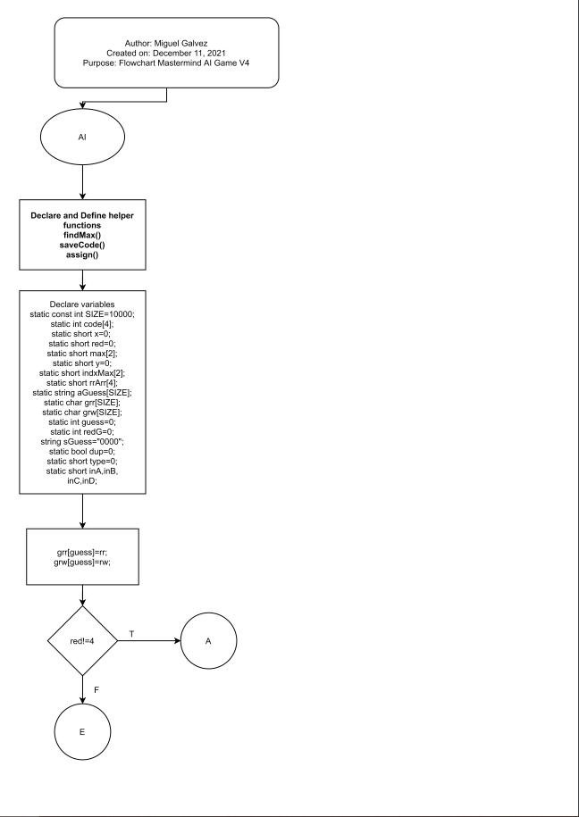
Flowchart

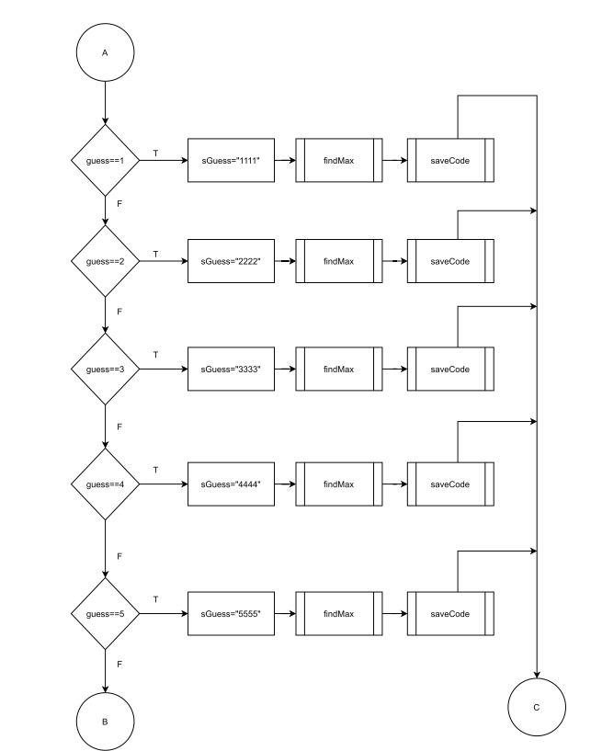

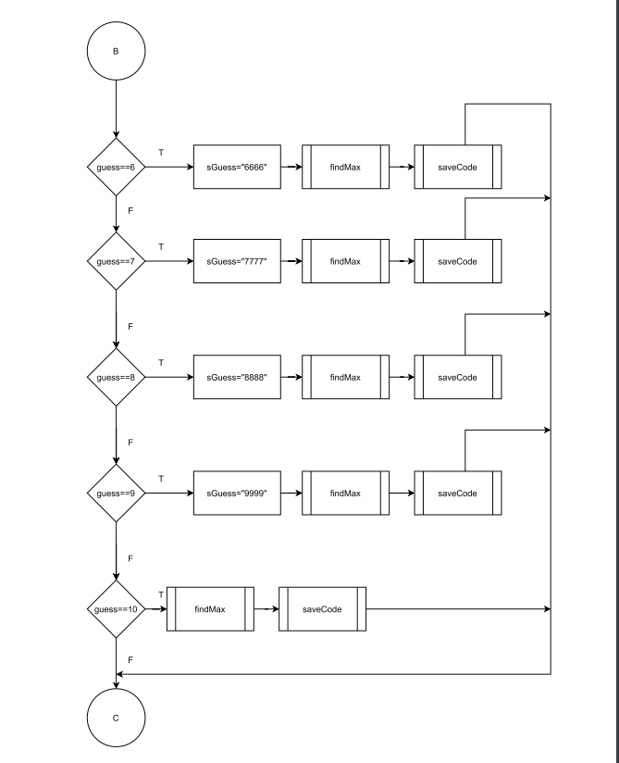

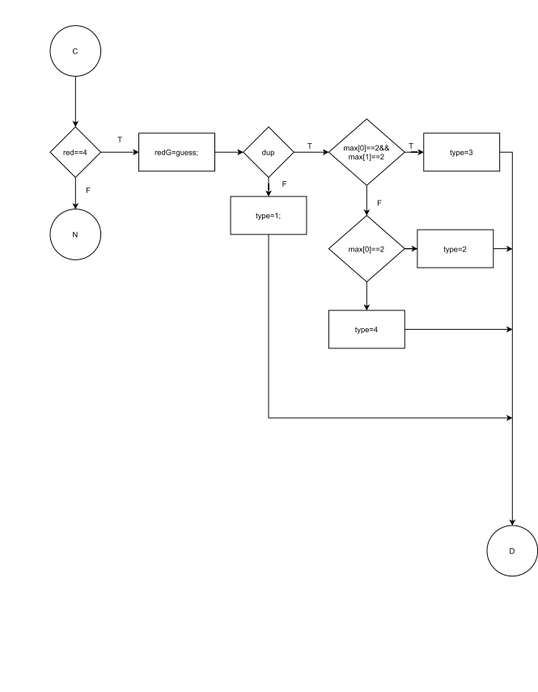
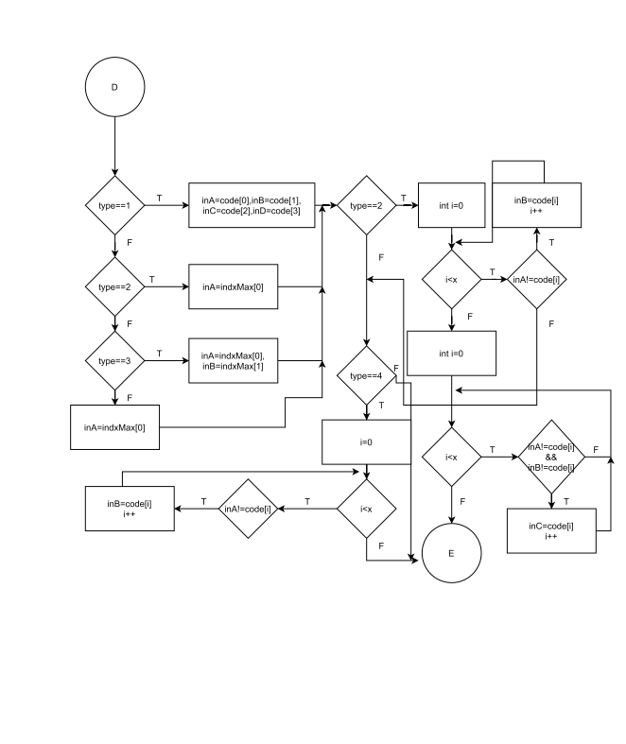
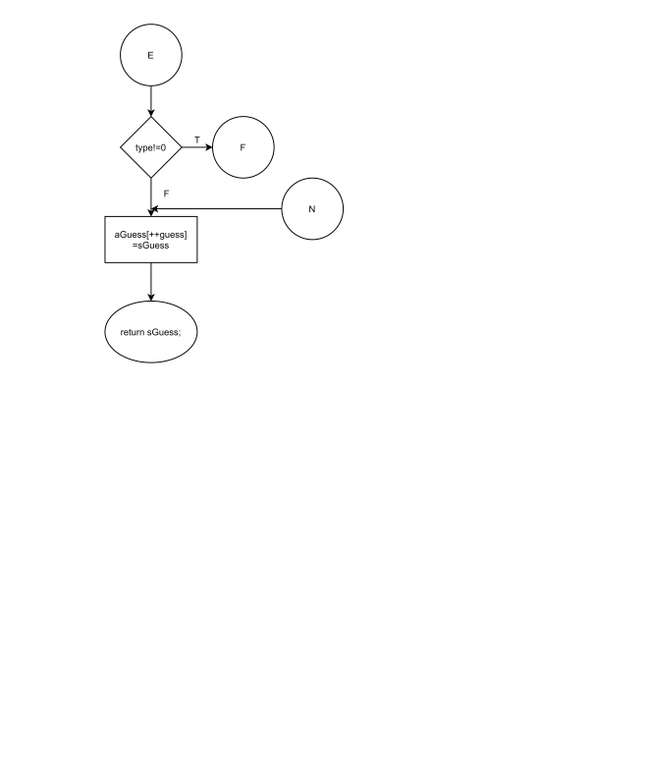

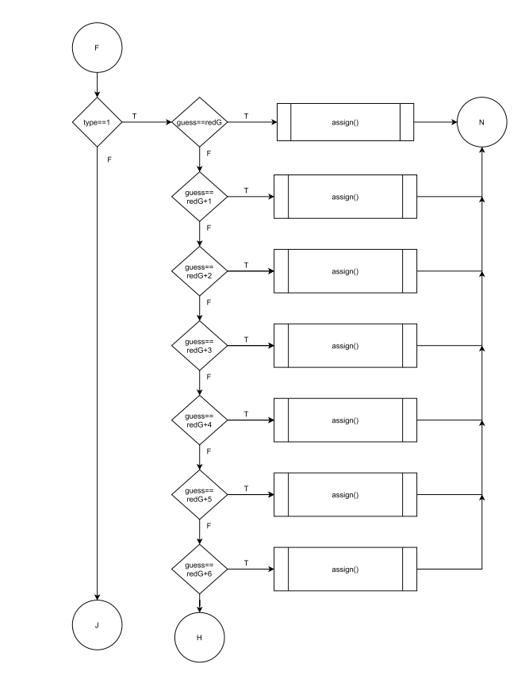
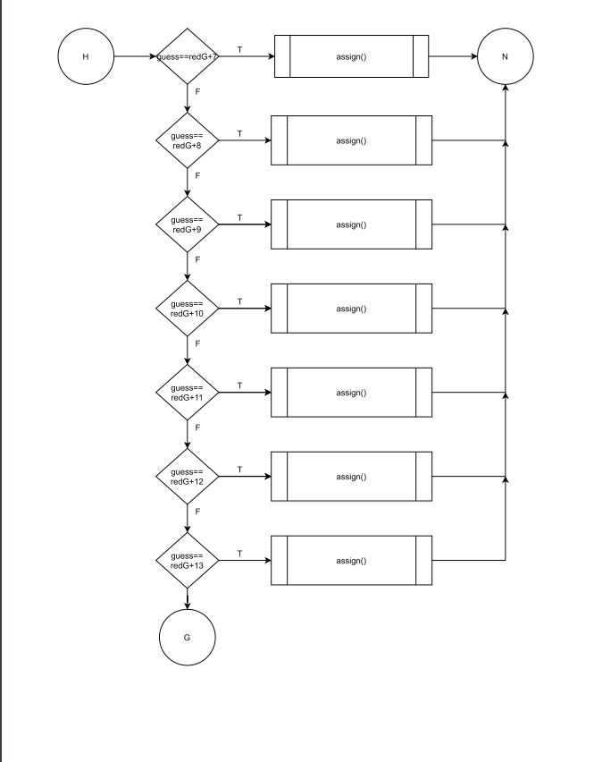

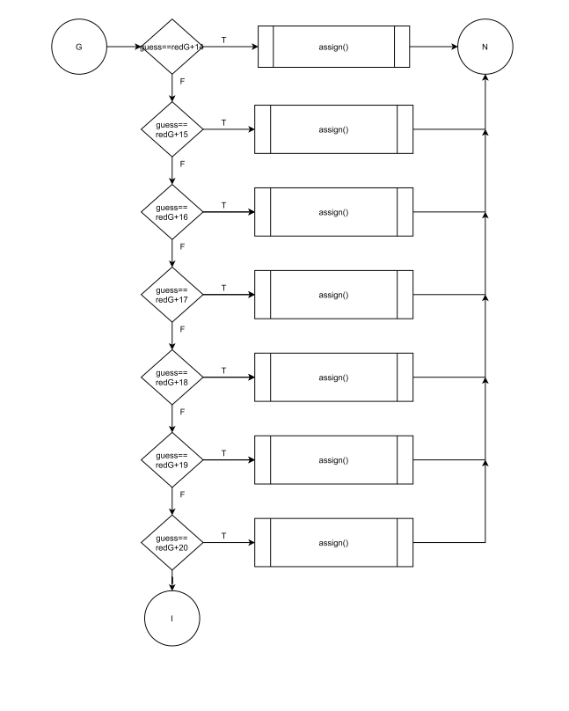

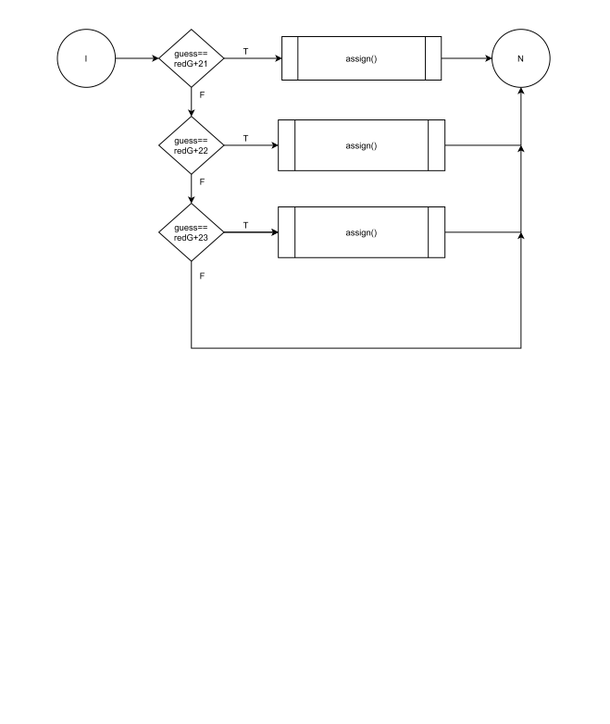

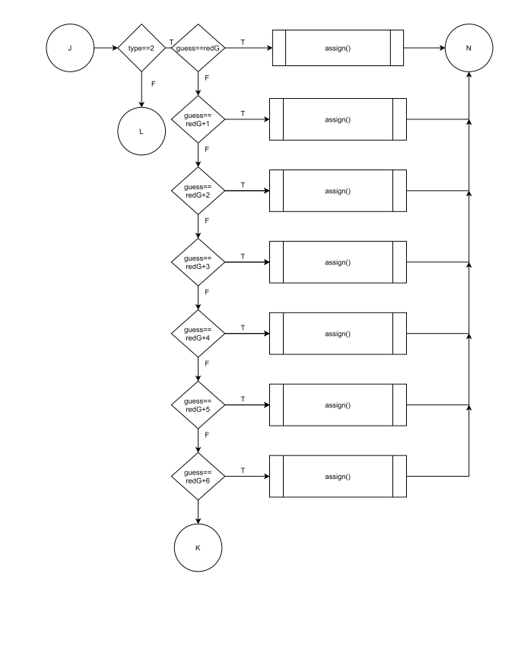

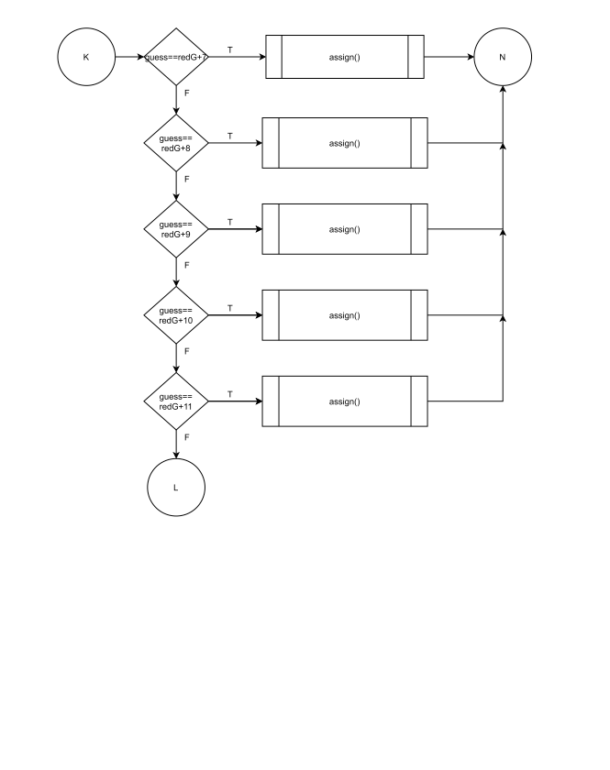

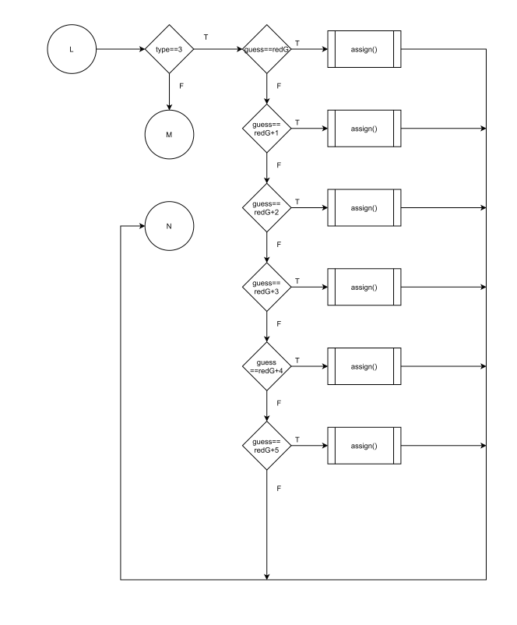

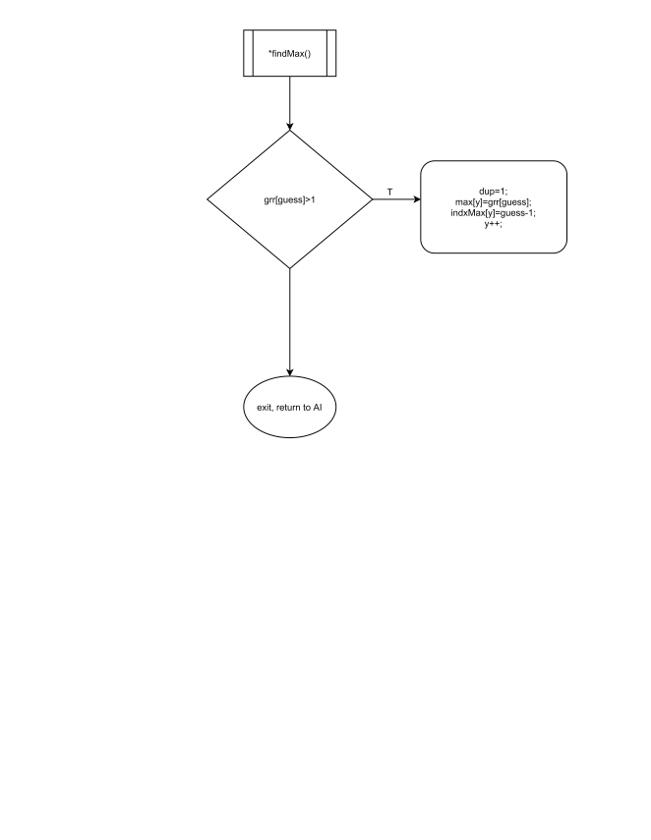
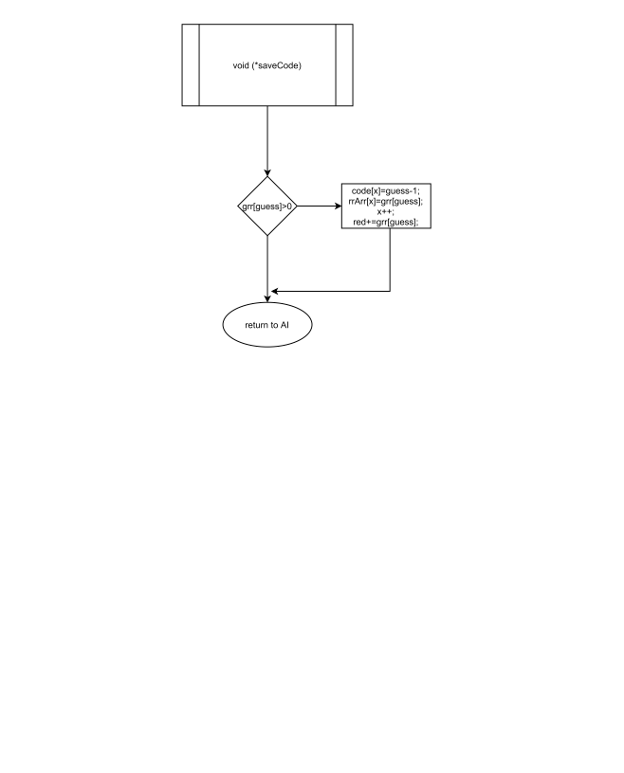
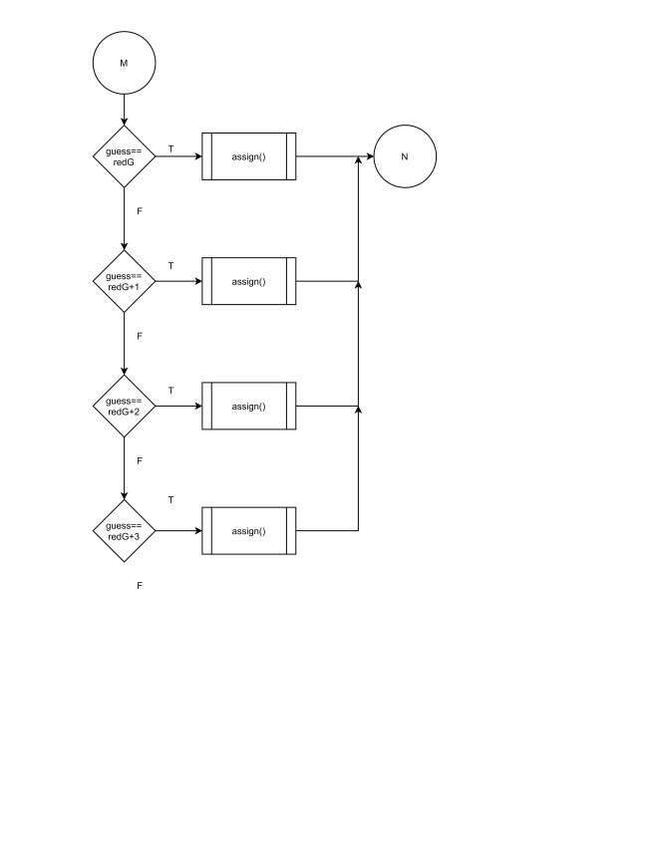

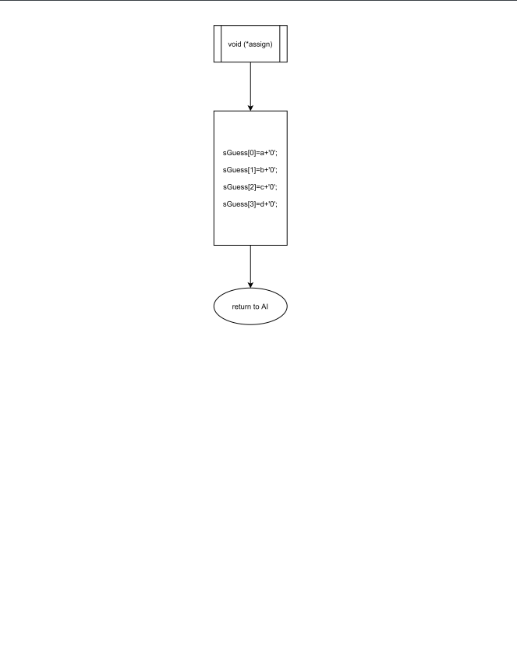

Pseudo code

start program
define functions
define variables
store results from last guess “rr=0 and rw=0 when initialized”
if red !=4
if guess==1
then sGuess= ”1111”
findMax
saveCode
else if guess==2
then sGuess=”2222”
findMax
saveCode
else if guess==3
then sGuess= ”3333”
findMax
saveCode
else if guess==4
then sGuess=”4444”
findMax
saveCode
else if guess==5
then sGuess= ”5555”
findMax
saveCode
else if guess==6
then sGuess=”6666”
findMax
saveCode
else if guess==7
then sGuess= ”7777”
findMax
saveCode
else if guess==8
then sGuess=”8888”
findMax
saveCode
else if guess==9
then sGuess= ”9999”
findMax
saveCode
else if guess==10
then
findMax
saveCode
if red==4
redG=guess
if dup
max[0]==2&&max[1]==2?
type=3:
max[0]==2?
type=2:
type=4;
else
type=1;
type==1?
inA=code[0],inB=code[1],inC=code[2],inD=code[3]:
type==2?
inA=indxMax[0]:
type==3?
inA=indxMax[0],inB=indxMax[1]:
inA=indxMax[0];
if type==2
for(int i=0;i<x;i++)
if(inA!=code[i])
inB=code[i];
for(int i=0;i<x;i++)
if(inA!=code[i]&&inB!=code[i])
inC=code[i];
else if (type==4)
for(int i=0;i<x;i++)
if(inA!=code[i])
inB=code[i];
if(type!=0)
switch(type)
case 1:
try every combination of non-duplicates using the numbers
with red pegs
case 2:
try every combination of aabc
case 3:
try every combination of aabb
default:
try every combination of aaab
Store the guess
return the guess
Major Variables

Type | Variable Name | Description | Location
static const int | SIZE=10000 | How many guesses to save | AI(),line80
static int | code[4] | Save the value associated with red pegs | AI(),line80
static short | x=0 | Accumulator for code array | AI(),line80
static short | red=0 | Accumulator for total red pegs | AI(),line80
static short | max[2] | max number of red pegs | AI(),line80
static short | indxMax[2] | Index of the element with the most red pegs | AI(),line80
static short | rrArr[4] | Array containing number of red pegs | AI(),line80
static string | aGuess[SIZE] | Save the guesses | AI(),line80
static char | grw[SIZE] | Save right guess in wrong spot | AI(),line80
static char | grr[SIZE] | Save right guess in right spot | AI(),line80
static int | guess=0 | status of whether following player needs to be skipped or not | AI(),line80
static int | redG=0 | primary source of input from players | AI(),line80
string | sGuess="0000" | Size the guest string | AI(),line80
static bool | dup=0 | flag for duplicates in array | AI(),line80
static short | type=0 | the type of duplicate default to 0 | AI(),line80
static short | inA,inB,inC,inD | place holders for sGuess | AI(),line80

References
1.Dr. Lehr's Lecture on Mastermind AI Project
Program
- /string AI(char rr,char rw){
- //Define helper functions here
- void (*findMax)(char [],bool&,short[],short[],short&,int)=
- [] (char grr[],bool &dup,short max[],short indxMax[],
- short &y,int guess){
- if(grr[guess]>1){
- dup=1; //assign flag as true for duplicates
- max[y]=grr[guess]; //Store the max red pegs into max array
- indxMax[y]=guess-1; //Store the index associated with max
- y++;
- }
- };
- void (*saveCode)(char [],int[],short[],short&,short&,int)=
- [] (char grr[],int code[],short rrArr[],short &x,
- short &red,int guess){
- if(grr[guess]>0){
- code[x]=guess-1; //store the index into code array
- rrArr[x]=grr[guess];//Assign no of reds for specific code
- x++; //increment x
- red+=grr[guess]; //Red peg accumulator
- }
- };
- void (*assign)(string&,short,short,short,short)=
- [] (string &sGuess,short a,short b,short c,short d){
- sGuess[0]=a+'0';
- sGuess[1]=b+'0';
- sGuess[2]=c+'0';
- sGuess[3]=d+'0';
- };
- //Save the historical values of guesses and results
- static const int SIZE=10000;//How many guesses to save
- static int code[4]; //Save the value associated with red pegs
- static short x=0; //Accumulator for code array
- static short red=0; //Accumulator for total red pegs
- static short max[2]; //max number of red pegs
- static short y=0; //Accumulator for total number of duplicates
- static short indxMax[2]; //Index of the element with the most red pegs
- static short rrArr[4]; //Array containing number of red pegs
- //aligned with code array
- static string aGuess[SIZE]; //Save the guesses
- static char grr[SIZE]; //Save right guess in right spot
- static char grw[SIZE]; //Save right guess in wrong spot
- static int guess=0; //Increment the guess number
- static int redG=0; //Number of guess after all 4 red pegs
- string sGuess="0000"; //Size the guest string
- static bool dup=0; //flag for duplicates in array
- static short type=0; //the type of duplicate default to 0
- static short inA,inB, //place holders for sGuess
- inC,inD;
- //Store the results from the last guess
- grr[guess]=rr;
- grw[guess]=rw;
- //Return a guess depending on which guess we're on
- //Unless we found a total of 4 red pegs
- if(red!=4){
- //Increment each element of guess, tally red pegs and their
- //indices
- if(guess==1){
- sGuess="1111";
- findMax(grr,dup,max,indxMax,y,guess);
- saveCode(grr,code,rrArr,x,red,guess);
- }else if(guess==2){
- sGuess="2222";
- findMax(grr,dup,max,indxMax,y,guess);
- saveCode(grr,code,rrArr,x,red,guess);
- }else if(guess==3){
- sGuess="3333";
- findMax(grr,dup,max,indxMax,y,guess);
- saveCode(grr,code,rrArr,x,red,guess);
- }else if(guess==4){
- sGuess="4444";
- findMax(grr,dup,max,indxMax,y,guess);
- saveCode(grr,code,rrArr,x,red,guess);
- }else if(guess==5){
- sGuess="5555";
- findMax(grr,dup,max,indxMax,y,guess);
- saveCode(grr,code,rrArr,x,red,guess);
- }else if(guess==6){
- sGuess="6666";
- findMax(grr,dup,max,indxMax,y,guess);
- saveCode(grr,code,rrArr,x,red,guess);
- }else if(guess==7){
- sGuess="7777";
- findMax(grr,dup,max,indxMax,y,guess);
- saveCode(grr,code,rrArr,x,red,guess);
- }else if(guess==8){
- sGuess="8888";
- findMax(grr,dup,max,indxMax,y,guess);
- saveCode(grr,code,rrArr,x,red,guess);
- }else if(guess==9){
- sGuess="9999";
- findMax(grr,dup,max,indxMax,y,guess);
- saveCode(grr,code,rrArr,x,red,guess);
- }else if(guess==10){
- findMax(grr,dup,max,indxMax,y,guess);
- saveCode(grr,code,rrArr,x,red,guess);
- }
- if(red==4){
- redG=guess; //Store the number of the guess once
- //We will determine the type of code that we're dealing with
- //Is duplicate
- if(dup){
- //Find what kind of duplicate it is
- max[0]==2&&max[1]==2?type=3: //aabb
- max[0]==2?type=2: //aabc
- type=4; //aaab
- //Not duplicate
- }else{
- type=1; //abcd
- }
- //We will store the number of guesses that we left off on to
- //number our permutations
- //Assign into inA,inB,inC,inD depending on the type
- type==1?inA=code[0],inB=code[1],inC=code[2],inD=code[3]:
- type==2?inA=indxMax[0]:
- type==3?inA=indxMax[0],inB=indxMax[1]:
- inA=indxMax[0];
- if(type==2){
- for(int i=0;i<x;i++){
- if(inA!=code[i]){
- inB=code[i];
- }
- }
- for(int i=0;i<x;i++){
- if(inA!=code[i]&&inB!=code[i]){
- inC=code[i];
- }
- }
- }else if (type==4){
- for(int i=0;i<x;i++){
- if(inA!=code[i]){
- inB=code[i];
- }
- }
- }
- }
- //At this moment, we have found all four reds, we either have 10
- //guesses or less
- }
- //Try every permutation of codes with red pegs
- if(type!=0){
- switch(type){
- case 1:
- //No duplicates abcd
- if(guess==redG){
- //abcd
- assign(sGuess,inA,inB,inC,inD);
- }else if(guess==redG+1){
- //bacd
- assign(sGuess,inB,inA,inC,inD);
- }else if(guess==redG+2){
- //cabd
- assign(sGuess,inC,inA,inB,inD);
- }else if(guess==redG+3){
- //dabc
- assign(sGuess,inD,inA,inB,inC);
- }else if(guess==redG+4){
- //abdc
- assign(sGuess,inA,inB,inD,inC);
- }else if(guess==redG+5){
- //badc
- assign(sGuess,inB,inA,inD,inC);
- }else if(guess==redG+6){
- //CADB
- assign(sGuess,inC,inA,inD,inB);
- }else if(guess==redG+7){
- //DACB
- assign(sGuess,inD,inA,inC,inB);
- }else if(guess==redG+8){
- //ACBD
- assign(sGuess,inA,inC,inB,inD);
- }else if(guess==redG+9){
- //BCAD
- assign(sGuess,inB,inC,inA,inD);
- }else if(guess==redG+10){
- //CBAD
- assign(sGuess,inC,inB,inA,inD);
- }else if(guess==redG+11){
- //DBAC
- assign(sGuess,inD,inB,inA,inC);
- }else if(guess==redG+12){
- //ACDB
- assign(sGuess,inA,inC,inD,inB);
- }else if(guess==redG+13){
- //BCDA
- assign(sGuess,inB,inC,inD,inA);
- }else if(guess==redG+14){
- //CBDA
- assign(sGuess,inC,inB,inD,inA);
- }else if(guess==redG+15){
- //DBCA
- assign(sGuess,inD,inB,inC,inA);
- }else if(guess==redG+16){
- //ADBC
- assign(sGuess,inA,inD,inB,inC);
- }else if(guess==redG+17){
- //BDAC
- assign(sGuess,inB,inD,inA,inC);
- }else if(guess==redG+18){
- //CDAB
- assign(sGuess,inC,inD,inA,inB);
- }else if(guess==redG+19){
- //DCAB
- assign(sGuess,inD,inC,inA,inB);
- }else if(guess==redG+20){
- //ADCB
- assign(sGuess,inA,inD,inC,inB);
- }else if(guess==redG+21){
- //BDCA
- assign(sGuess,inB,inD,inC,inA);
- }else if(guess==redG+22){
- //CDBA
- assign(sGuess,inC,inD,inB,inA);
- }else if(guess==redG+23){
- //DCBA
- assign(sGuess,inD,inC,inB,inA);
- }
- break;
- case 2:
- //max[0]==2
- //aabc
- if(guess==redG){
- //aabc
- assign(sGuess,inA,inA,inB,inC);
- }else if(guess==redG+1){
- //baac
- assign(sGuess,inB,inA,inA,inC);
- }else if(guess==redG+2){
- //abac
- assign(sGuess,inA,inB,inA,inC);
- }else if(guess==redG+3){
- //BACA
- assign(sGuess,inB,inA,inC,inA);
- }else if(guess==redG+4){
- //ABCA
- assign(sGuess,inA,inB,inC,inA);
- }else if(guess==redG+5){
- //CBAA
- assign(sGuess,inC,inB,inA,inA);
- }else if(guess==redG+6){
- //BCAA
- assign(sGuess,inB,inC,inA,inA);
- }else if(guess==redG+7){
- //ACBA
- assign(sGuess,inA,inC,inB,inA);
- }else if(guess==redG+8){
- //CABA
- assign(sGuess,inC,inA,inB,inA);
- }else if(guess==redG+9){
- //AACB
- assign(sGuess,inA,inA,inC,inB);
- }else if(guess==redG+10){
- //CAAB
- assign(sGuess,inC,inA,inA,inB);
- }else if(guess==redG+11){
- //ACAB
- assign(sGuess,inA,inC,inA,inB);
- }
- break;
- case 3:
- //max[0]==2&&max[1]==2
- //aabb
- if(guess==redG){
- //aabb
- assign(sGuess,inA,inA,inB,inB);
- }else if(guess==redG+1){
- //baab
- assign(sGuess,inB,inA,inA,inB);
- }else if(guess==redG+2){
- //abab
- assign(sGuess,inA,inB,inA,inB);
- }else if(guess==redG+3){
- //baba
- assign(sGuess,inB,inA,inB,inA);
- }else if(guess==redG+4){
- //abba
- assign(sGuess,inA,inB,inB,inA);
- }else if(guess==redG+5){
- //bbaa
- assign(sGuess,inB,inB,inA,inA);
- }
- break;
- default:
- if(guess==redG){
- //aaab
- assign(sGuess,inA,inA,inA,inB);
- }else if(guess==redG+1){
- //aaba
- assign(sGuess,inA,inA,inB,inA);
- }else if(guess==redG+2){
- //abaa
- assign(sGuess,inA,inB,inA,inA);
- }else if(guess==redG+3){
- //baaa
- assign(sGuess,inB,inA,inA,inA);
- }
- break;
- }
- }
- aGuess[++guess]=sGuess;//Save the result
- //Return the result
- return sGuess;
- }*

