Project 1
<Uno Game V9>

CSC-17a
Miguel Galvez
November 14,2021

Introduction
Title: Uno Game
Uno is a standard card game in which players must match the color or value of the card on the pile and toss their matching card accordingly.

The winner is the player who has 0 cards left in their hands. In standard Uno, people must shout “Uno” when they are left with one card in their hand.

Otherwise, if someone calls them out for not shouting “Uno”, they must draw a card.

However, in my version of Uno, there are only two players and there is no shouting requirement. The players must simply add to the pile until one person no longer has any cards.

Summary
Project Size: 513 lines
The number of variables:17

My version of Uno is fully operational in a 2-player format. However, as a result of there only being 2 players, the reverse card results in being a useless card since the reverse order of play still leads to the next player in queue. However, in a future object-oriented version. I'll probably add more players so that the reverse card will have that functionality.

I programmed utilizing most of the concepts I learned from this class regarding dynamic memory,binary files, strings/cstrings, and structures/enumeration.

The project took me about 3 weeks to complete. The first week I struggled to write a structure containing pointers to a file. So I redid version 1 into version 2 so that there is only one pointer in my nested structure. In the rest of the following weeks, I had to figure out the logic behind Uno rules and semantics. Overall, I enjoyed the experience I gained from this project.

Description

The objective of this program is to incorporate all that was learned from CSC5 review.

Flowchart
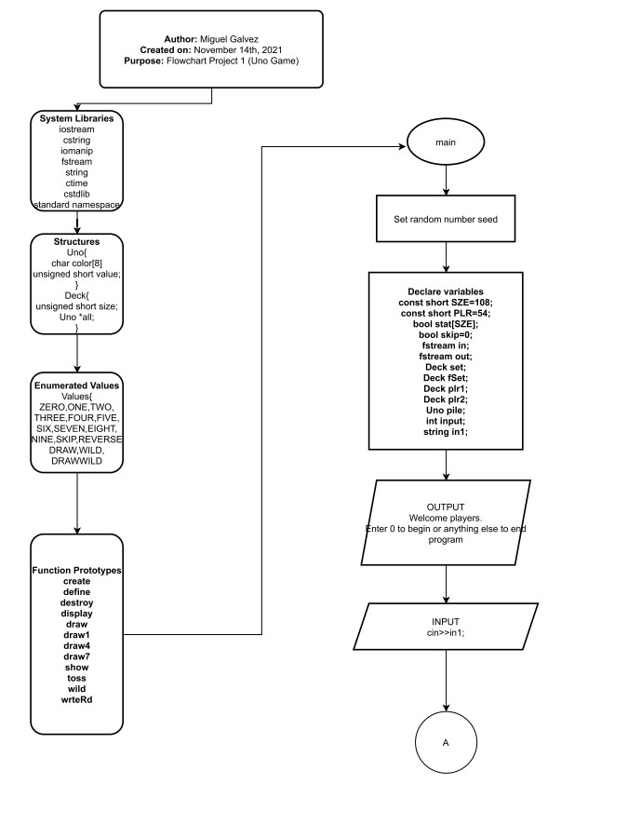
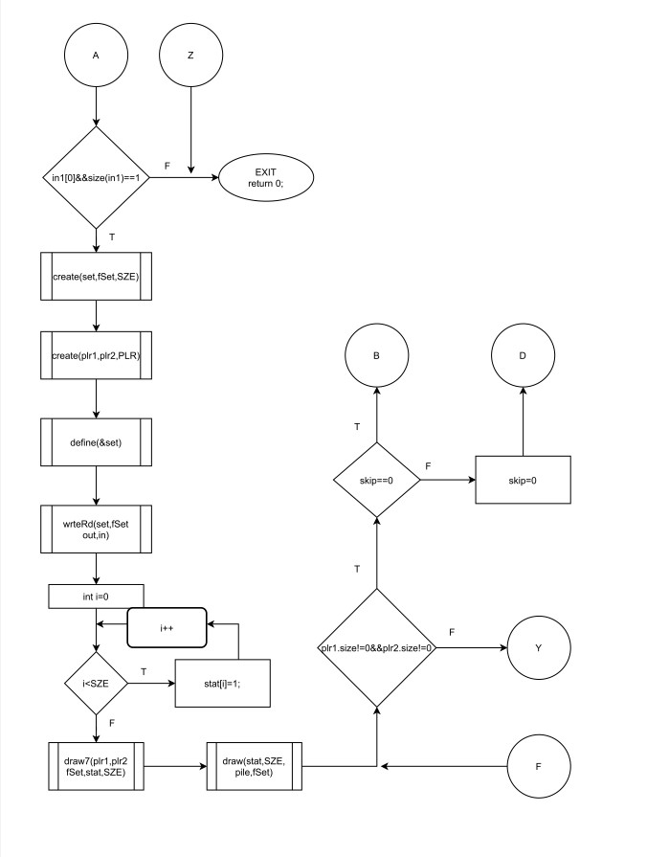

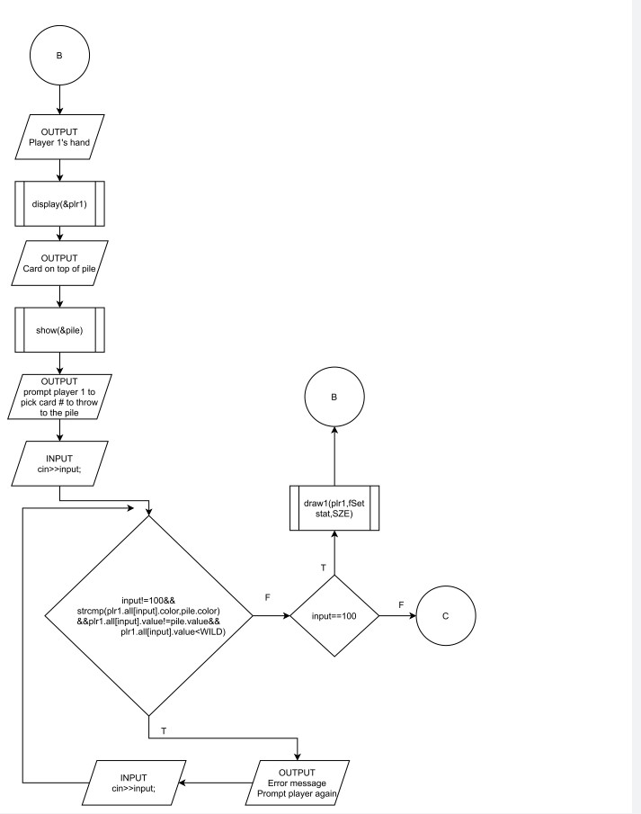

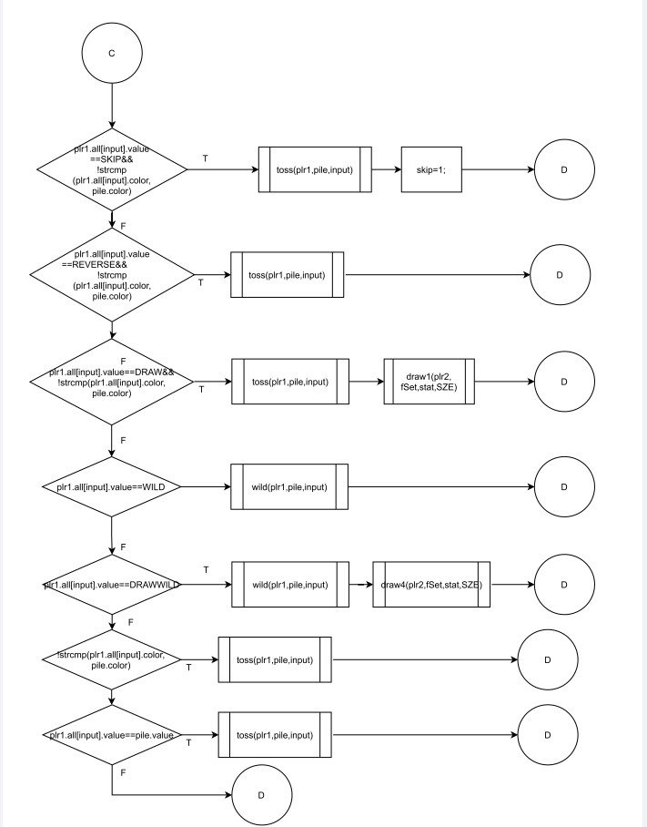

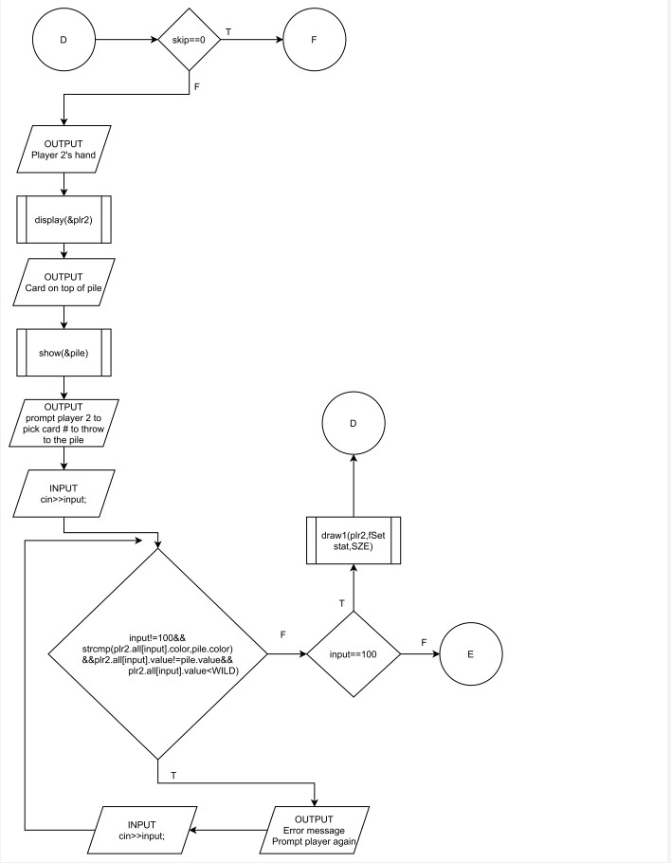

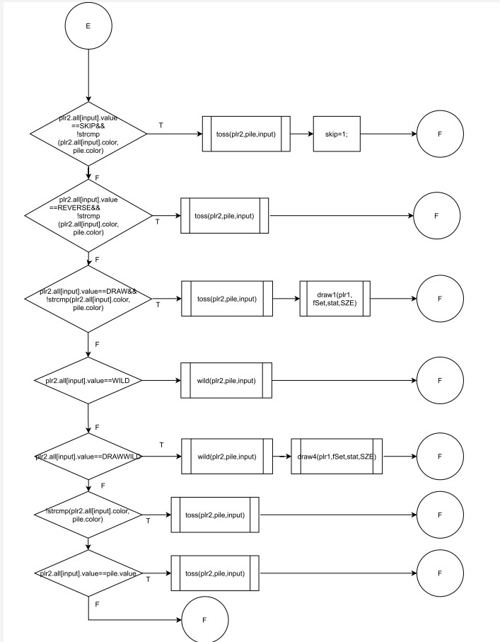

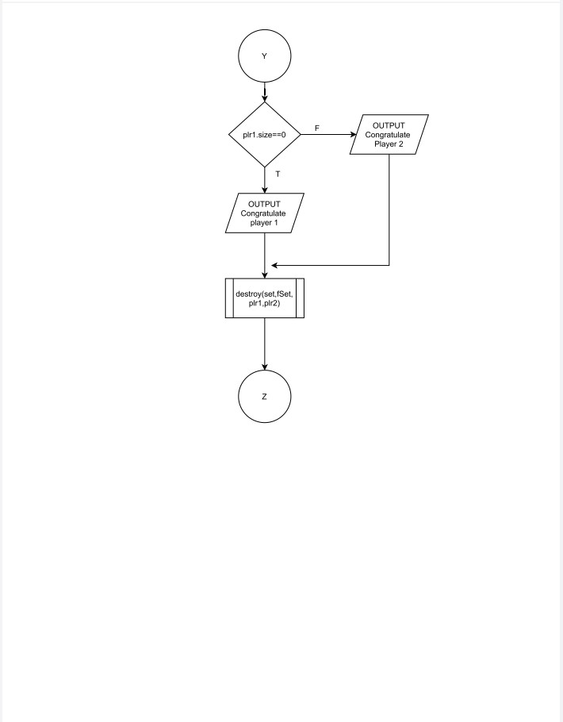

Pseudo code

start program
enter 0 to start program, or anything else to quit

If user entered 0,
Start the game
Create memory for set, set from file(fSet), player 1(plr1) and player 2(plr2)
Define Uno Cards into set
Create a binary file from set and write all Uno cards into file
Read from binary file just created into fSet
Make bool array stat[SZE] all equal 1
Draw 7 cards for each player from fSet
Draw 1 card for pile
While player 1's hand does not equal 0 and player 2's hand does not equal 0
If skip equals 0
Display player 1's hand and card on pile
Prompt player to select a card number to throw to pile or 100 to draw
While input is not 100 and colors do not match with pile and value does not
match with pile and player's card does not equal a wildcard
Reprompt player 1 for input
While input is 100
Draw a card for player 1
Reprompt player 1 for input
While input is not 100 and colors do not match with pile and value does not
match with pile and player's card does not equal a wildcard
Reprompt player 1 for input
If player 1 entered a card that's a skip and same color as pile
toss the card onto the pile
skip equals 1
Else If player 1 entered a card that's a reverse and same color as pile
toss the card onto the pile
Else If player 1 entered a card that's a Draw and same color as pile
toss the card onto the pile
player 2 draws a card
Else If player 1 entered a card that's a wildcard
toss the card onto the pile
pick a color for the pile
Else If player 1 entered a card that's a wildcard draw +4
toss the card onto the pile
pick a color for the pile
player 2 draws 4 cards
Else
skip=0
If skip equals 0
Display player 2's hand and card on pile
Prompt player 2 to select a card number to throw to pile or 100 to draw
While input is not 100 and colors do not match with pile and value does not
match with pile and player's card does not equal a wildcard
Reprompt player 2 for input
While input is 100
Draw a card for player 2
Reprompt player 1 for input
While input is not 100 and colors do not match with pile and value does not
match with pile and player's card does not equal a wildcard
Reprompt player 2 for input
If player 2 entered a card that's a skip and same color as pile
toss the card onto the pile
skip equals 1
Else If player 2 entered a card that's a reverse and same color as pile
toss the card onto the pile
Else If player 2 entered a card that's a Draw and same color as pile
toss the card onto the pile
player 2 draws a card
Else If player 2 entered a card that's a wildcard
toss the card onto the pile
pick a color for the pile
Else If player 2 entered a card that's a wildcard draw +4
toss the card onto the pile
pick a color for the pile
player 1 draws 4 cards
Else
skip=0
If player 1's hand size is 0
Congratulate player 1
Else
Congratulate player 2
Cleanup/Deallocate Memory from structures
end program

Major Variables

Type | Variable Name | Description | Location
Deck | set | Set of Uno cards | Main(),line23
Deck | fSet | set of uno cards from file | main(),line24
Deck | plr1 | player 1's hand | main(),line25
Deck | plr2 | player 2's hand | main(),line26
Uno | pile | card on the pile | main(),line27
fstream | in | input file | main(),line21
fstream | out | output file | main(),line 22
const short | SZE | Uno deck size | main(),line 19
const short | PLR | Player hand size | main(),line38
bool | stat[SZE] | Status of what cards are available in the deck | main(),line 19,48,50
bool | skip | status of whether following player needs to be skipped or not | main(),line 52,126,128,202
int | input | primary source of input from players | main(),lines  28,63,65,67,71
string | in1 | beginning input from user whether to initialize or end the program | main(),line29,34,35
char | color[8] | color associated with uno card | uno.h,line23 (inside Uno structure )
unsigned short | value | value associated with uno card | uno.h line24 (inside Uno structure)
unsigned short | size | size of Uno deck | uno.h line 27 (inside Deck structure)
Uno | *all | Pointer to data containing all uno cards in deck | uno.h line 28 (inside Deck structure)

Checkoff list
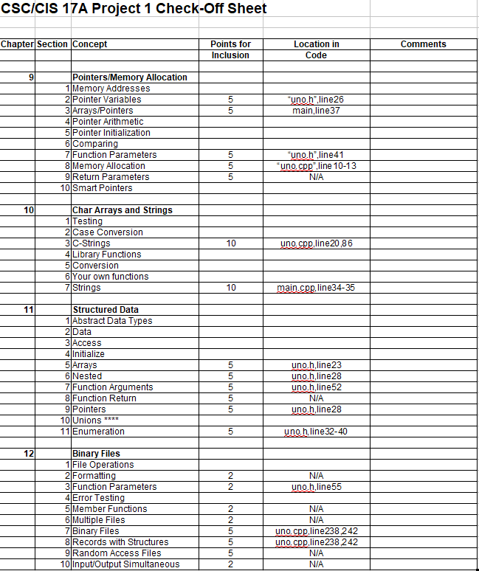
References
1.Tony Gaddis, Starting out with C++ From Control Structures through Objects [7th Ed]
2.Official UNO Rules (officialgamerules.org)
3.How many cards in uno? A complete breakdown of each card (unorules.org)
Program
- /*
- * File: uno.h
- * Author: Miguel Galvez
- * Purpose: Store all function prototypes/libraries/enums
- * Created on November 13, 2021, 3:14 PM
- */

- #ifndef UNO_H
- #define UNO_H

- #include <iostream> //cin,cout,endl
- #include <cstring> //strcpy, strcmp
- #include <iomanip> //xprecision,fixed,showpoint
- #include <fstream> //file operations
- #include <string> //string class
- #include <ctime> //time()
- #include <cstdlib> //rand()
- #include <valarray>
- using namespace std;
- //User Libraries Here
- //Structures
- struct Uno{ //Deck of Uno Cards
- char color[8]; //Color associated with uno card
- unsigned short value; //Value associated with the card
- };
- struct Deck{ //Structure of structure containing deck of uno cards
- unsigned short size; //Size of Uno Deck
- Uno *all; //Data of all uno cards
- };
- //Global Constants Only, No Global Variables
- //Like PI, e, Gravity, or conversions
- enum Values{ //Card Values
- ZERO,ONE,TWO,THREE,FOUR, //0-4
- FIVE,SIX,SEVEN,EIGHT,NINE, //5-9
- SKIP, //Skip Next Player's Turn
- REVERSE, //Reverse The Turn Order
- DRAW, //Next Person Draws a Card
- WILD, //Wildcard (Pick a color for pile)
- DRAWWILD //Wildcard Draw +4 Cards
- };
- //Function Prototypes Here
- void create(Deck&,Deck&,short); //Dynamically allocate memory
- void define(Deck *); //Define Uno cards
- void destroy(Deck&,Deck&,Deck&,Deck&); //Cleanup
- void display(Deck *); //Display hand
- void draw(bool [],short,Uno &,Deck); //Draw a single card to pile
- void draw1(Deck&,Deck,bool[],short); //Draw a single card to hand
- void draw4(Deck&,Deck,bool[],short); //Draw four cards to hands
- void draw7(Deck&,Deck&,Deck, //Draw seven cards to hands
- bool [],short);
- void show(Uno *); //Show the top of pile
- void toss(Deck&,Uno&,int); //Toss card from player's hand to pile
- void wild(Deck&,Uno&,int); //Handle case for wildcard
- void wrteRd(Deck &set,Deck &fSet,//Write entire deck of uno cards to file
- fstream &out,fstream &in);//and read file into another deck
- #endif /* UNO_H */
- /*
- * File: main.cpp
- * Author: Miguel Galvez
- * Created on November 13th 2021, 7:22PM
- * Purpose: Lastly, we will move function prototypes
- * /structures/libraries to our header file and function
- * declarations to their own .cpp file
- */

- //System Libraries Here
- #include "uno.h"
- //Program Execution Begins Here
- int main(int argc, char** argv) {
- //Set Random Number Generator Seed
- srand(static_cast<unsigned int>(time(0)));
- //Declare all Variables Here
- const short SZE=108; //Uno Deck Size
- const short PLR=54; //Player hand size
- bool stat[SZE]; //Status of Deck array
- bool skip=0; //Skip flag
- fstream in; //input file
- fstream out; //output file
- Deck set; //Deck of uno cards
- Deck fSet; //Deck of uno cards from file
- Deck plr1; //Player 1
- Deck plr2; //Player 2
- Uno pile; //Current card on the pile
- int input; //user input
- string in1; //First user input
- //Display Uno game header
- cout<<"Welcome to the game of Uno! "<<endl
- <<"Enter 0 to begin, or anything else to "
- <<"end this program. ";
- cin>>in1;
- if(in1[0]==48&&size(in1)==1){
- //Dynamically Allocate Memory for Deck and Players
- create(set,fSet,SZE);
- create(plr1,plr2,PLR);
- //Players start off with 0 cards before drawing
- //Define Uno Cards for Deck
- define(&set);
- //Write and read deck of cards
- wrteRd(set,fSet,out,in);
- //Default bool values to true
- for(int i=0;i<SZE;i++)
- stat[i]=1;
- //Draw cards from fSet into Players
- draw7(plr1,plr2,fSet,stat,SZE);
- //Draw a card for pile
- draw(stat,SZE,pile,fSet);
- while(plr1.size!=0&&plr2.size!=0){
- if(skip==0){
- //Show player 1's hands
- cout<<"Player 1's hand: "<<endl;
- display(&plr1);
- //Display card on top of pile
- cout<<"Card on \ntop \nof pile: ";
- show(&pile);
- //Prompt player 1 for an applicable card to throw to the pile
- //Otherwise draw a card
- cout<<"Enter the card # to throw to the pile. "<<endl
- <<"Otherwise, enter 100 to draw: ";
- cin>>input;
- //Input Validation
- while(input!=100&&strcmp(plr1.all[input].color,pile.color)
- &&plr1.all[input].value!=pile.value&&
- plr1.all[input].value<WILD){
- cout<<"Error: enter a valid number."<<endl;
- cout<<"Enter the card # to throw to the pile. "<<endl
- <<"Otherwise, enter 100 to draw: ";
- cin>>input;
- }
- //If card is valid, toss card onto pile
- while(input==100){
- draw1(plr1,fSet,stat,SZE);
- //Show player 1's hands
- cout<<"Player 1's hand: "<<endl;
- display(&plr1);
- //Display card on top of pile
- cout<<"Card on \ntop \nof pile: ";
- show(&pile);
- cout<<"Enter the card # to throw to the pile. \n"
- <<"Or enter 100 to draw. \n";
- cin>>input;
- //Input Validation
- while(input!=100&&strcmp(plr1.all[input].color,pile.color)
- &&plr1.all[input].value!=pile.value&&
- plr1.all[input].value<WILD){
- cout<<"Error: enter a valid number."<<endl;
- cout<<"Enter the card # to throw to the pile. "<<endl
- <<"Otherwise, enter 100 to draw: ";
- cin>>input;
- }
- //If value is skip and same color as pile
- }if(plr1.all[input].value==SKIP&&
- !strcmp(plr1.all[input].color,pile.color)){
- toss(plr1,pile,input);
- skip=1; //Set the skip flag
- //If value is reverse and same color as pile
- }else if(plr1.all[input].value==REVERSE&&
- !strcmp(plr1.all[input].color,pile.color)){
- toss(plr1,pile,input);
- //If value is draw +1 and same color as pile
- }else if(plr1.all[input].value==DRAW&&
- !strcmp(plr1.all[input].color,pile.color)){
- toss(plr1,pile,input);
- draw1(plr2,fSet,stat,SZE);
- //If value is a wildcard, toss and pick color for pile
- }else if(plr1.all[input].value==WILD){
- wild(plr1,pile,input);
- //If value is wildcard +4, toss, pick color for pile
- //and make next player draw four cards
- }else if(plr1.all[input].value==DRAWWILD){
- wild(plr1,pile,input);
- //Now plr2 needs to draw 4 cards
- draw4(plr2,fSet,stat,SZE);
- //If color is the same as pile
- }else if(!strcmp(plr1.all[input].color,pile.color)){
- toss(plr1,pile,input);
- //If value is the same as pile
- }else if(plr1.all[input].value==pile.value){
- toss(plr1,pile,input);
- }
- //If skip flag is set, skip player's turn and reset flag
- }else{
- skip=0;
- }
- if(skip==0){
- //Display player 2's hand
- cout<<"Player 2's hand: "<<endl;
- display(&plr2);
- //Display top of pile
- cout<<"Card on \ntop \nof pile: ";
- show(&pile);
- //Prompt player 1 for an applicable card to throw
- //to the pile. Otherwise, draw a card
- cout<<"Enter the card # to throw to the pile. "<<endl;
- cin>>input;
- //Input Validation
- while(input!=100&&strcmp(plr2.all[input].color,pile.color)
- &&plr2.all[input].value!=pile.value
- &&plr2.all[input].value<WILD){
- cout<<"Error: enter a valid number."<<endl;
- cout<<"Enter the card # to throw to the pile. \n"
- <<"Or enter 100 to draw. \n";
- cin>>input;
- }
- //If card is valid, toss card onto pile
- while(input==100){
- draw1(plr2,fSet,stat,SZE);
- //Display player 2's hand
- cout<<"Player 2's hand: "<<endl;
- display(&plr2);
- //Display top of pile
- cout<<"Card on \ntop \nof pile: ";
- show(&pile);
- cout<<"Enter the card # to throw to the pile. \n"
- <<"Or enter 100 to draw. \n";
- cin>>input;
- //Input Validation
- while(input!=100&&strcmp(plr2.all[input].color,pile.color)
- &&plr2.all[input].value!=pile.value
- &&plr2.all[input].value<WILD){
- cout<<"Error: enter a valid number."<<endl;
- cout<<"Enter the card # to throw to the pile. \n"
- <<"Or enter 100 to draw. \n";
- cin>>input;
- }
- }
- if(plr2.all[input].value==SKIP&&
- !strcmp(plr2.all[input].color,pile.color)){
- toss(plr2,pile,input);
- skip=1; //Set the skip flag
- //If card is reverse and same color as pile
- }else if(plr2.all[input].value==REVERSE&&
- !strcmp(plr2.all[input].color,pile.color)){
- toss(plr2,pile,input);
- //If card is draw +1 and same color as pile
- }else if(plr2.all[input].value==DRAW&&
- !strcmp(plr2.all[input].color,pile.color)){
- toss(plr2,pile,input);
- //Make player 1 draw a card
- draw1(plr1,fSet,stat,SZE);
- //If card is a wildcard, pick a color for pile
- }else if(plr2.all[input].value==WILD){
- wild(plr2,pile,input);
- //If card is wildcard draw +4, pick a color for pile
- //and next player draws 4 cards
- }else if(plr2.all[input].value==DRAWWILD){
- wild(plr2,pile,input);
- //Make player 1 draw four cards
- draw4(plr1,fSet,stat,SZE);
- //If card is same color as pile
- }else if(!strcmp(plr2.all[input].color,pile.color)){
- toss(plr2,pile,input);
- //If card is same value as pile
- }else if(plr2.all[input].value==pile.value){
- toss(plr2,pile,input);
- }
- //If skip flag is set, skip player and reset flag
- }else{
- skip=0;
- }
- }
- //Congratulate Winner
- plr1.size==0?cout<<"Congratulations! Player 1 wins."<<endl:
- cout<<"Congratulations! Player 1 wins."<<endl;
- //Cleanup
- destroy(set,fSet,plr1,plr2);
- }
- //Exit
- return 0;
- }
- #include "uno.h"
- /*
- * File: main.cpp
- * Author: Miguel Galvez
- * Created on November 13th 2021, 3:46PM
- * Purpose: All function declarations are here
- */

- void create(Deck &set,Deck &fSet,short SZE){
- set.all=new Uno [SZE];
- set.size=SZE;
- fSet.all=new Uno [SZE];
- fSet.size=SZE;
- }
- void define(Deck *x){
- //Define x of Uno cards
- for(int i=0;i<x->size;i++){
- //First 25 cards are Green
- if(i<25){
- strcpy(x->all[i].color, "Green");
- i==0?x->all[i].value=ZERO:
- i<=2?x->all[i].value=ONE:
- i<=4?x->all[i].value=TWO:
- i<=6?x->all[i].value=THREE:
- i<=8?x->all[i].value=FOUR:
- i<=10?x->all[i].value=FIVE:
- i<=12?x->all[i].value=SIX:
- i<=14?x->all[i].value=SEVEN:
- i<=16?x->all[i].value=EIGHT:
- i<=18?x->all[i].value=NINE:
- i<=20?x->all[i].value=SKIP:
- i<=22?x->all[i].value=REVERSE:
- x->all[i].value=DRAW;
- //Next 25 are Blue
- }else if(i<50){
- strcpy(x->all[i].color, "Blue");
- i==25?x->all[i].value=ZERO:
- i<=27?x->all[i].value=ONE:
- i<=29?x->all[i].value=TWO:
- i<=31?x->all[i].value=THREE:
- i<=33?x->all[i].value=FOUR:
- i<=35?x->all[i].value=FIVE:
- i<=37?x->all[i].value=SIX:
- i<=39?x->all[i].value=SEVEN:
- i<=41?x->all[i].value=EIGHT:
- i<=43?x->all[i].value=NINE:
- i<=45?x->all[i].value=SKIP:
- i<=47?x->all[i].value=REVERSE:
- x->all[i].value=DRAW;
- //Next 25 are Red
- }else if(i<75){
- strcpy(x->all[i].color, "Red");
- i==50?x->all[i].value=ZERO:
- i<=52?x->all[i].value=ONE:
- i<=54?x->all[i].value=TWO:
- i<=56?x->all[i].value=THREE:
- i<=58?x->all[i].value=FOUR:
- i<=60?x->all[i].value=FIVE:
- i<=62?x->all[i].value=SIX:
- i<=64?x->all[i].value=SEVEN:
- i<=66?x->all[i].value=EIGHT:
- i<=68?x->all[i].value=NINE:
- i<=70?x->all[i].value=SKIP:
- i<=72?x->all[i].value=REVERSE:
- x->all[i].value=DRAW;
- //Next 25 are Yellow
- }else if(i<100){
- strcpy(x->all[i].color, "Yellow");
- i==75?x->all[i].value=ZERO:
- i<=77?x->all[i].value=ONE:
- i<=79?x->all[i].value=TWO:
- i<=81?x->all[i].value=THREE:
- i<=83?x->all[i].value=FOUR:
- i<=85?x->all[i].value=FIVE:
- i<=87?x->all[i].value=SIX:
- i<=89?x->all[i].value=SEVEN:
- i<=91?x->all[i].value=EIGHT:
- i<=93?x->all[i].value=NINE:
- i<=95?x->all[i].value=SKIP:
- i<=97?x->all[i].value=REVERSE:
- x->all[i].value=DRAW;
- //Last 8 are Black wildcards
- }else{
- strcpy(x->all[i].color, "Black");
- i<=103?x->all[i].value=WILD:
- x->all[i].value=DRAWWILD;
- }
- }
- }
- void destroy(Deck &set,Deck &fSet,Deck &plr1,
- Deck &plr2){
- delete [] set.all;
- delete [] fSet.all;
- delete [] plr1.all;
- delete [] plr2.all;
- }
- void display(Deck *x){
- cout<<left<<setw(9)<<"Card #:"
- <<setw(10)<<"Color"<<setw(5)
- <<"Value"<<endl;
- for(int i=0;i<x->size;i++){
- cout<<setw(6)<<"Card "<<i<<": "
- <<setw(10)<<x->all[i].color
- <<setw(5);
- x->all[i].value==SKIP?cout<<"SKIP"<<endl:
- x->all[i].value==REVERSE?cout<<"REVERSE"<<endl:
- x->all[i].value==DRAW?cout<<"DRAW +1"<<endl:
- x->all[i].value==WILD?cout<<"WILDCARD"<<endl:
- x->all[i].value==DRAWWILD?cout<<"DRAW+4"<<endl:
- cout<<x->all[i].value<<endl;
- }
- }
- void draw(bool stat[],short SZE,Uno &pile,Deck fSet){
- //Draw a card for the pile
- unsigned int indx=rand()%SZE;
- //Keep trying random number until unique
- while(!stat[indx])
- indx=rand()%SZE;
- //Copy Contents from index in deck to player 1 hand
- strcpy(pile.color,fSet.all[indx].color);
- pile.value=fSet.all[indx].value;
- //Falsify index in bool array
- stat[indx]=0;
- }
- void draw1(Deck &plr,Deck fSet,bool stat[],short SZE){
- //Draw four cards into player's hand
- unsigned int indx=rand()%SZE;
- //Keep trying random number until unique
- while(!stat[indx])
- indx=rand()%SZE;
- //Copy Contents from index in deck to player 1 hand
- strcpy(plr.all[plr.size].color,fSet.all[indx].color);
- plr.all[plr.size].value=fSet.all[indx].value;
- //Falsify index in bool array
- stat[indx]=0;
- plr.size++;
- }
- void draw4(Deck &plr,Deck fSet,bool stat[]
- ,short SZE){
- //Draw four cards into player's hand
- unsigned int indx=rand()%SZE;
- //Increment hand size
- plr.size+=4;
- //Draw four cards and assign them to end of array
- for(int i=plr.size-4;i<plr.size;i++){
- //Keep trying random number until unique
- while(!stat[indx])
- indx=rand()%SZE;
- //Copy Contents from index in deck to player 1 hand
- strcpy(plr.all[i].color,fSet.all[indx].color);
- plr.all[i].value=fSet.all[indx].value;
- //Falsify index in bool array
- stat[indx]=0;
- }
- }
- void draw7(Deck &plr1,Deck &plr2,Deck fSet,
- bool stat[],short SZE){
- //Players start off with 0 cards
- plr1.size=0;
- unsigned int indx=rand()%SZE;
- for(int i=0;i<7;i++){
- //Keep trying random number until unique
- while(!stat[indx])
- indx=rand()%SZE;
- //Increment hand size
- plr1.size++;
- //Copy Contents from index in deck to player 1 hand
- strcpy(plr1.all[i].color,fSet.all[indx].color);
- plr1.all[i].value=fSet.all[indx].value;
- //Falsify index in bool array
- stat[indx]=0;
- }
- plr2.size=0;
- indx=rand()%SZE;
- for(int i=0;i<7;i++){
- //Keep trying random number until unique
- while(!stat[indx])
- indx=rand()%SZE;
- //Increment hand size
- plr2.size++;
- //Copy Contents from index in deck to player 1 hand
- strcpy(plr2.all[i].color,fSet.all[indx].color);
- plr2.all[i].value=fSet.all[indx].value;
- //Falsify index in bool array
- stat[indx]=0;
- }
- }
- void show(Uno *x){
- cout<<setw(10)<<x->color
- <<setw(5);
- x->value==SKIP?cout<<"SKIP"<<endl:
- x->value==REVERSE?cout<<"REVERSE"<<endl:
- x->value==DRAW?cout<<"DRAW +1"<<endl:
- x->value==WILD?cout<<"WILDCARD"<<endl:
- x->value==DRAWWILD?cout<<"DRAW+4"<<endl:
- cout<<x->value<<endl;
- }
- void toss(Deck &plr,Uno &pile,int input){
- //Assign color from player's hand to pile
- strcpy(pile.color,plr.all[input].color);
- //Assign value from player's hand to pile
- pile.value=plr.all[input].value;
- //Remove card from player's hand
- for(int i=input;i<plr.size;i++){
- strcpy(plr.all[i].color,plr.all[i+1].color);
- plr.all[i].value=plr.all[i+1].value;
- }
- //Decrement plr1's hand size
- plr.size--;
- }
- void wild(Deck &plr,Uno &pile,int input){
- //Assign value from player's hand to pile
- pile.value=plr.all[input].value;
- //Remove card from player's hand
- for(int i=input;i<plr.size;i++){
- strcpy(plr.all[i].color,plr.all[i+1].color);
- plr.all[i].value=plr.all[i+1].value;
- }
- //Assign a color based off player's decision
- do{
- cout<<"Enter :"<<endl
- <<"1 for yellow\n"
- <<"2 for green\n"
- <<"3 for red\n"
- <<"4 for blue\n";
- cin>>input;
- }while(input>4||input<0); //Input validation
- input==1?strcpy(pile.color,"Yellow"):
- input==2?strcpy(pile.color,"Green"):
- input==3?strcpy(pile.color,"Red"):
- strcpy(pile.color,"Blue");
- plr.size--;
- }
- void wrteRd(Deck &set,Deck &fSet,fstream &out,
- fstream &in){
- //Write Uno cards to file
- out.open("unoCards.dat",ios::out|ios::binary);
- out.write(reinterpret_cast<char *>(&set),sizeof(set)*set.size);
- out.close();
- //Read Uno cards to separate variable
- in.open("unoCards.dat",ios::in|ios::binary);
- in.read(reinterpret_cast<char *>(&fSet),sizeof(fSet)*fSet.size);
- in.close();
- }

