Software Design  
Document

VaqPack: Graduate-to-Professional Aid Pack  
Version 1.0  
November 20, 2015

**Project Manager**  
Mario Gracia III   
**Team**  
Carlos O. Silva  
Eduardo Tovar  
Jeffrey Serna  
Jonathan Monroe

Software Engineering CSCI-3340-02

Instructor: MK Quweider, Ph.D.

Fall 2014

# Revision History

|  |  |  |  |
| --- | --- | --- | --- |
| **Date** | **Description** | **Author** | **Comments** |
| 11/20/15 | Initial Version | PM/Team | Initial creation |
|  |  |  |  |
|  |  |  |  |
|  |  |  |  |

**Table of Contents**

Revision History ii

1. Introduction 1

**1.1 Purpose 1**

**1.2 Scope 1**

**1.3 Definitions, Acronyms, and Abbreviations 1**

**1.4 Overview 2  
1.4 Customer 2**

2. System overview 2

3. System architecture 2

**3.1 Subsystem decompostion 3**

**3.2 Class diagram 4**

**3.3 Sequence Diagram 4**

**3.4 State diagram 5**

**3.5 Activity Diagram 5  
3.6 Entity Relationship diagram 7**

**3.7 Gui Desgin 7**

4. Work schedule 12

# 1. Introduction

## 1.1 Purpose

The purpose of this document is provide a deeper understanding for the design of the VaqPack. It shows the structure of the project in a detailed manner. This will be used by the developers and for the creation and testing of the application.

## 1.2 Scope

The VaqPack will be a free software given to graduating students looking for work. It will create resumes/business cards based on data inputted by the student and send them out to prospective employers. All data will be stored in a database which the student will be able to access via username/password.

## 1.3 Definitions, Acronyms, and Abbreviations

|  |  |
| --- | --- |
| Term | Definition |
| GUI | Graphical User Interface |
| Database | An organized way to store data. (Uses tables) |
| Client | Hardware or software that requests services from a server. |
| Server | A central repository of data. |
| MySQL | Open-source relational database management system. |
| Email | Electronic Mail |
| IDE | Integrated Development Environment |
| GitHub | Web-based Git repository hosting service. |
| JRE | Java Runtime Environment |
| UML | Unified Modeling Language |
| PDF | Portable Document Format |
| XML | Extensible markup Language |
| HTML | Hyper Text Markup Language |
| UTRGV | University of Texas Rio Grande Valley |

## 1.4 Overview

In this document there will be detailed explanations on how the VaqPack application will work. Each section will describe the application in some way. There will also be diagrams that show the structure of the application.

## 1.5 Customer

The customers of the application are UTRGV students that are looking to graduate soon or even just students that are looking for employment.

# 2. System Overview

The VaqPack is an application that operates as a resume creation wizard. The functions of this application will let the user create resume related documents and perform different actions relating to resumes.

The Wizard will begin running  
Registration/Login will be first window shown.

* If new user they will be prompted for username/password
* If existing user must type username/password to continue

Input information pertaining to resume

* Personal information
* Employment history
* Education
* Skills

Select between 4 different themes for resume

Create Resume HTML/PDF

Select between 2 themes for business card

Create business card PDF

Input information of for cover letter

* Text for the letter
* Information for ad
  + Source
  + Date
  + Job Title
  + Reference number
  + Etc.

Select between 2 themes for cover letter

Create cover letter PDF

Email resume/cover letter to specific employers

# 3. System Architecture

## 3.1 Subsystem Decomposition

The application consists of different modules separated by their functionality

* GUI Module
* Database Module
* Networking Module
* Printing Module

*GUI Module*

The interface that will focus on user interaction. Will be used to take the user through different windows where they will provide input/make selections. Events will be implemented primarily through buttons.

*Database Module*

Module in charge of storing, retrieving and maintaining data in the database. Username/Password will be checked through the security module. Other data in the Database includes user information.

*Security Module*

Module in charge of user validation. Users must be registered in the database in order to proceed with application.

*Networking Module*

This module will handle email functions. Must support attachments and multiple emails to different addresses.

*Printing Module*

This module will be used to create a resume based on the data given by the user. The functions will create an XML document, convert it into an HTML (for website use), and from HTML into a PDF. It will also handle other document generation such as the cover letter and business cards.

## 3.2 Class Diagram

The Application class acts as the main class accessing other classes for functionality. After validation by the security class user class is set. Printer class has access to themes, user, and cover classes as documents created will use their data. Email class is tied to application and functions independently from other classes.

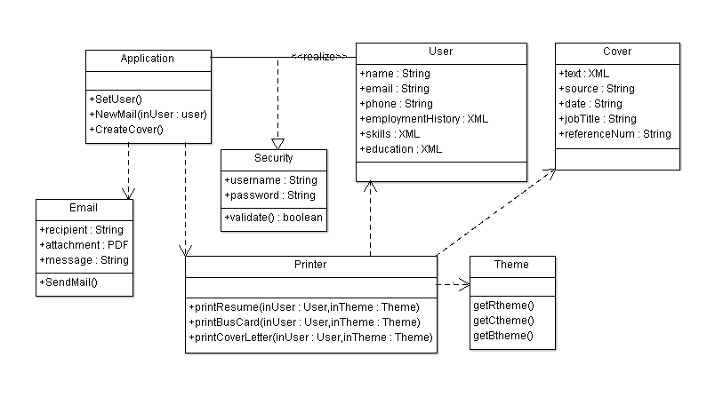

## 3.3 Sequence Diagram

## The following diagram shows the sequence of actions that take place

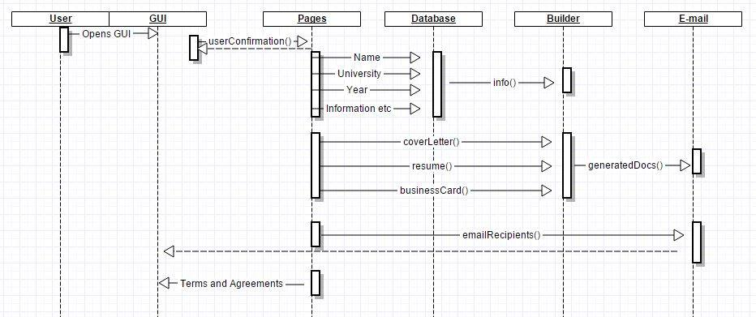

## 3.4 State Diagram

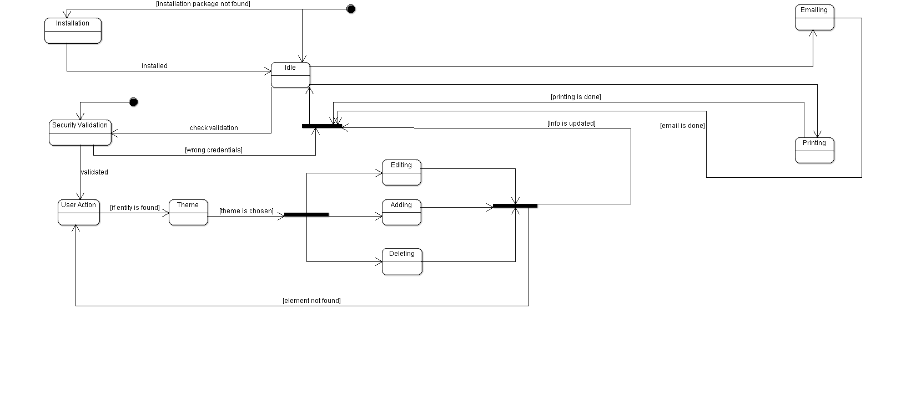

## 3.5 Activity Diagram

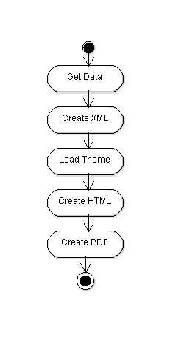 The following activity diagrams show the order of operations for different procedures. The diagrams represented include the printing, wizard, and email procedures.

Printer Activity Diagram

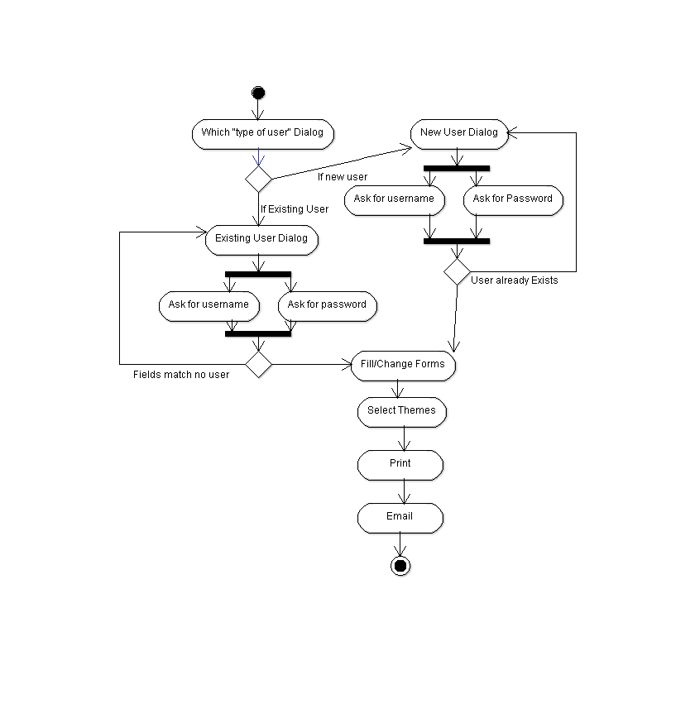

Wizard Activity Diagram

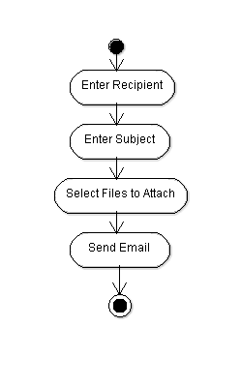

Email Activity Diagram

## 

## 

## 3.6 Entity Relationship Diagram

Database will consist of a user table. Will be the only entity in the database.

|  |  |  |
| --- | --- | --- |
| User | | |
| username | VARCHAR(15) | Primary key |
| pass | VARCHAR(10) | Password |
| fName | VARCHAR(30) | First name |
| lName | VARCHAR(30) | Last name |
| phoneNum | VARCHAR(12) | Phone Number |
| Email | VARCHAR(50) | E-mail address |

## 3.7 GUI Design

This project uses a GUI interface as the application is supposed take the user through a step by step process and GUI best accomplishes this. The final GUI will most likely implement a menu to handle email as well instead of doing it at the end.

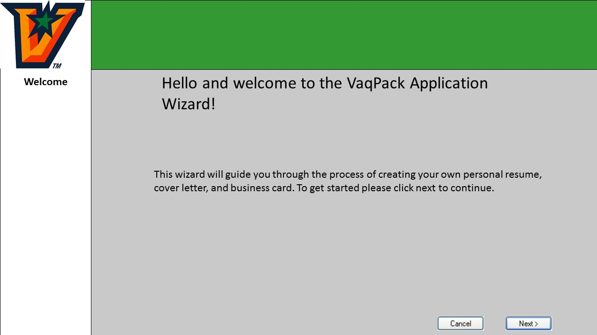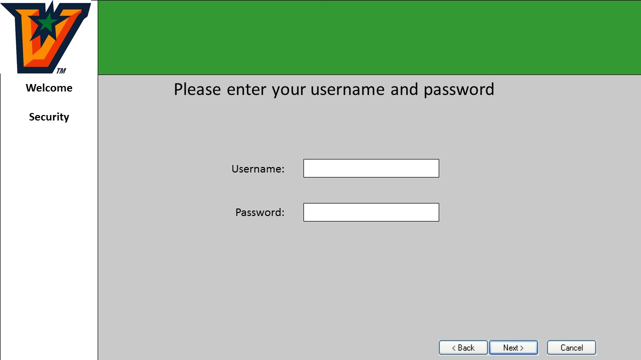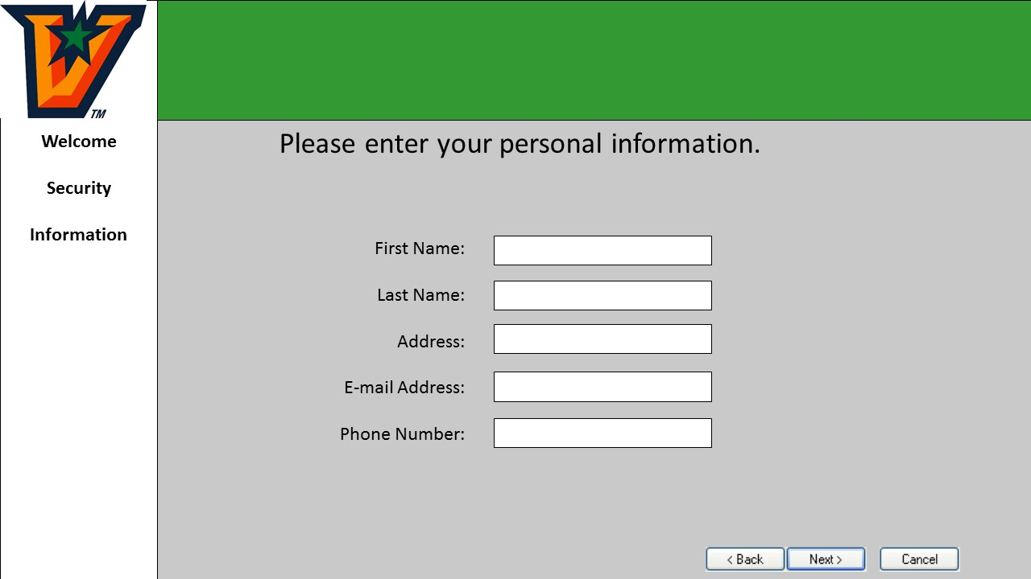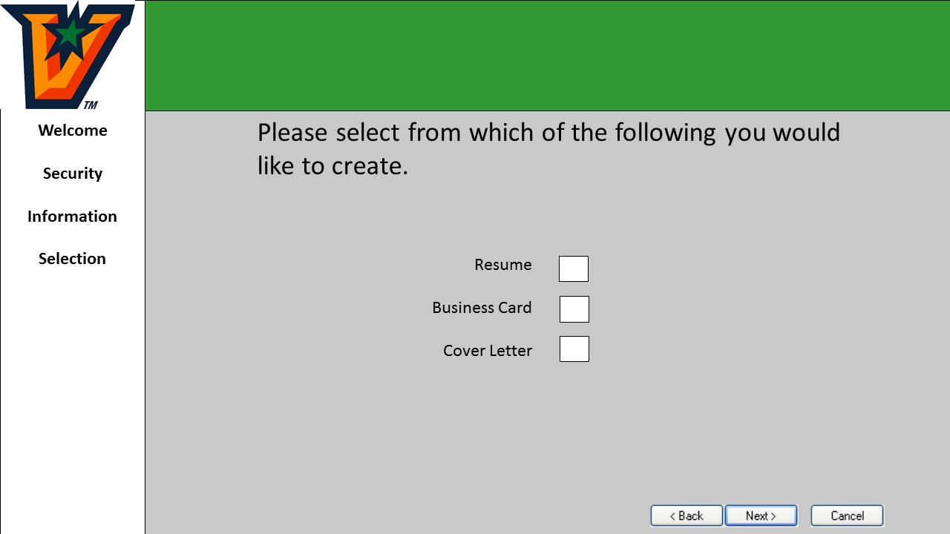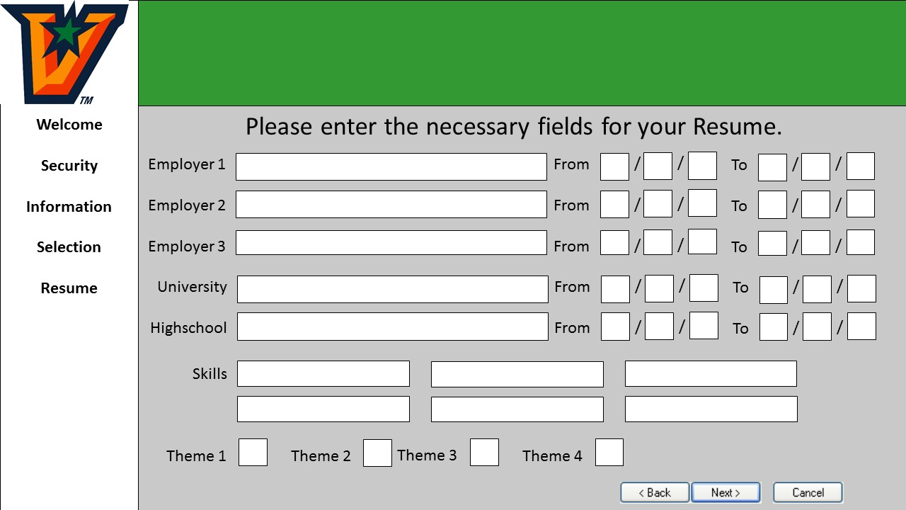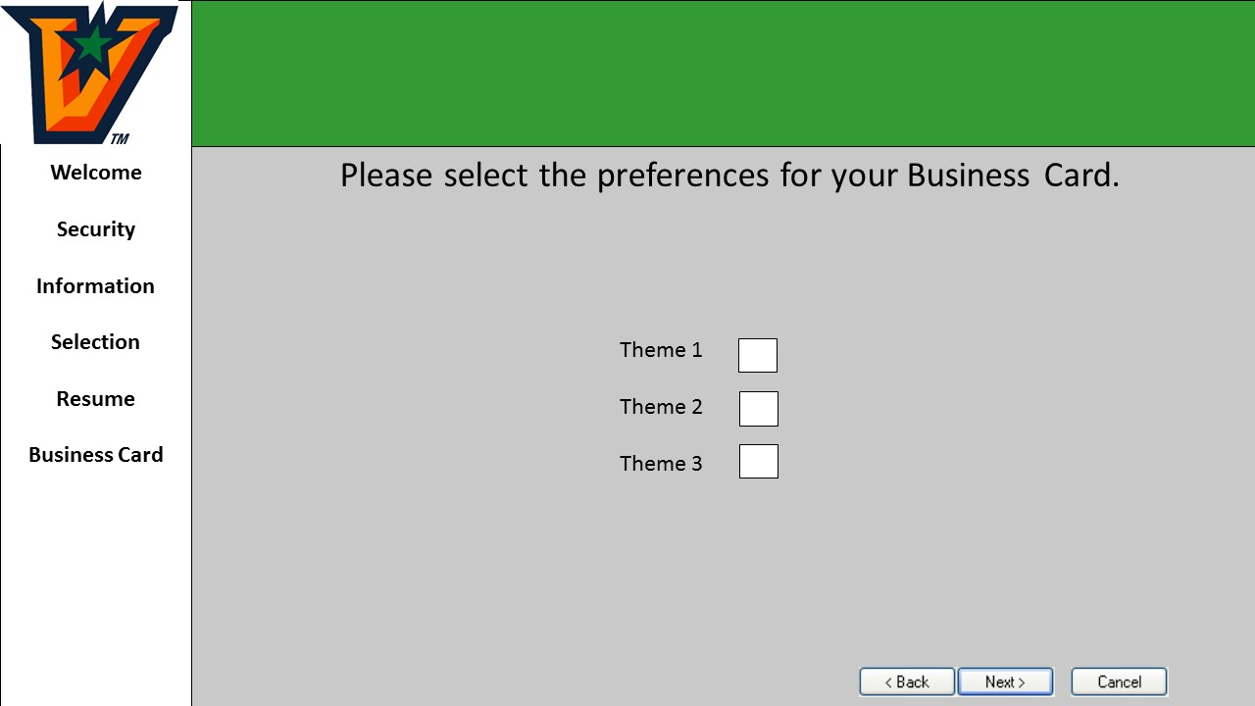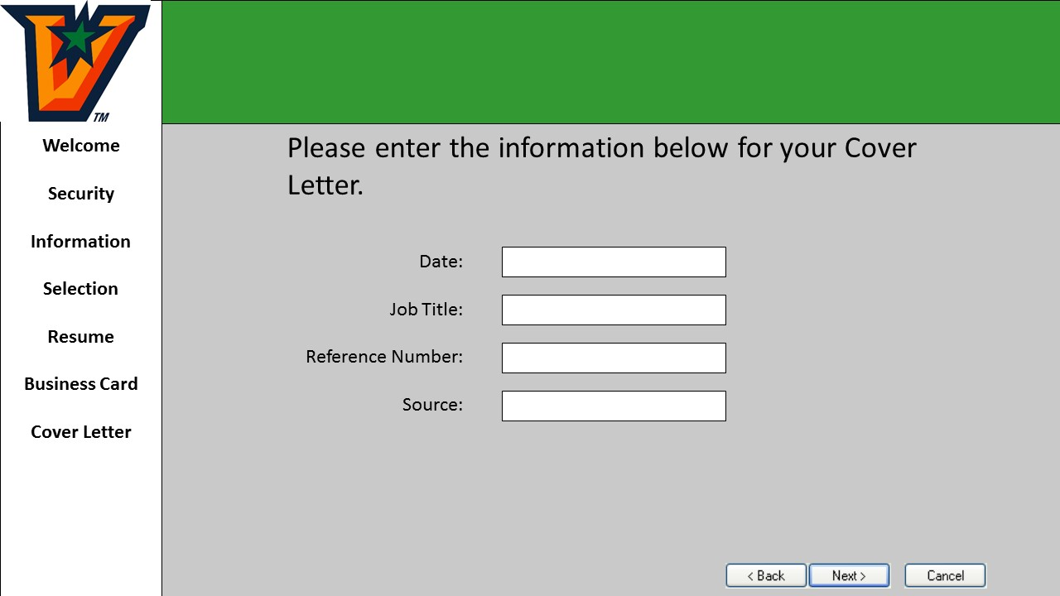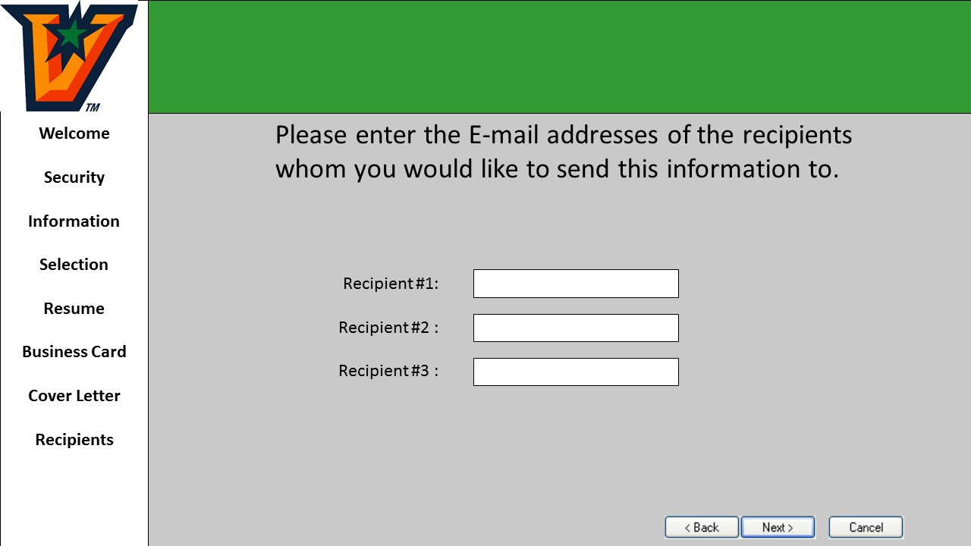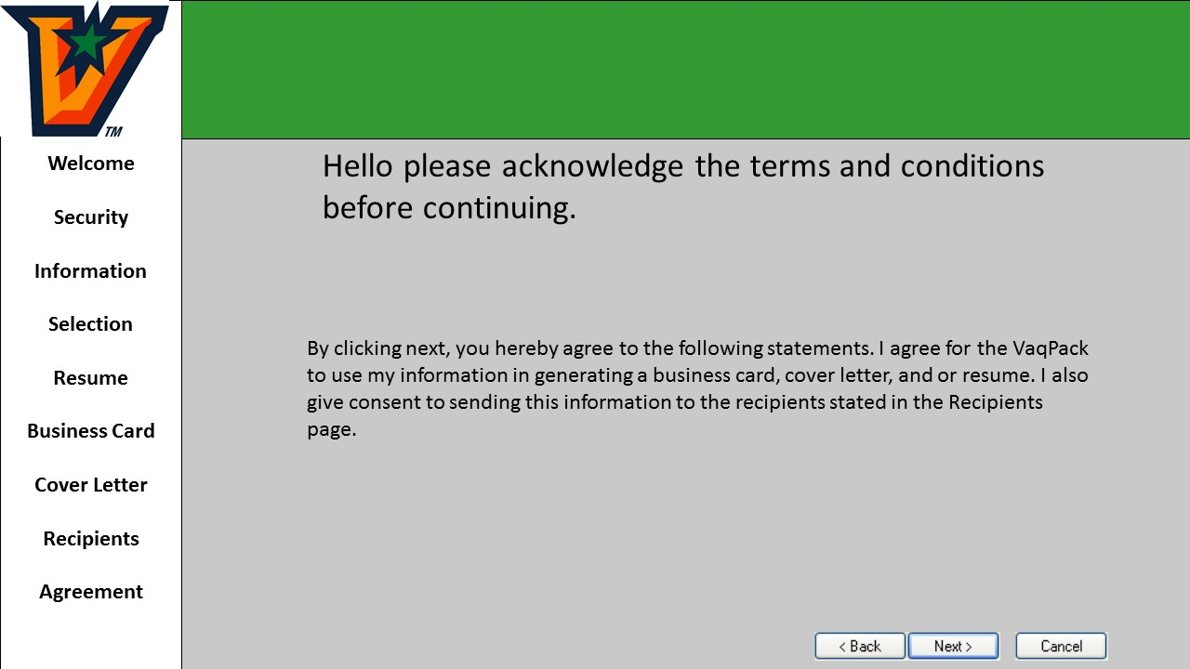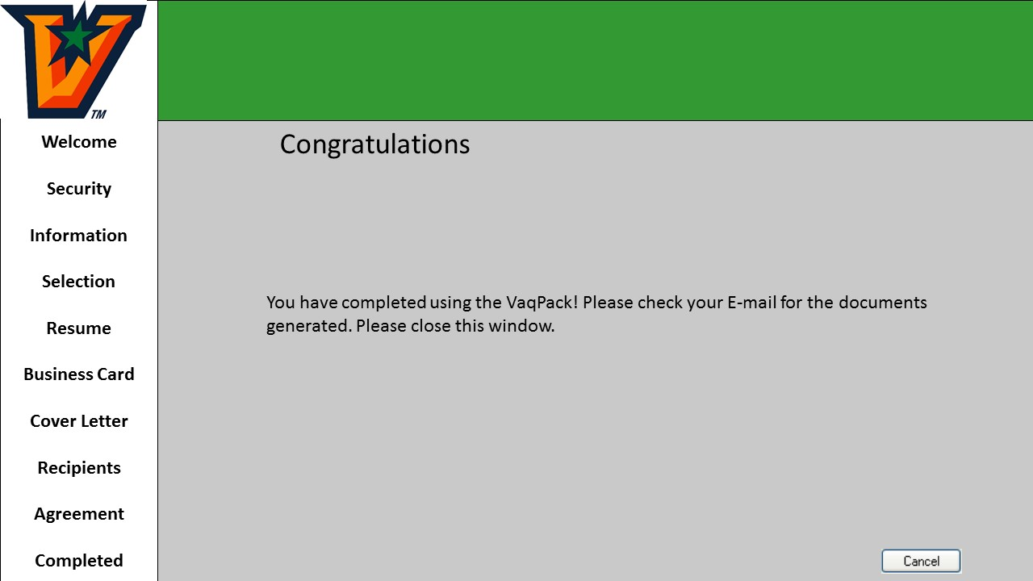

# 4. Work Schedule

|  |  |
| --- | --- |
| Deliverable | Deadline |
| * Prototypes for database*, email, GUI* * Code for handling document creation | 11/28/15 |
| * Implementation of GUI and Database in final project * Resume document & Business card creation implemented in GUI * Themes for Resume/Cover Letter/Business Card | 12/01/15 |
| * Cover letter creation implemented in GUI * Email functionality added to final project | 12/05/15 |
| * GUI fully functional with different modules * Begin final testing | 12/09/15 |
| * Finish Testing | 12/12/15 |

*priority