Summary:

In this exercise, I examine the index recomposition announcements and their impact on volumes and returns. I divide the index event data into in-sample period, from June 2022 to May 2023, and apply basic analysis on the return and volume patters, categorized by indices and event types. I formulate a basic strategy and backtest it with the out-of-sample period, from June 2023 to July 2024. I then introduce a hedge and adjust bet-sizing restrictions on the strategy, and evaluate their performance and risks.

1. Data Sources and Cleaning

For each individual event, I retrieve the open, close, and volume information of the relevant ticker in the period of 2 months before each announcement and 2 months after each trading date. There is one notable issue relating to data retrieval: out of 1562 event entries, 505 of them, representing 255 unique tickers. Further, only 219 of the tickers are associated with at least one delete events. This may create some issue with data incompleteness, but since Yahoo Finance not featuring a ticker is often associated with delisting events which has very different dynamics from liquidity events such as index recomposition announcements.

Below is a two-way table showing the decomposition of events into indices and event types (“Action”). Note that duplicate values, such as “Add” and “Addition”, are merged. One entry had action "z", changed to Upweight by context. Note also that the "Reclassification" action occurs only once, and created no share changes.

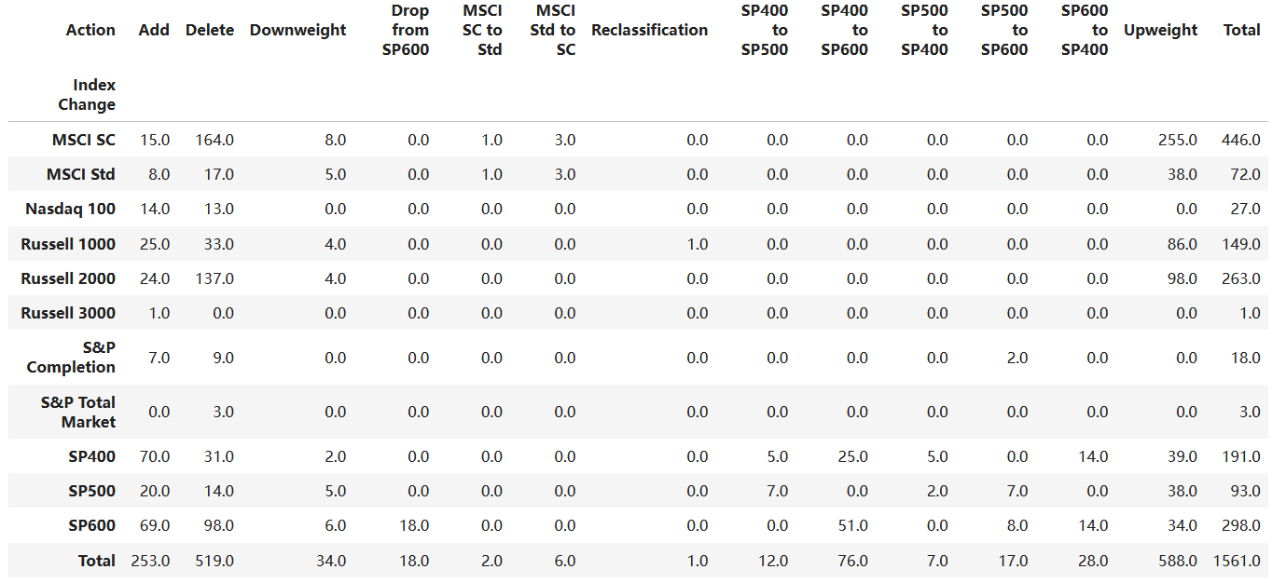

Here is the top 5 occurring comments. I use this to get a clue of the number of events associated with regular updating and the event characteristics. Due to the low number of quarterly rebalance entries, I consider that regular re-adjustments may not contain enough entries to warrant separate categorization and sub-grouping.

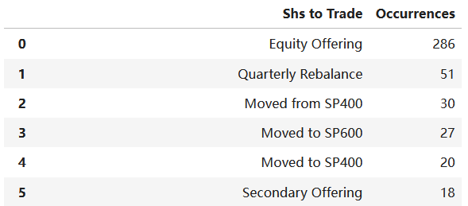

1. Analysis of the In-sample Data

First, here is a two-way table for the in-sample events, grouped into event types and indices:

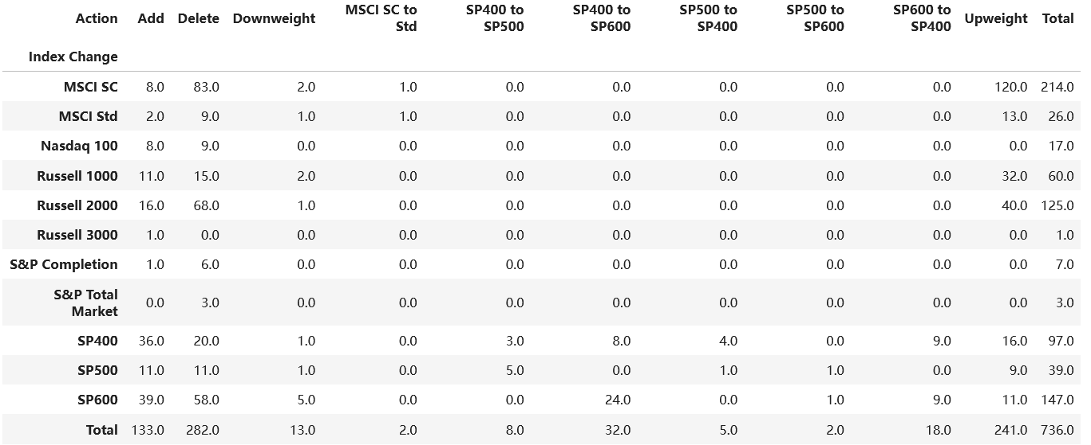As we can see, the in-sample data does not contain many entries for specific event type (e.g. “Delete”) and indices (e.g. Nasdaq 100) to make generalization on the return behaviors around announcements. Further, this low count in sample size create problems for statistical tools, such as linear regression and fixed effect estimations, in analyzing and estimating effect sizes and durations. Such attempts are recorded in the file “2’ Fixed Effect Estimation of Announcement Effects.”

Due to the time difference between announcements and index funds actually trading, I also analyze the average time gaps and standard errors of such events. It seems that announcements and trading dates often have relatively stable and short gaps. This suggests that the return patterns around the trading days would be just lags of the return patterns around announcements.

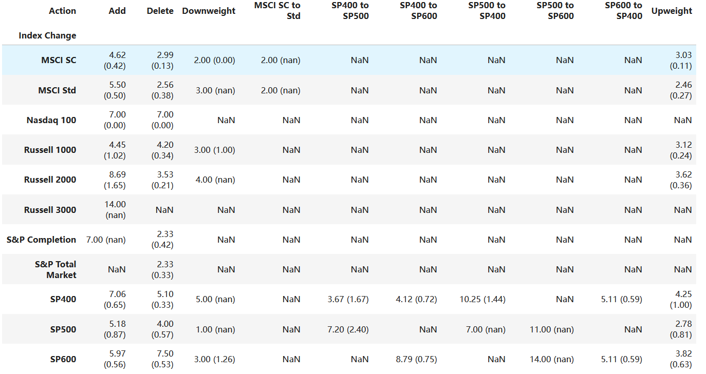

I focus on analyzing the cumulative return curves on average for each event categories. I divided the actions into five categories: Add, Delete, Upweight, Downweight, and Reclassification. Reclassification contains action types such as “MSCI SC to Std” and “SP500 to SP400”. I then decompose each categories into indices, and analyze trends and patterns for each indices. As an example, below are the graphs for cumulative returns and volumes for “Add” events, color coded by indices:

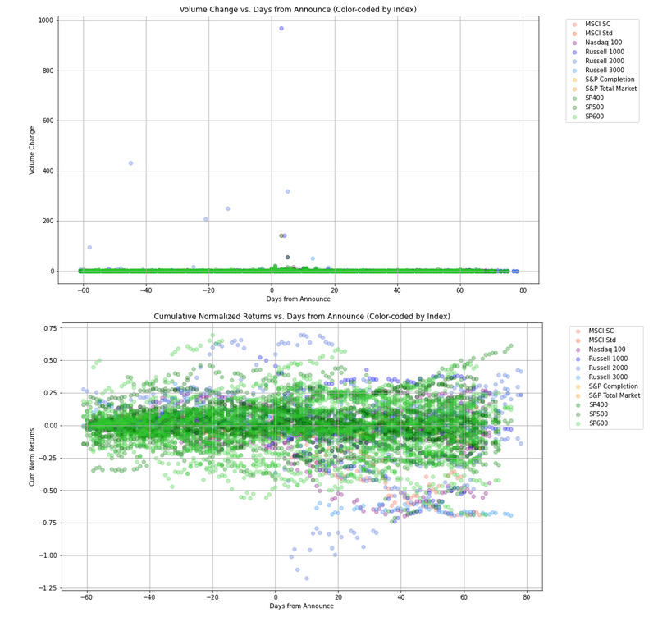

Below is the average cumulative returns for each indices in the “Add” events, from -10 days to 30 days around announcements:

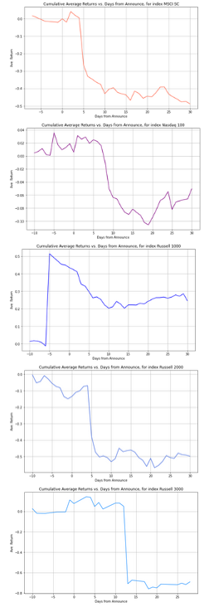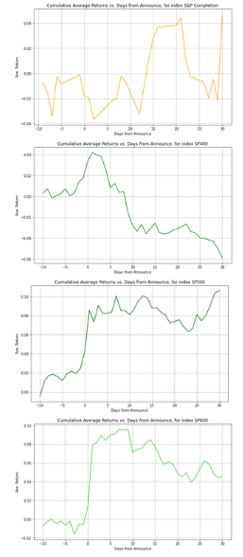

Below is the cumulative returns around the trading days, we see indeed they resemble lagged patterns from graphs mapping against announcement timelines:

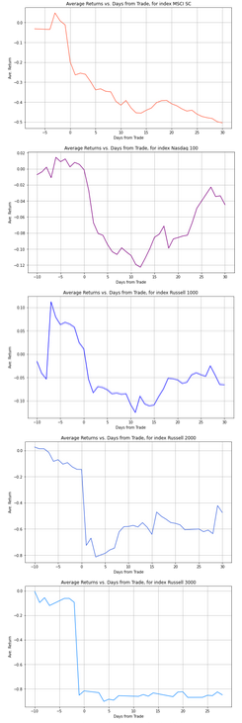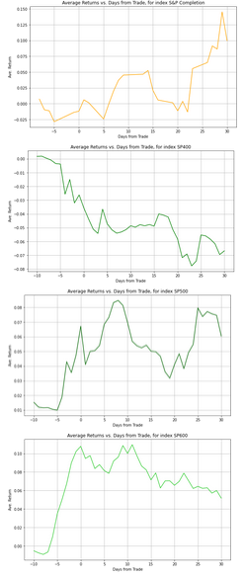

For the complete analysis, please see file “2 Basic Analysis and Strategy Formulation”.

My findings suggest that:

1. For "Add" events, there seems to be a return spike on the day after Announcement, followed by a sharp decline by about 10th day

2. For "Delete" events, MSCI SC, NASDAQ 100, and Russell 2000 seem to have stocks go up after announcement, in about 5 days; SP Completion seems to have no effect; SP 400, 500, and 600 seem to have a negative impact on returns after announcement, for at least 10 days.

3. For "Upweight" events, SP 500 index upweight seems to induce increase in return, while all other indices' "Upweights" experience a decrease in return, duration about 5 days, then an increase for about 10 days.

4. For "Downweight" events, there seems to be a down movement followed by a up movement. SP600, seeing increase, is notable exception.

5. For Reclassification events, such as "SP600 to SP500", it seems that in general, all cross-index reclassifications for the SP series led to a decrease in returns, for the next 10 days.

Our basic trading strategy is as follows:

1. For "Add" events,

a. For SP500 and SP600, to long for 5 days;

b. For other indices, to short on the day after announcement, close this position after 5 days.

2. For "Delete" events,

a. To short stocks impacted by SP 400, 500, 600 deletion events, and cover the position in 5 day;

b. To long stocks impacted by MSCI SC, NASDAQ 100, and Russell 2000 in 5 days.

3. For "Upweight" events,

a. To Long SP 500 after "Upweight" announcement for 5 days;

b. To Short other indices' "Upweight" announcement for 5 days, cover, then long for 5 days.

4. For "Downweight" events, we take no actions (due to lack of data)

5. For "Reclassification" events, to short, and close the positions after 5 days.

Liquidity constraint of no more than 1% of 20-day volume average is included.

I also formulated a variation on this strategy with hedging using SPY positions:

First, we modify the strategy by adding a hedge from SPY on the short legs of the strategy, i.e. to take a long position in SPY of equal value when we enter a short position, then close them at the same time. Since in the long term, SPY inceases in value, making a short leg in SPY as a hedge may be too risky.

Second, we change the "Upweight" part of the strategy to:

a. To Long SP 500 after "Upweight" announcement for 5 days;

b. To Short other indices' "Upweight" announcement for 5 days

Third, we also cap our trades to no more than 5% of our current portfolio value:

Note that due to computational constraints, I do not perform cointegrations to form hedges, as analyzing the co-integration of the entire market to determine time series correlations on the entire universe of listed tickers with relatively low frequency sample size may be both statistically unstable and computationally intensive. That however deserves to be a project of its own. I also did not perform hedges based on individual sectors, due to similar lack of sample size and evidence for sectorial indices behaviors.

1. Backtesting

The first iteration of the strategy does not perform well at all: its total return is -22% in the out-of-sample period, and below is the equity Curve with the strategy:

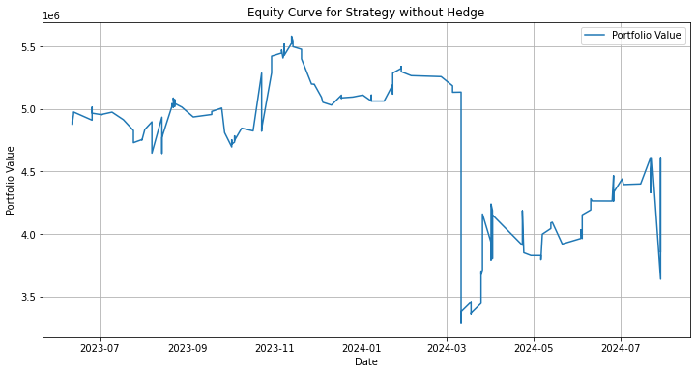

Considering the S&P went up during this period, this isn’t great.

The noticeable drop in 2024-06 is the result of a single event trade: VKTX was upweighted by Russell 2000 on 2024-03-11, and the shorting leg lost nearly 2 million. This demonstrates the importance of placing size limits on each trades.

Below is a two-way table showing the profits and losses of entries for each actions and indices:

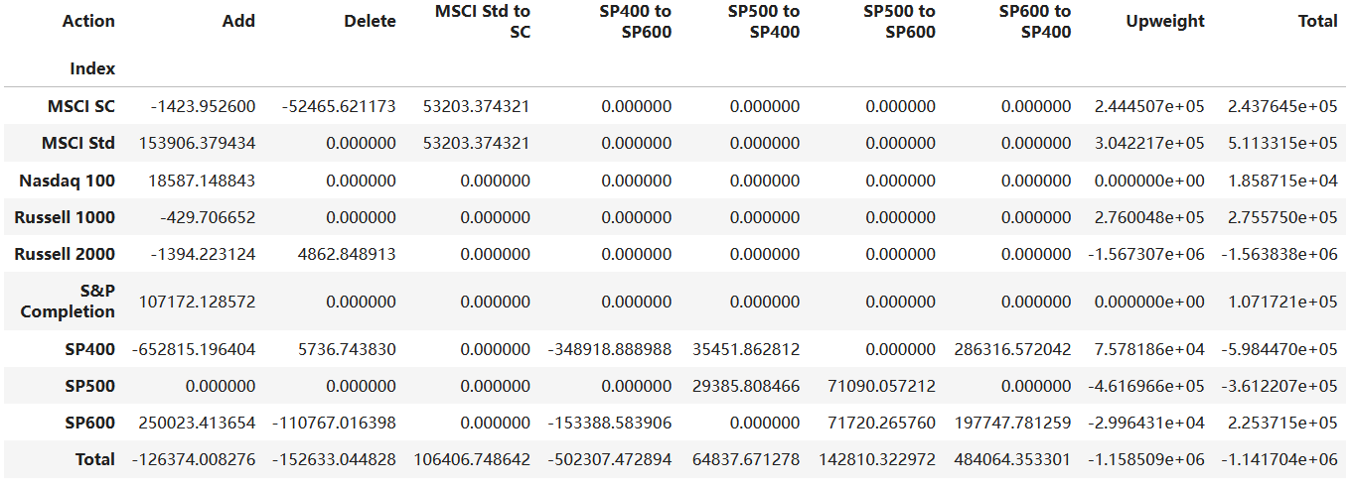

Evidently, I was very wrong about “Add”, “Delete” and “Upweight” events, and Russell 2000, SP400, and SP500.

The second iterations fares better, with a 0.04% return over the same period. It has a Sharpe Ratio of -0.079 when measuring against Fed Funds Rate. But this increase in return may be due mostly to the hedging SPY legs, while the variance is very high. Below is the equity curve of the modified strategy:

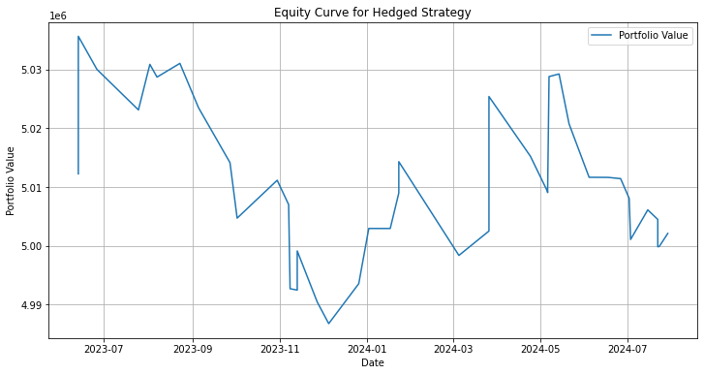

More analysis and code implementation found in “3 Backtesting”