nVoip = [10 20 30 40];
lambda_data = 1500; %pps
lambda_voip = 50; % time between packet arrivals is uniformly distributed
% between 16 milliseconds and 24 milliseconds
avg_size_data = 620; % bytes
avg_size_voip = 120; % bytes
throughput_per_voip_flow = avg_size_voip*8 * lambda_voip; %bits per second
throughput_voip = zeros(1, length(nVoip));
throughput_voip(1) = throughput_per_voip_flow * 10 / 1e6; % 10 voip flows
throughput_voip(2) = throughput_per_voip_flow * 20 / 1e6; % 20 voip flows
throughput_voip(3) = throughput_per_voip_flow * 30 / 1e6; % 30 voip flows
throughput_voip(4) = throughput_per_voip_flow * 40 / 1e6; % 40 voip flows
throughput_data = avg_size_data * 8 * lambda_data / 1e6; %bits per second
ber = 1e-5;
P_no_error_data = (1-ber)^(avg_size_data*8);
P_no_error_voip = (1-ber)^(avg_size_voip*8);
tt = zeros(1, length(nVoip));
tt(1) = throughput_voip(1) * P_no_error_voip + throughput_data * P_no_error_data;
tt(2) = throughput_voip(2) * P_no_error_voip + throughput_data * P_no_error_data;
tt(3) = throughput_voip(3) * P_no_error_voip + throughput_data * P_no_error_data;
tt(4) = throughput_voip(4) * P_no_error_voip + throughput_data * P_no_error_data;
ftt = figure;
hold on;
bar(nVoip, tt');
title('Total throughput')
xlabel('Number of VoIP Flows');
xticks(10:10:40);
ylabel('Throughput (Mbps)');
ylim([0 10]);
grid on;
set(ftt, 'Position', [100, 100, figureWidth, figureHeight]);
saveas(ftt, fullfile('figures', 'ftt.png'));
hold off;
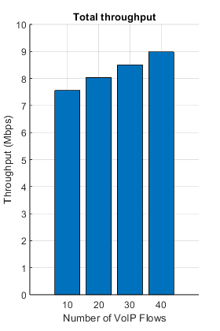
Published with MATLAB® R2024b

