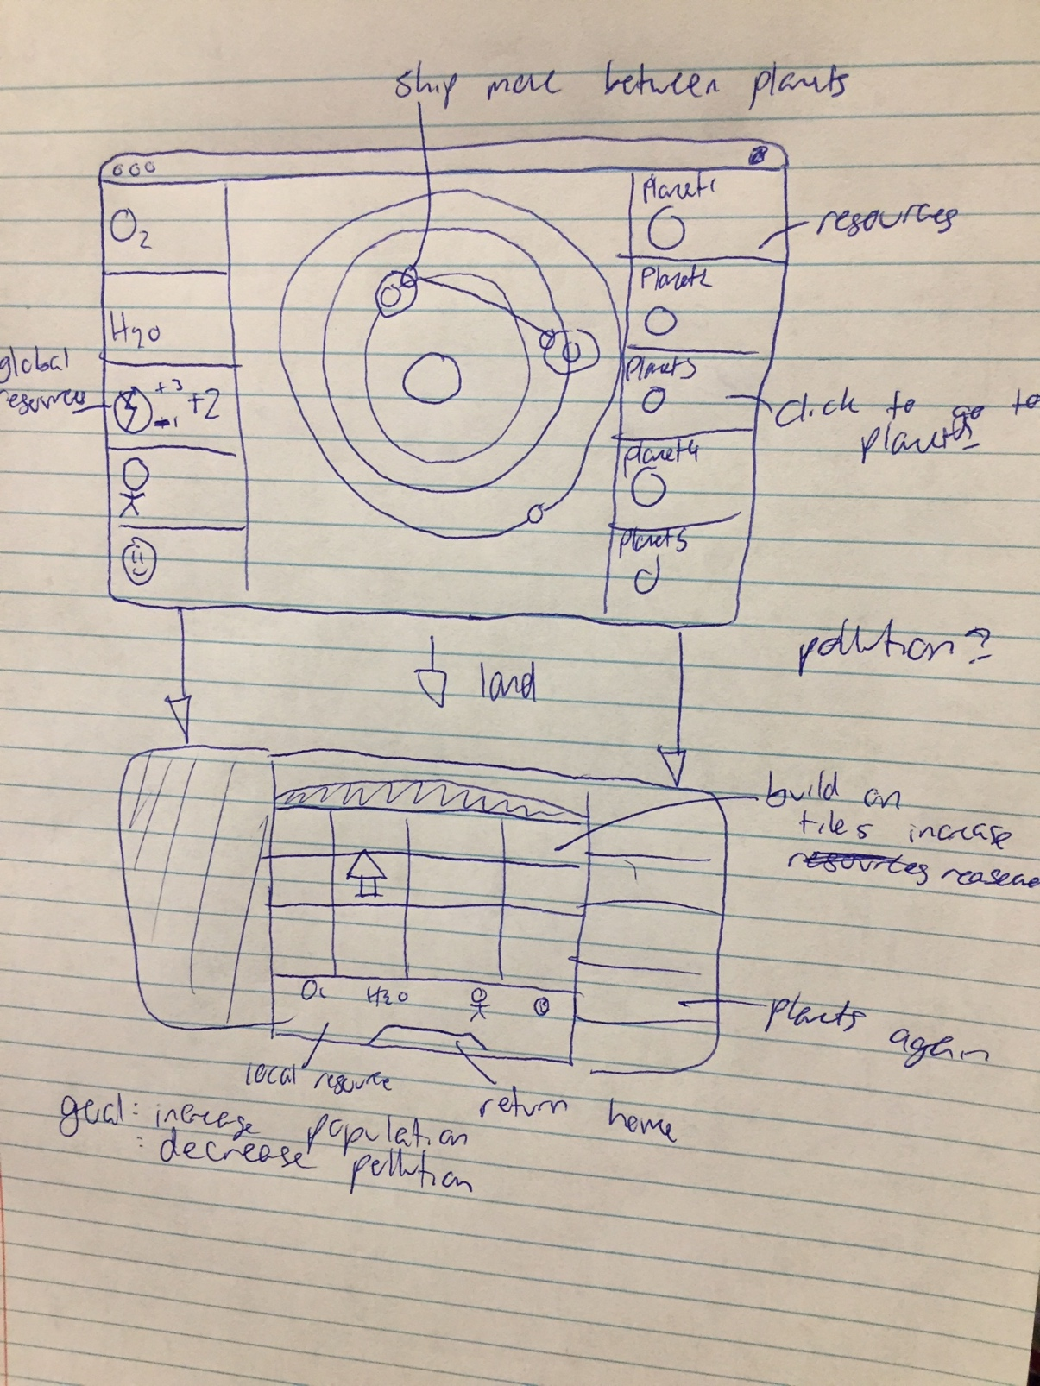**4.1** Program Design

Global grand challenge = space

idea = game inspired by old stellaris planet system where you start on one planet but need to expand to other planets to increase population to survive.

* solar system as area where you can jump from planet to planet using ship
* land on each planet and you can build buildings and stuff
* micromanage small amounts of resources on each planet
* try to get global pops above a certain amount
* events that arise that cause bad/good things to happen
* democracy/voting
* expansion to different solar systems
* upgrade ship and buildings to get better stuff
* military/fighting