POJPROEFSDB01  
Log Shipping Configuration Step

Version 0.2

Note:

In order for long shipping to works, both Primary and Secondary server must have same disk byte per physical sector. It can be either 512 in Primary and 512 in Secondary or 4096 in Primary and 4096 in Secondary

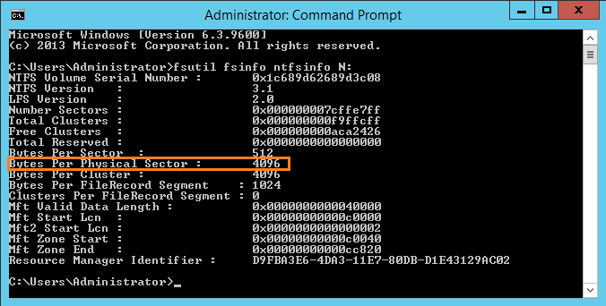

To check it, please run command prompt with administrator rights and run below command:

**fsutil fsinfo ntfsinfo N:**

N is representing the drive letter.

This info can be found from official Microsoft page in below article:

<https://support.microsoft.com/en-us/help/2987585/restore-log-with-standby-mode-on-an-advanced-format-disk-may-cause-a-9004-error-in-sql-server-2008-r2-or-sql-server-2012>

|  |  |
| --- | --- |
| **No** | **Description** |
| Step 1: Create a folder in primary and secondary server and share the folders | |
|  | Go to menu and type “Run”, type “mstsc” to start remote desktop connection |
|  | Type **10.19.14.190** and click Connect    You will be request to enter your credentials  .Login ID: administrator  Password: p@$$w0rd    Click “Yes” |
|  | Once enter remote desktop, right click and select “File Explore” |

|  |  |
| --- | --- |
|  | Select SQL Backup (N:) |
|  | Create a backup transaction log folder in the primary server local disk (Drive N)  Rename the folder (e.g Transaction_Log_Backup)  C:\Users\tonyliew\AppData\Local\Microsoft\Windows\INetCache\Content.Word\Capture.png |
|  | Once the folder created, right click the folder and select “Properties”, select tab “Sharing”  C:\Users\tonyliew\AppData\Local\Microsoft\Windows\INetCache\Content.Word\Screenshot (8).png  C:\Users\tonyliew\AppData\Local\Microsoft\Windows\INetCache\Content.Word\Capture4.png |

|  |  |
| --- | --- |
|  | Click on “Share…” button  C:\Users\tonyliew\AppData\Local\Microsoft\Windows\INetCache\Content.Word\Capture4.png |
|  | Enter “Everyone” to choose people to share the folder, and click “Add”  C:\Users\tonyliew\AppData\Local\Microsoft\Windows\INetCache\Content.Word\Capture5.png |
|  | Once you click “Add” ,right click “Everyone” and select “Read/Write” , and click “Ok”  C:\Users\tonyliew\AppData\Local\Microsoft\Windows\INetCache\Content.Word\Capture6.png |
|  | Select the folder and click “Done”  C:\Users\tonyliew\AppData\Local\Microsoft\Windows\INetCache\Content.Word\Capture7.png |
|  | Go to menu and type “Run”, type “mstsc” to start remote desktop connection in primary server    Type **10.29.112.183** and click Connect    Click “Yes”    You are now in secondary server |
|  | Once enter remote desktop, right click and select “File Explore” |
|  | Select SQL Backup (N:) |
|  | Create a backup transaction log folder in the primary server local disk (Drive N)  Rename the folder (e.g Transaction_Log_Backup)  C:\Users\tonyliew\AppData\Local\Microsoft\Windows\INetCache\Content.Word\Capture.png |

|  |  |
| --- | --- |
| Step 2: Backup production database in primary server | |
|  | Turn back to primary server, right click the “EFSDb”, select “Tasks” and select “Back Up…” |
|  | Backup the Database you want to backup, click “Remove” and click “Add…” |
|  | Select a folder to save the backup file, click “…” |
|  | Select the folder that shared across the network. In this case, select T_logbackupForScreenshot and click “Ok”  C:\Users\tonyliew\AppData\Local\Microsoft\Windows\INetCache\Content.Word\Capture12.png |

|  |  |
| --- | --- |
|  | You will see your file in the folder that you stored  C:\Users\tonyliew\AppData\Local\Microsoft\Windows\INetCache\Content.Word\Capture13.png |
| Step 3: Copy the backup file to secondary server | |
|  | Go to secondary server. Go to menu and type “Run”, type “**\\10.19.14.190**” |
|  | Click the folder that you stored the .bak file  C:\Users\tonyliew\AppData\Local\Microsoft\Windows\INetCache\Content.Word\Capture15.png |
|  | Extract the .bak file that you store into SQL backup (Drive N)  C:\Users\tonyliew\AppData\Local\Microsoft\Windows\INetCache\Content.Word\Capture16.png |
| Step 4: Restore the backup file in secondary server(standby mode) | |
|  | Before restore the database, log in to DRCPRDEFSDB01, go to “Run” and enter “services.”    Search “SQL Server Agent(MSSQLSERVER)”  Right click and click “Properties”    Select “Log on” tab  Click on “This account” and click “Browse”    In the file “Enter the object name to select”  Enter “administrator” and click “Check Names” button  Once clicked the button , the expected result as shown below and click “OK”    Enter the Password and Confirm password  Password: p@$$w0rdp@$$w0rd    And now you are log in as administrator |
|  | Right click the database in secondary server, and click “Restore Database”  C:\Users\tonyliew\AppData\Local\Microsoft\Windows\INetCache\Content.Word\Capture33.png |
|  | Select “Device” and click “…”  C:\Users\tonyliew\AppData\Local\Microsoft\Windows\INetCache\Content.Word\Capture34.png |
|  | Click “Add”  C:\Users\tonyliew\AppData\Local\Microsoft\Windows\INetCache\Content.Word\Capture35.png |
|  | Select the .bak that you extracted from shared network. In this case ,select Backup_TransactionLog_Test.bak C:\Users\tonyliew\AppData\Local\Microsoft\Windows\INetCache\Content.Word\Capture36.png |
|  | Click “Ok” C:\Users\tonyliew\AppData\Local\Microsoft\Windows\INetCache\Content.Word\Capture37.png |
|  | Select “Option” and Select “RESTORE WITH STANBY” at the Standby file C:\Users\tonyliew\AppData\Local\Microsoft\Windows\INetCache\Content.Word\Capture38.png |
|  | Click “OK” after complete selection  C:\Users\tonyliew\AppData\Local\Microsoft\Windows\INetCache\Content.Word\Capture39.png |

|  |  |
| --- | --- |
| Step 5 : Configure log shipping | |
|  | Go to primary server, right click the production database, select “Properties” |
|  | Select “Transaction Log Shipping” on the left side of the page  C:\Users\tonyliew\AppData\Local\Microsoft\Windows\INetCache\Content.Word\Capture3.png |
|  | Tick “Enable this as primary database in a log shipping configuration” box and click “Backup Settings…”C:\Users\tonyliew\AppData\Local\Microsoft\Windows\INetCache\Content.Word\Capture8.png |
|  | Enter Network path to backup folder. In this case, use \\10.19.14.190\EFSDb Click “Schedule…”  C:\Users\tonyliew\AppData\Local\Microsoft\Windows\INetCache\Content.Word\Capture17.png |
|  | In the field “Occurs every”, change it to **60** minute(s) and click “OK”  C:\Users\tonyliew\AppData\Local\Microsoft\Windows\INetCache\Content.Word\Capture18.png |
|  | Click “OK”  C:\Users\tonyliew\AppData\Local\Microsoft\Windows\INetCache\Content.Word\Capture17.png C:\Users\tonyliew\AppData\Local\Microsoft\Windows\INetCache\Content.Word\Capture19.png |
|  | Click “Add..” at the Secondary databases |
|  | Select “DRCPRDEFSDB01” at “Server name” and click “Connect” |
|  | Select “No, the secondary database in initialized.” C:\Users\tonyliew\AppData\Local\Microsoft\Windows\INetCache\Content.Word\Capture23.png |
|  | In the Copy Files tab, copy the path of destination located on the secondary server. In this case, use \\10.29.112.183\EFSDb_Log and click “Schedule”  C:\Users\tonyliew\AppData\Local\Microsoft\Windows\INetCache\Content.Word\Capture17.png |
|  | In the field “Occurs every”, change it to **60** minute(s) and click “OK” C:\Users\tonyliew\AppData\Local\Microsoft\Windows\INetCache\Content.Word\Capture18.png |
|  | At the “Restore Transaction Log” Tab, select “Standby mode” and tick “Disconnect users in the database when restoring backups”  Click “Schedule”  C:\Users\tonyliew\AppData\Local\Microsoft\Windows\INetCache\Content.Word\Capture17.png |

|  |  |
| --- | --- |
|  | In the field “Occurs every”, change it to **70** minute(s) and click “OK” C:\Users\tonyliew\AppData\Local\Microsoft\Windows\INetCache\Content.Word\Capture18.png  Click “OK”  C:\Users\tonyliew\AppData\Local\Microsoft\Windows\INetCache\Content.Word\Capture17.png |
|  | Click “OK” |

Remark: If you wish to change the schedule, you can click “…”

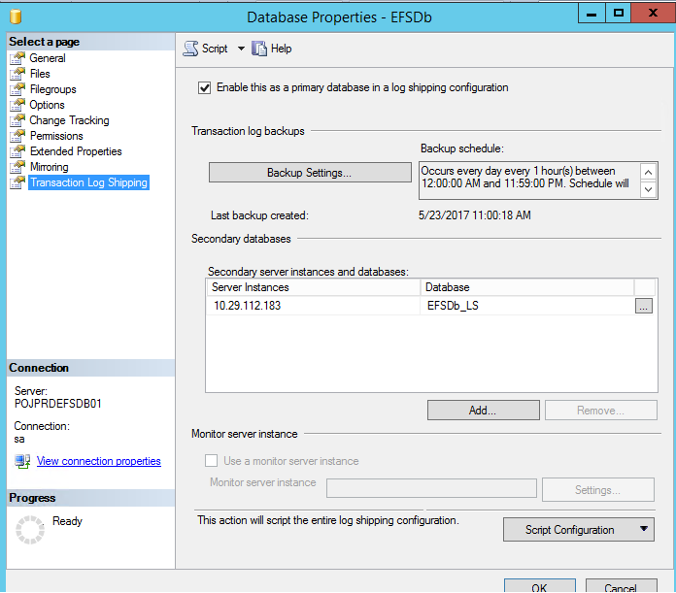  
Click “Edit Job”

