How to change system date

Select sysdate from dual;

ALTER SYSTEM SET FIXED_DATE = '2018-03-27';
ALTER SYSTEM SET FIXED_DATE='none';

'Your database connection has been reset. Any pending transactions or session state has been lost.'

Download the setup http://scristalli.github.io/SQLMemo/

Go to Help ----> check for updates
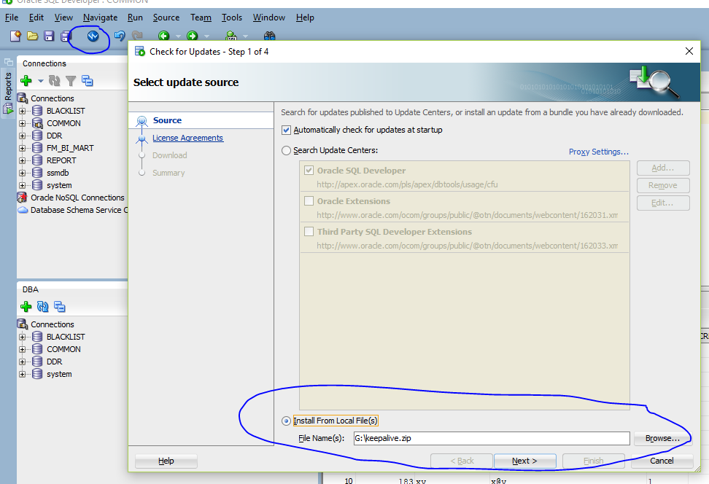
Restart Oracle SQL Developer
On the Oracle server, edit sqlnet.ora to add the line:

SSM-ROB-DB01
/oracleDB/u01/app/oracle/product/12.2.0/dbhome_2/network/admin/sqlnet.ora
CMLDBDVVPDC2301
/oracle/u01/app/oracle/product/12.2.0/dbhome_1/network/admin/

NAMES.DIRECTORY_PATH= (TNSNAMES, EZCONNECT)
TCP.CONNECT_TIMEOUT=10
SQLNET.EXPIRE_TIME=10
SQLNET.INBOUND_CONNECT_TIMEOUT = 60

in listener.ora
INBOUND_CONNECT_TIMEOUT_LISTENER=0
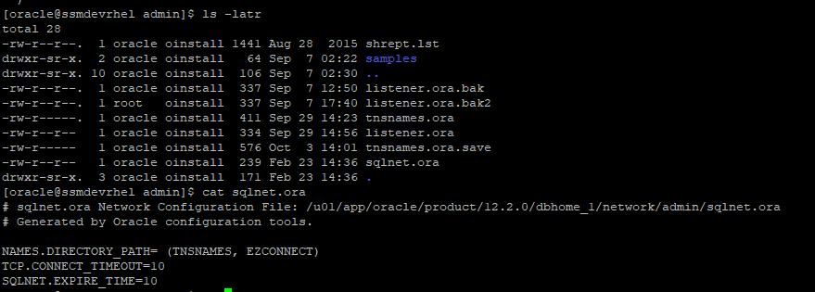
Restart the server.
ora 27038 created file already exists create tablespace
CREATE TABLESPACE Blacklist
DATAFILE 'blacklist.dbf'
SIZE 50mreuse
AUTOEXTEND ON
ONLINE;

ORA-65096: create 12c user without c## prefix
alter session set "_ORACLE_SCRIPT"=true;
create user fred identified by flintstone;
grant dba to pubs;
ORA-01157: cannot identify/lock data file string - see DBWR trace file

ORA-01157: cannot identify/lock data file 11 – see DBWR trace file
ORA-01110: data file 18: '/u02/app/oracle/product/12.2.0/dbhome_2/dbs/E:ORACLEORADATAORCLDATAFILESSMPDC001.DBF'

Solution:
alter database datafile 18 OFFLINE DROP;
http://nimishgarg.blogspot.com/2014/01/ora-01157-cannot-identifylock-data-file.html

Doing Impdp
With the Partitioning, OLAP, Advanced Analytics and Real Application Testing
ORA-31626: job does not exist
ORA-31637: cannot create job SYS_IMPORT_SCHEMA_02 for user SYS
ORA-06512: at "SYS.DBMS_SYS_ERROR", line 95
ORA-06512: at "SYS.KUPV$FT", line 1580
ORA-39062: error creating master process DM00
ORA-31613: Master process DM00 failed during startup.

--alter system set processes=800 scope=spfile;

SQL>startup force

ORA-01940 cannot drop a user that is currently connected
SELECT s.inst_id,
s.sid,
s.serial#,
p.spid,
s.username,
s.program
FROM gv$session s
JOIN gv$process p ON p.addr = s.paddr AND p.inst_id = s.inst_id
WHERE s.type != 'BACKGROUND';

---- alter system kill session '820,17331,@1';

ORA-28002 The Password Will Expire

selectprofile,username from dba_users where username = 'REPORT';
selectresource_name,limit from dba_profiles where profile='DEFAULT';
Alter the specific user password to never expire:
ALTER PROFILE DEFAULT LIMIT PASSWORD_LIFE_TIME 180;
ALTER FINBE LIMIT PASSWORD_LIFE_TIME 60;
alter profile my_profile limit password_life_time unlimited;
Alter the default SQL*Plus profile for all users as follows:
alter profile default limit password_life_time unlimited;
ALTER USER "FINBE" identified by "finbe123"
DEFAULT TABLESPACE "USERS"
TEMPORARY TABLESPACE "TEMP"
ACCOUNT UNLOCK ;

ora 28000 account is locked

alter user ZABBIX_MON ACCOUNT UNLOCK;
ORA-00257: archiver error. Connect internal only
select * from v$flash_recovery_area_usage

show parameter recovery;

archive log list;

select name , floor(space_limit / 1024 / 1024 /1024) "Size GB", ceil(space_used / 1024 / 1024/ 1024 ) "Used GB"from v$recovery_file_destorder by name;

---alter system set db_recovery_file_dest_size=300G scope=both;

After the RMAN backup:
[oracle@ol8-19 archivelog]$ rman target sys@MIBS

Recovery Manager: Release 19.0.0.0.0 - Production on Tue May 2 18:20:17 2023
Version 19.3.0.0.0

Copyright (c) 1982, 2019, Oracle and/or its affiliates. All rights reserved.

target database Password:
connected to target database: MIBS (DBID=3055713532)

RMAN> DELETE ARCHIVELOG ALL COMPLETED BEFORE 'SYSDATE-7';

DELETE ARCHIVELOG ALL COMPLETED BEFORE 'SYSDATE-7';

Error Message:
ORA-39083: Object type TYPE failed to create with error:
ORA-02304: invalid object identifier literal
Failing sql is:
CREATE TYPE "TEST"."TTTTT" OID '8E21EF4C1F6EF167E04011AC99643EB0' IS TABLE OF VARCHAR2(40);

---impdp again with parameter transform=OID:n

ORA-01219: database not open: queries allowed on fixed tables/views only)

SELECT wrl_parameter, status, wallet_type FROM v$encryption_wallet;

Show pdbs;
SQL> alter pluggable database PMBRSQA open;

Pluggable database altered.

ADMINISTER KEY MANAGEMENT SET KEY FORCE KEYSTORE IDENTIFIED BY "Password#123" with backup;

ORA-12532:TNS:invalid argument

if you have '@' character with the password field then remove the character.

ERROR at line 1:
ORA-03135: connection lost contact
Process ID: 298509
Session ID: 1053 Serial number: 14562
If there is a issue on standby database not startup in one node

Running the command to startup nomount;
alter database mount standby database;
----To Start MRP processs in first node
alter database recover managed standby database disconnect from session;
----To stop MRP process on second node
alter database recover managed standby database cancel;
----To check Archive applying or not
SQL> select process,status,thread#,sequence# from v$managed_standby where process like 'MRP%';

ora-00903 invalid table name
grant select on "AROC"."USER" to "RL_RO_AROC";

ORA-01000 maximum open cursors exceeded
select sql_text, count(*) as "OPEN CURSORS", user_name from v$open_cursor
group by sql_text, user_name order by count(*) desc;

select COUNT(*) from v$open_cursor where user_name='ROB'

SELECT value FROM v$parameter WHERE name = 'open_cursors'

--alter system set open_cursors = 500 scope=both;

ORA-12012: error on auto execute of job "SYS"."ORA$AT_OS_OPT_SY_2353"
ORA-20001: Statistics Advisor: Invalid task name for the current user
ORA-06512: at "SYS.DBMS_STATS", line 47207
ORA-06512: at "SYS.DBMS_STATS_ADVISOR", line 882
ORA-06512: at "SYS.DBMS_STATS_INTERNAL", line 20059
ORA-06512: at "SYS.DBMS_STATS_INTERNAL", line 22201
ORA-06512: at "SYS.DBMS_STATS", line 47197

select name, ctime, how_created
from sys.wri$_adv_tasks
where owner_name = 'SYS'
and name in ('AUTO_STATS_ADVISOR_TASK','INDIVIDUAL_STATS_ADVISOR_TASK');

EXEC dbms_stats.init_package();

ORA-65066: The specified changes must apply to all containers in 12C

SQL> connect / as sysdba
Connected.
SQL> alter user system identified by “Password!23”;

"incompatible"
>expdpsc/sc DIRECTORY=DUMPDIR SCHEMAS=SC
DUMPFILE=SC1expdp20230705_%U.dmp LOGFILE=sc.log PARALLEL=1 LOGTIME=ALL VERSION=12.1

ORA-01691: unable to extend lob segment

ALTER TABLESPACE "WEBBDS" ADD DATAFILE '/export/oradata/MIBS/webbds05.dbf' SIZE 3G
AUTOEXTEND ON NEXT 8192 MAXSIZE 32767M;

After delete to recover the space

alter table WEBBDS.SESSIONS enable row movement;
alter table WEBBDS.SESSIONS shrink space;
alter table WEBBDS.SESSIONS disable row movement;

-- Check Tablespace utilization
select null DUMMY,
a.tablespace_name,
round(a.size_gb,2) as "SIZE_GB",
round((a.size_gb - nvl(b.free_gb,0)),2) as "USED_GB",
round(nvl(b.free_gb,0),2) as "FREE_GB",
round((nvl(b.free_gb,0)/a.size_gb) * 100,2) as "PCT_FREE",
round(((a.size_gb-nvl(b.free_gb,0))/a.size_gb) *100,2) as "PCT_USED"
from
(selecttablespace_name, sum(bytes/1024/1024/1024) as "SIZE_GB"
fromdba_data_files
group by tablespace_name) a,
(selecttablespace_name, sum(bytes/1024/1024/1024) as "FREE_GB"
fromdba_free_space
group by tablespace_name) b
wherea.tablespace_name= b.tablespace_name(+)
order by 2;

-- Check Lob Segment and its size for Table EJF
SELECT *
FROM (SELECT l.owner,
l.table_name,
l.column_name,
l.segment_name,
l.tablespace_name,
ROUND(s.bytes/1024/1024,2) mb
FROM dba_lobs l
JOIN dba_segments s ON s.owner = l.owner AND s.segment_name = l.segment_name
ORDER BY 6 DESC) WHERE owner='WEBBDS' AND table_name='EJF';

-- Count Record for older than 60 days
SELECT count(*) FROM WEBBDS.EJF
WHERE REQTIMESTAMP < (SYSDATE - 60);

-- Delete Record for older than 60 days
DELETE FROM WEBBDS.EJF
WHERE REQTIMESTAMP < (SYSDATE - 60);

-- Reclaim Space Table and Lob Segment
alter table WEBBDS.EJF enable row movement;
alter table WEBBDS.EJF shrink SPACE cascade;

ALTER TABLE WEBBDS.EJF MODIFY LOB(TOTA) (SHRINK SPACE CASCADE);
ALTER TABLE WEBBDS.EJF MODIFY LOB(TITA) (SHRINK SPACE CASCADE);
ALTER TABLE WEBBDS.EJF MODIFY LOB(SCREENIMAGE) (SHRINK SPACE CASCADE);
ALTER TABLE WEBBDS.EJF MODIFY LOB(PARAMDATA) (SHRINK SPACE CASCADE);

ALTER TABLE WEBBDS.EJF MOVE LOB(TOTA) STORE AS (TABLESPACE WEBBDS);
ALTER TABLE WEBBDS.EJF MOVE LOB(TITA) STORE AS (TABLESPACE WEBBDS);
ALTER TABLE WEBBDS.EJF MOVE LOB(SCREENIMAGE) STORE AS (TABLESPACE WEBBDS);
ALTER TABLE WEBBDS.EJF MOVE LOB(PARAMDATA) STORE AS (TABLESPACE WEBBDS);

alter table WEBBDS.EJF disable row movement;

alter index ind_big_stuff rebuild online;

exec dbms_space_admin.drop_empty_segments(schema_name=>'HR');

SQL> ALTER TABLE sc.docview RENAME to sc.docview_ori;
ERROR at line 1:
ORA-14047: ALTER TABLE|INDEX RENAME may not be combined with other operations

ALTER TABLE sc.docview RENAME to docview_ori;

Datapump Export failed with ORA-31693 ORA-02354 ORA-39826
Oracle ver -->11.2.0.4
OS ver -->Linux x86-64
====================

Below errors reported

ORA-31693: Table data object "USER"."CMP4$xxxxxx" failed to load/unload and is being skipped due to error:
ORA-02354: error in exporting/importing data
ORA-39826: Direct path load of view or synonym (USER.CMP4$xxxxxx) could not be resolved.

Tables with names like CMP3$xxxxxx or CMP4$xxxxxx (where xxxxxx is a number) creates during Compression Advisor and dropped after the Compression Advisor. If you see Tables with names like CMP3$xxxxxx or CMP4$xxxxxx (where xxxxxx is a number) left over after running Compression Advisor, it is likely because Compression Advisor failed at some point. These are interim tables created/used by Compression Advisor, which are normally dropped when it completes. You can safely drop those tables.

Connected to: Oracle Database 19c Enterprise Edition Release 19.0.0.0.0 - Production
ORA-39002: invalid operation
ORA-39165: Schema WEBBDS2TEST was not found.

impdp webbds2test/webbds2test schemas=WEBBDS directory=DUMPDIR dumpfile=WEBBDS1expdpAfter20231206_06120440-%U.dmp logfile=webbds2test_import.log REMAP_SCHEMA=WEBBDS:WEBBDS2TEST REMAP_TABLESPACE=WEBBDS:WEBBDS2TEST

ora-31684 object type sequence already exists impdp

TABLE_EXISTS_ACTION=SKIP / APPEND / TRUNCATE / REPLACE
exclude=user

Service "MIBS" has 1 instance(s).
Instance "MIBS", status BLOCKED, has 1 handler(s) for this service...
Service "MIBSXDB" has 1 instance(s).
Instance "MIBS", status BLOCKED, has 1 handler(s) for this service...
The command completed successfully

SQL> shutdown abort
ORACLE instance shut down.
SQL>startup
ORACLE instance started.

How to kill the expdp/impd jobs

select * from dba_datapump_jobs;

SYS_IMPORT_SCHEMA_01

impdpsc/sc attach=SYS_IMPORT_SCHEMA_01

IMPORT> status
IMPORT>kill_job

Oracle ORA-03113: end-of-file on communication channel

Windows users report ORA-03113 errors from non-Oracle issues like Windows logs becoming full.
- Increase the storage disk

ORA-39171 error during an import:
statement in resumable session 'SYSTEM.SYS_IMPORT_FULL_02.1' was suspended due to

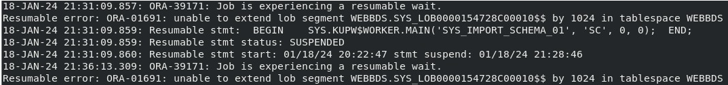

Import>

Next, stop the job without aborting it:

Import>stop_job=immediate

At this point, you can kill the job if you wish to start over:

Import>kill_job

Add the other tablespace

ALTER TABLESPACE WEBBDS ADD DATAFILE '/export/oradata/MIBS/webbds03.dbf'
SIZE 20M AUTOEXTEND ON NEXT 10M MAXSIZE 32767M;

ora-01950 no privileges on tablespace

ALTER USER CBOMOBILE2 quota unlimited on CBOMOBILE2;
ALTER USER CBOMOBILE2 quota 100M on CBOMOBILE2;

ORA-12716: Cannot ALTER DATABASE CHARACTER SET when CLOB data exists

selectowner,table_name,column_name,data_type from dba_tab_cols where data_type like 'CLOB%';

ORA-28014: cannot drop administrative users

alter session set "_oracle_script"=true;

drop user FOSUSER CASCADE;

Recover the missing control file

Show parameter control_files;
Select value from v$parameter where name=’contorl_files’;
!cp (copy the files)

