**Friday, October 13, 2023**

The camera we got is auto-focus instead of fixed-focus. I’m not sure why, but I am asking Austin, who is in Dr. Yilmaz’s Senior Research, and is also working with the cars, what happened.

According to both the documentation and some rudimentary tests I did, the auto-focus is unsuitable for high vibration/movement (such as mounting it on one of the cars). From my own observation, it is clear that under sudden high acceleration the camera is forced to re-focus, creating a constantly blurry stream. Here is a picture from a more rigorous test done with a drone:

It is clear that using the Auto-Focus camera as an input to the reinforcement learning algorithm would be a waste of time given how much clearer the Fixed Focus camera is. Austin says he will ask Dr. Yilmaz to return this camera and get the correct version.

I did try out some code for the camera since the two versions are otherwise the exact same, in particular a visual localization Python script. Here is an example output:

Overall, it was decent at determining its position/pose. However, due to the auto-focus lens, it would respond incorrectly to quick changes in focus. For instance, if I left it stationary and waved my hand around it, the auto-focus would reset and the camera would think it had moved when it really hadn’t.

Once that was done, I transitioned to getting the simulator working. I brought my hard drive to school with a Ubuntu image on it. I tried booting this off a non-functional and the functional workstation, but for unknown reasons it was not able to boot.

**Monday, October 16, 2023**

I was able to control the car in the simulation using the arrow keys on my keyboard. I was also able to collect training data from manual driving. The training data is organized as a JSON file with fields for timestep, throttle, steering, and the path to the corresponding image. Here is a screenshot of the simulator operating:

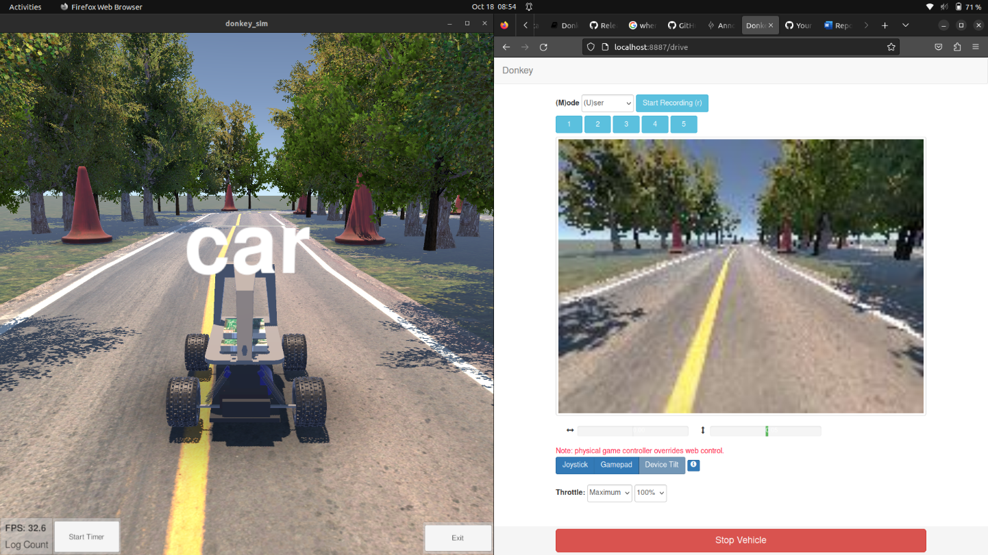On the right is the interface for controlling the car manually and seeing what its camera outputs. On the left is the simulator itself. There are different environments which can be used such as one which auto-generates itself infinitely – this one is particularly useful for reinforcement learning episodes of indeterminate length.

We also determined that you hadn’t actually sent Dr. Torbert the purchase request for the parts (you sent it to me accidentally). This will inevitably delay the date by which I will have a fully operational car.