**Friday, October 27, 2023**

*ML Period*

I worked on improving the reward function. The policy I trained ended up driving in circles, which helped it maximize forward velocity and not crashing, however, this is obviously not what I was trying to do. I implemented a gating system, where the track is divided up into 250 waypoints and the reward is increased as the car reaches successive waypoints. I trained this system briefly and it seemed to have decent progress on ~2000 timesteps of training. Of course, I will need to train it about 10 times as much to have an idea of how good it is.

Also, the parts I ordered (servo, servo adapter, bumper, Nvidia board, battery) came. I opened up the Nvidia board to determine how it will fit on the real car. I worked on the CAD model of the new mounting hardware. I plan on laser cutting a first prototype today during 8th period.

*Senior Research Period*

In the beginning of class I had a discussion with Dr. Gabor and Johnny where we talked about the PPO output and how it could be possibly fixed. Johnny suggested the same solution (using some sort of distance traveled along track function to determine real progress).

Then, I started setting up the Jetson board. I first formatted the old SD card from the previous car project. I then downloaded the boot image for the Jetson. It is a 7.4 GB file so it took a long time to download. Once it downloaded, I flashed the image to the SD card and booted the Nvidia board. It brought me to the setup menu where I set the timezone/language/etc. I was successfully able to boot into Ubuntu on the Nvidia board and connect to Wi-Fi. However, it is important to note that devices cannot see each other over Wi-Fi on a school network. I might try to devise a solution using a phone hotspot or Bluetooth for remote access, but it might be necessary to get a router.

During 8th period I verified the new servo motor is working.

**Monday, October 30, 2023**

Yesterday I trained the reinforcement learning overnight for 1,000,000 timesteps. This took about 13 hours on one of my parent’s computers (the CPU of which is faster than mine). The car was successfully able to drive around the track with a lap time of roughly 17.5 to 19 seconds. About half of the time, it clips the boundaries of the track which results in an early termination. Here is a recording of the model being evaluated over 10 episodes: <https://youtu.be/Ra9GO3K8PAc>

[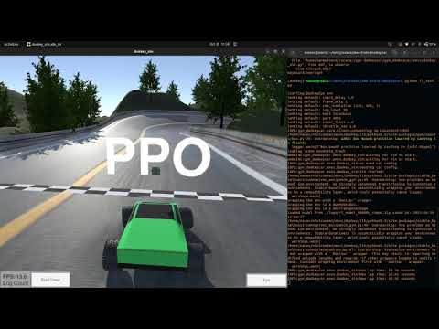](https://youtu.be/Ra9GO3K8PAc)

At this point, I will be moving on to the autoencoder structure which is the main focus of this project. I will first substitute it for the CNN in simulation before implementing this pipeline on the real car. This week, I plan on getting the physical hardware of the car set up. This includes:

1. Calibrating the PID (Proportional, Integral, Derivative) control on the motor controller so that velocity-based control, rather than voltage-based control can be used. Also, controlling the servo and drive motor simultaneously using the motor controller.
2. Acquiring plywood to use for the base plate for laser-cutting next Friday.
3. Setting up required packages/tools on the Nvidia Jetson board, most importantly ROS (Robot Operating System).
4. Establishing remote access of the Nvidia board from my own computer through FCPS or external Wi-Fi.

**Wednesday, November 1, 2023**

I was sick and not at school. I did some research into autoencoders. Specifically, I found that a variational autoencoder is a good fit for my project as it models the encoded state as a Gaussian distribution. This is useful because the idea of a “road” does follow a probability distribution - there is a smooth transition between roads which are steeply angled to the left, slightly angled to the left, slightly angled to the right, etc. When applying a VAE (variational autoencoder) to the MNIST dataset, the smooth transition between inputs is quite clear: 