**Friday, November 10th, 2023**

I tried another approach for re-flashing the firmware for the motor controller. I connected the motor controller to the Jetson board (as it runs Linux) and built the bldc-tool (Brushless DC Motor Controller Tool, <https://github.com/vedderb/bldc-tool>) from source. To do this, I first had to compile the Qt, which is a library used for many GUIs, from source. I had to deal with a few compilation issues, mostly because I had installed the wrong versions of some dependencies. Once I had sorted those out, the compile took a few minutes. The software ran successfully but when I attempted to establish a connection to the motor controller over USB, I received a serial exception. I looked through the source code of the tool but I wasn’t able to figure out what exactly were the possible causes of said serial exception. I then found a few online forums centered around these motor controllers (they are quite popular in electric skateboards and many other things where precise, measurable motor control is needed). I posted separately on Discord, the VESC Forum, and GitHub, asking for help with this firmware problem. Then, I looked into compiling the firmware myself for this specific motor controller.

During 8th period, an initial draft of the mounting plate was laser-cut. There are a few minor fixes we need to make before next Friday in terms of how the pieces are arranged.

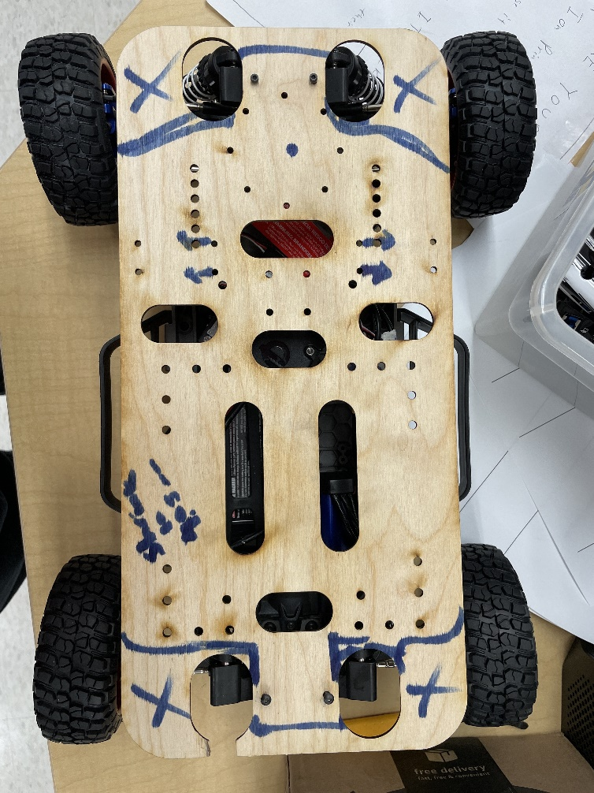

**Monday, November 13th, 2023**

I received a response both on GitHub and Discord. It turns out that I don’t need to compile a special firmware anymore as newer versions of the VESC tool can enable this functionality with the standard firmware. I also was sent a link to the appropriate firmware for this motor controller. I will try it out on Wednesday.

Over the weekend, I also 3D printed a piece for mounting the USB hub to the car.

**Wednesday, November 15th, 2023**

I didn’t receive another response on GitHub, so I was basically stuck with the motor controller already on the car. To clarify, I am able to access the motor controller’s firmware version, which is highly outdated. I can also use the official tool to update the firmware, and the software always reports that the firmware update is successful. However, upon rebooting (which is necessary when uploading new firmware), the tool reports the firmware version has not changed, which means I can’t actually do anything with it. (For reference, the current version loaded onto the motor controller is from 2016. The protocol has had a few breaking changes since then).

I then remembered from last year that Chris Nassif had borrowed another, bigger car from Dr. Torbert which has the same kind of controller. We asked Dr. Torbert for permission to take the motor controller off of the car. I discovered that it has the same (outdated) firmware as the other one. It also suffered from the same issue of not keeping the updated firmware I uploaded onto it (it always reverted back to the old one after a reboot).

**Friday, November 17th, 2023**

*(During ML)*

Shreyan brought in a ratcheting screwdriver he has and helped me install the bumpers onto the car. He also took the plastic covering off the motor controllers and I was able to verify the hardware seems unbroken (e.g., no blown capacitors or fuses). Furthermore, we verified that the clearance between the LiDAR and camera in the front of the car is reasonable so the cables will not obstruct each other.