**Friday, November 17th, 2023**

I am fairly certain that a new motor controller will be necessary. I emailed the company which makes them to ensure I won’t have the same problems that I have been having with the two motor controllers we already have. They responded, saying that they ship their motor controllers with the latest firmware out of the box. Furthermore, they confirmed the output wires are capable of powering the servo motor for steering the car. They said they have all the parts so they will ship the next day (since I don’t want to be waiting too long for it to arrive).

I also found a reinforcement learning paper which tests their code on a small car just like I am trying to do:

“The agent receives an image from the on-board camera as input and commands desired throttle and steering angle…The primary reward is a weighted sum between a survival bonus (no intervention by the safety driver) and the commanded throttle. There is only the continuity cost as secondary reward. One episode terminates when the safety driver intervenes (crash) or after a timeout of 1 minute. Training is done directly on the robot”(<https://arxiv.org/pdf/2005.05719.pdf>)

The concept of a safety driver is one I haven’t seen before, but I think it is a good idea to implement in the real-world reinforcement learning. In simulation, the car can reset its position instantaneously to the start of the track. However, in real life this is obviously not possible. Keeping a replay buffer of previous actions and playing it backwards won’t work either due to tire slip and inaccuracies in the servo and throttle compounding over time. Thus, the idea of using a safety driver to keep the laps around the track continuously going is probably a good approach. I will be contacting the authors of the paper to see if I can get their code.

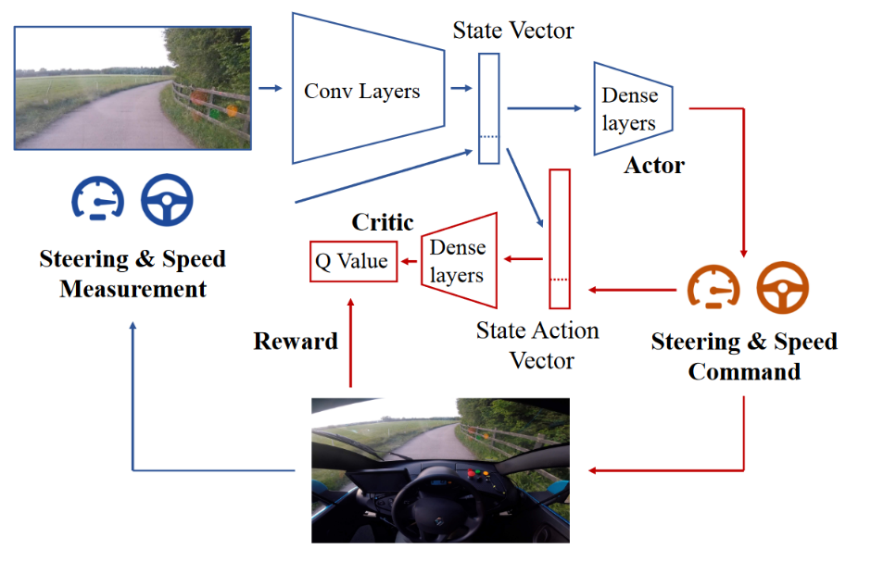I also realized that I never linked the original paper showing a variational autoencoder applied to a full-sized car. It is here: <https://arxiv.org/pdf/1807.00412.pdf>. There is a really good diagram in the paper showing how the overall process works:

I sent a message to the first author of the first paper I linked (the one where they use a small RC car) asking for a few details about their safety driver implementation and how they integrated it with the reward function.

During 8th period, we laser-cut a redesigned laser cut plate. It fits much better onto the car:

