**Friday, January 5th, 2024**

Since all the parts have arrived, I started testing/integrating them. I started with the power system and the Omni battery. The Omni battery has the ability to provide direct DC output from its barrel jack. This will allow me to avoid the heavy and cumbersome wall-plug adapter for powering the Nvidia Jetson computer board. I wanted to verify the adapter plugs I ordered were all correct because I don’t want to accidentally fry the Jetson.

First, I tested the AC adapter, which is rated for 19V/2.37 A. I found its true output voltage was 19.28 V, with positive being on the inside of the plug and negative on the outside of the plug.

Next, I tried to verify the voltage coming off the battery. As shown in the picture below, I first set the battery to *output* 19.3 V from its 5.5x2.1 mm female barrel jack.

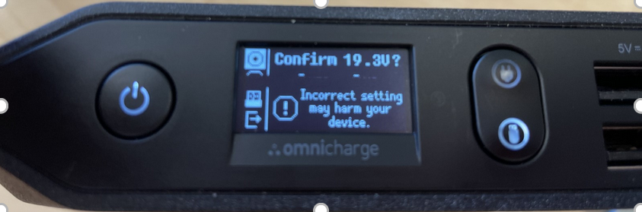

I then plugged in the adapter I ordered into the barrel jack and measured the voltage. It was zero volts, because I had ordered the wrong adapter:

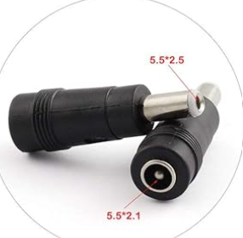

This is a screenshot from the Amazon page of the adapter. As you can see, the end going in the battery is 5.5x2.5 mm, not 5.5x2.1. Therefore, the adapter and battery aren’t even making electrical contact with each other. The other adapter I ordered also has the 5.5x2.1mm and 5.5x2.5mm ends switched compared to what I need:

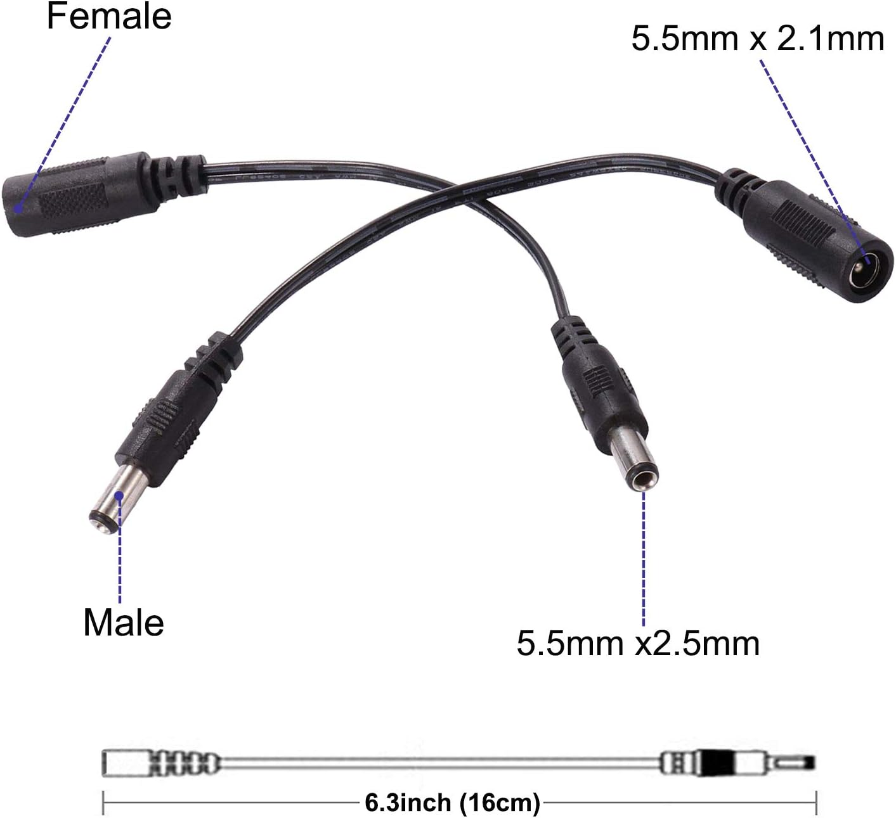

I will find and send a purchase order for the correct plugs now that I know that I got it precisely backwards this time around.

I also opened up the other parts that arrived, such as the USB cables, screw/washer set, and solid-state drive just to make sure they were intact/the correct part. I started mapping out how the wiring is going to be laid out on the car (e.g USB hub/Jetson/peripheral connections). The key consideration is making sure you aren’t using wires that are too long, because they can dangle outside of the car’s frame and get tangled in the wheels, obstruct the camera or LiDAR, and other generally unwanted things.

After class I talked with Dr. Torbert to check on the status of the VESC motor controller. He said he wasn’t sure when it would arrive.

During 8th period, my club members mostly finished assembling the car:

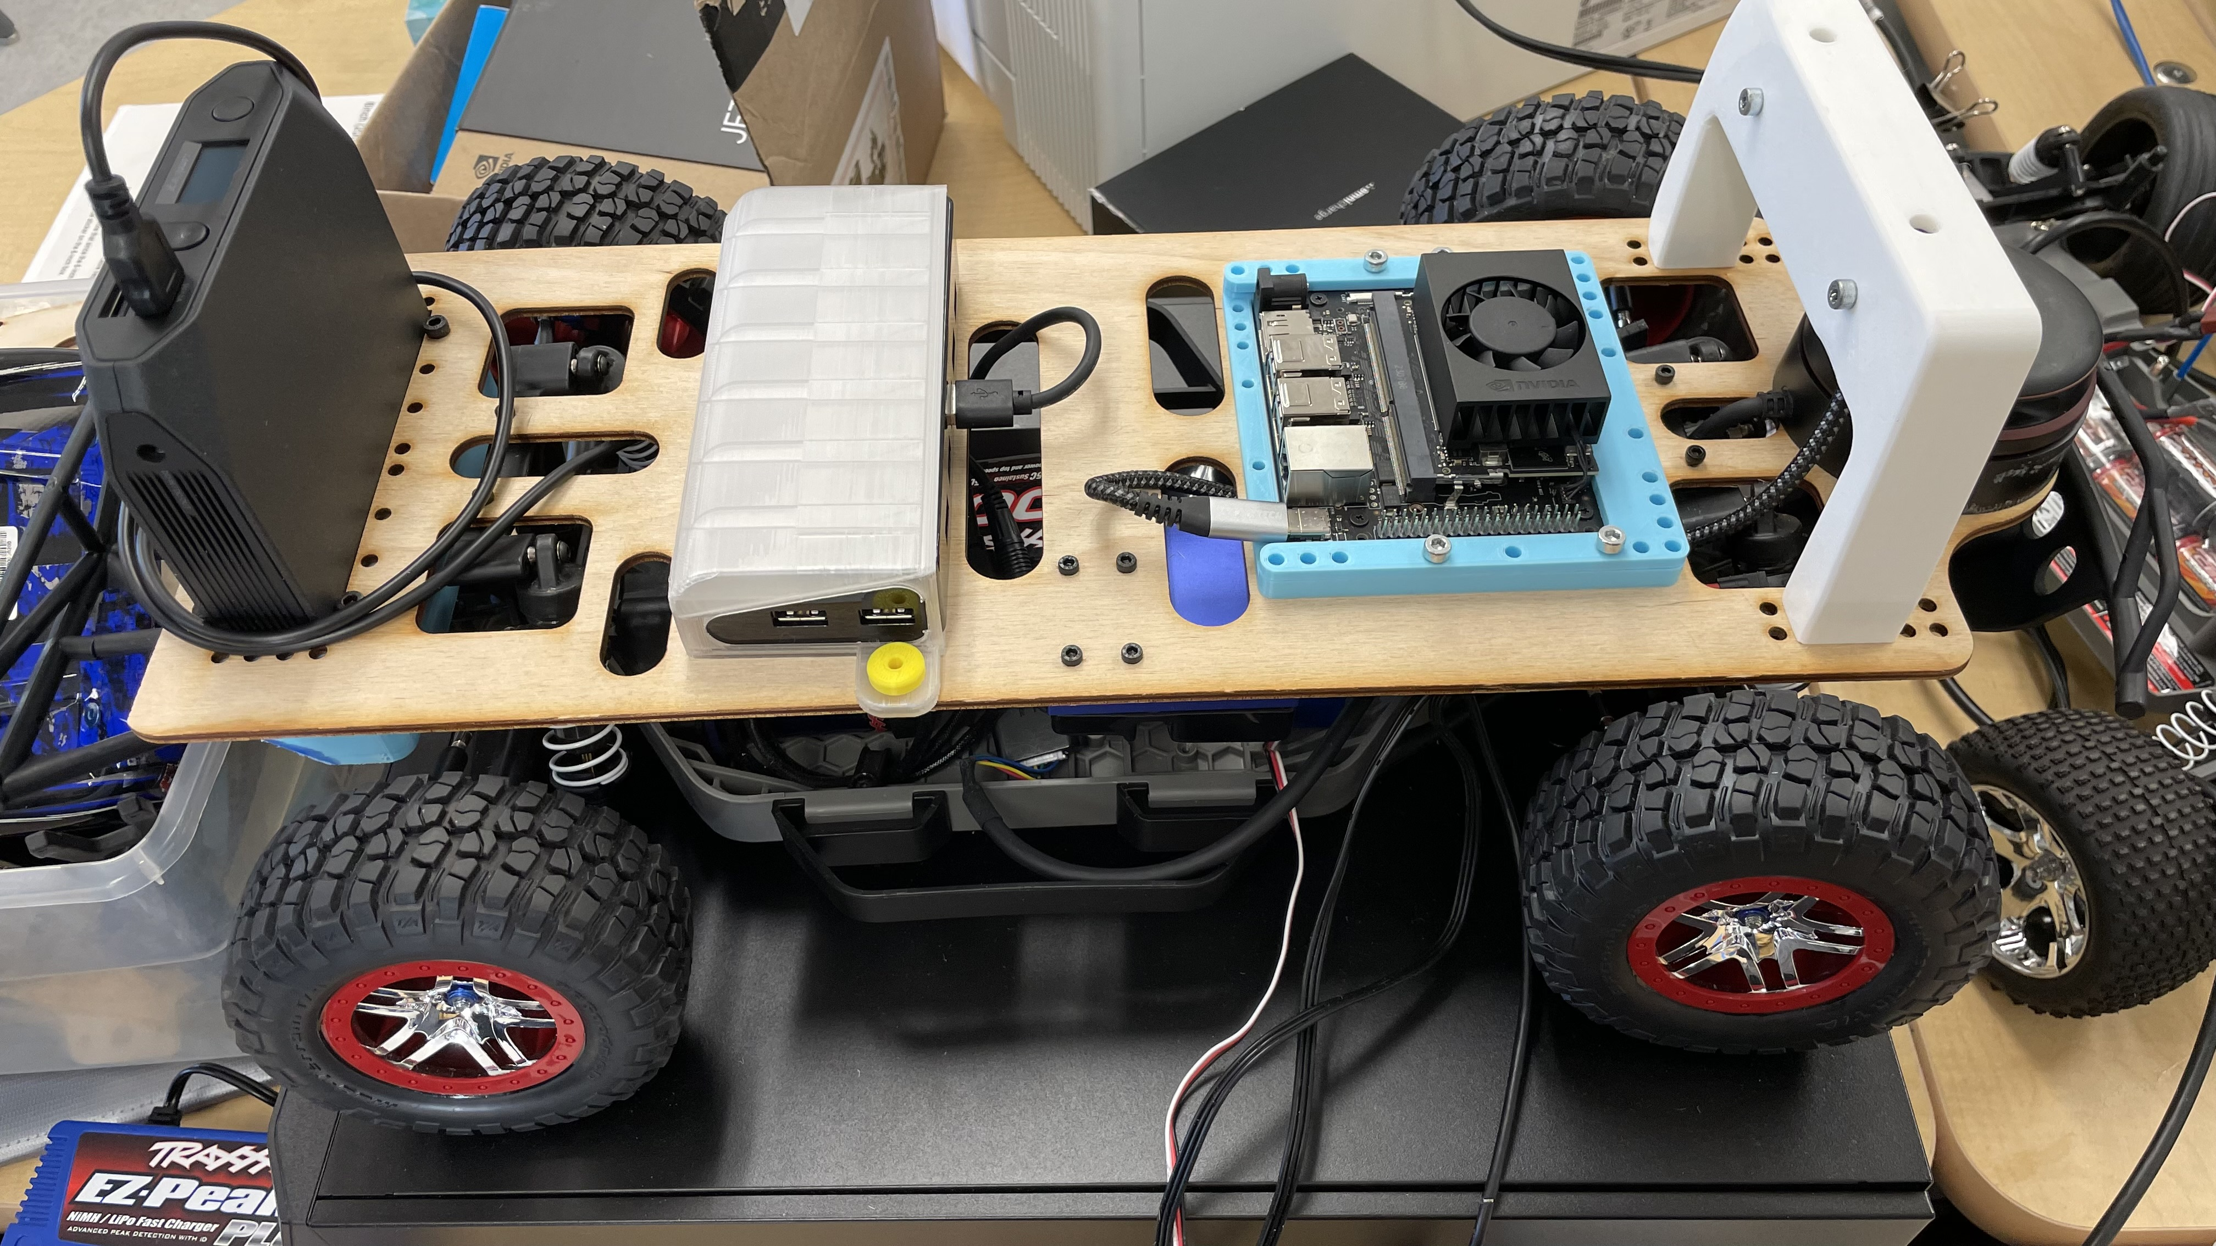

They attached the battery holder, LiDAR, and motor controller to the laser cut platform and started wiring everything together.