**MMC Store**

**Author: Mayur Gajapure**

**Version: 1.0**

Table of Contents

CHAPTER 1: GETTING STARTED

Introduction of Features

Requirement and Installation Process

CHAPTER 2: Login and Registration

Customer Login

Customer Registration

Provider Login

Provider Registration

CHAPTER 3: Customer

Products Listing

Buying Products

Customer Cart

Past Orders

Paying Due Amount of Past Bills

CHAPTER 4: Provider

Provider Products Listing

Adding New Product

Editing Existing Product

Managing Quantity

Order Management

Clients Listing (Paid and Unpaid)

CHAPTER 1: GETTING STARTED

Introduction:

MMC store is software for businesses to easily create and keep track of products, orders and bills. MMC store is designed to integrate easily into most businesses with functionality that aids managing consumer purchasing and provider store.

MMC store keeps track of which bill has been paid and which did not with report to customer as well as provider that can be used for chasing overdue bills.

Features of MMC store:

1. Customer Login

2. Customer Registration

3. Provider Login

4. Provider Registration

5. Customer can purchase products from multiple product providers

6. Customer can view his / her past orders

7. Customer can purchase in advance up to 2 bills

8. Customer can pay bill amount at the time of purchase or hi / she can pay later

9. Provider can add new products to store

10. Provider can update existing product

11. Provider can view his / her customers who purchase his /her products

12. Provider can view customers who did not paid bills.

System Requirement

1. Any microcomputer running Windows XP or later.

2. Up to 300MB of free space on the hard drive.

3. 1GB MB of RAM for XP, 2 GB RAM for later versions.

4. Optional Accessories - any printer for sales slips, a barcode reader.

CHAPTER 2: LOGIN AND REGISTRATION

Customer Login

MMCStore provides customer login where customer is able to login to his / her account. Customer has to provide his / her Username and Password to login to his / her account.

If Username and Password is valid and matched is system then customer can enter into the store else customer needs to create his / her account with the account.

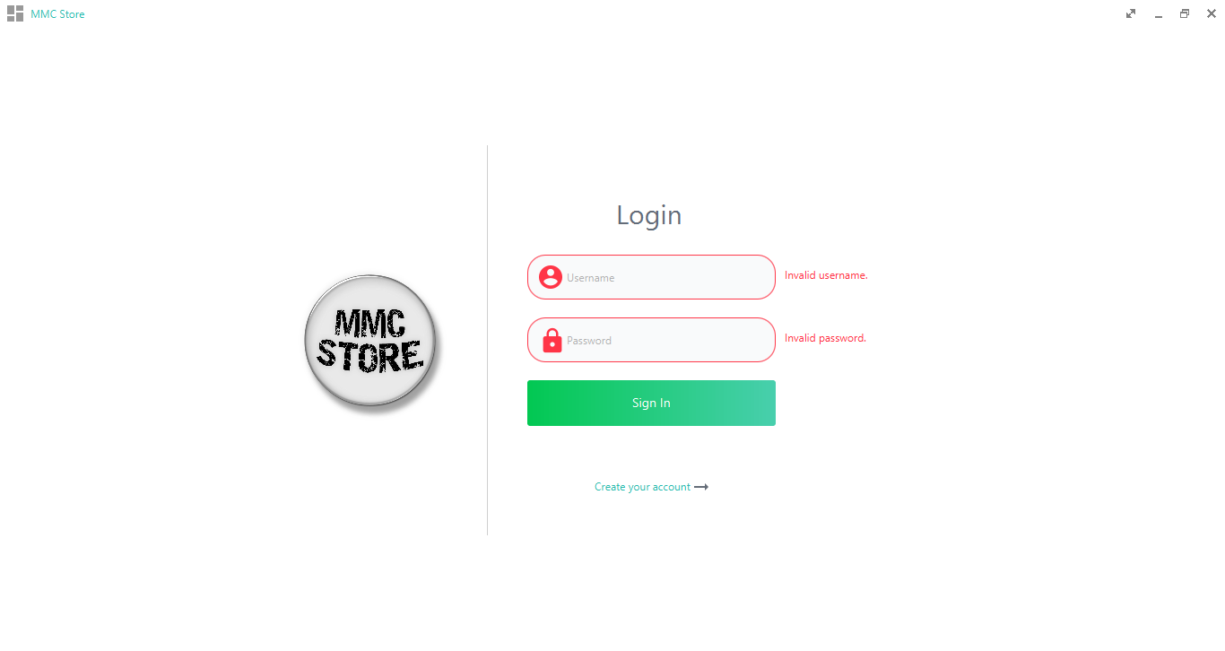

Customer Registration

MMCStore provides customer registration where customer is able to create his / her account in system. Customer has to provide his / her Username, Full name, Email address, Password and its mandatory to select he / she is customer from dropdown. If Username is not found in system then registration is valid else he / she has to provide valid username which is not available in our system. If username is valid and did not matched with other user is system then customer can enter into the store directly.

Screenshot :

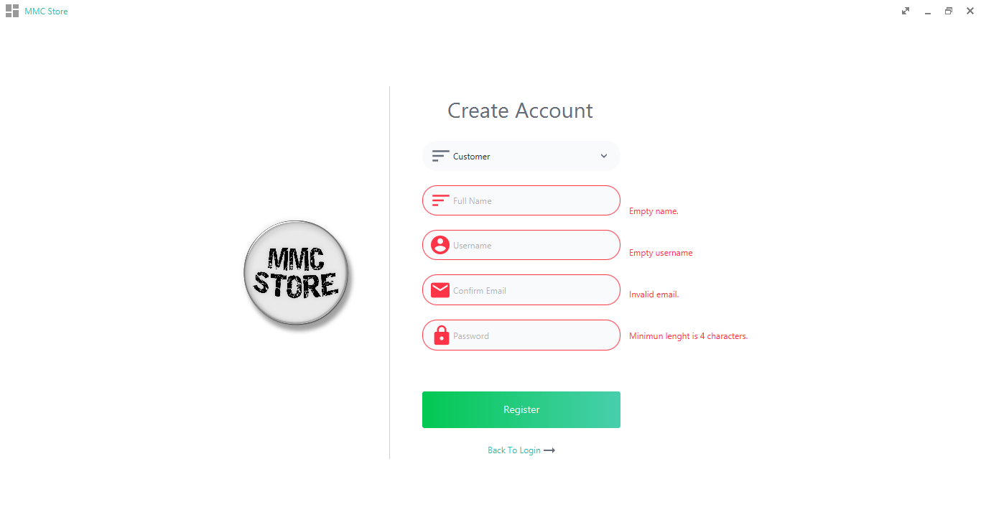

Screenshot for selecting as Customer

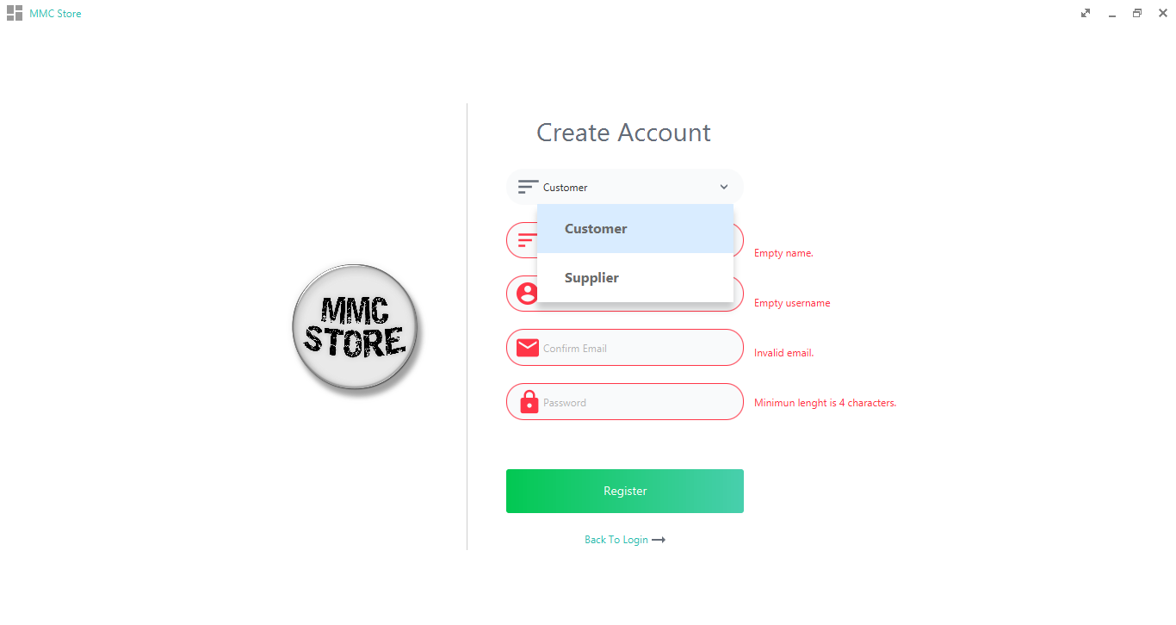

Provider Login

MMCStore provides provider / supplier login where provider is able to login to his / her account. Provider has to provide his / her Username and Password to login to his / her account.

If Username and Password is valid and matched is system then provider can enter into the store else provider needs to create his / her account with the system.



Provider Registration

MMCStore provides provider registration where provider is able to create his / her account in system. Provider has to provide his / her Username, Full name, Email address, Password and its mandatory to select he / she is provider from dropdown. If Username is not found in system then registration is valid else he / she has to provide valid username which is not available in our system. If username is valid and did not matched with other user is system then customer can enter into the store directly.



Chapter 3: Customer

3.1 Product Listing

After login into system customer can view all products from all providers. The screen shot below clearly show the listing of all active producs from all providers. Customer can search any specific product from search bar provided and if product available then the product will show and customer can add that product into his / her cart.

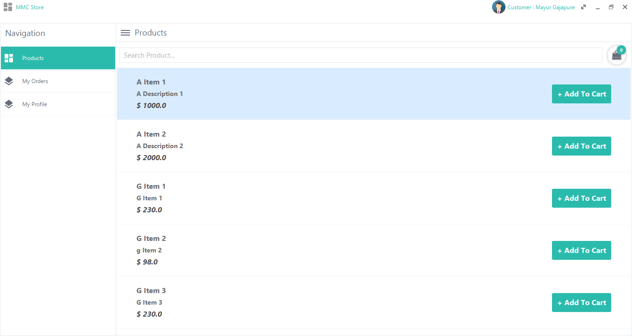

3.2 Buying Product

Customer can add product into cart and the number products he she add to cart will shown on cart icon. Next is customer can add only one quantity at product listing screen if he / she want more quantity then they can increse it from cart dialog. Cart dialog wil show all products customer add to cart and total cart value. Customer can increase quantity of product from here. Customer can remove product from cart as well. And Finally he can procced to buy now.

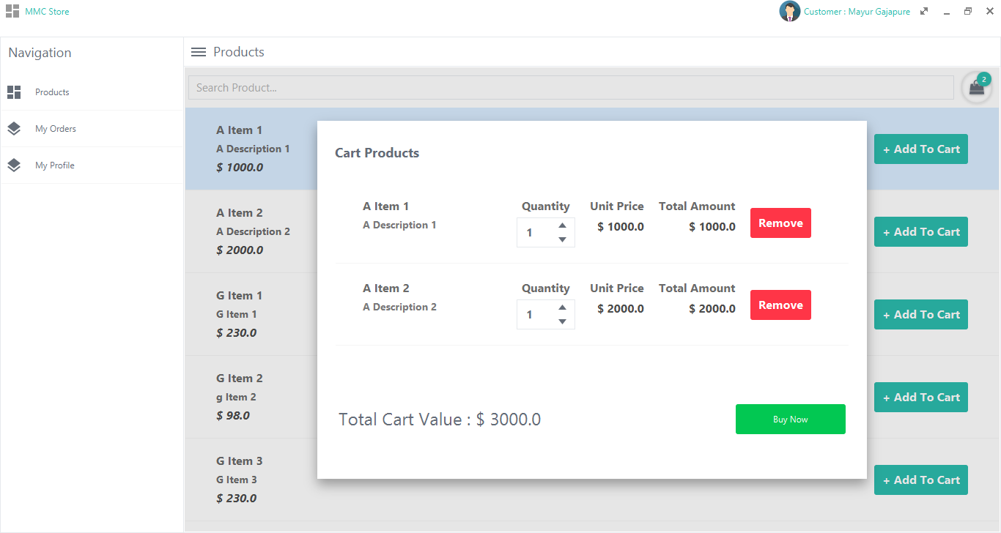

Buying Limit

If cutomer has pending due bills before and total number of due bills are 2 then customer can not place new order and customer will get message on cart dialog to pay previous atlest one bill first and then place new order.

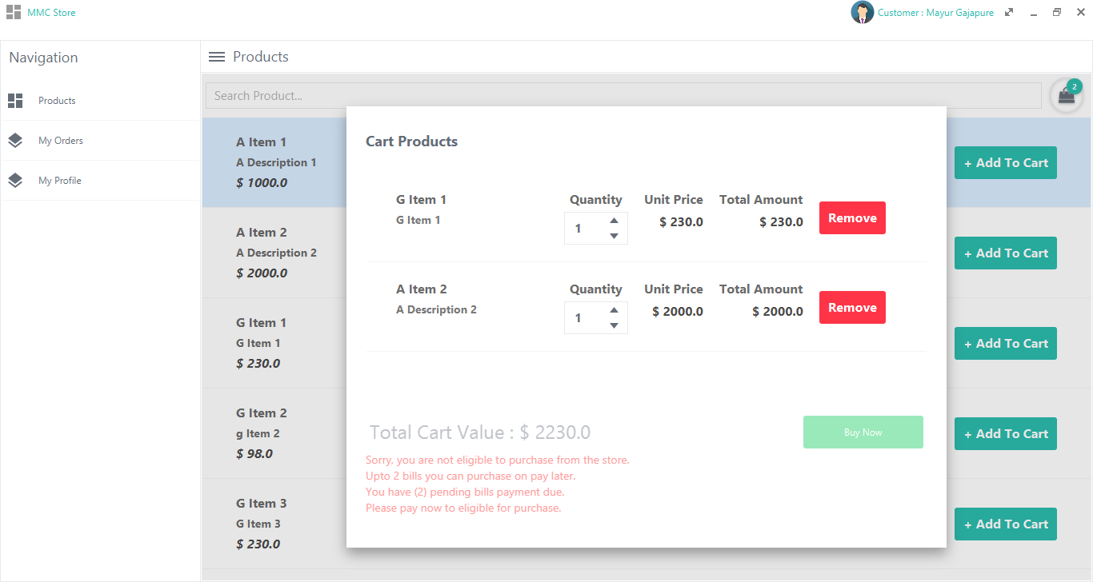

Place Order:

After clicking Buy now button from cart dialog customer will see place order dialog. Here Customer will see Bill to, Billing Address, Total Items Quantity, Total Amount. At Customer can choose Pay Now And Pay Later Option. He / She can select any option selection and can place order. If customer select pay now option then bill will not consider as pending bill else it consider as pending bill.

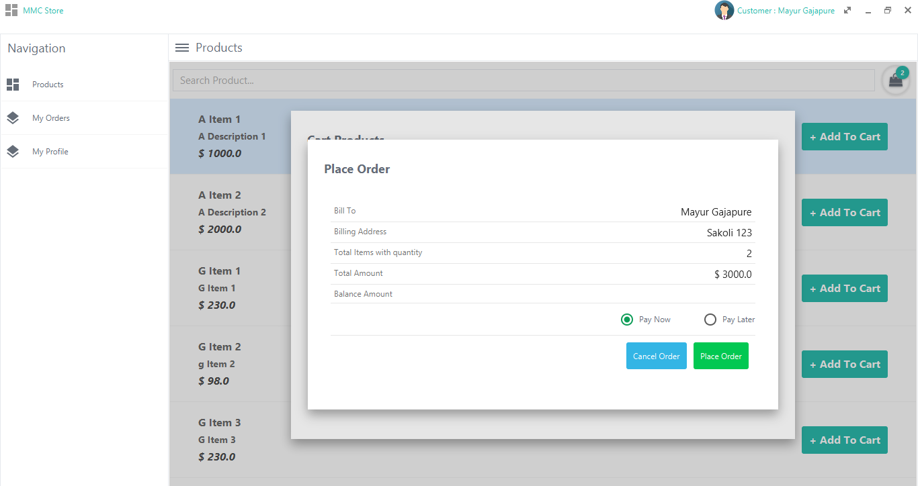

Customer My Profile:

Here on this screen customer can see overview of their all purchase. Customer get dashboard like widget here where customer get information about Total Bills count, Pending Bills count, Pending Amount and Paid Bills count summery.

Just Below dashboard widget customer can see all previous bill he / she purchase with the store. Customer can view bill detail, can view status of bill paid or unpaid, bill amount etc.

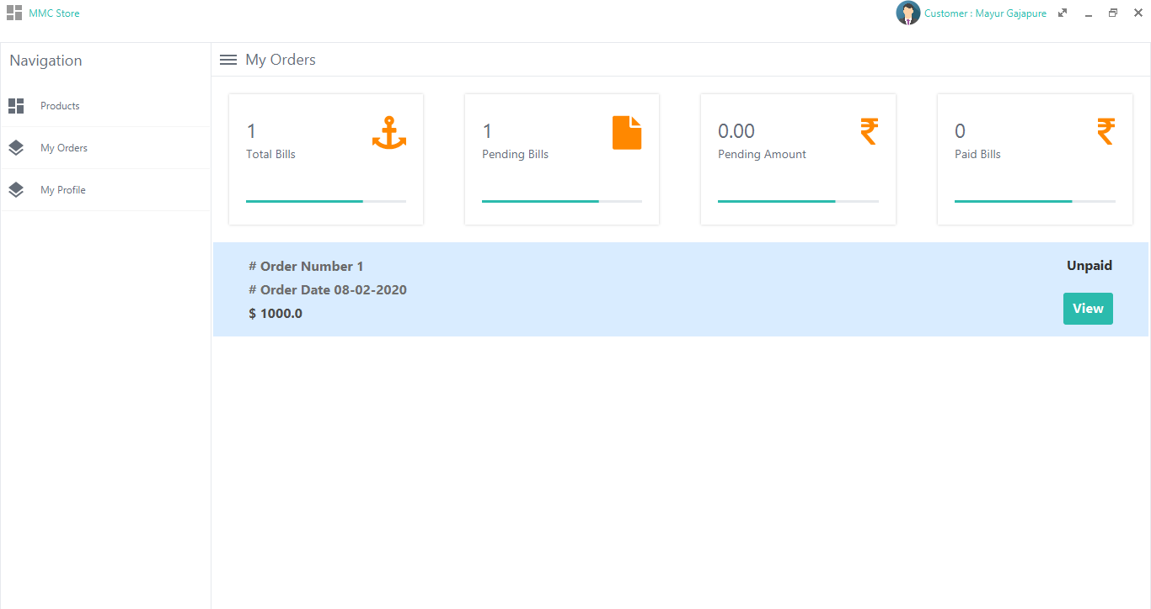

Bill Detail:

On clicking on view button from bill list customer can view its bill detail, all products of that bill and bill amount as well. Here again customer will have option for pay amount if the status of the bill is unpaid.

In this way customer can pay his / her pervious order amount.

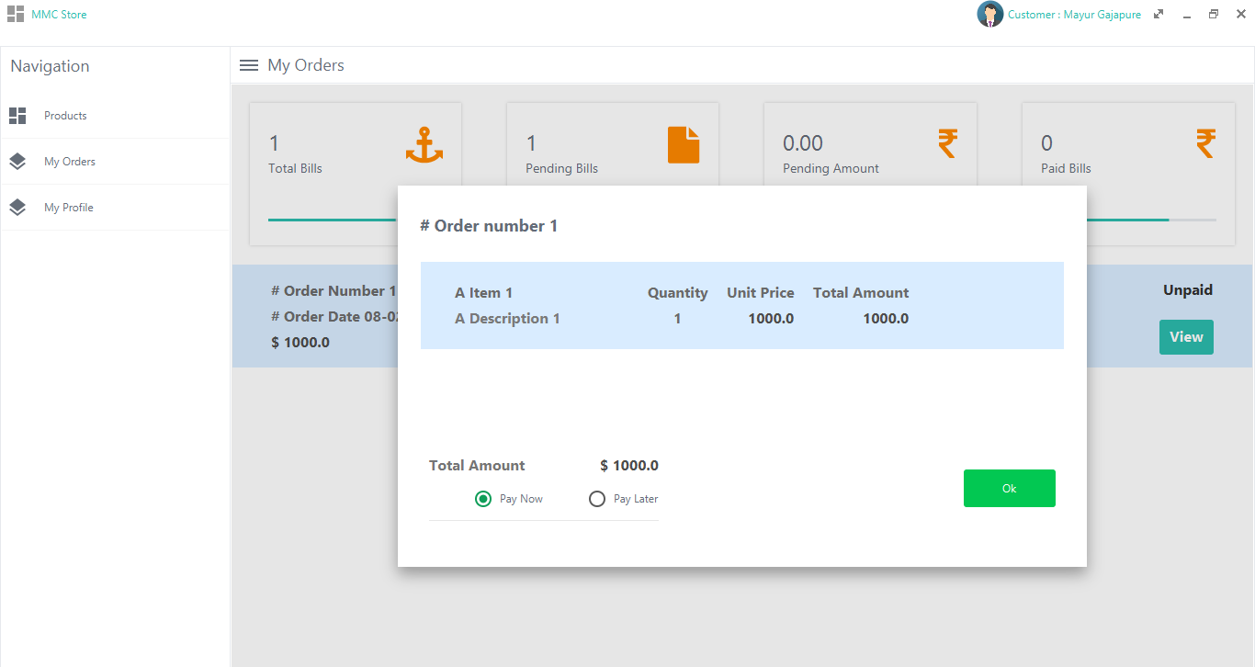

My Profile:

Here on this screen, customer can see his / her profile information like name, address and username.

Customer can change his / her profile information save it into the system.

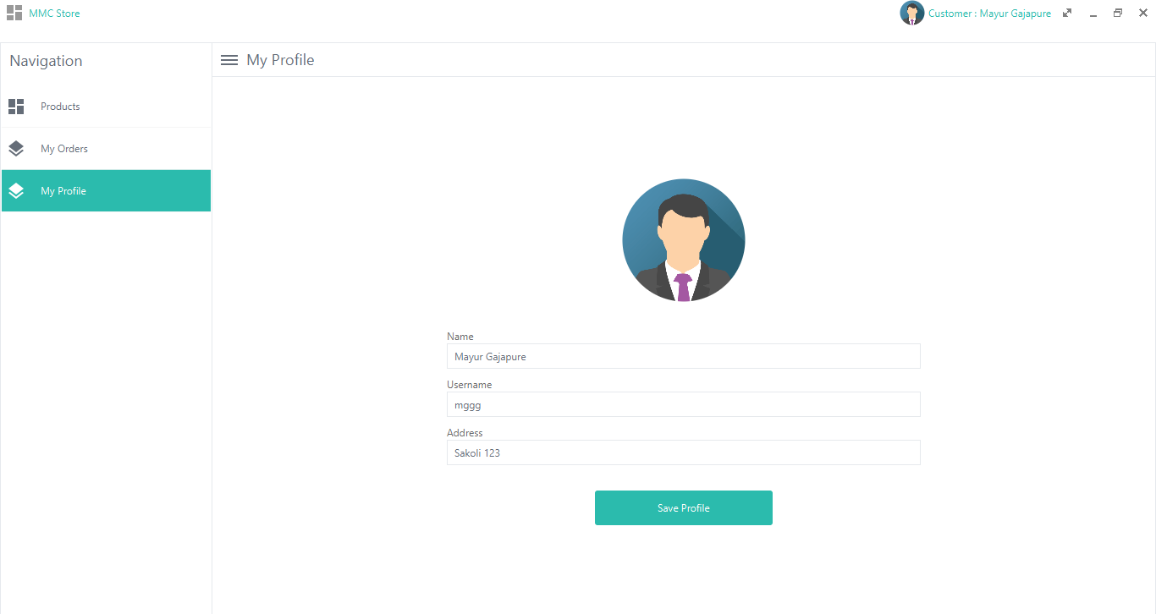

User Popup:

In this section of popup logded user can see his / her membership date and username whos account is logged in. From this popup user can also do sign out.

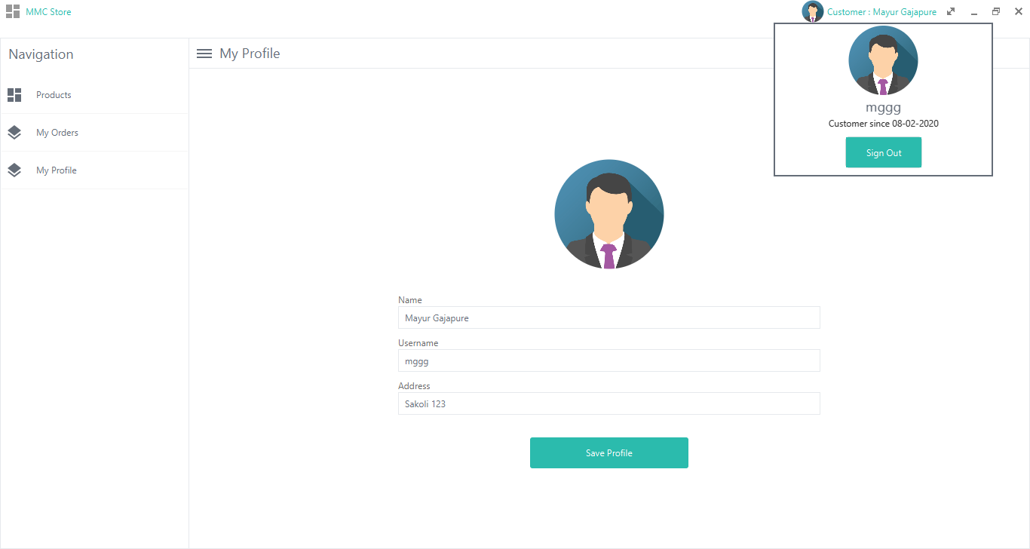

CHAPTER 4 : Provider

My Products:

After login to provider account, provider will first see his / her all products that are register with system. In this screen below, Provider can view all his / her product and detail of product.

Add product action is given in this screen, from where a provider can add new product into the store.

From product listing provider can update product information by clicking on button from indivisual product row.

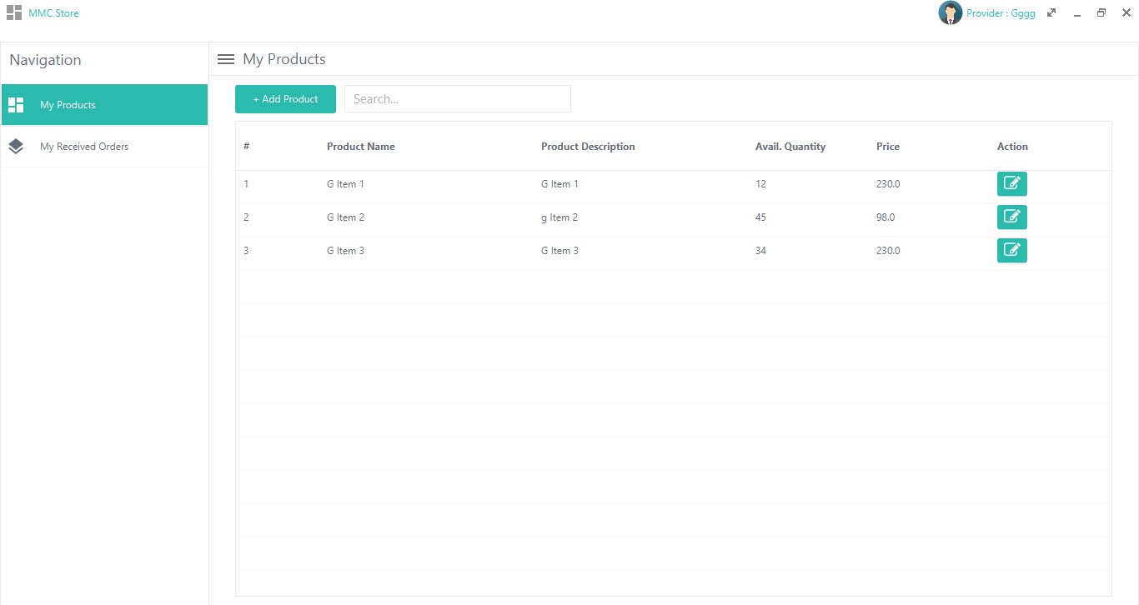

Adding Products:

Provider can add product by clicking Add Product Button and dialog will open to add product. In this dialog provider has to fill information about product like Product name, description of product, avilable quantity and product price. After filling information of product provider has to save the product by clicking on save product button.

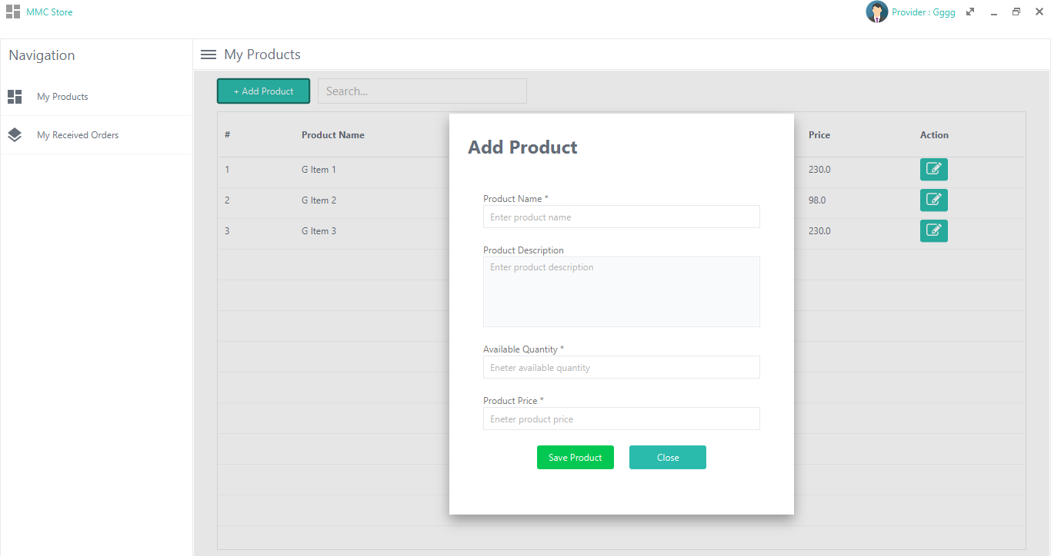

Updating Product:

Provier can update his / her product from from product listing screen. To update a product provider has to click on button available on each product row and update product dialog will open. Here provider will see his product information prefilled and he / she has to only update fields he / she want to update and to update information of product just click on Update Product Button so that product will update in system.

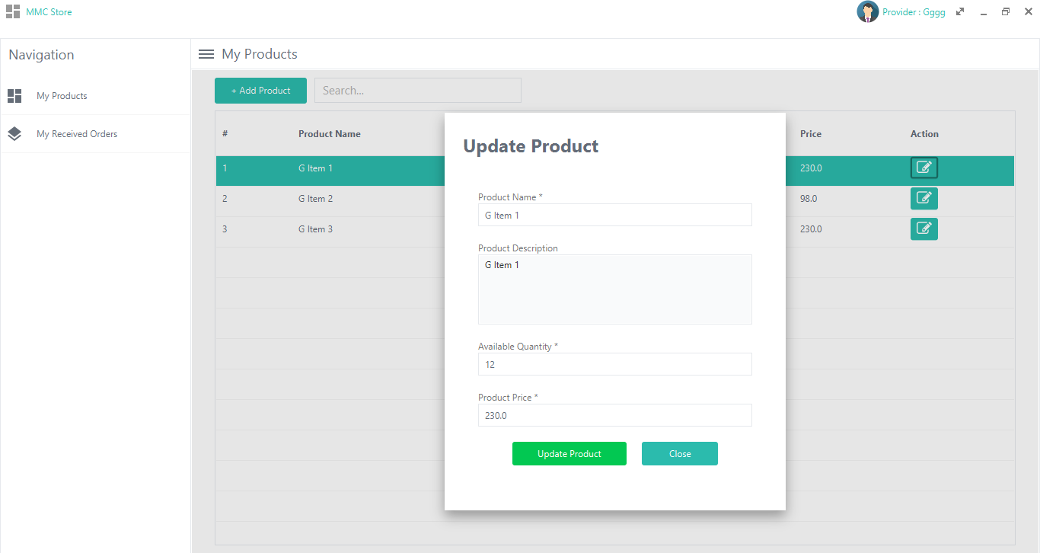

My Received Orders :

Here on this screen a provider will obtain his / her orders from customer who made purchase for the product of the provider.

