Submission Template for ACM Papers*

Insert Your Subtitle Here

First A. Author†

First Department Name, First Institution/University Name, City, State, Country, email@email.com

Second B. Author

Second Department Name, Second Institution/University Name, City, State, Country, email@email.com

* Place the footnote text for the title (if applicable) here.

† Place the footnote text for the author (if applicable) here.

ABSTRACT

This submission template allows authors to submit their papers for review to an ACM Conference or Journal without any output design specifications incorporated at this point in the process. The ACM “Submission Template” is a single column MS-Word document that allows authors to type their content into the pre-existing set of paragraph formatting styles applied to the sample placeholder text here, or copy-and-paste their text and then apply the respective paragraph styles (**Windows**: you can open the Styles task pane from the **Home** tab [it can also be opened with the keyboard shortcut Alt+Ctrl+Shift+S]; **MAC16**: you can access the Styles pane at the right of the **Home** toolbar.) Highlight a section that you want to designate with a certain style, and then select the appropriate style from the list. To view which style is being used in any part of this document, place your cursor on your text and look at the “Current style” field in the Styles pane.

It is beneficial to create your document in draft mode with the style panel open in the left-side panel. If the panel is not immediately visible when the Submission Template is opened, you will need to open the panel manually—for Windows: click on the following from the main ribbon above: File > Options > Advanced > Display > Style area pane width in Draft and Outline views. Set the style area width (1–1.5" is a good starting value.); for MAC: go to the “**View**” menu and select “**Draft**”; then go to the “**Word**” menu and select “**Preferences**” and then “**View**,” under the “**Window**” section insert “1.5” inches under the style area width.

For your reference, below is a list of the paragraph styles to be applied to the respective elements of your text:

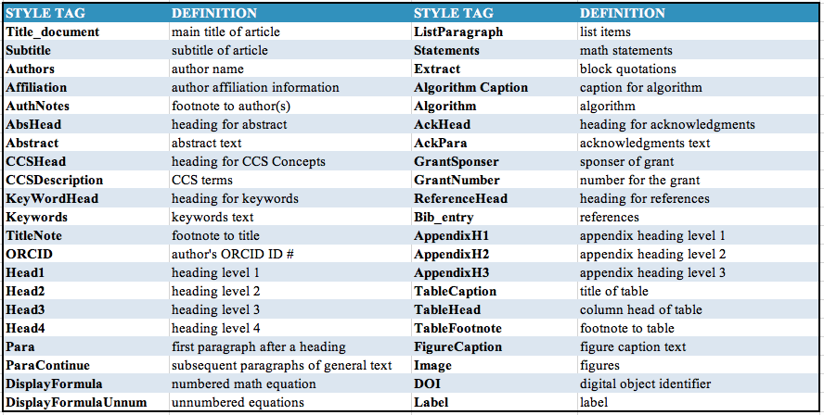

*If a paper is accepted for publication*, authors will be instructed on the next steps: to submit a revised document file after applying the Word version of the ACM Master Article Template to their paper. Building on the work authors have already completed using this “Submission Template,” the ACM Master Article Template will contain macros, functionalities, and validations that need to be applied before a paper can be submitted for publication. Authors must then follow the submission instructions found on their respective publication’s web page. Once your submission is received, your paper will be processed to produce the formatted Word, PDF, and HTML5 output formats, which will be provided to you for review, revision/resubmission (if applicable), and approval.

**CCS CONCEPT insertion**: The new template enables you to import required indexing concepts for your article from the [ACM Computing Classification System (CCS)](http://www.acm.org/publications/class-2012) using an [indexing support tool](http://dl.acm.org/ccs/ccs.cfm?) found in the ACM Digital Library (DL). The tool generates formatted text after you have selected your terms. To insert your CCS terms into your document, copy and paste the formatted text from the CCS tool using the “<https://dl.acm.org/ccs/ccs.cfm>” link into the “CCS CONCEPTS” section.

An additional step is necessary to ensure that the proper CCS terms are added to the Digital Library citation page: from the “view CCS TeX Code” listing, click on “Show the XML Only.” Highlight and copy the XML code from the window. You must insert the XML code into your Word document’s properties: from your Word document, click on “**File**”, then click on the “**Info**” tab on the left-hand side panel, then click “**Properties**” and select “**Show All Properties.**” Click within the “Comments” metadata field and paste the XML data.

CCS CONCEPTS

• Insert your first CCS term here • Insert your second CCS term here • Insert your third CCS term here

KEYWORDS

Insert comma delimited author-supplied keyword list, Keyword number 2, Keyword number 3, Keyword number 4

1. Introduction: About this Template

All style elements are specified in this template to facilitate the production of your paper and to have the styles consistent throughout. The paragraph styles are built-in and examples of the styles are provided throughout this document. *Save as you go and backup your work regularly!*

* 1. More about the submission template

Thissubmission version of your paper should not have headers or footers, Baldassare (2000). It should remain in a one-column format—please do not alter any of the styles or margins.[1]

* + 1. How to apply Display Math.

There are two types of math equations: the numbered display math equation and the un-numbered display math equation. Below are examples of both.[2]

 (1)

The **DisplayFormula** style (above) is applied in the numbered math equation. A numbered display equation always has an equation number (label) on the right.



The **DisplayFormulaUnnum** style (above) is applied only in unnumbered equations. An unnumbered display equation never contains an equation number Bertot and Grimes (2012) on the right—this element distinguishes it from the numbered equation. Please note: the subsequent text after the **DisplayFormula** (numbered equation) or **DisplayFormulaUnnum (unnumbered equation)** must have the paragraph style **ParaContinue** applied.

* + 1. Figures and Tables.

Figure(s) and table(s) are “float elements” which should be inserted after their first text reference, and have specific styles for identification. Insert a figure and apply the “**Image**” paragraph style to it. For the figure caption, apply the style “**FigureCaption.**” Below is an example of a figure and caption with the styles applied.



Figure 1: Figure caption and image above the caption [*in draft mode the image will not appear on the screen.*]

Authors can also insert a (Abdelghaffar, Kamel, and Duquenoy 2010) multi-part figure above a single caption. Every inserted figure must have the “**Image**” style applied. Below are instructions regarding how to insert a multi-part figure in your paper.

1. If the author wants to insert two multi-part images, they must draw a one row and one column table and insert the images one-by-one in the cells.
2. If the author wants to insert three multi-part images, they must draw a one-row and three-column table and insert the images one by one in all three cells.
3. If the author wants to insert four multi-part images, they must draw a two-row and two-column table and insert the images one-by-one in all four cells. (see the following example):

| Figure 2: The layout of multipart images should be as per the above example within the table in image 1. | Figure 2: The layout of multipart images should be as per the above example within the table in image 2. |
| --- | --- |
| Figure 2: The layout of multipart images should be as per the above example within the table in image 3. | Figure 2: The layout of multipart images should be as per the above example within the table in image 4. |

Figure 2: The layout of multipart images should be as per the above example within the table.   
All images must have the “Image” style applied.

The instruction list below describes the required steps authors need to follow in order to insert descriptive text for figures (alt-txt value) in **MS Word 2013 and 2016**:

1. Insert a picture in the document.
2. Right click on the inserted picture and select the **Format Picture** option.
3. In the settings at the right side of the window, click on the “Layout & Properties” icon (3rd option).
4. Expand **Alt Txt** option.
5. In the “Title” and “Description” text boxes, type the text you want to represent the picture, and then click “Close.”

NOTE: For additional information regarding how best to write alt text descriptions and why doing this is so important, please see: <https://www.acm.org/publications/taps/word-template-workflow>.

Below are steps to insert the alt-txt value in **MS Word 2010/2011 for Windows\***:

1. Insert a picture in the document.
2. Right click on the inserted picture and select the **Format Picture** option.
3. Select the **Alt Txt** option from the left-side panel options.
4. In the “Title” and “Description” text boxes, type the text you want to represent the picture, and then click “Close.”

* The Mac 2011 version 14.0.0 and later allows the option for inserting “alt-text.” In the MAC version of Word 2016, right-click on the image and select “Edit Alt Text” from the pop-up menu and then enter the description for the alt text.

Authors can also insert (please see Table 1) tables by using the MS Word option (INSERT ->Table) as Abdelsalam, Reddick, Gamal, and Al-shaar (2013) per the required row and column size. Every table must have a caption (title) and it must have the **“TableCaption**” style applied. Please note that tables **should not** be supplied as image files, but if they are images they must have the “Image” style applied. After a paper is accepted for publication, apply the “table head” style by highlighting the respective row and apply the “**TableHead**” style found in the “Body Element” section of the ACM Master Article Template.

Tables can be very difficult for screen reader users to understand unless they include markup that explicitly defines the relationships between all the parts (i.e.: headers and data cells). *A key to making data tables accessible to screen reader users is to clearly identify column and row headers.* For simple tables, the only step necessary for accessibility is to identify which row contains the column headers. Below are a few steps to help make tables accessible:

1. Select that table’s row, then right-click the row and select “Table Properties”;
2. In the *Table Properties* window, click the *Row* tab and select the box that says “Repeat as header row at the top of each page.”
3. If every row contains the column header, then select “Table Properties” and follow the same process.

Table 1: This is an example of the table caption.

| Table Head | Table Head | Table Head |
| --- | --- | --- |
| Row 1 Column 1 | Row 1 Column 2 | Row 1 Column 3 |
| Row 1 Column 1 | Row 2 Column 2 | Row 2 Column 3a |

a This is example of table footnote.

* 1. How to Set a Figure (Image, Table, etc.) to Span Two Columns

**After your paper has been accepted**, if there is a need for a figure to span both columns in the PDF/print output, please follow the steps below in your document to apply the “Large Float” style to the figure (which will be listed under the “Body Elements” menu after the ACM Master Article Template has been attached to your submission document):

1. Apply both the “Image” and “FigureCaption” styles to the respective figure.
2. After applying both styles, **select both elements** and apply the “Large Float” option found under Body Elements -> Large Float as shown in the following screenshot:

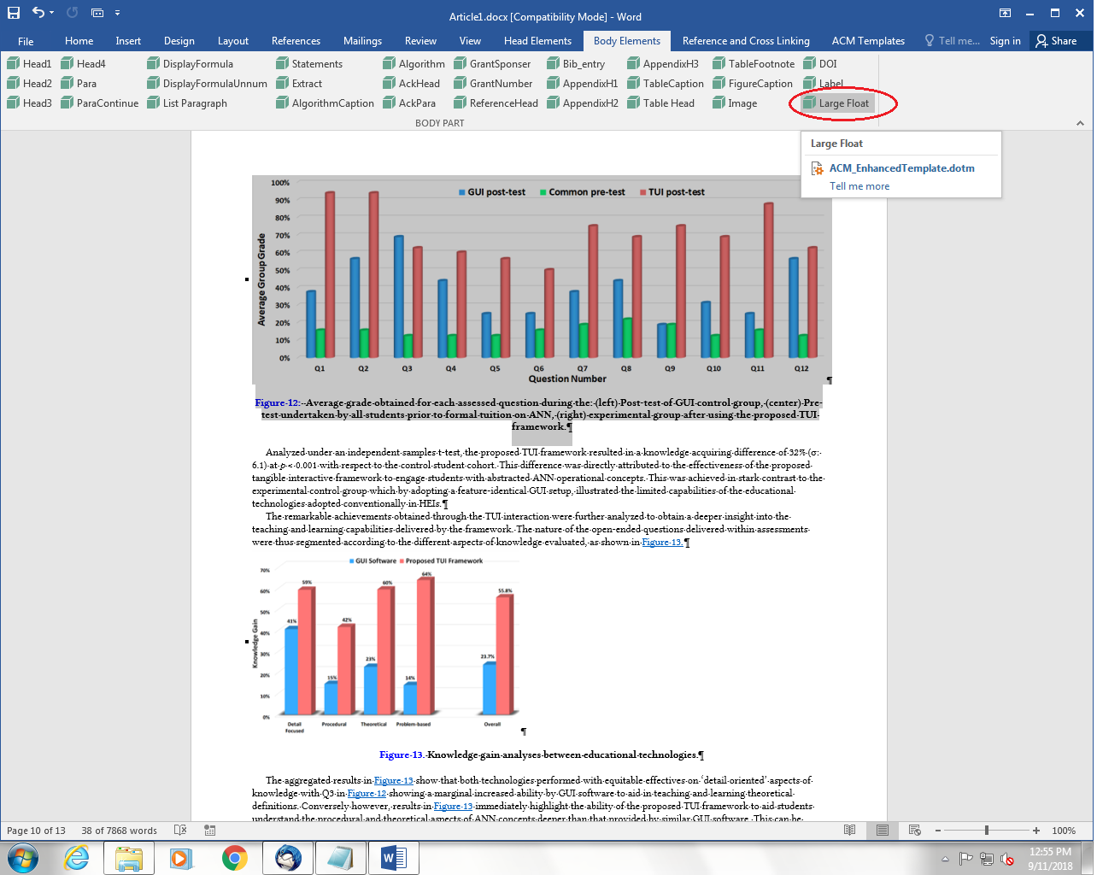

Figure 3: Example of the “Large Float” feature.

After completing these steps, the final layout generated by the production system’s conversion process will be rendered in the PDF/print output version as seen in the screenshot below. ACM recommends that you review the PDF proof of your text to ensure that your figure is properly formatted.

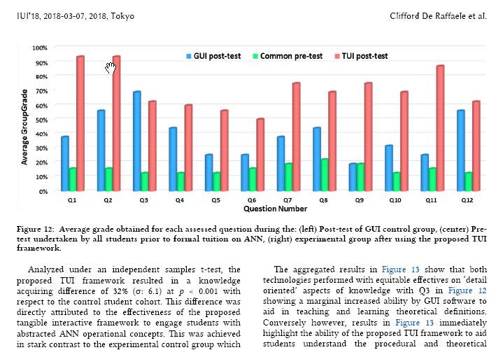

Figure 4: Large figure spanning in both the columns in final version.

* + 1. Formatting math statements and extracts.

**Theorem/Proof/Lemma.** Math statements should have the “**Statement**” style applied. This paragraph is an example of the “**Statement**” style.

“A clip, snippet, passage or extract from a larger work such as a news article, a film, a literary composition or other media is called the extract. An extract is a short passage taken from a text, film, or piece of music.”

.... This is an example of a short Extract which is usually 1-2 lines of text. Please notice the placement of the ellipses and either end of the short extract...

ALGORITHM 1: Iterative Algorithm

current_position center

current_direction up

current_position is inside circle

while current_position is inside circle, do

neighborhood all grid hexes within two hexes from current_position

for each hex in neighborhood, do

for each neuron in hex do

convert neuron_orientation to vector

scale vector by neuron_excitation

vector_sum vector_sum + vector

end

end

normalize vector_sum

end

ACKNOWLEDGMENTS

Acknowledgments are placed before the references. Add information about grants, awards, or other types of funding that you have received to support your research. Author can capture the **grant sponsor information**, by select the grant sponsor text and apply style ‘GrantSponser’. After this, select grant no and apply ‘GrantNumber’ from style panel. Example of Grant sponsor: Competitive Research Programme and example of Grant no: CRP 10-2012-03.

REFERENCES

[1] Patricia S. Abril and Robert Plant. 2007. The patent holder's dilemma: Buy, sell, or troll? *Commun. ACM* 50, 1 (Jan. 2007), 36-44. DOI: https://doi.org/10.1145/1188913.1188915

[2] Sarah Cohen, Werner Nutt, and Yehoshua Sagic. 2007. Deciding equivalences among conjunctive aggregate queries. J. ACM 54, 2, Article 5 (April 2007), 50 pages. DOI: https://doi.org/10.1145/1219092.1219093.

[3] David Kosiur. 2001. *Understanding Policy-Based Networking* (2nd. ed.). Wiley, New York, NY.

[4] Sten Andler. 1979. Predicate path expressions. In *Proceedings of the 6th. ACM SIGACT-SIGPLAN Symposium on Principles of Programming Languages (POPL '79)*. ACM Press, New York, NY, 226-236. DOI: https://doi.org/10.1145/567752.567774.

A  APPENDICES

In the appendix section, three levels of Appendix headings are available.

A.1 General Guidelines

1. Save as you go and backup your file regularly.
2. Do not work on files that are saved in a cloud directory. To avoid problems such as MS Word crashing, please only work on files that are saved locally on your machine.
3. Equations should be created with the built-in Microsoft® Equation Editor included with your version of Word. (Please check the compatibility at <http://tinyurl.com/lzny753> for using MathType.)
4. Please save all files in DOCX format, as the DOC format is only supported for the Mac 2011 version.
5. Tables should be created with Word’s “Insert Table” tool and placed within your document. (Tables created with spaces or tabs will have problems being properly typeset. To ensure your table is published correctly, Word’s table tool must be used.)
6. Do not copy-and-paste elements into the submission document from Excel such as charts and tables.
7. Footnotes should be inserted using Word’s “Insert Footnote” feature.
8. Do not use Word’s “Insert Shape” function to create diagrams, etc.
9. Do not have references appear in a table/cells format as it will produce an error during the layout generation process.
10. MS Word does not consistently allow the original formatting to be modified in the text. In these cases, it is best to copy all the document’s text from the specific file and paste into a new MS Word document and then save it.
11. At times there are font problems such as “odd” stuff/junk characters that appear in the text, usually in the references. This can be caused by a variety of reasons such as copying-and-pasting from another file, file transfers, etc. Please review your text prior to submission to make sure it reads correctly.

A.1.1 Preparing Graphics

* Accepted image file formats: TIFF (.tif), JPEG (.jpg).
* Application files (e.g., Corel Draw, MS Word, MS Excel, PPT, etc.) are NOT recommended.
* Images created in Microsoft Word using text-box, shapes, clip-art are NOT recommended.
* Scalable vector formats (i.e., SVG, EPS and PS) are greatly preferred.
* IMPORTANT: All fonts must be embedded in your figure files.
* Set the correct orientation for each graphics file.

1. Instructions for inserting the footnotes in **Windows and Mac16 platform**: Place the cursor in text where the footnote mark should be located, go to “References” tab, select “Insert Footnote” and enter the footnote text. Return to your place in the document by double-clicking on the footnote marker at the beginning of the note.
2. Instructions for inserting the footnotes in **Mac11 platform**: Click at the end of the word where you want to insert the footnote. Click on the Insert menu. Now click on Footnotes. Microsoft Word shifts the document to the footnote area. Insert the footnote text in the provided pane.