Template v**ersion: 1.0.1**

PuzzlesCloud Website

Think Green. No paper prints anymore

Online Documentation

PuzzlesCloud Team

<https://puzzlescloud.com/>

**Document ID: 00001**

**Version: 1.0**

**Release Date: 25.11.2020**

Intellectual Property Rights

This document is exclusive property of PuzzlesCloud.com and its content is published documentation of the docs website: <https://puzzlescloud.com/docs/>.

**Table of Content**

1 Blog 3

1.1 Why docs-as-code? 3

1.1.1 Introduction 3

1.1.2 Docs-as-code for Online Docs and Blogs 3

1.1.3 Docx-as-code for Offline Docs 4

1.1.4 Benefits of docs-as-code using Git 4

1.1.5 Conclusion 5

2 Docs 6

2.1 Welcome to Docs 6

2.2 Use Cases 6

2.2.1 UC1 Work in GIT and Produce DOCX & PDF 6

2.2.2 UC2 Make Your Website Docs Available Offline 8

2.2.3 UC3 Work in our App and Publish Docs in GIT 10

2.3 Integrations with other Apps 12

2.3.1 Integration with Git Repositories 12

2.3.2 CopyIntegration with OAuth Providers 12

2.4 FAQ 13

2.5 Policies 13

2.5.1 Terms and Conditions 13

2.5.2 Privacy Policy 18

**Table of Figures**

Figure 1: work-in-git-produce-docx-pdf 7

Figure 2: make-website-docs-available-offline 9

Figure 3: work-in-our-app-and-publish-in-git 11

Figure 4: integrations 12

**Table of Tables**

**No table of figures entries found.**

# Blog

## Why docs-as-code?

### Introduction

Documentation as Code Concept (docs-as-code) is getting more into the focus. Considering that many organizations, even outside of IT, are moving to Agile and DevOps ways of operation and docs-as-code concept natively supports it, it is completely natural that is getting so much attention.

Documentation as Code (docs-as-code) refers to a philosophy of writing documentation with the same tools as code. The most popular tool nowadays for writing, developing and maintaining code is Git version control system. Git in combination with MarkDown (you probably wrote a lot README.md files) is most convenient for docs-as-code as well. Documentation written this way is called source and represents single source of truth. In other words, can be converted to any other form, namely HTML, PDF, DOCX, or any other needed. This conversion is usually happening with CI/CD pipelines, therefore automatically. Considering previous conversion use cases, we could divide the concept into two areas:

* Docs-as-code for online documentation (generated static HTML pages out of the source files)
* Docs-as-code for offline docs delivery(generated PDF, DOCX or any other documents)

### Docs-as-code for Online Docs and Blogs

The technical concept of having static content in Git and out of it create static websites (docs, blogs) is supported by Static Site Generators and is called Jamstack. With this concept all documentation is kept as the source files, in one of the lightweight markup languages, such as MarkDown, asciidoc or similar formats. Those files are converted by some of the Static Site Generators to HTML pages, or other formats (e.g PDF)

Even writing blogs could be conducted with the same approach.

This approach could be further enriched by embedding feedback to the HTML documentation by using native Git features, such as issue tracker, comments etc.

The trend in the last couple of years is to create docs websites (docs.example.com), on some platform that natively supports it: GitHub or GitLab with Pages service.

Some examples of the most popular Open Source Static Site Generators (SSG) are: Jekyll (supported by GitHub and GitLab), Hugo, Next, Gatsby (supported by GitLab only). The full list of available SSGs on the market could be found on the following link: <https://jamstack.org/generators/>.

There are also corresponding Headless CMSs used for the content management. There are Git and API based and both have its own advantages.  
The list of available Headlass CMSs can be found on the following link: <https://jamstack.org/headless-cms/>

Nice examples of how Microsoft, GitHub or GitLab have done it could be found on the following links:

1. <https://docs.microsoft.com/en-us/teamblog/a-new-feedback-system-is-coming-to-docs>
2. <https://github.com/github/docs>
3. <https://gitlab.com/gitlab-org/gitlab-docs>

### Docx-as-code for Offline Docs

DevOps and Agile teams develop also a lot of documentation. Some examples are:

* API documentation
* Internal Knowledge Bases
* Internal Operational Procedures
* Design and Architecture Documents etc

Very often they need to work with Tech Writers, Product Teams and Marketers to deliver professional documentation to their end customers. There the problems starts. There are no common tools where all feel comfortable. One side uses Git and Markdown (DevOps and Agile team members) and the other mainly Word/DOCX (Tech Writers,Product Teams and Marketers).

The answer would be docx-as-code. They all work in Git on the source files and Marketers could change DOCX templates on regular basis. All would have available very professional documents for external deliverables continuously delivered, as part of the CI/CD automation process. Examples of the documents that could be delivered this way are the following:

* Design Documents
* User Guides
* Product docs
* API docs
* Code tutorials
* Operational Guides
* Technical Specifications

The list is of course not exhaustive, could be many more.

Source documents mentioned in the previous paragraph for Online documentation could also be re-used for this purpose.

### Benefits of docs-as-code using Git

If you ever used Git, you would know what kind of benefits it brings with its native features. For the documentation writing, it would bring the following benefits:

* Forget about document re-formatting. All documents are written in simple MarkDown format, which doesn't have great variety of formats/styles supported
* Allow seamless documentation writing collaboration with possibility to work in offline mode (locally on your PC)
* Native review/approval workflow through branching and pull/merge requests
* Simple documentation issue reporting and tracking
* Keep track of every single documentation line in version control system
* Check the diffs historically and understand changes between two document versions
* Native documentation release management (possible also to take continuous publishing approach)
* Tag the documents exported to your customer while keep working on them continuously
* Someone deleted your document – no problem, restore it from the previous Git version
* Test the documentation and get error free docs

The last mentioned great advantage of using docs-as-code approach is documentation testing possibility (executed during CI/CD pipeline run), which will provide error free documents (functional hyperlinks, correct URL references, correct formatting, great look etc.)

The intention is that Technical Writers, Developers, Product Teams and all others involved in docs production process use the same tool set and collaborate in same environment. This approach would boost productivity drastically.

### Conclusion

Unblock your productivity and efficiency progress and start practicing docs-as-code now. If you improve your productivity every month 2%, year over year will be 1/4. Think about it.

**For further reading we would recommend the following references:**

1. <https://technology.blog.gov.uk/2017/08/25/why-we-use-a-docs-as-code-approach-for-technical-documentation/>
2. <https://docs.microsoft.com/en-us/teamblog/a-new-feedback-system-is-coming-to-docs>
3. <https://www.writethedocs.org/guide/docs-as-code/>
4. <https://docs-as-co.de/>
5. <https://idratherbewriting.com/docs-as-code-tools-and-workflows/#/1>

# Docs

## Welcome to Docs

Here you can access complete documentation for PuzzlesCloud, explanation of the Use Cases covered, User Guides, Frequently Asked Questions and many more…

Download our docs website content as [.pdf](https://puzzlescloud.com/assets/puzzlescloud/puzzlescloud.pdf) or [.docx](https://puzzlescloud.com/assets/puzzlescloud/puzzlescloud.docx)

## Use Cases

In this section we cover our Application Use Cases, for Developers, DevOps/Agile/Product Teams, Tech Writers and Marketers.

Here are the articles in this section:

### UC1 Work in GIT and Produce DOCX & PDF

* Do you work in Git?
* Do you like current DOCX editors?
* Do you need to produce high quality DOCX?

If answers are: **yes, no, yes** respectively, you are at the right place.

In this section we will explain the workflow on how you can work in Git and still produce high quality DOCX and PDF using our solution (very convenient for DevOps and Agile teams). This concept is known as docs-as-code, or we like to call it docx-as-code. The workflow is outlined in the following UML diagram:

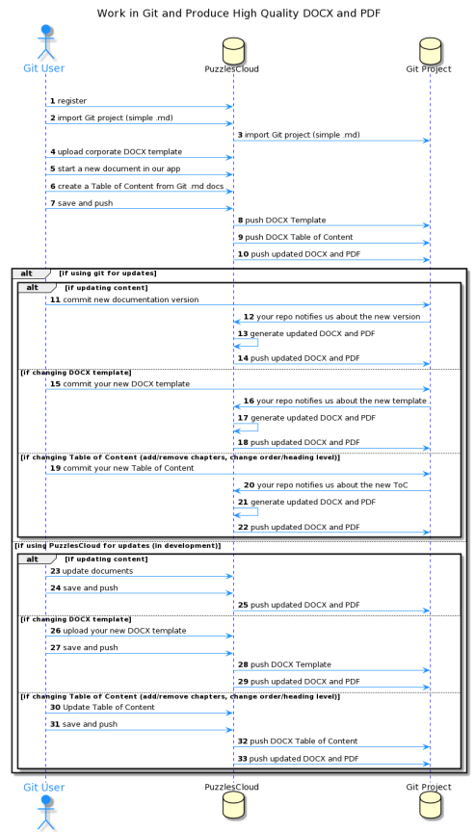

Figure 1: work-in-git-produce-docx-pdf

1. Register (if not already done) and login to our application
2. Import a Git project where you have MarkDown based documentation.
3. Our application will connect to your repo and import it.
4. Upload your DOCX corporate template. For more details how to do it please check [Create docx Template](create-docx-template).
5. Start a new doc in our application.
6. Create manually the structure (Table of Content) of the new document, based on MarkDown docs in your Git repo.
7. Save your new doc in our application and push it to your Git repo.
8. Our App will push to your Git project uploaded DOCX template.
9. Our App will push to your Git project created DOCX structure (Table of Content).
10. Our App will push to your Git project new updated DOCX and PDF documents.
11. **[If Updating the Content]** You can update the content and commit the change to your repo.
12. Your repo through webhook service will notify our App about the change.
13. Our App will generate updated DOCX and PDF.
14. Our App will push to your Git project new updated DOCX and PDF documents.
15. **[If Changing DOCX Template]** You can update the DOCX Template and commit the change to your repo.
16. Your repo through webhook service will notify our App about the new Template.
17. Our App will generate updated DOCX and PDF.
18. Our App will push to your Git project new updated DOCX and PDF documents.
19. **[If Changing Table of Content]** You can update the Table of Content and commit the change to your repo. There are different possibilities: add/remove chapters/ .md docs, change order/heading level
20. Your repo through webhook service will notify our App about the new Table of Content.
21. Our App will generate updated DOCX and PDF.
22. Our App will push to your Git project new updated DOCX and PDF documents.

**If using PuzzlesCloud for Updates**

This option is still in development, coming soon.

### UC2 Make Your Website Docs Available Offline

* Do you use some of the Jamstack Static Site Generators (SSG) - Jekyll, Hugo, Next.js, Gatsby etc?
* Do you you think is cool to make your wesite content available offline?

If answers are: **yes, yes** respectively, you are at the right place.

In this section we will explain the workflow on how you can keep using your favorite SSG and still make your website content available offline. The workflow is outlined in the following UML diagram:

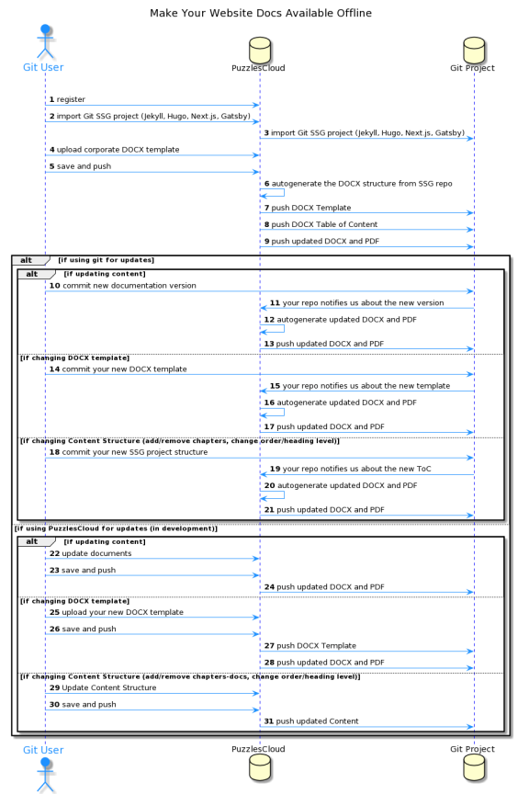

Figure 2: make-website-docs-available-offline

1. Register (if not already done) and login to our application
2. Import a Git project where you have MarkDown based documentation.
3. Our application will connect to your repo and import it.
4. Upload your DOCX corporate template. For more details how to do it please check [Create DOCX Template](create-docx-template.html).
5. Save your new doc in our application and push it to your Git repo.
6. Our App will autogenerate the DOCX structure from the SSG repo
7. Our App will push to your Git project uploaded DOCX template.
8. Our App will push to your Git project created DOCX structure (Table of Content).
9. Our App will push to your Git project new updated DOCX and PDF documents.
10. **[If Using Git for Updates][If Updating the Content]** You can update the content and commit the change to your repo.
11. Your repo through webhook service will notify our App about the change.
12. Our App will autogenerate updated DOCX and PDF.
13. Our App will push to your Git project new updated DOCX and PDF documents.
14. **[If Changing DOCX Template]** You can update the DOCX Template and commit the change to your repo.
15. Your repo through webhook service will notify our App about the new Template.
16. Our App will autogenerate updated DOCX and PDF.
17. Our App will push to your Git project new updated DOCX and PDF documents.
18. **[If Changing Table of Content]** You can update the Content structure and commit the change to your repo. There are different possibilities: add/remove chapters/ .md docs, change order/heading level
19. Your repo through webhook service will notify our App about the new Table of Content.
20. Our App will autogenerate updated DOCX and PDF.
21. Our App will push to your Git project new updated DOCX and PDF documents.

**If using PuzzlesCloud for Updates**

This option is still in development, coming soon.

### UC3 Work in our App and Publish Docs in GIT

In this section we will explain the workflow on how you can work in our Webapp and publish docs in Git. The workflow is outlined in the following UML diagram:

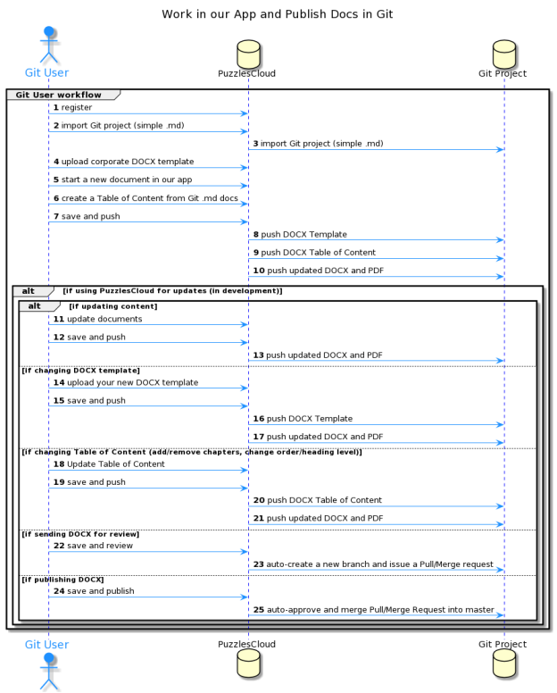

Figure 3: work-in-our-app-and-publish-in-git

## Integrations with other Apps

We do support integrations with other popular Apps. Check out the details below.

On the following Figure, are outlined integration capabilities with the other apps:

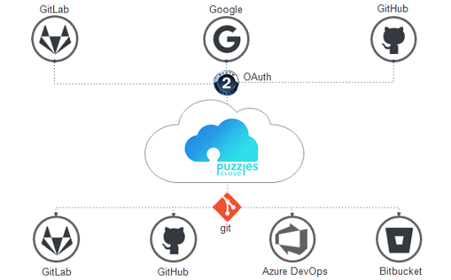

Figure 4: integrations

### Integration with Git Repositories

In order to import one of your projects to our App, you would need to keep your cool projects in one of the supported Git service providers.

Currently we support the following Git providers:

1. GitHub
2. GitLab
3. Azure DevOps
4. Atlassian (Bitbucket)

But no worries, we are working hard to support the others as well. Stay tuned.

### Integration with OAuth Providers

We want your user experience on the top level. You don’t need to remember many passwords any more. It is enough to register and login with one of the supported authentication providers.

Currently we support the following OAuth providers:

1. Google
2. GitHub
3. GitLab

## FAQ

In this section you’ll find commonly asked questions regarding our application. It is work in progress, stay tuned.

## Policies

In this section we cover our Policies, what are the terms under which you can use the App, how we handle your data and many more.

Here are the articles in this section:

### Terms and Conditions

**Effective:** 24.11.2020

Welcome to the PuzzlesCloud website (“the Site”, ”the Website”). Through the Site, you have access to the Software as a Service (“the Service”) offering.  
Please read these Terms of Service carefully before accessing or using our website. By accessing or using any part of the site, you agree to be bound by these Terms of Service. If you do not agree to all the terms and conditions of this agreement, then you may not access the website or use any services. If these Terms of Service are considered an offer, acceptance is expressly limited to these Terms of Service.  
Please note that you retain all rights and ownership you have in your content that you make available through the Services.  
If you do not wish to be bound by these Terms and Conditions then you may not use our Website, however you can contact us to discuss your constraints.

#### Reservation of Rights

The Site and Content provided on or through the Site are the intellectual property and copyrighted works of PuzzlesCloud or a third party provider. All rights, title and interest not expressly granted with respect to the Site and Content provided on or through the Site are reserved.

#### About PuzzlesCloud

PuzzlesCloud is a trading name of PuzzlesCloud Team operating under the laws of Serbia.

#### Registration for the Service

Our Services requires you to open an account. You must complete the registration process by providing us with current, complete and accurate information as required by the applicable registration form. User who is opening an Account on behalf of some company, must be entitled to represent that company. By opening an PuzzlesCloud Account User commits to us that action does not violate any laws or regulations applicable to him. You will be required to choose a password. Access to and use of password protected or secured areas of the Site are restricted to authorized users only. You agree not to share your password(s), account information, or access to the Site with any other person. You are responsible for maintaining the confidentiality of password(s) and account information, and all activities that occur through the use of your password(s) or account(s) or as a result of your access to the Site. You agree to notify PuzzlesCloud immediately of any use of your password(s) or account(s) that you did not authorize or that is not authorized by these Terms and Conditions.

#### Use of the Service

Subject to your compliance with these terms and the law, you may access and use the Services.  
PuzzlesCloud remains the sole owner of all right, title, and interest in the Services and Software. We reserve all rights not granted under these terms.  
Our Service provides storage, we recommend that you backup your generated documents regularly. We may create reasonable technical limits on your content, such as limits on file size, storage space, processing capacity, and other technical limits.  
Users can communicate with us and submit suggestions, ideas, comments, feedbacks, questions or any other information as long as the content is not illegal, obscene, threatening, invasive of privacy, infringing of intellectual property rights, or otherwise injurious to third parties or objectionable and does not consist of or contain software viruses, political campaigning, commercial solicitation, chain letters, mass mailings, or any other form of “spam”.

#### Our Packages

We are offering the packages described under the following link: <https://puzzlescloud.com/pricing/>

#### Customer Support Service

We strive to provide excellence in our services, however without special Service Level Agreement contract, customers will be served without any service level guarantees.

The best and the fastest way to open a customer service or technical support ticket through the Application Dashboard page or drop us an email: **support@puzzlescloud.com**.

#### Invoicing and Service Payment

Invoices will be sent out once a month or year depending on plan type. Payment deadline is 10 days after customer has been invoiced.

#### Your Content

Our Service allows you to upload, store and generate content. You retain ownership of any intellectual property rights that you hold in that content. In short, what belongs to you stays yours.  
Our systems may analyze your content (if you configure this option) in course of providing you relevant application features (such as content search results). We don’t use analysis outcome of your content for any other purposes except providing application functionalities.  
We do not monitor or control what your account users do with your content. You are responsible for determining the limitations that are placed on your content and for applying the appropriate level of access to your content. If you do not choose the access level to apply to your content, the system may default to its most permissive setting. It’s your responsibility to let other users know how your content may be shared and adjust the setting related to accessing or sharing of your content.  
You can find more information about how PuzzlesCloud uses, stores and secures the Content in the privacy policy.

#### Prohibited Actions

The PuzzlesCloud community often consists of users who expect a certain degree of courtesy and professionalism. You must use the Services responsibly.  
You agree not to access or use the Site in any manner that could damage, disable, overburden, or impair any PuzzlesCloud accounts, computer systems or networks. You agree not to attempt to gain unauthorized access to any parts of the Site or any PuzzlesCloud accounts, computer systems or networks. You agree not to interfere or attempt to interfere with the proper working of the Site or any PuzzlesCloud accounts, computer systems or networks. You agree not to use any robot, spider, scraper or other automated means to access the Site or any PuzzlesCloud accounts, computer systems or networks without PuzzlesCloud express written permission.  
You must not misuse the Services, Software, or content that we provide to you as part of the Services. For example, you must not:

1. Copy, modify, host, stream, sublicense, or resell the Services, or content;
2. Enable or allow others to use the Service, or content using your account information;
3. Use the content or Software included in the Services to construct any kind of database;
4. Access or attempt to access the Services by any means other than the interface we provided or authorized;
5. Circumvent any access or use restrictions put into place to prevent certain uses of the Services;
6. Share content or engage in behavior that violates anyone’s Intellectual Property Right (“Intellectual Property Rights” means copyright, moral rights, trademark, trade dress, patent, trade secret, unfair competition, right of privacy, right of publicity, and any other proprietary rights);
7. Upload or share any content that is unlawful, harmful, threatening, abusive, tortious, defamatory, libelous, vulgar, lewd, profane, invasive of another’s privacy or hateful;
8. Impersonate any person or entity, or falsely state or otherwise misrepresent your affiliation with a person or entity;
9. Attempt to disable, interrupt, negatively impact, impair, or destroy the PuzzlesCloud Services, software, or hardware;
10. Disrupt, interfere with, or inhibit any other user from using the Services (such as stalking, intimidating, or harassing others, inciting others to commit violence, or harming minors in any way),
11. Engage in chain letters, junk mails, pyramid schemes, spamming, or other unsolicited mess;
12. Commercialize any information or software associated with PuzzlesCloud platform;
13. Use any data mining or similar data gathering and extraction methods in connection with the Services; or
14. Violate applicable law.

#### Copyright and Monitoring

The contents of the Site are protected by international copyright laws and other intellectual property rights. The owner of these rights is PuzzlesCloud or other third party licensors. All product and company names and logos mentioned in our Website are the trademarks, service marks or trading names of their respective owners, including us.  
Copyright© 2021, PuzzlesCloud and/or its subsidiaries/affiliates. All rights reserved.

#### Electronic Communications and Contract

When a User uses PuzzlesCloud Service, or send e-mails to us, he is communicating with us electronically. User consent to receive communications from us electronically. We will communicate with the User by e-mail or by posting notices on this site.  
User agrees that all agreements, notices, disclosures and other communications that we provide to user electronically satisfy any legal requirement by domestic or international law that such communications be in writing.  
By registering on the PuzzlesCloud Website, contract between User and PuzzlesCloud is considered concluded, in accordance with article 7, of Law on foreign exchange operations.

#### Privacy Policy

PuzzlesCloud is taking care about your privacy and has developed a policy to address privacy concerns. For more information, please see PuzzlesCloud's Privacy Policy that is integral part of the Terms and Conditions.

#### Termination of Use

You may stop using the Services at any time. Termination of your account does not relieve you of any obligation to pay any outstanding fees.  
Under specific circumstances, based on reasonable grounds PuzzlesCloud reserves right to refuse, temporarily suspend or otherwise restrict access to the website or it’s functionalities to any user without any notice (if it is possible we will make reasonable effort to notify you in the timely manner prior to termination).

Potential reasons for termination or access limitation are:

1. You breach any provision of these terms (or act in a manner that clearly shows you do not intend to, or are unable to, comply with these terms);
2. You fail to make the timely payment of fees for the Services, if any;
3. We are required to do so by law (for example, where the provision of the Services to you is, or becomes, unlawful);
4. We elect to discontinue the Services, in whole or in part, (such as if it becomes impractical for us to continue offering Services in your region due to change of law);

#### Linked Sites

The Site provides links to Web sites and access to Content, products and services of third parties, including users, advertisers, affiliates and sponsors of the Site. PuzzlesCloud is not responsible for third party Content provided on or through the Site or for any changes or updates to such third party sites, and you bear all risks associated with the access to, and use of, such Web sites and third party Content, products and services.

#### Availability of the Website

We use all necessary measures to keep our Site highly available but cannot guarantee that our Website will operate continuously or without interruptions or be error free and can accept no liability for its unavailability or errors on or in it.

#### The Application Updates

PuzzlesCloud is constantly changing and improving our Services. We may add or remove functionalities or features, and we may suspend or stop a Service altogether.

#### Terms and Conditions Updates

We may assign, novate or subcontract any or all of our rights and obligations under these terms and conditions at any time.  
We may alter these terms and conditions from time to time and post the new version on our Website, following which all use of our Website will be governed by that version.  
We’ll post notice of modifications to these terms on this page and in the applicable Service. Changes will not apply retroactively and will be effective starting from the date published on this page.  
We reserve the right to defer the date of delivery, amend the order or the Services (including without limitation, the amount ordered or their specification) if we are prevented from or delayed in carrying on our business due to circumstances beyond our reasonable control.

#### Disclaimer

EXCEPT WHERE EXPRESSLY PROVIDED OTHERWISE, THE SITE, AND ALL CONTENT PROVIDED ON OR THROUGH THE SITE, ARE PROVIDED ON AN "AS IS" AND "AS AVAILABLE" BASIS. PUZZLESCLOUD EXPRESSLY DISCLAIMS ALL WARRANTIES OF ANY KIND, WHETHER EXPRESS OR IMPLIED, INCLUDING, BUT NOT LIMITED TO, THE IMPLIED WARRANTIES OF MERCHANTABILITY, FITNESS FOR A PARTICULAR PURPOSE AND NON-INFRINGEMENT WITH RESPECT TO THE SITE AND ALL CONTENT PROVIDED ON OR THROUGH THE SITE. PUZZLESCLOUD MAKES NO WARRANTY THAT: (A) THE SITE OR CONTENT WILL MEET YOUR REQUIREMENTS; (B) THE SITE WILL BE AVAILABLE ON AN UNINTERRUPTED, TIMELY, SECURE, OR ERROR-FREE BASIS; (C) THE RESULTS THAT MAY BE OBTAINED FROM THE USE OF THE SITE OR ANY CONTENT PROVIDED ON OR THROUGH THE SITE WILL BE ACCURATE OR RELIABLE;

ANY CONTENT ACCESSED, DOWNLOADED OR OTHERWISE OBTAINED ON OR THROUGH THE USE OF THE SITE IS USED AT YOUR OWN DISCRETION AND RISK. PuzzlesCloud SHALL HAVE NO RESPONSIBILITY FOR ANY DAMAGE TO YOUR COMPUTER SYSTEM OR LOSS OF DATA THAT RESULTS FROM THE DOWNLOAD OR USE OF CONTENT.  
PuzzlesCloud RESERVES THE RIGHT TO MAKE CHANGES OR UPDATES TO, AND MONITOR THE USE OF, THE SITE AND CONTENT PROVIDED ON OR THROUGH THE SITE AT ANY TIME WITHOUT NOTICE.

#### Contact Information

If you have any questions regarding these Terms and Conditions, please contact PuzzlesCloud at **support@puzzlescloud.com**

#### Definitions

“We”, “us”, “our” stands for PuzzlesCloud team.

“PuzzlesCloud Website”, “The Website” or “The Site” stands for the website available at <https://puzzlescloud.com>

“The Account” is a company’s account that can be opened and maintained through PuzzlesCloud Website.

“User” stands for the person that has rights to access the Account, and that uploads, shares, and generate content on our Website.

“The Content” stands for Business Information (Documents) that Users upload, share and generate on our Website.

“Privacy Policy” is the PuzzlesCloud's policy governing the processing of personal data that is available on our Website, as may be amended from time to time.

“Terms and Conditions”, stands for these Terms and Conditions under which an Account can be opened and used, published on the Website and as may be amended from time.

**Sincerely yours,  
The PuzzlesCloud Team**

### Privacy Policy

**Effective:** 24.11.2020

PuzzlesCloud takes your privacy seriously. With this document we want to disclose how information about you is used and shared, and we appreciate the trust that you place in us. Moreover, our Privacy Policy explains what information we collect from you, also how we use that information, and what choices you have with respect to that personal information.  
Throughout this Privacy Policy, we use the term “Personal Data” to describe information that can be associated with a specific person and could be used to identify that person or a company. References in this Statement to “we,” “us” or “our” are references to the PuzzlesCloud entity that is operating the relevant Website, or providing the applicable Services. Statements referring to “you” or “your” are references to the company or individual we are collecting Personal Data about. We do not consider Personal Data to include information that has been made anonymously or aggregated so that it can no longer be used, whether in combination with other information or otherwise, to identify a specific person.  
By registering you consent to the collection, use and transfer of your information under the terms of this Policy.  
PuzzlesCloud respects individual privacy. PuzzlesCloud strives to collect and use Personal Data in a manner consistent with the laws of the countries in which it does business.

#### Data Types and Collection Methods

1. Personal Data - Information we request from you
2. Statistical & Activity Data - Information we collect from you
3. Customer Business Data (The Content) - Information you share with us

#### Data Collection Purpose and Data Usage

We will use your **Personal and Statistical & Activity Data** for a range of different purposes including:

1. To respond to your specific inquiry or request and to provide you with information and access to resources that you have requested from us;
2. To administer, protect, operate and maintain the Website and our systems;
3. To improve the navigation and content of our Website, system administration and security;
4. To compile aggregated statistics about the site usage and to better understand the preferences of our site visitors;
5. To help deliver our Services to our customers and to provide customer service and support;
6. To process and complete business transactions and send related information, including transaction confirmations and invoices;
7. To send information to our customers about their account, technical alerts or updates, and other administrative or service-related communications;
8. To carry out research and development to improve our Services;
9. To carry out other legitimate business purposes, as well as other lawful purposes about which we will notify our users and customers.

We will use your **Customer Business Data** exclusively to provide the Service you have requested.

#### Data Transfer and Links to Third Parties

We do not sell or disclose any of your data to companies, organizations or individuals outside of PuzzlesCloud.  
We may share only your Personal Data with trusted agents or consultants in order to improve the quality of PuzzlesCloud support service.  
Customer Business Data will not be exposed to any third parties by any means.  
PuzzlesCloud website may contain links to other sites that are not owned or controlled by PuzzlesCloud. Please be aware that we, PuzzlesCloud, are not responsible for the privacy practices of such other sites. We encourage you to be aware when you leave our site and to read the privacy statements of each and every website that collects personally identifiable information. This Privacy Policy applies only to the information collected by our website.

#### Legal and Other Disclosures

Under certain circumstances, we may be required to disclose your personal information in response to valid requests by public authorities, including to meet national security or law enforcement requirements.

We may disclose your personal information if required to do so by law in order to (for example) respond to a subpoena or request from law enforcement, a court or a government agency, or in the good faith belief that such action is necessary (a) to comply with a legal obligation, (b) to protect or defend our rights, interests or property or that of third parties, (c) to prevent or investigate possible wrongdoing in connection with the Site or our Services, (d) to act in urgent circumstances to protect the personal safety of users of the site, our Services or the public; or (e) to protect against legal liability.

We may share or transfer your information in connection with a prospective or actual sale, merger, transfer or other reorganization of all or parts of our business. Also, we reserve the right to fully use and share any information that is not in personally identifiable form (such as statistics and survey results that do not identify you individually by name).

#### Security

We continuously invest our efforts and resources to improve security of PuzzlesCloud and all user data. We follow generally accepted best practice industry standards to protect the Personal Data and Customer Business Data submitted to us, in particular:

1. We encrypt the transmission of that information using secure socket layer technology (SSL);
2. We keep all Customer Business Data encrypted in the database;
3. We keep access to the database to restricted PuzzlesCloud employees;
4. We keep clear separation between frontend and backend services where backend services are fully protected;

For our web systems on which you have a user account, you have access to your information to update and maintain your profile. It is solely your responsibility to maintain the confidentiality of your password. If you believe your password has been compromised, please contact **support@puzzlescloud.com**. If your personally identifiable information changes, or if you no longer desire to receive marketing materials, you may correct, update, delete or deactivate it by emailing **support@puzzlescloud.com**. PuzzlesCloud will respond to your request within 24 hours of receiving the request. Your account is active for as long as needed to provide you services and comply with our legal obligations, resolve disputes, and enforce our agreements. Your password is the key to your account. Use unique numbers, letters and special characters, and do not disclose your PuzzlesCloud password to anyone. If you do share your password or your personal information with others, remember that you are responsible for all actions taken in the name of your account. If you lose control of your password, you may lose substantial control over your personal information. It is important for you to protect against unauthorized access to your password and to your computer, so be sure to sign off when finished using a shared computer.

PuzzlesCloud serves as a Data Processor for the clients who use these applications. More specifically, PuzzlesCloud does not own the Customer Business Data that is submitted to our applications. The information that is submitted to our applications will be subject to our clients’ privacy policies.

No method of transmission over the Internet, or method of electronic storage, is 100% secure, however. PuzzlesCloud is not responsible for any interception or interruption of any communications through the Internet or for changes to or losses of information. Therefore, while we strive to use commercially acceptable means to protect your personal information, we cannot guarantee its absolute security.

If you have any questions about security on our Website, you can send email us at **support@puzzlescloud.com**.

#### Changes to Our Privacy Policy

We reserve the right to modify this Privacy Policy at any time, so please review it frequently. If we make material changes to this Policy, we will notify you here, or by email, or by means of a notice on our home page so that you are aware of what information we collect, how we use it, and under what circumstances, if any, we disclose it.

#### Contact

All comments, queries and requests relating to our use of your information are welcomed and should be addressed to **support@puzzlescloud.com**.

**Sincerely yours,  
The PuzzlesCloud Team**

