The rank effect of trade on Brazil’s foreign policy political alignment with China
Manoel Galino
2024-06-30
Abstract
This paper investigates the causal effect of China’s rise to Brazil’s top trade partner status on Brazil’s foreign policy alignment with China. Using a synthetic difference-in-differences (SDiD) approach, the study leverages a “rank effect” — the change in salience when China became Brazil’s largest trade partner in 2009 — as a natural experiment. We measure foreign policy alignment through ideal point estimates from UNGA voting data (Bailey et al., 2017) over the period 1997–2015. The findings suggest that surpassing historical trade partners triggers a qualitative shift in political alignment, decreasing the ideological distance between Brazil and China at the UNGA by 40%.

Word count: 5780

Introduction
“China overtakes US as EU’s biggest trading partner” (BBC News 2021). That was the headline at the BBC. Brazilian newspapers employed a similar frame in 2009, when China surpassed the United States as Brazil’s top trade partner after nearly eight decades. Sensing the symbolic weight of the milestone, President Lula da Silva promptly announced a high-profile trip to Beijing, flanked by an unusually large business delegation.
Should a one-off rank reversal, rather than gradual accumulation of trade, have lasting foreign-policy effects? An extensive empirical literature shows that as a country’s trade dependence on China accumulates, its UN-voting distance from Beijing tends to fall (Kastner and Pearson 2021; Yan and Zhou 2021; Morgan 2019; Flores-Macías and Kreps 2013), the same being true for Brazil and China in particular (Neto and Malamud 2015; Mourón and Urdinez 2014). Analysts interpret this association in three ways: coercive leverage, i.e., China rewards or punishes to shape votes (Tanner 2007; Reilly 2013), interest redefinition (growing commerce makes cooperation intrinsically valuable), and societal pressure (business lobbies or public opinion pull leaders toward Beijing). What these perspectives share is the assumption that influence scales smoothly with commercial exposure: the more trade, the more alignment — no particular trade share or moment is distinguished from another.
Research in cognitive psychology and political communication, by contrast, emphasizes that actors respond disproportionately to salient thresholds—events that break routine patterns and become focal in media and politicians’ agendas (Baekgaard et al. 2019; Sheffer et al. 2018; Edwards and Wood 1999; Mintz and Geva 1997). A partner’s leap to first place in a trade ranking is one such threshold: it condenses years of incremental growth into a single, easy-to-understand signal that can reweight elite calculations and marshal pro-partner coalitions. The argument does not predict an instantaneous jump in policy outputs; instead, it predicts that any effect of trade should begin with the rank reversal and be absent both before the milestone and after the subsequent plateau. Brazil’s 2009 experience — continuous growth in China trade but a clear rank switch only that year — offers a clean setting to evaluate whether such salience thresholds, and not mere volume, drive foreign-policy realignment.
We assess the empirical evidence supporting our argument by leveraging a discontinuity in the rank of an otherwise continuous variable: the amount of trade with a given country. The treatment is China becoming Brazil’s first trade partner in 2009. We use a synthetic difference-in-differences approach to estimate the causal effect of China becoming the first, as opposed to second, trade partner for Brazil to estimate its causal effect on foreign policy orientation, measured as the absolute distance in UNGA ideal point estimation (Bailey, Strezhnev, and Voeten 2017) between Brazil and China over 1997-2015. Our results show that when salient, the trade position of a country has a distinctive causal effect on the foreign policy of a country like Brazil. We found that the change in the rank position decreased the distance by -0.26 points. To put this number in context, Brazil had an average absolute distance of 0.65 points before 2009, indicating that we estimate a 40% decrease in the average ideal point distance between Brazil and China after 2009.
All the arguments and discussions about China as an emerging power overlooked the importance of becoming salient in a qualitatively distinct way to impact the foreign policy of other countries. It is not only a matter of having more trade ties, but overcoming historical trade partners that matter. It has broad implications for the study of economic ties with an emerging power and the foreign policy of countries. Similar rank effects may be important for the impact of other economic variables (such as Foreign Direct Investment, aid, and loans) on the foreign policy of countries.
The rest of the paper is organized as follows. Next, we discuss the importance of salience effects in the realm of trade effects and political alignment. The third section evaluates how to measure political alignment, our main outcome variable. In the fourth section of the paper, we present our methodology, data, and variables. Then, we present our empirical findings. The sixth section discusses some robustness checks. The last section presents our concluding remarks.

Trade and Political Alignment
Some studies argue that the trade effects are due to China’s coercive capacity to threaten countries into behaving in the ways China wants (Tanner 2007; Reilly 2013). Other studies suggest that deepening economic ties create vested interests in which economic groups would lobby on behalf of China due to their self-interest (Kastner and Pearson 2021). Another argument is that economic integration can transform public and elite opinion about China, either through soft power (Morgan 2019) or by influencing the way media reports on China, thereby changing public perceptions (Kastner and Pearson 2021). Finally, there is the dimension of structural power. China’s diplomatic inroads into Latin America opened up the possibility of more autonomy from the US in the region (Struver 2014). Schenoni and Leiva (2021) argue that recent changes in Brazilian foreign policy are the result of the pull of China as a new great power, resulting in what they call a “dual hegemony”. According to the groundbreaking work by Neto (2011), as Brazil became a more powerful country, it could distance itself from the US. It is thus expected that as China emerged as an important country, it would attract some alignment of Brazilian foreign policy due to this power effect. Mourón and Urdinez (2014) argued that the power gap was the most important factor, and that it was true for the broader South American countries: the smaller the power gap between a country and the US, the less it aligned with the US at the UN.
Qualitative studies have also highlighted the connection between trade and foreign policy. In a study on President Lula’s speech on China, (Guilhon-Albuquerque 2014) shows that trade is the thematic emphasis of Brazil’s foreign policy during Lula’s second term. From the other side, Vadell (2011) emphasizes how the diplomatic ties between China and South American countries followed the economic interests of the Asian power in the region.
Other studies have emphasized the reverse causal order. They contend that complementarity of aligned national interests and shared identities with the emerging discourse (Haibin 2010) and a revisionist stance towards the international order promoted more trade links between countries (Coutinho and Rodriguez 2024). Numerous studies have found evidence that political alignment (or its absence) can have a significant impact on trade flows. Countries that bucked China’s political preferences suffered subsequent trade declines (Fuchs and Klann 2013). Countries that voted in support of the PRC (political alignment) in 1971 on the matters of Taiwan enjoyed a surge in bilateral trade with China in the immediately following year (Yan and Zhou 2021). In a more general quantitative study, Chen and Zhou (2021) shows that a country tends to import more from partners with whom it has friendly relations, which is especially true for authoritarian states (such as China). Studies have found a similar effect in other economic variables, such as foreign direct investment (Aiyar, Malacrino, and Presbitero 2024)..
The most similar study to ours in terms of causal ambition is the pioneering quantitative study of Flores-Macías and Kreps (2013). They show that the more countries trade with China, the more likely they are to side with China on foreign policy, as measured by vote similarity at the UNGA. To control for endogeneity, the authors employed two distinct approaches: a fixed-effects model with lagged variables and two-stage least squares. The first model is just wrong from a causal point of view, since one key identification assumption in fixed effects models is no carry over effects, which precludes the use of lagged dependent variable in the regression (Blackwell and Glynn 2018; Imai and Kim 2019, 2021). The instrument used in the latter approach is the lagged energy production of a country. This variable, however, fails to meet the exclusion restriction assumption needed for a valid instrument, since energy production is, for example, related to economic development, which may be a causal pathway from the instrument to the outcome (political alignment). In general, it is very hard to justify the exclusion restriction of instruments (Mellon 2021; Bastardoz et al. 2023; Lal et al. 2024), and this is no exception, diminishing the credibility of the assumptions needed for causal identification.
Another limitation of the literature is that all quantitative studies measuring Brazil’s foreign policy alignment with UNGA votes used some similarity measure based on the percentage of votes at the UNGA (Neto 2011; Flores-Macías and Kreps 2013; Mourón and Urdinez 2014). However, as Bailey, Strezhnev, and Voeten (2017) demonstrate, such votes cannot be used in a panel data set because they do not distinguish between changes in the UN’s agenda and shifts in state preferences. As a result, many attributions of changes in policy orientation can be attributed to changes in the content of the votes. Bailey, Strezhnev, and Voeten (2017) developed an alternative measure, based on ideal point estimation, that disentangles the effect of agenda change from the change in foreign policy preference. By using the estimates developed by Bailey, Strezhnev, and Voeten (2017), we will be able to consider only state preference reorientation over time, which is crucial for the paper’s purpose.
While important, the idea that economic ties with China can alter the perception and beliefs of political elites often overlooks how decision-makers process information about economic relationships. Recent work in cognitive and behavioral sciences suggests that the salience of economic ties — not just their material depth — influences attention and policy choices. In the next section, we introduce the concept of the ‘rank effect’ as a mechanism capturing this overlooked cognitive dimension in the trade-foreign policy nexus.

Political effects of rank
Decision-makers live in a complex, noisy world. In such situations, it is ecologically rational to use cues from the environment to choose what to pay attention to and react accordingly (Enke 2024). Many studies in international relations on policymakers have emphasized the roles of cues and heuristics in making foreign policy decisions (Jabarian and Sartori 2024).
Recent literature at the intersection of cognitive and social sciences has emphasized the role of heuristics in decision-making. Mechanisms include how redundant pieces of information nonetheless work by shifting one’s attention (Conlon 2023), whereby people neglect the correlated structure of information and treat them as independent (Enke and Zimmermann 2017), or the importance of coarse categorization alongside granular information by news organizations in helping people decide what to pay attention to (Graeber, Roth, and Sammon 2025).
In the field of International Relations, the poliheuristic theory is a standard account on how decision makers also behave like regular people in this regard (Mintz 2004, 2005). On of the main arguments is that, due to information-processing constraints, poliheuristic decision-making process is based on a non exhaustive search in the sense that “comparisons of policy options are made within a (very) restrictive alternative set and attribute set” (Mintz and Geva 1997, 84). Consequently, policy dimensions or issues that attract attention may newly enter decision-makers’ consideration sets, even if they were previously ignored.
The rank effect is not new in the political science literature and has been documented in domestic politics before (Anagol and Fujiwara 2016; Folke, Persson, and Rickne 2016; Granzier, Pons, and Tricaud 2023). It helps to coordinate decisions and produce some bandwagon effect on voters who want to vote for the winner. However, as far as we know, no one discussed rank effects in international politics, although they could be just as likely to be real, as argued above.
Drawing on the notion of coarse categorization — the tendency to rely on broad, easily processed bins rather than fine-grained metrics when confronting complexity (Graeber, Roth, and Sammon 2025) —, we argue that China becoming Brazil’s first trade partner or overtaking the US are coarse categories that are often easier to process or require less mental effort than granular information. If trade between Brazil and China was USD 10 billion around 2009, was it big or small? By comparing it with the US, we know it is large. Even though decision-makers specialized in trade may know the meaning of specific numbers and how to put them in context, their job is easier when talking with parliamentary representatives, asking for funding for an initiative, or even selling it from a marketing point of view. As a result, we hypothesise that either directly or indirectly, such coarse news is important in driving momentum to produce changes in the foreign policy of a country like Brazil.
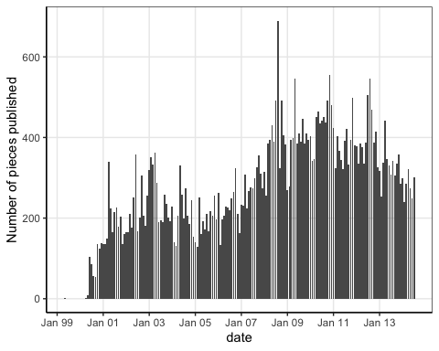
Number of pieces published with term ‘China’ at newspaper Folha de São Paulo.
It is pretty clear from Figure 1 that, up to 2006, the main themes related to China covered health issues, North Korea and nuclear issues, as well as some sports themes (“seleção brasileira”). In 2009, those themes continued to be covered by the press, but much more news about Asia, China and Hong Kong stock market, along with a central network of news piece about brazilian company Vale do Rio Doce, a major exporter of raw products to China, connected to the Dollar, always an issue for the Brazilian trade. This evidence is central to the mechanism we are proposing here. The economic ties between Brazilian companies, the Brazilian economy, and China are qualitatively different, as shown in the press. It is helpful to zoom in and compare 2008 with 2009. We must remember that 2008 was the year of the financial economic crisis known in the US as the Great Recession. Given the growing importance of China for the global economy at the time, as well as for Brazil, news about the stock market and the Chinese economy would be prevalent. However, it is crucial for our argument that there is no news about Brazilian or Chinese companies, nor any mention of trade in the news regularly before 2009. To illustrate this, we filtered trigrams with a frequency higher than five when comparing 2008 with 2009.
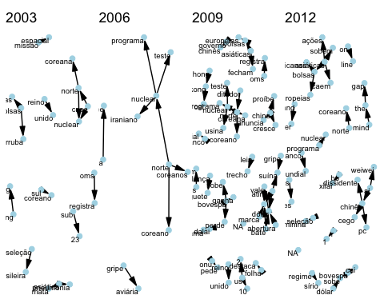
Trigram of pieces published about China at newspaper Folha de São Paulo. Darker arrows are more frequent trigrams. Only trigrams with co-occurrence frequency higher than 8 are shown. The low number of trigrams in 2003 and 2006 is due to the lower number of pieces published.
To establish that a rank effect occurred around the time we are discussing, we collected all headlines, stories, op-eds, and editorials including the term “China” published in the newspaper Folha de São Paulo, the paper with the widest circulation in Brazil (Folha de S.Paulo 2016). The results include some false positives (such as a piece involving a football player nicknamed “China”), but these are rare. In a random sample of 100 stories we found no instance of a false positive. Additionally, the stories encompass a wide range of themes, including sports, natural disasters, politics, economics, science, and more. Nonetheless, they are a measure of interest in everything related to China. Over time, news pieces about China reached a peak in 2008, the year of the Summer Olympics in China and the year when China overtook the US as Brazil’s first trade partner.
Here are some headlines with “bate” (meaning “reach”): On January 9th, 2009, “Exportações do agronegócio batem recorde, com destaque para China” (Agribusiness exports reach record high, with China as the main highlight). On April, “China bate recorde de importações de minério de ferro em abril” (China hits record iron ore imports in April). In August: “Vendas de minério do Brasil para China batem recorde em julho” (Ore sales from Brazil to China reach record high in July) and so on. A key formulation using the word “bate” (reaching or hitting a record high) in an economic context appeared many times in 2009, but only once in 2008, in the context of agribusiness.
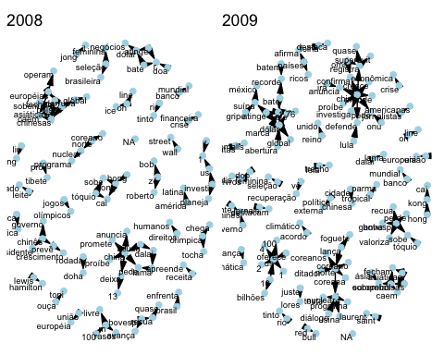
Trigram of pieces published about China at newspaper Folha de São Paulo in 2008 and 2009. Only trigrams with co-occurrence frequency higher than 5 are shown.
What about the content over time? If our hypothesis is correct, not only should we expect more pieces about China, but also a growing number of pieces about economics and trade in particular. To assess this, we computed the trigrams of each headline for four years (2003, 2006, 2009, and 2012) to examine their evolution over time. Trigrams are strings of three tokens that are used to divide a sentence into parts of words (Violos et al. 2018). By looking at the most frequent trigrams, we can have a sense of what kind of content was present in each year.
If, as we argued, symbolic milestones like surpassing historical trade partners attract disproportionate attention from policymakers, then the moment China became Brazil’s largest trade partner constitutes a plausible, exogenous ‘shock’ to the salience of the bilateral relationship. This logic motivates our empirical strategy, which leverages this rank change as a quasi-experimental treatment using a Synthetic Difference-in-Differences approach, as detailed in the next section.

Methodology
We explore a discontinuity in Brazil’s trade partner shift from the US to China to estimate the (local) causal effect of China’s increased importance as Brazil’s second-largest trade partner. Since we have a discontinuity, it seems we could use a Regression Discontinuity Design. However, we have a time series around a discontinuity, which means that it is not an adequate design for our data.
A better alternative is the difference-in-differences (DiD) methodology. As we know, the key identification assumption in DiD is the so-called parallel trends assumption, which states that, absent the intervention, the treated unit (Brazil) would behave just as the average of the control group of countries. This assumption is not credible in the present case, because many things happened during this period (like the 2008 economic crisis and its economic and political effects in the following years), which breaks the credibility that countries would respond the same way to this shock, leading to bias in the estimate of the causal effect.
To avoid these problems, we employ the recently developed synthetic difference-in-differences (SDiD) method (Arkhangelsky et al. 2021), which combines the DiD estimator with the synthetic control method (SCM). It offers a more flexible approach than either method separately. On one hand, DiD methods do not work well with a single treated unit (inflating he standard error) and they also rely on the parallel trends assumption for identification of the causal effect. On the other hand, SCM tries to match the pre-treatment trend in the outcome based on covariates to estimate the counterfactual outcome. However, it compares the whole period before and after the intervention and does not allow for the inclusion of unit fixed effects, which can be a cause of bias, especially in cases where relevant time-invariant or slowly changing variables are omitted. SDiD attempts to address both problems (non-parallel trends for DiD, time weights, and the absence of fixed effects for SCM) by combining the two methods. Similar to the SCM model, we are still attempting to estimate the causal effect by comparing the post-treatment behavior of the synthetic control and the treated unit, albeit “with steroids”, so to speak. The specific model is as follows:
Consider a complete panel: $N$ countries measured over $T$ years, the outcome variable for country $i$ in time $t$ is $Y_{it}$ and the binary treatment variable $D_{it}∈\{0,1\}$. Suppose also that the first $N_{\text{countries}}$ do not receive the treatment and the last country $N_{\text{Brazil}}$ do receive the treatment at $t_{0}$. The job is, like in SCM, to find weights ${\hat{w}}^{\text{SDiD}}$ such that before $t_{0}$ treated and control countries match as closely as possible, that is, $\sum_{i=1}^{\text{countries}}{{\hat{w}}^{\text{SDiD}}}Y_{it}≈\sum_{i=1}^{\text{Brazil}}{Y_{it}}$, for all $t=1,...,t_{0}$. Differently from SCM, we do not stop here. We then find ${\hat{λ}}_{t}^{\text{SDiD}}$ to balance the time trend before and after $t_{0}$. Lastly, the average causal effect on the treated $τ_{ATT}$ is estimated by a two-way fixed effect regression model (as in standard DiD models):
$$\left({\hat{τ}}_{ATT}^{\text{SDiD}},\hat{μ},\hat{β}\right)=\underset{τ_{ATT},μ,β,α}{arg min}\sum_{i=1}^{N}{\sum_{t=1}^{T}{(}}Y_{it}−μ−α_{i}−β_{t}−D_{it}τ_{ATT})^{2} {\hat{w}}^{\text{SDiD}}{\hat{λ}}_{t}^{\text{SDiD}}$$
In order to gain intuition, it is worthwhile to contrast it with both DiD and SCM. A DiD model estimates:
$$\left({\hat{τ}}_{ATT}^{\text{DiD}},\hat{μ},\hat{λ},\hat{β}\right)=\underset{τ_{ATT},μ,α,β}{arg min}\sum_{i=1}^{N}{\sum_{t=1}^{T}{(}}Y_{it}−μ−α_{i}−β_{t}−D_{it}τ_{ATT})^{2}$$
As we can see, while SDiD assigns weights to the control group that are more similar to those of the treated unit and in time periods comparable to the pre-treatment period, classic DiD does not use any weights at all.
The SCM model can be written as follow:
$$\left({\hat{τ}}_{ATT}^{\text{SCM}},\hat{μ},\hat{β}\right)=\underset{τ_{ATT},μ,β}{arg min}\sum_{i=1}^{N}{\sum_{t=1}^{T}{(}}Y_{it}−μ−β_{t}−D_{it}τ_{ATT})^{2} {\hat{w}}^{\text{SDiD}}{\hat{λ}}_{t}^{\text{SDiD}}$$
The equations show that there is no unit fixed effect and no time weight. As a result, the SCM cannot use unit-specific unobserved invariant characteristics to approximate the counterfactual outcome and must consider the entire period when estimating the causal effect. This poses a problem for our data, as the relationship between China and Brazil becomes increasingly entangled over time. Consequently, years far removed from the treatment period may not be a suitable comparison to periods long before the treatment.
Another key advantage of the SDID is that it reduces the variance of the estimator, allowing more precise estimation (Arkhangelsky et al. 2021). One problem with the model developed originally, however, is that it does not include time-varying covariates that are important for a more accurate match to the pre-treatment period. Thus, to account for time-varying covariates and better adjust the model, we include a vector of time-varying controls as suggested by (Hirshberg and Klosin 2024), such that the estimated equation is now:
$$\left({\hat{τ}}_{ATT}^{\text{SCM}},\hat{μ},\hat{β},\hat{γ}\right)=\underset{τ_{ATT},μ,β,α,γ}{arg min}\sum_{i=1}^{N}{\sum_{t=1}^{T}{(}}Y_{it}−μ−α_{i}−β_{t}−D_{it}τ_{ATT}−X_{it}γ)^{2} {\hat{w}}^{\text{SDiD}}{\hat{λ}}_{t}^{\text{SDiD}}$$
We have now the best of all words, without many of the problems of SCM and DiD in isolation.

Data and Variables
Since we need to fit a model to a complete panel, we constraint the sample to 105 countries over a period of 21 years, from 1997 to 2011.
Our outcome variable, vote similarity between a country and China at UNGA, is based on the ideal point estimates based on UNGA vote data from Bailey, Strezhnev, and Voeten (2017). It measures state preferences apart from the agenda, which is important whenever there is a comparison over time, which is exactly the case here.
Predictors include per capita GDP from the Gravity Dabatase (Gurevich and Herman 2018). Trade data are drawn from the International Trade and Production Database (Borchert et al. 2021). To avoid double counting, I use the value reported by the importer country to compute total trade between two dyads, since importers have more interest in measuring this value accurately for tax collection reasons (Borchert et al. 2021). We copmpute the share of total trade with China and the share of total trade with the United States as our two measures of trade. As our measure of power, we used the Global Power Index (GPI) from Diplometric – Pardee Institute, University of Denver. GPI combines demographic, economic, military, technology and diplomatic dimensions and then we computed the power gap between Brazil and the US. We also include distance to the US, as countries closer to the US will have a bigger incentive to align its foreign policy with it. Another economic variable is the exchange rate, since a complaint of China is its devalued currency. A country with a more devalued currency is expected to be more aligned with China than not. The definitions and measurements of key variables are provided in table 1. Table 2 presents the descriptive statistics.
Another possible threat to our research design is the fact that in 2008 there was the global economic crisis (Frankel and Saravelos 2012). It is possible, thus, that Brazil would be reacting differently in its foreign policy than other countries due to the financial crisis. To rule out the possibility that Brazil’s alignment shift in 2009 was driven by macroeconomic turbulence rather than rank salience, we augment our SDiD covariate matrix with four annual indicators capturing different facets of the 2008–09 crisis, all drawn from the Global Macro Database (Müller et al. 2025):
Current Account Balance (% GDP), to capture external‐sector stress and reliance on foreign financing; Government Budget Deficit (% GDP), to reflect fiscal pressure and stimulus capacity; Government Tax Revenue (% GDP). to gauge revenue‐side capacity to respond to shocks, Central Bank Policy Rate (annual average, %), a measure of monetary‐policy stance and financial‐market conditions.
Characteristic | N = 3,036¹
year
Mean (SD) | 2,008.00 (6.63)
Min, Max | 1,997.00, 2,019.00
treatment | 11 (0.4%)
abs_distance_china
Mean (SD) | 0.78 (0.73)
Min, Max | 0.00, 4.22
gpi
Mean (SD) | 0.00 (0.50)
Min, Max | -0.13, 5.58
abs_distance_usa
Mean (SD) | 2.76 (0.87)
Min, Max | 0.00, 5.06
perc_trade_with_us
Mean (SD) | 0.00 (0.50)
Min, Max | -0.40, 2.16
perc_trade_with_china
Mean (SD) | 0.00 (0.50)
Min, Max | -0.29, 3.62
GDP (current US$)
Mean (SD) | 0.00 (0.50)
Min, Max | -0.36, 2.96
Official exchange rate (LCU per US$, period average)
Mean (SD) | 0.00 (0.50)
Min, Max | -0.11, 10.28
distance_us
Mean (SD) | 0.00 (0.50)
Min, Max | -1.25, 1.08
us_power_gap
Mean (SD) | 0.00 (0.50)
Min, Max | -3.80, 0.51
hog_left | 1,297 (43%)
Current Account Balance as % of GDP
Mean (SD) | 0.00 (0.50)
Min, Max | -4.82, 2.59
Government Deficit as % of GDP
Mean (SD) | 0.00 (0.50)
Min, Max | -6.83, 3.43
¹n (%)

Descriptive Analysis
In the figure below, we plot the evolution of UNGA’s ideal point of US, Brazil and China over time. As we can see, Brazil is closer to China than to the US since the beginning of the series of my data, in 1990 up to 2022, during Bolsonaro’s government. Even though there is a distance of Brazil under Bolsonaro’s term, it is still closer to China than to the US. This is a testimonement of how much Brazil is structurally closer to China at the UNGA.
It also shows that Brazil is moving more over time than China, which is mostly stable over time. Thus, that is an indication that Brazil is moving closer to China than the opposite, as expected, given the differential of power and importance of both Countries and the dependence between them.
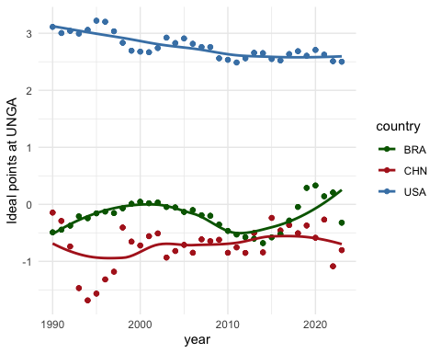
caption
Having established that it is mostly Brazil moving around than China, we can use as our main variable the absolute distance between Brazil and China’s ideal point, with the understand that, a part from the beginning of the nineties, Brazil is almost always closer to the center than China and that Brazil is the one moving around.
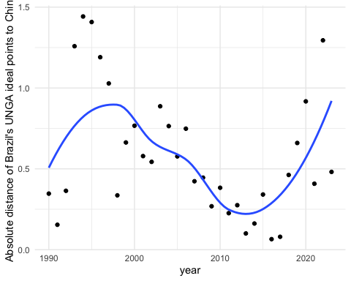
caption
The question one wonders after seeing the graphs is: why Brazil was getting closer over time? The main hypothesis discussed in the literature is the gravitational pull of the China economy, perhaps as shown in the percentage of exports of Brazil that went to China in the period considered. The figure below shows that around the year 2000, the percentage of exports destined to China increased at a roughly constant rate, in a very steep variation, which does not exactly fit the political alignment as measured by UNGA ideal points, although there is some positive correlation.
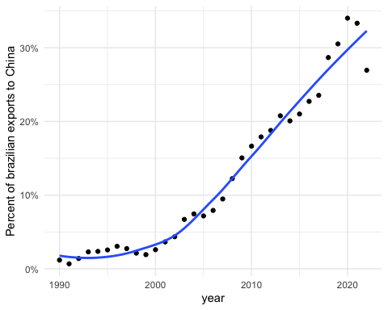
caption

Empirical Results
The graph below presents the evolution of political alignment between Brazil and China at UNGA and a donor pool of countries before and after China becoming the main trade partner of Brazil. The counterfactual estimate from the donor pool allows us to estimate the causal effect of the treatment on similarity of vote at UNGA. The estimate is -.27 points, which means that becoming the main trade partner implied a decrease of .27 points in the absolute distance between the ideal point of Brazil and China after 2006. The result is statistically significant at the 5% level, allowing us to reject the null hypothesis of no increase in the distance between the ideal points of both countries.
point estimate: -0.26 with 95% CI (-0.47, -0.04)
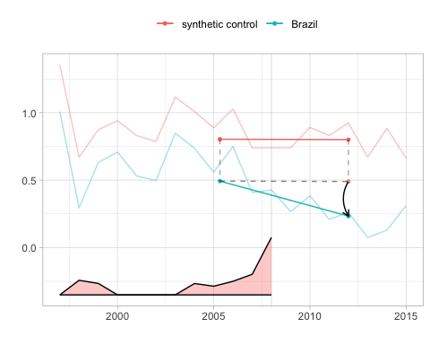
The blue line shows Brazil’s change from the weighted pre-treatment average to the post-treatment average. The red one does the same for synthetic control. The relative size of the time weights are in the bottom.
In figure 8 we plot the results of Brazil along with top 10 controls according to their weight size. As we can see from the graph, no other country has a behavior similar to Brazil, which lends credibility to the estimation of the causal effect.
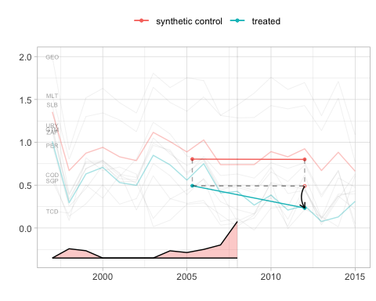
10 controls with the largest weights

Robustness Checks
The target estimand of the SDiD estimator is the average treatment effect on the treated for the period post treatment whose weights are different than zero. This means that, in theory, it may be capturing the effect of other treatments that happened in a prior or later time. The main argument of the paper is that there is a distinctive quality in becoming the number one trade partner. If that is the case, then we should not find any effect when China became the second (in 2003 after overcoming Argentina and again in 2005, after momentarily losing the second spot for Argentina in 2004), nor a few years after being the top one for a while.
Thus, we ran three placebo in-time tests, in which we pretend the true treatment happened in 2003, 2005 and 2012. For the first two placebo tests, we limit the sample data to the year 2008, in order to not include the effect of the true treatment that started in 2009. The table below presents the results for the three models, along with the original model for comparison. As we can see, the effects are smaller and not statistically significant at conventional 95% level.
Synthetic DiD placebo tests and true treatment
Model | Estimate | Std. Error | 95 % CI lower | 95 % CI upper
True model (2009) | -0.26 | 0.11 | -0.47 | -0.04
Placebo (2003) | -0.08 | 0.15 | -0.38 | 0.23
Placebo (2005) | -0.07 | 0.17 | -0.41 | 0.27
Placebo (2012) | -0.06 | 0.13 | -0.33 | 0.20

Conclusion
This study has shown that there is a rank effect when China overtook the US as the leading trade partner of a country like Brazil, which was salient enough to induce a foreign policy realignment toward China. The symbolic significance of overtaking a historic trade partner prompted a substantive shift in diplomatic posture, beyond changes in trade volume. This finding suggests that we should look beyond the increasing trade ties between countries, as the literature has done so far (Yan and Zhou 2021; Flores-Macías and Kreps 2013; Reilly 2013), and also focus on qualitative shifts in the public perception of a trade partner based on rank effects.
We used a Synthetic Difference-in-Differences design to estimate that China’s ascent to Brazil’s top trade partner reduced their UNGA ideal-point absolute distance by 0.26 points (40%). Moreover, we provide evidence from a natural language process analysis of Brazilian main newspaper headlines to offer credible evidence that rank salience drives the alignment.
Our study has several limitations that future research could investigate further. Firstly, we are considering only the case of Brazil. We do not know if the findings would hold for other countries, nor whether there is any interaction with other variables, such as the power status of a country, or whether it matters that Brazil’s previous major partner was the US, a relationship that lasted for almost eight decades.
The proposed mechanism has only indirect evidence. We have shown that newspaper coverage of trade ties with China shifted when it surpassed the US as the primary trade partner. However, we do not have evidence about how business lobbies reacted to it, nor do we have information about the public or political elites. Qualitative studies with political and economic elites could attempt to recover their thinking at the time, for instance. Laboratory experiments could be conducted to provide evidence on the psychological and cognitive mechanisms underlying rank effects.
Despite these limitations, our study is the first to provide evidence for such rank effects in international relations. By spotlighting rank salience, this study also opens new avenues for understanding how discrete milestones in economic ties can reshape international alignments and invites extensions to other domains (FDI, diplomatic visits) and regions.

References
Aiyar, Shekhar, Davide Malacrino, and Andrea F. Presbitero. 2024. “Investing in Friends: The Role of Geopolitical Alignment in FDI Flows.” European Journal of Political Economy 83 (June): 102508. https://doi.org/10.1016/j.ejpoleco.2024.102508.
Anagol, Santosh, and Thomas Fujiwara. 2016. “The Runner-up Effect.” Journal of Political Economy 124 (4): 927–91.
Arkhangelsky, Dmitry, Susan Athey, David A. Hirshberg, Guido W. Imbens, and Stefan Wager. 2021. “Synthetic Difference-in-Differences.” American Economic Review 111 (12): 4088–118. https://doi.org/10.1257/aer.20190159.
Baekgaard, Martin, Julian Christensen, Casper Mondrup Dahlmann, Asbjørn Mathiasen, and Niels Bjørn Grund Petersen. 2019. “The Role of Evidence in Politics: Motivated Reasoning and Persuasion Among Politicians.” British Journal of Political Science 49 (3): 1117–40. https://doi.org/10.1017/S0007123417000084.
Bailey, Michael A, Anton Strezhnev, and Erik Voeten. 2017. “Estimating Dynamic State Preferences from United Nations Voting Data.” Journal of Conflict Resolution 61 (2): 430–56.
Bastardoz, Nicolas, Michael J. Matthews, Gwendolin B. Sajons, Tyler Ransom, Thomas K. Kelemen, and Samuel H. Matthews. 2023. “Instrumental Variables Estimation: Assumptions, Pitfalls, and Guidelines.” The Leadership Quarterly 34 (1): 101673. https://doi.org/10.1016/j.leaqua.2022.101673.
BBC News. 2021. “China Overtakes US as EU’s Biggest Trading Partner.” https://www.bbc.com/news/business-56093378.
Blackwell, Matthew, and Adam N Glynn. 2018. “How to Make Causal Inferences with Time-Series Cross-Sectional Data Under Selection on Observables.” American Political Science Review 112 (4): 1067–82.
Borchert, Ingo, Mario Larch, Serge Shikher, and Yoto V Yotov. 2021. “The International Trade and Production Database for Estimation (ITPD-E).” International Economics 166: 140–66.
Chen, Qin, and Yi Zhou. 2021. “Whose Trade Follows the Flag? Institutional Constraints and Economic Responses to Bilateral Relations.” Journal of Peace Research 58 (6): 1207–23. https://doi.org/10.1177/0022343321992825.
Conlon, John J. 2023. “Attention, Neglect, and Persuasion.”
Coutinho, Yuri Bravo, and Júlio César Cossio Rodriguez. 2024. “Chinese Double Effect on Brazilian Foreign Policy (2003-2018).” Contexto Internacional 46 (2): e20230014. https://doi.org/10.1590/s0102-8529.20244602e20230014.
Edwards, George C., and B. Dan Wood. 1999. “Who Influences Whom? The President, Congress, and the Media.” American Political Science Review 93 (2): 327–44. https://doi.org/10.2307/2585399.
Enke, Benjamin. 2024. “The Cognitive Turn in Behavioral Economics.”
Enke, Benjamin, and Florian Zimmermann. 2017. “Correlation Neglect in Belief Formation.” The Review of Economic Studies, December. https://doi.org/10.1093/restud/rdx081.
Flores-Macías, Gustavo A., and Sarah E. Kreps. 2013. “The Foreign Policy Consequences of Trade: China’s Commercial Relations with Africa and Latin America, 1992–2006.” The Journal of Politics 75 (2): 357–71. https://doi.org/10.1017/S0022381613000066.
Folha de S.Paulo. 2016. “Alcance total dos jornais.” https://arte.folha.uol.com.br/graficos/QcVNh/.
Folke, Olle, Torsten Persson, and Johanna Rickne. 2016. “The Primary Effect: Preference Votes and Political Promotions.” American Political Science Review 110 (3): 559–78.
Frankel, Jeffrey, and George Saravelos. 2012. “Can Leading Indicators Assess Country Vulnerability? Evidence from the 2008–09 Global Financial Crisis.” Journal of International Economics 87 (2): 216–31.
Fuchs, Andreas, and Nils-Hendrik Klann. 2013. “Paying a Visit: The Dalai Lama Effect on International Trade.” Journal of International Economics 91 (1): 164–77. https://doi.org/10.1016/j.jinteco.2013.04.007.
Graeber, Thomas, Christopher Roth, and Marco Sammon. 2025. “Coarse Categories in a Complex World.” University of Bonn and University of Cologne, Germany.
Granzier, Riako, Vincent Pons, and Clemence Tricaud. 2023. “Coordination and Bandwagon Effects: How Past Rankings Shape the Behavior of Voters and Candidates.” American Economic Journal: Applied Economics 15 (4): 177–217. https://doi.org/10.1257/app.20210840.
Guilhon-Albuquerque, José-Augusto. 2014. “Brazil, China, US: A Triangular Relation?” Revista Brasileira de Política Internacional 57 (spe): 108–20. https://doi.org/10.1590/0034-7329201400207.
Gurevich, Tamara, and Peter Herman. 2018. “The Dynamic Gravity Dataset: 1948–2016.” USITC Working Paper, 2018–02–A.
Haibin, Niu. 2010. “Emerging Global Partnership: Brazil and China.” Revista Brasileira de Polı́tica Internacional 53: 183–92.
Hirshberg, David, and Sylvia Klosin. 2024. “Synthetic Differences-in-Differences with Covariates.”
Imai, Kosuke, and In Song Kim. 2019. “When Should We Use Unit Fixed Effects Regression Models for Causal Inference with Longitudinal Data?” American Journal of Political Science 63 (2): 467–90. https://doi.org/10.1111/ajps.12417.
———. 2021. “On the Use of Two-Way Fixed Effects Regression Models for Causal Inference with Panel Data.” Political Analysis 29 (3): 405–15.
Jabarian, Brian, and Elia Sartori. 2024. “Critical Thinking and Storytelling Contexts.”
Kastner, Scott L., and Margaret M. Pearson. 2021. “Exploring the Parameters of China’s Economic Influence.” Studies in Comparative International Development 56 (1): 18–44. https://doi.org/10.1007/s12116-021-09318-9.
Lal, Apoorva, Mackenzie Lockhart, Yiqing Xu, and Ziwen Zu. 2024. “How Much Should We Trust Instrumental Variable Estimates in Political Science? Practical Advice Based on 67 Replicated Studies.” Political Analysis 32 (4): 521–40.
Mellon, Jonathan. 2021. “Rain, Rain, Go Away: 194 Potential Exclusion-Restriction Violations for Studies Using Weather as an Instrumental Variable.” American Journal of Political Science.
Mintz, Alex. 2004. “How Do Leaders Make Decisions? A Poliheuristic Perspective.” Journal of Conflict Resolution 48 (1): 3–13.
———. 2005. “Applied Decision Analysis: Utilizing Poliheuristic Theory to Explain and Predict Foreign Policy and National Security Decisions.” International Studies Perspectives 6 (1): 94–98. https://doi.org/10.1111/j.1528-3577.2005.00195.x.
Mintz, Alex, and Nehemia Geva. 1997. “The Poliheuristic Theory of Foreign Policy Decisionmaking.” In Decisionmaking on War and Peace: The Cognitive–Rational Debate, edited by Nehemia Geva and Alex Mintz, 81–101. Boulder, CO: Lynne Rienner.
Morgan, Pippa. 2019. “Can China’s Economic Statecraft Win Soft Power in Africa? Unpacking Trade, Investment and Aid.” Journal of Chinese Political Science 24 (3): 387–409. https://doi.org/10.1007/s11366-018-09592-w.
Mourón, Fernando, and Francisco Urdinez. 2014. “A Comparative Analysis of Brazil’s Foreign Policy Drivers Towards the USA: Comment on Amorim Neto (2011).” Brazilian Political Science Review 8 (2): 94–115. https://doi.org/10.1590/1981-38212014000100013.
Müller, Karsten, Chenzi Xu, Mohamed Lehbib, and Ziliang Chen. 2025. “The Global Macro Database: A New International Macroeconomic Dataset.” Working {{Paper}} 33714. Working Paper Series. National Bureau of Economic Research. https://doi.org/10.3386/w33714.
Neto, Octavio Amorim. 2011. De Dutra a Lula: A Condução e Os Determinantes Da Polı́tica Externa Brasileira. Elsevier Brasil.
Neto, Octavio Amorim, and Andrés Malamud. 2015. “What Determines Foreign Policy in Latin America? Systemic Versus Domestic Factors in Argentina, Brazil, and Mexico, 1946–2008.” Latin American Politics and Society 57 (4): 1–27.
Reilly, James. 2013. “China’s Economic Statecraft: Turning Wealth into Power.”
Rodrigues, Azelma. 2009. “China desbanca os EUA como maior parceiro comercial do Brasil.” https://oglobo.globo.com/economia/china-desbanca-os-eua-como-maior-parceiro-comercial-do-brasil-3170484; O Globo.
Schenoni, Luis L., and Diego Leiva. 2021. “Dual Hegemony: Brazil Between the United States and China.” In Hegemonic Transition, edited by Florian Böller and Welf Werner, 233–55. Cham: Springer International Publishing. https://doi.org/10.1007/978-3-030-74505-9_12.
Sheffer, Lior, Peter John Loewen, Stuart Soroka, Stefaan Walgrave, and Tamir Sheafer. 2018. “Nonrepresentative Representatives: An Experimental Study of the Decision Making of Elected Politicians.” American Political Science Review 112 (2): 302–21. https://doi.org/10.1017/S0003055417000569.
Struver, G. 2014. “’Bereft of Friends’? China’s Rise and Search for Political Partners in South America.” The Chinese Journal of International Politics 7 (1): 117–51. https://doi.org/10.1093/cjip/pot018.
Tanner, Murray Scot. 2007. Chinese Economic Coercion Against Taiwan: A Tricky Weapon to Use. Rand Corporation.
Vadell, Javier. 2011. “A China Na América Do Sul e as Implicações Geopolı́ticas Do Consenso Do Pacı́fico.” Revista de Sociologia e Polı́tica 19: 57–79.
Violos, John, Konstantinos Tserpes, Iraklis Varlamis, and Theodora Varvarigou. 2018. “Text Classification Using the n-Gram Graph Representation Model over High Frequency Data Streams.” Frontiers in Applied Mathematics and Statistics 4: 41.
Yan, Jiaqiang, and Yonghong Zhou. 2021. “Economic Return to Political Support: Evidence from Voting on the Representation of China in the United Nations.” Journal of Asian Economics 75 (August): 101325. https://doi.org/10.1016/j.asieco.2021.101325.

Appendix
Below we present the weights for the top 10 controls.
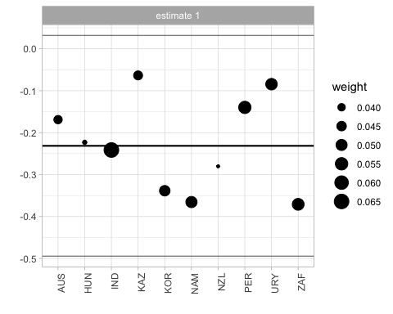
Weights of countries which contributed more to the construction of the synthetic control. The size of the dot represents the weight.
We also fit a model for a donor pool of Latin American states (excluding Caribean countries), which would be arguably closer to Brazil than countries for all over the world. Even though the estimated causal effect is quite similar, the low number of controls induces noise and increases the uncertainty of the model. It is known that usage of placebo to compute standard errors inflate the uncertainty of the estimation. For this reason, we prefer the model with the more ample donor pool. Below is the plot of the model fitted for Latam.
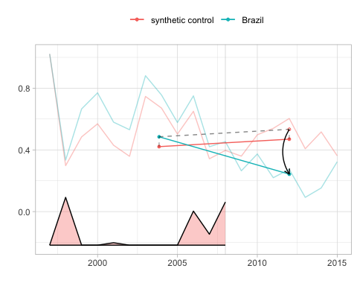
SDiD fit with Latin American countries. Bigger estimated causal effect, but worse pre-treatment fit
Estimate is -0.29 with standard error 0.18. In any case, it is interest to look at the countries with biggest weights. Argentina, Guatemala, Paraguay and Uruguay, all but Guatemala founding Mercosul countries, contribute the most for synthetic control.
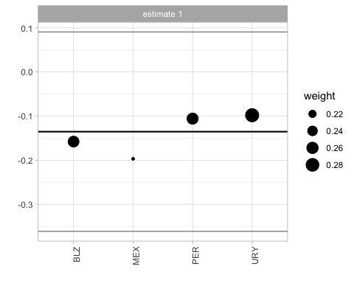
SDiD fit with Latin American countries. Bigger estimated causal effect, but worse pre-treatment fit

For instance: “China desbanca os EUA como maior parceiro comercial do Brasil” (Rodrigues 2009), which translates as “China displaces the United States as Brazil’s main trading partner”
see appendix
I have used chatgpt 4o to assist in the headlines translation from Portuguese into English. See https://chatgpt.com/share/6862b919-4630-800e-ab9c-df9dee5ae56c
sometimes called a balanced panel. We prefer the term “complete” to avoid confusion with balancing of covariates, which is a standard analysis in causal studies
A figure with the weights for top controls is in the appendix

