DATE: JUNE 2, 2026
DEPARTMENT: ADMINISTRATION
FROM: RENÉ MENDEZ, CITY MANAGER
BY: CHRISTOPHER A. CALLIHAN, CITY ATTORNEY
PATRICIA M. SORATOS, CITY CLERK
TITLE: MEASURE G TRANSACTIONS AND USE TAX RENEWAL; NOVEMBER 3, 2026 GENERAL MUNICIPAL ELECTION

RECOMMENDED MOTION:

A motion to approve a Resolution calling for the holding of a General Municipal Election to be held on Tuesday, November 3, 2026 to ask the voters of the City of Salinas to approve, restate, and amend an ordinance enacting a general transactions and use tax of one cent to remain in effect until ended by the voters, with the use of the tax revenue to be reviewed and reported on by a citizens’ oversight committee; and requesting that the Board of Supervisors of the County of Monterey consolidate the election with the established election to be held on the date pursuant to California Elections Code section 10403 on the City’s behalf.

EXECUTIVE SUMMARY:

In an initial discussion with the City’s Finance Committee on October 14, 2025, staff discussed the ballot measure polling and public outreach process and possibility of placing the extension of Measure G on the ballot in November 2026. As currently stated, Measure G expires in 2030. Starting in 2024, staff discussed the importance of Measure G with the Council on several occasions, in particular, the challenge to reduce the City budget by $47 million (or 21%). Additionally, anticipated budget deficit concerns have been emphasized across several budget updates to Council and the community, including through the adoption of the FY 25/26 operating budget and the proposed FY26/27 and FY27/28 budget discussions. Staff also indicated that a potential extension of Measure G would be brought forward for Council action and to receive direction pertaining to engagement with the community in advance of the November 2026 General Election. A progress report was also presented to the Measure G Oversight Committee on January 16, 2026. On March 24, 2026, the City Council received a report regarding the results of the scientific ballot polling survey of likely November 2026 voters.

Staff requests the City Council consider calling for an election to place this measure on the November 3, 2026, General Municipal Election ballot.

BACKGROUND:

In 2014, Salinas residents approved a one-cent transactions and use tax measure establishing the tax for a period of fifteen (15) years (“Measure G”). Measure G generates over $30 million in revenue per year. Since its inception, Measure G funding has provided for ongoing capital project needs and staffing, including 106.5 City staff positions within the City’s operating budget. The City continues to allocate Measure G funding to citywide operational and capital project needs while sustaining staffing levels and services. Measure G will expire in 2029.

The City’s five-year budget forecast assumes a structural budget deficit as identified in the Salinas Plan and the sunset of Measure G in FY 2029. The Salinas Plan document also recommended the City request the voters extend Measure G as soon as possible. Although there is still the possibility for future election year ballot placement (2028, for example), the Measure G survey results are being brought forward for consideration and placement of the extension before the voters in November 2026. If the Council elects not to place the extension on the November 2026 ballot, or if the measure does not pass, there would be another opportunity in 2028. However, sound fiscal management would warrant that the City begin moderating expenditures and avoid incurring new ongoing costs without generating new revenue. While such actions would be challenging, and likely affect services, a phased approach over the years would help mitigate financial impacts.

Based on the current budget and assumptions for future growth, the City should expect positive net revenue through 2029. However, in FY 2030, there would be a drop in net revenue as a result of the expiration of Measure G. If Measure G is not extended, the City will face a budget shortfall of approximately $47.8 million or (21%), thereby significantly impacting funding operations at current levels.

As shown below, the Measure G impact on the general fund forecast illustrates the projected revenue shortfall:
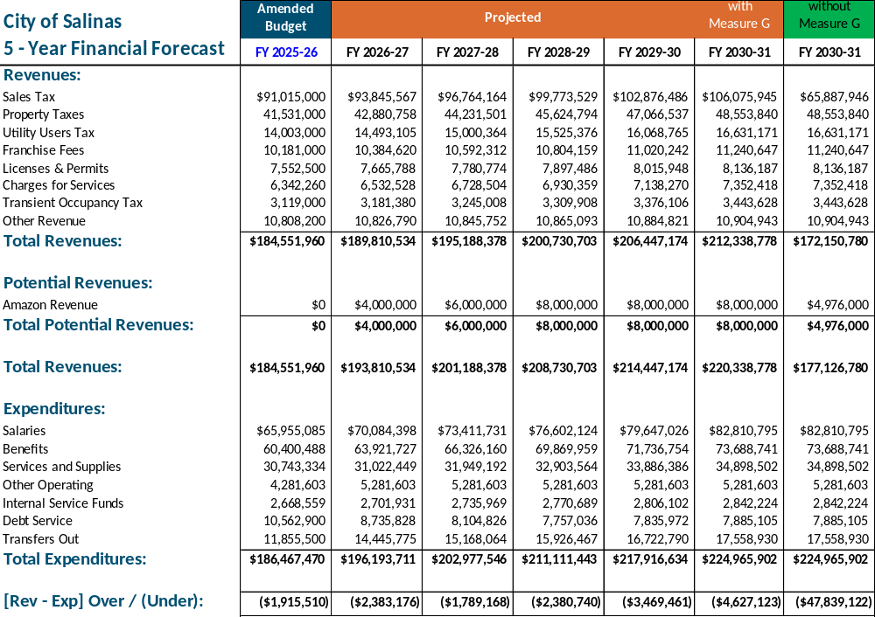

Overall, 81% of those polled rate the quality of life in Salinas as good or fair and identified the community’s top concerns as maintaining streets and sidewalks, responding to homelessness, and planning for housing availability and affordability. The results demonstrated support from the community to renew Measure G. Following that meeting, City staff also conducted two community meetings to inform the community of Measure G revenue, expenditures, projects and services provided. Additional educational information is also available on the City of Salinas website. City administration staff continue to work collaboratively to share information to stakeholder community groups and on engagement and communication avenues.

It is important to note that the proposed measure is an extension of the existing one-cent sale tax, and not an increase to or a new sales tax.

A timeline of the actions is attached hereto and briefly outlined below.
March 24, 2026 Presentation to City Council
March 25, 2026 Commence Educational Communication and Outreach
March 26, 2026 Presentation to Joint Measure G and Measure E Oversight Committee
April 18, 2026 Measure G Community Meeting
April 29, 2026 Measure G Community Meeting
June 2, 2026 Public Hearing: Draft Ballot Measure Extension Ordinance and Fiscal Impact Analysis

September 30, 2026 End Educational Communication and Outreach

November 3, 2026 Election Day

CALIFORNIA GOVERNMENT CODE §84308 APPLIES:

No.

STRATEGIC PLAN INITIATIVE:

This report meets all the City Council goals, City Services, Public Safety, Infrastructure, Youth and Senior, Housing, and Economic Development as Measure G funds support services, projects and operations city-wide across all departments.

DEPARTMENTAL COORDINATION:

City Administration coordinated with the Finance Department and the City Attorney’s Office on this report.

FISCAL AND SUSTAINABILITY IMPACT:

There is no immediate impact to the City’s General Fund associated with the City Council’s approval of the proposed Resolution; however, there will be an impact on the City’s General Fund associated with the November 2026 general municipal election. The estimated cost for a general municipal election can range between $423,186 and $705,310; $6.00 to $10.00 per registered voter and will be included in the budget presented to the Council for adoption.

The cost for including the Measure G renewal on the November 2026 general election ballot will be included as part of the budget development process for the upcoming fiscal year.

Fund | General Ledger Number  (Operating/CIP) | General Ledger Account Name | Remaining Budget Appropriation | Amount Requested
N/A | N/A | N/A | N/A | N/A

ATTACHMENTS:
Resolution
Ordinance
Impartial Analysis

