DMS emissions from the Arctic marginal ice zone

Martí Galí^{1,2}, Martine Lizotte¹, David J. Kieber³, Achim Randelhoff¹, Marcel Babin¹, Rachel Hussherr¹, Lei Xue³, Julie Dinasquet^{4,5}, Eric Rehm¹, Maurice Levasseur¹

* Corresponding author: marti.gali.tapias@gmail.com

Manuscript submitted to Elementa: Science of the Anthropocene

¹ Takuvik Joint International Laboratory, Laval University (Canada), CNRS, FR; Département de biologie et Québec-Océan, Université Laval, Québec, CA
² Barcelona Supercomputing Center
³ Department of Chemistry, College of Environmental Science and Forestry, State University of New York, 1 Forestry Drive, Syracuse, New York 13210, United States
⁴ Marine Biology Research Division, Scripps Institution of Oceanography, La Jolla, USA
5 CNRS, Sorbonne Université, Laboratoire d’Océanographie Microbienne, Banyuls-sur-Mer, France

Abstract (target < 300 words)

Phytoplankton blooms in the Arctic marginal ice zone (MIZ) can be prolific dimethylsulfide (DMS) producers. Yet, their influence on aerosol formation and cloud radiative forcing is not well known due to poor quantitative knowledge of MIZ DMS emissions. Here, we describe the distribution of DMS and its precursor dimethylsulfoniopropionate (DMSP) across four transects, from under-ice to ice-free waters, measured in Baffin Bay in summer 2016. Overall, DMS(P) increased towards warmer waters of Atlantic origin, concurrent with earlier ice melt and more mature bloom stages. Relatively high DMS (median 6.3, maximum 22 nM) and total DMSP (median 70, maximum 255 nM) were observed in the surface layer. Yet, the highest DMS (74 nM) and DMSPt (524 nM) occurred at the subsurface biomass maximum (15-30 m depth). Microscopy and pigment evidence indicated that subsurface DMS(P) peaks were associated with Phaeocystis pouchetii biomass, which was observed at unprecedented levels in Baffin Bay. In surface waters, however, DMS concentration reflected the combined influence of other phytoplankton groups (diatoms, dinoflagellates), bacterial metabolism and, possibly, the successive increase in phytoplankton light and nutrient stress as ice melt progressed. Mean sea-air DMS fluxes ranged from 0.3 µmol m⁻² d⁻¹ in ice-covered waters to 10 µmol m⁻² d⁻¹ in open waters (maximum of 26 µmol m⁻² d⁻¹), and were largely determined by the sea-surface DMS concentration. Using remotely sensed sea-ice, we upscaled a compilation of sea-air DMS flux (FDMS) data to assess pan-Arctic DMS emission (EDMS) from the MIZ. We estimate a mean annual MIZ EDMS of between 6 and X Gg S between 70°N and 85°N, which is sizable compared to pan-Arctic EDMS from ice-free waters in summer (~50 Gg S). Moreover, north of 80°N, MIZ EDMS may exceed open-water EDMS in [June? July?] and might have increased at X% per year between 2002 and 2014.

1. Introduction

The reduction of Arctic sea ice extent and thickness is one of the most striking consequences of anthropogenic global warming (AMAP, 2017; IPCC, 2019). Model projections indicate that the Arctic could become entirely ice free in summer by 2040-2050 (Thackeray & Hall, 2019). In this new regime, the belt of retreating sea ice known as the marginal ice zone (MIZ) will travel every year from its southernmost extent in late winter to its northernmost extent prior to complete melt in late summer. Therefore, biogeochemical processes occurring within the MIZ, including the emission of biogenic gases and particles to the atmosphere, have the potential to reshape marine ecosystems and geosystems across the entire Arctic ocean.

The MIZ is an ephemeral environment, in this study operationally defined as the zone where sea ice cover decreases from nearly total (>85%) to nearly absent (<15%) before permanent ice opening in spring and summer (ref). With a spatial extent of a few tens of km in the direction of ice retreat and a duration on the order of days to weeks (Randelhoff et al., 2019), the MIZ hosts intense exchanges of freshwater, heat and momentum between the ocean and the atmosphere (McPhee et al., 2008; Barber et al., 2015). From a biogeochemical standpoint, the MIZ period marks the transition between two major blooms in the Arctic. Prior to the melt season, biological activity generally concentrates in the bottom layer of the sea ice, where sympagic algae grow massively as soon as sufficient light penetrates through the ice or snow surface (Leu et al., 2015). When sufficient sunlight crosses the sea ice or the free ocean surface, phytoplankton can also bloom in the water column, taking advantage of nutrient stocks replenished over the winter and stable stratification caused by ice melt. These pulses of sympagic and pelagic algal growth, largely dominated by diatom species, account for a major portion of annual primary production and emit a wide diversity of biogenic particles and gases to the atmosphere (see ref suggestions in comment).

Biogenic emissions play an important role in the Arctic climate in late spring and summer, when biological activity is maximal and the atmosphere is depleted of aerosols (both natural and anthropogenic) (see ref suggestions in comment). The low aerosol baseline, caused by limited transport from lower latitudes and efficient scavenging, favors aerosol nucleation from local gaseous emissions (see ref suggestions in comment). The gas dimethylsulfide (DMS) is, quantitatively, the main volatile organic compound emitted by the activity of marine and sea-ice microbes (add numbers here? See suggestions for refs in comment). In the clean Arctic atmosphere, DMS oxidation products (sulfuric and methanesulfonic acids) readily form new aerosol particles that scatter sunlight (refs). When these particles grow large enough to act as cloud condensation nuclei (CCN), they alter the balance between cloud shortwave forcing (increasing cloud albedo) and longwave forcing (increasing heat retention) (see ref suggestions in comment). In aerosol-depleted areas and over the pack ice this radiative balance is particularly delicate and sensitive to local CCN sources (refs). Thus, changes in DMS emission patterns can influence the ensemble of climate feedbacks, known as Arctic amplification, that cause the Arctic to warm faster than the global average (refs). In turn, changes in atmospheric radiative transfer and ice dynamics can modulate phytoplankton productivity, potentially establishing a feedback mechanism that has yet to be verified (refs).

DMS emission (EDMS) in the Arctic originates from both surface seawater and ice environments such as the ice bottom (Galindo et al., 2014), and saline melt ponds (Gourdal et al., 2018; Park et al., 2019). Current estimates obtained with different approaches indicate that ice-free waters largely dominate DMS emission (EDMS) at the pan-Arctic level (Lana et al., 2011; Galí et al., 2019; Hayashida et al., submitted). Yet, DMS has an atmospheric lifetime of a few days, at most, which limits atmospheric transport and magnifies the role of local DMS sources in conjunction with local meteorological conditions. Recent studies highlighted the broad variability and patchiness in tropospheric DMS concentrations (Mungall et al., 2016; Ghahremaninezhad et al., 2019), and also the episodic nature of new particle formation events (Collins et al., 2017; Dall’Osto et al. 2017; Heintzenberg et al. 2017). These findings stress the need to better understand and quantify DMS emissions from ephemeral environments such as the MIZ that can produce intense but short-lived emission events.

Marine DMS emission results from a complex network of biotic and abiotic processes (ref). The primary precursor of DMS is dimethylsulfoniopropionate (DMSP), a compound that accumulates at high concentrations in the cytosol of marine algae, serving different physiological functions such as osmoregulator, antioxidant or cryoprotectant (refs). Intracellular DMSP concentration varies widely across phytoplankton taxonomic groups, with most high DMSP producers found among the haptophytes (prymnesiophytes) and dinoflagellates (Stefels et al., 2007; McParland & Levine, 2018). Conversion of DMSP to DMS proceeds mostly through enzymatic cleavage by algal (Alcolombri et al., 2015) and bacterial (Curson et al., 2011) DMSP-lyase enzymes. The cleavage pathway typically consumes <30% of the DMSP flux (Kiene & Linn, 2000; Galí & Simó, 2015; Lizotte et al. 2017), and the remainder is transferred to bacteria and protists and diverted away from DMS production. However, the efficiency of DMSP-to-DMS conversion can vary widely in response to food-web processes such as grazing (Simó e al., 2018),bacterial metabolism (Kiene et al., 2000), physiological stressors such as nutrient limitation (Sunda et al., 2007), high irradiance (Galí et al., 2013a,b), and environmental stressors such as ocean acidification (Bénard et al. XXXX). In the upper mixed layer of the ocean, dissolved DMS is readily transformed to dissolved non-volatile sulfur species by DMS-consuming bacteria (Kiene et al., 1991; Del Valle et al., 2009; Lidbury et al., 2016) and photolysis (Kieber et al., 1996; Galí et al., 2016), whilehile <15% is usually vented to the atmosphere in ice-free waters (Galí & Simó, 2015).

The multiple biogeochemical pathways that mediate between DMSP synthesis and DMS emission generally tend to buffer DMS concentrations in open ocean settings (Galí & Simó, 2015), where sea-surface DMS concentrations above 10 nM are rare (Lana et al., 2011). In the MIZ, however, seawater DMS concentrations and sea-air DMS fluxes (FDMS) can greatly increase when some factors co-occur including the formation of massive phytoplankton blooms (Perrette et al., 2011; Renaut et al., 2018; Randelhoff et al., 2019), the presence of high DMSP and DMS producers (Levasseur, 2013), the type of ice edge (multi-year versus first-year sea ice; Lizotte et al. 2020), the enhancement of DMS production by food web interactions or physiological stress (Matrai et al., 1995), and weak biological DMS removal (del Valle et al., 2009). Among these factors, blooming of the colony-forming haptophyte Phaeocystis pouchetii is thought to play a prominent role. This species has an intracellular DMSP content of about 5-10% of cell carbon (Stefels et al., 2007; Sheehan et al., 2019), roughly one order of magnitude higher than diatoms and, unlike diatoms, displays high DMSP-lyase activity. These factors, together with the global distribution of Phaeocystis (ref), make Phaeocystis blooms a major source of atmospheric DMS globally (Schoemann et al., 2005; Wang et al., 2015).

In this article we describe DMS and DMSP distribution patterns across a receding first-year ice edge in Baffin Bay, seeking to better understand the relationship between these patterns and the biogeochemical setting, the progression of the bloom and the composition of the microbial community, focussing on the role of key phytoplankton groups. Finally, we compare our findings to a compilation of in situ studies, and upscale in situ observations using remote sensing to provide pan-Arctic estimates of EDMS from the MIZ between 2003 and 2016.

2. Methods
2.1 Hydrographic stations and sampling
The Green Edge expedition sampled seven transects across the ice edge in the Southern Baffin Bay, north of the Davis Strait (approximately at 70°N and 60°W) aboard the icebreaker Canadian Coast Guard Ship (CCGS) Amundsen. Here we report measurements from four East-West transects, named T4-T7, sampled during the second leg of the cruise between 24 June and 10 July, 2016 (Fig. 1). At each station, vertical profiles of water column properties were measured down to at least 300 m using a sampling rosette with attached Seabird SBE-911 plus Conductivity-Temperature-Depth (CTD) sensors, a Seapoint SCF fluorometer, and a WetLabs C-Star transmissometer (0.25 m pathlength). The CTD data were processed according to standard Amundsen Science Team procedures (Guillot, 2016). Transmissometer profiles were used to calculate the beam attenuation coefficient due to particles at 650 nm, c_{p} (m⁻¹), following standard procedures (Loisel and Morel, 1998).

2.2 Satellite sea-ice concentration data sets
Daily images of sea ice concentrations (SIC) on a 3.125 km grid from the AMSR2 sensor (Spreen et al., 2008) were downloaded from ttp://www.iup.uni-bremen.de:8084/amsr2data/asi_daygrid_swath/n3125/. SIC time series were extracted from the satellite pixel closest to each station to describe ice dynamics over the entire melt season in the Green Edge study area.

An additional SIC dataset for the entire Arctic between 2003 and 2016 was downloaded from the National Snow and Ice Data Center (http://nsidc.org). This dataset consisted of images obtained by the Special Sensor Microwave/Imager (2003–2007) and the Special Sensor Microwave Imager/Sounder (2008–2016). Daily SIC images at 25-km resolution were re-projected onto a 4.64-km sinusoidal grid to better match ocean color remote sensing products, and then bin-averaged into 6x6 macropixels (27.84 km) and 8-day periods (Galí et al., 2019). This dataset was used to compute pan-Arctic estimates of EDMS from the MIZ (Section 2.10) in a format that was directly comparable to previous satellite-based estimates of EDMS from open waters (Galí et al., 2019).

2.3 Irradiance
Downwelling photosynthetically available radiation (PAR) above the sea surface was estimated using the atmospheric radiative transfer model SBDART (Ricchiazzi et al., 1998) using precomputed look-up tables (Laliberté et al., 2016). Hourly SBDART time series showed good agreement with in situ data recorded on the ship’s meteorological tower (Kipp & Zonen PAR Lite; sampling frequency 1 min^{–1}), with R² = 0.88 and mean bias = -6%. Measurements taken on the ship were deemed not representative of the daily mean PAR at any fixed station because they reflected rapid variations in ice albedo and fog conditions as the CCGS Amundsen traversed back and forth across the MIZ. Thus, the mean irradiance during the 24-h prior to sampling at each station was computed from the hourly SBDART output.

Downwelling PAR was measured in the water column down to 100 m using a Compact Optical Profiling System (C-OPS, Biospherical Instruments Inc.) deployed from either a small craft or through a hole in the ice. Underwater measurements were referenced to simultaneous above-surface measurements to calculate the vertical PAR transmittance profile for a given C-OPS cast. To correct for the effect of variable ice cover, the mean PAR transmittance profile at each station was computed as the SIC-weighted average of the closest ice-free and ice-covered C-OPS casts (Randelhoff et al., 2019). To obtain the mean daily PAR profile, the mean transmittance profile was multiplied by the mean daily PAR above the sea surface.

2.4 DMS and DMSP sampling
DMS and DMSP samples were collected during the morning CTD cast at ~8 am local timefaat several stations from 5 or 6 depths between the surface and 100 m ; additional samples were occasionally taken from the CTD casts performed around noon. Several intermediate hydrographic stations, located between full stations, samples were collected only from the surface (1 m) and the subsurface chlorophyll maximum (SCM). The SCM depth was estimated from fluorescence depth profiles. A total of 25 stations and 35 CTD casts were sampled.

Samples for DMS analysis were collected into 120-mL precleaned borosilicate vials leaving no head space, allowing some overflow and taking care to avoid bubbling. The vials were filled using a precleaned silicone tube connected to the Niskin bottle spigot, fitted with a 5-µm Nitex mesh at its tip to gently screen out large phytoplankton cells and colonies (Kinsey et al. 2016). Occasionally, additional vials were filled using a 100 µm mesh nylon screen to test for DMS measurement artifacts associated with Phaeocystis cell breakage upon filtration (see below). DMS samples were stored in the dark at 4°C and processed within 2 h of collection.

Samples for DMSP analysis were collected in triplicate and included a set of unfiltered samples for total DMSP (DMSP_{t}) and a second set of filtered samples for dissolved DMSP (DMSP_{d}). Unfiltered seawater samples were collected into 20-mL pre-cleaned borosilicate scintillation vials screw-capped with a solid cap containing a Teflon-lined silicone insert. Samples were microwaved with the cap loosened, then bubbled with air to remove DMS, and acidified followed by storage in the dark at room temperature (Kinsey and Kieber, 2016). Filtered samples were obtained by the small volume, gravity drip filtration (SVDF) method outlined in Kiene and Slezak (2006) using prebaked (550 ºC, 8 h) 25-mm diameter glass fiber filters (GF/F); samples were bubbled with purified air for several minutes to remove DMS followed by addition of acid and storage at room temperature in the dark.
2.5 DMS analysis
A volume of 10-20 mL was drawn from the vials, spiked with deuterated DMS internal standards ( DMS-d3 and DMS-d6 (99 atom %), at 0.54 and 4.5 nM final concentration) and injected into the sparge chamber of a purge-and-trap device (pre-rinsed with MilliQ (MQ) water) using a syringe fitted with a 25-mm GF/F filter. Samples were sparged with ultra-high purity (UHP) helium for 5 min to strip the DMS from the seawater and trap it on a glass tube containing Tenax-TA that was placed downstream of the sparge chamber. The Tenax-filled glass tube Tenax column was placed over a vessel filled with liquid nitrogen to maintain it below -10°C. After sparging, the glass tubecolumn was removed from the cryogenic trap and immediately stored at -80°C until analysis or, most frequently, placed in the injector chamber of a gas chromatograph-mass spectrometer (GC-MS, model) for analysis.

The GC-MS was calibrated at the beginning of each transect and at the end of the last transect (every four days). Four to six standard solutions were prepared by dissolving DMS-d3 and DMS-d6 in MQ water at 4 to 6 different concentrations between 0.5 and 45 nM. The R² of the log-log linear calibration equation was generally >0.99 and the mean slope (± std) was 0.978 (± 0.018). We determined the DMS concentration using a fixed mean calibration curve throughout the cruise for better temporal consistency, which resulted in deviations of ±7% compared to the time-varying calibration.

The peak areas of DMS, with a mass-to-charge ratio (m/z) of 62, and those of the internal standards (DMS-d3, m/z = 65; DMS-d6, m/z = 68) were determined using the MassHunter workstation software. Initial concentrations were obtained by applying the calibration equation to blank-corrected peak areas (blank signals were generally less than 10% of the smallest peak areas detected in samples). The initial values for endogenous DMS (DMS_{M}) were subsequently corrected using the DMS-d6 internal standard according to the equation:

DMS = DMS_{M} · d6-DMS_{E} / d6-DMS_{M}

Where d6-DMS_{E} is the expected (known) concentration of d6-DMS internal standard (4.5 nM) and d6-DMS_{M} is the initially measured d6-DMS concentration. This procedure corrects for errors associated with sample handling, inefficiencies of the purge-and-trap system or instrument drift. The d3-DMS internal standard, added at a lower concentration, showed more variability and was not used to correct endogenous DMS. No technical replicates were performed for the majority of samples.

The mean propagated uncertainty of DMS measurements was estimated at 10%, which results from adding in quadrature the mean range of 6.5% obtained for a subset of samples analyzed in duplicate (n = 16) and the 7% uncertainty due to the calibration equation. The 10% propagated uncertainty does not take into account errors associated with sample pre-screening. We obtained a mean (median) concentration ratio of 1.19 (1.19) between samples pre-screened with the 100-µm mesh and their 5 µm-screened counterparts. However, the test was inconclusive because the ratio of the concentrations obtained with the two procedures ranged between 0.60 and 1.9 (n = 19), with interquartile range of 0.93-1.46. Using bootstrapping (n = 10000), we obtained a 95% confidence interval for the ratio of concentrations that was only marginally different from 1 (1.02-1.36 for the untransformed ratio and 0.93-1.36 for the log10 transformed ratio). Our results are consistent .with those from del Valle et al. (2009) during a Phaeocystis bloom in the Ross Sea (Antarctica), who observed a mean (median) ratio of 1.67 (1.70) between unscreened samples and their 20 µm-screened counterparts (samples were GF/F-filtered upon injection, as in our study). Despite the different mesh sizes used, these results clearly point to the importance of pre-screening Phaeocystis colonies (and even cells) from samples to avoid DMS measurement artifacts.

2.6 DMSP analysis
Processed DMSP samples were stored in the dark at 4°C and analyzed at Laval University (UL, Québec City) and at the State University of New York, College of Environmental Science and Forestry (SUNY_ESF, Syracuse, NY) within 30 months of collection. These circumstances prompted us to perform storage tests and interlab comparisons. Standards of known DMSP concentration were prepared on the ship by diluting a 20-µM stock solution of DMSP·HCl (Sigma-Aldrich; solution in MQ water kept frozen) in GF/F-filtered 1900 m-depth seawater, and subsequently processed as regular samples. Additional aliquots of some samples were also analyzed on the ship within a few days of collection using standard base cleavage procedures (see below) to allow for later comparisons. We obtained 100.0±1.5% recovery of DMSP standards prepared on the ship (triplicates at 25, 100 and 400 nM) and 95.1±5.9% recovery for surface seawater samples that had been analyzed on the ship (n = 4 duplicates, 18-123 nM concentration range). Regarding interlab comparisons, we obtained a mean difference of 1.2±10% between UL and SUNY for a subset of samples that were sent to both labs (n = 4 duplicates, 2.5-126 nM concentration range). In summary, our tests indicated that no DMSP loss occurred during the storage period and confirmed the accuracy and consistency of the analytical methods described below.

At UL, stoichiometric conversion of DMSP to DMS was achieved by adding 3 mL of 5 M NaOH to 5 mL of sample or standard in a 40-mL gas-tight glass vial. After xx h, samples were sparged with UHP helium at a flow rate of 40 mL per minute via a Teledyne Tekmar Atomx XYZ automated purge and trap system for 11 min to allow complete adsorption of the stripped DMS on a U-shaped proprietary trap. Following full extraction of DMS, the U-shaped trap was heated to 250ºC to allow elution of the gas onto a Gas Chromatograph (GC, model Intuvo 9000, Agilent, oven: 60ºC, capillary column: DB-5ms, 30 m x 250 µm x 0.25 µm, He: 1.0 mL min⁻¹) at a flow rate of 300 mL min⁻¹. After chromatographic separation, the GC effluent was carried through to a Mass Spectrometer (MS, model 5977B, Agilent), where the peak area of ionized DMS (m/z = 62) was determined with the MassHunter workstation software and converted to concentration against a 7-point calibration of a diluted DMSP standard solution (Research Plus Inc. 100 nM DMSP solution acidified with 10% H₂SO₄ and diluted with MQ water). Calibrations were performed on a weekly basis with an average R2 regression coefficient of 0.99. The mean standard error of the internal standard was on average of 0.21 nmol L⁻¹. The working detection limit of the instrument was 1.1 nM and was calculated as the addition of the mean blank concentration and 3 times its standard deviation.

At SUNY-ESF, DMSP was quantified following the procedure outlined in Kinsey and Kieber (2016). Briefly, 200 µL of 5 M NaOH solution was added to 1 mL of a DMSP standard or seawater sample in a precleaned 10-mL borosilicate serum vial. Following the addition of base, each serum vial was immediately capped with a Teflon-lined butyl rubber stopper and sealed with an aluminum crimp cap. Basified samples were stored for 24 h in the dark at room temperature prior to analysis. The DMS was quantified in the standards and samples using a cryogenic purge-and-trap system (sparging time, 4 min) and a Shimadzu GC-14A with flame photometric detector (temperature, 225 °C). Separation of DMS from other volatile sulfur compounds was achieved isothermally at 60°C using a Chromosil 330 column (3.2 mm i.d. × 2.4 m long, Supelco Inc.) with UHP helium as the carrier gas (Kinsey and Kieber, 2016).

2.7 Calculation of sea-air DMS flux
We estimated FDMS as the product of the sea–air gas transfer coefficient (K_{w}), the DMS gradient across the sea–air interface, and the ice-free water fraction (1 - SIC):

FDMS = K_{w} · (DMS_{w} - DMS_{a}) · (1 - SIC)

K_{w} was computed using the wind speed-based gas exchange parameterization of Woolf (1997), taking into account air- and water-side resistance and the effects of SST and salinity on DMS diffusivity and solubility, and assuming DMS_{a} = DMS_{w}/253 based on field measurements (Land et al., 2014). Wind speed measurements were acquired at 1 min⁻¹ frequency by the anemometer located at 16 m above sea level on the ship’s meteorological tower (Burgers et al. 2017), and converted to 10-m wind speeds according to a standard wind profile for neutral atmospheric stability (Hsu et al. 1994). At each station we calculated FDMS using one single value for DMS_{w} and SST and the 1 min⁻¹ time series of wind speed during the 24 h prior to sampling, and then calculated the daily mean FDMS. The reader is referred to Galí et al. (2019) and its supplementary information (SI) section for further details on gas exchange calculations.

2.8 Ancillary biogeochemical data
Water samples were collected from Niskin bottles on the CTD rosette at each hydrographic station for the determination of inorganic nutrients (nitrate, nitrite, phosphate and silicate) and phytoplankton pigments. Samples for nutrient analysis were pre-filtered through a GF/F filter and stored in acid-washed and sample-rinsed 15-mL polyethylene tubes in the dark at 4°C, and analyzed within a few hours on a Bran+Luebbe Autoanalyzer 3 using standard colorimetric methods (Grasshoff et al., 1999). Pigment samples were collected by filtration of <2.7 L seawater on Whatman GF/F filters and stored in liquid nitrogen until analysis. Back on land, filters were extracted in 100% methanol, disrupted by sonication, clarified by filtration (GF/F), and analyzed using High Performance Liquid Chromatography (HPLC) on an Agilent Technologies HPLC 1200 system equipped with a diode array detector (Ras et al., 2008). EXTRA INFO?

At 9 stations (out of 25), samples for identification and counting of micro- and nanophytoplankton were taken at the surface and at the depth of the fluorescence maximum, preserved in lugol and kept at 4°C. Cells were counted under an inverted microscope after sedimentation of 25 to 50 mL following standard procedures (Uthermöhl, 1958). In addition to traditional microscopy, an Imaging FlowCytobot (Olson & Sosik, 2007) was used to take pictures of phytoplankton and detritus that were subsequently identified and counted with the software EcoTaxa (https://ecotaxa.obs-vlfr.fr/) (details are described elsewhere).

The abundances of phytoplankton cells and detrital particles were converted to carbon biomass using allometric relationships (Menden-Deuer & Lessard, 2000), and subsequently used to estimate their contribution to the particulate DMSP (DMSP_{p}) stock using literature values for cell quotas or intracellular concentrations of DMSP (Stefels et al., 2007). For this calculation we assumed, based on DMSP_{d} measurements performed at stations 713 and 719 and on literature values (Kiene & Slezak, 2006; Kinsey et al., 2016), that DMSP_{p} represented 90% of the total DMSP. Further details are given in SI Section X.
Bacterial abundance, production and genes associated to DMSP metabolism
Samples (1.5 mL) were preserved with glutaraldehyde (1% final concentration) and stored at -80°C. Samples were stained with SYBR® Green I (ThermoFisher Scientific) and analyzed on a flow cytometer (FACSCanto, BD Biosciences) as previously described (Gasol and del Giorgio, 2000).
Bacterial production was measured by [H3]-Leucine incorporation (Smith and Azam, 1992). Triplicate 1.7 ml aliquots were incubated with a mixture of 50/50 (v/v) [H3]-leucine (Perkin Elmer) and nonradioactive leucine for 4h at in situ temperature (1.5°C). Samples with 5% trichloroacetic acid added prior to isotope served as blank. Saturation and time course were performed beforehand to determine the concentration of leucine and minimum incubation time. Leucine incorporation was converted to carbon production using a conservative conversion factor of 1.5 kg C mol leucine-1 (Simon and Azam, 1989).
Functional genes associated with DMSP cleavage pathway (dddP) and demethylation pathway (dmdA) were quantified by q-PCR following previously described protocols (Levine et al., 2012; Zeng et al., 2016). Briefly, universal primers dddP 874F/971R and dmdA 282F/591R were used to quantify dddP and dmdA respectively. Quantification was performed on a AriaMx (Agilent) using SsoAdvanced Sybr Green universal supermix (BioRad). Technical triplicates were run for each sample. Seven-fold serially diluted standard curves and no template controls were run in triplicates on each plate. Genomic DNA from a strain presenting both genes was used as standard. Single amplifications were confirmed by melt curve for each run.

2.9 Analysis of spatio-temporal biogeochemical patterns
We calculated the number of open water days (OWD) at each station using the time series of remotely sensed SIC. If the station was ice-free (SIC < 15%) at the time of observation, the OWD was defined as the number of days of SIC < 15% since April 29. Otherwise, OWD was the negative of the number of days with SIC > 15% through July 31 (Randelhoff et al. 2019). Stations were classified into three categories according to SIC and OWD metrics (Table 1). Ice-covered (ICE) stations were defined by OWD < -3d, which generally corresponded to SIC persistently higher than 85% during the 3 days ending on the day of sampling. MIZ stations were defined by OWD comprised between -3d and 3d. Open water (OW) stations were defined by OWD > 3, which corresponded to SIC persistently below 15% during the 3 days ending on the day of sampling.

Median and average profiles were calculated for the three OWD categories after additional binning of the measurements into four depth (z) layers: z ≤ 9, 9 < z ≤ 21, 21 < z ≤ 41 and 41 < z ≤ 81 m. The biogeochemical setting was further characterized by calculating descriptors of vertical mixing, light penetration, biological nutrient utilization and phytoplankton biomass maxima. The mixed layer depth was calculated as the shallowest depth where sigma-t exceeded by 0.03 kg m⁻³ the value at 1 m depth (MLD0.03). Vertical mixing was also characterized using the “equivalent mixed layer depth” h_{BD} (Randelhoff et al. 2017). The equivalent mixed layer depth is defined as h_{BD} = BD/Δσ_{θ}, where BD is the vertically integrated buoyancy deficit compared to a reference state, taken to be the shallowest depth that is not affected by seasonal density variations, and Δσ_{θ} is the difference between densities at that reference depth and the surface, usually an average over the upper meters. This metric was developed for meltwater-influenced surface waters in the MIZ and was found to constrain the extent of vertical mixing better than criteria based on density or temperature thresholds (Randelhoff et al. 2017, 2019). The lower depth limit of phytoplankton growth was estimated as the depth where daily PAR was 0.415 mol photons m⁻² d⁻¹, here referred to as the 0.415 isolume (Letelier et al., 2004; Randelhoff et al., 2019). The nitracline depth was defined as the shallowest depth where nitrate concentration exceeded 1 µM, based on a linear interpolation of discrete nutrient measurements to a vertical spacing of 1 m. The depth of the subsurface biomass maximum (SBM) was estimated from c_{p} profiles smoothed with a 5-point running mean to remove spikes.

We calculated vertically-integrated stocks for variables measured from CTD casts (c_{p}) and discrete Niskin bottle profiles (DMS, DMSP, pigments). To this end, profiles were first binned (c_{p}) or interpolated (Niskin bottle variables) to 1-m resolution between the surface and 100 m. Discrete Niskin bottle profiles were "closed" by imposing a concentration of 0 at 100 m. Profiles were integrated by summation between 0 and 60 m, a range that comprised most of the phytoplankton and dimethylated sulfur stocks and sufficient discrete measurements (profiles with n < 4 between 0-60 m depth were discarded).

To examine the relationship between sulfur compounds and water masses we calculated the “Arctic N-P relationship” (ANP), a tracer that distinguishes the nutrient signature of Atlantic Water (AW) from that of the Pacific-derived water (PW). Essentially, an ANP of zero means the NO₃⁻ - PO₄³⁻ pairs fall on the regression line for AW, whereas for an ANP of one they fall on the regression line for PW (see Randelhoff et al., 2019, and references therein). Finally, multiple linear regressions with stepwise variable selection (sMLR) were used to develop empirical equations linking concentrations of DMS and DMSP as well as FDMS to their main environmental drivers. Data analyses were performed with the Matlab (release R2013b), R (version 3.3.3; R citation) and python (version) softwares.

2.10 Satellite-based estimates of EDMS from the MIZ
We computed pan-Arctic EDMS from the MIZ as the product of MIZ ice-free area, estimated from satellite images, and mean FDMS per unit of ice-free ocean area in the MIZ (<FDMS>), based on a compilation of in situ studies (Table 4). The calculation was based on three simplifying assumptions. First, pixels were flagged as MIZ or non-MIZ using the SIC time series for each pixel (see below). Second, <FDMS> was multiplied by (1 - SIC) in flagged pixels to obtain maps of FDMS from the MIZ (8-day and 28 km resolution). Third, the resulting flagged pixels were summed over 5° latitude bands between 65°N and 85°N and over time, applying appropriate unit conversions to obtain annual EDMS estimates.

To obtain a range of possible EDMS from the MIZ, we used two different criteria (“A” and “B”) for flagging pixels as MIZ. Both criteria rely on the date of permanent ice opening calculated from daily SIC time series (Renaut et al., 2018), but they differ in the duration of the MIZ period. In case A, the MIZ period was defined as the 8 days that comprised the ice opening date in a given pixel. This duration is similar to the one observed at our study site. In case B, the duration of the MIZ period was defined by a backwards search starting with the ice opening 8-day period and ending with the period when either SIC exceeded 85% or the MIZ duration exceeded 32 days. Thus, case B allowed for geographic and interannual variations in MIZ duration.

Table 1. Physical and biogeochemical characteristics of the stations across the ice edge.
 | Ice cover categories
 | ICE | MIZ | OW
OWD thresholds (d) | OWD < -3 | -3 ≤ OWD ≤ 3 | OWD > 3
Mean observed OWD | -12 | 0 | 13
SIC thresholds (%)  (days -2,-1, 0 ) | SIC > 85 | 85 ≥ SIC ≥ 15 | SIC < 15
Mean observed SIC (%) (days -2,-1, 0 ) | 94, 93, 90 | 52, 45, 15 | 0, 1, 0
"Arctic" stations | 400, 403, 406, 600, 719 | 519, 603, 604.5, 605, 716 | 608, 700, 703, 707, 713,
"Atlantic" stations | 409, 412, 413 | 507, 512, 515, | 418, 506, 612, 615,
Total N of stations | 8 | 8 | 9
Descriptors of the water column physics: mean (min-max)
MLD03 (m) | 6 (2-22) | 3 (1-5) | 7 (1-15)
hBD(m) | 20 (15-32) | 15 (11-17) | 18 (12-31)
Isolume 0.415 (m) | 26 (11-41) | 35 (21-47) | 42 (29-60)
Nitracline (m) | 1 (0-7) | 4 (0-15) | 21 (1-43)
SBM (m) | 8 (3-21) | 12 (7-16) | 24 (16-31)

3. Results
3.1 Oceanographic and biogeochemical setting
Transect hydrography was characterized by east-west gradients in water masses and gradual ice retreat (Fig. 1; Table 1). At the eastern end of the station grid, close to the West Greenland shelf, the clear signature of warm Atlantic-derived water flowing in through the Davis Strait was observed. The western end was influenced by lighter and colder Arctic-derived waters coming from the Canadian Archipelago (Tang, 2004). Consequently, ice retreat started in the east, with the ice edge steadily moving west at around 4 km/day. This retreat led to a parallel gradient in surface layer properties: eastern stations had sea ice concentrations at or close to 0 %, and near-surface layer (<~50 m) hydrography showed substantial surface warming (Randelhoff et al., 2019). The Atlantic and Arctic-derived water masses also had distinct nutrient signatures. In the west, pre-bloom nutrient supply was restricted by the lower nutrient concentrations characteristic of the Arctic outflow (ultimately of Pacific origin) and the strong stratification in the upper ~200 m of the water column.

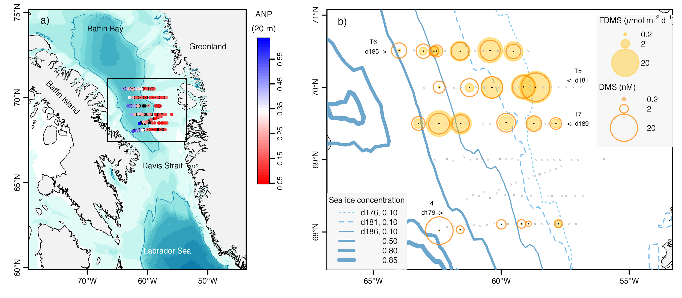

Figure 1. Map of the study area and sea-surface DMS concentrations and fluxes (FDMS). (a) Bathymetric map of southern Baffin Bay, Davis Strait and northern Labrador Sea. Dots show the grid of Green Edge cruise stations, colored according to the “Arctic N-P relationship” (ANP), a proxy for the Arctic water fraction, at 20 m. Stations sampled for DMS are marked with small black dots; (b) Close-up of the study area. The size of empty orange circles and filled yellow circles indicates the magnitude of sea-surface DMS concentrations and sea-air DMS fluxes, respectively. Contours of satellite-retrieved sea-ice fractional coverage are shown in different textures and shades of blue for different periods of 5 Julian days: d176-d180 (0.10 contour), d181-d185 (0.10 contour), and d186-d190 (0.10, 0.50, 0.80 and 0.85 contours). Sampled transects are labelled (T4, T5, T6 and T7) and their start dates (day of year, d) are also indicated.

The development of the phytoplankton bloom tracked the east-west gradient in ice retreat and water mass distribution. Overall (or As a whole), phytoplankton growth was in the early stages of development in ice-covered western stations, as indicated by the near-surface nitracline and shallow SBM depths (Table 1; Fig. 2). At the eastern side, the phytoplankton bloom had further developed into a mature or even post-bloom stage and considerable nutrient depletion had occurred by the time of sampling, causing a deepening of the nitracline to around 20 m (T4-T6) or even ~40 m (T7). The 0.415 µE m⁻² d⁻¹ isolume was deeper than the nitracline regardless of ice cover and surface plankton biomass (Fig. 2) (Randelhoff et al., 2019), resulting in the formation of a prominent SBM between 10 and 40 mat some eastern-side stations.

Distinct phytoplankton communities were found across the ice edge, with biomass usually dominated by diatoms (see details in Lafond et al., 2019). In terms of numerical abundance, pennate diatoms (Fragilariopsis spp., Pseudo-nitzschia spp., Ceratoneis closterium) dominated in the western side, whereas colonial centric diatoms (Thalassiosira spp., Chaetoceros spp.) dominated in the eastern side. Due to their larger size, centric diatom species generally dominated phytoplankton biomass (accompanied by the ice diatom Melosira arctica and its spores at some MIZ stations). The haptophyte Phaeocystis pouchetii was present in variable abundances at different sucessional stages of the bloom (st. 512, 615, 707) and formed massive proliferations below the pycnocline at some ice-free stations along the eastern side (st. 512 and 615), either dominating phytoplankton biomass (st. 615) or co-dominating with diatoms (st. 512). Other taxa that made smaller but relevant contributions to phytoplankton biomass were haptophytes of the genus (Chrysochromulina sp.), athecate dinoflagellates of the genus Gymnodinium and Gyrodinium (more abundant in the eastern side), cryptophytes, chrysophytes, choanoflagellates, prasinophytes (Pyramimonas sp.) and unidentified autotrophic nanoflagellates.

Differences in plankton community structure and functioning across the ice edge were also evident in the abundance and activity of heterotrophic organisms (Saint-Béat et al., 2020). The ice-free, eastern side stations were characterized by higher bacterial abundance and production, and generally hosted greater relative abundances of Rhodobacteraceae (α-proteobacteria) and Polaribacter (Bacteroidetes) and lower relative abundances of SAR11 (α-proteobacteria) (see section 3.4). Food web structure and zooplankton.

3.2 Distribution of DMSP_{t} and DMS
DMSP_{t} and DMS concentrations showed contrasting vertical and horizontal features in the four transects sampled (T4-T7) superimposed on the temporal progression of ice retreat (Fig. 2). The earliest and southernmost transect, T4 (68°N), had the heaviest ice cover and the lowest DMS and DMSP concentrations among all transects. DMSP_{t} (<90 nM) and DMS (<2.5 nM) decreased with depth, and vertical profiles were similar across most of the ICE zone and in the only OW station sampled (st. 418). The westernmost station (st. 400) was a stark exception, with high DMSP_{t} (255 nM) and DMS (22 nM) measured just beneath the sea ice.

Across transect T5 (70°N), nearly all stations were located in the MIZ. High DMSP_{t} (90-200 nM) and DMS (11-22 nM) were recorded at the very surface, and their concentrations decreased towards greater depths. The exception to this trend was st. 512, where extremely high DMSP_{t} (524 nM) and DMS (74 nM) were observed at the SBM (15 m depth). The highest sea-surface DMS (22 nM) was recorded at the easternmost station (st. 506), which had been entirely ice free for over two weeks.

The northernmost transect T6 (70.5°N) covered the full gradient of ice-cover conditions, from ICE through MIZ and OW conditions. Although DMSPt and DMS concentrations increased markedly towards OW, relatively high concentrations also occurred under ice (st. 600). DMSPt increased towards the SBM, with maxima of 200-300 nM at the eastern side, and decreased below the SBM. In contrast to DMSPt, DMS was highest at the surface (2-11 nM) and decreased with depth. The exception was the very high DMS (44 nM) recorded at the SBM (30 m depth) of the easternmost station (st. 615; OWD = 13 d).

Transect T7 (69.5°N) sampled mostly OW conditions except for its western end. Concentrations of DMSPt and DMS generally decreased with depth and, unlike in T5 and T6, no prominent SBM features were observed. The range of sea-surface concentrations was narrower for DMS (4-12 nM) than for DMSP_{t} (20-150 nM), and these different patterns propagated to deeper waters. Sea-surface DMS concentrations peaked in the middle of the transect, where ice had retreated within the last 3-9 days.

Grouping the profiles of DMSPt and DMS by ice cover categories revealed some general patterns (Fig. 3). Dimethylated sulfur concentrations generally decreased with depth, with a stronger vertical trend for DMSP_{t} (Fig. 3c), and increased towards OW, with a stronger horizontal trend for DMS (Fig. 3d). ICE stations were relatively more homogeneous than MIZ and OW stations, where the occurrence of extremely high concentrations was reflected in the difference between means and medians. Subsurface DMSP_{t} maxima were confined to the top 20 m in the MIZ and OW stations, whereas DMS peaked in the top 20 m in the MIZ but anywhere between 0 and 41 m in the OW stations. In the next two sections drivers of the DMSP_{t} and DMS distributions are explored.

ADD HERE OR NEXT 2 SECTIONS: ON A SAMPLE BASIS, LITTLE DMS(P) VARIANCE EXPLAINED BY ENVIRONMENTAL VARIABLES ACCORDING TO CORR ANALYSIS AND RDA. THE SAME WAS TRUE FOR PHYTOPLANKTON PIGMENTS. ON THE CONTRARY, WE FOUND STRONG COVARIATION BETWEEN DMS(P) AND SOME PHYTOPLANKTON PIGMENTS, POINTING TO DOMINANT ROLE OF BLOOM DYNAMICS IN CONTROLLING DMS(P) CYCLING, TERMED BLOOM REGIME BY T&S 2004. REPLACE CORR AND MULTIPLE REGRESSION TABLES BY RDA OF DMS(P) VS. ENV, DMS(P) VS PIGMENTS, AND KIND OF VENN DIAGRAM SHOWING PIGMENT ASSOCIATIONS.

Figure 2. Vertical profiles of DMS and DMSP_{t} across the four sampled transects ordered by latitude, with stations distinguished by color within a given transect. Bottom left panels show depth-longitude transects of DMS (filled circles) and total DMSP_{t} (empty circles), with the radius of the DMSP_{t} circles scaled to DMS in a 0.10 proportion (i.e., DMS and DMSP_{t} have the same circle radius when DMS:DMSP_{t} = 0.10 in a given sample). The superimposed lines indicate the depths of the equivalent mixed layer (hBD), the isolume of 0.415 mol photons m⁻² d⁻¹, the nitracline, and the subsurface biomass maximum (see text for definitions). Top left plots show the percent sea-ice coverage on the day of sampling (gray bars) and corresponding open water days (black line); OWD are indicated on top of the circles, and filled circles indicate stations classified as MIZ; vertical dashed lines separate Arctic and Atlantic domains according to a multivariate clustering coefficient. The center and right panels show DMS and DMSP_{t} vertical profiles following the same color coding for stations.
FIGURE IN NEXT PAGE

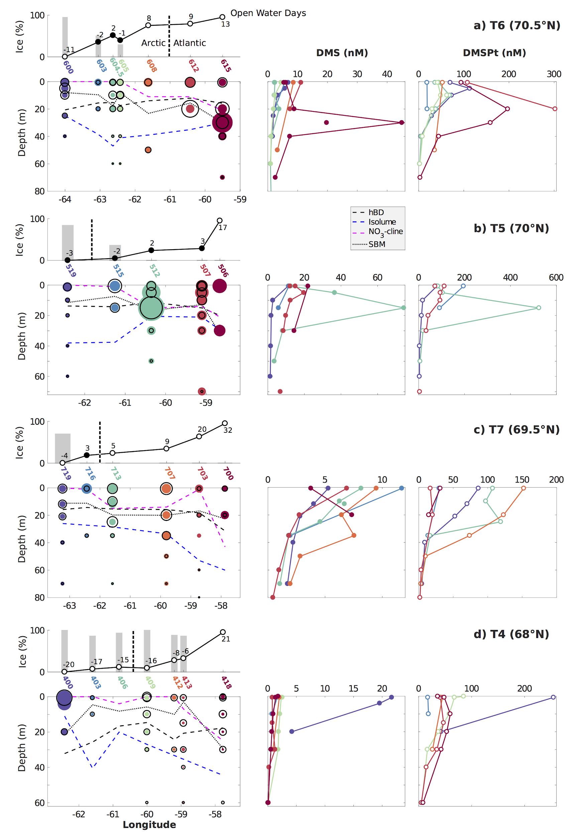

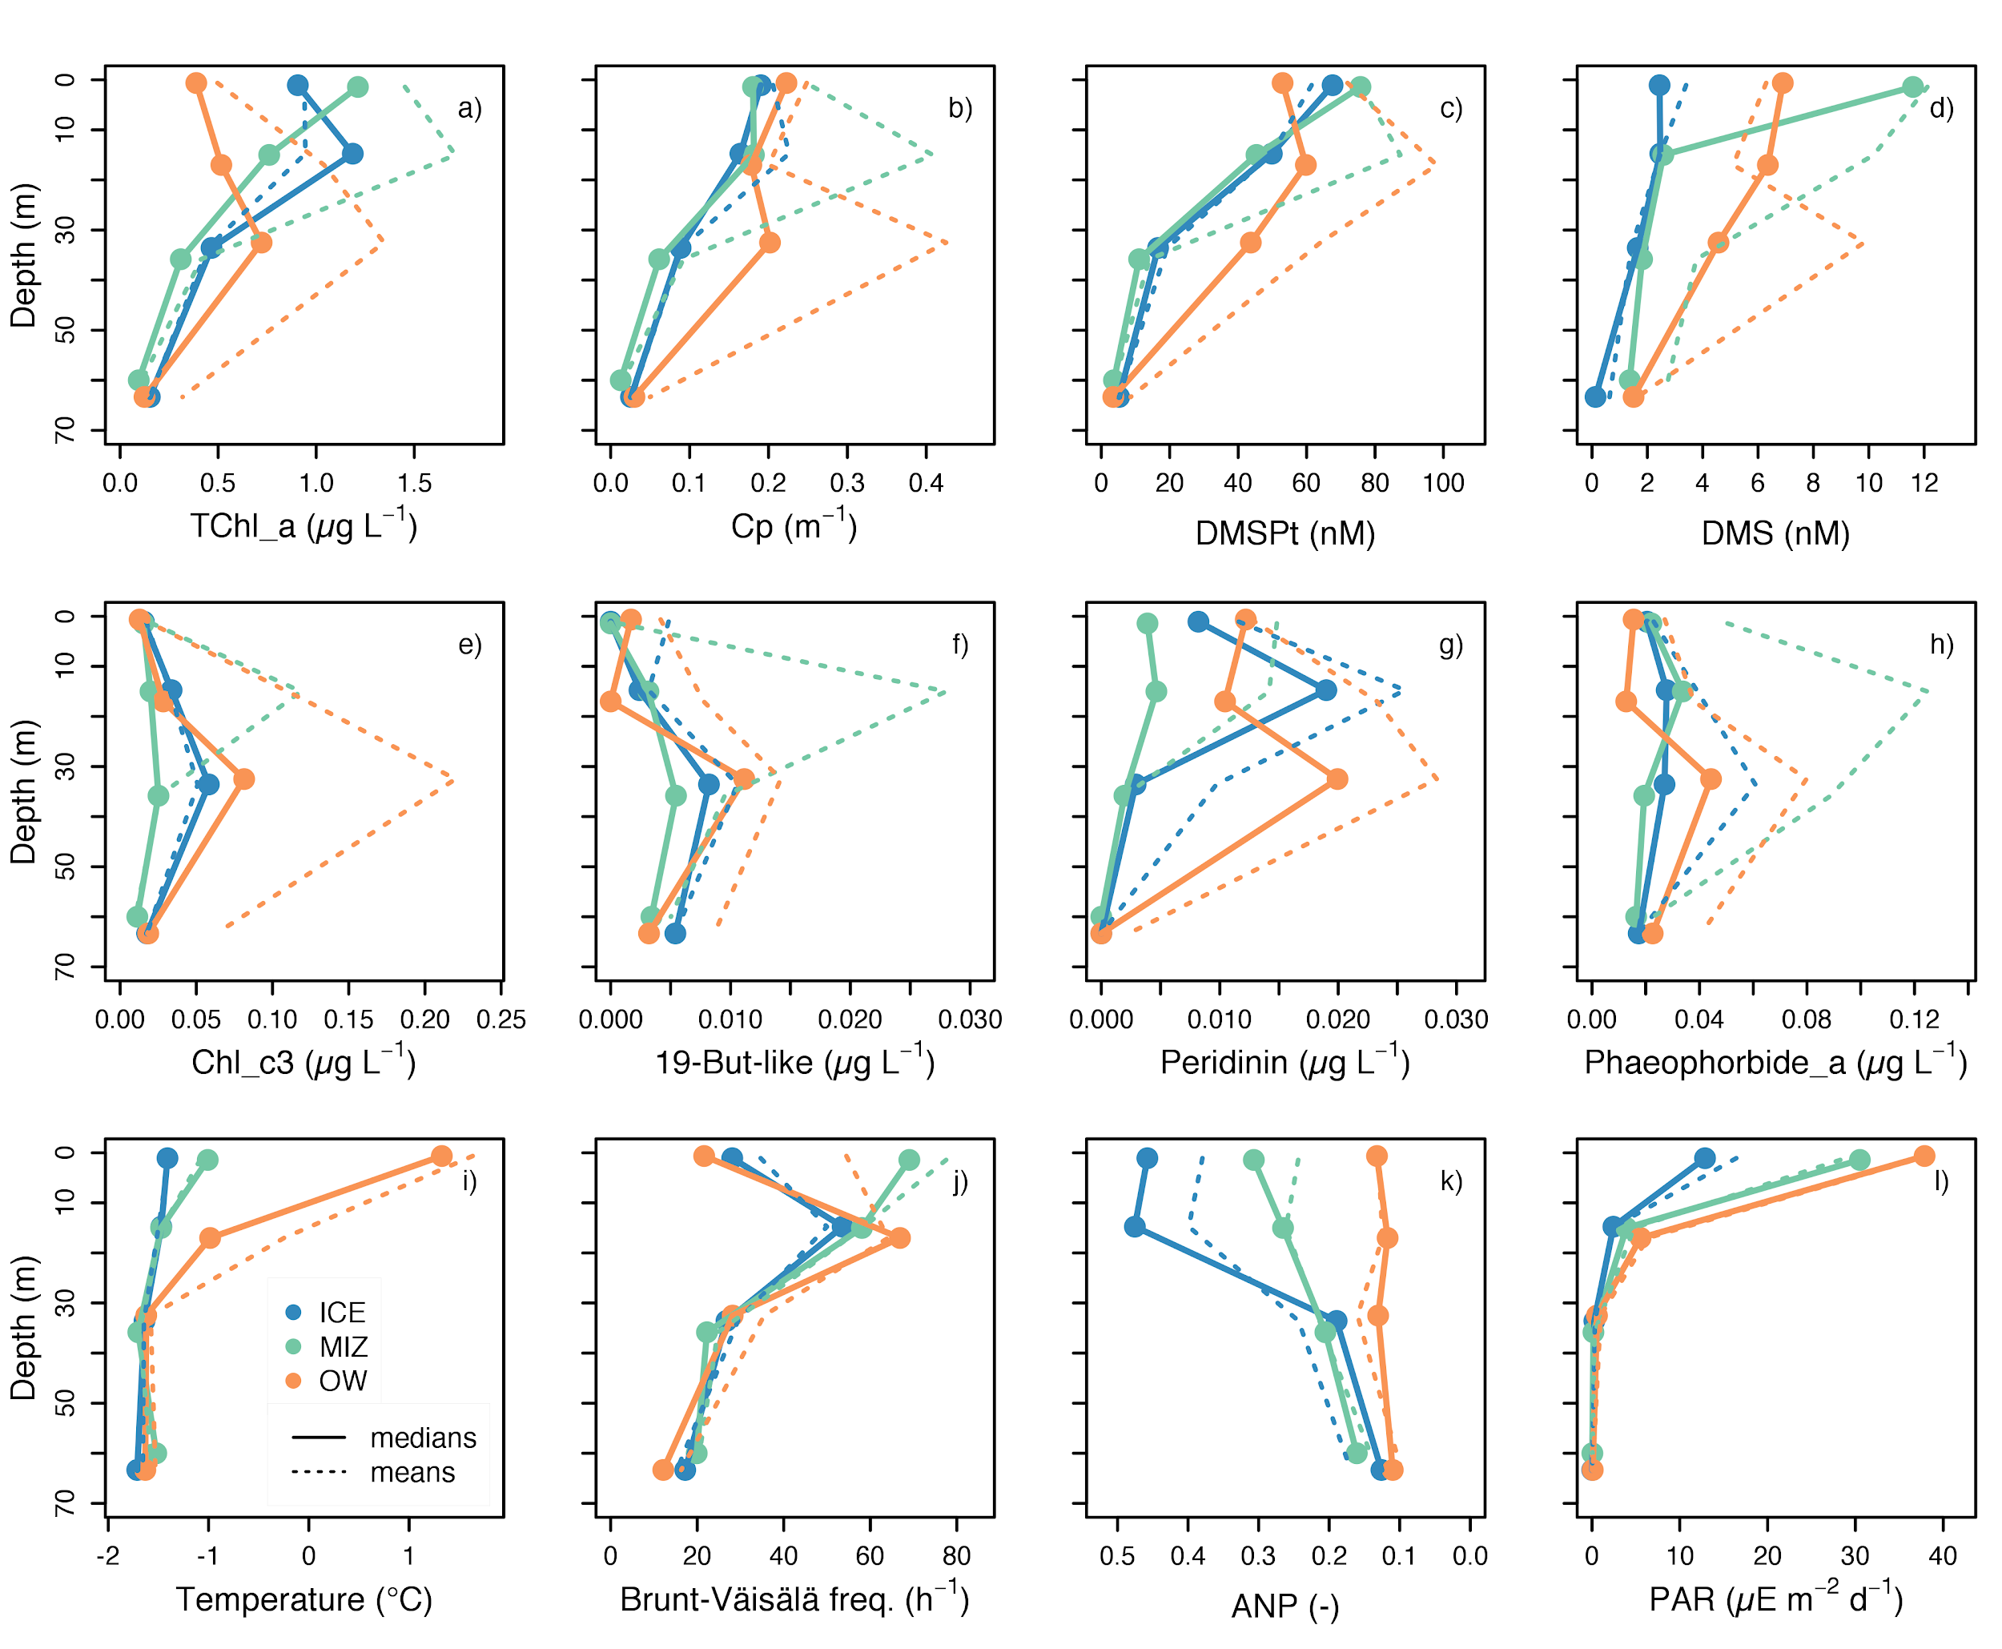

Figure 3. Median and mean vertical profiles grouped according to ice cover and binned into 4 depth horizons. Note that the surface depth of st. 400 was removed owing to suspected influence of ice-derived materials. a) Total chlorophyll a (TChla)…. b) Cp…. Description needed eventually when final plots are chosen, with reminder of abbreviation meaning.

3.3 Biogeochemical factors affecting DMSP_{t} concentrations
DMSP_{t} concentrations were strongly correlated to c_{p}, a proxy of particulate organic carbon (POC) and phytoplankton biomass in the euphotic layer, which explained 56% of the DMSP_{t} variance (Fig. 4a). The linear regression model between DMSP_{t} and c_{p} could not be improved by including environmental variables such as temperature, salinity, ANP, daily PAR or the Brunt-Väisälä buoyancy frequency (vertical water column stability) as predictors. Data pairs of DMSP_{t} vs. c_{p} clustered around a DMSP_{t}:c_{p} ratio of ~230 (Fig. 4a). This ratio changed little across the ice edge and along the vertical profiles (Fig. 5a), except for the high DMSP_{t}:c_{p} measured at the subsurface of the OW stations 612 and 615, concurrent with very high Phaeocystis pouchetii biomass, and just beneath the ice at station 400, probably indicating the release of bottom ice biomass (Fig. 4a).

Total chlorophyll a (TChla) explained 52% of the DMSP_{t} variance (Table 2). In the surface layer, DMSP_{t}:TChla ratios were typically ~70 nmol µg⁻¹ in MIZ and ICE stations and ~130 nmol µg⁻¹ in the OW stations (Fig. 5b). In deeper layers, DMSP_{t}:TChla ratios decreased to 30-50 nmol µg⁻¹. The higher DMSP_{t}:TChla ratios found closer to the surface and especially in OW can be attributed, at least partially, to the reduction of phytoplankton Chla content caused by photoacclimation to high light (Fig. 3l; see also Fig. 5c, 5j and 5k). The contribution of different phytoplankton groups to DMSP production is explored in further detail below.

Phytoplankton cell counts, available at 9 stations, revealed a strong positive correlation between DMSP_{t} and the abundance and biomass of Phaeocystis pouchetii solitary cells (Fig. 6a and 6b) at the SCM. Concentrations of DMSP_{t} were also strongly correlated to pennate diatoms at the SCM. At the surface, correlations between DMSP_{t} and phytoplankton abundance were generally weaker and less significant, highlighting the role of Phaeocystis and pennate diatoms deeper in the water column. Thecate dinoflagellates and unidentified nanoflagellates were also highly correlated to DMSP_{t} but their role will not be discussed further given their low contribution to total biomass.

In MIZ and OW stations, subsurface DMSP_{t} peaks co-occurred with elevated concentrations of the pigment Chl c3, identified by Lafond et al. (2019) as a diagnostic compound for Phaeocystis pouchetii, and a 19'-butanoyloxyfucoxanthin-like pigment, a putative marker for Phaeocystis pouchetii (Rowan et al., 1986, Zapata et al. 2004). Yet, these two pigments were not identically distributed. Chl c3 occurred in nearly all samples and showed the highest concentrations in OW stations (Fig. 3e, Fig. SX), whereas the 19'-butanoyloxyfucoxanthin-like pigment occurred in about two thirds of the samples and peaked at station 512 in the MIZ (Fig. SX). Note, however, that the correlations between these two marker pigments and DMSP_{t} (Table 2) were lower than those found between DMSP_{t} and more widespread pigments like Chl a or Chl c2 (the latter occurs in diatoms, haptophytes and dinoflagellates; Zapata et al., 2006, Jeffrey et al., 2011). A moderate correlation was also found between DMSPt and peridinin, a good marker for DMSP-rich dinoflagellates (Caruana and Malin, 2015), which occurred at relatively high concentrations in the OW stations at depths between 21 and 40 m) and also under ice (Fig. 3g). Finally, some of the highest Spearman rank correlations were found between DMSP_{t} and the photoprotective carotenoids β carotene and diadinoxanthin + diatoxanthin (Table 2).

To better assess the quantitative relationship between DMSP_{t} and phytoplankton pigments, we subjected these variables to stepwise multiple linear regression (sMLR). An optimal model including TChl a, Chl b, Chl c2, 19’-hexanoyloxyfucoxanthin, fucoxanthin and β carotene explained 80% of the DMSP_{t} variance. Interestingly, this regression model relied on pigments that are not specific to high DMSP producers, and the Phaeocystis diagnostics Chl c3 and 19'-butanoyloxyfucoxanthin-like were excluded from the predictor matrix (Table 3), as well as the dinoflagellate diagnostic compound peridinin. Thus, pigment data suggests Phaeocystis did not overwhelmingly dominate DMSP production in the ensemble of stations and depths, but just in the most prominent subsurface biomass maxima.

Using microscopic estimates of phytoplankton biomass, we assessed the partitioning of particulate DMSP (DMSP_{p}) among phytoplankton groups (Fig. SX). The main algal groups present in the water column varied spatially with no algal group predominating or accounting for the majority of DMSP_{p} at all stations or at all depths. The maximum fraction of DMSP_{p} was explained by single-celled Phaeocystis pouchetii i in the SCM at the OW station 615 (29-46%; 6.6·10⁶ Phaeocystis cells L-1, 159 nM DMSP_{t}) and the MIZ station 512 (15-24%; 1.2·10⁷ Phaeocystis cells L-1, 524 nM DMSP_{t}). For all remaining stations, solitary Phaeocystis accounted for only 7±6% and 2% of the DMSP_{p} at the SCM and the sea surface, respectively. Diatoms (pennate + centric) were the main the algal group present i in the sea surface and SCM at the MIZ station 507 (~40%; 72-94 nM DMSP_{t}). Athecate dinoflagellates contributed a large share at the SCM of stations 605, 707, 713 and 719 (30-50%; 30-120 nM DMSP_{t}), and chrysophytes dominated at st. 703 surface (~40%; 17 nM DMSP_{t}). In summary, group- or taxon-specific contributions to DMSP_{p} were generally lower than 10%, but exceeded 30% at some stations and depths. It must be noted, however, that phytoplankton groups explained less than 40% and less than 70% of DMSP_{p} concentrations in the sea surface and SCM, respectively. Imaging FlowCytobot (iFCB) measurements suggest Phaeocystis colonies and detrital particles, which were not quantified by traditional microscopy, might account for the missing DMSP_{p} at some stations. Unfortunately, iFCB data are not available at most surface stations concurrent with traditional microscopy, and their conversion into DMSP_{p} relies on very uncertain conversion factors (see SI).

Table 2. Correlations between sulfur compounds and selected phytoplankton pigments. We report two types correlation coefficients: Spearman's rank correlation (r_{S}) indicates monotonic relationships, whereas Pearson's linear correlation (r_{P}) indicates linear relationships. Bold face distinguishes correlations with p < 10⁻⁴; non-significant correlations (p > 0.05) are not shown. Sample size ranged from 80 to104, except for 19’-butanoyloxyfucoxanthin-like (58 for DMSP_{t}, 69 for DMS) and peridinin (58, 72). ADD CORRS WITH Cp AS BULK Cphyto CONTROL? MAKE APPENDIX TABLE WITH ABBREVIATIONS?
Pigments |  | c_{p} |  | DMSP_{t} |  | DMS
 |  | r_{S} | r_{P} | r_{S} | r_{P} | r_{S} | r_{P}
Chlorophylls | Total chlorophyll a |  |  | 0.82 | 0.72 | 0.72 | 0.76
Chlorophylls | Chlorophyll b |  |  | 0.64 | 0.29 | 0.33
Chlorophylls | Chlorophyll c2¹ |  |  | 0.73 | 0.72 | 0.69 | 0.76
Chlorophylls | Chlorophyll c3 |  |  | 0.34 | 0.59 | 0.32 | 0.67
Photosynthetic carotenoids (PSC) | Fucoxanthin |  |  | 0.63 | 0.61 | 0.65 | 0.68
Photosynthetic carotenoids (PSC) | 19’-hexanoyloxyfucoxanthin |  |  | 0.69 | 0.29 | 0.41
Photosynthetic carotenoids (PSC) | 19’-butanoyloxyfucoxanthin |  |  | 0.48 | 0.44 | 0.34
Photosynthetic carotenoids (PSC) | 19’-butanoyloxyfucoxanthin-like |  |  | 0.47 | 0.77 | 0.47 | 0.83
Photosynthetic carotenoids (PSC) | Peridinin |  |  | 0.68 | 0.53 | 0.43 | 0.28
Photosynthetic carotenoids (PSC) | Prasinoxanthin |  |  | 0.56 | 0.46 | 0.33 | 0.28
Photoprotective carotenoids (PPC) | β carotene² |  |  | 0.87 | 0.63 | 0.70 | 0.45
Photoprotective carotenoids (PPC) | Diadinoxanthin + Diatoxanthin |  |  | 0.80 | 0.62 | 0.56 | 0.43
Photoprotective carotenoids (PPC) | Violaxanthin + Antheraxanthin + Zeaxanthin |  |  | 0.63 | 0.25 | 0.27
Degradation products | Pheophorbide a |  |  | 0.33 | 0.23 | 0.42 | 0.35
¹ Chl c2 group comprises X, Y, Z.
² Includes α+β carotene because of challenges in quantifying them separately, but α carotene is assumed to occur at much lower concentration (e.g., Bricaud et al., 2004).

3.4Biogeochemical factors affecting DMS concentration
DMS concentration was strongly correlated to its precursor DMSP_{t}, which explained 59% of its variance (Fig. 4b). Surprisingly, strong relationships were also found between DMS and c_{p} (R² = 0.60) or TChl a (R² = 0.53) (Fig. SX). An optimal linear regression model including only c_{p} and DMSP_{t} as predictors (both with positive coefficients and p-values of 10⁻¹⁴ and 10⁻³, respectively) explained 80% of DMS variance (intercept not significantly different from 0). This result indicates that DMS was driven to first order by phytoplankton biomass, and that c_{p} and DMSP_{t} were not entirely redundant DMS predictors.

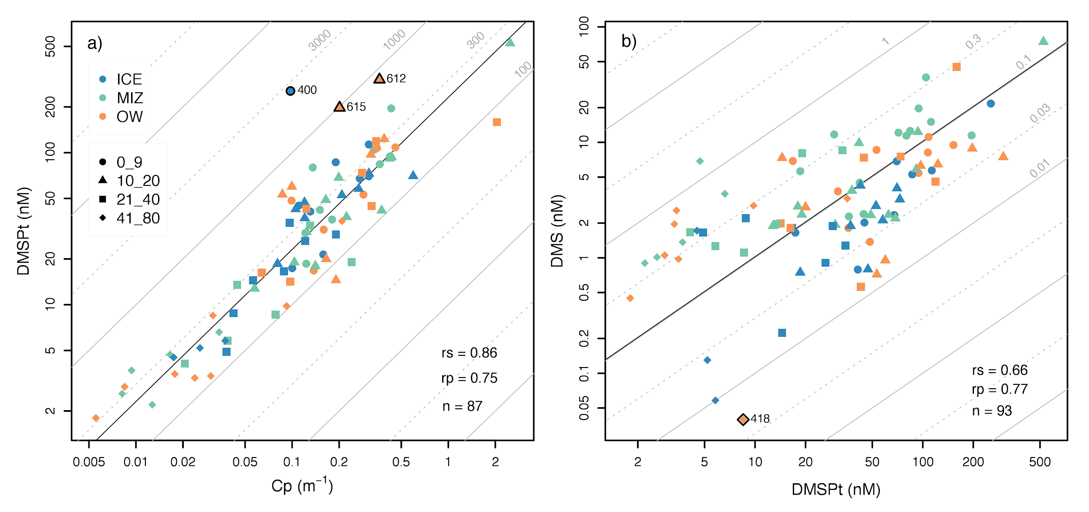
Figure 4. Scatterplots of DMSP_{t} against c_{p} (left) and DMS against DMSP_{t} (right). Points are colored by whether they were sampled under ice, in the MIZ, or in the OW, and symbols represent depth intervals. Outliers, defined as points beyond the 1st or 3rd quartile -/+ 1.5 times the interquartile range, are highlighted with black lines. Reference straight lines on the background mark different values of the y/x ratio (gray) and the median y/x ratio (black). Linear-space Pearson and Spearman correlations (r_{p} and r_{s}) and sample sizes (n) are also shown.

The highest DMS concentrations were clearly associated with high Phaeocystis pouchetii biomass but only in the SCM, as found for DMSP_{t}. In the subset of 9 stations where microscopy counts were available, the abundance of this species explained virtually all (X%) DMS variance at the SCM (Fig. 6d). Yet, the relationship between Phaeocystis and DMS was not as strong in the surface layer, pointing to more complex interaction between various DMS production and removal pathways. Pigment data confirmed the results based on phytoplankton counts, with highest DMS concentrations (> 20 nM; Fig. 2) matched by the highest concentrations of the 19’-butanoyloxyfucoxanthin-like pigment (> 0.03 mg m⁻³), i.e. st. 400 (surface), st. 512 (15 m) and st. 615 (30 m). Using the same subset of predictor pigments as for DMSPt (except for TChl a, see table 3) , 81% of the DMS variance could be explained with an optimal regression model (Table 4). However, unlike DMSP_{t}, a striking 94% of DMS variance was explained by adding to the regression model the 19'-butanoyloxyfucoxanthin-like pigment in the subset of samples that contained it. Good qualitative agreement was also found between high concentrations of the dinoflagellate marker peridinin and DMS, especially in the OW stations (Fig. 3g, Fig. 5g), but this relationship was not captured by correlation (Table 2, Fig. 6c and d) or sMLR (Table 3) analyses, possibly masked by Phaeocystis-dominated samples.

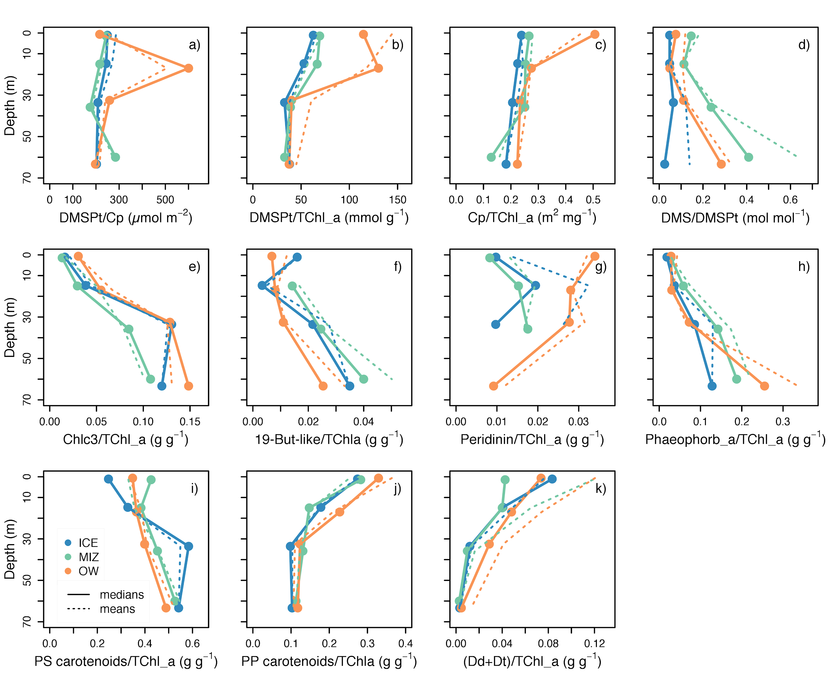
Figure 5. Median (solid lines) and mean (dashed lines) vertical profiles as in figure 3 for different ratios: a) DMSP_{t}:c_{p}, a proxy for DMSP_{t}:POC; b) DMSP_{t}:TChl a; c) c_{p}:TChl a, a proxy for POC:TChl a; d) DMS:DMSP_{t}; e) Chl c3:TChl a, a proxy for Phaeocystis pouchetii relative abundance; f) 19’-butanoyloxyfucoxanthin-like to TChl a ratio, a proxy for Phaeocystis pouchetii relative abundance; g) Peridinin:TChl a, a proxy for dinoflagellates relative abundance; h) Pheophorbide a to TChl a ratio, a proxy for phytodetritus degradation; i) Photosynthetic carotenoids to TChl a ratio; j) Photoprotective carotenoids:TChl a, an indicator of photoprotection; k) (Diadinoxanthin + diatoxanthin):TChl a, an indicator of photoprotection through the xanthophyll cycle.

In the absence of DMSP and DMS cycling rate measurements, the net DMSP_{t}-to-DMS conversion efficiency can be approximated using the DMS:DMSP_{t} ratio, with higher ratios implying relatively fast DMS production, relatively weak DMS removal, or both (Galí et al., 2018). The median DMS:DMSP_{t} ratio was 0.10, but values were scattered across two orders of magnitude (0.01 to 1) (Fig. 4b; see also Fig. 2). The most striking feature of the DMS:DMSP_{t} ratio was its marked increase from ~0.10 at the surface to ~0.30 at 60 m at the MIZ and OW stations, but not under ice (Fig. 5d). The increase of DMS:DMSP_{t} with depth closely paralleled proxies of Phaeocystis relative abundance (Chl c3:TChl a, 19’-butanoyloxyfucoxanthin-like:TChl a) and thephytoplankton biomass decay and grazing intensity (Pheophorbide a:TChl a), suggesting both factors enhanced DMS yields away from the sea surface. However, DMS:DMSP_{t} ratios showed, beyond their clear increase with depth, more subtle vertical and horizontal variations that were not matched by Phaeocystis or phytodetritus proxies. First, DMS:DMSP_{t} ratios were equal or higher in the surface layer compared to the subsurface layer. Moreover, for a given Phaeocystis abundance, DMS was invariably higher at the surface than at the SCM (Fig. 6d). Second, median DMS:DMSP_{t} ratios were maximal in the MIZ at all depths (Fig. 5d), including the top 5 m (Fig. 7g). These patterns cannot be explained by abiotic DMS removal processes controlling spatial distributions, since removal rates will be maximal in the surface layer and would likely increase towards the OW stations owing to stronger gas exchange and light penetration (Fig. 3l), as discussed in ensuing sections. Therefore, variations in net biological production arising from bacterial, algalactivityalgal or grazing activity likely controlled spatial distributions.

To further examine the role of biological processes controlling the distribution of DMS and DMSP, we examined genes associated to bacterial DMSP metabolism at several stations. Unfortunately, quantifications were performed for leg 1a where DMS and DMSP where not measured and for st. 507 and 519 (T5). Overall, the abundance of dddP and dmdA genes appeared to decrease towards the surface. Generally following the vertical trend of bacterial abundance and production (Fig. SX and SY). The dddP gene encodes for a widespread bacterial DMSP-lyase, while dmdA codes for the demethylation enzyme that diverts DMSP away from DMS production. Hence, the dddP:dmdA ratio should reflect the relative importance of these competing pathways, i.e., it should serve as a proxy of bacterial DMS yields from dissolved DMSP. hdddP:dmdA ratios was generally higher than 1 at the surface in the MIZ (values up to 3), and between 0 and 40 m in the OW stations, with values up to 7. This high dddp:dmdA ratio suggest that variations in bacterial DMSP metabolism may partly explain spatial patterns of DMS and DMS:DMSP_{t}.

Phytoplankton light stress, caused by rapid disappearance of the ice shading, is another potential explanation for high DMS:DMSP_{t} in the MIZ. Trends in photoprotective pigment concentrations (Fig. 5j, k) followed the vertical attenuation of irradiance (Fig. 3l) but, more strikingly, did not increase towards ice-free waters following the increase in irradiance, or did it very subtly (Fig. 5j). At the sea surface, the median ratio between xanthophyll cycle pigments and TChl a was minimal in the MIZ, perhaps suggesting a transient decrease in photoprotection capacity that might entail stress-driven release of DMSP and DMS by phytoplankton.

Table 3. Stepwise multiple linear regression (MLR) models between DMSP_{t} or DMS and phytoplankton pigments.The predictor matrix was standardized by calculating the z-score; .pigment z-score values which are independent of pigment concentrations, represent the. relative influence of each pigment on DMSP and DMS . DMSP_{t} and DMS were not standardized, so the y-intercepts represent the mean concentration observed in the water column in each data subset. Significance levels: p ≥ 0.05 is non-significant (marked with n.s. only if the pigment was in the initial predictor matrix); 0.05 > p ≥ 0.01 is marginally significant (marked in italics); p < 10⁻¹⁰ is extremely significant (marked in bold). For each compound, the left column includes all available samples and the right column the sample subset where the 19’-butanoyloxyfucoxanthin-like pigment was detected. Chl c3 gave marginally significant coefficients in just one case and was excluded from all other MLR models shown below. For simplicity it is excluded here from all initial predictor matrices (with no effect on adjusted R²).
Fit statistics | Predicted variables
Fit statistics | DMSPt |  | DMS
n | 89 | 58 | 103 | 69
Adjusted R² | 0.80 | 0.82 | 0.81 | 0.94
MLR terms (value ± standard error)
Intercept | 59.2±3.6 | 60.6±5.0 | 6.7±0.4 | 6.6±0.3
Total chlorophyll a | -167±39 | -212±45 | n.s. | 18.4±1.7
Chlorophyll b | -13.4±6.6 | n.s. | -4.7±0.7 | -3.5±0.5
Chlorophyll c2 | 312±37 | 356±52 | 24.3±1.9 | n.s.
Fucoxanthin | -135±16 | -116±28 | -17.8±1.9 | -11.1±1.5
19’-hexanoyloxyfucoxanthin | -24.2±4.7 | -32.8±7.0 | -4.8±0.6 | -3.9±0.4
β carotene | 80.8±9.6 | 85.5±11.5 | 5.6±0.8 | 1.7±0.6
19’-butanoyloxyfucoxanthin-like |  | n.s. |  | 4.8±0.5

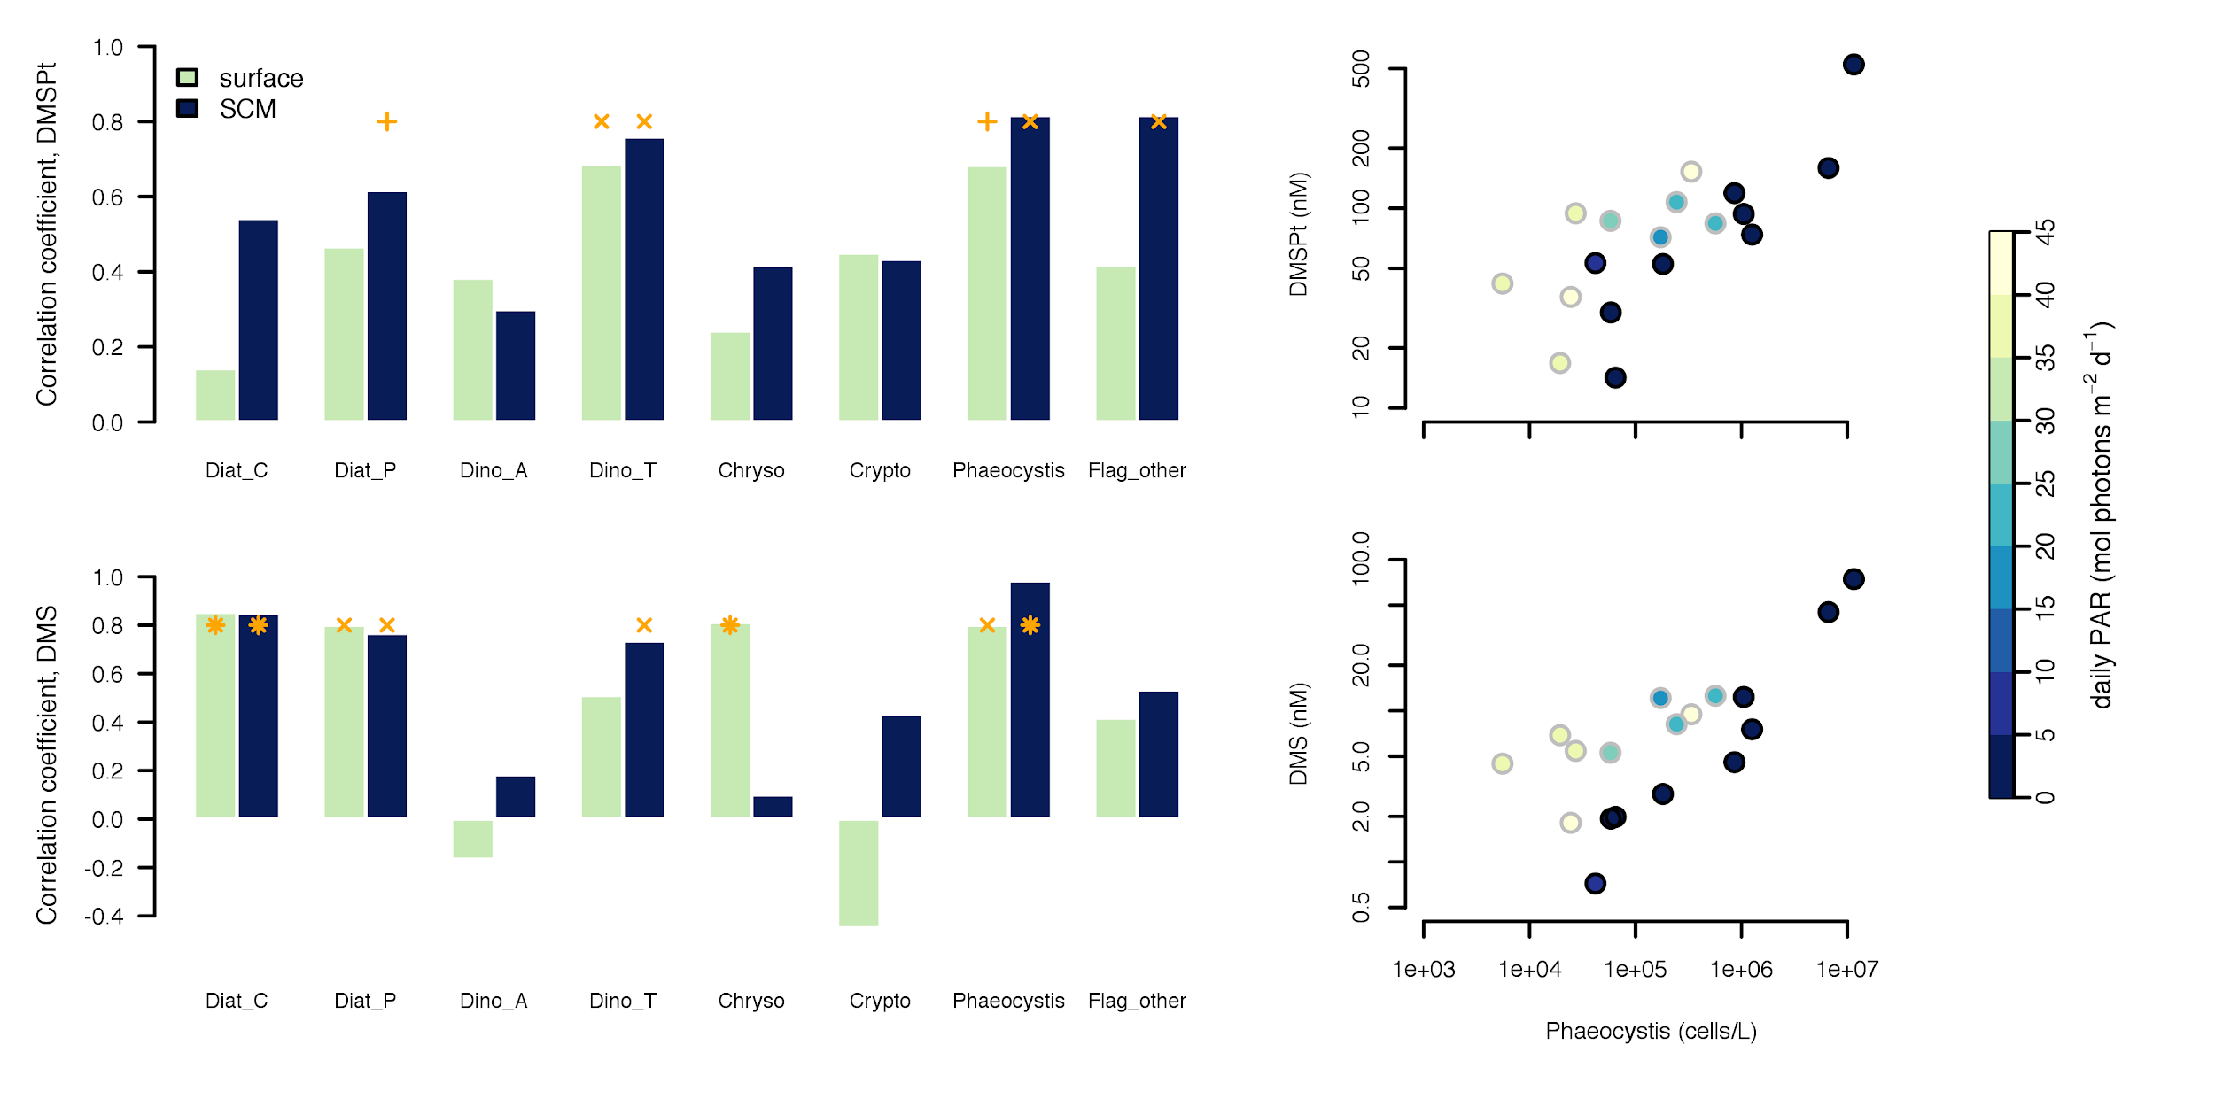
Figure 6. Correlation (Spearman’s rank correlation coefficient) between phytoplankton abundance and DMSPt (panel Aleft ) or DMS (panel Cleft ). Scatterplots on the right show the relationship between solitary Phaeocystis pouchetii cells abundance and DMSP_{t} (panel B) or DMS (panel D) concentrations.

3.5 Sea-air DMS flux (FDMS) and its drivers
Sea-air fluxes ranged between <0.05 and 26 µmol m⁻² d⁻¹ and increased towards ice-free waters, with a maximum mean FDMS of 10.0 µmol m⁻² d⁻¹ observed in the OW stations (Fig. 7a). Correcting for the daily fractional ice cover (i.e., multiplying the FDMS from ice-free waters by 1-SIC) decreased mean FDMS from 2.3 to 0.3 µmol m⁻² d⁻¹ in the ICE stations and from 7.3 to 6.9 µmol m⁻² d⁻¹ in the MIZ stations. However, the main driver of the increasing FDMS towards OW was not the decreasing sea-ice cover (Fig. 7b), but the concomitant increase in sea-surface DMS concentration, wind speed and SST (Fig. 7c-e). Among these four factors, sea-surface DMS concentration and wind speed exerted the strongest control on FDMS, together explaining 75% of the total variance in the flux data. Assuming DMS ventilation losses affected the entire mixed layer represented by hBD, DMS turnover due to sea-air exchange was typically <0.03 d⁻¹ (>30 days) at the ICE stations and 0.04-0.10 d⁻¹ (10-25 days) at the MIZ and OW stations. Assuming instead that ventilation affected only the shallower layer defined by MLD0.03 (Table 1), we obtained shorter turnover times, especially in the MIZ where a median of ~0.3 d⁻¹ (3 days) and a maximum of ~1 d⁻¹ (1 day) were found.

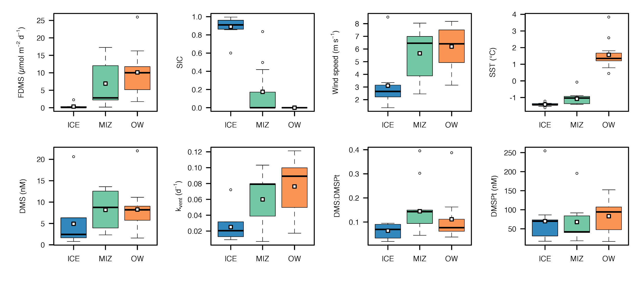
Figure 7. Box and Whisker plot summary of sea-air DMS fluxes and corresponding controlling factors across the ice edge transects from ICE to OW. (a) sea-air DMS flux, (b) fractional sea-ice coverage, (c) wind speed, (d) sea surface temperature, (e) near sea-surface DMS concentration, (f), DMS ventilation rate constants in the equivalent mixed layer (hBD; see text), (g) DMS:DMSP_{t} ratio, and (h) near sea-surface DMSP_{t} concentration. Boxplots distinguish between ice-covered waters (ICE), the marginal ice zone (MIZ), and open waters (OW) (see text and Table 1). Thick horizontal lines represent group medians and empty squares represent group means. Near sea surface DMS and DMSP_{t} concentrations and their ratios correspond to the 0-5 m layer.

Table 4. Compilation of mean (range) sea-air DMS fluxes (FDMS) in the ICE, MIZ and OW stations in our study and that from other investigators in the Arctic. Note that FDMS reported here were not corrected by the fraction of ice-free water surface (1-SIC) because they are used in section X in combination with satellite-observed SIC.
Reference  (region) | Ice cover categories
Reference  (region) | ICE | MIZ | OW
Matrai & Vernet 1997  (Barents Sea) | n.a. | 17 (6-33)  n=3 | 33  n=1
Galí & Simó (2010)
(Greenland Sea, Fram Strait)
This study  (Baffin Bay) | 2.3 (0.2-6.0)  n=10 | 7.3 (1.1-17.1)  n=13 | 10.0 (1.7-25.7)  n=12

4. Discussion

Articulate around the following points:
4.1 Variations in DMS(P) across the ice edge
- Summary: not that variable, except for very high DMS(P) in a few Phaeocystis dominated layers.
- DMSP per unit biomass is strikingly constant across ice edge if one discounts the stations stations with very high Phaeocystis. Choral contribution of different groups to DMSP synthesis. Intriguing question: how can we account for missing DMSP, especially at surface? Are we missing DMSP in colonies or detritus?
- DMS more variable across ice edge, increasing towards OW possibly as a result of phyto community (dinos!) and food web processes (greater bacterial DMS production; perhaps grazing?).
- Patterns of DMS:DMSPt across ice edge suggest net bio DMS production overcompensates abiotic losses towards OW. Bacteria? Light stress? Nutrient stress?
- Background question: Can we really untangle temporal bloom progression from water mass and ice retreat spatial patterns? Spatial correlation between water masses, ice retreat patterns and bloom composition and development stage make their effects on DMS(P) hard to disentangle. This problem is common to other Arctic areas where Atlantic water masses meet Arctic outflow (Greenland Sea, Barent Sea).
- I also think that we are dealing with two systems evolving in parallel. However, there is probably a narrow zone between the two systems where the Arctic/Pacific plankton assemblage is exposed to light due to ice retreat. Would it be possible to define this narrow zone based on salinity and temperature characteristics and try to see if the Arctic/Pacific assemblage produces more DMS under these MIZ conditions? It is tempting to analyze the transects in terms of a temporal progression (Randelhoff 2019), but studies of phytoplankton communities (Lafond 2019) and ecosystem structure and carbon flows (Saint-Béat 2020) concluded that the ecosystem observed in the western side was unlikely to evolve towards the ecosystem of the eastern side.

4. 2 Vertical segregation in biological and physical DMS drivers
- Variations in microbial communities and physics shape different S cycling regimes along vertical axis.
- Absolute and relative abundance of Phaeocystis increases between surface and SCM according to phyto counts and pigments. Phaeocystis clearly drives DMS production and concentration below surface layer, and aggregates sinking from subsurface Phaeocystis peaks seem to export DMSP (that is readily transformed to DMS) away from layers that can exchange with atmosphere. However, DMS(P) cycling in/around large aggregates (colonies, detritus) poorly quantified and understood. Check Scarratt et al. 2000 for size fractionated DMS prod, and del Valle 2009 for bact DMS cons in aggregates.
- At the surface where the role of free-living bacteria (e.g. transforming DMSP released by non-DMS producers like diatoms) may be relatively more important. Dinoflagellates too. Role of light exposure?

4. 3 Re-evaluating the role of phytoplankton community composition and the potential for ecological shifts
- The bgc setting can be described as choral with some Phaeocystis solos. Northward expansion of Phaeocystis (e.g. in Baffin Bay) along with Atlantic waters suggests potential for floristic shifts impacting Arctic FDMS. HOWEVER:
  - Some evidence of Phaeocystis more abundant in Atlantic waters in our study (eg ANP vs. pigments, Fig 3 and 5, new figure). Drivers of Phaeocystis distribution are not sufficiently understood (eg different nutrient ratios in Atlantic vs Arctic-Pacific waters? N:P? N:Si?). It’s possible that energetic submesoscale blurs Atlantic-Arctic boundary and thus biogeographic dispersion pathways.
  - Potential for Phaeocystis growing in sea ice and seeding pelagic bloom: evidence from st. 400 and 19-but-like pigment. Check Assmy et al. 2017. Evidence for coexistence of seawater and ice DMS(P) sources under ice and in MIZ.
  - Putative Phaeocystis diagnostics in our dataset (chlc3, 19-but-like) show different patterns. Regarding pigments, I read a couple of papers (Jeffrey et al. 2011 in Roy's book, and Zapata et al. 2004). The 19'-but-like pigment that was strongly correlated to DMS(P) in our study may indeed be a Phaeocystis marker. Although 19-hex is the most widespread haptophyte marker pigment, the so-called "type 8" of haptophyte pigmentation groups is characterized by variable presence of 19'-but. And 19'-but-like pigments have been reported in a couple of studies. In contrast, chl c3 is a major pigment in most diatoms and haptophytes so, even though it was suggested as a goof Phaeocystis proxy for our cruise, I am not convinced it can tease apart haptophytes from diatoms. This is also what the comparison to DMS(P) data indicates. CHECK WHETHER SAMPLES WHERE 19-BUT-LIKE IS ABSENT ARE MOSTLY ARCTIC. BY ANP (0.3 DIVIDE) AND CLUSTERRING COEFF (0.4 DIVIDE).
  - Need more knowledge and better quantification of colonial Phaeo.
  - Phaeocystis is not dominant in the surface layer that regulates FDMS. Role of dinoflagellates possibly important and traditionally overlooked (as found by Steinke 2002 in cocco bloom) because in these environments they don’t seem to form conspicuous blooms compared to haptophytes. Upregulation of diatom DMSP by nutrient limitation (McParland & Levine 2018) may imply higher than expected DMS produced via DMSPd→ bacteria pathway.
  - Some ideas:
    - Vogt et al. 2013 database: highest abundance of 1.2*1e7 cells/L in Arctic fjord in 1989. Very similar to our highest abundance, and to max reported for Gulf of Maine of 1.4*1e7 cells/L (see Borkman below).
    - Brisbin & Mitarai 2019 report upregulated DMS and acrylate production in colonial Phaeo globosa and invoke protective roles against grazing etc.
    - Borkman et al. 2016 describe 1992-2012 time series of phyto in Gulf of Maine. Report increased occurrence of Phaeo pouchetii after 2000. Increased intrusion of warmer saltier Atlantic warmer with higher N relative to P and Si favour Phaeocystis spring blooms in detriment of centric diatoms.
    - Krawczyk 2018: Cold and relatively saline waters in spring favoured the single haptophyte species Phaeocystis cf. pouchetii, while in summer, fresher waters influenced by glacial discharge favoured diatoms, followed by dinoflagellates and predatory ciliates in autumn.
    - Kubiszyn et al. 2017: The spring bloom was initially dominated by the prymnesiophyte Phaeocystis pouchetii and Bacillariophyceae (primarily from the genera Thalassiosira, Fragilariopsis and Chaetoceros) and was later strictly dominated by Phaeocystis colonies. Bacillariophyceae dominated the spring bloom when local water masses prevailed, while Phaeocystis pouchetii dominated the spring bloom when Atlantic water prevailed.
    - Engel et al. 2017 Phaeocystis and TEP interannual variability Arctic. Same idea that Phaeocystis goes with Atlantic waters.
    - Read Simo-Matchim et al. 2017 MEPS.
    - Keys et al. 2017: Phaeocystis (pouchetii + globosa) in English Channel (L4) long time series, + positive response to acidification in microcosm exp (recheck).
    - Stabell et al. 1999, Hansen & Eilertsen 2007: Phaeocystis pouchetii toxins.

4.4 Can we generalize and upscale results to the pan-Arctic ice edge?
- DMS(P) distribution patterns in Baffin Bay resemble those encountered in other Arctic areas where Atlantic inflow encounters Arctic outflow (Table 4), determining both ice edge location and phytoplankton blooming.
- Uncertain whether analogous settings may be found in the Pacific sector although with distinct biogeochemical signatures (eg N:P ratios)
- Arctic MIZ can make strong episodic contributions to atm. DMS (Fig. 8). Regardless of exact magnitude (estimates uncertain) these emissions cannot be overlooked.

Figure 8. Evolution of Arctic MIZ DMS emission during the summer period (May through August), aggregated by 5-degree latitude bands (panels). Lines represent DMS emission (EDMS; right axis) and bars the % additional EDMS from the MIZ compared to OW (left axis). Colors represent methods A (dark cyan) and B (light cyan) used to compute MIZ extent (see text). Note y axes are different in each panel. Lines/bars?

NEXT PAGE
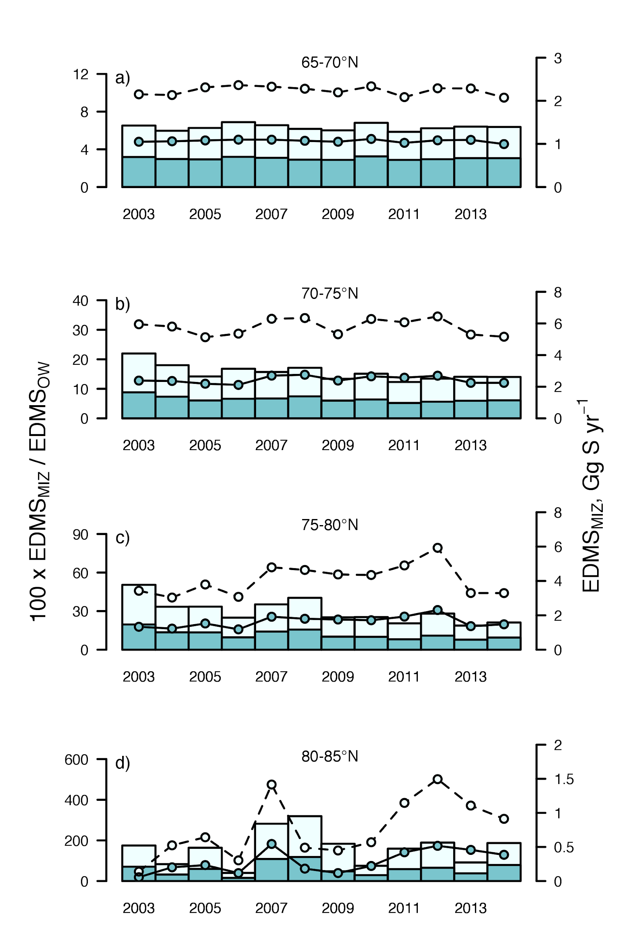
5. Conclusions and outlook
Short summary? (1 paragraph)

Future studies should…
- Measure process rates, with special emphasis on processes occurring in and around particles across the entire size spectrum (from cells to large detrital aggregates).
- Attempt Lagrangian tracking of water masses with distinct origin (starting before ice breackup) to understand microbial succession and S budgets along temporal bloom progression, effectively separating it from the distribution of water masses and ice retreat patterns (admittedly difficult in such a dynamic environment).
- Describe S cycling and FDMS in the MIZ in other Arctic regions with different biogeochemical settings: Central Arctic, inner (mostly Siberian) and inflow (Pacific sector) shelves.
- Regarding modeling studies, the ability to reproduce the vertical segregation of plankton communities, and the corresponding differences in sulfur cycling regimes, is crucial to project DMS emission in the future Arctic MIZ.

Short wrap up paragraph turning back to the atmosphere?

Acknowledgments

Data availability
CYBER database
Conflicts of interest
None
References

