# CS374 – Intro to Database Management

# Application Development Project

# Rubric for Status Update

## Group Member #1: McKenna Galle (The Great Generator)

## Group Member #2: Tersa Almaw (The Awesome Advocate)

## Group Member #3: Vina Le (The Lifeline Leader)

**TEAM G-AL-LE**

|  |  |  |  |
| --- | --- | --- | --- |
| Name | Requirements | Points | Awarded |
| Description of Application | * An overview of your application * *changes since second deliverable* * System requirements (e.g. hardware, DBMS, other software) * A detailed description of your application * Are there features that will not be implemented? What are they, and why won’t you fulfill them? | 5 |  |
| Schedule | * *changes since second deliverable* * Detailed schedule of who will do what part of project, by when | 5 |  |
| Logical Diagram | * *changes since second deliverable* * Logical diagram in UML or E-R * Discussion of how your data model will satisfy the needs of your application * Discussion of alternative designs that you did not do (and why) | 5 |  |
| Queries Required | * *changes since second deliverable* * Required queries in English (not SQL) * What entities and/or relationships are required for each query? * How will each query satisfy the needs of your application | 5 |  |
| Grammar, punctuation, syntax, and references | * Follow rules from the Penguin handbook on writing * References as appropriate (e.g. if you are modeling your application after an existing application, make note of that) | 5 |  |

**Application Description**

For a system requirement, we have our database implemented in Microsoft Access and embedded SQL code using Visual Studios. The user is able to choose from a given menu on what queries can be viewed when accessed. Due to the fact that this was originally created to be out in a mobile application, Eclipse was unable to process Access’ new packet software. With the database already completed at the time, the group has decided to create the queries using C++ instead. The user has the options to view all items that is currently in their refrigerator, view specific allergy-based or quality-based items that are in the fridge. In addition to that, the user also has the option to view what is in their shopping list when the fridge only has one item left in the fridge or when a specific item is expiring soon. Originally, the database was planned to be implemented using JavaScript and put into an app. That is the feature that will be created next as a side project for the group whenever time allows us to learn more about DBMS and put our skills to the test.

**Modified** **Project Management – Schedule (Current)**

Week 0 (Nov. 9 – 13):

* Do the deliverable 2
* Plan all of this even though we know we’re not going to stick to it

Week 1 (Nov. 14 – 20):

* Schema created and rough outline of the E-R diagram
* Implementing the database:
  + McKenna: Type/Food
  + Tersa: Location and Shopping List
  + Vina: “In the Fridge”

Week 2 and 3 (Nov. 21 – Dec.4):

* Complete database
* Complete Update Deliverable
* Start the outline for how the code will be implemented
  + McKenna: Connect the embedded SQL to the Access file
  + Tersa and Vina: Evaluate the queries

Week 4 (Dec. 5 – 11):

* Modify the E-R diagram
* Modify the DBMS and SQL
* Get the code running and making it look pretty

**Schema (Current)**

* Fridge(ID, foodID, expireDate, boughtDate, quantity, quality, typeBrand, compartment, brand, foodDescription)
* Food(ID, fridgeID, foodType, foodGroup, foodName, foodDescription, allergy, vegan, freezable, price, packaging, locationID)
* Location(ID, name, address, phoneNum, aisle)
* List(ID, locationID, fridgeID, foodID, quantity)

**Logical Diagram UPDATED**

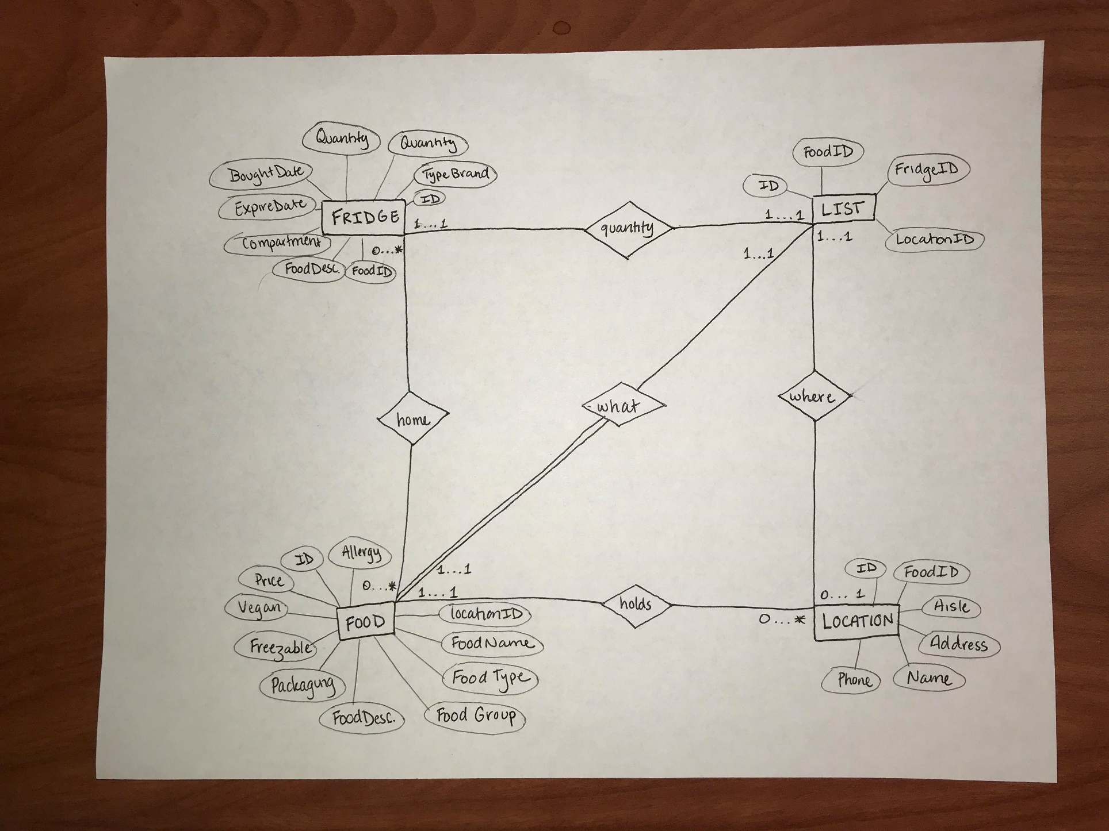

**Queries:**

* Displays all items in the fridge

SELECT *

FROM Fridge R, Food O

WHERE O.ID = R.FoodID

* Displays all items that will expire before 12/14/2017

SELECT ExpireDate

FROM Fridge R

WHERE ExpireDate = “12/14/2017”

* Displays all items that are GMO

SELECT Quality

FROM Fridge R

WHERE Quality = “GMO”

* Displays all items in freezer

SELECT O.FoodName

FROM Fridge R, Food O

WHERE Compartment = “Freezer” AND O.ID = R.FoodID

* Displays all items that are gluten-free

SELECT FoodName

FROM Food O

WHERE Allergy = “Gluten-Free”

* Displays all items that contain nuts

SELECT FoodName

FROM Food O

WHERE Allergy = “Nuts”

* Displays all location in which soda can be found

SELECT L.Name, L.Address,L.Aisle

FROM Location L, Food O

WHERE O.ID = L.FoodID AND O.FoodName = “Soda”

* Displays all items that expire before 12/20/17 or has a quantity less than 3 in the fridge into the grocery-shopping list.

SELECT O.FoodName, R.ExpireDate, R.Quantity

FROM Food O, Fridge R

WHERE (ExpireDate “12/20/17 OR R.Quantity< 3) AND O.ID = R.FoodID