Pocket Piccolo
McKenna Gameros
14 April 2020
Introduction 1
Piccolo Harmonics 1
Piccolo Note to Generated Note Comparison 2
ADSR Window 3
Hardware Design 4
Software Design 5
COVID-19 Revised Plan 6
Program 6
Sources 8

Introduction
The purpose of this project was to create a digital piccolo that will allow me to play my instrument without the risk of damaging my or anyone else’s ears. I wanted the piccolo to be able to play the full range of a piccolo, which is from D6 to C8, or almost 3 octaves.

Piccolo Harmonics
To get the sound of a piccolo, I needed to figure out how a piccolo generates sound. In my research, I found that a piccolo’s sound is multiple cosine functions added together. Each cosine is generated at a harmonic frequency, which is found by multiplying the target frequency by a number from 1 to 10. For each harmonic, there is a decreasing amplitude on the cosine function. These are the harmonics of a wave as given by the Hyperphysics website:
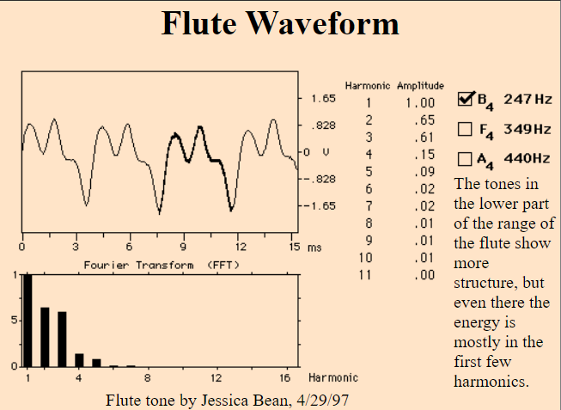

Piccolo Note to Generated Note Comparison
I started creating the sound using the harmonics found in the website I used as my primary source, however, it actually wound up sounding more like a harmonica than an actual piccolo. So I recorded myself playing my piccolo and found the harmonics of the sound using the DFT of the wave. This gave me 4 peaks with the amplitudes of the wave, and I found the true harmonics of the piccolo. Surprisingly, there was a harmonic tone at 1/40 of the desired frequency as well. However, using this combination of harmonics rather than the ones suggested actually made the program sound more like a real piccolo. This is to show the harmonic levels on my piccolo I used to calculate my algorithm.
[y, piccFs] = audioread('Picc.wav');
%sound(y, piccFs);
N=size(y,1);
scale=(0:1:N-1)*Fs/N;
x=fft(y(:,1));
realx = abs(x);
M = max(realx);
spect=realx./M;
figure;
plot(scale,spect);
xlim([0 Fs/2]);
title('Piccolo Harmonic Levels');
xlabel('Frequency (Hz)');
ylabel('Harmonic Level (Percent)');
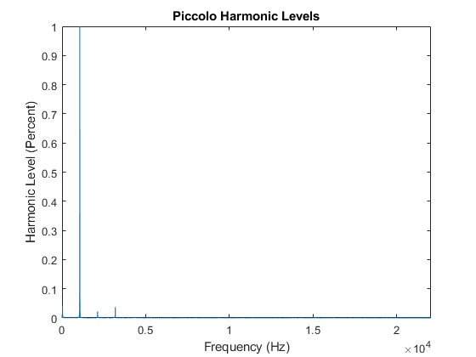

ADSR Window
The other piece of a piccolo’s sound is what is called an ADSR window. ADSR stands for “Attack, Decay, Sustain, Release.” This window is a sound modifier that imitates how a real instrument would sound. As a player begins blowing air into their instrument, there is a sharp increase in air going into the instrument, before the amount of air reduces slightly, then it sustains until the player wants to stop playing the note, then there is a slow release as the player stops blowing air into the instrument. When modifying the cosine functions with this window, it makes it sound more like a real instrument rather than a computer generated sound. I have the maximum volume set to 0.8 rather than 1 because it was too loud when I was using 1 as the max.

Hardware Design
I had wanted to have a breadboard with buttons connected to the DSP board that would interpret it and play the music. However, since I don't have the DSP board with me and I think I would need a lot of help from Dr. Waldo to connect it, I decided to come up with an alternate software UI as well. I'm putting this in the hardware design because it would take the place of the hardware.
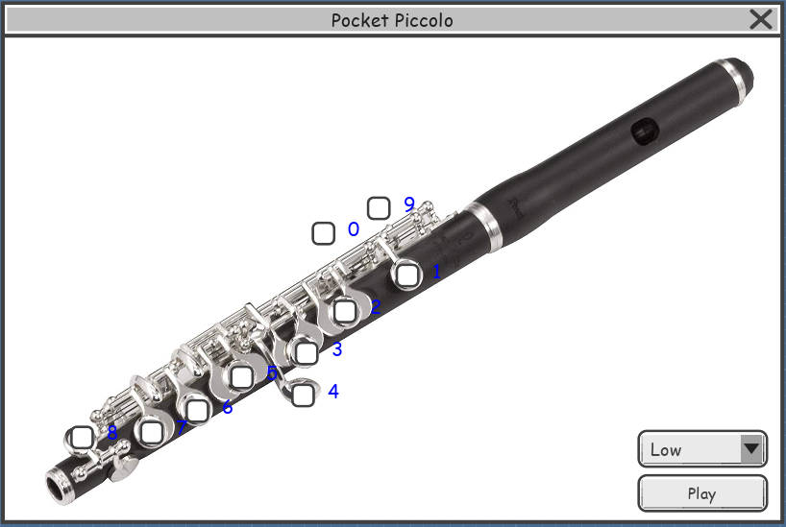

Software Design
Below is the pseudocode for the proposed software UI.

Visual Studio Code:
Keys()
{
Get the user’s input
If the user inputs a number, check the corresponding key
}
Play Button on Clicked()
{
Check each button to see if it’s been clicked
Check the combo box to see which octave to play in
Send the note to the DSP Board
}

DSP Board Code:
Main()
{
Initialize speakers
Initialize connection to Visual Studio Code
}

Thread()
{
While(1)
{
Get the input from Visual Studio Code
Send to speakers
}
}

Speakers()
{
Generate the sound from the given frequency
Play the sound from the given frequency
Return to Thread
}

COVID-19 Revised Plan
Due to COVID-19, I can no longer make the Piccolo I wanted. However, since I still have access to MATLAB, I will do an alternate project. This will take input from the user in the form of a number that corresponds to the piccolo's keys (very much like the software UI I had proposed) and output a sound for that note.

Program
This is the code for the MATLAB program to generate a piccolo sound
clear;
clc;
% The sampling frequencies and time t are the same throughout, so we'll
% define it here
Fs = 44100;
t = 0:1/Fs:1;
% Get harmonic levels for a piccolo sound
Levels = [0.04216 1 0.02235 0.03738];
% Generate ADSR envelope
% The ADSR envelope is how notes are normally played in instruments: a
% sharp attack at the beginning, a sustain, and then a drop.
% ADSR stands for "Attack, Decay, Sustain, Release"
A=linspace(0,0.8,0.1*(Fs+1));
D=linspace(0.8,0.6,0.15*(Fs+1));
S=linspace(0.6,0.6,0.6*(Fs+1));
R=linspace(0.6,0,0.15*(Fs+1));
ADSR = [A D S R 0];
% Read the note tables in.
low = readtable('Low.csv');
low.Properties.VariableNames{'x___Note'} = 'Note';
mid = readtable('Middle.csv');
mid.Properties.VariableNames{'x___Note'} = 'Note';
high = readtable('High.csv');
high.Properties.VariableNames{'x___Note'} = 'Note';
while 1
octave = input('Piccolo octave (default middle): ','s');
if isempty(octave)
octave = 'M';
end
note = input('Piccolo note: ');
if octave == 'L' || octave == 'l'
f = low.Frequency(low.Note == note);
elseif octave == 'M' || octave == 'm'
f = mid.Frequency(mid.Note == note);
elseif octave == 'H' || octave == 'h'
f = high.Frequency(high.Note == note);
end
% Generate harmonics
H1 = Levels(:,1).*cos(2.*pi.*f.*t./40);
H2 = Levels(:,2).*cos(2.*pi.*f.*t);
H3 = Levels(:,3).*cos(2.*pi.*2.*f.*t);
H4 = Levels(:,4).*cos(2.*pi.*3.*f.*t);
% Generate pitch
tone = H1+H2+H3+H4;
note = ADSR.*tone;
sound(note,Fs);
end

Sources
http://hyperphysics.phy-astr.gsu.edu/hbase/Music/flutew.html
http://www.a-mc.biz/makemusic/2018/05/30/attack-decay-sustain-release-adsr-explained/
https://pages.mtu.edu/~suits/notefreqs.html

Published with MATLAB® R2018a

